Jocelyn Dupuis

03/16/2023

Web 231 – Exercise 1.2

**Link to GitHub Repository:** <https://github.com/jdupuis825/web-231>

**Screenshot of GitHub Repository:**

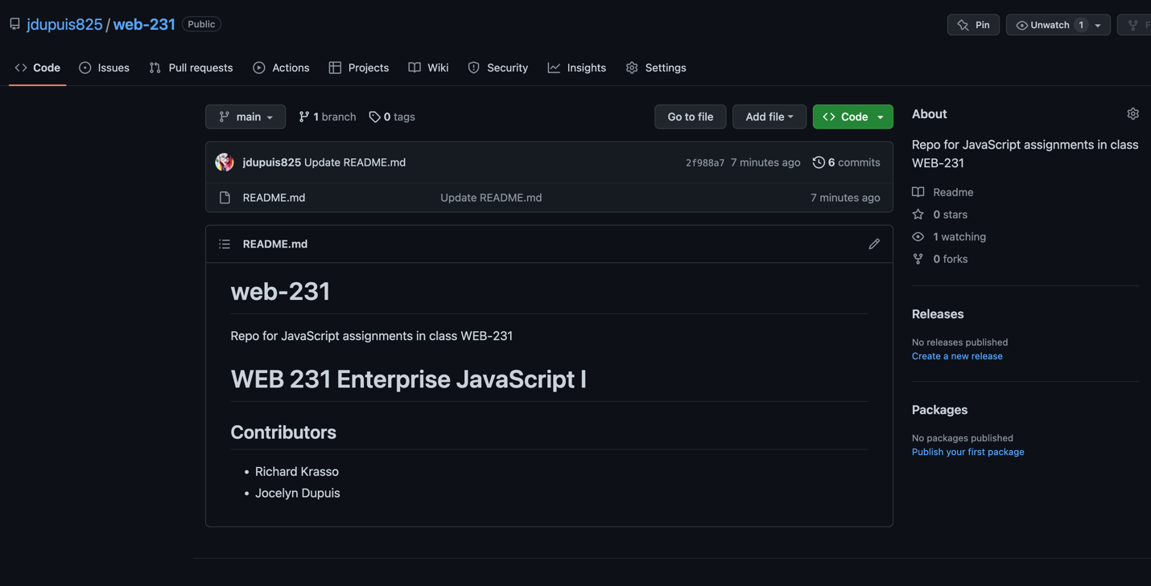

**Screenshot of local directory:** (tried to get everything in there)

