R Markdown Example

## R Markdown

This is an R Markdown document. Markdown is a simple formatting syntax for authoring HTML, PDF, and MS Word documents. For more details on using R Markdown see <http://rmarkdown.rstudio.com>.

When you click the **Knit** button in R Studio a document will be generated that includes both content as well as the output of any embedded R code chunks within the document.

A useful summary of RMarkdown syntax can be found here: <https://www.rstudio.com/resources/cheatsheets/>

## Formating Text

Enclose parts of text with asterisk to obtain change it to italics or bold: writing *this text is in italics* and **this text is bold** will result in *this text is in italics* and **this part is in bold** when you knit the document. End a line with two spaces to start a new paragraph.

To include a link use the following [text for link](www.rstudio.com) which yields [text for link](www.rstudio.com)

Use hashtag to make headers: one for level 1 header as in # Header 1, two for level 2 e.g. ## Header 2, etc:

# Header 1

## Header 2

### Header 3

To create lists starts each line with an asterisk or a dash, for numbered lists start the line with numbers.

## Math Formulas

To include math formulas you can use standard LaTeX syntax to obtain:

* for inline math write $1+1=2$ to get $1+1=2$
* use $$ before and after to get an equation
$$x+y=3$$

* for an equation array use
* $$  
  \begin{aligned}  
  x + y &= 3 \\  
  x - y &= 2  
  \end{aligned}  
  $$
* to obtain

$$\begin{matrix}x+y & =3 \\ x−y & =2\end{matrix}$$

For more details on LaTeX syntax please see <https://en.wikibooks.org/wiki/LaTeX/Mathematics>

## R Code and Output

You can embed chunks of R code in RMarkdown document easily: start a chunk of R code with three backticks followed by r in curly brackets, and end it with three backtips. For example, including the following four lines in an R Markdown document

```{r}  
summary(cars)  
plot(cars)  
```

is going to run the summary and plot functions on cars dataset and produce the following output

summary(cars)

## speed dist   
## Min. : 4.0 Min. : 2.00   
## 1st Qu.:12.0 1st Qu.: 26.00   
## Median :15.0 Median : 36.00   
## Mean :15.4 Mean : 42.98   
## 3rd Qu.:19.0 3rd Qu.: 56.00   
## Max. :25.0 Max. :120.00

plot(cars)

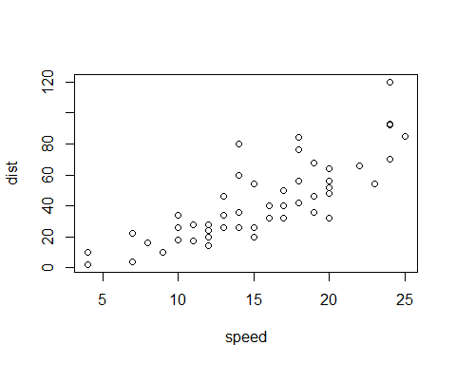

To include some result inline put the R expression between single backticks, for example including the following line in the R Markdown file

The averege speed is `r mean(cars$speed)` mph.

yields: The averege speed is 15.4 mph.

To supress the R code, warnings, or results to be printed out for any chunk you can use chunk options echo=FALSE, warning=FALSE and include=FALSE. Thus for example if the R Markdown file contains the following chunk

```{r}  
plot(cars$speed, type='o', xlab='', ylab='speed, in mph')  
```

graph will be shown but the command used to create it is not going to be displayed

