UCLA Extension – Data Science and Visualization

COM SCI X 450.2

Jennifer Dusendang

2/17/2020

What makes songs popular and does this vary by time and/or place?

Question:

Music streaming services allow for unprecedented data collection on musical features and popularity. Given the large amount of data available through Spotify, I aimed to answer three questions:

1. Of several audio features available from Spotify, which make a song more popular?
2. Do popular audio features vary over time (2010-2019)?
3. Do popular audio features vary by place?

Data:

I used three main datasets that are available from Kaggle.com, each of which contain information about musical features for each track on Spotify (1). Acousticness, danceability, energy, instrumentalness, speechiness, and valence are all measured on a scale from 0 to 100 with numbers closer to 100 indicating more of that quality.

The first dataset I used was the Audio Features dataset, which contains information on 130,326 tracks on Spotify (2). I chose to do the preliminary analysis of popular features on this dataset because it contains the highest number of tracks. This dataset contains all the musical features described above as well as an indicator for the popularity of the track. The popularity indicator is based on the number of plays for a specific track.

The Top10 dataset includes information about 603 tracks that were each a Billboard hit during 2010-2019 (3). It also includes information about the genre of the track.

The World dataset has information about the most popular songs from 2019 from different countries (4).

Methods:

I chose to analyze this data all within Tableau because it allows for easy exploration and visualization of data. My first exploration involved plotting the average popularity for songs based on certain selected traits (acousticness, danceability, energy, instrumentalness, speechiness, and valence).

I then graphed the features of the most popular songs for each year between 2009 and 2019 and added trend lines to the graphs to see if any of the trends are increasing or decreasing overtime.

Finally, I analyzed data using Tableau’s mapping features to create color-coded maps to investigate which countries’ most popular songs have which features.

Because Tableau is an interactive display tool, I also utilized the tooltips for each visualization so that the actual values can be seen by hovering over the points/lines/countries.

Conclusion:

For 130,326 tracks on Spotify, tracks with higher danceability, energy, and valence and lower instrumentalness and speechiness tend to be more popular (Figure 1). Based on the R2 value for line fitness, danceability seems to most closely correlate with popularity (R2 = 0.29).

Between 2009 to 2019, the most dramatic trend is the 1.4 point average drop per year in the energy level of popular tracks (Figure 2). Valence is also declining overtime, while danceability and acousticness are increasing. Speechiness does not appear to be changing overtime.

Average acousticness of popular songs varies the most between countries, ranging from 15 points in Japan to 51 points in the United States (Figure 3). The United States also tends to favor songs with the lowest energy levels and low speechiness. The maps allow us to see more regional trends than the alphabetical graphs. For example, South America tends to prefer energetic, danceable, and happy songs, while North America seems to prefer low energy, low danceability, and low speechiness. It’s interesting that for many of the characteristics, it appears that Australia and Southeast Asia tend to resemble North America, while Europe and South America appear to have similar tastes.

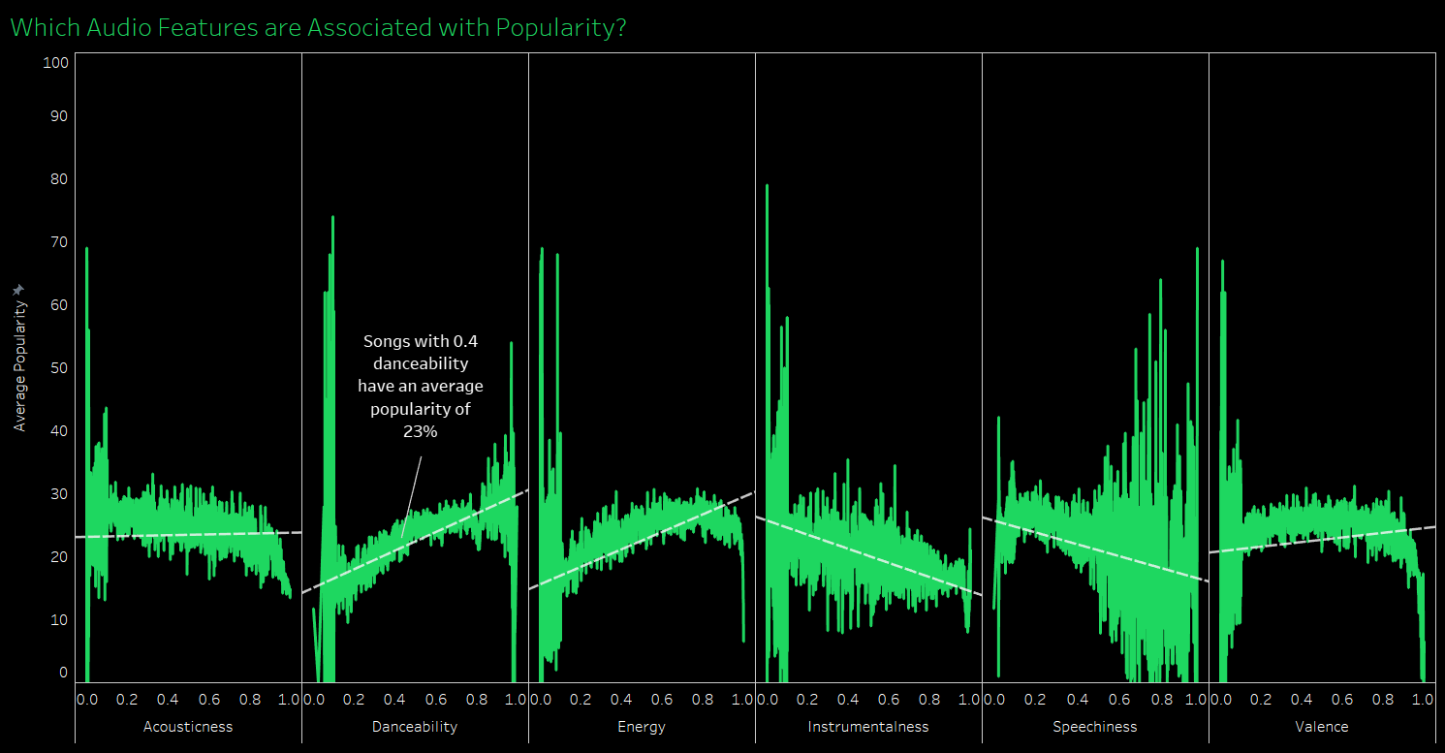

Figure 1

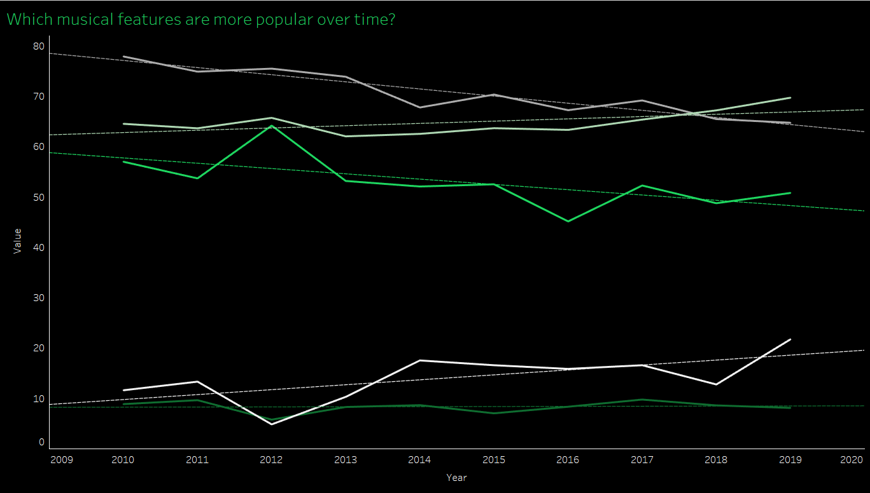

Figure 2

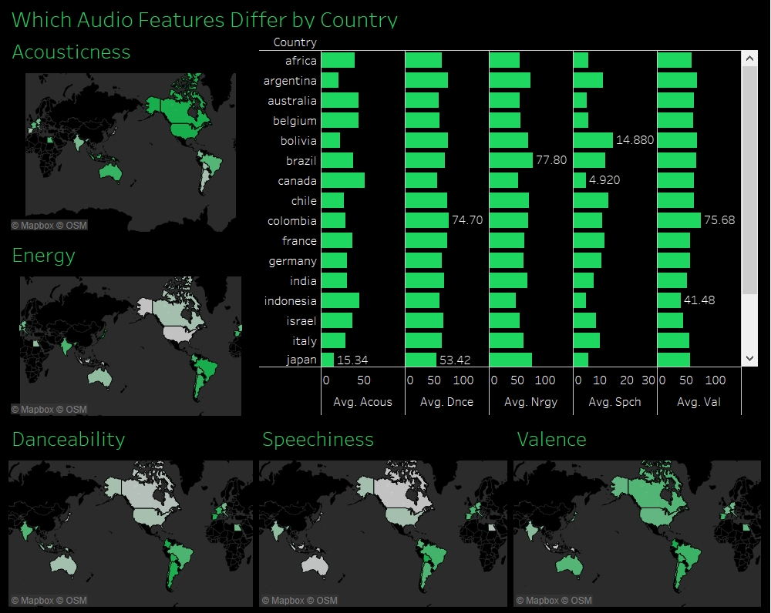

Figure 3

References:

1. <https://developer.spotify.com/documentation/web-api/reference/tracks/get-audio-features/>
2. <https://www.kaggle.com/tomigelo/spotify-audio-features>
3. <https://www.kaggle.com/leonardopena/top-spotify-songs-from-20102019-by-year>
4. <https://www.kaggle.com/leonardopena/top-50-spotify-songs-by-each-country>