Abstract— This comprehensive literature review explores the dynamic evolution of business analytics education, focusing on curriculum innovation, experiential learning, and emerging pedagogical strategies. Analyzing 103 scholarly articles from 2012 to 2024, the study identifies three core themes: Curriculum Innovation for Industry Competencies, Experiential Learning in Analytical Decision-Making, and Innovative Pedagogies for Skill Development. These themes are further examined through nine critical dimensions: Curriculum Design, Analytical Skills Development, Industry Collaboration, and Technology-Enhanced Learning. The review underscores the growing importance of aligning curricula with industry demands, integrating data literacy and ethical considerations, and leveraging technology to improve learning outcomes. Challenges such as the academic-industry gap and the need for ongoing faculty development are also discussed. This review synthesizes current trends in business analytics education. It offers insights for future curriculum innovation and industry collaboration, emphasizing the necessity of equipping graduates with essential competencies for the modern workforce.
Trends in Business Analytics Education: Innovation, Learning, and Pedagogy
First A. Author, Second B. Author, Jr., and Third C. Author, Member, IEEE

Index Terms—Business Analytics Education, Curriculum Innovation, Experiential Learning, Pedagogical Advances, Analytical Skills Development

INTRODUCTION
Business Analytics (BA) uses data analysis, statistical models, and advanced computational techniques to enhance decision-making and optimize business processes. It is a critical capability that empowers organizations to gain actionable insights from large volumes of data, thereby driving agility, innovation, and competitive advantage [1], [2], [3]. The education and skills development in BA has become increasingly essential in response to the growing demand for data-driven decision-making across industries [4], [5], [6]. BA is pivotal in equipping students with the knowledge and competencies needed to succeed in a data-centric world [4], [5], [7]. The significance of BA education lies in its role in fostering critical thinking, problem-solving, and decision-making skills, all of which are vital for navigating the complexities of modern business environments [4], [5], [7], [8].
The integration of BA into academic curricula, especially in business schools, is driven by the need to align educational programs with industry demands [9], [10]. This interdisciplinary field combines data science, information systems, and business strategy elements, enhancing student employability by focusing on competencies directly applicable to the job market [10], [11]. The importance of this alignment is underscored by the adoption of experiential learning techniques, such as case studies, data mining projects, and hands-on training with analytical tools, which enhance students’ practical understanding and readiness for industry challenges [12], [13], [14], [15].
Moreover, BA education emphasizes the importance of curriculum design and learning pathways that cover theoretical aspects and provide hands-on experience [16], [17]. This approach ensures that students are well-prepared to handle real-world data challenges, a critical component in maintaining a competitive edge in today’s data-driven marketplace [4], [18], [19]. Educational institutions are continuously refining their curricula to keep pace with technological advancements and market needs, ensuring that graduates possess the skills necessary to thrive in various business sectors [18], [19], [20], [21]. Developing robust BA education programs is essential for meeting the growing industry demand for skilled professionals. These programs equip students with technical expertise and foster critical thinking and problem-solving abilities, thereby contributing to the success of individuals and the organizations they join [22], [23]. As the demand for skilled business analytics professionals continues to rise, the role of blended learning in developing analytical skills cannot be overstated. Blended learning environments allow for the seamless integration of theoretical knowledge with practical application, enabling students to engage with real-world datasets through online simulations and collaborative projects. This pedagogical approach enhances technical proficiency and nurtures critical thinking and problem-solving abilities essential for success in complex business environments. Furthermore, the flexibility of blended learning accommodates varying levels of student preparedness, thereby fostering an inclusive learning atmosphere where all students can thrive.
To the best of the authors' knowledge, literature reviews on this topic have yet to be published. The unique document classified as a review is the work of Zhang [15], where business visual analytics is introduced. A literature review on BA education is crucial, given the need for comprehensive analyses that address the pedagogical advancements and curricular innovations in this rapidly evolving field. As BA continues to become integral to industry practices, examining how educational institutions adapt to equip students with the necessary skills and competencies is essential. This review is critical in filling the gap by synthesizing existing research and identifying key trends and challenges, providing a foundation for future curriculum development and fostering more effective industry-academic collaboration. Without such a review, educators and institutions may lack the insights needed to evolve their programs in alignment with industry demands and the evolving landscape of BA.
This article critically analyzes current BA education and skills development trends, proposes future research directions and discusses prevailing challenges. To achieve this, the study employs a methodology grounded in co-word analysis and tech-mining techniques to identify dominant themes within the literature. These themes highlight significant trends in BA education and student skills acquisition. Subsequently, each thematic cluster is thoroughly analyzed, and the findings are synthesized into a cohesive narrative in the discussion section.
The structure of this paper is organized as follows: Section 2 details the methodology employed in this study. Section 3 reports the results obtained. Section 4 critically discusses current trends, challenges, and potential future research avenues. Lastly, Section 5 provides the conclusions.

Materials and Methods
This section outlines and critically discusses the standard literature analysis workflow, drawing on established methodologies [24], [25], [26]. The employed method is structured into four key steps:

1. Study Design.
2. Data Collection and Preparation.
3. Data Analysis.
4. Data Interpretation and Synthesis.

This structured approach ensures a comprehensive and systematic literature review, enabling a thorough understanding of the current trends, challenges, and opportunities within the field of study.

Study Design
Table 1 outlines the study's parameters, adhering to the literature review guidelines proposed by Kitchenham [27]. Scopus was chosen as the primary bibliographic database for this research. The search strategy was designed to identify relevant BA education and skills development documents indexed in Scopus. The initial phase of the search strategy, as illustrated in Fig. 1, involves searching for documents with the term "business analytics" in the title or author keywords without any time constraints. A manual analysis was then conducted on the information provided by Scopus, the titles, author keywords, and index keywords during the iterative phase of the process. This manual review aimed to identify other relevant terms to be incorporated into the search string. Each time a new term was identified, it was added to the search string, and the search was rerun. This process continued until no new terms were discovered. The final search string used in Scopus is shown in Fig. 1.

TABLE I
Parameters of the Study
Parameter | Value
Database | Scopus
Years of analysis | Without restrictions
Data retrieval | Aug 30, 2024
Search string | It is derived using an iterative construction method, which will be elaborated upon in the subsequent section.
Inclusion criteria | Documents published in peer-reviewed journals and conference proceedings, books, and book chapters. The documents are directly related to the education and skills development in Business Analytics
Exclusion criteria | Documents where Business Analytics is not the central theme.

Fig. 2 illustrates the total number of documents retrieved from Scopus, following the PRISMA guidelines [26]. The search initially yielded 108 documents from Scopus without any restrictions. However, five papers were excluded from the analysis. These excluded documents comprised works irrelevant to business analytics.

Data collection and preliminary preparation
In line with the procedures outlined by Donthu et al. [25] and Page et al. [26], all bibliographic data from Scopus was downloaded in CSV format. This data set included document titles, abstracts, author keywords, index keywords, authors, affiliations, source titles, and bibliographies. The data processing involved both automated techniques and manual adjustments, which included the transformation from text to uppercase, the standardization of spelling from British to American English, and the normalization of hyphenated words. In the initial data preparation stage, noun phrases were extracted from the articles' titles and abstracts. Subsequently, a new column labeled "descriptors" was added, incorporating these noun phrases along with author and index keywords. This descriptors column was then used to identify the dominant themes within the literature.

Data Analysis
The data analysis process consists of two main stages. The first stage involves cleaning the descriptors, while the second focuses on identifying emergent themes within the analyzed database. Fig. 3 illustrates the algorithm for cleaning the descriptors, which aims to standardize text strings representing the same conceptual idea. This step is crucial, as failing to clean the descriptors can result in low-quality outcomes and inaccurate interpretations when discovering emergent themes. Although this issue has been extensively addressed in innovation literature, it must be explored in literature reviews and science mapping studies [28], [29], [30], [31]. The process involves creating and refining a thesaurus consisting of 267 author keywords, 437 index keywords, and 1,647 noun phrases. By the end of this process, the terms were reduced to 236 author keywords, 384 index keywords, and 1,234 noun phrases. As a result, the analysis uses 1529 cleaned descriptors.

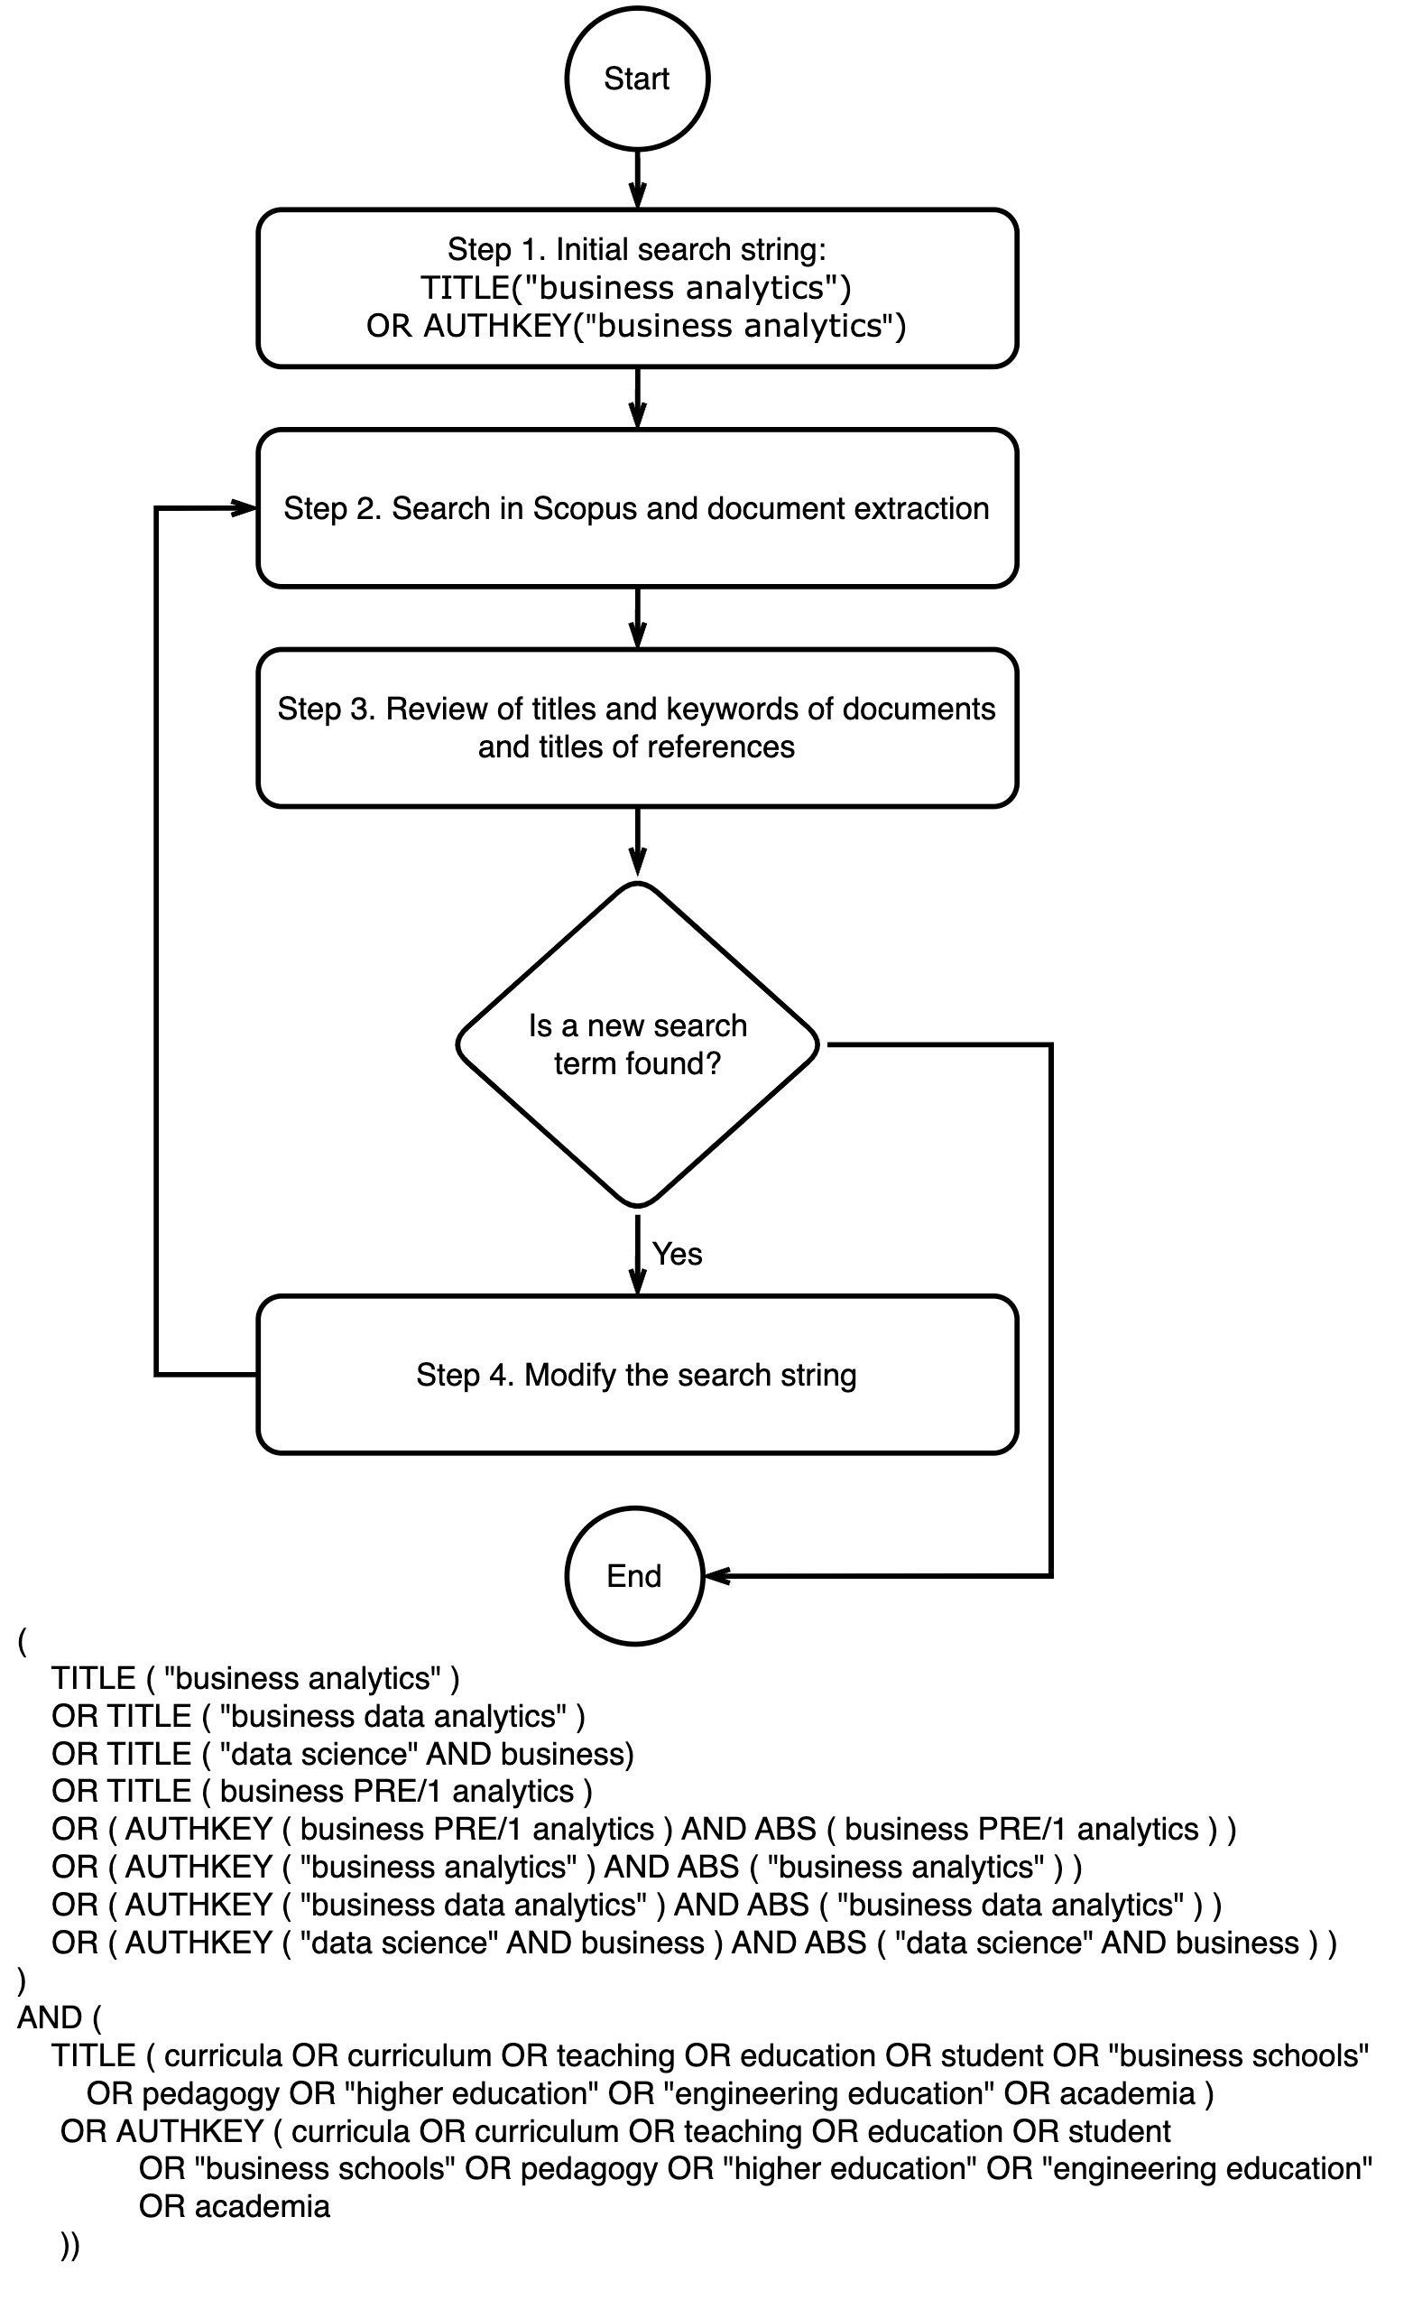
Fig. 1. Search string design.

Results

General Dataset Description
The dataset consists of 103 publications from 2012 to mid-2024, demonstrating a robust annual growth rate of 35.4%. The publications are relatively recent, with an average age of 5.23 years, and each document receives an average of 9.8 citations, equating to 0.76 citations per document per year. The dataset comprises 57 articles, 43 conference papers, two book chapters, and one review (The work of Zhang [15] previously mentioned in the introduction of this paper). The dataset features contributions from 2,110 authors, with an average of 2.87 authors per document and 3.35 co-authors per document. International co-authorship is notable at 25.9%, and the authors are affiliated with 83 countries and 1,187 distinct institutions.

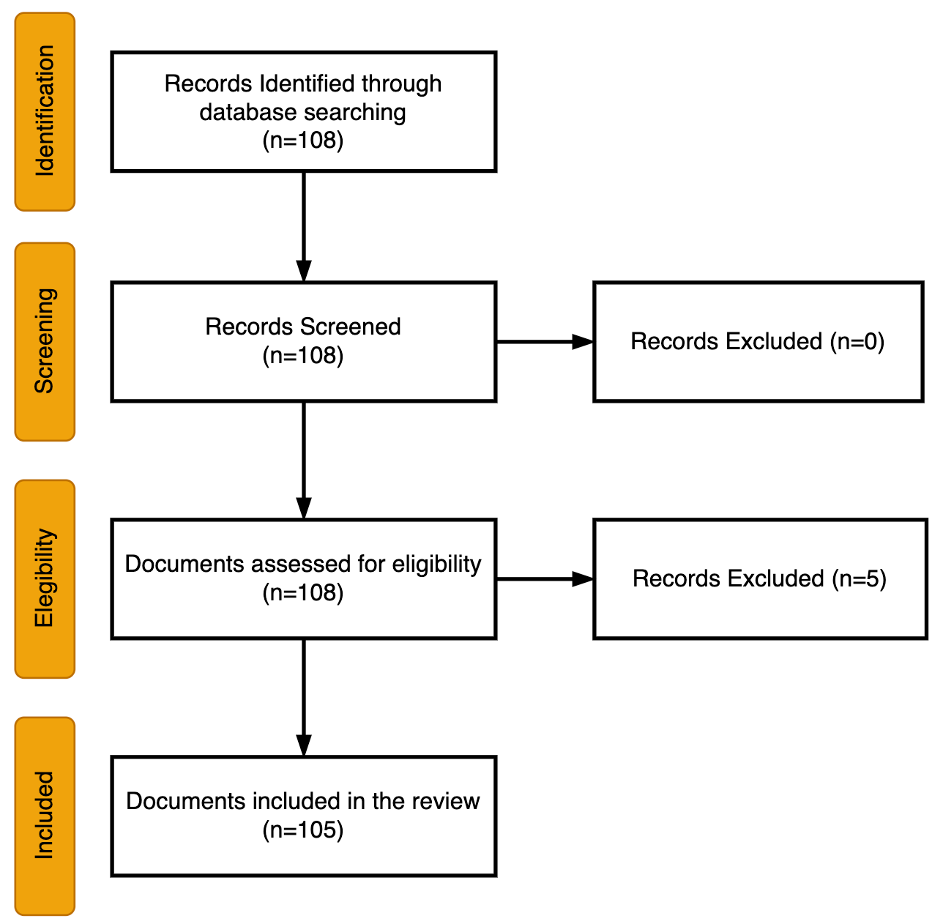
Fig. 2. The PRISMA flow chart.

Dominant Themes
Table II shows the five themes identified using the methodology outlined in Fig. 3. In the analysis, only descriptors that occurred at least four times were included, covering 98.9% of the database, representing 95 documents. For each cluster, documents containing these descriptors were selected and examined. Table II displays only the ten most common descriptors.
The first thematic cluster (Curriculum Innovation for Industry Competencies) focuses on curriculum design and skills development in business schools, emphasizing the alignment of educational programs with evolving industry needs. Business schools play a pivotal role in bridging the gap between academic knowledge and market demands by fostering competencies in data analytics, decision-making, and quantitative analysis [10], [11], [32]. Institutions increasingly integrate experiential learning and innovative pedagogies, such as case-based and gamified approaches, to enhance student engagement and practical decision-making skills [4], [5], [33]. Despite this progress, gaps remain, particularly in emerging technological demands and core areas like data quality [34], [35]. No standardized model curriculum creates inconsistencies in graduate skills and complicates employer expectations [36]. To maintain competitive advantage, educational institutions must continuously refine curricula by integrating interdisciplinary approaches, partnerships with external organizations, and adaptive educational models [18], [37], [38]. These reforms are necessary to prepare graduates for the data-driven business landscape, ensuring they possess the practical knowledge and technological competencies, including analytics and AI, required for success in modern industries [20], [39], [40].

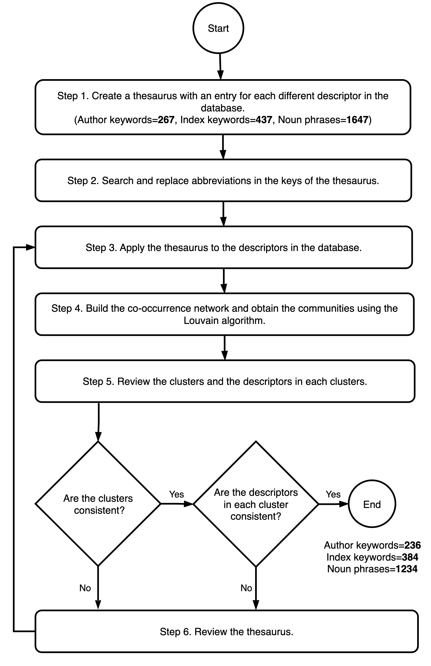
Fig. 3. Methodology to obtain the dominant themes from database descriptors.

The second thematic cluster (Experimental Learning in Analytical Decision-Making) consistently highlights integrating experiential learning as a critical strategy for enhancing student engagement, decision-making skills, and learning outcomes in business analytics education. Across the provided paragraphs, experiential learning is emphasized as a means of bridging the gap between theoretical knowledge and practical application, with methods such as real-world case studies, project-based learning, and hands-on labs playing a central role [4], [41], [42]. These approaches, including flipped classrooms and scaffolded activities, mitigate students' apprehensions about complex quantitative subjects while promoting deeper cognitive engagement and mastery of analytical skills [33], [43]. Furthermore, the involvement of industry partners and interdisciplinary contexts in these experiential strategies enables students to apply classroom learning to real-world challenges, enhancing their readiness for professional roles as analytics professionals [37], [44]. This cluster underscores the importance of active, applied learning experiences in preparing students for the complexities of real-world analytics tasks, making experiential learning a cornerstone of modern business analytics education [12], [38]. Through these immersive methods, students not only gain technical expertise but also develop the critical decision-making abilities necessary to thrive in today’s competitive, data-driven business environment [20], [45], [46], [47].

TABLE II
Founded Thematic Clusters
Name | Number of Descriptors | Main Descriptors
Curriculum Innovation for Industry Competencies | 21 | Curriculum; Skills; Education; Information Use; Business Schools; Curriculum Design; Programs; Education Institutions; Competitive Advantages; Knowledge
Experimental Learning in Analytical Decision-Making | 15 | Students; Courses; Experiential Learning; Decision Making; Learning; Student Learning; Student Engagement; Insights; Learning Outcomes; Analytics Professionals
Innovative Pedagogies and Curriculum Development | 11 | Teaching; Information Management; Academic Professionals; Pedagogy; Competitive Intelligence; Curriculum Development; Electronic Learning; Technology; Analytics

The third thematic cluster (Innovative Pedagogies and Curriculum Development) centers on the dynamic intersection of innovative pedagogical approaches, curriculum development, and the integration of emerging technologies in business analytics education [48], [49]. This cluster underscores the necessity of evolving traditional pedagogy by integrating experiential learning techniques—such as case-based learning, modular teaching frameworks, hands-on learning experiences, interactive visual narratives, collaborative environments, and real-world problem-solving projects—to cater to diverse student backgrounds and skill levels, thereby enhancing student engagement, satisfaction, and performance in analytics courses [4], [8], [12], [33], [42], [50], [51], [52]. Emphasizing the critical role of academic professionals, it highlights the incorporation of emerging technologies like blockchain, artificial intelligence, and data science into curricula, addressing challenges in adapting to the rapidly evolving field of analytics and ensuring educational programs remain relevant to industry demands [35], [51], [53]. By focusing on developing innovative teaching methods and adaptive curricula that cover technical skills and address the evolving needs of industries—particularly in data management and decision-making—the cluster underscores the importance of preparing students with the analytical and practical knowledge needed for complex business environments, including bridging the gap between technical and non-technical learners [12], [37], [38], [51], [54], [55], [56]. The cluster further emphasizes the strategic importance of aligning curriculum design with industry needs, necessitating a rethinking of traditional educational frameworks to include experiential learning and application-oriented models, ensuring continuous curriculum refinement and better preparing students for the complexities of the modern, data-driven business environment [8], [39], [48], [52], [57], [58].

Discussion

Curriculum Design and Development
The design and development of curricula in business analytics education increasingly emphasize the alignment of academic programs with evolving industry demands. Educational institutions are progressively integrating advanced analytics, big data, and business intelligence tools into their curricula to equip students with the necessary skills to tackle real-world challenges. This integration is driven by the recognition that business analytics represents a competitive advantage in the modern data-driven marketplace. Consequently, universities have expanded their offerings, creating specialized undergraduate and graduate programs focusing on technical and analytical skills relevant to industry needs. However, this rapid curriculum evolution presents significant challenges. One of the primary challenges is maintaining a balance between the inclusion of cutting-edge technologies and the foundational theories and concepts critical to developing broader analytical skills and critical thinking. The pace of technological advancement necessitates frequent curriculum updates, which can strain institutional resources and lead to disparities in the quality of business analytics education across different institutions.
Moreover, there is a persistent challenge in creating curricula catering to diverse student backgrounds while ensuring that all graduates possess a comprehensive skill set that includes technical proficiency and strategic business knowledge. To address these challenges, future research should focus on developing modular, adaptive curricula that can evolve with the field without requiring frequent overhauls. Additionally, there is a need for interdisciplinary approaches that blend technical skills with business acumen, ensuring that students are prepared for the complexities of the business analytics profession.

Analytical Skills Development
The development of analytical skills in business analytics education is increasingly centered on equipping students with technical proficiency and the ability to apply these skills in real-world contexts. Educational programs focus on integrating hands-on, experiential learning opportunities, such as project-based learning and real-world data analysis, to ensure students are prepared to meet industry demands. For example, using advanced business intelligence tools and incorporating predictive modeling and data visualization into the curriculum is critical in enhancing students' ability to analyze and interpret complex datasets [45], [49]. These approaches build technical expertise and foster critical thinking and problem-solving abilities, which are essential for data-driven decision-making in business environments. Despite these efforts, challenges persist, particularly in addressing the varying levels of preparedness among students entering these programs. Many students, especially those with non-technical backgrounds, may need help with the mathematical and statistical rigor required in advanced analytics courses [13]. This gap in foundational skills can hinder their ability to engage with and benefit from the curriculum entirely.
Additionally, the rapid pace of technological advancements in the field necessitates continuous curriculum updates, which can be resource-intensive for educational institutions [49]. Future research should explore adaptive learning environments that tailor instruction to individual student needs, thereby bridging the skills gap and ensuring all students can develop the necessary analytical competencies. Moreover, studies examining the long-term impact of different pedagogical approaches on student outcomes, particularly in their ability to apply analytical skills in professional settings, would provide valuable insights for curriculum development [41], [45]. These efforts are crucial for advancing business analytics education and ensuring that graduates are well-equipped to succeed in a data-driven world.
As the demand for skilled BA professionals continues to rise, the role of blended learning in developing analytical skills cannot be overstated. Blended learning environments allow for the seamless integration of theoretical knowledge with practical application, enabling students to engage with real-world datasets through online simulations and collaborative projects. This pedagogical approach enhances technical proficiency and nurtures critical thinking and problem-solving abilities essential for success in complex business environments [59]. Furthermore, the flexibility of blended learning accommodates varying levels of student preparedness, fostering an inclusive learning atmosphere where all students can thrive [60].

Experiential Learning Approaches
Experiential learning approaches have become increasingly central to business analytics education, emphasizing the importance of practical, hands-on experiences that bridge the gap between theoretical knowledge and real-world application. Programs now integrate real-world projects, internships, and interdisciplinary collaborations into their curricula, allowing students to engage deeply with complex business problems and apply their analytical skills in realistic settings. For instance, threaded case studies and project-based learning enhance student engagement and improve learning outcomes by immersing students in scenarios that mimic real business challenges [4], [41]. Additionally, gamification techniques, such as using SAP and ERPsim games, have effectively deepened students’ understanding of business processes through interactive and experiential learning frameworks [33]. Despite the clear benefits, the implementation of experiential learning faces significant challenges. One key issue is ensuring scalability and consistency in quality across diverse educational contexts, particularly when resources and faculty expertise are limited [4]. The alignment of these hands-on experiences with academic goals and industry needs is also complex. It requires careful planning to ensure they are educationally valuable and relevant to students’ future careers [61].
Furthermore, the need to continuously update and adapt experiential learning activities to keep pace with the rapidly evolving business analytics landscape adds another layer of difficulty, demanding significant investment in both time and resources [62]. Future research could focus on developing adaptive learning environments that tailor experiential activities to individual student needs, ensuring equitable access and enhancing learning outcomes across varying skill levels. Additionally, investigating the long-term impact of these approaches on students' career success could provide valuable insights into the most effective strategies for integrating experiential learning into business analytics education [37], [38].

Industry Collaboration
Industry collaboration has become increasingly integral to business analytics education, with academic programs actively seeking partnerships to align curricula with the practical needs of the job market. Universities collaborate with industry stakeholders to co-design courses, integrate real-world projects, and offer internships that provide students with hands-on experience and insights into current industry practices. For example, initiatives like the Teradata University Network (TUN) facilitate knowledge sharing and innovative teaching practices through partnerships between academia and industry professionals [63]. Such collaborations ensure that graduates are equipped with relevant skills, enhancing their employability and readiness for the workforce [10], [63]. However, these collaborations present significant challenges, particularly in balancing the differing priorities of academia and industry. While universities aim to provide foundational knowledge and long-term educational outcomes, industry partners often focus on immediate practical skills, leading to potential misalignment in curriculum design [64].
Additionally, the rapid evolution of the business analytics field requires continuous updates to collaborative projects and curricula, which can strain resources and create logistical difficulties in maintaining relevant and impactful partnerships [48]. Future research should explore sustainable models of industry collaboration that balance these differing needs and allow for ongoing curriculum adaptation in response to industry trends. Investigating the long-term impact of such collaborations on student outcomes, including employability and career progression, is crucial for understanding their value in business analytics education. Furthermore, efforts to make these opportunities more inclusive and accessible to all students, regardless of their background or resources, would ensure that the benefits of industry collaboration are widely distributed [38], [57].
Moreover, incorporating experiential learning within blended learning frameworks can significantly enhance student engagement and outcomes in business analytics education. By facilitating access to industry partnerships and real-world projects, blended learning models enable students to apply theoretical concepts practically, deepening their understanding of analytical tools and methodologies. This integration bridges the gap between academia and industry and cultivates essential soft skills, such as teamwork and communication, which are crucial for future analytics professionals. As educational institutions continue to innovate their curricula, leveraging blended learning strategies will be critical in ensuring graduates are well-equipped to meet the evolving demands of the business analytics landscape.

Student Engagement and Outcomes
Student engagement and outcomes are critical concerns in business analytics education, with a growing emphasis on using innovative pedagogical strategies to enhance learning experiences. Experiential learning approaches, such as threaded case studies and project-based learning, have significantly improved engagement, particularly in large and diverse classrooms [4], [65]. These methods allow students to apply theoretical knowledge to real-world problems, deepening their understanding and retention of key concepts. For instance, integrating social media analytics into capstone projects engages students with relevant and current issues and connects them with community organizations, further enriching their educational experience [65]. However, challenges still need to be addressed in maintaining high levels of student engagement, especially in online and hybrid learning environments where traditional methods may be less effective [17]. The asynchronous nature of these environments can lead to reduced interaction and motivation, negatively impacting learning outcomes.
Additionally, designing engaging content for technical and non-technical students poses a significant challenge, as it requires balancing the complexity of business analytics with accessibility for all students [12]. To address these challenges, future research could explore adaptive learning technologies that tailor content to individual needs, thus enhancing engagement and learning outcomes. Moreover, investigating the long-term effects of different pedagogical strategies on student retention and success in traditional and online settings could provide valuable insights into effective educational practices in business analytics [33], [66]. Finally, integrating feedback mechanisms that support student learning and achievement may further enhance engagement, particularly in complex and technical subjects like business analytics [33].

Faculty and Professional Development
Faculty and professional development are critical for successfully implementing business analytics education, as the growing demand for graduates with these skills necessitates that academic institutions continuously update their programs. Faculty must stay current with the latest tools and methodologies, particularly as business analytics intersects with computer science, statistics, and business management [18]. Programs like the Business Data Analytics Graduate Certificate at Loyola University Chicago highlight the importance of ongoing professional development for educators to deliver relevant content effectively [66]. However, challenges remain, including the rapid pace of technological advancements, the interdisciplinary nature of the field, and the need for structured professional development programs tailored to business analytics educators. These challenges can lead to faculty burnout as they need help to balance teaching, research, and administrative duties [18]. To address these issues, there is a need for more targeted and structured professional development programs that focus on the latest trends in analytics tools and teaching methodologies. Research should also explore the benefits of collaborative learning environments among faculty and the role of institutional support in facilitating continuous professional development. Additionally, partnerships between academia and industry could help align faculty development programs with the evolving demands of the business analytics profession, ensuring that educators remain equipped to teach effectively in this rapidly changing field [66].

Innovative Teaching Methods
Innovative teaching methods in business analytics education are increasingly focused on experiential learning and integrating real-world applications to bridge the gap between theoretical knowledge and practical skills. The use of hands-on labs, enterprise BA tools like MS SQL Server and Cognos, and collaborative environments such as wiki-based platforms have proven effective in enhancing student engagement, learning, and confidence [42], [48], [51]. These methods are designed to prepare students for the demands of the business analytics field, which relies heavily on data-driven decision-making and the ability to apply analytical skills in real-world contexts [67]. Additionally, pedagogical frameworks that guide students through data acquisition, preparation, analysis, visualization, and interpretation are gaining traction, offering a comprehensive learning experience that aligns with industry needs [8]. However, implementing these innovative methods presents challenges, particularly in ensuring accessibility and effectiveness for all students, regardless of their prior experience. The rapid evolution of technology in business analytics further complicates the task, requiring educators to continuously adapt their teaching practices to stay relevant [8], [48].
Moreover, experiential learning's resource-intensive nature and the complexity of integrating these methods into traditional curricula pose significant obstacles, especially in institutions with limited resources [67]. Research opportunities include developing scalable experiential learning models, exploring cross-disciplinary curricula to ensure broader access to BA skills, and expanding collaborative platforms for sharing best practices in innovative teaching [49], [51]. These efforts would help refine and enhance business analytics education, ensuring it remains adequate and relevant in a rapidly changing field.
The effective integration of technology into business analytics education is essential for enhancing student learning experiences and for the strategic design of curricula that meet contemporary industry demands. By adopting blended learning approaches, educators can create a rich learning environment that combines traditional classroom instruction with digital resources, allowing for a more personalized and interactive educational experience. This pedagogical strategy enables the seamless incorporation of advanced data analytics tools and platforms into curricula, ensuring students gain practical, hands-on experience that aligns with real-world applications. Furthermore, the thoughtful curricula design that emphasizes ICT can equip students with the necessary analytical skills while fostering critical thinking and problem-solving abilities. As educational institutions continuously adapt to technological advancements, integrating these elements into curriculum design will be crucial for preparing graduates who can navigate the complexities of a rapidly evolving business landscape. By prioritizing the alignment of educational programs with industry needs and leveraging innovative pedagogical methods, institutions can enhance the employability and readiness of their graduates in the competitive field of business analytics.

Data Literacy and Ethics
Current trends in business analytics education emphasize the importance of integrating data literacy and ethics alongside technical skills. As data becomes central to business decision-making, students must be prepared to navigate ethical challenges such as privacy, security, and potential biases in data-driven decisions. Educators are increasingly incorporating ethics discussions into their curricula to ensure students are equipped to make responsible, informed career decisions [68]. However, teaching abstract ethical concepts within a technically focused curriculum poses challenges, particularly in balancing practical skills with critical thinking about data use. The rapidly evolving landscape of data technology further complicates this, as ethical guidelines must be continuously updated, requiring educators to stay informed on technological and ethical developments.
Additionally, resistance from students or institutions that prioritize technical proficiency over ethics can hinder the integration of ethical considerations into analytics education. Research opportunities in this area include developing innovative methods to effectively integrate ethics into technical curricula, creating standardized ethical guidelines for use across educational institutions, and investigating the impact of ethics education on students' professional behavior and decision-making [68]. These efforts would help cultivate a more ethically responsible generation of business analytics professionals.

Technology-Enhanced Learning
Current trends in business analytics education are increasingly focusing on technology-enhanced learning, emphasizing integrating advanced data analytics tools and platforms into curricula. This approach aims to provide students with hands-on experience that aligns closely with industry needs, utilizing tools like SAS Enterprise Miner and data visualization technologies to develop practical skills in data analysis and decision-making [45], [47]. The growing demand for business analytics professionals proficient in theoretical knowledge and cutting-edge tools underscores the importance of this trend [57]. However, significant challenges remain, particularly in the gap in faculty expertise, where many instructors may need more skills to teach these advanced tools effectively. This issue is notably prominent in regions like the Philippines, where a shortage of qualified instructors hampers the full integration of business analytics into the curriculum [47], [57]. Additionally, the rapid pace of technological change makes it difficult for educational institutions to keep their curricula up to date, risking the possibility of students graduating with outdated skills [47], [69]. To address these challenges, future efforts should focus on developing faculty training programs to equip educators with the necessary skills, continuous curriculum evaluation, and the creation of standardized syllabi that can be adapted to new tools and technologies, ensuring that graduates are prepared for the demands of the business analytics field [45], [57].

Conclusions
This paper has provided a comprehensive analysis of the current trends, challenges, and opportunities in BA education, emphasizing curriculum innovation, experiential learning, and pedagogical strategies. By examining 103 scholarly articles from 2012 to 2014, the study identified key themes and dimensions that are shaping the evolution of BA education. The findings reveal a significant shift towards aligning educational practices with industry needs, fostering critical analytical skills, and leveraging technology-enhanced learning tools.
One of the most critical insights from this review is the growing emphasis on curriculum innovation to address the dynamic and complex nature of the BA field. Programs are increasingly designed to incorporate interdisciplinary knowledge, data literacy, and ethical decision-making frameworks, ensuring graduates are well-equipped to meet the demands of a data-driven industry. However, gaps remain in ensuring seamless integration of industry competencies, requiring further collaboration between academia and practitioners.
The focus on experiential learning emerged as a pivotal strategy to enhance analytical decision-making skills. Case studies, simulations, and real-world projects allow students to engage directly with complex datasets and business challenges. While such approaches have proven effective, the need for scalable and cost-efficient experiential learning models remains a significant challenge for educational institutions.
Moreover, the adoption of innovative pedagogical strategies underscores the importance of active learning environments in BA education. The integration of technology, such as machine learning tools, cloud computing platforms, and data visualization software, has transformed the way analytical concepts are taught. However, faculty development and resource availability are critical barriers to the widespread implementation of these advanced teaching methods.
Despite the strides made in BA education, this review highlights persistent challenges, such as the academic-industry gap and the need for ongoing faculty training to stay current with technological advancements. Addressing these issues requires a collaborative and adaptive approach, fostering partnerships between educational institutions and industry leaders.
Finally, this review provides actionable insights for educators, policymakers, and industry stakeholders to advance BA education. By focusing on curriculum alignment, experiential learning, and pedagogical innovation, institutions can better prepare students for the rapidly evolving demands of the analytics workforce, ensuring they possess the skills necessary to thrive in a data-driven world.
Acknowledgment
The authors ...
References
[1] A. Ashrafi, A. Zare Ravasan, P. Trkman, y S. Afshari, «The role of business analytics capabilities in bolstering firms’ agility and performance», Int. J. Inf. Manag., vol. 47, pp. 1-15, 2019, doi: 10.1016/j.ijinfomgt.2018.12.005.
[2] G. Cao, Y. Duan, y T. Cadden, «The link between information processing capability and competitive advantage mediated through decision-making effectiveness», Int. J. Inf. Manag., vol. 44, pp. 121-131, 2019, doi: 10.1016/j.ijinfomgt.2018.10.003.
[3] Y. M. Omar, M. Minoufekr, y P. Plapper, «Business analytics in manufacturing: Current trends, challenges and pathway to market leadership», Oper. Res. Perspect., vol. 6, 2019, doi: 10.1016/j.orp.2019.100127.
[4] R. Kachouie, S. Williams, y H. Suri, «Teaching Tip Threaded Case-Studies to Deepen Engagement in Foundation Business Analytics Courses», J. Inf. Syst. Educ., vol. 35, n.º 2, pp. 112-121, 2024, doi: 10.62273/PZAN1114.
[5] A. Gharehgozli, A. Gupta, y S.-K. Paik, «Developing an undergraduate business analytics program for a public state-funded business school», J. Educ. Bus., vol. 99, n.º 1, pp. 11-19, 2024, doi: 10.1080/08832323.2023.2248348.
[6] T. Anand y D. Mitchell, «Objectives and curriculum for a graduate business analytics capstone: Reflections from practice», Decis. Sci. J. Innov. Educ., vol. 20, n.º 4, pp. 235-245, 2022, doi: 10.1111/dsji.12272.
[7] S. Al-Haddad, B. Thorne, V. Ahmed, y W. Sause, «Teaching information technology alongside business analytics: Case study», J. Educ. Bus., vol. 94, n.º 2, pp. 92-100, 2019, doi: 10.1080/08832323.2018.1507987.
[8] A. Jeyaraj, «Teaching Tip: Pedagogy for business analytics courses», J. Inf. Syst. Educ., vol. 30, n.º 2, pp. 67-83, 2019.
[9] Y. Zheng, T. Hameed, R. Lavoie, y P. Sendall, «An overview of current business analytics programs across US AACSB schools», Issues Inf. Syst., vol. 22, n.º 2, pp. 306-317, 2021, doi: 10.48009/2_iis_2021_322-333.
[10] K. Dickson y V. Zlatev, «An Integrated Framework for Assessing Data and Business Analytics Skills for the Job Market», presentado en Lecture Notes of the Institute for Computer Sciences, Social-Informatics and Telecommunications Engineering, LNICST, 2023, pp. 305-320. doi: 10.1007/978-3-031-44668-9_24.
[11] J. Peta, «Delivery of Quant and Business Statistics courses to the Business students and developing MS in Business Analytics to meet the demands of the businesses», presentado en Proceedings of the International Conference on Industrial Engineering and Operations Management, 2018, pp. 1936-1936. [En línea]. Disponible en: https://www.scopus.com/inward/record.uri?eid=2-s2.0-85067029777&partnerID=40&md5=6caafdfc2a17c5659970ed05e2fc0e3d
[12] Y. G. Zhang, M. Y. Dang, y M. D. Albritton, «Delivering a Business Analytics Course Focused on Data Mining for Both Technical and Non-Technical Students», J. Inf. Syst. Educ., vol. 35, n.º 1, pp. 86-98, 2024, doi: 10.62273/MWCG1518.
[13] P. Carroll, «Analytics Modules for Business Students», Oper. Res. Forum, vol. 4, n.º 2, 2023, doi: 10.1007/s43069-023-00216-5.
[14] Z. Cadersaib, H. B. Sta, y B. Gobin-Rahimbux, «Enterprise Resource Planning integrated with Business Analytics in Higher Education», presentado en IEEE Global Engineering Education Conference, EDUCON, 2022, pp. 2114-2120. doi: 10.1109/EDUCON52537.2022.9766575.
[15] Y. Zhang, K. K. Chan, y J. Liu, «Introducing Business Visual Analytics into Business Education by Information Technology and Computing Methods», Mob. Inf. Syst., vol. 2022, 2022, doi: 10.1155/2022/9018733.
[16] L. F. Laker y M. Sena, «Accuracy and detection of student use of ChatGPT in business analytics courses», Issues Inf. Syst., vol. 24, n.º 2, pp. 153-163, 2023, doi: 10.48009/2_iis_2023_113.
[17] R. Sebastianelli y N. Tamimi, «ONLINE MS IN BUSINESS ANALYTICS BEST PRACTICES AND BEYOND», presentado en 17th International Conference on e-Learning and Digital Learning 2023, ELDL 2023 and 11th International Conference on Sustainability, Technology and Education 2023, STE 2023, 2023, pp. 210-214. [En línea]. Disponible en: https://www.scopus.com/inward/record.uri?eid=2-s2.0-85188433694&partnerID=40&md5=6eb0420b08709135b42abae6c730c119
[18] R. J. Mills, K. J. Fadel, T. Olsen, K. M. Chudoba, y P. A. Dupin-Bryant, «Examining Trends in Business Analytics Education From 2011 to 2020 in AACSB-Accredited Information Systems Programs», J. Inf. Syst. Educ., vol. 33, n.º 3, pp. 232-244, 2022.
[19] E. V. Kuz’mina, N. G. Pyankova, N. V. Tretyakova, y L. V. Kukharenko, «Using the Technology of Collecting and Analyzing Structured Information for the Forming Mechanisms of Professional Adaptation Among Students of Engineering Disciplines», presentado en Smart Innovation, Systems and Technologies, 2022, pp. 571-581. doi: 10.1007/978-981-16-8829-4_55.
[20] O. Turel y B. Kapoor, «A business analytics maturity perspective on the gap between business schools and presumed industry needs», Commun. Assoc. Inf. Syst., vol. 39, n.º 1, pp. 96-109, 2016, doi: 10.17705/1cais.03906.
[21] X. Deng, Y. Li, y R. D. Galliers, «Business analytics education: A latent semantic analysis of skills, knowledge and abilities required for business versus NonBusiness Graduates», presentado en 2016 International Conference on Information Systems, ICIS 2016, 2016. [En línea]. Disponible en: https://www.scopus.com/inward/record.uri?eid=2-s2.0-85019423915&partnerID=40&md5=3d1388fadbd7ba0a36542b9373b5ab12
[22] R. Dubey y A. Gunasekaran, «Education and training for successful career in big data and business analytics», Ind. Commer. Train., vol. 47, n.º 4, pp. 174-181, 2015, doi: 10.1108/ICT-08-2014-0059.
[23] F. Rodammer, C. Speier-Pero, y J. Haan, «The integration of business analytics into a Business College undergraduate curriculum», presentado en 2015 Americas Conference on Information Systems, AMCIS 2015, 2015. [En línea]. Disponible en: https://www.scopus.com/inward/record.uri?eid=2-s2.0-84963517333&partnerID=40&md5=3e006df5bcbeda4310b4479cd9e0db39
[24] M. Aria y C. Cuccurullo, «bibliometrix: An R-tool for comprehensive science mapping analysis», J. Informetr., vol. 11, n.º 4, pp. 959-975, nov. 2017, doi: 10.1016/j.joi.2017.08.007.
[25] N. Donthu, S. Kumar, D. Mukherjee, N. Pandey, y W. M. Lim, «How to conduct a bibliometric analysis: An overview and guidelines», J. Bus. Res., vol. 133, pp. 285-296, 2021, doi: https://doi.org/10.1016/j.jbusres.2021.04.070.
[26] M. J. Page et al., «The PRISMA 2020 statement: an updated guideline for reporting systematic reviews», BMJ, vol. 372, p. n71, mar. 2021, doi: 10.1136/bmj.n71.
[27] B. Kitchenham, «Procedures for performing systematic reviews», Keele UK Keele Univ., vol. 33, n.º 2004, pp. 1-26, 2004.
[28] C. Courseault Trumbach y D. Payne, «Identifying synonymous concepts in preparation for technology mining», J. Inf. Sci., vol. 33, n.º 6, pp. 660-677, 2007.
[29] A. L. Porter, J. Garner, S. F. Carley, y N. C. Newman, «Emergence scoring to identify frontier R&D topics and key players», Technol. Forecast. Soc. Change, vol. 146, pp. 628-643, 2019.
[30] A. L. Porter, A. Kongthon, y J.-C. Lu, «Research profiling: Improving the literature review», Scientometrics, vol. 53, pp. 351-370, 2002.
[31] Y. Zhang, A. L. Porter, Z. Hu, Y. Guo, y N. C. Newman, «“Term clumping” for technical intelligence: A case study on dye-sensitized solar cells», Technol. Forecast. Soc. Change, vol. 85, pp. 26-39, 2014, doi: 10.1016/j.techfore.2013.12.019.
[32] F. Nosrati, T. Burns, Y. Gao, y C. A. Sherman, «A Systematic Review of the US Graduate Programs in Business Analytics», presentado en 28th Americas Conference on Information Systems, AMCIS 2022, 2022. [En línea]. Disponible en: https://www.scopus.com/inward/record.uri?eid=2-s2.0-85192535813&partnerID=40&md5=36a49d762a3ae7d2d9b57e4a15309864
[33] M. Wang, J. Zhan, y T. Hu, «Introducing a Teaching Framework for BDA Curricula With the SAP and ERPsim Games: Pedagogy and Assessment», J. Inf. Syst. Educ., vol. 35, n.º 3, pp. 271-283, 2024, doi: 10.62273/GKLQ9635.
[34] H. Zhu, «TEACHING DATA QUALITY IN BUSINESS ANALYTICS», presentado en AIS SIGED International Conference on Information Systems Education and Research 2022, 2022, pp. 201-205. [En línea]. Disponible en: https://www.scopus.com/inward/record.uri?eid=2-s2.0-85158971871&partnerID=40&md5=e8353a65227189040475ca88af1e4952
[35] A. Qasim y F. F. Kharbat, «Blockchain technology, business data analytics, and artificial intelligence: Use in the accounting profession and ideas for inclusion into the accounting curriculum», J. Emerg. Technol. Account., vol. 17, n.º 1, pp. 107-117, 2020, doi: 10.2308/jeta-52649.
[36] M. Mashayekhi, E. Yetgin, y J. Shen, «Toward designing a business analytics model curriculum for undergraduate business students», presentado en 26th Americas Conference on Information Systems, AMCIS 2020, 2020. [En línea]. Disponible en: https://www.scopus.com/inward/record.uri?eid=2-s2.0-85097722485&partnerID=40&md5=17b1bbd4137bcb616f2ee85320c0fbd9
[37] S. Gottipati y V. Shankararaman, «Designing a datawarehousing and Business Analytics course using experiential learning pedagogy», presentado en 2016 AIS SIGED International Conference on IS Education and Research, 2016. [En línea]. Disponible en: https://www.scopus.com/inward/record.uri?eid=2-s2.0-85048732362&partnerID=40&md5=e4b7335c9c4f8e30837735797df037b6
[38] B. S. Price, V. F. Kleist, y N. McIntyre, «Incorporating program-spanning experiential learning into an online/hybrid master of science business data analytics program», presentado en Proceedings of the 33rd Information Systems Education Conference, ISECON 2016, 2016, pp. 142-155. [En línea]. Disponible en: https://www.scopus.com/inward/record.uri?eid=2-s2.0-85072898156&partnerID=40&md5=a6edcf54d559624b0bf55c472cd34f24
[39] T. R. Seaba, M. Anna Segooa, B. M. Kalema, y R. Kekwaletswe, «Business analytics for institutional academic management: A case of South African higher education», presentado en 2018 International Conference on Intelligent and Innovative Computing Applications, ICONIC 2018, 2018. doi: 10.1109/ICONIC.2018.8601236.
[40] M. E. Johnson, A. Albizri, y R. Jain, «Exploratory Analysis to Identify Concepts, Skills, Knowledge, and Tools to Educate Business Analytics Practitioners», Decis. Sci. J. Innov. Educ., vol. 18, n.º 1, pp. 90-118, 2020, doi: 10.1111/dsji.12195.
[41] H. J. Yazici, «Project-Based Learning for Teaching Business Analytics in the Undergraduate Curriculum*», Decis. Sci. J. Innov. Educ., vol. 18, n.º 4, pp. 589-611, 2020, doi: 10.1111/dsji.12219.
[42] L. Yang y X. Liu, «Teaching business analytics», presentado en Proceedings - Frontiers in Education Conference, FIE, 2013, pp. 1516-1518. doi: 10.1109/FIE.2013.6685090.
[43] M. D. Dean, «Using the learning assistant model in an undergraduate business analytics course», Inf. Trans. Educ., vol. 20, n.º 3, pp. 125-133, 2020, doi: 10.1287/ITED.2019.0221.
[44] O. Marjanovic, «Using collaborative visual analytics for innovative industry-inspired learning activities», presentado en ACIS 2015 Proceedings - 26th Australasian Conference on Information Systems, 2015. [En línea]. Disponible en: https://www.scopus.com/inward/record.uri?eid=2-s2.0-85044742065&partnerID=40&md5=4417c94d106b4bf0f4ccceb3669d5416
[45] S. Balkan y H. Demirkan, «Teaching predictive model management in MIS classrooms: A tutorial», Commun. Assoc. Inf. Syst., vol. 37, n.º 1, pp. 586-604, 2015, doi: 10.17705/1cais.03728.
[46] J. Morgan y S. Ravindran, «Using business analytics to target baseball free agents: A case study», presentado en AMCIS 2017 - America’s Conference on Information Systems: A Tradition of Innovation, 2017. [En línea]. Disponible en: https://www.scopus.com/inward/record.uri?eid=2-s2.0-85048387384&partnerID=40&md5=5beb7025cc656e509ba0583deb0d9350
[47] A. H. Zadeh, S. Schiller, y K. Duffy, «Teaching analytics: A demonstration of association discovery with SAS enterprise miner», presentado en AMCIS 2016: Surfing the IT Innovation Wave - 22nd Americas Conference on Information Systems, 2016. [En línea]. Disponible en: https://www.scopus.com/inward/record.uri?eid=2-s2.0-84987622024&partnerID=40&md5=c773c46c841776c1f7504296c614a885
[48] B. Wixom et al., «The current state of business intelligence in academia: The arrival of big data», Commun. Assoc. Inf. Syst., vol. 34, n.º 1, pp. 1-13, 2014, doi: 10.17705/1cais.03401.
[49] G. A. Davis y C. R. Woratschek, «Evaluating business intelligence / business analytics software for use in the information systems curriculum», presentado en 2014 Proceedings of the Information Systems Educators Conference, ISECON 2014, 2014. [En línea]. Disponible en: https://www.scopus.com/inward/record.uri?eid=2-s2.0-85084020157&partnerID=40&md5=358eb521184f2baafe6ac488ee96a583
[50] D. Saundage, J. L. Cybulski, S. Keller, y L. Dharmasena, «Teaching data analysis with interactive visual narratives», J. Inf. Syst. Educ., vol. 27, n.º 4, pp. 233-248, 2016.
[51] O. Marjanovic, «Sharing and co-Creation of innovative teaching practices in business analytics - Insights from an action design research project», presentado en Proceedings of the 25th Australasian Conference on Information Systems, ACIS 2014, 2014. [En línea]. Disponible en: https://www.scopus.com/inward/record.uri?eid=2-s2.0-84959455583&partnerID=40&md5=3a324d9ad941f33d9b660c45a18c059d
[52] D. Jiang, «Teaching Research of Business Data Analytics Course Based on Python», presentado en Proceedings - 2021 6th International Symposium on Computer and Information Processing Technology, ISCIPT 2021, 2021, pp. 577-582. doi: 10.1109/ISCIPT53667.2021.00123.
[53] S. Heister, M. Kaufman, y K. Yuthas, «Blockchain and the future of business data analytics», J. Emerg. Technol. Account., vol. 18, n.º 1, pp. 87-98, 2021, doi: 10.2308/JETA-2020-053.
[54] K. J. Shim, S. Gottipati, y Y. M. Lau, «Integration of professional certifications with information systems business analytics track curriculum», presentado en IEEE Global Engineering Education Conference, EDUCON, 2021, pp. 1337-1344. doi: 10.1109/EDUCON46332.2021.9453976.
[55] J. Lu, «Data science in the business environment: Skills analytics for curriculum development», presentado en Lecture Notes in Computer Science (including subseries Lecture Notes in Artificial Intelligence and Lecture Notes in Bioinformatics), 2019, pp. 116-128. doi: 10.1007/978-3-030-13709-0_10.
[56] R. Sharda, D. A. Asamoah, y N. Ponna, «Research and pedagogy in business analytics: Opportunities and illustrative examples», J. Comput. Inf. Technol., vol. 21, n.º 3, pp. 171-183, 2013, doi: 10.2498/cit.1002194.
[57] E. R. L. Jalao, «Developing the Manpower Complement for Business Analytics Service Professionals: A Case Study on the Challenges Faced by the Philippines», presentado en Procedia Manufacturing, 2015, pp. 3494-3497. doi: 10.1016/j.promfg.2015.07.661.
[58] F. K. Andoh-Baidoo, A. Villa, Y. Aguirre, y G. M. Kasper, «Business intelligence & analytics education: An exploratory study of business & non-business school IS program offerings», presentado en 20th Americas Conference on Information Systems, AMCIS 2014, 2014. [En línea]. Disponible en: https://www.scopus.com/inward/record.uri?eid=2-s2.0-84905965728&partnerID=40&md5=e5a9e6f2f804e89724bab0e99684824a
[59] K. J. Rudestam y R. R. Newton, Surviving Your Dissertation: A Comprehensive Guide to Content and Process. Sage Publications, 2015.
[60] D. R. Garrison y N. D. Vaughan, Blended Learning in Higher Education: Framework, Principles, and Guidelines. en Blended Learning in Higher Education: Framework, Principles, and Guidelines. 2012, p. 245. doi: 10.1002/9781118269558.
[61] M. C. Tremblay, G. J. Deckard, y R. Klein, «Health informatics and analytics - building a program to integrate business analytics across clinical and administrative disciplines», J. Am. Med. Inform. Assoc., vol. 23, n.º 4, pp. 824-828, 2016, doi: 10.1093/jamia/ocw055.
[62] P. Tarasewich y Y. Lee, «Building an online business analytics graduate program», presentado en AMCIS 2017 - America’s Conference on Information Systems: A Tradition of Innovation, 2017. [En línea]. Disponible en: https://www.scopus.com/inward/record.uri?eid=2-s2.0-85048386568&partnerID=40&md5=c9d3b011ccf26004415fd4da41e91fef
[63] O. Marjanovic, «Sharing and reuse of innovative teaching practices in emerging business analytics discipline», presentado en Proceedings of the Annual Hawaii International Conference on System Sciences, 2013, pp. 50-59. doi: 10.1109/HICSS.2013.480.
[64] K. Gillon, E. Brynjolfsson, J. Griffin, M. Gupta, y S. Mithas, «Business analytics: Radical shift or incremental change?», presentado en International Conference on Information Systems, ICIS 2012, 2012, pp. 2383-2388. [En línea]. Disponible en: https://www.scopus.com/inward/record.uri?eid=2-s2.0-84886460003&partnerID=40&md5=c2bb943adb9eaef6fb3c30b8a5dfc3b3
[65] C. Ye y L. Zhao, «A Social Media Analytics Capstone Research Project with Community Engagement», J. Inf. Syst. Educ., vol. 34, n.º 4, pp. 406-417, 2023.
[66] D. Bačić, N. Jukić, M. Malliaris, S. Nestorov, y A. Varma, «Building a Business Data Analytics Graduate Certificate», J. Inf. Syst. Educ., vol. 34, n.º 2, pp. 216-228, 2023.
[67] S.-H. Sunny Park, S. Park, y L. B. Oldham, «Teaching a Man to Fish: Teaching Cases of Business Analytics», presentado en Springer Proceedings in Business and Economics, 2020, pp. 317-328. doi: 10.1007/978-3-030-30967-1_29.
[68] S. Wang y H. Wang, «Teaching tip a teaching module of database-centric online analytical process for MBA business analytics programs», J. Inf. Syst. Educ., vol. 30, n.º 1, pp. 19-26, 2019.
[69] B. Ghosh, «Project based learning to support enterprise busineß analytics education: The Role of Croß Functional Groups to Enhance Cognitive Outcomes», presentado en CSEDU 2015 - 7th International Conference on Computer Supported Education, Proceedings, 2015, pp. 5-13. [En línea]. Disponible en: https://www.scopus.com/inward/record.uri?eid=2-s2.0-84943541595&partnerID=40&md5=ac4b0bd6b2b3ae8beddb4cee34f4a93

 F. A. Author is with the National Institute of Standards and Technology, Boulder, CO 80305 USA (corresponding author to provide phone: 303-555-5555; fax: 303-555-5555; e-mail: author@ boulder.nist.gov). S. B. Author, Jr., was with Rice University, Houston, TX 77005 USA. He is now with the Department of Physics, Colorado State University, Fort Collins, CO 80523 USA (e-mail: author@lamar. colostate.edu). T. C. Author is with the Electrical Engineering Department, University of Colorado, Boulder, CO 80309 USA, on leave from the National Research Institute for Metals, Tsukuba, Japan (e-mail: author@nrim.go.jp). DOI (Digital Object Identifier) Pendiente

