Mapping the Structure and Thematic Landscape of Latin American Engineering Journals Indexed in SciELO and Scopus

Mapeo de la estructura y el panorama temático de las revistas latinoamericanas de ingeniería indexadas en SciELO y Scopus

Ana María López-Morenoª, Juan David Velásquez-Henao^{b}, Diana Lorena Cadavid-Higuita^{c}

ªFacultad de Ingeniería y Ciencias Agropecuarias, Institución Universitaria Digital de Antioquia, Medellín, Colombia. ana.lopez@udigital.edu.co
^{b}Facultad de Minas, Universidad Nacional de Colombia, Medellín, Colombia. jdvelasq@unal.edu.co
^{c}Facultad de Minas, Universidad Nacional de Colombia, Medellín, Colombia. dlcadavi@unal.edu.co

Received: July 1st, 2025. Received in revised form: December 1st, 2025. Accepted: December 5th, 2025.

Abstract
This study presents a bibliometric and network-based analysis of engineering journals published in Latin America and indexed in both SciELO and Scopus simultaneously. It aims to characterize their disciplinary scope, thematic specialization, and scientific collaboration. Using a correlation map of Scopus subject areas and performance indicators, the study identifies key contributors, highlighting the roles of leading institutions and the global visibility of top journals. Author keywords reveal thematic trends, terminological consistency, and a shift toward high-impact areas, including digital technologies, artificial intelligence, and sustainability. Inter-journal relationships are explored through keyword correlation, while citation, co-citation, and bibliographic coupling networks highlight intellectual linkages. A co-occurrence analysis identifies dominant and emerging research themes. These include sustainability, technological innovation, public health, education, and core fields like materials, optimization, and risk analysis. The findings offer a multidimensional perspective on Latin American engineering journals and their integration into the global scholarly landscape, and provide practical insights for authors, editors, and policymakers seeking to strengthen regional engineering research.

Keywords: Engineering Journals; Bibliometric Analysis; Citation Networks; Thematic Mapping; Scientific Collaboration; Research Performance.

Resumen
Este estudio presenta un análisis bibliométrico y basado en redes de las revistas de ingeniería publicadas en América Latina e indexadas simultáneamente en SciELO y Scopus. El objetivo es caracterizar su alcance disciplinar, su especialización temática y sus patrones de colaboración científica. A través de un mapa de correlación entre áreas temáticas de Scopus y indicadores de desempeño, se identifican los principales actores, destacando el papel de instituciones líderes y la visibilidad internacional de las revistas más reconocidas. El análisis de palabras clave del autor permite identificar tendencias temáticas, consistencia terminológica y una transición hacia áreas de alto impacto, como las tecnologías digitales, la inteligencia artificial y la sostenibilidad. Las relaciones entre revistas se exploran mediante la correlación de palabras clave, mientras que las redes de citación, co-citación y acoplamiento bibliográfico evidencian vínculos intelectuales. Un análisis de coocurrencia permite identificar temas dominantes y clústeres emergentes en sostenibilidad, innovación tecnológica, salud pública, educación y áreas fundamentales como materiales, optimización y análisis de riesgos. Los hallazgos ofrecen una perspectiva multidimensional sobre las revistas latinoamericanas de ingeniería y su integración en el panorama académico global, además de brindar orientaciones prácticas para autores, editores y responsables de políticas comprometidos con el fortalecimiento de la investigación en ingeniería en la región.

Palabras clave: Revistas de Ingeniería; Análisis Bibliométrico; Redes de Citaciones; Mapeo Temático; Colaboración Científica; Desempeño Investigativo.

Introduction

The Scientific Electronic Library Online (SciELO) is a cooperative, open-access publishing platform launched in 1998 to enhance the visibility, accessibility, and quality of scientific journals from Latin America and other regions in the Global South [1], [2], [3], [4]. Developed by BIREME/PAHO and FAPESP, SciELO provides a robust infrastructure for indexing, publishing, and disseminating peer-reviewed scholarly content, with a strong emphasis on regional integration and multilingual dissemination [5]. It is vital to democratize access to scientific knowledge, particularly for researchers, institutions, and countries that are often underrepresented in mainstream citation databases, such as Web of Science and Scopus.
Today, SciELO includes over a thousand journals across disciplines and has become a strategic platform for fostering scientific communication in Latin America. Its alignment with global indexing standards has increased international visibility, with many SciELO journals now also indexed in Scopus [6]. Understanding the interrelationships between these journals offers valuable insights into regional collaboration, thematic specialization, and knowledge flows within and beyond Latin America.
Despite SciELO's recognized importance in promoting regional scientific visibility, there is limited comprehensive research on the structural and thematic interrelationships among Latin American journals indexed in both SciELO and Scopus, particularly in engineering.
This study aims to fill that gap by providing an in-depth bibliometric and network-based analysis of engineering journals published in Latin America and indexed in both databases. The analysis begins by examining the disciplinary breadth of these journals through a cross-correlation map of Scopus subject areas assigned at the journal level, highlighting the distribution and overlap of thematic fields. Fundamental performance indicators—such as publication volume and citation impact—are used to assess authors, institutions, countries, and journals and identify leading contributors. Furthermore, author keywords are analyzed to explore thematic patterns and terminological consistency. A correlation map based on shared author keywords analyzes the interrelationships among journals, where stronger connections imply greater thematic similarity. In addition, a citation network reveals the direct referencing structure among journals, while co-citation and bibliographic coupling analyses uncover indirect intellectual linkages. Finally, a co-occurrence network of author keywords is used to identify dominant research themes and conceptual clusters within the engineering literature. Together, these analyses provide a multidimensional view of the structure, dynamics, and thematic orientation of engineering research in Latin America, offering valuable insights into regional integration, collaboration, and visibility in the global scientific landscape.
This study focuses exclusively on engineering journals published in Latin America and indexed in both SciELO and Scopus. By limiting the analysis to journals present in both databases, the study ensures international visibility and metadata consistency, facilitating bibliometric and network-based comparisons. This scope excludes engineering journals that are indexed in only one of the two databases. The analysis is conducted at the journal level, rather than at the level of individual authorship networks, which may limit the granularity of insights into micro-level collaboration patterns. Ultimately, the study offers a snapshot of the structural and thematic dynamics based on the available metadata at the time of analysis. It does not account for recent changes or future trends in journal indexing policies or editorial practices.
The rest of this paper is organized as follows: Section 2 discusses the methodology used. Section 3 presents the results. Section 4 discusses the findings. Finally, Section 5 presents the conclusions.

Materials and Methods

This section outlines and examines the standard workflow commonly employed in literature analysis and tech-mining studies, which also serves as the methodological foundation of this paper. This process has been widely discussed in the research literature, including by Aria and Cuccurullo [7], Donthu et al [8], Page et al [9], and Zupic and Carter [10]. The adopted methodology comprises four key stages:

1. Design of the study.
2. Collection and preparation of data.
3. Analysis of the data.
4. Interpretation of the findings.

Design of the Study

The methodological parameters of this study are presented below, following the literature review criteria established by [11], [12]. The search strategy consisted of identifying the ISSNs of relevant journals in SciELO (and indexed in Scopus) and using them to conduct targeted searches in Scopus. The study parameters are:
- Database: Scopus.
- Years of analysis: From Jan 2015 to Dec 2024.
- Data retrieval: Feb 3, 2025.
- Search string: The ISSN search operator was used to retrieve information on each engineering journal indexed in SciELO from Scopus.
- Inclusion criteria: None.
- Exclusion criteria: Documents whose abstracts are not written in English.
The exclusion criterion was based on two primary considerations: the predominance of English as the language of abstracts in the selected journals and the use of text-processing tools optimized for English-language content. Consequently, documents with abstracts in languages other than English were excluded to ensure consistency and analytical accuracy.
Fig. 1 presents the PRISMA flow chart, a standardized framework for reporting the identification, screening, eligibility, and inclusion of documents in systematic reviews and meta-analyses. During the identification phase, the search string returned 29,499 papers. In the screening phase, a time filter was applied, excluding 12,849 papers published before 2015 or in 2025. The eligibility phase involved reviewing the titles and abstracts of the remaining 16,603 documents published between 2015 and 2024, excluding 1,307 papers. As a result, the final dataset consists of 15,286 documents.

Collection and preparation of data

Following widely accepted practices in the literature, all bibliographic data were downloaded from Scopus in CSV format for analysis [8], [9]. The downloaded dataset includes document titles, abstracts, author keywords, index keywords, authors, affiliations, source titles, and bibliographic references.
Data processing combined automated procedures with manual refinements to ensure consistency and quality. The cleaning process applied to the raw author keywords included:
- Converting all text to uppercase.
- Translating British spelling to American variants.
- Removing multiple consecutive spaces within strings.
- Standardizing the formatting of hyphenated words.
To unify text strings referring to the same concept, we applied rule-based normalization that grouped equivalent terms via exact-match merging, applied stemming patterns, and manually inspected ambiguous cases to ensure conceptual consistency across author keywords. This preprocessing step was essential to ensure accurate keyword grouping and analysis in the subsequent stages. All preprocessing, keyword cleaning, and network analyses were performed entirely in Python using the TechMiner package, with no external software required for visualization or data processing. Author keywords were used directly for thematic exploration, reflecting the terminology and concepts the authors prioritized. Identifying dominant themes based on cleaned author keywords supports a multifaceted analysis of the engineering papers published in SciELO, as detailed in the following section.

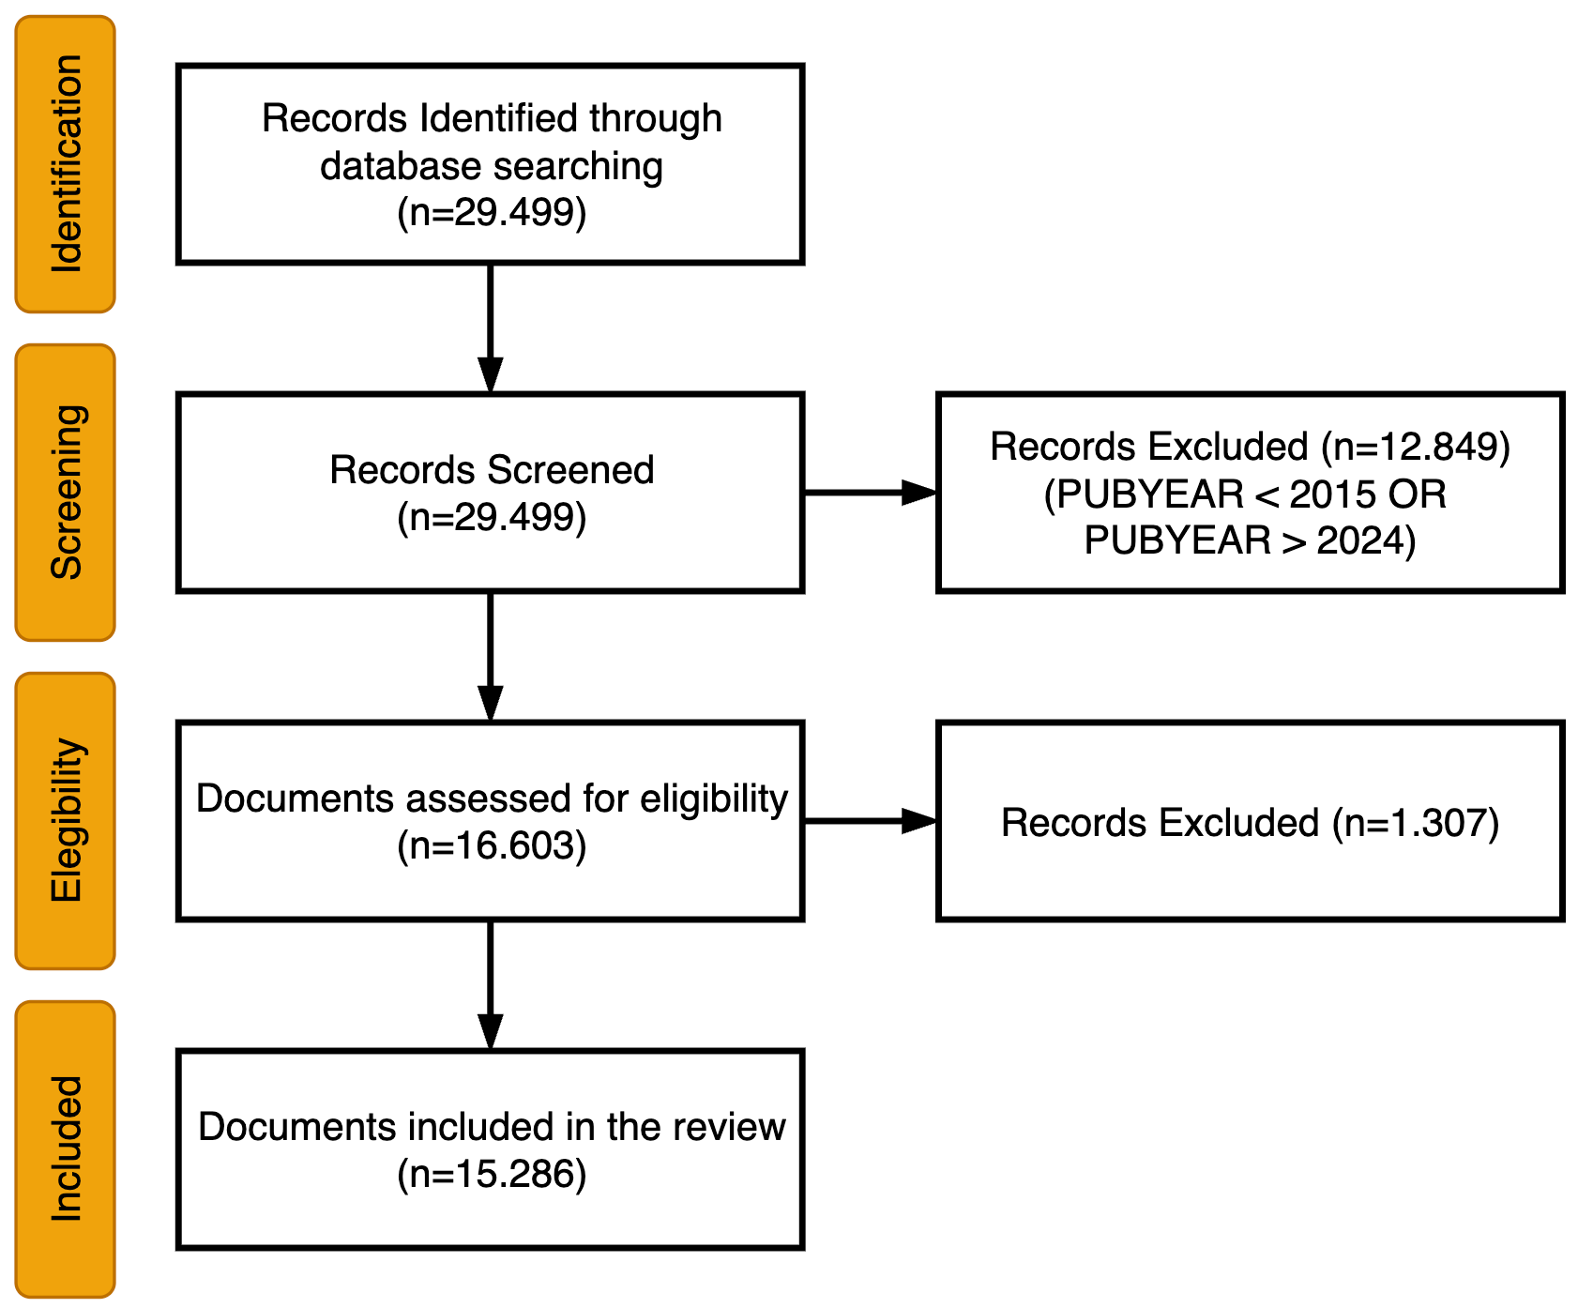
Figure 1. The PRISMA flow chart
Source: The authors.

Analysis of the data
Various analyses were conducted to understand better the papers published in engineering journals indexed in SciELO. The following sections detail the specific procedures and findings of each study.

Interpretation of the findings
The interpretation phase focused on reviewing and synthesizing results from the various analyses to draw conclusions aligned with this study's objectives. Patterns, trends, and thematic clusters identified during the data analysis phase were examined in depth and contextualized within the broader landscape of engineering research in Latin America. This step ensured that the insights were coherent and relevant to the study’s overall analytical framework.

Results and Discussion
This section presents the fundamental bibliometric indicators of the analyzed dataset.

General Metrics
The dataset includes scientific publications from January 2015 to December 2024, totaling 15,286 documents and reflecting an annual growth rate of 28.05%. The average document age is 5.77 years, with each work receiving approximately 4.11 citations overall, or 0.41 citations per year. Publications originate from 37 different sources, averaging 413.14 documents per source. The dataset comprises 14,822 journal articles, 35 conference papers, 21 editorials, two errata, one letter to the editor, and 402 review papers. A total of 40,773 authors (1,609 unique) contributed to the publications, with a strong tendency toward collaboration, averaging 3.61 authors and 3.92 co-authors per document. International collaborations account for 18.84% of the dataset. The contributing authors are affiliated with 10,687 organizations across 127 countries.
These patterns are consistent with findings from bibliometric studies in other disciplines—such as health sciences, management, and education—where thematic clustering and institutional concentration similarly influence the structure and evolution of scholarly production.

Leading Scopus Subject Areas

This section analyzes the subject areas assigned by Scopus, which are attributed at the journal level rather than to individual articles. These classifications help identify the disciplinary focus of the research published in SciELO-indexed engineering journals. The dataset used in this study comprises 15,286 documents distributed across 18 of Scopus's 27 subject areas. Notably, eight subject areas are associated with 1,000 or more documents. The most prominent areas are:
- Engineering: 7,257 documents (as anticipated).
- Materials Science: 2,664 documents.
- Computer Science: 1,884 papers.
- Chemical Engineering: 1,629 documents.
- General: 1,609 documents.
- Agricultural and Biological Sciences: 1,401 papers.
- Environmental Science: 1,263 documents.
- Business, Management, and Accounting: 1,017 papers.
Fig. 2 displays a cross-correlation map between Scopus subject areas and SciELO journals. This visualization provides insight into the interconnections between journals based on their associated subject areas. The numbers alongside each subject area indicate the corresponding documents and citations. Links between nodes reflect the degree of similarity, while node size is proportional to the number of documents associated with each subject area.
The correlation map reveals a strong central cluster dominated by Engineering and its closely related subfields, such as Materials Science, Computer Science, and Energy, reflecting the core disciplinary focus of the journal set. However, the map also highlights additional groups of subject areas that, while internally cohesive, exhibit weaker connections to the engineering core. For example, Physics and Astronomy and Mathematics form a distinct, well-defined cluster, whereas Medicine, Immunology and Microbiology, Biochemistry, Genetics and Molecular Biology, and Environmental Science are tightly interrelated but display limited thematic overlap with engineering. Notably, the Social Sciences appear as an isolated node, indicating minimal correlation with other disciplines in the network. These peripheral clusters underscore the multidisciplinary intersections in the dataset while reinforcing the centrality of engineering within the overall structure.

Basic Performance Metrics

Authors

Table 1 presents the 20 most frequent authors publishing in engineering journals indexed in SciELO between 2015 and 2024, including the number of papers, citations received within SciELO, total publications indexed in Scopus, and the ratio of SciELO to Scopus publications. This ratio provides insight into each author's publication preferences and engagement with the SciELO platform in the broader Scopus-indexed literature.

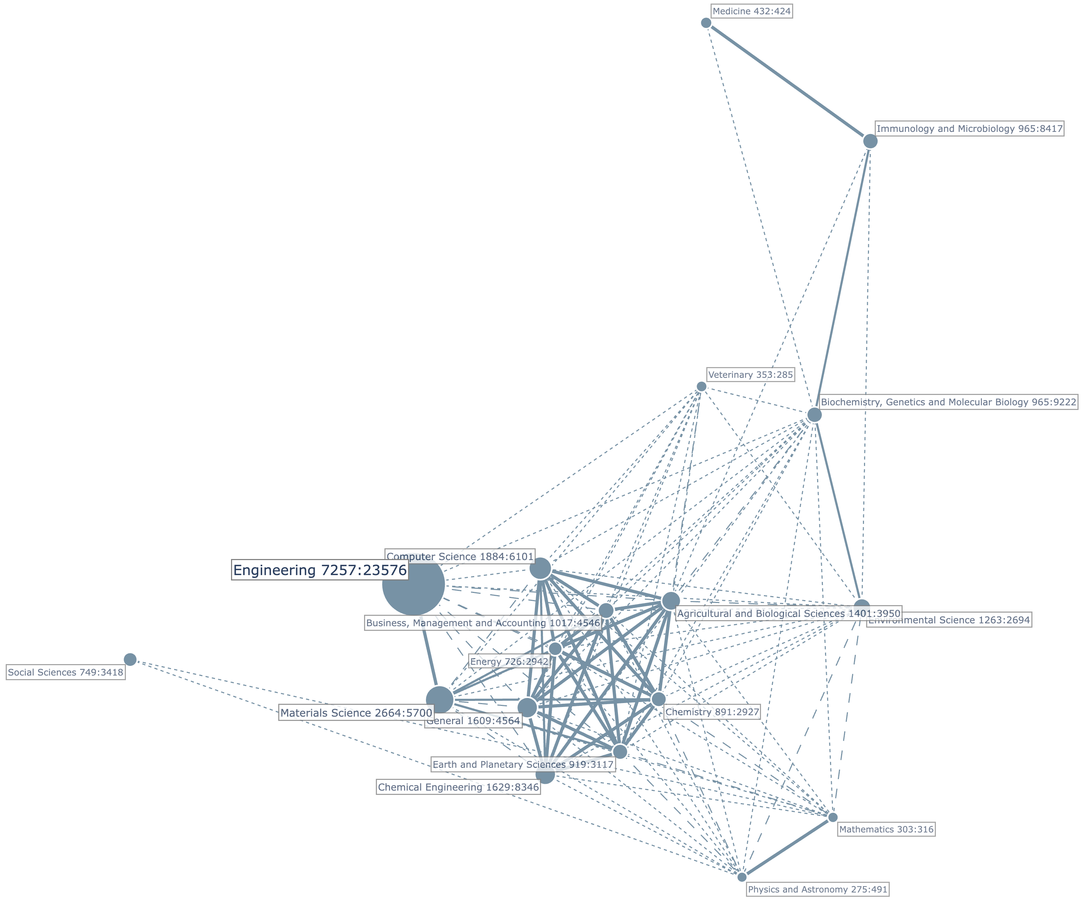
Figure 2. Correlation map of Scopus Subject Areas crossed with engineering SciELO journals.
Source: The authors.

Table 1.
Most Frequent Authors.
Author Name | Papers  SciELO | Citations  Scielo | Papers  Scopus | Ratio
Ganga-Contreras F.A. | 39 | 182 | 153 | 25.4 %
Pedraja-Rejas, L.M. | 37 | 240 | 108 | 34.3 %
Campos-Aranda D.F. | 37 | 64 | 43 | 86.0 %
Severino-González P. | 36 | 221 | 61 | 59.0 %
Gelbukh A. | 33 | 219 | 287 | 11.5 %
Acevedo-Correa D. | 33 | 164 | 57 | 57.9 %
López-Lezama J.M. | 30 | 177 | 131 | 22.9 %
Vidal-Silva C.L. | 29 | 152 | 88 | 33.0 %
Valencia-Arias A. | 28 | 178 | 237 | 11.8 %
Muñoz-Galeano, N. | 27 | 148 | 85 | 31.8 %
Rodríguez-Ponce E.R. | 26 | 185 | 87 | 29.9 %
Ortega-Toro R. | 26 | 157 | 96 | 27.1 %
Dávila-Morán, R.C. | 25 | 21 | 84 | 29.8 %
Preciado-Rangel, P. | 24 | 63 | 118 | 20.3 %
Escobar D.A. | 23 | 86 | 88 | 26.1 %
Paz-Pellat F. | 23 | 58 | 44 | 52.3 %
Bustamante-Ubilla M.A. | 22 | 117 | 42 | 52.4 %
Fontalvo-Herrera, T. | 21 | 167 | 46 | 45.7 %
Castrillón O.D. | 20 | 110 | 33 | 60.6 %
Zapata J.E. | 20 | 109 | 48 | 41.7 %
Source: The authors.

Table 2.
Most Frequent Institutions.
Name | Papers | Global  Citations | Local  Citations
Univ Nac de Colombia (COL) | 829 | 3754 | 28
Inst Politec Nac (MEX) | 602 | 2342 | 39
Univ de Antioquia (COL) | 353 | 1406 | 6
Univ Nac Autonoma de Mexico (MEX) | 254 | 1171 | 13
Univ Autonoma Metropolitana (MEX) | 248 | 910 | 18
Univ de Tarapaca (CHL) | 237 | 761 | 4
Tecnol Nac de Mexico (MEX) | 234 | 695 | 7
Univ del Valle (COL) | 232 | 983 | 9
CONICET (ARG) | 192 | 528 | 13
Univ Ind de Santander (COL) | 179 | 656 | 4
Source: The authors.

Among the authors, Ganga-Contreras F.A. leads with 39 publications in SciELO, accounting for 25.4% of their total output in Scopus, followed closely by Pedraja-Rejas, L.M., and Campos-Aranda D.F., both with 37 papers. Notably, Campos-Aranda D.F. shows a very high SciELO/Scopus ratio of 86.0%, suggesting a strong focus on SciELO as their primary publication venue. Similarly, Severino-González P. and Acevedo-Correa D. also exhibit high ratios (59.0% and 57.9%, respectively), indicating a substantial portion of their research is disseminated through SciELO journals.
In contrast, authors such as Gelbukh, A., and Valencia-Arias, A. have much lower ratios (11.5% and 11.8%, respectively), suggesting a broader, more international publication strategy that favors Scopus journals over SciELO. Despite this, they maintain a notable presence in SciELO and receive many citations.
Authors like Bustamante-Ubilla M.A. (52.4%) and Castrillón O.D. (60.6%) also strongly engage with SciELO relative to their total output. In contrast, others, such as Preciado-Rangel, P., and Escobar, D.A., have lower ratios but remain among the most frequent contributors.

Organizations

Table 2 lists the ten most frequent institutions contributing to engineering journals indexed in SciELO between 2015 and 2024. The total number of publications in the dataset ranks these institutions. Two citation metrics are included: Global citations, which count the total number of citations recorded in Scopus, and Local citations, which count citations made within the analyzed database.
Of the 10,687 unique organizations represented in the dataset (4,956 of which appear as first-author affiliations), the top 10 institutions account for a substantial share of the overall scientific output. These institutions are geographically concentrated in Colombia and Mexico, with eight out of the ten based in these two countries. This concentration highlights their significant contribution to regional engineering research. Notably, institutions such as the Universidad de Tarapacá (Chile) and CONICET (Argentina) also appear among the top contributors, reflecting the broader participation of Latin American countries in SciELO’s indexed engineering literature.
Leading the list is the Universidad Nacional de Colombia with 829 publications, followed by the Instituto Politécnico Nacional (Mexico) with 602 publications, and the Universidad de Antioquia (Colombia) with 353 publications. Together, these three institutions account for over 11% of all documents analyzed, highlighting their central role in the engineering research landscape in SciELO.
In terms of global impact—measured by Scopus citations—the Universidad Nacional de Colombia again stands out, with 3,754 citations —the highest among all institutions —signaling strong visibility and influence beyond the local context. The Instituto Politécnico Nacional also demonstrates a high global impact, with 2,342 citations. At the same time, institutions such as the Universidad Nacional Autónoma de México and the Universidad del Valle show solid performance, with over 900 citations each.
As expected in a dataset covering a wide range of journals and topics, local citations—used here as a proxy for intra-database scholarly exchange—are generally lower. However, the Instituto Politécnico Nacional exhibits a relatively high local citation count (39), suggesting a strong internal connection within the SciELO engineering network. Other institutions, such as the Universidad Nacional Autónoma de México and CONICET, also show moderate levels of local citation activity (13 each), indicating some degree of scholarly interaction within the indexed journals.

Countries

Table 3 highlights the geographic distribution of contributions to engineering publications in SciELO between 2015 and 2024, underscoring the platform’s role as a key hub for regional and international scholarly communication. Overall, the Americas dominate the dataset with 11,235 documents and 40,220 global citations, followed by Asia with 3,237 papers and Europe with 1,922. Within the Americas, Latin America and the Caribbean emerge as the core of SciELO’s engineering output, contributing 11,094 documents, 39,040 global citations, and 506 local citations. This regional concentration reinforces SciELO’s identity as a platform rooted in Latin American scholarship while also reflecting growing global engagement, particularly from Asia and Europe.
A closer look at subregional dynamics reveals that Eastern and Southern Asia show notable levels of participation, with Southern Asia standing out for its relatively high rate of local citations, suggesting meaningful engagement with the SciELO research network. Spain, though publishing fewer papers, distinguishes itself by a substantial citation impact, indicating visibility and influence within the global scientific community.
At the national level, Colombia and Mexico lead in publication volume, with 3,524 and 3,452 papers, respectively, together accounting for nearly 46% of the total 15,286 documents in the dataset. While Colombia registers the highest number of publications, Mexico demonstrates more robust intra-database citation activity, pointing to greater local scholarly interaction. China ranks third in productivity, with 2,148 papers. Although it exhibits high global citation counts, its local engagement appears limited, possibly reflecting a more external orientation in citation behavior.

Table 3.
Most Frequent Countries.
Name | Papers | Global  Citations | Local  Citations
Colombia | 3,524 | 13,447 | 102
Mexico | 3,452 | 12,408 | 154
China | 2,148 | 6,326 | 59
Chile | 1,265 | 6,100 | 85
Spain | 1,226 | 5,341 | 42
Brazil | 951 | 4,351 | 133
Ecuador | 859 | 1,697 | 8
Peru | 661 | 1,474 | 25
Argentina | 543 | 1,162 | 15
Cuba | 415 | 889 | 8
Source: The authors.

Other Latin American countries, including Chile, Brazil, Ecuador, Peru, Argentina, and Cuba, significantly contribute to the dataset, further consolidating SciELO’s regional character. Their participation highlights both the collaborative potential and diversity of engineering research across Latin America.

Sources

Table 4 presents the ten most frequent journals in the dataset, drawn from 37 sources, with an average of 413 documents per journal. BOLETIN TECNICO leads with 1,820 papers but shows relatively low citation counts (2,810 global and 12 local), suggesting high productivity but limited impact. In contrast, DYNA, with 1,341 papers, has a much higher global citation count (5,321), indicating greater visibility. COMPT SIST and REV MEX ING QUIMICA also show strong performance, with over 1,000 and 900 papers, respectively, and significant local citations—particularly the latter, which leads in local citations (197), suggesting strong engagement within the SciELO community.

Table 4.
Most Frequent Journals.
Name | Papers | Global  Citations | Local  Citations
Boletin Tecnico | 1,820 | 2,810 | 12
DYNA | 1,341 | 5,321 | 45
Comput. Sist. | 1,037 | 3,310 | 100
Rev. Mex. Ing. Quimica | 903 | 5,404 | 197
Inf. Tecnol. | 882 | 3,698 | 7
Interciencia | 871 | 2,342 | 8
Form.Univ. | 701 | 4,205 | 7
Tecnologia Ciencias Agua | 625 | 1,552 | 2
Electron. J. Biotechnol. | 593 | 11,229 | 85
J App Res Tech | 580 | 5,889 | 65
Source: The authors.

ELECTRON J BIOTECH stands out with the highest global citation count (11,229) despite ranking lower in document volume (593 papers), reflecting a high citation impact per paper. Similarly, J APP RES TECH shows strong citation metrics relative to its output. These results suggest that while some journals prioritize volume, others exert greater influence through their citation impact. Overall, the data reflect diverse publication strategies across journals in SciELO’s engineering collection, with varying balances between productivity and scholarly impact.

Temporal trends in engineering research topics

The analyzed dataset contains 42,141 unique text strings representing the author-assigned keywords. As described in Section 3.2, these raw keywords underwent a cleaning procedure to unify different text strings that represented the same concept or idea. As a result of this process, 39,450 cleaned author keywords were obtained.
Fig. 3 presents the six most frequent author keywords per year from 2015 to 2024, based on their occurrence and citation impact, and serves as the basis for analyzing temporal keyword dominance. The early years (2015–2016) featured specialized terms such as social networking, bi-level programming, and asphaltenes, reflecting narrower research focuses. From 2017 onward, broader and high-impact terms such as big data, data mining, and genetic algorithms emerged, marking a shift toward digital technologies and computational methods. Keywords such as simulations, artificial neural networks, and optimization have gained sustained relevance and high global citations. Education-related terms, such as teaching, learning, and higher education, also gained visibility, peaking around 2018-2020. More recently, terms like machine learning, deep learning, and natural language processing reflect current AI-driven trends. Post-2020 entries, such as COVID-19, circular economy, and digital transformation, indicate responses to global disruptions. In 2023-2024, emerging technologies such as large language models, blockchain, and cybersecurity suggest a forward-looking research agenda. The diversity and evolution of keywords underscore the dynamic nature of engineering research indexed in SciELO, spanning traditional disciplines, applied technologies, and societal challenges.

Mapping knowledge structures

Core journals and direct citation clusters

Fig. 5 presents the citation network of engineering journals indexed in SciELO, clustered using the Louvain algorithm. In bibliometric analysis, a citation network is a graphical representation in which nodes correspond to documents (e.g., journals or articles) and edges represent citation links between them ([13]). These networks help identify thematic clusters, influential sources, and patterns of knowledge dissemination across disciplines. The Louvain clustering revealed 14 distinct clusters, each grouping journals with stronger internal citation ties. Each resulting cluster is depicted in a different color, with node size reflecting keyword frequency and edge width corresponding to the number of co-occurrences between terms. The cluster, most densely populated by grouping 13 sources, includes highly cited journals, such as DYNA, INF TECNOL, and INTERCIENCIA, suggesting this cluster forms the core of SciELO’s engineering literature. These journals exhibit high publication volume and citation impact, indicating centrality in the network. The journals BOL MALARIOL SALUD AMBIENT contain the second central cluster, J TECHNOL MANAGE IINOV, and REV LASA INVEST. REV ING CONSTR, INGENIERIA, and REV ALCONPAT conform to the third most crucial cluster. There are no more essential relationships to highlight among the journals.

Intellectual structure of Latin American engineering research

The co-citation network [14] (Fig. 6), constructed from references to journals in SciELO that are also indexed in Scopus, reveals the intellectual structure underpinning Latin American engineering research. The analysis shows that the network is organized into three distinct clusters, each representing a group of journals that are frequently cited together, suggesting thematic or disciplinary affinities. The first cluster includes journals such as REV CONSTR, COMPUT SIST, and J APPL RES TECHNOL, focusing on applied engineering, construction, and computing technologies. This cluster reflects interdisciplinary connections within practical and technological domains. The second cluster is centered around REV MEX ING QUIMICA and ELECTRON J BIOTECHNOL, suggesting a strong emphasis on chemical engineering and biotechnology, with CTyF CIENC TECNOL FUTURO contributing additional coverage of scientific and technological development themes. The third comprises DYNA, INGEN INVEST, and ING UNIVERS, three general engineering journals that are among the most prolific in the region. Their co-citation is central to supporting foundational engineering knowledge and cross-cutting topics. The presence of distinct, well-formed clusters reflects the specialization of Latin American engineering journals. At the same time, their internal cohesion suggests the formation of stable, recognizable thematic communities within the regional research ecosystem.

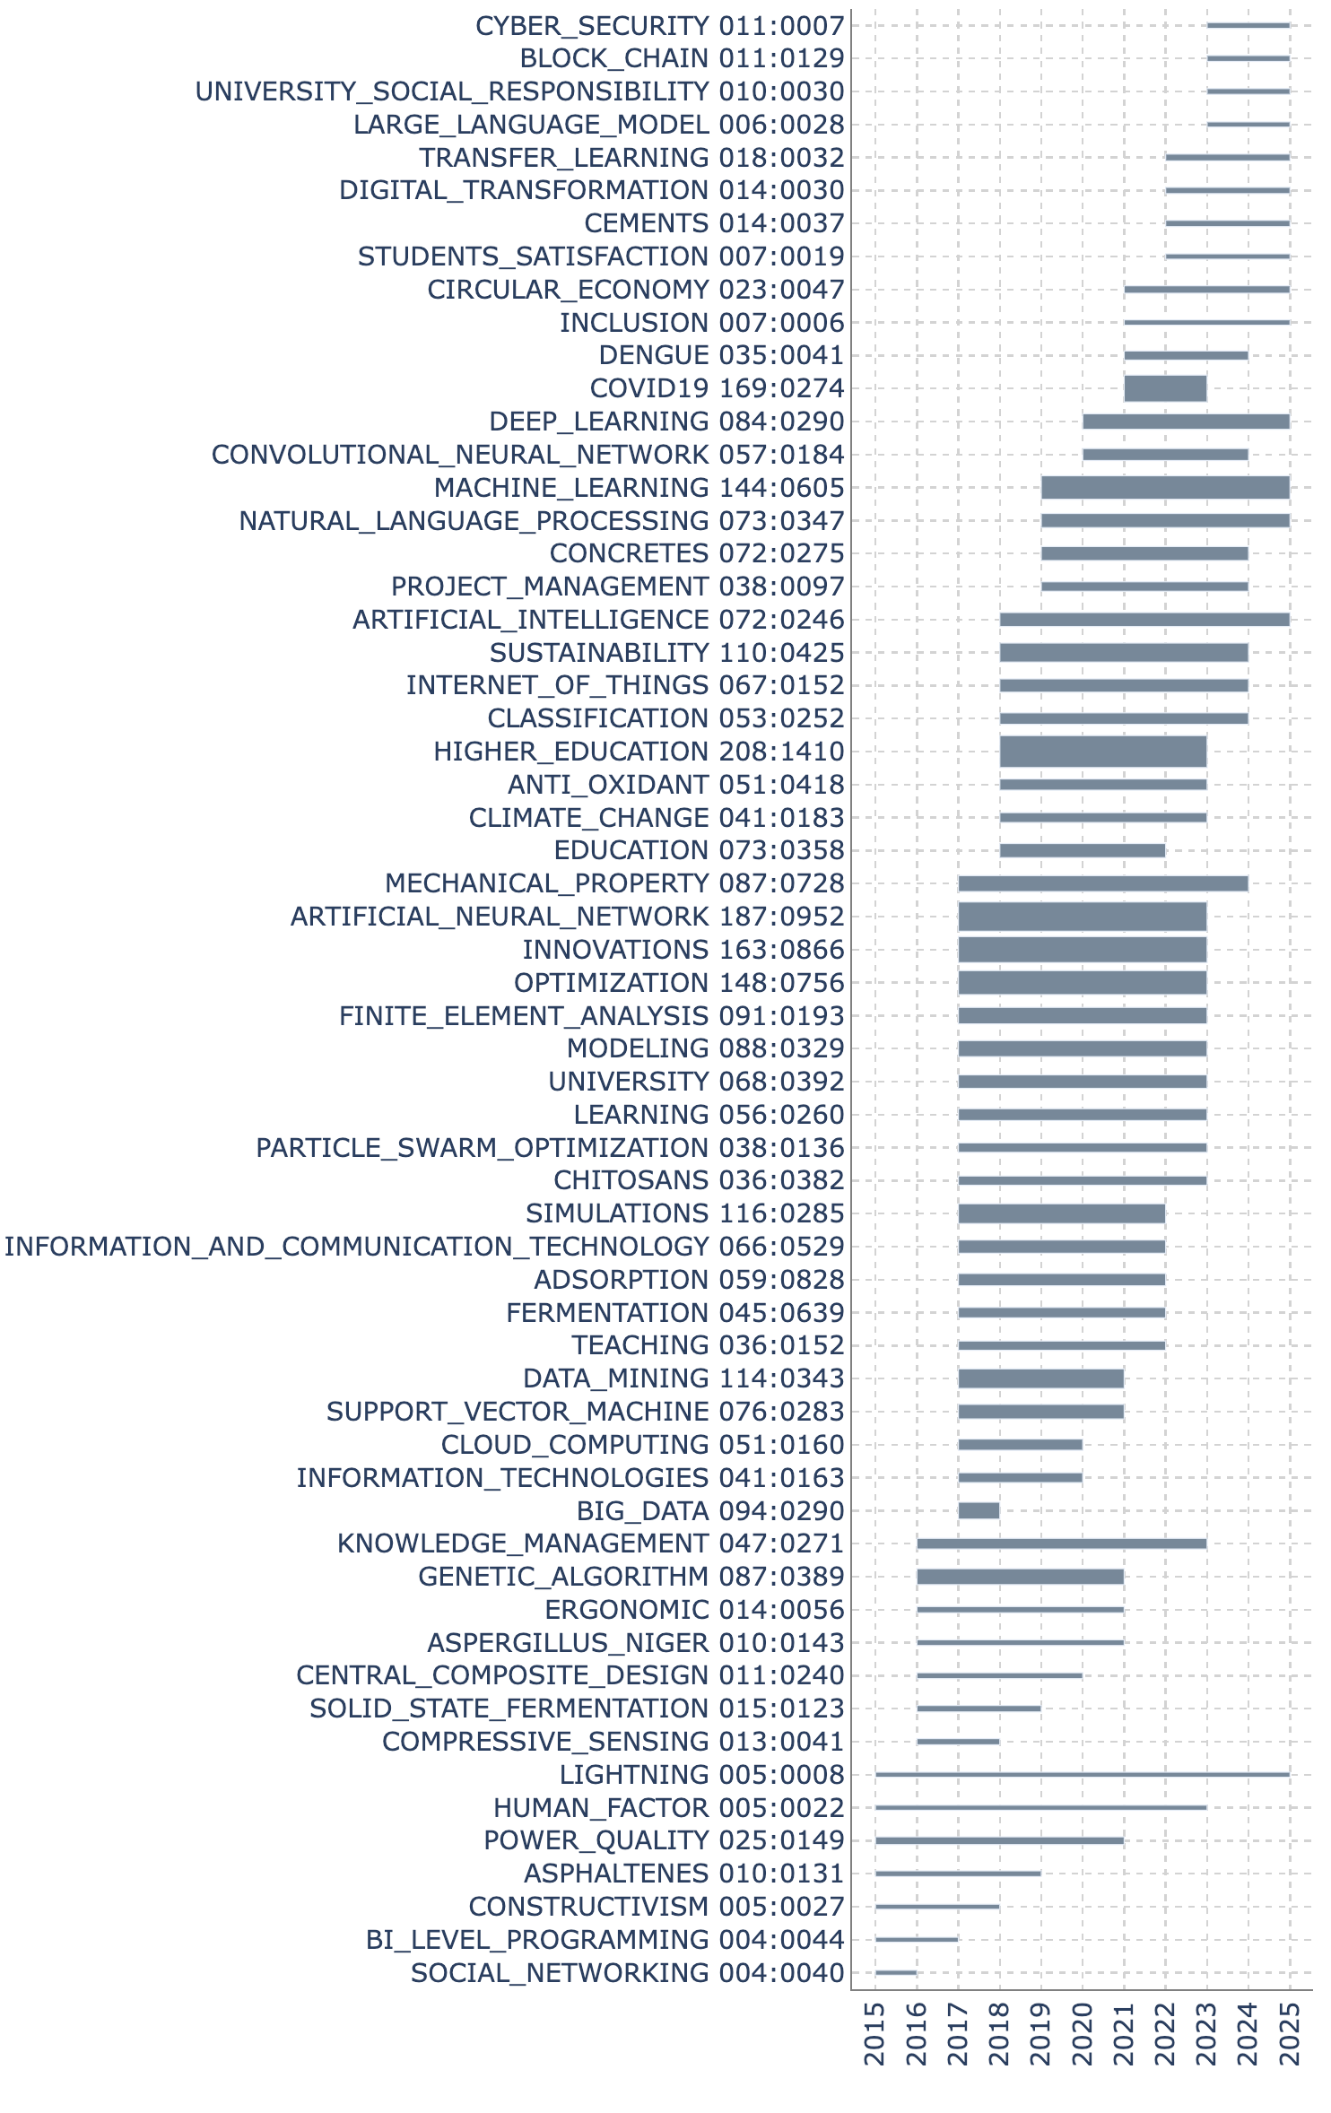
Figure 3. Dominant author keywords per year
Source: The authors.

Thematic clustering of SciELO engineering journals

Fig. 4 presents a correlation map of SciELO engineering journals based on the cleaned author keywords, which serve as the cross-variable. The size of each node is proportional to the number of documents published by the corresponding journal. In this map, node colors correspond to clusters detected by the Louvain algorithm, where each color represents a group of journals sharing stronger internal keyword correlations than with the rest of the network. At the same time, the width and intensity of the connecting lines reflect the strength of the cross-correlations between journals. The map reveals a well-defined core of closely interrelated journals, all actively publishing in engineering fields. This core includes journals such as DYNA, BOLETIN TECNICO, and COMPUT SIST. In contrast, journals like TERRA LATINOAM and PAP PHYS appear on the periphery of the correlation map, suggesting that their thematic focus diverges from the core journals' central topics. The map highlights a strong correlation between ANAL INVEST ARQUIT and ESTOA, suggesting a shared thematic scope or overlapping research interests within a specific subfield.

Thematic affinities

A journal coupling network is a bibliometric structure in which links between journals are established based on the number of shared references they cite [15], [16], [17]. The more two journals cite the same sources, the stronger their coupling relationship. This method reveals similarities in the intellectual foundations and thematic orientations of journals, regardless of whether they cite each other directly. This study constructed the coupling network using journals indexed in both SciELO and Scopus. The Louvain algorithm identified four clusters, each representing a distinct thematic community based on shared citations.

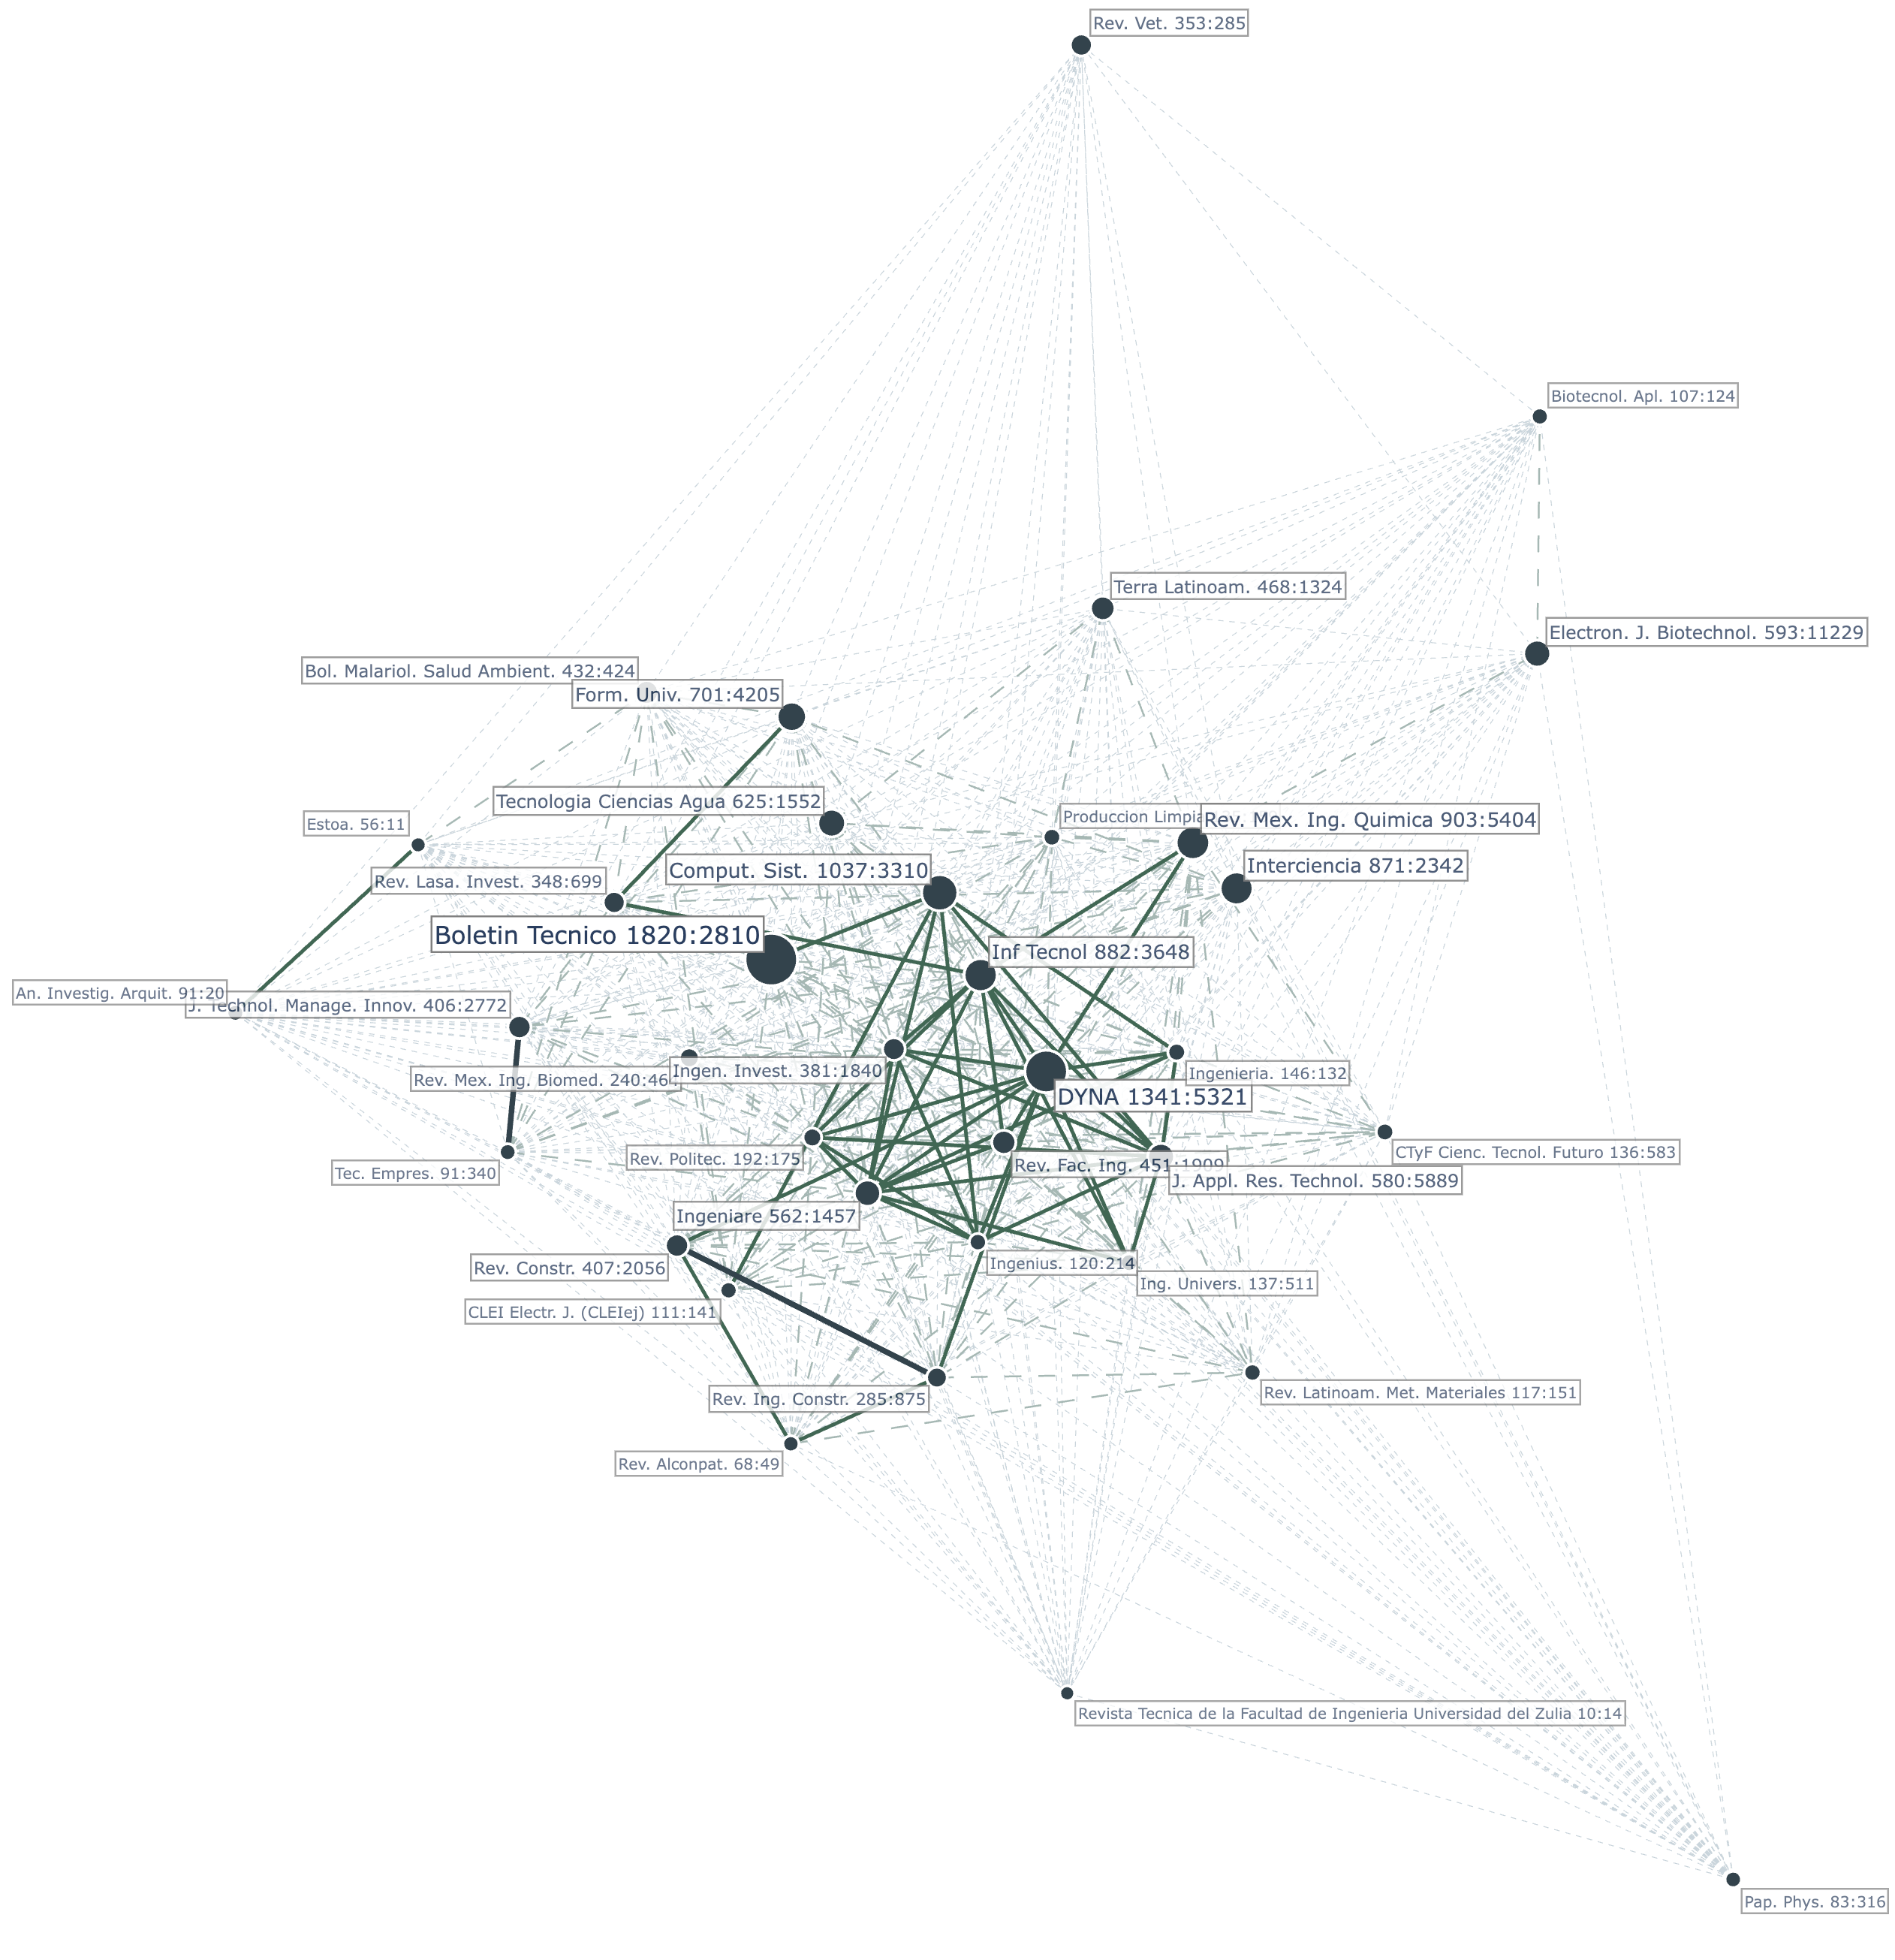
Figure 4. Correlation map of the engineering SciELO journals based on the author keywords.
Source: The authors.

Fig. 7 presents the obtained coupling network, which contains four clusters. In the coupling network, each color corresponds to a cluster of journals with similar reference patterns, and edge thickness indicates the strength of bibliographic coupling between journals. The first cluster, the largest, includes general and applied engineering journals such as FORM UNIV, J APPL RES TECHNOL, COMPUT SIST, and INGEN INVEST, reflecting a core of publications grounded in multidisciplinary engineering education, technology, and construction. The second cluster features journals like INF TECHNOL, INTERCIENCIA, and REV FAC ING, suggesting a group focused on innovation, institutional research, and technology management. The third cluster brings together journals such as REV MEX ING QUIMICA, ELECTRON J BIOTECHNOL, and TERRA LATINOAM, indicating a strong thematic alignment with chemical engineering, biotechnology, and environmental sciences. The fourth cluster group, comprised of CTYF CIENC TECNOL FUTURO and DYNA, forms a tightly coupled pair, possibly representing a more interdisciplinary or policy-oriented focus. The coupling network reveals clear thematic divisions and shared intellectual foundations among Latin American engineering journals.

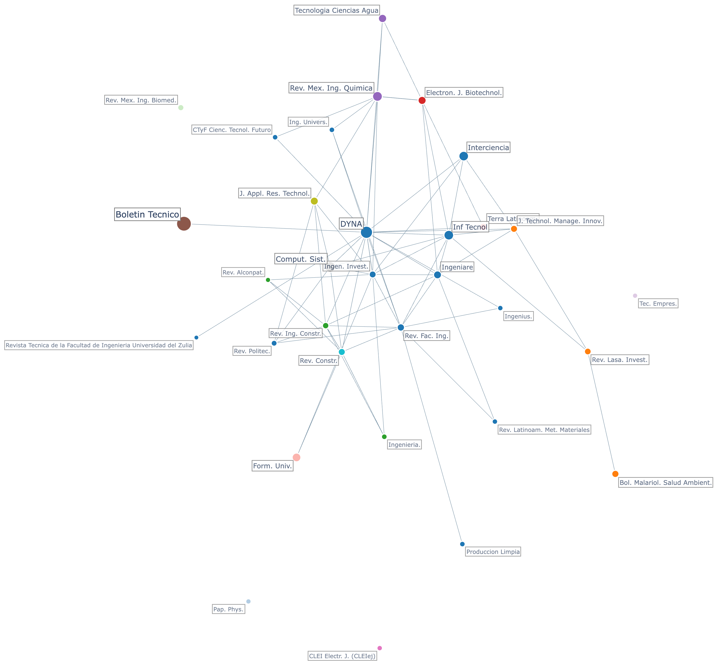
Figure 5. Citation network.
Source: The authors.

Dominant Themes

Table 5 presents the eight main dominant themes identified in engineering journals indexed in SciELO. These themes were obtained by applying the Louvain algorithm to the co-occurrence network of author keywords. A co-occurrence network is a graph in which nodes represent keywords, and links connect keywords that appear together in the same document. The strength of the link increases with the number of co-occurrences, revealing relationships between concepts and uncovering thematic structures. For this analysis, only cleaned author keywords with a frequency of five or more occurrences were included, ensuring the focus remained on the most relevant and recurring terms across the dataset. The Louvain algorithm, a widely used community detection method in network analysis, groups densely connected nodes into clusters, allowing for the identification of coherent topics or research areas. Each resulting cluster represents a dominant theme within the SciELO engineering literature. This method offers a data-driven approach to thematic mapping, highlighting the field’s conceptual organization and providing insights into how topics are interlinked across publications.
The eight dominant themes identified through this analysis are described in detail below, highlighting their internal coherence, conceptual focus, and relevance within the broader landscape of engineering research in Latin America.
Similar thematic structures have been reported in bibliometric studies from fields such as environmental sciences, computer science, and health research, where keyword co-occurrence networks and thematic clusters also reveal discipline-wide intellectual communities and emerging research fronts.

Bioremediation and bioenergy for environmental sustainability

This thematic cluster integrates biogenic materials, fermentation processes, and waste valorization to address pollution, enhance water quality, and generate renewable products. Studies highlight the transformation of biomass into antimicrobial and antioxidant compounds, such as copper nanoparticles from bacterial polysaccharides [18] and nanoemulsions from essential oils [19]. Fermentation emerges as a key process for producing high-value food and beverage products with enhanced biochemical stability and antioxidant capacity ([20], [21]). Wastewater treatment through biosorption and microbial reduction effectively removes heavy metals and endocrine disruptors [22], [23]. Simultaneously, civil engineering studies employing rice husk ash and silica fume emphasize circular strategies for reducing environmental impact [24]. These works reveal a systemic shift toward eco-innovative bioprocesses that integrate food, energy, and material systems, positioning biomass not as residue but as a central agent of bioremediation, sustainability, and renewable energy production [25], [26], [27].

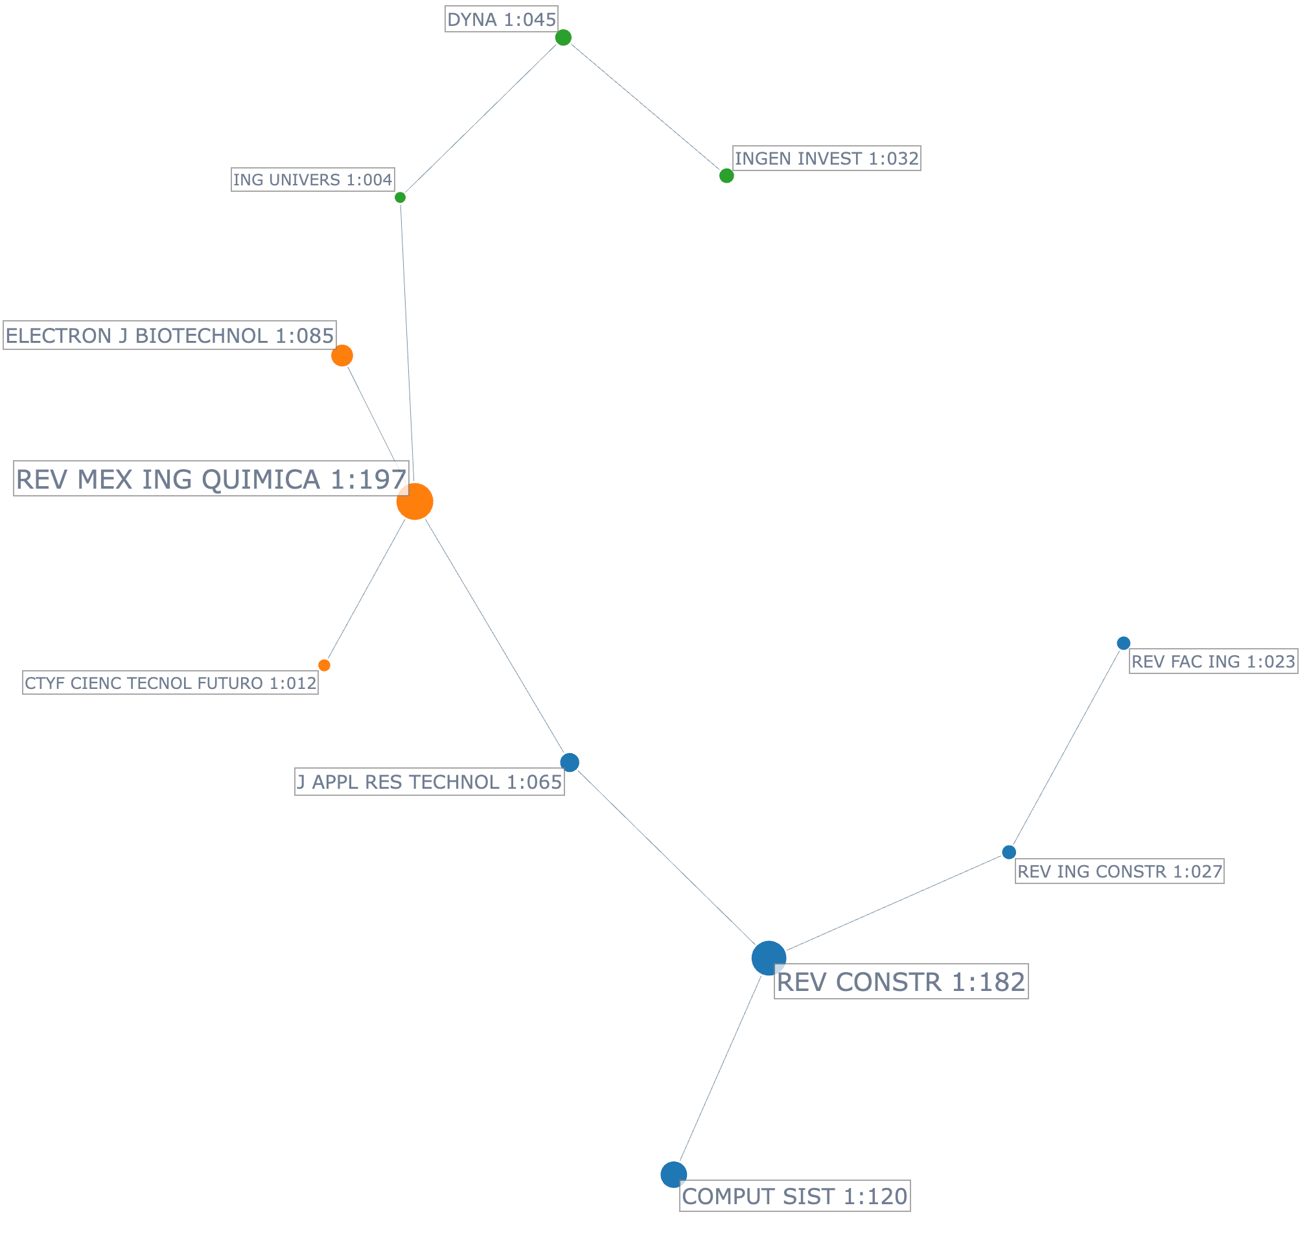
Figure 6. Co-citation network
Source: The authors.

Innovation, ICT, and knowledge management in higher education

This thematic cluster reflects the convergence of technological innovation, entrepreneurship, and knowledge management as transformative forces in higher education. Universities are increasingly integrating Information and Communication Technologies (ICTs) into teaching, management, and performance enhancement, thereby fostering adaptive learning and institutional efficiency [28], [29], [30]. Entrepreneurship emerges as a strategic objective linked to the development of small and medium enterprises (SMEs), supported by academic-industry collaboration and student-driven initiatives [28], [31], [32]. These dynamics align with values-based education and social responsibility, preparing students for socio-environmental challenges through digital competencies and civic engagement [33]. As institutions embrace digital transformation, universities evolve into responsive platforms for innovation, sustainability, and socio-economic development [34], [35], [36].

AI and data-driven technologies

This thematic cluster highlights the convergence of artificial intelligence, machine learning, and data-driven technologies applied to complex classification and optimization tasks across domains such as healthcare, agriculture, engineering, and digital security. Core methods, such as convolutional neural networks, support vector machines, and fuzzy logic, are used to extract and interpret high-dimensional data, thereby enhancing prediction accuracy and decision-making efficiency [28], [37], [38], [39]. Applications emphasize the development of context-aware, scalable systems enabled by big data, cloud computing, and the Internet of Things (IoT) infrastructures [29], [30]. Energy efficiency and sustainability emerge as underlying priorities in computational model design [37], [40]. Natural language processing extends these approaches to unstructured data, illustrating AI’s cross-functional versatility [30]. Collectively, these studies reflect a shift toward intelligent, adaptive systems that unify digital architectures and learning-based models to solve real-world engineering problems [28], [41].

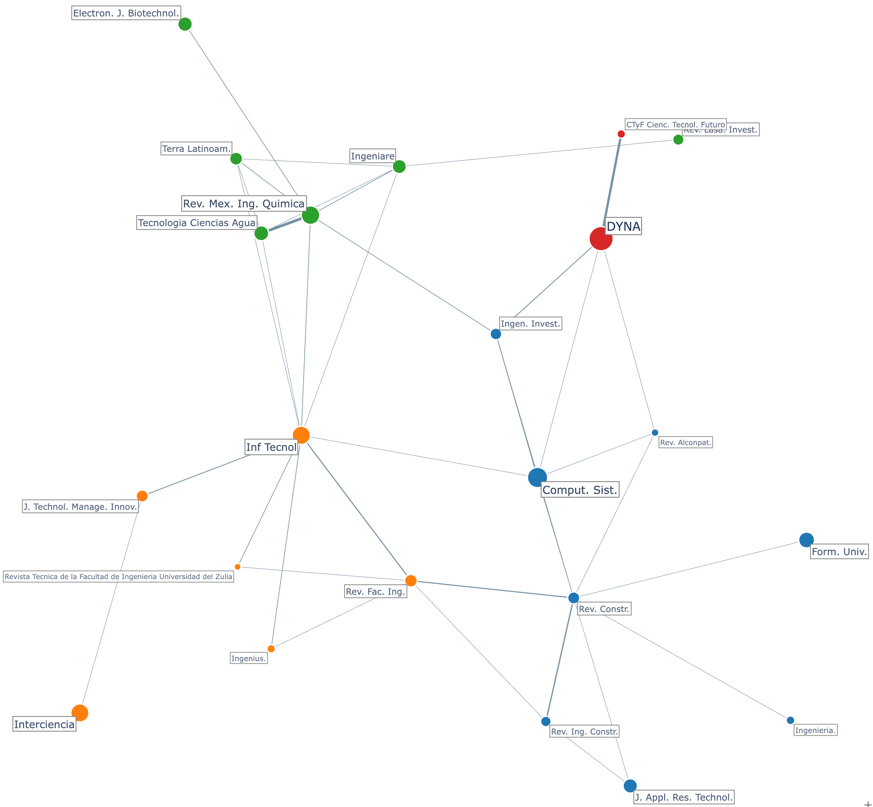
Figure 7. Coupling network.
Source: The authors.

Table 5.
Dominant themes.
Theme Name | Num Terms | Percentage | Main Terms
Bioremediation and bioenergy for environmental sustainability | 478 | 24.8 % | Adsorption; biomass; antioxidant; heavy metals; fermentation; antioxidant activities; wastewater; pollution; biofuel; bio diesel
Innovation, ICT, and knowledge management in higher education | 413 | 21.4 % | Higher education; innovations; education; university; information and communication technology; learning; small and medium enterprises; management; university students; knowledge management
AI and data-driven technologies | 339 | 17.6 % | Artificial neural network; machine learning; data mining; big data; deep learning; support vector machine; natural language processing; artificial intelligence; internet of things; convolutional neural network
Engineering materials and structural analysis | 290 | 15.0 % | Finite element analysis; mechanical property; concretes; computational fluid dynamics; nano particle; compressive strength; numerical simulations; corrosion; chitosan; rheology
Climate modeling and risk assessment | 130 | 6.7 % | Simulations; modeling; temperatures; climate change; remote sensing; precipitation; mathematical modeling; risks; accessibility; risks assessment
Optimization and intelligent engineering systems | 111 | 5.8 % | Optimization; genetic algorithm; response surface methodology; reliability; micro grid; wireless sensor network; multi objective optimization; power quality; heuristics; production
Epidemiology and public health | 103 | 5.3 % | Covid19; dengue; pandemic; risk factors; dogs; prevalence; cattle; epidemiology; stresses; prevention
Sustainability, circular economy, and environmental management | 64 | 3.3 % | Sustainability; sustainable development; recycling; circular economy; solar energies; environmental impacts; agriculture; environmental education; solid wastes; costs
Source: The authors.

Engineering materials and structural analysis

This thematic cluster reflects the convergence of material science, environmental engineering, and computational modeling to enhance mechanical performance, durability, and sustainability in engineering applications. Studies emphasize the use of agricultural and industrial residues—such as fly ash, chitosan, and coffee husk ash—to improve concrete and composite materials while supporting waste valorization and pollutant removal [22], [27], [42]. Numerical simulations, including finite element analysis and computational fluid dynamics, guide structural optimization and microstructural analysis under diverse loading and environmental conditions [43], [44]. Rheological assessments and kinetic models contribute to understanding degradation processes and thermal stability, especially in systems incorporating nano- and bioactive components [31], [45]. Applications range from predicting concrete strength using image analysis [46] to studying the transformation of endocrine disruptors [47], illustrating a shift toward multifunctional, simulation-driven, and eco-efficient material solutions grounded in experimental validation and predictive modeling.

Climate modeling and risk assessment

This thematic cluster focuses on integrating mathematical modeling, simulations, and geospatial analysis to assess environmental vulnerabilities driven by climate variability and anthropogenic pressures. Studies use remote sensing and geostatistical tools to simulate the impacts of precipitation, temperature, and pollution on water systems, informing risk assessments and sustainability strategies [48], [49], [50], [51]. Emphasis is placed on evaluating system behavior under dynamic conditions, including water accessibility and air quality degradation, often using empirical data to guide scenario-based interventions [23], [26], [52]. Climate models reveal how slight temperature or precipitation shifts substantially alter hydrological flows, highlighting the compounded effects of climate change [51]. Accessibility and environmental justice also intersect with sustainability objectives, connecting technical evaluations to social outcomes [32]. Overall, the cluster advances a systems-level framework for understanding and managing environmental risk through simulation, spatial analysis, and predictive modeling.

Optimization and intelligent engineering systems

This thematic cluster reflects the integration of multi-objective optimization and metaheuristic algorithms with energy systems, production processes, and infrastructure management to enhance reliability, efficiency, and sustainability. Techniques such as genetic algorithms and response surface methodology are widely applied in smart grids, microgrids, and wireless sensor networks to optimize power quality, distributed generation, and system robustness under uncertainty [19], [22], [28]. These methods support predictive maintenance and energy-efficient production, particularly in scenarios that require real-time decision-making and adaptive control [40], [41]. The convergence of algorithmic models with practical applications—ranging from pH optimization in environmental remediation to dynamic response tuning in control systems—underscores a systems-oriented approach that blends computational intelligence with sustainable engineering design [24], [53].

Epidemiology and public health

This thematic cluster reflects a multidisciplinary approach to zoonotic and vector-borne diseases, emphasizing the convergence of epidemiological surveillance, environmental stressors, and digital communication to enhance public health resilience. Across the abstracts, infectious diseases, such as COVID-19, dengue, malaria, and canine-related illnesses, are studied for their prevalence, risk factors, and spatial dynamics in both human and animal populations, suggesting a One Health framework [18], [19], [54]. The role of social media in risk communication and mental health detection during pandemics demonstrates a shift toward digital epidemiology [28], [55], [56]. Studies also highlight the use of modeling and indices to forecast disease patterns and support prevention strategies under various climatic and urban conditions [57], [58], [59]. The integration of engineering approaches—ranging from environmental modeling to biomedical innovations—positions this cluster at the intersection of disease ecology, technological adaptation, and health systems preparedness.

Sustainability, circular economy, and environmental management

This thematic cluster reflects a systems-oriented integration of environmental sustainability, circular economy, and technological innovation across engineering and agricultural domains. Studies emphasize the reuse of materials such as rice husk ash, refractory waste, and coffee husk ash to reduce the environmental footprint of concrete while preserving its mechanical performance [42], [50]. Food engineering research supports sustainability through drying and fermentation processes that enhance nutritional value and improve energy efficiency by utilizing agro-industrial residues [26], [60]. Simultaneously, biosurfactant-based pollutant control [22] and biotechnological innovations such as copper nanoparticles and essential oil nanoemulsions [18], [19] reinforce low-impact solutions. The roles of life cycle assessment, social responsibility, and environmental education emerge in efforts to align industrial processes, university practices, and consumer behavior with sustainability goals [61], [62], positioning engineering research within a multidimensional ecological framework.

Conclusions

This study provides a multidimensional portrait of engineering journals from Latin America indexed in both SciELO and Scopus, revealing a complex interplay between structural visibility, thematic specialization, and regional collaboration. The cross-correlation of Scopus subject areas reveals a broad but uneven disciplinary coverage, with clusters of journals focusing on applied fields, including civil, environmental, and industrial engineering. Performance indicators highlight a concentration of scientific output among a small group of institutions and countries, underscoring the presence of regional research hubs. Thematic analysis of author keywords reveals recurring areas, including sustainability, materials science, and energy, and highlights inconsistencies in terminological usage across journals. Correlation networks based on keywords and citations reveal both thematic proximities and intellectual communities, with co-citation and bibliographic coupling patterns indicating shared epistemic foundations. Using keyword co-occurrence analysis, we identified eight dominant themes that reflect the diversity and priorities of engineering research in Latin America, encompassing topics such as sustainability, public health, data-driven technologies, and core engineering domains. The findings confirm SciELO's strategic role in enhancing regional visibility and suggest that journals with stronger thematic focus and inter-journal connectivity tend to achieve greater integration in the global scientific landscape. Ultimately, this bibliometric mapping highlights the evolving structure and knowledge production patterns of Latin American engineering research, providing valuable guidance for scholars, journal editors, and policymakers seeking to strengthen regional scientific communication and enhance the international relevance of their work.
For authors, the results highlight where thematic opportunities and visibility gaps exist across journals, helping align research topics with regional and global impact areas. For editors, the structural and thematic maps provide actionable insights to refine journal scope, strengthen interdisciplinary positioning, and enhance citation connectivity. For policymakers, the findings offer evidence to guide investment in emerging research fronts, support regional collaboration networks, and reinforce SciELO’s strategic role in scientific capacity-building.

References

[1] A. L. Packer et al., “SciELO: a methodology for electronic publishing,” Ciência da informação, vol. 27, p. nd-nd, 1998.
[2] E. Schultes, “SciELO 25: A reflection on technologies enabling accessibility.” SAGE Publications Sage UK: London, England, 2024.
[3] F. Beigel, A. L. Packer, O. Gallardo, and M. Salatino, “OLIVA: The Scientific output in journals edited in Latin America. Disciplinary Diversity, Institutional Collaboration, and Multilingualism in SciELO and Redalyc (1995-2018),” Dados, vol. 67, no. 1, 2024, doi: 10.1590/dados.2024.67.1.307x.
[4] A. A. Abadía, “Number of references in scientific production. An approximation to its evolution based on the journals included in SciELO Colombia,” Revista Espanola de Documentacion Cientifica, vol. 47, no. 2, 2024, doi: 10.3989/redc.2023.2.1462.
[5] R. Meneghini, R. Mugnaini, and A. L. Packer, “International versus national oriented Brazilian scientific journals. A scientometric analysis based on SciELO and JCR-ISI databases,” Scientometrics, vol. 69, no. 3, pp. 529–538, 2006.
[6] F. Collazo-Reyes, “Growth of the number of indexed journals of Latin America and the Caribbean: the effect on the impact of each country,” Scientometrics, vol. 98, pp. 197–209, 2014.
[7] M. Aria and C. Cuccurullo, “bibliometrix: An R-tool for comprehensive science mapping analysis,” Journal of informetrics, vol. 11, no. 4, pp. 959–975, 2017.
[8] N. Donthu, S. Kumar, D. Mukherjee, N. Pandey, and W. M. Lim, “How to conduct a bibliometric analysis: An overview and guidelines,” Journal of Business Research, vol. 133, pp. 285–296, 2021, doi: https://doi.org/10.1016/j.jbusres.2021.04.070.
[9] M. J. Page et al., “The PRISMA 2020 statement: an updated guideline for reporting systematic reviews,” BMJ, vol. 372, p. n71, Mar. 2021, doi: 10.1136/bmj.n71.
[10] I. Zupic and T. Čater, “Bibliometric Methods in Management and Organization,” Organizational Research Methods, vol. 18, no. 3, pp. 429–472, 2015, doi: 10.1177/1094428114562629.
[11] B. Kitchenham, “Procedures for performing systematic reviews,” Keele, UK, Keele University, vol. 33, no. 2004, pp. 1–26, 2004.
[12] B. Kitchenham, O. P. Brereton, D. Budgen, M. Turner, J. Bailey, and S. Linkman, “Systematic literature reviews in software engineering–a systematic literature review,” Information and software technology, vol. 51, no. 1, pp. 7–15, 2009.
[13] F. Collazo-Reyes, “Growth of the number of indexed journals of Latin America and the Caribbean: the effect on the impact of each country,” Scientometrics, vol. 98, pp. 197–209, 2014.
[14] A. González-Teruel, G. González-Alcaide, M. Barrios, and M.-F. Abad-García, “Mapping recent information behavior research: an analysis of co-authorship and co-citation networks,” Scientometrics, vol. 103, pp. 687–705, 2015.
[15] W. E. Nwagwu, “Bibliographic coupling networks of global research on data literacy by documents, sources and authors,” Journal of Librarianship and Information Science, 2024, doi: 10.1177/09610006241252655.
[16] H. Zhu, L. Qian, W. Qin, J. Wei, and C. Shen, “Evolution analysis of online topics based on ‘word-topic’ coupling network,” Scientometrics, vol. 127, no. 7, pp. 3767–3792, 2022, doi: 10.1007/s11192-022-04439-x.
[17] C. Biscaro and C. Giupponi, “Co-authorship and bibliographic coupling network effects on citations,” PLoS ONE, vol. 9, no. 6, 2014, doi: 10.1371/journal.pone.0099502.
[18] A. Banerjee, R. K. Roy, S. Sarkar, J. L. López, S. Vuree, and R. Bandopadhyay, “Synthesis of hot spring origin bacterial cell wall polysaccharide-based copper nanoparticles with antibacterial property,” Electronic Journal of Biotechnology, vol. 68, pp. 11–19, 2024.
[19] A. H. Hashem et al., “A novel nanoemulsion based on clove and thyme essential oils: Characterization, antibacterial, antibiofilm and anticancer activities,” Electronic Journal of Biotechnology, vol. 68, pp. 20–30, 2024.
[20] P. Ertürkmen, Ö. Bulantekin, and D. Alp-Baltakesmez, “Investigation of the potential of Rosa damascena vinegar fermented with probiotic lactic acid bacteria as a functional food Investigación del potencial del vinagre de Rosa damascena fermentado con bacterias lácticas probióticas como un alimento funcional”.
[21] E. Cappelin et al., “Low-alcohol light beer enriched with olive leaves extract: Cold mashing technique associated with interrupted fermentation in the brewing process,” Electronic Journal of Biotechnology, vol. 68, pp. 81–89, 2024.
[22] F. A. Alcázar-Medina, S. Valle-Cervantes, T. L. Alcazar-Medina, and M. D. J. Rodríguez-Rosales, “Optimization of copper removal through spherical agglomeration: Effect of pH precipitation and the use of Agave spp. leaf extracts as biosurfactants,” Revista Mexicana de Ingeniera Quimica, vol. 23, no. 1, 2024, doi: 10.24275/rmiq/Bio24170.
[23] C. D. Loreto-Muñoz, G. López-Avilés, M. C. De la Cruz-Leyva, A. R. Martin-García, and F. J. Almendariz-Tapia, “Sulfidogenic activity related to microbial diversity in a biological system employed for sulfate-rich wastewater treatment,” Revista Mexicana de Ingeniera Quimica, vol. 23, no. 1, 2024, doi: 10.24275/rmiq/IA24167.
[24] F. Nadim et al., “Effect of silica fume on the microstructural and mechanical properties of concrete made with 100% recycled aggregates,” Revista de la Construccion, vol. 23, no. 2, pp. 413–443, 2024, doi: 10.7764/RDLC.23.2.413.
[25] D. Gallardo-Martínez, G. Viniegra-González, F. Figueroa-Martínez, J. Rocha, and A. Cruz-Guerrero, “Isolation and characterization of epiphytic, fructanolytic, homofermentative lactic acid bacteria from Agave salmiana,” Revista Mexicana de Ingeniera Quimica, vol. 23, no. 1, 2024, doi: 10.24275/rmiq/Alim24142.
[26] N. M. Thuy, T. N. Giau, H. V. Hao, N. C. Dung, N. V. Tai, and V. Q. Minh, “Effects of steaming and drying on quality and antioxidant activity of white-fleshed sweet potato powder (Ipomoea batatas),” Revista Mexicana de Ingeniera Quimica, vol. 23, no. 1, 2024, doi: 10.24275/rmiq/Alim24184.
[27] L. Loan, B. Vinh, and N. Tai, “Effect of gum arabic concentrations on drying kinetics, anthocyanin degradation and product qualities of purple rice bran extract dried by foam-mat technique,” Revista Mexicana de Ingeniería Química, vol. 23, no. 1, pp. 1–15, 2023.
[28] O. O. Adebanji, O. E. Ojo, H. Calvo, I. Gelbukh, and G. Sidorov, “Adaptation of transformer-based models for depression detection,” Computación y Sistemas, vol. 28, no. 1, pp. 151–165, 2024.
[29] A. Mena, E. Vázquez, E. Fernández, and E. López, “Artificial intelligence and its scientific production in the area of education,” Formación universitaria, vol. 17, no. 1, pp. 155–164, 2024.
[30] A. Gelbukh, D. A. Pérez Alvarez, O. Kolesnikova, L. Chanona-Hernandez, and G. Sidorov, “Multi-instrument based N-grams for composer classification task,” Computación y Sistemas, vol. 28, no. 1, pp. 85–98, 2024.
[31] V. Ramos-Villacob, J. A. Figueroa-Flórez, J. G. Salcedo-Mendoza, J. E. Hernandez-Ruydíaz, and L. A. Romero-Verbel, “Development of modified cassava starches by ultrasound-assisted amylose/lauric acid complex formation,” Revista Mexicana de Ingeniera Quimica, vol. 23, no. 1, 2024, doi: 10.24275/rmiq/Alim24109.
[32] Ma. M. G. C. Castillo-Esparza, G. Maldonado-Guzmán, and J. Mejía-Trejo, “Green Business Strategy and its effect on Financial Performance: The mediating role of Corporate Social Responsibility,” Tec Empresarial, vol. 18, no. 2, pp. 1–17, 2024, doi: 10.18845/te.v18i2.7134.
[33] R. Loza, G. Romaní, W. Castañeda, and G. Arias, “Influence of skills and knowledge on the financial attitude of university students,” Tec Empresarial, vol. 18, no. 1, pp. 65–83, 2024.
[34] Y. Sánchez-Suárez, V. Sánchez-Castillo, and C. A. Gómez-Cano, “Dashboard for assessing patient flow management in hospital institutions,” DYNA (Colombia), vol. 91, no. 232, pp. 49–57, 2024, doi: 10.15446/dyna.v91n232.111259.
[35] F. Ganga-Contreras, W. Suarez-Amaya, N. Alarcón-Henríquez, P. Viancos-González, F. Henríquez-Fuentes, and J. Abello-Romero, “Scientific production of the relationship between leadership, higher education and digital transformation: A bibliometric analysis,” Interciencia, vol. 49, no. 1, pp. 8–18, 2024.
[36] Y. López-Angulo, F. Sáez-Delgado, and J. Mella-Norambuena, “Life and academic purposes of Chilean university students in STEM careers (Science, Technology, Engineering, and Mathematics),” Formacion Universitaria, vol. 17, no. 2, pp. 83–100, 2024, doi: 10.4067/S0718-50062024000200083.
[37] I. K. Fourati and S. Kammoun, “A matlab based graphical user interface for the monitoring and early detection of keratoconus,” Journal of Applied Research and Technology, vol. 22, no. 1, pp. 22–31, 2024.
[38] R. S. Luna-Lozoya, H. de Jesús Ochoa-Domínguez, J. H. Sossa-Azuela, V. G. Cruz-Sánchez, and O. O. Vergara-Villegas, “Lightweight CNN for Detecting Microcalcifications Clusters in Digital Mammograms,” Computacion y Sistemas, vol. 28, no. 1, pp. 245–256, 2024, doi: 10.13053/CyS-28-1-4892.
[39] F. Garibaldi-Márquez, G. Flores, and L. M. Valentín-Coronado, “Corn/Weed Plants Detection Under Authentic Fields based on Patching Segmentation and Classification Networks,” Computación y Sistemas, vol. 28, no. 1, pp. 271–282, 2024.
[40] J. M. Alkhasraji, S. W. Shneen, and M. Q. Sulttan, “Reduction of large scale linear dynamic mimo systems using aco-pid controller,” Ingeniería e Investigación, vol. 44, no. 1, p. 9, 2024.
[41] H. Khalid, “Modern techniques in detecting, identifying and classifying fruits according to the developed machine learning algorithm,” Journal of Applied Research and Technology, vol. 22, pp. 219–229, 2024, doi: 10.22201/icat.24486736e.2024.22.2.2269.
[42] S. M. Pérez, M. R. Segura, Y. A. Bustamante, and L. V. Zapata, “Study of the combined effect of coffee husk ash and polypropylene fibres on the mechanical properties of concrete,” Journal of Applied Research and Technology, vol. 22, no. 1, pp. 32–41, 2024.
[43] G. O. Barrionuevo, I. La Fé-Perdomo, E. Cáceres-Brito, and W. Navas-Pinto, “Tensile/Compressive Response of 316L Stainless Steel Fabricated by Additive Manufacturing,” Ingenius. Revista de Ciencia y Tecnología, no. 31, pp. 9–18, 2024.
[44] I. Ustabas, S. Erdogdu, C. Akyuz, Z. Kurt, and T. Cakmak, “Heavy aggregate and different admixtures effect on pavings: pyrite, corundum and water-retaining polymer,” Revista de la Construccion, vol. 23, no. 1, pp. 31–46, 2024, doi: 10.7764/RDLC.23.1.31.
[45] M. Shahriari, A. Mohabati Mobarez, A. Talebi Bazminabadi, and M. Tavakoli Yaraki, “Enhancing Lactobacillus plantarum viability using novel chitosan-alginate-pectin microcapsules: Effects on gastrointestinal survival, weight management, and metabolic health,” Electronic Journal of Biotechnology, vol. 72, pp. 20–28, 2024, doi: 10.1016/j.ejbt.2024.07.004.
[46] G. Doğan, A. Özkiş, and M. H. Arslan, “A New Methodology Based on Artificial Intelligence for Estimating the Compressive Strength of Concrete from Surface Images,” Ingenieria e Investigacion, vol. 44, no. 1, 2024, doi: 10.15446/ing.investig.99526.
[47] Y. A. Guerrero-Martínez, C. Romo-Gómez, C. Camacho-López, O. A. Acevedo-Sandoval, C. A. González-Ramírez, and S. Montiel-Palma, “HCO− 3production from 17β-estradiol oxidation by photo-Fenton as a strategy to avoid the generation of greenhouse gases,” Revista Mexicana de Ingeniera Quimica, vol. 23, no. 2, 2024, doi: 10.24275/rmiq/IA24118.
[48] E. Rodríguez, C. García-Echeverri, A. González, J. Sandoval, M. Patarroyo-González, and D. E. Agudelo-Duque, “Evaluating the IMERG precipitation satellite product to derive intensity-duration-frequency curves in Colombia,” Revista Facultad de Ingenieria, no. 110, pp. 31–47, 2024, doi: 10.17533/UDEA.REDIN.20230212.
[49] S. P. Muñoz-Pérez, E. Sánchez-Díaz, D. Barboza-Culqui, and J. M. Garcia-Chumacero, “Use of recycled concrete and rice husk ash for concrete: A review,” Journal of Applied Research and Technology, vol. 22, pp. 138–155, 2024, doi: 10.22201/icat.24486736e.2024.22.1.2248.
[50] J. Bereche and J. García, “Replacement of Fine Aggregate with Refractory Brick Residue in Concrete Exposed to Elevated Temperatures,” Revista Politecnica, vol. 53, no. 2, pp. 79–88, 2024, doi: 10.33333/rp.vol53n2.08.
[51] W. Laqui, R. Zubieta, Y. Laqui-Vilca, R. Alfaro, C. Laqui-Vilca, and L. Aragón, “Assessment of the hydrological response to precipitation and temperature changes in the Peruvian Altiplano,” Tecnología y Ciencias del Agua, vol. 15, no. 1, pp. 1–53, 2024.
[52] J. Bastida-Vázquez, G. Roa-Morales, R. M. Gómez-Espinosa, P. Balderas-Hernández, and R. Natividad-Rangel, “Water treatment applying electrocoagulation and filtration processes with a functionalized membrane of a contaminated water body from San Cayetano de Morelos, Toluca,” Revista Mexicana de Ingeniera Quimica, vol. 23, no. 1, 2024, doi: 10.24275/rmiq/IA24164.
[53] K. Candassamy, J. Sreerambabu, and P. Sasikumar, “A comparative study between linear regression analysis and various codes for predicting the mechanical characteristics of polymer concrete using R-sand and M-sand,” Revista de la Construccion, vol. 23, no. 1, pp. 129–150, 2024, doi: 10.7764/RDLC.23.1.129.
[54] C. Nuñez-Delgado, A. Luna-Flores, L. Conde-Hernández, E. Flores-Aquino, A. Romero-López, and N. Tepale, “Biosynthesis of gold nanoparticles using the aqueous extract of Hippocratea excelsa root bark. Antioxidant and photocatalytic evaluation,” Rev Mex Ing Quim, vol. 22, pp. 1–15, 2023.
[55] F. Lillo, L. García, and P. Severino-González, “MACHINE LEARNING MODEL FOR PREDICTING PRIMARY SCHOOL SCORES BASED ON SPATIAL, SOCIO DEMOGRAPHIC AND SCHOOL–RELATED INFORMATION,” Interciencia, vol. 49, no. 1, pp. 60–67, 2024.
[56] F. C. MG and D. O. JL, “Bacterial Self-Healing of Concrete: A Scoping Review,” 2023.
[57] A. M. Sánchez-Gálvez, S. Sánchez-Gálvez, R. Álvarez-González, and F. Rojas-Alarcon, “Covid-19 Mortality Risk Prediction Model Using Machine Learning,” Computación y Sistemas, vol. 27, no. 4, pp. 881–888, 2023.
[58] L. A. Canas Mendoza, Y. Pineda Triana, and L. Mujica Roncery, “Study Of the Effect of Titanium Additions on The Mechanical and Corrosion Properties of AISI 316 Powder Metallurgical Steel,” Ingeniería, vol. 28, no. 3, 2023.
[59] J. J. Arango Benjumea, C. A. Montoya Agudelo, and M. Á. Vásquez Mira, “Non-discrimination at work as a component of decent work for human dignity,” Revista Lasallista de Investigación, vol. 20, no. 2, pp. 99–125, 2023.
[60] Y. Castro-Montoya et al., “Effect of the extrusion process on phytochemical, antioxidant, and cooking properties of gluten-free pasta made from broken rice and nopal Efecto del proceso de extrusión sobre las propiedades fitoquímicas, antioxidantes y de cocción de pastas libres de gluten elaboradas a partir de arroz quebrado y nopal,” 2024.
[61] P. Severino-Gonzalez, D. Gallardo-Vázquez, H. Lira-Ramos, G. Sarmiento-Peralta, J. D. J. Romero-Argueta, and C. Ortuya-Poblete, “University social responsibility and environmental education: Challenges that contribute to the development of educational policies in Chile,” Interciencia, vol. 49, no. 2, pp. 94–103, 2024.
[62] V. Ortiz-Cea, V. V. Geldres-Weiss, J. Dote-Pardo, and R. Reveco-Sepúlveda, “COSTS AND CARBON FOOTPRINT: EXPLORING THE CONTEMPORARY LITERATURE,” Interciencia, vol. 49, no. 11, pp. 632–640, 2024.

A.M. López received her B.S. in Electronic Engineering in 2006 from Pontificia Universidad Javeriana. In 2012, she earned an M.Sc. in Information Technology and Telecommunications Management from ICSI University, and in 2015, a specialization in Business Intelligence from Universidad Pontificia Bolivariana. She is currently a Cloud Solution Architect with experience as a Data Science and Machine Learning consultant and technical leader. She has extensive experience in designing and developing field solutions, with responsibilities ranging from strategic planning to operational execution. She is a professional with strong analytical skills, a high level of commitment, a goal-oriented focus, and excellent teamwork capabilities, making her well-suited to lead and manage projects.

J.D. Velásquez-Henao received his B.S. in Civil Engineering in 1994, M.S. in Systems Engineering in 1997, and Ph.D. in Energy Systems in 2009, all from the National University of Colombia in Medellín, Colombia. From 1994 to 1999, he worked in the electricity sector, holding positions in utilities and consulting firms. In 2000, he joined the National University of Colombia in Medellín, where he was appointed Full Professor of Computer Science in 2012. He served as Associate Dean for Research from 2004 to 2006 and led the Department of Computing and Decision Sciences at the Facultad de Minas from 2009 to 2018. His research focuses on simulation, modeling, optimization, and forecasting in energy markets. His areas of expertise include nonlinear time-series analysis, forecasting using statistical and computational intelligence methods, numerical optimization with metaheuristics, and analytics and data science. He currently teaches postgraduate courses in data science, machine learning, and big data within the Analytics program, with an emphasis on Python programming.
ORCID: 0000-0003-3043-3037
L. Cadavid earned a BS in Management Engineering in 2006, an MSc in Systems Engineering in 2010, and a PhD in Systems Engineering in 2015, all from the National University of Colombia, Medellín, Colombia. She currently serves as an Assistant Professor at the National University of Colombia, Medellín Campus. Her primary research focuses and publications include the diffusion of innovations, agent-based modeling and simulation, and clean energy.
ORCID: 0000-0002-6025-5940

