Title

Abstract:

Keywords:

# Introduction

Multi-agent systems (MASs) in supply chains represent a foundational shift from centralized control architectures to decentralized, autonomous networks capable of managing complexity, uncertainty, and dynamic interactions across production and logistics environments. Defined as distributed computational systems, MASs are intelligent, autonomous software agents that interact, negotiate, and collaborate to simulate coordinated decision-making processes across diverse supply chain functions (Chen & Xu, 2018; Yang et al., 2018; Yu & Wong, 2015). Each agent operates with localized intelligence yet contributes to collective goals, enabling the system to self-organize and adapt to disruptions, demand fluctuations, or conflicting constraints (Baena et al., 2020; Rzevski et al., 2018; Sun & Sun, 2016). This autonomy fosters flexibility and resilience in networks challenged by evolving market demands, interdependencies, and environmental pressures (Kessentini et al., 2019; Ponnambalam et al., 2015; Skobelev, 2018). The literature consistently identifies MASs as decision-aid models that improve coordination, enhance planning accuracy, and support adaptive scheduling and resource allocation (Li et al., 2019; Padmavathi et al., 2016; Rebollo et al., 2018). These models are particularly well-suited for distributed environments, where they align stakeholder objectives without centralized oversight, enabling collaborative responses to logistical challenges (Achatbi et al., 2020; Laouadi et al., 2017; Yan, 2015). MASs extend their relevance by modeling complex adaptive systems, offering real-time negotiation capabilities, and facilitating multi-objective optimization—characteristics that are central to modern supply chain intelligence (Bala et al., 2024; Darbari & Ahmad, 2019; Du et al., 2017; Liu et al., 2021; Zhang, 2024). In urban logistics and last-mile delivery, MASs are applied to manage decentralized transport systems by leveraging autonomous agents for real-time coordination among delivery vehicles, logistics firms, and even crowdsourced participants. These agents optimize delivery routes, balance economic and environmental objectives, and reduce traffic congestion and emissions by dynamically adapting to infrastructure and demand changes (Arishi & Krishnan, 2023; Bu, 2024; Dharmapriya et al., 2022; Gómez-Marín et al., 2023). This integration into city logistics underlines MASs’ scalability and sustainability, offering flexible frameworks that can be tailored to diverse delivery scenarios. Collectively, these approaches affirm MAS as transformative technologies that effectively support the strategic, adaptive, and operational objectives of modern supply chain systems. Their contributions to distributed intelligence, systemic resilience, and computational decision-making firmly position MAS at the forefront of innovation in production and logistics. Moreover, MASs directly align with key research areas in production research, including production system and supply network engineering, the analysis of essential behaviors of production resources and systems, the development of production strategies and related economic considerations, the formulation and evaluation of production policies, production planning, and scheduling, and the application of production research to service-oriented environments.

At the time of writing, only five documents published since 2015 are classified as reviews on MASs in supply chains in Scopus. Teo et al. (2015) evaluated the effectiveness and viability of urban distribution centers (UDCs) in city logistics using a multi-agent modeling approach supported by geographic information systems. The study addressed current challenges to delivery efficiency, such as depot distance, road restrictions, customer demands, and socio-environmental costs, which are exacerbated by increasing urbanization. Using a case study in Osaka City, Japan, the authors found that UDCs have the potential to reduce emissions; however, their sustainability depends heavily on the pricing of UDC services and the sensitivity of carriers to these charges.

Hanga and Kovalchuk (2019) provide a comprehensive survey on the application of machine learning (ML) and MASs in the oil and gas industry (OGI), highlighting the sector's complexity and the significant data management challenges it faces. The study outlines how AI—particularly ML—has been increasingly adopted to enhance efficiency, support maintenance scheduling, and prevent fraud. MASs, as a branch of distributed AI, are also noted for their suitability in managing the distributed nature of OGI operations. While both technologies show promise, ML has been applied mainly to isolated tasks, and MASs have seen limited real-world adoption despite favorable results in simulations. The authors argue that further research, especially on integrating ML within MASs, is crucial to unlocking their full potential and accelerating their acceptance in the OGI.

Dominguez and Cannella (2020) review the literature on multi-agent system applications in supply chain management, providing an overview of the state of the art. It highlights key industrial applications, examines generic frameworks used for supply chain modeling, and analyzes the main topics addressed and the maturity of existing contributions in the field.

Herrera et al. (2020) review the integration of multi-agent systems and complex network theory in addressing systems engineering and management challenges across various engineering disciplines. It highlights how these approaches help manage complexity and dynamics in optimizing physical, natural, and virtual systems. The review also explores current and future research directions, focusing on theoretical advancements and industrial applications, including mesoscale, multiscale, and multilayer networks. Key application areas include smart infrastructure, manufacturing processes, and supply chain networks.

Ma et al. (Ma et al., 2025) present a systematic review of supply chain resilience from a network modeling perspective, emphasizing its growing importance amid increasing global complexity. It outlines the evolution and definition of supply chain resilience, using literature visualization to explore current research trends, challenges, and risk management practices. The study highlights the role of network modeling techniques, particularly complex networks and agent-based modeling, in simulating macro-level supply chain evolution and micro-level entity behavior. It assesses the strengths and limitations of these approaches and proposes future research directions, such as improving firm-level behavior modeling, analyzing information network dynamics, and designing task-oriented models. The findings suggest that enhancing supply chain resilience can yield widespread economic benefits, contributing to global stability and growth.

The necessity of a new review on MASs in supply chains is driven by both the rapid evolution of the field and the increasingly complex challenges faced by modern logistics and production systems. While previous reviews have contributed important insights, they often present a fragmented or narrow perspective, focusing on isolated applications, specific industrial sectors, or theoretical discussions without fully capturing the integrated impact of MASs across the broader supply chain landscape. The diversity of methodologies used and the absence of a consistent analytical framework have further limited the ability to derive generalizable conclusions or best practices applicable to complex, distributed logistics environments. Therefore, A new review is warranted to consolidate and critically examine the current state of research on MASs in supply chains, focusing on identifying dominant thematic areas, methodological trends, and gaps that hinder broader adoption and innovation. This review will provide a systematic and nuanced field mapping by employing text mining techniques—specifically, extracting and analyzing noun phrases from abstracts, titles, author keywords, and index keywords.

This review aims to systematically investigate and synthesize the current research on applying MASs in city logistics, urban freight, and last-mile delivery. The review seeks to uncover and critically examine the dominant thematic clusters within the literature using tech-mining techniques to analyze noun phrases (extracted from abstracts and titles), author, and index keywords. This data-driven approach identifies coherent research domains and supports a nuanced exploration of prevailing trends, critical challenges, and emerging opportunities. Through this comprehensive synthesis, the review intends to bridge existing knowledge gaps, enhance understanding of MAS applications in urban logistics, and promote the development of innovative, context-sensitive solutions. The resulting analysis will offer a structured roadmap for future academic inquiry and practical implementation, particularly as urban environments become increasingly complex and demand more flexible, intelligent, and resilient logistics systems. This review is also strategically aligned with the broader objectives of advancing production research. It contributes to developing decision-aid frameworks, optimizing planning and scheduling processes, and integrating intelligent technologies into modern supply chain and logistics systems. By addressing both the theoretical underpinnings and practical dimensions of MAS deployment, the review responds to the growing demand for scalable, adaptable, and computationally robust approaches to managing interdependent and dynamic logistics networks. As such, it offers a timely and relevant contribution to the ongoing transformation of urban supply chain systems.

The remainder of this paper is structured as follows: Section 2 outlines the materials and methods employed to conduct the review. Section 3 presents the main results derived from the analysis. Section 4 offers an in-depth examination of the dominant thematic clusters identified over the past decade. Finally, Section 5 summarizes the key conclusions and implications of the study.

# Materials and Methods

This section presents and discusses the methodology used. This research uses the standard workflow for literature analysis (Aria & Cuccurullo, 2017; Donthu et al., 2021; Page et al., 2021). The methodology used consists of the following steps:

1. Study design.
2. Data collection and preparation.
3. Data analysis.
4. Data visualization and interpretation.

## Study Design

**Table 2** details the study's parameters. The database chosen for information gathering was Scopus. Recognized for its broad and sophisticated capabilities, Scopus offers access to a vast array of global scholarly literature, comprehensive data, and analytical resources. It maintains a robust database containing over 93 million records, which includes more than 28,000 active serial titles and over 327,000 books. Equipped with advanced search functionalities and filters, Scopus aids in the identification of pertinent sources, tracking of research trends or emerging topics, and the discovery of potential research collaborators (www.elsevier.com/products/scopus). This study distinguishes itself from earlier research by focusing exclusively on literature from the past ten years to pinpoint the most significant current trends.

**Table 2**

Parameters of the study.

Parameter Value

Database Scopus.

Years of Analysis From January 2015 to December 2024.

Data Retrieval January 30, 2025.

Search String It is derived using an iterative construction method, which will be elaborated upon in the subsequent section.

Inclusion Criteria Documents published in peer-reviewed journals and conference proceedings, books, and book chapters.

Exclusion Criteria Documents not related directly to the multi-agent methodologies applied to supply chains.

The objective of the search string is to capture all documents pertinent to MAS, using the iterative approach depicted in **Fig. 1**. The process begins with the formulation of an initial search string. This string is then utilized in Scopus to extract relevant documents. An exhaustive review of both the titles of these documents and their bibliographic references is performed to unearth any terms missing from the initial search string. Titles cited in the references are similarly examined. Newly discovered terms are then added to the search string, and the process is repeated until no further terms are found. It has also been confirmed that all pertinent search terms identified in the reviews shown in Table 1 are included. Each author conducted the procedure independently, and the findings were consolidated to formulate the final search string.

The finalized search string successfully extracted 1156 documents from the Scopus bibliographic database, as indicated in **Fig. 2**. During the subsequent document screening and selection phase, 713 documents were excluded. Reasons for exclusion included publication dates outside the range of 2014 to 2024, retracted documents or erratum documents. As a result, the complete database for this study ultimately includes 443 documents.

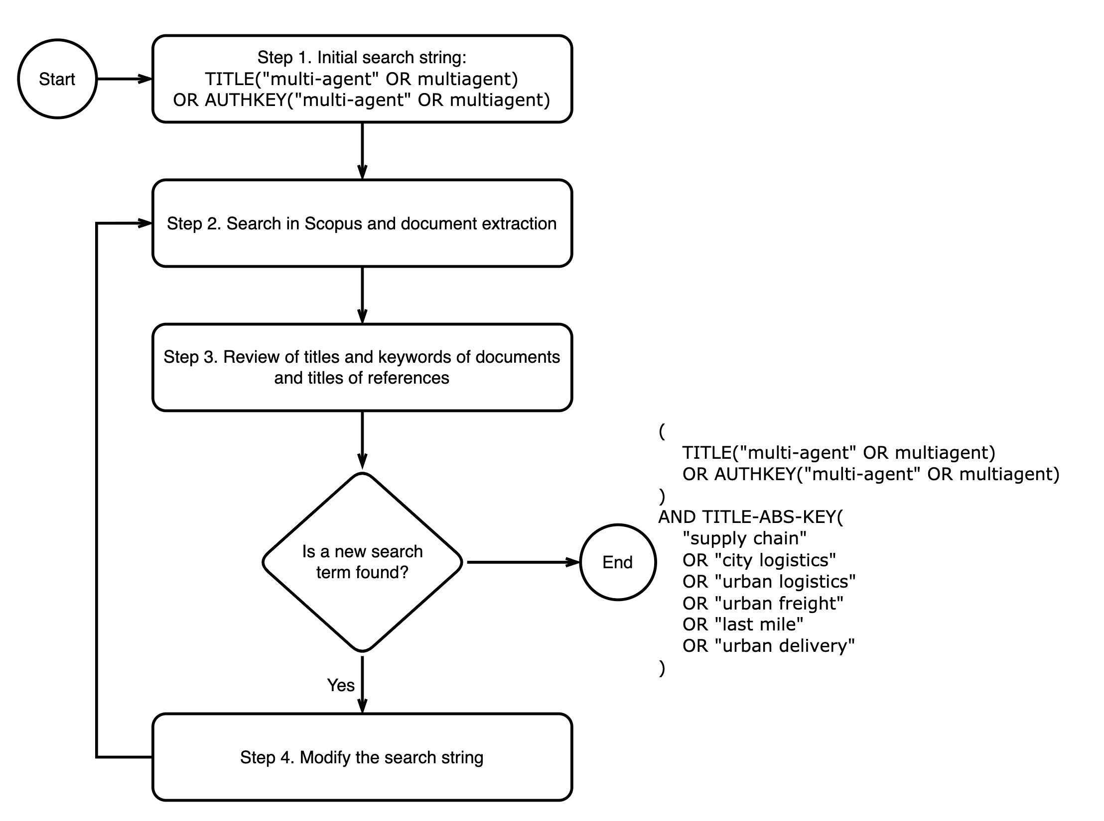

**Fig 1.** Search string design.

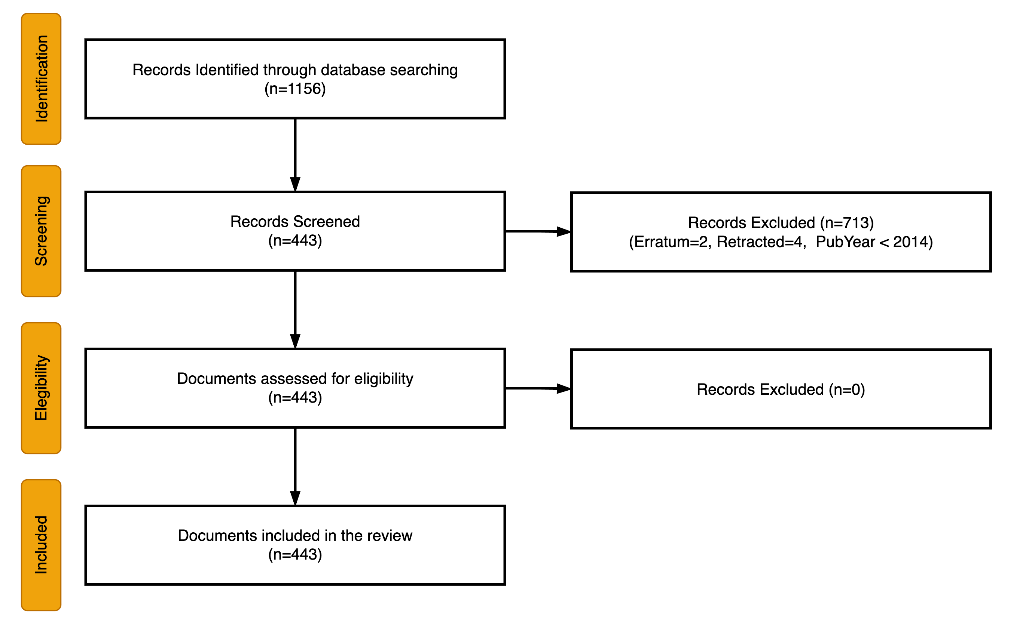

**Fig. 2.** The PRISMA flow chart.

## Data collection and preliminary preparation

The bibliographic data was sourced from Scopus in CSV format, with all available fields selected for download. The preparation of this data involved several steps to standardize the text strings, such as converting all text to uppercase, translating British English spellings into American English, removing diacritical marks, and harmonizing terminology. During the initial data preparation phase, noun phrases were extracted from the titles and abstracts of the articles. Subsequently, a new column named "descriptors" was created. This column integrates the author keywords, index keywords, and the extracted noun phrases, and it is intended to facilitate addressing the research questions.

## Data Analysis

The algorithm shown in Fig. 3 facilitated the identification of the main thematic clusters within the bibliographic database. As pointed out by Porter & Zhang (2012), clustering using a specific set of terms from a bibliographic database is fraught with complexities due to various linguistic variations. These include differences in British and American spellings, singular and plural forms, spelling mistakes, and inconsistent usage of hyphens, among others. While normalizing these linguistic discrepancies is relatively simple, addressing conceptually synonymous terms is more complex and often requires human involvement. This complexity increases with the size of the database, rendering it unfeasible to manually review each term used for clustering.

In this study, the approach depicted in **Fig. 3** combines text mining tools with manual efforts to tackle these challenges. It is important to note that achieving complete uniformity in terms is not crucial and becomes nearly impossible as the document base expands. The clustering algorithm prioritizes descriptors that exceed a certain occurrence threshold, since descriptors with low occurrence rates contribute minimally to the definition of the database’s dominant themes. Thus, the homogenization of low-frequency descriptors does not significantly affect the outcomes of the clustering algorithm. Moreover, organizing descriptors by cluster in a table simplifies the process for researchers to identify which descriptors need homogenization, compared to reviewing a comprehensive list of all terms.

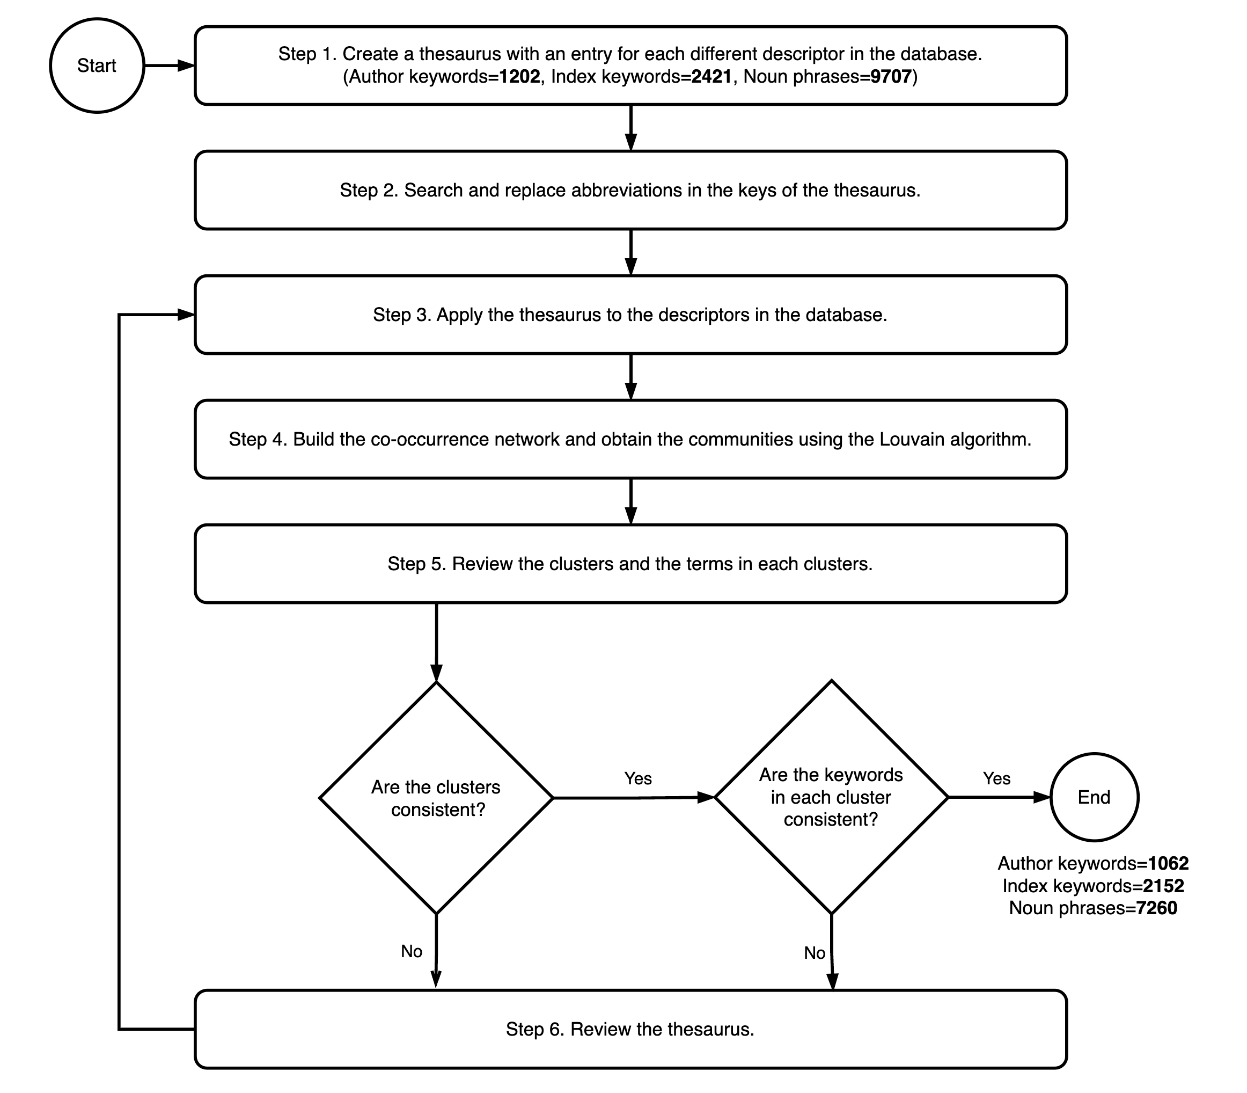

**Fig 3**. Used methodology to obtain the dominant themes from database descriptors.

The method outlined in **Fig. 3** begins with creating a thesaurus with all descriptors in the database. Descriptors are obtained as the union of the author and index keywords and the noun phrases extracted from titles and abstracts. This initial step has 1132 author keywords, 1155 index keywords, and 6754 noun phrases.

The second step consists of obtaining all the abbreviations present in the descriptors and their corresponding meanings, such as "PA" and "people analytics." In this same step, all abbreviations are replaced in the descriptors; for example, "PA tools" are replaced by "people analytics tools." This process obtained 1059 author keywords, 1101 index keywords, and 6336 noun phrases.

From step 3 ahead, an iterative process of computer-assisted manual refinement begins. The thesaurus is applied to the descriptors of each article, and then the clustering procedure is carried out using the Louvain community detection algorithm. The terms belonging to each cluster are reviewed, and the necessary changes are introduced to unify terms that represent conceptual synonyms. Note that clustering is only justified in this step because it facilitates the descriptor review process. We obtain 985 author keywords, 1049 index keywords, and 5790 noun phrases when the process converges.

# Results

## General Dataset Description

The dataset spans 2014 to 2024, containing 443 scientific publications with an annual growth rate of 23.62%. Most of these are either articles (218) or conference papers (183). The average document age is approximately five years, and each publication garners an average of 11.38 citations, translating to about 1.03 citations per year. A total of 1088 authors contributed to these works, with a level of international co-authorship at 22.59%. The involvement of 579 organizations from 57 different countries underscores the global collaboration in the field. The dataset contains 1202 raw author keywords, 2421 raw index keywords, and 9707 raw descriptors. The cleaning process reduces the these quantities to 1062, 2152 and 7260 respectively.

## Dominant Themes

**Table 3** displays the four themes identified using the method outlined in Figure 3. For these calculations, only descriptors that appeared seven times or more were included. This selection criterion covered 94.1% of the documents in the database.

**Table 3**

Dominant thematic clusters

Cluster Name Num Terms Percentage Main Descriptors

AI-driven Logistics 39 42.4 Decision Making; Intelligent Agents; Artificial Intelligence; Decision Support System; Information System; Cyber Physical Systems; Planning; Internet Of Things; Machine Learning; Embedded Systems

Reinforced Learning for Urban Logistics 16 17.4 Reinforcement Learning; Inventory Management; Learning Systems; Heuristics And Meta Heuristics; Vehicle Routing Problem; Computational Methods; Deep Learning; Vehicles; Deep Reinforcement Learning; Learning Algorithms

Efficient Supply Chain Optimization 15 16.3 Optimization; Scheduling; Competition; Production Control; Coordination; Genetic Algorithm; Integer Programming; Production Scheduling; Transportation; Mathematical Models

Sustainable Logistics Optimization 15 16.3 Sustainable Development; Bullwhip Effects; Game Theory; System Dynamics; Sustainability; Information Dissemination; Sharing Information; Uncertainty; Environmental Impact; Event Simulators

Demand-driven Negotiation Strategies 7 7.6 Negotiation Model; Demand; Negotiation; Negotiation Strategies; Negotiation Mechanisms; Negotiation Process; Project Management

# Discussion

This section presents a critical review of the dominant clusters founded in the most relevant literature published during the last ten years.

## Cluster 1:

## Cluster 2:

## Cluster 3: Efficient Supply Chain Optimization

## Cluster 4: Sustainable Logistics Optimization

## Cluster 5: Demand-driven Negotiation Strategies

# Conclusions

# References