John David Watts and Christopher Tillery
jdw0069 and cat0050
GID 01
9/23/2019
Lab1

Report

Lab 1.2 TCP Calculator

- For Lab1.2, we did successfully get our code to compile on the tux and mallard machines. In order to compile and execute our code, you must use the following steps. Assumptions will be made that you have an engineering account along with access to the tux and mallard machines. We also assume that you have moved the appropriate C files that you will be compiling and executing to its proper locations on these machines and that each command window you are using is connected to the same tux machine.

- Navigate to the working directory under which you have moved your files to compile and run. In the example below, we are connected to the tux machines using SSH connection and the command is as follows ‘ssh username@gate.eng.auburn.edu’. The directory where our files are located in this example is called ‘Networks’ and we can navigate to it using the following commands as shown below.

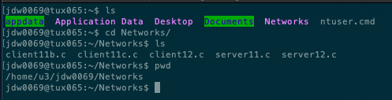

- Once we are in the directory where our files are stored, we can now compile and run them. Using the standard GCC compiler already installed on the tux machines, we can run the command ‘gcc -o fileToExecute filename.c’. The -o flag will build the output to an output file from the filename.c. In the example below we call this output file ‘serverExe’ and the file we are compiling is ‘server12.c’. You can see that the ‘serverExe’ file was created and is now colored green which indicates that it was a successful compilation this executable is now ready to be run.

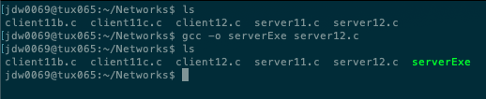

- To run this executable, we use the following command ‘./filename PortNumber’. For the server you must provide a port number onto which the client can connect to. In this example our filename is our ‘serverExe’ executable we just created from compiling ‘server12.c’ In this case we will use the port number 9898.

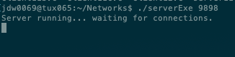

- We can see clearly from the previous run that our server code has compiled correctly and is now actively listening for incoming connections. In order to compile and run the client code, a very similar process is used. The only difference is that the client MUST PROVIDE a hostname and portnumber. In this case, the hostname is the tux machine ‘tux065’ (the one the server is also connected to) and the portnumber is 9898 (the portnumber the server is listening on). An example of compiling and running the client code is shown below with corresponding output.

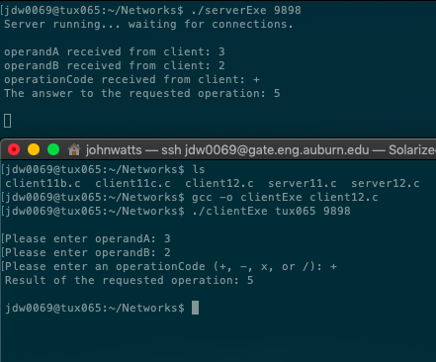

- In order to test the mallard to tux connection, be sure on the client side to use the hostname as ‘mallard’ instead of ‘tux…’. An example of this with the correct output is shown below.

