A Signal-Adaptive Ω Specification for Black-Litterman Portfolios with Machine-Learning Views
Abstract
We examine the construction of the Ω matrix in a Black-Litterman portfolio framework when investor views are generated from machine-learning and deep-learning forecasts. Existing data-driven applications of the Black-Litterman model often place primary emphasis on the expected-return view vector Q. By contrast, our analysis treats view uncertainty as a separate design choice. The proposed specification adjusts the diagonal elements of Ω using both a forecast-quality proxy and the strength of the forecast signal at each rebalancing date. Using 22 large-cap U.S. stocks over 2013-2026, we compare 13 forecasting models under a common walk-forward design. LightGBM- and LSTM-based Black-Litterman strategies achieve modest improvements in sample-average Sharpe ratios relative to the NoView benchmark. The ranking of models by directional accuracy, however, differs from the ranking by portfolio performance. These results indicate that forecast evaluation and portfolio evaluation should be treated as distinct steps when machine-learning forecasts are used as Black-Litterman views.
Keywords: Black-Litterman; Ω matrix; machine learning; portfolio optimization; forecast quality; signal strength

1. Introduction
Mean-variance optimization remains a natural starting point for portfolio choice, but its dependence on estimated expected returns is well known (Markowitz, 1952; Michaud, 1989; Best & Grauer, 1991). Small changes in expected-return inputs can produce large changes in optimal weights, often resulting in extreme allocations and weak out-of-sample performance. The problem is especially relevant when predictive signals are brought into portfolio construction, since the signal must be translated into portfolio weights without allowing estimation noise to dominate. The Black-Litterman model addresses this problem by combining market-implied equilibrium returns with investor views in a Bayesian updating framework (Black & Litterman, 1992; He & Litterman, 1999).
Investor views in the Black-Litterman framework are represented through a pick matrix P, a view vector Q, and a view-uncertainty matrix Ω. The view vector Q specifies the return implication of each view, while Ω controls the extent to which the view affects posterior expected returns. The mapping between confidence and Ω is therefore a central implementation issue (Idzorek, 2007; Meucci, 2008; Walters, 2014). For forecast-based views, the key question is not only what the model predicts, but how much weight the portfolio model should place on that prediction.
Prediction-based equity strategies and statistical arbitrage models have long used data-driven signals in portfolio construction (Avellaneda & Lee, 2010). More recent studies apply machine-learning and deep-learning methods to return prediction and portfolio formation (Krauss et al., 2017; Fischer & Krauss, 2018; Gu et al., 2020). Such forecasts provide a natural source of Black-Litterman views. Yet their reliability is unlikely to be constant across models, dates, or market environments. A fixed diagonal Ω, equal uncertainty across views, or a simple forecast-error rule may therefore understate the role of time-varying confidence in the view-generation process.
The paper focuses on this reliability channel. Rather than attempting to establish that one forecasting model persistently predicts equity returns, we ask how model-generated views should be scaled once they enter the Black-Litterman updating equation. We propose a signal-adaptive Ω specification in which view uncertainty depends on both historical forecast quality and the current magnitude of the forecast signal.
The contribution is fourfold. First, the analysis shifts attention from the construction of Q to the specification of Ω. Second, it provides an operational rule for assigning different uncertainty levels to views across models and rebalancing dates. Third, the empirical design compares 13 forecasting models under the same walk-forward protocol, allowing forecast accuracy and portfolio performance to be examined separately. Fourth, an auxiliary reinforcement-learning exercise evaluates whether dynamic model selection can complement the proposed Black-Litterman view specification.

2. Literature Review and Theoretical Background
2.1 Mean-Variance Optimization and Estimation Error
Markowitz's (1952) mean-variance framework chooses the portfolio that maximizes expected return for a given level of risk, or minimizes risk for a given expected return, using expected returns and a covariance matrix. Its practical limitation is the sensitivity of optimal weights to expected-return estimation error (Michaud, 1989; Best & Grauer, 1991). Because small input differences can lead to sharply different allocations, empirical implementations often face unstable weights and high turnover.
Several approaches have been developed to reduce this sensitivity, including shrinkage, robust optimization, the 1/N portfolio, and Bayesian estimation of expected returns (Jorion, 1986; Ledoit & Wolf, 2004; DeMiguel et al., 2009; Kan & Zhou, 2007). The Black-Litterman model belongs to this broader line of work: it starts from market-implied equilibrium returns and then updates those returns using investor views (Black & Litterman, 1992).
2.2 The Black-Litterman Model and the Ω Matrix
The Black-Litterman model combines market-implied equilibrium returns with investor views to obtain posterior expected returns (Black & Litterman, 1992; He & Litterman, 1999). The market-implied equilibrium return is computed as:
In this expression, π denotes the market-implied equilibrium expected return, δ is the risk-aversion coefficient, Σ is the asset-return covariance matrix, and wʳᵉᶠ is the reference market weight within the investment universe. The empirical implementation uses reference market weights within the selected universe to compute π.
Investor views are expressed as follows.
Here, P identifies the assets or asset combinations to which the views apply, Q is the vector of views, and Ω is the covariance matrix of view errors. Lower values of Ω increase the influence of the corresponding view on posterior expected returns; higher values leave the posterior closer to the market-equilibrium prior.

The posterior expected return in the Black-Litterman model is given by the following expression.
Here, τ scales prior uncertainty. Equation (3) shows that Ω determines the strength with which views enter posterior expected returns. A machine-learning forecast cannot therefore be treated simply as a value to place in Q. Its reliability must also be encoded in Ω (Idzorek, 2007; Meucci, 2008; Satchell & Scowcroft, 2000; Walters, 2014).
2.3 Machine-Learning-Based Investor View Generation
Machine-learning and deep-learning models are widely used in return prediction because they can capture nonlinearities, variable interactions, and temporal patterns (Breiman, 2001; Friedman, 2001; Hastie et al., 2009; Gu et al., 2020). Tree ensembles and boosting methods are well suited to nonlinear cross-sectional structure (Chen & Guestrin, 2016; Ke et al., 2017; Prokhorenkova et al., 2018), while LSTM and Transformer-based models are commonly used for sequential dependence in time-series data (Hochreiter & Schmidhuber, 1997; LeCun et al., 2015; Vaswani et al., 2017; Fischer & Krauss, 2018). In the empirical analysis below, the forecasting target is the raw return over the next five trading days, and all model families are evaluated under the same walk-forward structure.
The objective is not to declare a single best forecasting model. In financial applications, a model with high directional accuracy or low forecast error need not produce the best portfolio. Performance depends on the direction and magnitude of the signal, the selected assets, the covariance matrix, optimization constraints, and the rebalancing rule. Comparisons across many candidate models also raise concerns about data snooping and backtest overfitting (White, 2000; Bailey et al., 2017; Harvey et al., 2016). For these reasons, forecast performance and portfolio performance are analyzed separately.
2.4 Positioning of This Study
The paper is positioned within machine-learning applications of the Black-Litterman model, but it emphasizes Ω rather than Q. The proposed specification assigns different uncertainty levels across models and dates by combining a forecast-quality proxy with forecast signal strength. This treatment differs from fixed-Ω or simple forecast-error specifications and is related to the active-management literature's focus on rank forecasting ability and the information coefficient (Grinold, 1989; Grinold & Kahn, 2000).

3. Research Design
3.1 Data and Investment Universe
The sample consists of 22 large-cap U.S. stocks observed from 2013 to 2026 using Yahoo Finance-based data. The investment universe comprises AAPL, AMZN, BRK-B, CAT, COST, CVX, EQIX, GE, GOOGL, JPM, LIN, LLY, META, NEE, NVDA, PLD, SHW, SO, TSLA, UNH, WMT, and XOM. The prediction target is the five-day forward raw return. The predictor set includes price and return variables, technical indicators, and macro-market variables such as VIX, MOVE, HY OAS, the 10-year minus 2-year Treasury yield spread, and the U.S. Dollar Index.
Table 1. Summary of Data and Experimental Design
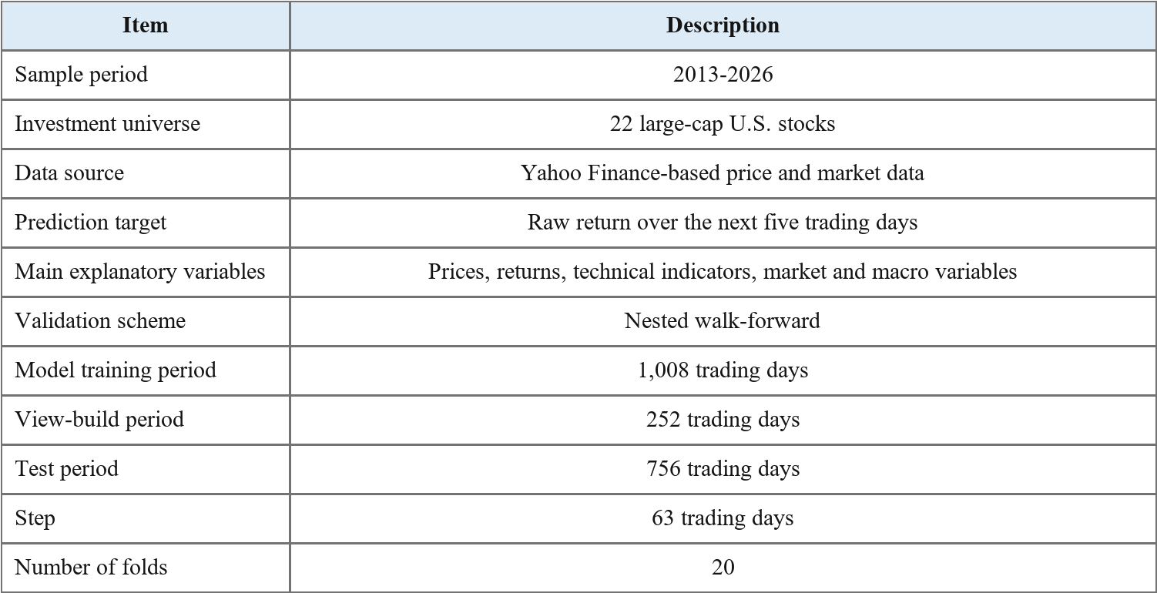
3.2 Walk-Forward Validation Design
A walk-forward validation scheme is used to limit look-ahead bias in the time-series setting. Each fold is split into a model-training period, a view-build period, and a test period. Forecasting models are estimated on the training period. The view-build period is then used to calculate the forecast-quality proxy and to train the reinforcement-learning auxiliary module. Portfolio performance is evaluated only on the test period.
3.3 Forecasting Models
The model set contains 13 forecasting models covering linear methods, tree-based models, ensemble and boosting methods, and neural time-series models. Ridge and Lasso serve as regularized linear benchmarks (Hoerl & Kennard, 1970; Tibshirani, 1996). Random Forest and boosting models are included to capture nonlinearities and interactions (Breiman, 2001; Friedman, 2001; Chen & Guestrin, 2016). LSTM, CNN1D, Transformer, and PatchTST-type models provide deep-learning benchmarks for sequential financial data (Hochreiter & Schmidhuber, 1997; Vaswani et al., 2017; Nie et al., 2023).
Table 2. Forecasting Model Set
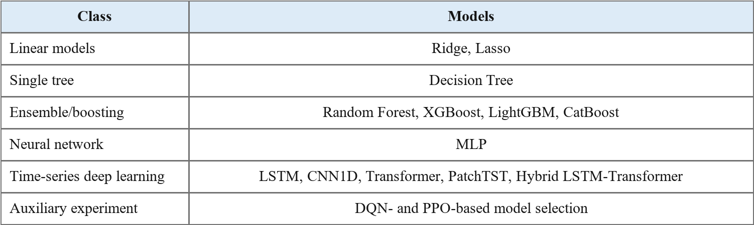
3.4 Prediction Target and Investor View Construction
The prediction target is the following raw return over the next five trading days.
Each forecasting model m generates the following forecast for asset i at time t.
In the baseline experiment, investor views are constructed as absolute views on the top K=3 assets with the highest predicted returns.

For each selected asset iⱼ ∈ Sₘ,ₜ, the view vector and pick matrix are constructed as follows.
Here, |ŷᵢ,ₜ⁽ᵐ⁾| is used not as the criterion for selecting views, but as a signal-strength variable that adjusts the diagonal elements of Ω.
3.5 Forecast-Quality Proxy and Signal-Adaptive Ω
Forecast quality is measured by a Rank IC-based proxy computed over the view-build period. Rank IC is the Spearman rank correlation between predicted-return rankings and realized-return rankings. This measure is appropriate for portfolio selection because the relative ordering of assets can matter as much as the level of the return forecast (Grinold, 1989; Grinold & Kahn, 2000).
The quality proxy uses only forecast-realization rank information from the view-build period. Test-period portfolio performance is not used when the proxy is constructed.
Here, IC̃ₘ denotes the view-build-period forecast-quality proxy for model m, and κₘᵢₙ is a lower bound used to reduce instability caused by excessively small values.
The signal-adaptive Ω is specified as a diagonal matrix. The diagonal structure avoids the sample instability that can arise when view-error covariances are estimated directly, and it keeps the analysis focused on the effect of model-specific reliability adjustment.
The term $u_{i_{j},t}^{\left(m\right)}$represents the baseline view-uncertainty component. It is measured as the standard deviation of the five-day forecast errors of model $m$ over the view-build period. This design separates the model’s historical error variability from the current magnitude of the forecast signal. The parameter λ controls scale, while α and β govern the sensitivity of Ω to forecast quality and signal strength. Higher forecast quality or a stronger absolute forecast signal reduces ω and increases the posterior influence of the corresponding view. The specification is related to confidence calibration in Black-Litterman implementations (Idzorek, 2007; Meucci, 2008), but confidence is inferred from forecasting information rather than imposed as a subjective input.

Table 3. Main Methodological Settings
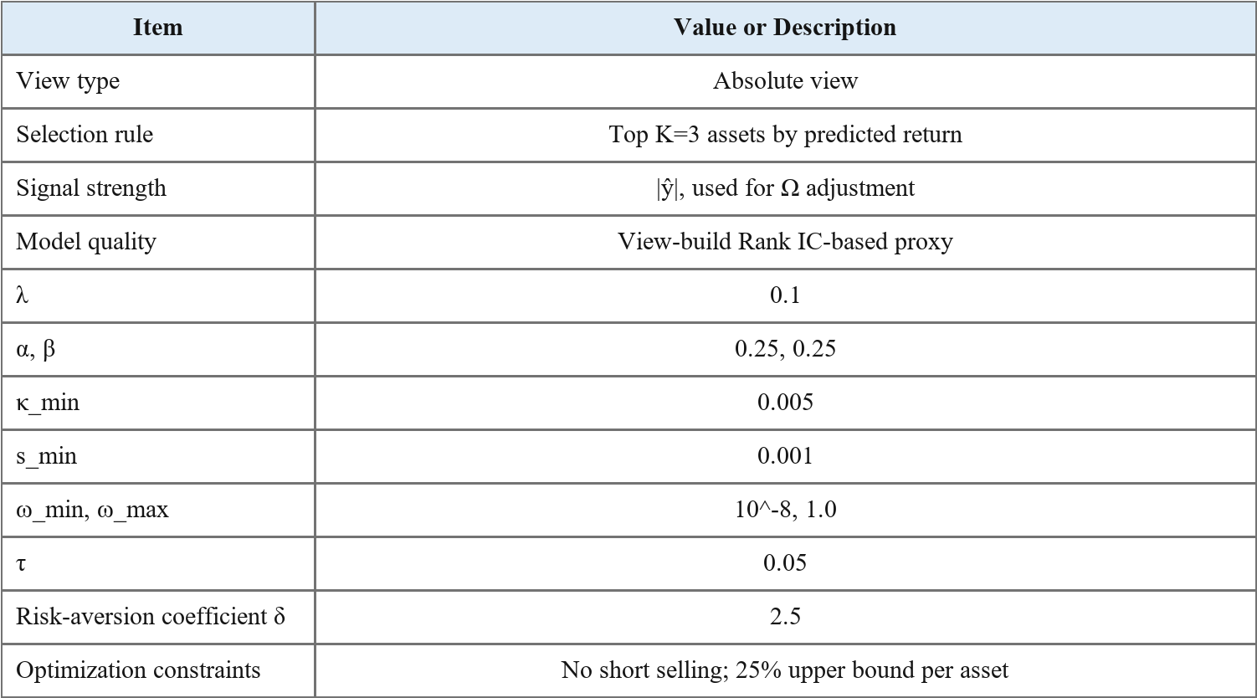

3.6 Portfolio Optimization
After posterior expected returns are obtained, portfolios are formed by maximizing the Sharpe ratio subject to no-short-selling constraints. The Sharpe ratio is a standard performance measure, but it is also sensitive to estimation error and sample dependence (Lo, 2002).
Performance measures are calculated before transaction costs.
3.7 Reinforcement-Learning-Based Auxiliary Model Selection Experiment
As an auxiliary analysis, we also evaluate DQN- and PPO-based model selection. Reinforcement learning has been applied to portfolio management and trading-strategy design (Moody & Saffell, 2001; Jiang et al., 2017; Liu et al., 2020). Here, however, the reinforcement-learning agent does not choose portfolio weights directly. It selects which forecasting model should generate the Black-Litterman view at each rebalancing date.
The model selector is defined as a meta-policy over the 13 candidate forecasting models. At each rebalancing date, the state vector concatenates the raw model forecasts, z-score-normalized forecasts across models, and the cross-model mean and standard deviation. With M candidate models, the state dimension is 2M+2, and the action space consists of M discrete model-selection actions.
Two reward definitions are considered. The prediction reward is the negative absolute forecast error of the selected model. The portfolio reward is the EMA-Sharpe ratio of the Black-Litterman portfolio formed from the selected model's views. These definitions yield four auxiliary strategies: DQN_Pred, DQN_Port, PPO_Pred, and PPO_Port.
The DQN selector estimates state-action Q-values and chooses the forecasting model with the highest value (Mnih et al., 2015). It uses an MLP with hidden layers (128, 64), ReLU activations, ε-greedy exploration, experience replay, and a target network. The PPO selector instead learns a policy over model choices (Schulman et al., 2017) using an Actor-Critic architecture and clipped policy updates.
This reinforcement-learning exercise is intended to complement, rather than replace, the proposed Ω specification. It is included to examine whether the model-selection rule can vary across rebalancing dates. Network architectures and training hyperparameters are reported in Appendix A.
4. Empirical Results
4.1 Directional Accuracy of Forecasting Models
Table 4 reports directional accuracy by forecasting model. All models exceed 0.5, although the cross-model differences are modest. The forecasts therefore contain some directional information, but the investment value of that information must be assessed through the portfolio results.
Table 4. Directional Accuracy by Forecasting Model
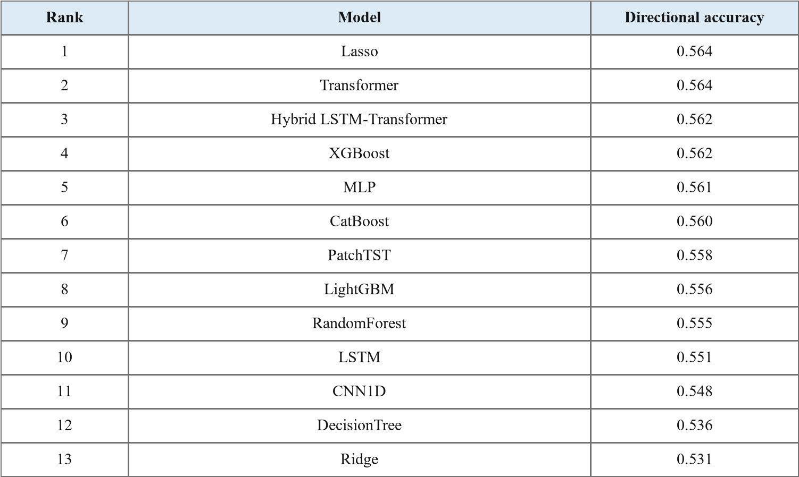

Lasso and Transformer rank relatively high on directional accuracy. In contrast, the portfolio results below favor the LightGBM- and LSTM-based Black-Litterman strategies. Forecast accuracy and portfolio performance therefore do not produce the same ordering of models.
4.2 Black-Litterman Portfolio Performance
Table 5 reports the performance of the main Black-Litterman strategies. BL_NoView, which does not use investor views, is the benchmark. On average, BL_LightGBM and BL_LSTM achieve slightly higher Sharpe ratios than BL_NoView. Total return is the cumulative return over the evaluation period, maximum drawdown is reported as a negative value, and the Sharpe win rate is the share of folds in which the strategy outperforms BL_NoView in terms of the Sharpe ratio.
Table 5. Portfolio Performance by Black-Litterman Strategy
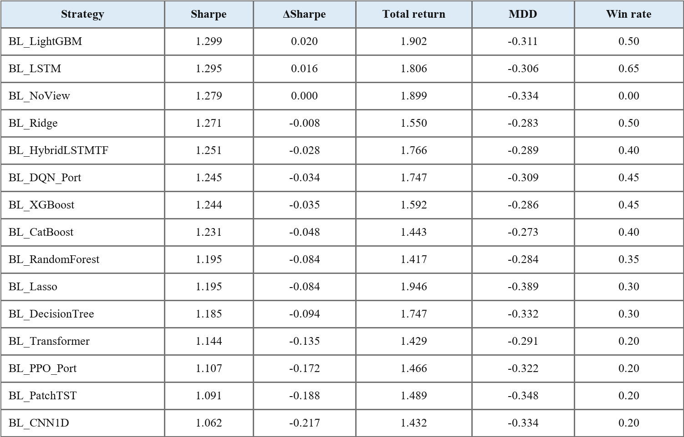

BL_LightGBM records the highest Sharpe ratio, exceeding BL_NoView by about 0.020. Although the improvement is economically modest, it suggests that reliability-adjusted views can contribute to risk-adjusted performance. Notably, LightGBM is not among the highest-ranked models by directional accuracy, yet it performs best once its views are passed through the Black-Litterman allocation step.
4.3 Results of the Reinforcement-Learning Auxiliary Experiment
The reinforcement-learning model-selection strategies do not outperform BL_NoView in terms of the Sharpe ratio. BL_DQN_Port has an average Sharpe ratio of 1.245, compared with 1.279 for BL_NoView. Its maximum drawdown, however, improves from -0.334 to -0.309, a reduction of roughly 7.5%.

Table 6. Comparison of Reinforcement-Learning Auxiliary Strategies and NoView
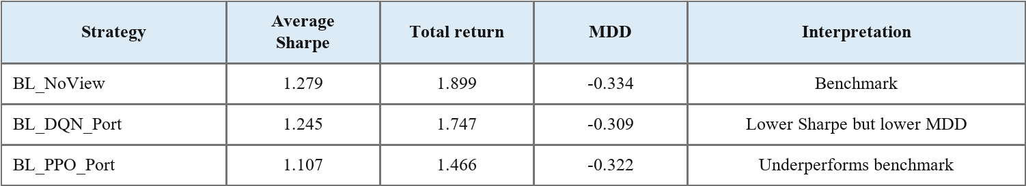

The auxiliary reinforcement-learning results are therefore mixed. They do not improve the Sharpe ratio, but the DQN-based portfolio reward reduces maximum drawdown. This pattern is consistent with the view that reinforcement learning may be more useful as a dynamic risk-management or model-selection layer than as a stand-alone tool for improving returns in this setting (Jiang et al., 2017; Liu et al., 2020).
4.4 Relationship Between Forecast Performance and Portfolio Performance
Tables 4 and 5 show a clear disconnect between directional accuracy and portfolio Sharpe rankings. Lasso, for instance, belongs to the top group by directional accuracy but underperforms the benchmark in portfolio Sharpe ratio. LightGBM shows the opposite pattern: its directional-accuracy rank is middle of the pack, but its Black-Litterman portfolio has the highest Sharpe ratio.
The discrepancy reflects the fact that portfolio performance depends on more than sign prediction. Signal magnitude, asset covariance, view-confidence scaling through Ω, and optimization constraints all affect the final allocation. Forecast evaluation and investment evaluation should therefore be separated when machine-learning forecasts are used in portfolio construction. Rank forecasting ability remains relevant through the information coefficient channel (Grinold, 1989), but economic performance also depends on transaction costs and rebalancing constraints.
5. Discussion and Conclusion
The empirical findings lead to four observations.
First, the key issue in using machine-learning forecasts as investor views is not the forecast alone but its reliability inside the portfolio model. Since Ω controls the influence of views on posterior expected returns (Black & Litterman, 1992; Idzorek, 2007), scaling Ω by forecast quality and signal strength becomes a central methodological choice. The proposed signal-adaptive specification avoids treating all model forecasts as equally reliable and instead gives stronger posterior weight to views supported by better historical rank performance and stronger current signals.
Second, forecast accuracy and portfolio performance should not be conflated. Directional accuracy measures whether individual assets move in the predicted direction, whereas portfolio performance depends on how the signals interact with weights, covariances, constraints, and the view-uncertainty specification. A model can therefore look attractive as a forecasting device without producing the strongest portfolio.
Third, the reinforcement-learning exercise points to a possible risk-management role. The DQN-based selector does not raise the Sharpe ratio, but it lowers maximum drawdown. This result is secondary to the main Ω specification, yet it suggests that dynamic model selection may be worth exploring when the objective is downside-risk control rather than pure Sharpe improvement.
Fourth, the specification has a practical interpretation. A large predicted return should not automatically translate into a high-confidence view. If a model has weak recent forecast quality or produces only a weak signal, a larger Ω keeps the posterior closer to the prior. When forecast quality and signal strength are both high, the view receives more weight. This rule links the Bayesian prior-view structure of Black-Litterman with the empirical reliability of machine-learning forecasts.
5.1 Summary
We study the design of the Ω matrix for Black-Litterman portfolios whose investor views are generated by machine-learning and deep-learning models. The proposed signal-adaptive specification combines a forecast-quality proxy with signal strength to assign different uncertainty levels to different views. The empirical analysis covers 22 large-cap U.S. stocks from 2013 to 2026 and compares 13 forecasting models under a common walk-forward design.
LightGBM- and LSTM-based Black-Litterman strategies achieve higher sample-average Sharpe ratios than BL_NoView. The LightGBM strategy is especially informative: it is not a top-ranked model by directional accuracy, but it has the highest portfolio Sharpe ratio. The result reinforces the distinction between forecast accuracy and portfolio performance and highlights the role of reliability and signal-strength scaling in the allocation step.
The main contribution is to make Ω, rather than only Q, an explicit object of design in machine-learning applications of Black-Litterman. By linking view uncertainty to forecast quality and current signal strength, the framework provides a transparent bridge between return forecasts and portfolio optimization. For practitioners, the results favor a reliability-adjusted use of model outputs over a direct translation of raw forecasts into portfolio positions.
5.2 Limitations and Future Research
Several extensions are natural.
First, the same Ω specification can be evaluated in markets and asset classes beyond large-cap U.S. equities.
Second, regime-level tests could examine whether signal strength and Ω scaling behave differently in rising markets, drawdown periods, and high-volatility states.
Third, explicit transaction costs and turnover constraints would allow the economic value of the strategies to be assessed more directly. For forecast-based trading rules, after-cost performance is the relevant benchmark (Fischer & Krauss, 2018).
Fourth, the reinforcement-learning selector could be extended with alternative reward functions, richer state variables, and model-selection rules targeted specifically at downside-risk control.
Fifth, a more detailed decomposition of the link between forecast-quality measures and portfolio performance would help identify when forecast accuracy is converted into investment value.

Appendix A. Detailed Settings of the Reinforcement-Learning Auxiliary Module
A.1 Common Structure of the Reinforcement-Learning Model Selector
The reinforcement-learning selector is a meta-selector over forecasting models rather than a direct portfolio optimizer. At each rebalancing date t, the agent observes a state built from candidate-model forecasts, chooses one model as its action, and receives a reward based on the selected model's prediction or the portfolio formed from that prediction.
For each date-stock pair, the state vector collects the forecasts of M candidate models. It concatenates raw forecasts, z-score-normalized forecasts across models, and the cross-model mean and standard deviation. The state dimension is therefore 2M+2. The action set is A = {1, 2, ..., M}, where each action corresponds to one candidate model.
Two reward specifications are used. The prediction reward (_pred) is r = -|ŷ-y|, so more accurate forecasts receive larger rewards. The portfolio reward (_port) is the EMA-Sharpe ratio of the Black-Litterman portfolio formed from the selected model's views, so the reward is tied directly to risk-adjusted portfolio performance.
A.2 DQN-Based Model Selector
DQN (Deep Q-Network) is a value-based reinforcement-learning method that approximates the state-action value function with a neural network (Mnih et al., 2015). The DQN selector takes the state vector sₜ as input and outputs Q-values Q(sₜ, a; θ) for the M candidate actions. The Q-network is an MLP with hidden layers (128, 64) and ReLU activations.
Actions are chosen using an ε-greedy policy. A random action is selected with probability ε, while the highest-Q action is selected with probability 1-ε. The exploration rate starts at 1.0 and decays by 0.995 after each episode until it reaches 0.05. Learning stability is improved through an experience replay buffer of size 50,000, mini-batches of 128 observations, and a target network updated every 200 steps.
The Q-network minimizes a temporal-difference loss based on the Bellman equation. Smooth L1 Loss is used, with discount factor γ = 0.95, learning rate 10⁻³, and gradient clipping at max norm 5.0. At inference, the model with the highest predicted Q-value is selected.
A.3 PPO-Based Model Selector
PPO (Proximal Policy Optimization) is a policy-based reinforcement-learning method that optimizes the policy π(a|s; θ) directly rather than estimating Q-values (Schulman et al., 2017). Unlike DQN, PPO outputs a probability distribution over actions and samples from that distribution during training.
The PPO selector uses an Actor-Critic architecture. The Actor maps the state to a probability distribution over the M forecasting models, while the Critic estimates V(s; ϕ). The two networks share hidden layers (256, 256), followed by separate output layers for action probabilities and the scalar value estimate.
PPO controls policy updates through clipping. The policy ratio rₜ(θ) = πθ(aₜ|sₜ) / πθold(aₜ|sₜ) is clipped to [1-ε, 1+ε], limiting the size of each update. The clipping coefficient is ε = 0.2. The advantage function is estimated with Generalized Advantage Estimation, using γ = 0.9 and λ = 0.95.
The loss combines policy loss, value-function loss, and an entropy bonus. The value-loss coefficient is 0.5, the entropy coefficient is 0.01, the learning rate is 3×10⁻⁴, and four mini-batch updates are performed per episode. At inference, the action with the highest Actor probability is chosen.
A.4 Comparison Between DQN and PPO
DQN and PPO approach the same model-selection problem differently. DQN estimates action values and selects the highest-value model, whereas PPO learns a stochastic policy over model choices. DQN can be data-efficient because of experience replay, but it is less naturally suited to continuous action spaces. PPO provides more stable policy updates through clipping and extends more naturally to continuous actions. We apply both the prediction reward (_pred) and the portfolio reward (_port), yielding DQN_Pred, DQN_Port, PPO_Pred, and PPO_Port.

References
Avellaneda, M., & Lee, J. H. (2010). Statistical arbitrage in the U.S. equities market. Quantitative Finance, 10(7), 761-782.
Bailey, D. H., Borwein, J. M., Lopez de Prado, M., & Zhu, Q. J. (2017). The probability of backtest overfitting. Journal of Computational Finance, 20(4), 39-69. https://doi.org/10.21314/JCF.2016.322
Best, M. J., & Grauer, R. R. (1991). On the sensitivity of mean-variance-efficient portfolios to changes in asset means. The Review of Financial Studies, 4(2), 315-342.
Black, F., & Litterman, R. (1992). Global portfolio optimization. Financial Analysts Journal, 48(5), 28-43.
Breiman, L. (2001). Random forests. Machine Learning, 45, 5-32.
Chen, T., & Guestrin, C. (2016). XGBoost: A scalable tree boosting system. Proceedings of the 22nd ACM SIGKDD International Conference on Knowledge Discovery and Data Mining, 785-794. https://doi.org/10.1145/2939672.2939785
DeMiguel, V., Garlappi, L., & Uppal, R. (2009). Optimal versus naive diversification: How inefficient is the 1/N portfolio strategy? The Review of Financial Studies, 22(5), 1915-1953.
Fama, E. F. (1970). Efficient capital markets: A review of theory and empirical work. The Journal of Finance, 25(2), 383-417.
Fischer, T., & Krauss, C. (2018). Deep learning with long short-term memory networks for financial market predictions. European Journal of Operational Research, 270(2), 654-669.
Friedman, J. H. (2001). Greedy function approximation: A gradient boosting machine. The Annals of Statistics, 29(5), 1189-1232.
Grinold, R. C. (1989). The fundamental law of active management. The Journal of Portfolio Management, 15(3), 30-37.
Grinold, R. C., & Kahn, R. N. (2000). Active Portfolio Management: A Quantitative Approach for Producing Superior Returns and Controlling Risk (2nd ed.). McGraw-Hill.
Gu, S., Kelly, B., & Xiu, D. (2020). Empirical asset pricing via machine learning. The Review of Financial Studies, 33(5), 2223-2273.
Harvey, C. R., Liu, Y., & Zhu, H. (2016). ... and the cross-section of expected returns. The Review of Financial Studies, 29(1), 5-68.
Hastie, T., Tibshirani, R., & Friedman, J. (2009). The Elements of Statistical Learning: Data Mining, Inference, and Prediction (2nd ed.). Springer.
He, G., & Litterman, R. (1999). The intuition behind Black-Litterman model portfolios. Goldman Sachs Asset Management, Quantitative Strategy Group. SSRN: https://ssrn.com/abstract=334304
Hochreiter, S., & Schmidhuber, J. (1997). Long short-term memory. Neural Computation, 9(8), 1735-1780.
Hoerl, A. E., & Kennard, R. W. (1970). Ridge regression: Biased estimation for nonorthogonal problems. Technometrics, 12(1), 55-67.
Idzorek, T. M. (2007). A step-by-step guide to the Black-Litterman model: Incorporating user-specified confidence levels. In S. Satchell (Ed.), Forecasting Expected Returns in the Financial Markets (pp. 17-38). Elsevier/Academic Press.
Jiang, Z., Xu, D., & Liang, J. (2017). A deep reinforcement learning framework for the financial portfolio management problem. arXiv preprint arXiv:1706.10059.
Jorion, P. (1986). Bayes-Stein estimation for portfolio analysis. Journal of Financial and Quantitative Analysis, 21(3), 279-292.
Kan, R., & Zhou, G. (2007). Optimal portfolio choice with parameter uncertainty. Journal of Financial and Quantitative Analysis, 42(3), 621-656.
Ke, G., Meng, Q., Finley, T., Wang, T., Chen, W., Ma, W., Ye, Q., & Liu, T.-Y. (2017). LightGBM: A highly efficient gradient boosting decision tree. Advances in Neural Information Processing Systems, 30, 3146-3154.
Krauss, C., Do, X. A., & Huck, N. (2017). Deep neural networks, gradient-boosted trees, random forests: Statistical arbitrage on the S&P 500. European Journal of Operational Research, 259(2), 689-702.
LeCun, Y., Bengio, Y., & Hinton, G. (2015). Deep learning. Nature, 521, 436-444.
Ledoit, O., & Wolf, M. (2004). A well-conditioned estimator for large-dimensional covariance matrices. Journal of Multivariate Analysis, 88(2), 365-411.
Liu, X.-Y., Yang, H., Chen, Q., Zhang, R., Yang, L., Xiao, B., & Wang, C. D. (2020). FinRL: A deep reinforcement learning library for automated stock trading in quantitative finance. arXiv preprint arXiv:2011.09607.
Lo, A. W. (2002). The statistics of Sharpe ratios. Financial Analysts Journal, 58(4), 36-52.
Markowitz, H. (1952). Portfolio selection. The Journal of Finance, 7(1), 77-91.
Meucci, A. (2008). The Black-Litterman approach: Original model and extensions. SSRN Working Paper. https://doi.org/10.2139/ssrn.1117574
Michaud, R. O. (1989). The Markowitz optimization enigma: Is optimized optimal? Financial Analysts Journal, 45(1), 31-42.
Mnih, V., Kavukcuoglu, K., Silver, D., Rusu, A. A., Veness, J., Bellemare, M. G., Graves, A., Riedmiller, M., Fidjeland, A. K., Ostrovski, G., Petersen, S., Beattie, C., Sadik, A., Antonoglou, I., King, H., Kumaran, D., Wierstra, D., Legg, S., & Hassabis, D. (2015). Human-level control through deep reinforcement learning. Nature, 518, 529-533. https://doi.org/10.1038/nature14236
Moody, J., & Saffell, M. (2001). Learning to trade via direct reinforcement. IEEE Transactions on Neural Networks, 12(4), 875-889.
Nie, Y., Nguyen, N. H., Sinthong, P., & Kalagnanam, J. (2023). A time series is worth 64 words: Long-term forecasting with transformers. International Conference on Learning Representations. https://openreview.net/forum?id=Jbdc0vTOcol
Prokhorenkova, L., Gusev, G., Vorobev, A., Dorogush, A. V., & Gulin, A. (2018). CatBoost: Unbiased boosting with categorical features. Advances in Neural Information Processing Systems, 31, 6639-6649.
Satchell, S., & Scowcroft, A. (2000). A demystification of the Black-Litterman model: Managing quantitative and traditional portfolio construction. Journal of Asset Management, 1(2), 138-150. https://doi.org/10.1057/palgrave.jam.2240011
Schulman, J., Wolski, F., Dhariwal, P., Radford, A., & Klimov, O. (2017). Proximal policy optimization algorithms. arXiv preprint arXiv:1707.06347.
Tibshirani, R. (1996). Regression shrinkage and selection via the Lasso. Journal of the Royal Statistical Society: Series B, 58(1), 267-288.
Vaswani, A., Shazeer, N., Parmar, N., Uszkoreit, J., Jones, L., Gomez, A. N., Kaiser, L., & Polosukhin, I. (2017). Attention is all you need. Advances in Neural Information Processing Systems, 30, 5998-6008.
Walters, J. (2014). The Black-Litterman model in detail. SSRN Working Paper. https://doi.org/10.2139/ssrn.1314585
White, H. (2000). A reality check for data snooping. Econometrica, 68(5), 1097-1126.

