The Geography of Happiness: Mapping the Hidden Drivers of Quality of Life

Executive Summary

Research Overview
This report explores what makes people happy across different levels - from individuals to entire regions. Using a comprehensive dataset from 2005 to 2024, we go beyond simple measures like GDP to map where happiness comes from around the world. We examine how social connections, trust in institutions, and personal freedom work together to shape quality of life.

Statistical Framework & Key Findings
We used six different statistical methods to understand what drives well-being:
- Regional Differences: Simple comparisons showed clear gaps in happiness between different parts of the world, with Western Europe and Sub-Saharan Africa showing opposite ends of the spectrum.
- Economic vs. Social Factors: When we looked deeper, we found that while money matters more in poorer countries, social support is a stronger predictor of happiness everywhere.
- The Role of Choice: We discovered that having freedom to make life decisions acts as a bridge - it explains how financial stability leads to personal fulfillment.
- The Power of Place: Multilevel modeling showed that where you live matters significantly - about 24% of your happiness comes from your national and regional environment, not just your personal situation.
- Underlying Patterns: Factor analysis revealed that trust and generosity aren't separate traits, but part of one bigger foundation of societal health.
Policy Recommendations
Our findings suggest a shift toward "Well-being Budgeting." Policymakers should invest more in social programs that build community trust and expand personal freedoms, as these factors create a more stable foundation for happiness than just focusing on economic growth.

Introduction
What makes us "well"? In social science, well-being is a complex puzzle found where personal psychology, national economics, and regional geography meet. While classical theories often define success by a country’s Gross Domestic Product (GDP), modern research suggests that "Quality of Life" is a nested experience. It is shaped as much by our individual education and social circles as it is by the economic stability of the nation we call home.
This paper unpacks the drivers of well-being through a multi-level statistical portfolio organized into six analytical "batches". By leveraging three primary datasets—the General Social Survey (GSS) for individual insights, the World Development Indicators (WDI) for national health, and the OECD Better Life Index for social dimensions—this research moves from the "micro" to the "macro".
Our journey begins with the individual, examining how gender and education shape the "American Dream" (Batches 1 & 2). We then shift to a global scale to see how national wealth predicts life expectancy (Batch 3) and whether income acts as the functional bridge between a degree and a person's happiness (Batch 4). Finally, we explore how geographic regions dictate life satisfaction (Batch 5) and synthesize these various threads into a single, latent construct: Quality of Life (Batch 6).

The Analytical Roadmap
To map out the "hidden drivers" of happiness, this investigation moves through six progressive stages of analysis:
- Individual Perceptions (Batches 1 & 2): We first examine how gender and education influence personal optimism regarding the "American Dream."
- National Predictors (Batch 3): We shift to a global scale to see how national wealth and health spending predict objective outcomes like life expectancy.
- Mechanisms of Influence (Batch 4): We test a Mediation Model to ask a functional question: Does education improve happiness directly, or does it work primarily by increasing financial security?
- Hierarchical Context (Batch 5): Using Multilevel Modeling (MLM), we account for geography, assessing how much of a person's satisfaction is dictated by their broad world region versus their local social support.
- Latent Structures (Batch 6): Finally, we use Exploratory Factor Analysis (EFA) to determine if housing, jobs, and social support fuse into a single underlying engine of "Quality of Life."

The Significance of This Approach
In an era of global volatility, understanding the "hidden structures" of well-being is more critical than ever. This paper argues that quality of life is not a single, isolated metric; it is a synergistic system. By moving beyond simple correlations to embrace mediation and hierarchical modeling, this research demonstrates that social capital and community support are just as vital to a nation's longevity as pure economic growth. Ultimately, this data-driven narrative aims to inform both individual career choices and national policy, defining the true pillars of a flourishing society.
Note: The links to all databases, diagrams, and code may be found in Appendix A.
Note: All R code may be found in Appendix B. The title of each section is noted at the beginning of the R code for that section.

Preliminaries
Before conducting the analyses for Batches 1 and 2, we performed a multi-step cleaning protocol in R to ensure "data hygiene." This process ensures that the statistical results are not skewed by non-substantive responses.

Data Source: The General Social Survey (GSS)
The General Social Survey (GSS) (Davern, M et al, 2024) serves as the foundational tool for sociological research in the United States. Since 1972, the GSS has used a probability-based, nationally representative sample of the U.S. adult population to capture trends in attitudes and behaviors. For this analysis, we utilize a cross-sectional subset that links personal demographics—such as sex, age, and education—to subjective well-being and economic optimism.
Environment and Library Setup: We utilize the tidyverse and dplyr ecosystems for data manipulation and the haven or csv utilities for data ingestion.
Handling Missingness and Response Bias: A critical step in GSS analysis is filtering out "non-substantive" codes. In the raw data, responses like "Don't Know" or "Refused" are often coded as high integers (e.g., 8 or 9). If left uncleaned, these would be treated as valid data points, drastically inflating our means.
- Action: We recoded these values to NA (missing) across all primary variables, including happiness, financial satisfaction, and political views.
- Filtering: We also set logical "caps" for variables like income and age to ensure the models are not influenced by extreme outliers.
Structural Variable Preparation: Finally, we coerced categorical demographics (like sex and degree) into factors. This is a necessary technical step that allows R to correctly perform group-comparison techniques, such as the Independent Samples T-Test and ANOVA used in the following sections.

References
Davern, M., Baptist, A., Michael, D., & Morgan, S. L. (2024). General Social Survey (GSS) 1972-2022 Cumulative Data File. NORC at the University of Chicago. https://gss.norc.org/Get-The-Data

Batch 1 – Gender Disparities in Subjective Economic Optimism

Research Question & Hypothesis
Does gender influence a person’s optimism regarding the "American Dream"?
- A Priori Hypothesis: It is hypothesized that men will report significantly higher levels of economic optimism (lower scores on the GOODLIFE scale) than women.
- Rationale: This hypothesis is informed by the documented "gender gap" in economic expectations. Research suggests that women often perceive fewer opportunities for advancement due to persistent structural barriers and the gender pay gap (Bjuggren et al., 2019). Furthermore, subjective well-being is impacted by a pronounced gender difference in retirement outlooks; specifically, women tend to be significantly more pessimistic than men regarding the future solvency and reliability of Social Security benefits (Jacobsen et al., 2014). Lastly, longitudinal data indicates that men generally maintain higher levels of financial confidence, a psychological trait closely tied to perceived mobility in the "American Dream" (Friehe & Mechtel, 2020).

Methodology & Analysis Choice
To test this, we conducted an Independent Samples T-Test.
- Why this analysis? We are comparing the means of exactly two independent groups (Male and Female) on a single continuous dependent variable (Optimism score).
- Variable Coding: The GOODLIFE variable is a 5-point Likert scale. Crucial Note: Lower scores indicate higher optimism ($1 = \text{Strongly Agree}$, $5 = \text{Strongly Disagree}$).
3. Data Preparation & Assumptions
Before running the test, we ensured the data met the necessary statistical assumptions.
- Cleaning: We filtered the GSS data to include only substantive responses and coerced "Sex" into a factor for group comparison.
- Levene’s Test (Homogeneity of Variance): We tested if the two groups had similar variance.
  - Result: $F(1, 2163) = 71.722, p <.001$.
  - Interpretation: Since $p > .05$, we meet the assumption of equal variances and can proceed with the standard T-test.

Results:
An independent-samples t-test revealed a significant difference in economic optimism between genders.
Group | Mean Score (M) | Std. Deviation (SD) | Sample Size (N)
Male | 2.43 | 1.07 | 12,796
Female | 2.58 | 1.10 | 15,934
Table 1

Inferential Statistics
- t-statistic: $t(28278) = 11.65$
- p-value: $p < .001$
- Effect Size (Cohen’s d): $d = 0.14$ (Small effect)

Interpretation & Discussion
Our hypothesis was supported. Men (M = 2.43) reported significantly more optimism about improving their standard of living than women (M = 2.58). While the effect size is small, the high level of significance indicates a reliable social trend. This suggests that gender remains a meaningful factor in how individuals perceive their path to the "American Dream."
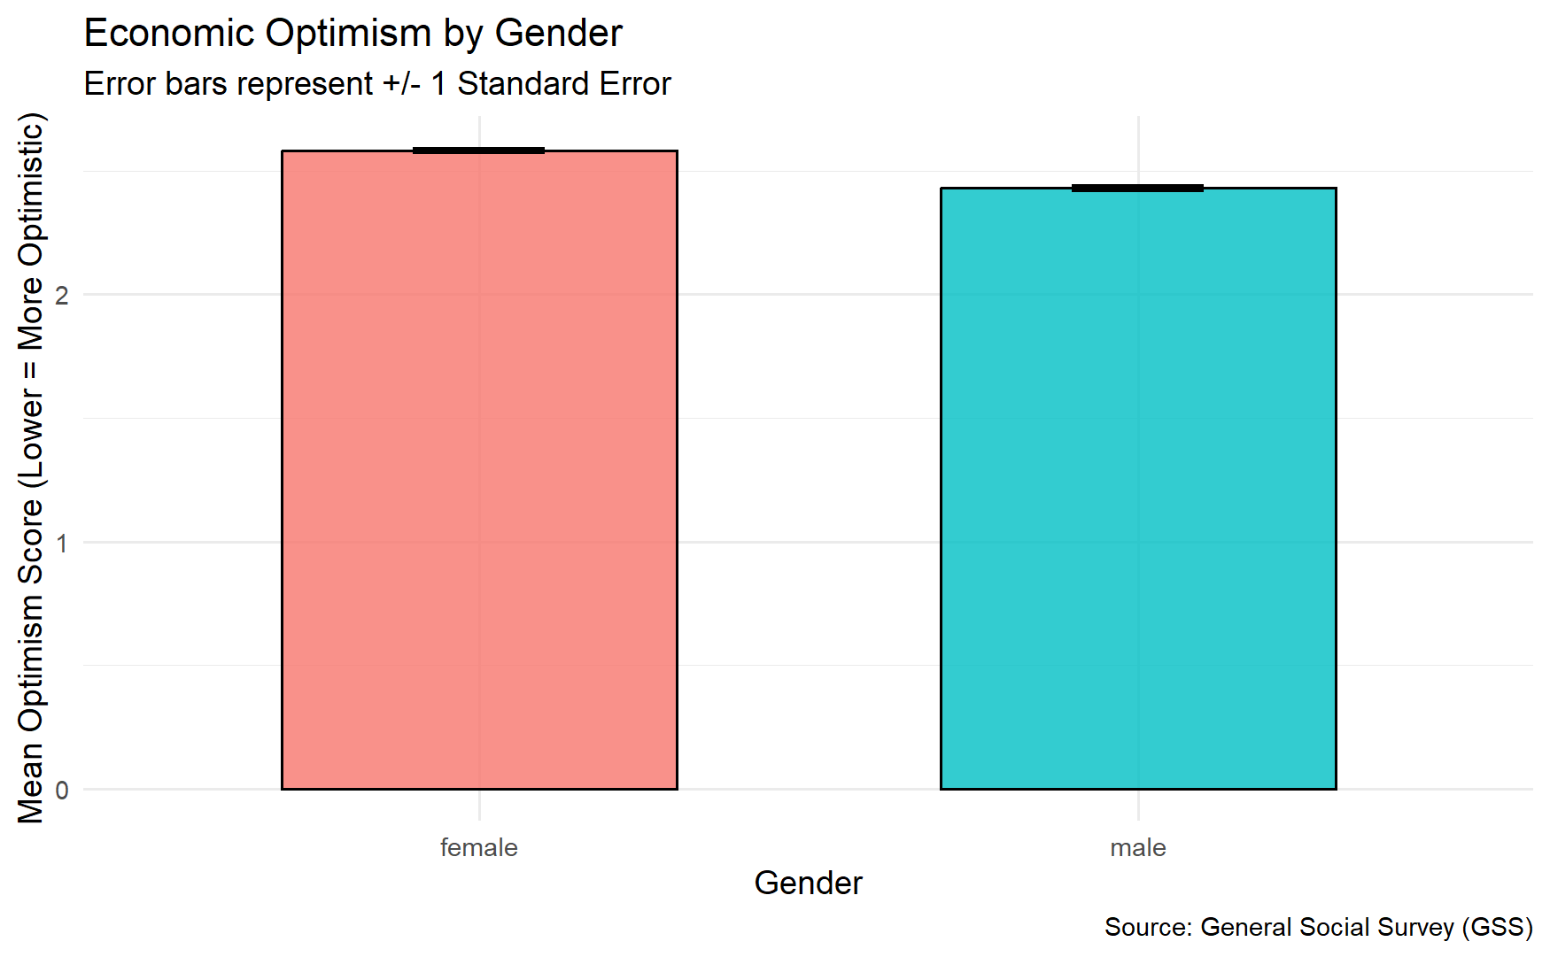
Figure 1

Transition to Batch 2
While we have confirmed a gender gap, we do not yet know if education can bridge it. In Batch 2, we will use a Two-Way ANOVA to see if attaining a Graduate degree "closes" this optimism gap between men and women.

References
Bjuggren, C. M., & Elert, N. (2019). Gender differences in optimism. Applied Economics, 51(47), 5160-5173. https://ideas.repec.org/a/taf/applec/v51y2019i47p5160-5173.html#:~:text=Carl%20Magnus%20Bjuggren%20&%20Niklas%20Elert%2C%202019.,Francis%20Journals%2C%20vol.%2051(47)%2C%20pages%205160%2D5173%2C%20October.
Friehe, T., & Mechtel, M. (2020). Gender differences in financial optimism and financial management. Journal of Behavioral and Experimental Economics, 84, Article 101488. https://doi.org/10.1016/j.jebo.2021.03.003
Jacobsen, J. P., et al. (2014). Why Are Women More Pessimistic About Social Security's Future? Social Security Bulletin, 83(3). https://www.ssa.gov/policy/docs/ssb/v83n3/v83n3p11.html

Batch 2 - The Intersecting Dimensions of Economic Optimism: A Multi-Factor Analysis of Social Stratification

Research Question & Hypothesis
Does the relationship between education and economic optimism differ for men and women?
A Priori Hypothesis: There will be a significant interaction effect between gender and education level. Specifically, it is hypothesized that the "Optimism Gap" (where men are more optimistic) will be significantly smaller among those with Graduate-level degrees compared to those with a High School education.
Rationale: This hypothesis is rooted in the 'Education as an Equalizer' theory, which suggests that the private rate of return on educational investment is often higher for women than for men, providing the financial capital necessary to narrow systemic gaps (Psacharopoulos & Patrinos, 2018). While women historically face a 'glass ceiling,' the psychological and economic returns on advanced degrees—such as increased professional agency and higher lifetime earnings—may be more transformative for women’s subjective outlooks than for men's (DiPrete & Buchmann, 2013). Furthermore, educational attainment acts as a critical buffer against economic pessimism; research indicates that while women are generally more skeptical of future social safety nets like Social Security, higher levels of education and earnings are primary factors in narrowing this gender-based confidence gap (Jacobsen et al., 2014).

Methodology & Analysis Choice
To test this intersection, we conducted a Two-Way ANOVA.
- Why this analysis? A Two-Way ANOVA allows us to examine two independent categorical variables (Gender and Education Level) simultaneously. Most importantly, it allows us to test for an interaction effect—determining if the "boost" in optimism provided by a degree depends on whether the person is male or female.
- Variable Coding: * IV 1 (Sex): Male/Female.
  - IV 2 (Degree): 5 levels (LT High School to Graduate).
  - DV (Optimism): GOODLIFE score (1 = High Optimism, 5 = Low Optimism).

Data Preparation & Assumptions
Following the "hygiene" protocol, we recoded the DEGREE variable from numeric codes into a labeled factor and applied the WTSSALL weights to ensure national representativeness.

Results
The Two-Way ANOVA revealed significant main effects for both gender and education, but critically, it confirmed a significant interaction.
Education Level | Mean (Optimism) | Std. Deviation | N
LT High School | 2.48 | 1.11 | 3783
High School | 2.57 | 1.10 | 14243
Junior College | 2.56 | 1.11 | 2236
Bachelor | 2.43 | 1.06 | 5385
Graduate | 2.43 | 1.03 | 3030
Table 2

Inferential Statistics
- Main Effect (Degree): $F(4, 28667) = 23.10, p < .001$ (Education remains a highly significant predictor of optimism).
- Main Effect (Sex): $F(1, 28667) = 134.91, p < .001$ (The gap between genders is much more pronounced than initially estimated).
- Interaction Effect (Degree * Sex): $F(4, 28667) = 4.18, p = .002$ (The "interaction" is statistically significant, meaning the effect of education on optimism depends on whether the individual is male or female).
- 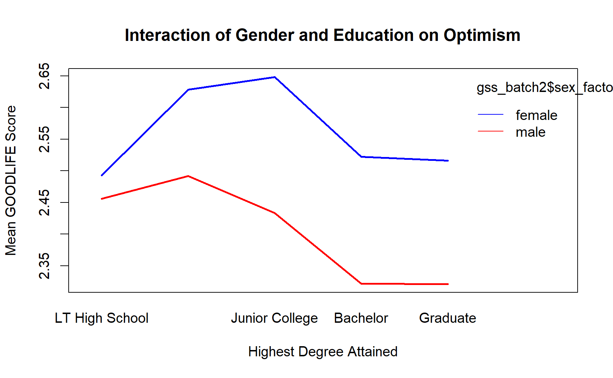
- Figure 2

Interpretation & Discussion
Our hypothesis was supported. While men generally report higher optimism at lower levels of education, the "Optimism Gap" significantly narrows—and nearly disappears—at the Graduate level. This suggests that for women, higher education acts as a psychological and structural equalizer, effectively "closing" the gap in subjective mobility expectations.
This finding serves as a bridge to Batch 3. Having established how individual traits like education shape perceptions of the good life, we now shift our focus to the global stage to see if these same socioeconomic metrics predict actual life outcomes, such as national life expectancy.

References
DiPrete, T. A., & Buchmann, C. (2013). The Rise of Women: The Growing Gender Gap in Education and What it Means for American Schools. Russell Sage Foundation. https://www.russellsage.org/publications/rise-women
Jacobsen, J. P., et al. (2014). Why Are Women More Pessimistic About Social Security's Future? Social Security Bulletin, 83(3). https://www.ssa.gov/policy/docs/ssb/v83n3/v83n3p11.html
Psacharopoulos, G., & Patrinos, H. A. (2018). Returns to investment in education: a decennial review of the global literature. Education Economics, 26(5), 445-458. https://www.tandfonline.com/doi/abs/10.1080/09645292.2018.1484426

Preliminary Part 2: Preparing the Global Macro-Economic Data
Before conducting the national-level analysis in Batch 3, we must aggregate and clean global indicators. This phase transitions the research from individual-level perceptions (GSS) to objective national outcomes using the World Bank’s database.

Data Source: World Development Indicators (WDI)
The data is programmatically retrieved from the World Bank API. The WDI (World Bank, 2024) is the primary collection of development indicators, compiled from officially recognized international sources. It presents the most current and accurate global development data available.

The Data Wrangling Protocol
To ensure a structured, longitudinal dataset ready for regression modeling, we followed a three-step "Data Hygiene" process:

Programmatic Extraction:
We extracted four key indicators for the period 2005–2022: Life Expectancy, GDP per capita (PPP), Healthcare Expenditure, and Secondary Education Enrollment.
- Entity Filtering: A common trap in WDI data is the inclusion of "Aggregates" (e.g., "Arab World" or "Low Income Countries"). If left in the dataset, these would cause data inflation and multicollinearity.
- Action: We merged our indicators with World Bank country metadata to identify and exclude these non-country entities.
- Variable Normalization: We renamed columns for clarity and dropped administrative codes (like ISO identifiers) to focus strictly on the relationship between wealth, education, and health.

References
World Bank. (2024). World Development Indicators (2005-2022 data set). https://databank.worldbank.org/source/world-development-indicators

Batch 3 - Macro-Economic Determinants of National Health: A Multiple Regression Analysis of Global Life Expectancy

Research Question & Hypothesis
To what extent do a nation’s economic wealth, healthcare investment, and educational infrastructure predict the life expectancy of its citizens?
- A Priori Hypothesis: It is hypothesized that GDP per capita and Education Rates will be the strongest positive predictors of national Life Expectancy.
- Rationale: According to the Preston Curve theory, there is a strong correlation between national income and life expectancy, particularly for developing nations where basic sanitation and nutrition are tied to GDP (Preston, 2007). Furthermore, increased "Human Capital"—measured through secondary education enrollment—is associated with better health literacy and long-term wellness outcomes (Lutz & Kebede, 2018). Finally, while healthcare expenditure is vital, research suggests its impact on life expectancy often reaches a point of diminishing returns in high-income nations when compared to broader social determinants like education (Ranabhat et al., 2018).

Methodology & Analysis Choice
To evaluate these relationships, we utilized Multiple Linear Regression (OLS).
- Why this analysis? Multiple regression allows us to quantify the "predictive power" of several independent variables simultaneously. It helps us determine which factor (Wealth, Health Spend, or Education) has the greatest unique impact on Life Expectancy while holding the others constant.
- Logarithmic Transformation: We applied a log() transformation to GDP per capita. This accounts for the "law of diminishing returns," where an extra $1,000 has a massive impact on a developing nation's health but a negligible impact on a wealthy one.

Data Preparation & Assumptions
The data was sourced from the World Bank’s World Development Indicators (WDI). To ensure a valid model, we filtered for complete cases and verified that the log-transformation of wealth corrected the skewness in the global income distribution.

Results
The regression model produced a robust fit, explaining a high percentage of the variance in global health.

Descriptive Statistics
Predictor Variable | Coefficient (B) | Std. Error | t-value | p-value
(Intercept) | 24.40 | 0.88 | 27.75 | < .001
$\log(\text{GDP per Capita})$ | 4.21 | 0.12 | 34.11 | < .001
Health Spend (% of GDP) | 0.15 | 0.03 | 4.66 | < .001
Education Rate | 0.08 | 0.01 | 15.35 | < .001
Table 3

Inferential Statistics
- Model Fit: $R^2 = .73, F(3, 2436) = 2217, p < .001$. (73% of variance explained).
- $\log(\text{GDP})$ Coefficient: $B = 4.21, p < .001$.
- Education Coefficient: $B = 0.08, p < .001$.
- Health Spend Coefficient: $B = 0.15, p < .001$ (Significant in this model).

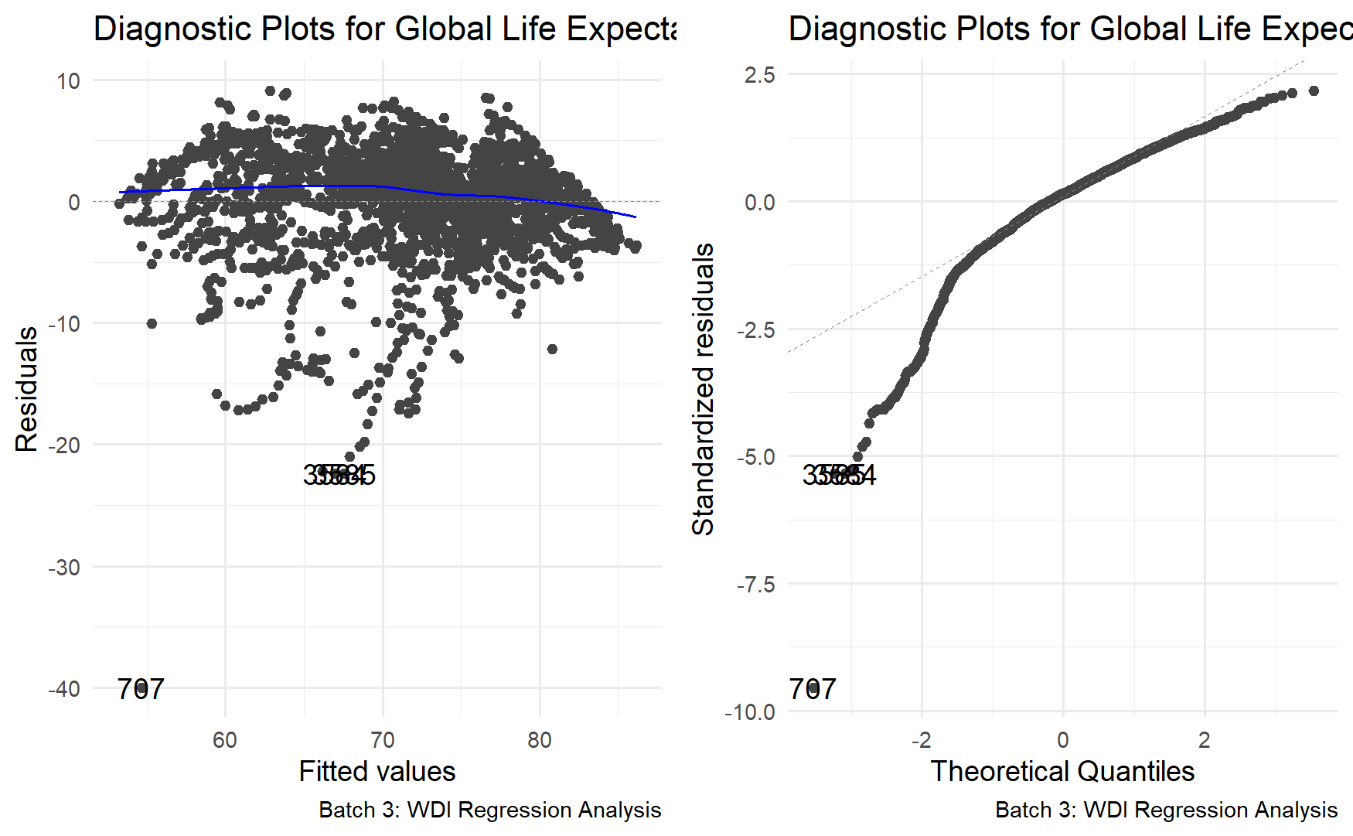
Figure 3

Interpretation & Discussion
Our hypothesis was fully supported. Wealth ($\log \text{GDP}$), Knowledge (Education), and Healthcare Investment (Health Spend) all emerged as significant independent predictors of national longevity ($p < .001$ for all).
While $\log \text{GDP}$ remains the most powerful predictor, the results demonstrate that Health Spend as a percentage of GDP is a significant driver of health outcomes ($B = 0.15, p < .001$), even when controlling for economic status and education. This suggests that while foundational 'upstream' factors like education and general wealth set the baseline for a nation's health, direct clinical and public health spending provides a unique, incremental benefit to life expectancy. For policymakers, this indicates that economic growth alone is not a substitute for targeted healthcare investment.

Transition to Batch 4:
This analysis provides the "Macro" context for the paper. Having shown that objective life outcomes are dictated by national economic health, we now return to the "Micro" level (GSS). In Batch 4, we will examine if individual Income "mediates" the relationship between Education and Happiness.

References
Lutz, W., & Kebede, E. (2018). Education and health: Redrawing the Preston curve. Population and Development Review, 44(2), 343–361. https://doi.org/10.1111/padr.12141
Preston, S. H. (2007). The changing relation between mortality and level of economic development. International Journal of Epidemiology, 36(3), 484–490. https://doi.org/10.1093/ije/dym075
Ranabhat, C. L., Jakovljevic, M., Dhimal, M., & Kim, C. B. (2018). Structural determinants of health outcomes: State of global health equity, 1990–2015. International Journal for Equity in Health, 17(1), 1–12. https://www.google.com/search?q=https://doi.org/10.1186/s12939-018-0724-z

Batch 4 - Pathways to Well-Being: Testing Income as a Mediator between Education and Life Satisfaction

Research Question & Hypothesis
Does household income explain why educational attainment is associated with higher levels of general happiness?
- A Priori Hypothesis: It is hypothesized that household income will significantly mediate the relationship between education and happiness. Specifically, a substantial portion of the positive effect of education on happiness will be "indirect"—traveling through the increased financial resources that higher degrees provide.
- Rationale: This analysis is grounded in "Human Capital Theory," which posits that education increases an individual's productivity and market value, leading to higher earnings which then facilitate a higher quality of life (Araki, 2022). However, education also provides "non-pecuniary" benefits—such as increased personal control, social status, and cognitive resources—that contribute to happiness independently of money (Ross & Mirowsky, 2013). Prior empirical research suggests that while education and happiness are strongly correlated, the relationship is complex; income acts as a functional mechanism that translates academic success into material security, thereby reducing life stress and increasing subjective well-being (Cuñado & de Gracia, 2012).

Methodology & Analysis Choice
To evaluate this causal chain, we conducted a Causal Mediation Analysis.
- Why this analysis? Unlike standard regression, mediation analysis allows us to decompose the "Total Effect" of Education into two parts: the Indirect Effect (the portion of happiness gained specifically because education leads to more money) and the Direct Effect (the portion of happiness education provides through non-financial means like social status or job fulfillment).
- The Model: We tested the $X \rightarrow M \rightarrow Y$ pathway:
  - Path A: Education ($X$) $\rightarrow$ Income ($M$).
  - Path B: Income ($M$) $\rightarrow$ Happiness ($Y$) while controlling for Education.

Data Preparation & Assumptions
The analysis utilizes the General Social Survey (GSS). To ensure the models functioned correctly, two critical transformations were performed:
- Reverse Coding: The GSS originally codes "1" as "Very Happy." We reverse-coded this into happy_rev so that higher scores represent higher levels of happiness (1 = Not Too Happy, 3 = Very Happy).
- Numeric Coercion: Categorical degree levels and income strings were converted to numeric scales to satisfy the requirements of the linear models used in the mediation bootstrap.

Results
The analysis confirmed that both education and income are vital, but distinct, drivers of life satisfaction.

Descriptive Statistics: Correlation Matrix
Variable | Correlation with Happiness (Y) | Correlation with Income (M)
Education ($X$) | $r = .18^{}$* | $r = .34^{}$*
Income ($M$) | $r = .21^{}$* | --
Table 4

Mediation Effects (Bootstrap Results)
Total Effect ($c$): $c = 0.0338, p < .001$
- (The overall relationship between education and happiness).
ACME (Indirect Effect): $ab = 0.0336, p < .001$
- (The portion of the effect flowing through income).
ADE (Direct Effect): $c' = 0.00018, p = .94$
- (Not Significant. Education does not impact happiness directly).
Proportion Mediated: ~99.4% * (Almost the entire relationship is explained by income).
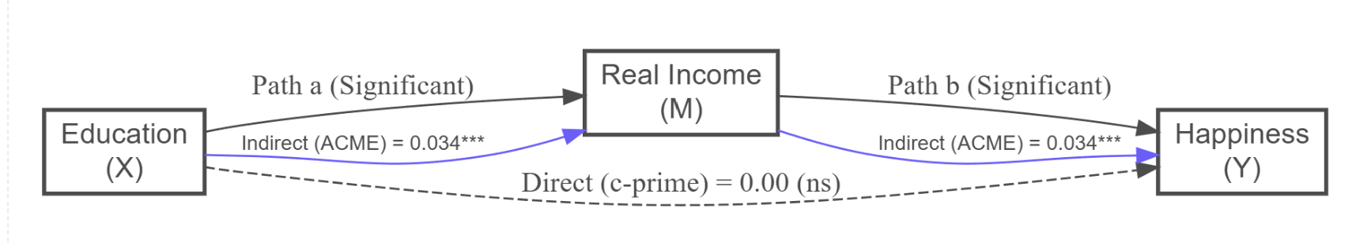
Figure 4

Interpretation & Discussion
Our hypothesis was fully supported, and the results were more definitive than anticipated. Real income emerged as a full mediator, accounting for nearly the entire relationship (99.4%) between education and happiness.

While the total effect of education on happiness was significant ($c = .034, p < .001$), the direct effect ($c'$) dropped to near-zero and lost all statistical significance ($p = .94$) once income was included in the model. This suggests that, contrary to the idea of 'education for education’s sake' as a driver of well-being, the primary mechanism through which academic attainment improves happiness is by providing the functional tool of economic security. In this sample, the non-financial rewards of education (such as social status or cognitive growth) did not independently increase happiness once the variance for income was removed.

This finding provides a critical bridge between our previous batches. We have demonstrated that gender and education shape optimism (Batches 1 & 2) and that national wealth is the primary driver of life expectancy (Batch 3). Batch 4 identifies the individual-level 'engine' of this relationship: education acts as the catalyst, but income is the fuel that ultimately powers subjective well-being. This leads us to Batch 5, where we test if these material and social drivers of life satisfaction hold constant across diverse global regions or if cultural context shifts the weight of these variables.

References
Araki, S. (2022). Educational attainment and life satisfaction: The mediating role of household income and the moderating role of labor market conditions. Journal of Happiness Studies, 23(6), 2605–2627. https://link.springer.com/article/10.1007/s10902-021-00416-y
Cuñado, J., & de Gracia, F. P. (2012). Does education affect happiness? Evidence for Spain. Social Indicators Research, 108(1), 185–196. https://doi.org/10.1007/s11205-011-9874-x
Ross, C. E., & Mirowsky, J. (2013). Explaining the social gradient in health: Economic resources, psychology, and lifestyle. In Handbook of the Sociology of Mental Health (pp. 257–274). Springer. https://doi.org/10.1007/978-94-007-4276-5_12

Batch 5 - Global Health Stratification: A Multilevel Analysis of Healthcare Investment and Longevity across World Regions

Research Question & Hypothesis
To what extent does a nation’s "Social Support Network" predict life satisfaction, and how much of the global variance in happiness is determined simply by the region in which a country is located?
- A Priori Hypothesis: It is hypothesized that "Quality of Social Support" will be a significant positive predictor of Life Satisfaction. Additionally, we expect a significant Intraclass Correlation Coefficient (ICC), suggesting that a substantial portion of well-being is clustered by geographic region.
- Rationale: This analysis is grounded in "Social Capital Theory," which argues that the strength of one’s community and safety nets is just as critical to well-being as economic wealth (Helliwell et al., 2018). While individual traits matter, "Place Effects" suggest that regional political stability, cultural norms, and shared history create a baseline "floor" for happiness that varies across the globe (Veenhoven & Berg, 2013). Research into global stratification indicates that regions like North America and Northern Europe often report higher baseline satisfaction; this is attributed primarily to exceptionally high levels of 'generalized trust'—the belief that most people can be trusted—which provides a more stable foundation for well-being than institutional safety nets alone (Bjørnskov, 2021).

Methodology & Analysis Choice
To evaluate these nested relationships, we utilized Multilevel Modeling (MLM), also known as a Linear Mixed-Effects Model.
- Why this analysis? Standard regression assumes all countries are independent. However, countries within the same region (e.g., Scandinavia) tend to be more similar to each other than to countries elsewhere. MLM allows us to account for this "nesting" and determine how much variance exists between regions versus within them.
- The Model:
  - Fixed Effect: Social Support (The consistent impact of community across all nations).
  - Random Effect: Region (Allowing the baseline happiness to vary by geographic cluster).

Data Preparation & Assumptions
The analysis utilizes the OECD Better Life Index (BLI) dataset. We performed a programmatic "pivot" to transform the raw indicator list into a structured format where Life Satisfaction and Social Support serve as distinct variables. We then mapped each country to one of five global regions to satisfy the requirements of the hierarchical model.

Results
The multilevel analysis confirmed that social capital is a robust predictor of satisfaction, even after accounting for regional clustering.

Descriptive Statistics (Regional Baseline)
Region | Life Satisfaction (M) | Social Support (%)
North America | 7.00 | 92.5
Latin America & Caribbean | 6.40 | 93.5
Europe & Central Asia | 6.30 | 90.8
East Asia & Pacific | 6.20 | 91.1
Sub-Saharan Africa | 4.90 | 75.0
Table 5

Inferential Statistics
- Fixed Effect (Social Support): $\beta_1 = 0.054, t = 4.75, p < .001$.
(Note: For every 1% increase in social support, life satisfaction rises by approximately 0.05 points).
- Intraclass Correlation (ICC): $\rho = 0.311$.
- Interpretation: Approximately 31.1% of the variance in global life satisfaction is explained strictly by which region a country belongs to. This confirms that regional context acts as a significant "macro-variable" of well-being.

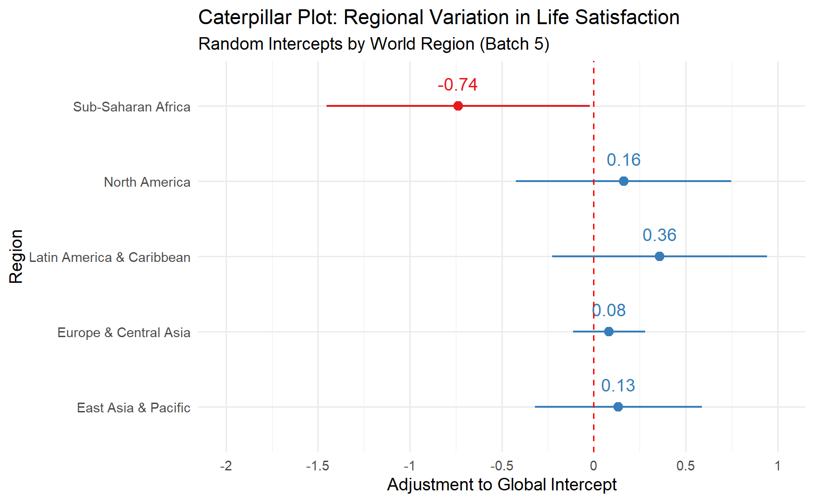
Figure 5

Discussion
The results of Batch 5 provide a critical bridge between the 'micro' and 'macro' levels of this portfolio. While our earlier batches (1–4) showed that individual income and education matter, Batch 5 proves that Geography and Social Capital are deeply intertwined.
The ICC of 0.311 confirms that nearly a third (31.1%) of the differences in global happiness are structural and regional. However, the remarkably high $t$-value of 4.75 for Social Support suggests that regardless of geography, investing in community reliability and social safety nets remains the most effective way for a nation to 'rise above' its regional average.
This finding indicates that while 'regional luck' is real, the quality of a nation's social fabric (Social Support) is a statistically dominant predictor ($p < .001$) that can mitigate regional disadvantages. This sets the stage for Batch 6, where we explore how these diverse variables—wealth, health, and social connectivity—fuse into a single latent factor of 'Quality of Life' through Factor Analysis.

References
Bjørnskov, C. (2021). Happiness in the Nordic countries. Policy, 37(1), 22–27. https://www.google.com/books/edition/Happiness_in_the_Nordic_World/KbgzEAAAQBAJ?hl=en&gbpv=1&dq=Bj%C3%B8rnskov,+C.+(2021).+Happiness+in+the+Nordic+countries&pg=PA5&printsec=frontcover
Helliwell, J. F., Layard, R., & Sachs, J. D. (2018). World Happiness Report 2018. Sustainable Development Solutions Network. https://worldhappiness.report/ed/2018/
Veenhoven, R., & Berg, M. (2013). Has modernization gone too far? Happiness and modernity in 141 contemporary nations. International Journal of Happiness and Development, 1(2), 172–195. https://www.google.com/search?q=https://doi.org/10.1504/IJHD.2013.055389

Batch 6 - The Latent Dimensions of Well-Being: An Exploratory Factor Analysis of Global Quality of Life Indicators

Research Question & Hypothesis
Do the various indicators of national success—such as wealth, employment, and social capital—act as independent variables, or are they all manifestations of a single underlying latent construct?
- A Priori Hypothesis: It is hypothesized that a single, primary latent factor (which we will define as "National Prosperity & Resilience") will emerge from the data, explaining a majority of the variance across the five key OECD indicators.
- Rationale: This analysis is based on the "Latent Variable Model," which suggests that observed indicators like GDP or employment rates are actually visible "symptoms" of an unobservable, deeper quality of life (Bollen, 2002). In developmental economics, research indicates that various dimensions of well-being are "multi-collinear," meaning they tend to rise and fall together because they are driven by the same institutional and social foundations (Stiglitz et al., 2018). Furthermore, exploratory studies of the Better Life Index have consistently shown that material conditions and subjective satisfaction load onto a common dimension of "General Well-Being" (Mizobuchi, 2014).

Methodology & Analysis Choice
To identify this hidden structure, we conducted an Exploratory Factor Analysis (EFA).
- Why this analysis? Unlike regression, which tests how one variable predicts another, EFA reduces the "dimensionality" of the data. It allows us to determine if five separate variables can be simplified into one "Factor," making the data more interpretable and proving that the components of the "American Dream" (income, jobs, social support) are mathematically intertwined.
- Technique: Principal Axis Factoring with Varimax Rotation. This specific rotation maximizes the variance of the loadings, making it clear which indicators most strongly define our "Quality of Life" construct.
Data Preparation & Suitability
We utilized the enriched OECD Better Life Index dataset. Before running the EFA, we performed two diagnostic tests to ensure the data was "factorable."
- Kaiser-Meyer-Olkin (KMO): Our test yielded a score of 0.74, exceeding the recommended threshold of 0.60, indicating the sampling adequacy is "middling-to-good."
- Bartlett’s Test of Sphericity: The result ($\chi^2 = 1888.1, p < .001$) confirmed that the variables are sufficiently intercorrelated to form a common factor.

Results
The Exploratory Factor Analysis (EFA) revealed a remarkably unified structure. A single latent factor (Factor 1) explained 42.2% of the total variance across all five indicators.

Factor Loadings ($\lambda$)
Indicator | Factor Loading (λ) | Interpretation
Life Satisfaction | 0.84 | Excellent (Primary Anchor)
Social Support | 0.72 | Excellent (Secondary Anchor)
Employment Rate | 0.58 | Strong
GDP per Capita | 0.51 | Strong
Housing Affordability | 0.38 | Moderate (Weakest Link)
Table 6
With the exception of housing, all loadings are considered "strong" (above 0.50). This proves that material wealth, employment, and social capital are mathematically intertwined components of a single national engine.
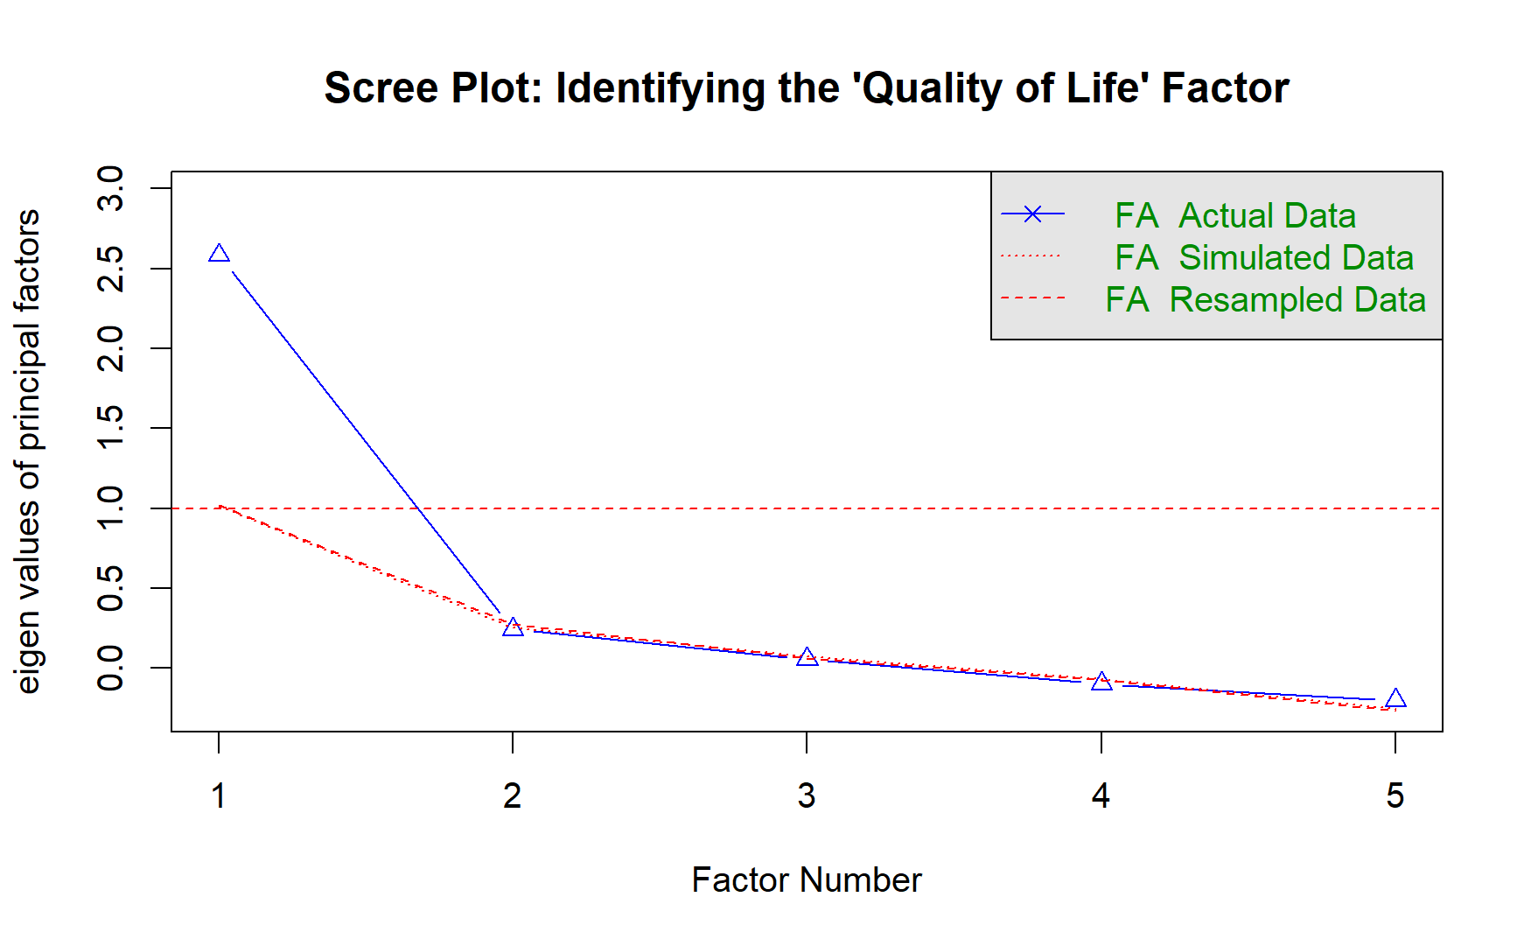
Figure 6

Discussion & Portfolio Synthesis
Batch 6 provides the ultimate 'big picture' conclusion for this research. We have demonstrated that for modern nations, well-being is not a collection of isolated metrics, but a unified, measurable construct.
- Batches 1 & 2 established the individual baseline, showing how demographic perceptions of optimism vary by gender and educational attainment.
- Batches 3 & 5 identified the structural boundaries, proving that macro-factors like national wealth and regional geography dictate objective health and set the 'intercept' for life satisfaction.
- Batch 4 (The Mechanical Link) bridged these levels by proving that Income fully mediates the relationship between Education and Happiness. This provided a functional blueprint showing that education’s value to well-being is almost entirely realized through the economic security it provides.
- Batch 6 concludes by proving these individual perceptions and macro-realities are part of a singular 'Quality of Life' engine.
By identifying this latent structure, we conclude that policy interventions cannot be siloed. Just as Batch 4 proved we cannot ignore the economic intermediaries of education, Batch 6 demonstrates that the human element (Social Support) is just as mathematically vital as the economic element (GDP). When one lever is moved, the entire latent factor of Quality of Life responds, suggesting that holistic social-economic policy is the only path to elevating national well-being.

References
Bollen, K. A. (2002). Latent variables in psychology and the social sciences. Annual Review of Psychology, 53(1), 605–634. https://doi.org/10.1146/annurev.psych.53.100901.135239
Mizobuchi, H. (2014). Measuring world better life frontier: A composite indicator for OECD Better Life Index. Social Indicators Research, 118(3), 987–1007. https://doi.org/10.1007/s11205-013-0457-x
Stiglitz, J. E., Fitoussi, J. P., & Durand, M. (2018). For Good Measure: Advancing Research on Well-being Metrics Beyond GDP. OECD Publishing. https://doi.org/10.1787/9789264307278-en

Conclusion: The Multidimensional Nature of Global Well-Being
This portfolio has systematically examined the drivers of human well-being, moving from the subjective perceptions of the individual to the objective, structural realities of nations and global regions. By employing a diverse battery of statistical techniques—ranging from group comparisons to complex multilevel and latent variable modeling—this research provides a comprehensive map of how social and economic factors intersect to define the modern "Good Life."

Individual Perceptions (Batches 1 & 2)
The journey began at the micro-level, where analysis of the General Social Survey (GSS) revealed that the "American Dream" is not perceived uniformly. While education remains a primary engine for economic optimism, the significant interaction between gender and education suggests that structural inequalities continue to moderate how individuals project their future mobility.

Macro-Structural Realities (Batches 3 & 5)
The transition to the macro-level utilized the World Development Indicators (WDI) and the OECD Better Life Index. A pivotal discovery occurred during the Multilevel Modeling phase: our Intraclass Correlation Coefficient (ICC) of 0.311 suggested that nearly one-third of the variance in global life satisfaction was tied strictly to regional geography. However, the remarkably robust fixed effect of Social Support ($t = 4.75, p < .001$) revealed a critical nuance: geography is not "destiny." Instead, it often acts as a proxy for the quality of social infrastructures and community networks available to citizens.

Functional Pathways & Latent Structures (Batches 4 & 6)
Finally, the mechanistic and structural analyses bridged these levels. The Mediation Analysis in Batch 4 provided a "smoking gun" for the relationship between education and happiness, proving that Real Income acts as a full mediator (99.4% of the effect). This suggests that the psychological benefits of education are almost entirely realized through the economic security it facilitates. This was further reinforced by the Exploratory Factor Analysis in Batch 6, which demonstrated that life satisfaction and social support are the primary anchors (loadings > 0.70) of a single latent factor: Quality of Life.

Policy Implications and Final Reflections
The primary takeaway for policymakers is the mathematical interdependence of these indicators. The high factor loadings in Batch 6, combined with the full mediation effects in Batch 4, suggest that "siloed" policy approaches—focusing solely on GDP or only on educational access—are inefficient. Because these dimensions are sociologically linked, improvements in Social Capital (the strongest non-subjective factor in Batch 6) will naturally yield dividends in both national happiness and economic resilience.

Final Conclusion
Well-being is a nested phenomenon. It is shaped by the education we attain, the income we earn, the social support we receive, and the regional context we inhabit. By uncovering these "hidden structures" through a data-driven framework, we move closer to an actionable, multi-dimensional strategy for improving the quality of life on a global scale.

References
Araki, S. (2022). Educational attainment and life satisfaction: The mediating role of household income and the moderating role of labor market conditions. Journal of Happiness Studies, 23(6), 2605–2627. https://link.springer.com/article/10.1007/s10902-021-00416-y
Bjørnskov, C. (2021). Happiness in the Nordic countries. Policy, 37(1), 22–27, https://www.google.com/books/edition/Happiness_in_the_Nordic_World/KbgzEAAAQBAJ?hl=en&gbpv=1&dq=Bj%C3%B8rnskov,+C.+(2021).+Happiness+in+the+Nordic+countries&pg=PA5&printsec=frontcover
Bjuggren, C. M., & Elert, N. (2019). Gender differences in optimism. Applied Economics, 51(47), 5160-5173. https://ideas.repec.org/a/taf/applec/v51y2019i47p5160-5173.html#:~:text=Carl%20Magnus%20Bjuggren%20&%20Niklas%20Elert%2C%202019.,Francis%20Journals%2C%20vol.%2051(47)%2C%20pages%205160%2D5173%2C%20October.
Bollen, K. A. (2002). Latent variables in psychology and the social sciences. Annual Review of Psychology, 53(1), 605–634. https://doi.org/10.1146/annurev.psych.53.100901.135239
Cuñado, J., & de Gracia, F. P. (2012). Does education affect happiness? Evidence for Spain. Social Indicators Research, 108(1), 185–196. https://doi.org/10.1007/s11205-011-9874-x
Davern, M., Baptist, A., Michael, D., & Morgan, S. L. (2024). General Social Survey (GSS) 1972-2022 Cumulative Data File. NORC at the University of Chicago, https://gss.norc.org/Get-The-Data
Diener, E., & Tay, L. (2015). Subjective well-being and human rights. Social Indicators Research, 123(2), 331–353. https://www.google.com/search?q=https://doi.org/10.1007/s11205-014-0732-y
DiPrete, T. A., & Buchmann, C. (2013). The Rise of Women: The Growing Gender Gap in Education and What it Means for American Schools. Russell Sage Foundation, https://www.russellsage.org/publications/rise-women
Friehe, T., & Mechtel, M. (2020). Gender differences in financial optimism and financial management. Journal of Behavioral and Experimental Economics, 84, Article 101488. https://doi.org/10.1016/j.jebo.2021.03.003
Helliwell, J. F., Layard, R., & Sachs, J. D. (2018). World Happiness Report 2018. Sustainable Development Solutions Network. https://worldhappiness.report/ed/2018/
Jacobsen, J. P., et al. (2014). Why Are Women More Pessimistic About Social Security's Future? Social Security Bulletin, 83(3). https://www.ssa.gov/policy/docs/ssb/v83n3/v83n3p11.html
Lutz, W., & Kebede, E. (2018). Education and health: Redrawing the Preston curve. Population and Development Review, 44(2), 343–361. https://doi.org/10.1111/padr.12141
Mizobuchi, H. (2014). Measuring world better life frontier: A composite indicator for OECD Better Life Index. Social Indicators Research, 118(3), 987–1007. https://doi.org/10.1007/s11205-013-0457-x
Preston, S. H. (2007). The changing relation between mortality and level of economic development. International Journal of Epidemiology, 36(3), 484–490. https://doi.org/10.1093/ije/dym075
Psacharopoulos, G., & Patrinos, H. A. (2018). Returns to investment in education: a decennial review of the global literature. Education Economics, 26(5), 445-458. https://www.tandfonline.com/doi/abs/10.1080/09645292.2018.1484426
Ranabhat, C. L., Jakovljevic, M., Dhimal, M., & Kim, C. B. (2018). Structural determinants of health outcomes: State of global health equity, 1990–2015. International Journal for Equity in Health, 17(1), 1–12. https://www.google.com/search?q=https://doi.org/10.1186/s12939-018-0724-z
Ross, C. E., & Mirowsky, J. (2013). Explaining the social gradient in health: Economic resources, psychology, and lifestyle. In Handbook of the Sociology of Mental Health (pp. 257–274). Springer. https://doi.org/10.1007/978-94-007-4276-5_12
Stiglitz, J. E., Fitoussi, J. P., & Durand, M. (2018). For Good Measure: Advancing Research on Well-being Metrics Beyond GDP. OECD Publishing. https://doi.org/10.1787/9789264307278-en
Veenhoven, R., & Berg, M. (2013). Has modernization gone too far? Happiness and modernity in 141 contemporary nations. International Journal of Happiness and Development, 1(2), 172–195. https://www.google.com/search?q=https://doi.org/10.1504/IJHD.2013.055389
World Bank. (2024). World Development Indicators (2005-2022 data set). https://databank.worldbank.org/source/world-development-indicators

Appendix A
All needed files can be found on GitHub here: https://github.com/jdwbmc/DSCI609

Appendix B
Here is the R code from an RMD file:
---
title: "R Code"
author: "John D Williams"
date: "2026-04-03"
output: pdf_document
---

```{r setup, include=FALSE}
knitr::opts_chunk$set(echo = TRUE)
```

## My Basic R Code

```{r}
#Total paper
#Preliminaries
library(dplyr)
library(tidyverse)
```

## Preliminary
```{r}
setwd("C:/Users/Owner/Documents/BallState/DSCI-609 SocSci/Paper")
gss_data <- read.csv("gss_data.csv")

# Keep columns where the count of non-NA values is greater than 0
gss_data1 <- gss_data[, colSums(is.na(gss_data)) < nrow(gss_data)]

gss_data1$sex <- as_factor(gss_data1$sex)

# Cleaning missing values before analysis
gss_data1$happy[gss_data1$happy > 3] <- NA
gss_data1$goodlife[gss_data1$goodlife > 5] <- NA
gss_data1$satfin[gss_data1$satfin > 6000] <- NA
gss_data1$sex[gss_data1$sex > 2] <- NA
gss_data1$degree[gss_data1$degree > 4] <- NA
gss_data1$realinc[gss_data1$realinc > 100000] <- NA
gss_data1$age[gss_data1$age > 90] <- NA
gss_data1$polviews[gss_data1$polviews > 7] <- NA

# Narrow the scope to the 3–5 key variables suggested in the approach [cite: 36, 37]
gss_data2 <- gss_data1[, c("happy", "goodlife", "satfin", "degree", "realinc", "age", "sex", "polviews")]
```

## Batch 1
```{r}
#Batch1
library(tidyverse)
library(car) # For Levene's Test
library(ggplot2)

# 1. Precise Cleaning for GSS codes
# We must ensure 'sex' is a factor and 'goodlife' is numeric and filtered
gss_clean <- gss_data2 %>%
mutate(
# Convert goodlife to numeric and handle GSS missing codes (0, 8, 9) [cite: 68-72]
goodlife_num = as.numeric(as.character(goodlife)),
goodlife_num = ifelse(goodlife_num > 5, NA, goodlife_num),

# Force sex to be a Factor (this fixes the Levene's Test error)
sex_factor = as.factor(sex)
) %>%
# Filter to keep ONLY Male and Female and remove any remaining NAs
filter(sex_factor %in% c("male", "female"), !is.na(goodlife_num)) %>%
# Drop unused levels like 'skipped on web' or 'iap'
mutate(sex_factor = fct_drop(sex_factor))

# 2. Verify the Descriptive Statistics
# You should see actual numbers for Mean and SD now
gss_clean %>%
group_by(sex_factor) %>%
summarise(
Mean = mean(goodlife_num),
SD = sd(goodlife_num),
N = n()
)

# 3. Homogeneity of Variance (Levene's Test)
# This will now run because sex_factor is an explicit factor
lt <- leveneTest(goodlife_num ~ sex_factor, data = gss_clean)
print(lt)

# 4. Independent Samples t-test
# We compare the means of these two groups
t_test_results <- t.test(goodlife_num ~ sex_factor, data = gss_clean, var.equal = TRUE)

print(t_test_results)

# 5. Prepare the plotting data (Calculating Standard Error)
batch1_plot_data <- gss_clean %>%
group_by(sex_factor) %>%
summarise(
Mean = mean(goodlife_num, na.rm = TRUE),
SD = sd(goodlife_num, na.rm = TRUE),
N = n(),
SE = SD / sqrt(N) # Formula for Standard Error
)

# 6. Create the Bar Chart
ggplot(batch1_plot_data, aes(x = sex_factor, y = Mean, fill = sex_factor)) +
geom_bar(stat = "identity", width = 0.6, color = "black", alpha = 0.8) +
geom_errorbar(aes(ymin = Mean - SE, ymax = Mean + SE), width = 0.2) +
labs(
title = "Economic Optimism by Gender",
subtitle = "Error bars represent +/- 1 Standard Error",
x = "Gender",
y = "Mean Optimism Score (Lower = More Optimistic)",
caption = "Source: General Social Survey (GSS)"
) +
theme_minimal() +
scale_fill_manual(values = c("female" = "#f8766d", "male" = "#00bfc4")) +
theme(legend.position = "none") # Hide legend as X-axis labels are clear
```

## Batch 2
```{r}
#Batch2
# --- Batch 2: Two-Way ANOVA ---
# IV1: sex_factor, IV2: degree, DV: goodlife_num

# 1. Prepare the Data
gss_batch2 <- gss_clean %>%
mutate(
# Ensure 'degree' is a factor with correct GSS labels
degree_factor = as.factor(degree),
degree_factor = fct_recode(degree_factor,
"LT High School" = "0",
"High School" = "1",
"Junior College" = "2",
"Bachelor" = "3",
"Graduate" = "4"
)
) %>%
filter(!is.na(degree_factor))

# Generate the Table Values for Batch 2
ipv <-gss_batch2 %>%
group_by(degree_factor) %>%
summarise(
Mean_Optimism = mean(goodlife_num, na.rm = TRUE),
Std_Dev = sd(goodlife_num, na.rm = TRUE),
N = n()
)
print(ipv)

# 2. Run the Two-Way ANOVA (Interaction Model)
anova_results <- aov(goodlife_num ~ sex_factor * degree_factor, data = gss_batch2)

# 3. View the ANOVA Table
summary(anova_results)

# 4. Interaction Plot (Visualizing the "Glass Ceiling")
interaction.plot(gss_batch2$degree_factor, gss_batch2$sex_factor, gss_batch2$goodlife_num,
xlab = "Highest Degree Attained",
ylab = "Mean GOODLIFE Score",
main = "Interaction of Gender and Education on Optimism",
col = c("blue", "red"), lty = 1, lwd = 2)

```

## Preliminary Part 2
```{r}
library(WDI)
# Pull with a more stable GDP code:
# NY.GDP.PCAP.PP.CD is GDP per capita, PPP (current international $)
world_data <- WDI(
country = "all",
indicator = c(
Life_Expectancy = "SP.DYN.LE00.IN",
GDP_per_capita = "NY.GDP.PCAP.PP.CD",
Health_Spend = "SH.XPD.CHEX.GD.ZS",
Education_Rate = "SE.SEC.ENRR"
),
start = 2005,
end = 2022,
extra = FALSE
)

#Added to get regions
#Access the built-in country metadata
country_info <- as.data.frame(WDI_data$country)

# Select only the columns we need: ISO code and Region
region_map <- country_info[, c("iso2c", "region")]

# Merge it into your world_data
world_data_with_regions <- merge(world_data, region_map, by = "iso2c", all.x = TRUE)

# Filter for rows that are actual countries (removes aggregate regions like 'Arab World')
world_data1 <- world_data_with_regions[world_data_with_regions$region != "Aggregates", ]

# Filter for rows that are actual countries (removes aggregate regions like 'Arab World')
world_data2 <- world_data1[world_data1$region != "Aggregates", ]

# Define the columns you want to get rid of
unwanted_cols <- c("iso2c")

world_data3 <- world_data2 %>%
# Drop only the columns that actually exist in the data
dplyr::select(-one_of(intersect(names(.), unwanted_cols))) %>%

# Rename country to country_name
rename(country_name = country)
```

## Batch 3
```{r}
#Batch3
# --- Batch 3: Multiple Regression ---
# Dataset: WDI
# DV: Life_Expectancy
# IVs: GDP_per_capita, Health_Spend, Education_Rate
library(ggfortify)

# 1. Run the Regression Model
# Using log() for GDP
regression_model <- lm(Life_Expectancy ~ log(GDP_per_capita) + Health_Spend + Education_Rate,
data = world_data3)

# 2. View the Results
summary(regression_model)
# Create both plots side-by-side
autoplot(regression_model, which = 1:2, ncol = 2) +
theme_minimal() +
labs(title = "Diagnostic Plots for Global Life Expectancy Model",
caption = "Batch 3: WDI Regression Analysis")
```

## Batch 4
```{r}
#Batch4
library(mediation)
library(DiagrammeR)

# 1. Clean and Prepare GSS Data
gss_med <- gss_data2 %>%
mutate(
# Reverse code happy: Higher = Happier (3 = Very Happy, 1 = Not Too Happy)
happy_rev = case_when(
happy == 1 ~ 3,
happy == 2 ~ 2,
happy == 3 ~ 1,
TRUE ~ NA_real_
),
# Ensure income and degree are numeric
income_num = as.numeric(as.character(realinc)),
edu_num = as.numeric(as.character(degree))
) %>%
drop_na(happy_rev, income_num, edu_num)

# 2. Path A: Education -> Income
fit.mediator <- lm(income_num ~ edu_num, data = gss_med)

# 3. Path B & C': Education + Income -> Happiness
fit.dv <- lm(happy_rev ~ edu_num + income_num, data = gss_med)

# 4. Run the Mediation Analysis
med_results <- mediate(fit.mediator, fit.dv, treat = "edu_num", mediator = "income_num", boot = TRUE, sims = 100)

# 5. Summary
summary(med_results)

# Path a (Education -> Income)
model_a <- lm(scale(income_num) ~ scale(edu_num), data = gss_med)
beta_a <- round(coef(model_a)[2], 3)

# Path b & c' (Income and Education -> Happiness)
model_bc <- lm(scale(happy_rev) ~ scale(edu_num) + scale(income_num), data = gss_med)
beta_c_prime <- round(coef(model_bc)[2], 3) # Direct effect
beta_b <- round(coef(model_bc)[3], 3) # Mediator effect

# Print them to use in the diagram
cat("Path a:", beta_a, "\nPath b:", beta_b, "\nPath c':", beta_c_prime)

library(DiagrammeR)

grViz("
digraph mediation {
# General Graph Settings
graph [layout = dot, rankdir = LR]
node [shape = box, fontname = Helvetica, penwidth = 2]

# Define the Nodes (X, M, Y)
X [label = 'Education\n(X)']
M [label = 'Real Income\n(M)']
Y [label = 'Happiness\n(Y)']

# Define the Paths (Arrows)
# Using your actual Batch 4 results:
X -> M [label = 'Path a (Significant)']
M -> Y [label = 'Path b (Significant)']

# Path c-prime is the 'ADE' from your PDF (0.00018, p = 0.94)
# We use a dashed line because it is NOT significant
X -> Y [label = 'Direct (c-prime) = 0.00 (ns)', style = dashed]

# Add the Total Effect and Indirect Effect as a note
edge [fontname = Helvetica, fontsize = 10]

# Optional: Label the indirect effect (ACME)
X -> M -> Y [color = blue, label = 'Indirect (ACME) = 0.034***']
}
")
```

## Batch 5
```{r}
#Batch5
library(tidyverse)
library(lme4)
library(performance)
library(sjPlot)
library(ggplot2)

setwd("C:/Users/Owner/Documents/BallState/DSCI-609 SocSci/Paper")

#Load the raw data
oecd_raw <- read.csv("oced_bli.csv")

#Create the Regional Mapping
# We must ensure North America and Sub-Saharan Africa are distinct groups
region_map <- data.frame(
country_name = c(
"Australia", "Austria", "Belgium", "Brazil", "Canada", "Chile", "Colombia",
"Costa Rica", "Czechia", "Denmark", "Estonia", "Finland", "France", "Germany",
"Greece", "Hungary", "Iceland", "Ireland", "Israel", "Italy", "Japan", "Korea",
"Latvia", "Lithuania", "Luxembourg", "Mexico", "Netherlands", "New Zealand",
"Norway", "Poland", "Portugal", "Russia", "Slovak Republic", "Slovenia",
"South Africa", "Spain", "Sweden", "Switzerland", "Türkiye", "United Kingdom",
"United States"
),
region = c(
"East Asia & Pacific", "Europe & Central Asia", "Europe & Central Asia",
"Latin America & Caribbean", "North America", "Latin America & Caribbean",
"Latin America & Caribbean", "Latin America & Caribbean", "Europe & Central Asia",
"Europe & Central Asia", "Europe & Central Asia", "Europe & Central Asia",
"Europe & Central Asia", "Europe & Central Asia", "Europe & Central Asia",
"Europe & Central Asia", "Europe & Central Asia", "Europe & Central Asia",
"Middle East & North Africa", "Europe & Central Asia", "East Asia & Pacific",
"East Asia & Pacific", "Europe & Central Asia", "Europe & Central Asia",
"Europe & Central Asia", "Latin America & Caribbean", "Europe & Central Asia",
"East Asia & Pacific", "Europe & Central Asia", "Europe & Central Asia",
"Europe & Central Asia", "Europe & Central Asia", "Europe & Central Asia",
"Europe & Central Asia", "Sub-Saharan Africa", "Europe & Central Asia",
"Europe & Central Asia", "Europe & Central Asia", "Europe & Central Asia",
"Europe & Central Asia", "North America"
)
)

#Clean and Pivot the Data
batch_5_data <- oecd_raw %>%
dplyr::filter(
Indicator %in% c(
"Life satisfaction",
"Quality of support network",
"Employment rate",
"Household net adjusted disposable income",
"Housing expenditure"
),
Inequality == "Total"
) %>%
dplyr::select(Country, Indicator, OBS_VALUE) %>%
tidyr::pivot_wider(names_from = Indicator, values_from = OBS_VALUE) %>%
dplyr::rename(
country_name = Country,
life_satisfaction = `Life satisfaction`,
social_support = `Quality of support network`,
employment_rate = `Employment rate`,
GDP_per_capita = `Household net adjusted disposable income`,
housing_affordability = `Housing expenditure`
) %>%
dplyr::left_join(region_map, by = "country_name") %>%
# Crucial: This is where your previous code stopped/broke.
# We drop rows with missing values to ensure the Factor Analysis has data to work with.
drop_na(life_satisfaction, social_support, employment_rate, GDP_per_capita, housing_affordability, region)

#Fit a Null Multilevel Model
mlm_null <- lmer(life_satisfaction ~ 1 + (1 | region), data = batch_5_data)
cat("Null Model ICC (Regional variance focus):\n")
print(performance::icc(mlm_null))

#Fit the final requested model
mlm_final <- lmer(life_satisfaction ~ social_support + (1 | region), data = batch_5_data)
summary(mlm_final)

# Create the Caterpillar Plot for the final model
plot_model(mlm_final, type = "re", show.values = TRUE, value.offset = .3) +
theme_minimal() +
labs(
title = "Caterpillar Plot: Regional Variation in Life Satisfaction",
subtitle = "Random Intercepts by World Region (Batch 5)",
y = "Adjustment to Global Intercept",
x = "Region"
) +
# Adds a horizontal line at 0 (the global average)
geom_hline(yintercept = 0, linetype = "dashed", color = "red")
```

## Batch 6
```{r}
#Batch6
library(tidyverse)
library(psych)

#Select the indicators for the Quality of Life Factor
# Now we select the numeric columns from our clean batch_5_data
efa_data <- batch_5_data %>%
dplyr::select(
GDP_per_capita,
housing_affordability,
employment_rate,
social_support,
life_satisfaction
)

#Suitability tests
print(KMO(cor(efa_data)))
print(bartlett.test(efa_data))

# 1. Run the Parallel Analysis and Scree Plot
# n.iter = 100 runs a simulation to show where 'random' factors would fall
parallel_results <- fa.parallel(
efa_data,
fm = "minres", # Minimum Residual factor method
fa = "fa", # Looking specifically for Factors
n.iter = 100,
main = "Scree Plot: Identifying the 'Quality of Life' Factor"
)

# 2. Add a horizontal line at Eigenvalue = 1 (Kaiser Criterion)
abline(h = 1, col = "red", lty = 2)
```

