DSCI-610 FinalPaper Output
#Load Libraries
> if (!require("tidyverse")) install.packages("tidyverse")
Loading required package: tidyverse── Attaching core tidyverse packages ───────────────────────────────── tidyverse 2.0.0 ──
✔ dplyr 1.1.4 ✔ readr 2.1.6
✔ forcats 1.0.1 ✔ stringr 1.6.0
✔ ggplot2 4.0.2 ✔ tibble 3.3.1
✔ lubridate 1.9.4 ✔ tidyr 1.3.2
✔ purrr 1.2.1
── Conflicts ─────────────────────────────────────────────────── tidyverse_conflicts() ──
✖ dplyr::filter() masks stats::filter()
✖ dplyr::lag() masks stats::lag()
ℹ Use the conflicted package to force all conflicts to become errors
> library(tidyverse)
> if (!require("MASS")) install.packages("MASS")
Loading required package: MASS

Attaching package: ‘MASS’

The following object is masked from ‘package:dplyr’:

select> library(MASS)
> if (!require("ggplot2")) install.packages("ggplot2")
> library(ggplot2)
> if (!require("broom")) install.packages("broom")
Loading required package: broom> library(broom)
Rows: 2200 Columns: 15
── Column specification ─────────────────────────────────────────────────────────────────
Delimiter: ","
chr (12): Notes, Census Region, Census Region Code, Race, Race Code, Hispanic Origin,...
dbl (2): Year, Year Code
lgl (1): Sex Code
Use `spec()` to retrieve the full column specification for this data.
ℹ Specify the column types or set `show_col_types = FALSE` to quiet this message.
> # 1. Convert Year to integer and Drop the Notes column
> df1 <- df1 %>%
+ mutate(Year = as.integer(Year))
>
> # 2. Replace the text "Suppressed" with "5" (the mean(Deaths))
> df1$Deaths[df1$Deaths == "Suppressed"] <- "5"
>
> # 3. Convert the entire Deaths column to numeric
> df1$Deaths <- as.integer(df1$Deaths)
>
> #Fix Race
> # 4. We use mutate with ifelse (or case_when) to overwrite the values
> df1 <- df1 %>%
+ mutate(
+ # Ensure both columns are strings to avoid type errors
+ `Hispanic Origin` = as.character(`Hispanic Origin`),
+ Race = as.character(Race),
+
+ # Use case_when to precisely map the new Race values
+ Race = case_when(
+ `Hispanic Origin` == "Hispanic or Latino" ~ "Hispanic",
+ `Hispanic Origin` == "Not Hispanic or Latino" ~ Race,
+ is.na(`Hispanic Origin`) ~ Race, # Keeps original Race if Hispanic info is missing
+ TRUE ~ Race # Safety net: keep original value otherwise
+ ),
+
+ # Do the same for the Codes
+ `Race Code` = case_when(
+ `Hispanic Origin` == "Hispanic or Latino" ~ `Hispanic Origin Code`,
+ TRUE ~ as.character(`Race Code`)
+ )
+ )
>
> # 5. Verification check
> # This should now show "Hispanic", "White", "Black", AND "American Indian..."
> unique(df1$Race)
[1] "Hispanic" "American Indian or Alaska Native"
[3] "Asian or Pacific Islander" "Black or African American"
[5] "White" NA
>
> # 6. Drop columns by name
> df1_cleaned <- df1[, !(names(df1) %in% c("Hispanic Origin", "Hispanic Origin Code", "Notes"))]
>
> # 7. Drop rows 2113 through 2200
> df1_cleaned <- df1_cleaned %>%
+ slice(-(2113:2200))
>
> # See the count of each category
> table(df1_cleaned$`Crude Rate`)

0.12 0.13 0.14 0.15 0.16
1 2 2 5 6
0.17 0.18 0.19 0.20 0.21
4 2 4 2 2
0.22 0.23 0.24 0.25 0.26
7 6 3 1 3
0.27 0.28 0.29 0.30 0.31
1 1 4 2 2
0.32 0.33 0.34 0.35 0.36
2 1 1 3 6
0.37 0.38 0.39 0.40 0.43
6 2 3 1 1
0.44 0.45 0.46 0.47 0.48
1 1 1 2 1
0.49 0.52 0.53 0.56 0.57
1 2 1 2 1
0.59 0.62 0.66 0.71 0.76
1 1 1 1 1
0.85 0.90 0.92 0.98 1.48
2 1 1 1 1
Not Applicable Suppressed Unreliable
704 341 957
>
> # See the count of each category
> table(df1_cleaned$Deaths)

0 5 10 11 12 13 14 15 16 17 18 19 20 21 22 23 24
1582 354 7 6 4 7 7 6 7 5 7 10 8 8 3 3 9
25 26 27 28 29 30 31 32 33 34 35 36 37 38 39 40 41
3 3 4 6 2 3 2 6 1 1 1 1 5 2 1 2 1
42 45 46 47 48 49 51 55 56 59 60 61 62 66 68 72 75
1 2 3 1 2 1 2 1 2 2 2 2 2 1 1 1 2
81 84 85 86 90 116 132
1 1 1 1 1 1 1
>
> # See the count of each category
> table(df1_cleaned$Race)

American Indian or Alaska Native Asian or Pacific Islander
352 352
Black or African American Hispanic
352 704
White
352
>
df2 <- read_csv("CensusOnlyK.csv")
Warning: One or more parsing issues, call `problems()` on your data frame for details, e.g.:
dat <- vroom(...)
problems(dat)
Rows: 2192 Columns: 15
── Column specification ─────────────────────────────────────────────────────────────────
Delimiter: ","
chr (12): Notes, Census Region, Census Region Code, Race, Race Code, Hispanic Origin,...
dbl (2): Year, Year Code
lgl (1): Sex Code

ℹ Use `spec()` to retrieve the full column specification for this data.
ℹ Specify the column types or set `show_col_types = FALSE` to quiet this message.
# 1. Convert Year to integer and Drop the Notes column
> df2 <- df2 %>%
+ mutate(Year = as.integer(Year))
>
> # 2. Replace the text "Suppressed" with "5" (the mean(Deaths))
> df2$Deaths[df2$Deaths == "Suppressed"] <- "5"
>
> # 3. Convert the entire Deaths column to numeric
> df2$Deaths <- as.integer(df2$Deaths)
>
> #Fix Race
> # 4. We use mutate with ifelse (or case_when) to overwrite the values
> df2 <- df2 %>%
+ mutate(
+ # Ensure both columns are strings to avoid type errors
+ `Hispanic Origin` = as.character(`Hispanic Origin`),
+ Race = as.character(Race),
+
+ # Use case_when to precisely map the new Race values
+ Race = case_when(
+ `Hispanic Origin` == "Hispanic or Latino" ~ "Hispanic",
+ `Hispanic Origin` == "Not Hispanic or Latino" ~ Race,
+ is.na(`Hispanic Origin`) ~ Race, # Keeps original Race if Hispanic info is missing
+ TRUE ~ Race # Safety net: keep original value otherwise
+ ),
+
+ # Do the same for the Codes
+ `Race Code` = case_when(
+ `Hispanic Origin` == "Hispanic or Latino" ~ `Hispanic Origin Code`,
+ TRUE ~ as.character(`Race Code`)
+ )
+ )
>
> # 5. Verification check
> # This should now show "Hispanic", "White", "Black", AND "American Indian..."
> unique(df2$Race)
[1] "Hispanic" "American Indian or Alaska Native"
[3] "Asian or Pacific Islander" "Black or African American"
[5] "White" NA
>
> # 6. Drop columns by name
> df2_cleaned <- df2[, !(names(df2) %in% c("Hispanic Origin", "Hispanic Origin Code", "Notes"))]
>
> # 7. Drop rows 2113 through 2192
> df2_cleaned <- df2_cleaned %>%
+ slice(-(2113:2192))
Warning in left_join(., df2_cleaned %>% dplyr::select(Year, `Census Region`, :
Detected an unexpected many-to-many relationship between `x` and `y`.
ℹ Row 1 of `x` matches multiple rows in `y`.
ℹ Row 3 of `y` matches multiple rows in `x`.
ℹ If a many-to-many relationship is expected, set `relationship = "many-to-many"` to
silence this warning.
[1] 704
[1] 0
[1] 0
Race  <chr> | Avg_Crude_Rate_Total  <dbl> |  | Total_Deaths_Estimated  <dbl>
Hispanic | 181.719227 |  | 1443856
American Indian or Alaska Native | 21.877289 |  | 50020
White | 9.279736 |  | 1839728
Black or African American | 6.673042 |  | 212560
Asian or Pacific Islander | 2.195863 |  | 38716
Race  <chr> | Avg_Crude_Rate  <dbl>
American Indian or Alaska Native | 0.43751341
Hispanic | 0.10800348
White | 0.10285869
Black or African American | 0.08945424
Asian or Pacific Islander | 0.07291777
Race  <chr> | Total_Pop  <dbl>
American Indian or Alaska Native | 309691204
Asian or Pacific Islander | 2237323108
Black or African American | 5053516584
Hispanic | 9451942336
White | 25065291060
# A tibble: 5 × 4
Race Grand_Total_Deaths Grand_Total_Pop True_Crude_Rate
<chr> <dbl> <dbl> <dbl>
1 American Indian or Alaska Native 50020 309691204 16.2
2 Hispanic 1443856 9451942336 15.3
3 White 1839728 25065291060 7.34
4 Black or African American 212560 5053516584 4.21
5 Asian or Pacific Islander 38716 2237323108 1.73
# A tibble: 5 × 4
Race True_Crude_Rate Both_True_Rate Diabetes_Contribution…¹
<chr> <dbl> <dbl> <dbl>
1 American Indian or Alaska Native 16.2 0.304 0.940
2 Hispanic 15.3 0.315 0.515
3 White 7.34 0.0658 0.448
4 Black or African American 4.21 0.0402 0.478
5 Asian or Pacific Islander 1.73 0.0601 1.74
# ℹ abbreviated name: ¹​Diabetes_Contribution_Percent
data = analysis_df, init.theta = 0.3273612582, link = log)

Coefficients:
Estimate Std. Error z value Pr(>|z|)
(Intercept) -1.056e+02 3.391e+00 -31.145 < 2e-16 ***
RaceAmerican Indian or Alaska Native 1.371e+00 5.470e-02 25.074 < 2e-16 ***
RaceAsian or Pacific Islander -4.505e-01 5.301e-02 -8.497 < 2e-16 ***
RaceBlack or African American -2.370e-01 4.965e-02 -4.773 1.82e-06 ***
RaceHispanic 6.188e-01 3.576e-02 17.306 < 2e-16 ***
SexMale 3.015e-01 2.101e-02 14.351 < 2e-16 ***
Year 4.557e-02 1.687e-03 27.009 < 2e-16 ***
---
Signif. codes: 0 ‘***’ 0.001 ‘**’ 0.01 ‘*’ 0.05 ‘.’ 0.1 ‘ ’ 1

(Dispersion parameter for Negative Binomial(0.3274) family taken to be 1)

Null deviance: 31445 on 56319 degrees of freedom
Residual deviance: 28956 on 56313 degrees of freedom
AIC: 120999

Number of Fisher Scoring iterations: 1

Theta: 0.32736
Std. Err.: 0.00469

2 x log-likelihood: -120983.22100
Year  <int> | Year Code  <dbl> | Census Region  <chr> |  | Census Region Code  <chr> |  | Race  <chr>
1999 | 1999 | Census Region 1: Northeast |  | CENS-R1 |  | Hispanic
1999 | 1999 | Census Region 1: Northeast |  | CENS-R1 |  | Hispanic
1999 | 1999 | Census Region 1: Northeast |  | CENS-R1 |  | Hispanic
1999 | 1999 | Census Region 1: Northeast |  | CENS-R1 |  | Hispanic
1999 | 1999 | Census Region 1: Northeast |  | CENS-R1 |  | Hispanic
1999 | 1999 | Census Region 1: Northeast |  | CENS-R1 |  | Hispanic
Race Code  <chr> | Sex  <chr> | Sex Code  <lgl> | Deaths_Both  <int> | Crude Rate  <chr> | Age Adjusted Rate  <chr>
 | 2135-2 | Female | FALSE | 0 | Unreliable | Unreliable
 | 2135-2 | Female | FALSE | 0 | Unreliable | Unreliable
 | 2135-2 | Female | FALSE | 0 | Unreliable | Unreliable
 | 2135-2 | Female | FALSE | 0 | Unreliable | Unreliable
 | 2135-2 | Female | FALSE | 0 | Unreliable | Unreliable
 | 2135-2 | Female | FALSE | 0 | Unreliable | Unreliable

 | Deaths_Both  <int> | Crude Rate  <chr> | Age Adjusted Rate  <chr> | Population  <dbl> | Calculated_Crude_Rate  <dbl>
 | 0 | Unreliable | Unreliable | 4207 | 0
 | 0 | Unreliable | Unreliable | 4207 | 0
 | 0 | Unreliable | Unreliable | 4207 | 0
 | 0 | Unreliable | Unreliable | 4207 | 0
 | 0 | Unreliable | Unreliable | 4207 | 0
 | 0 | Unreliable | Unreliable | 4207 | 0

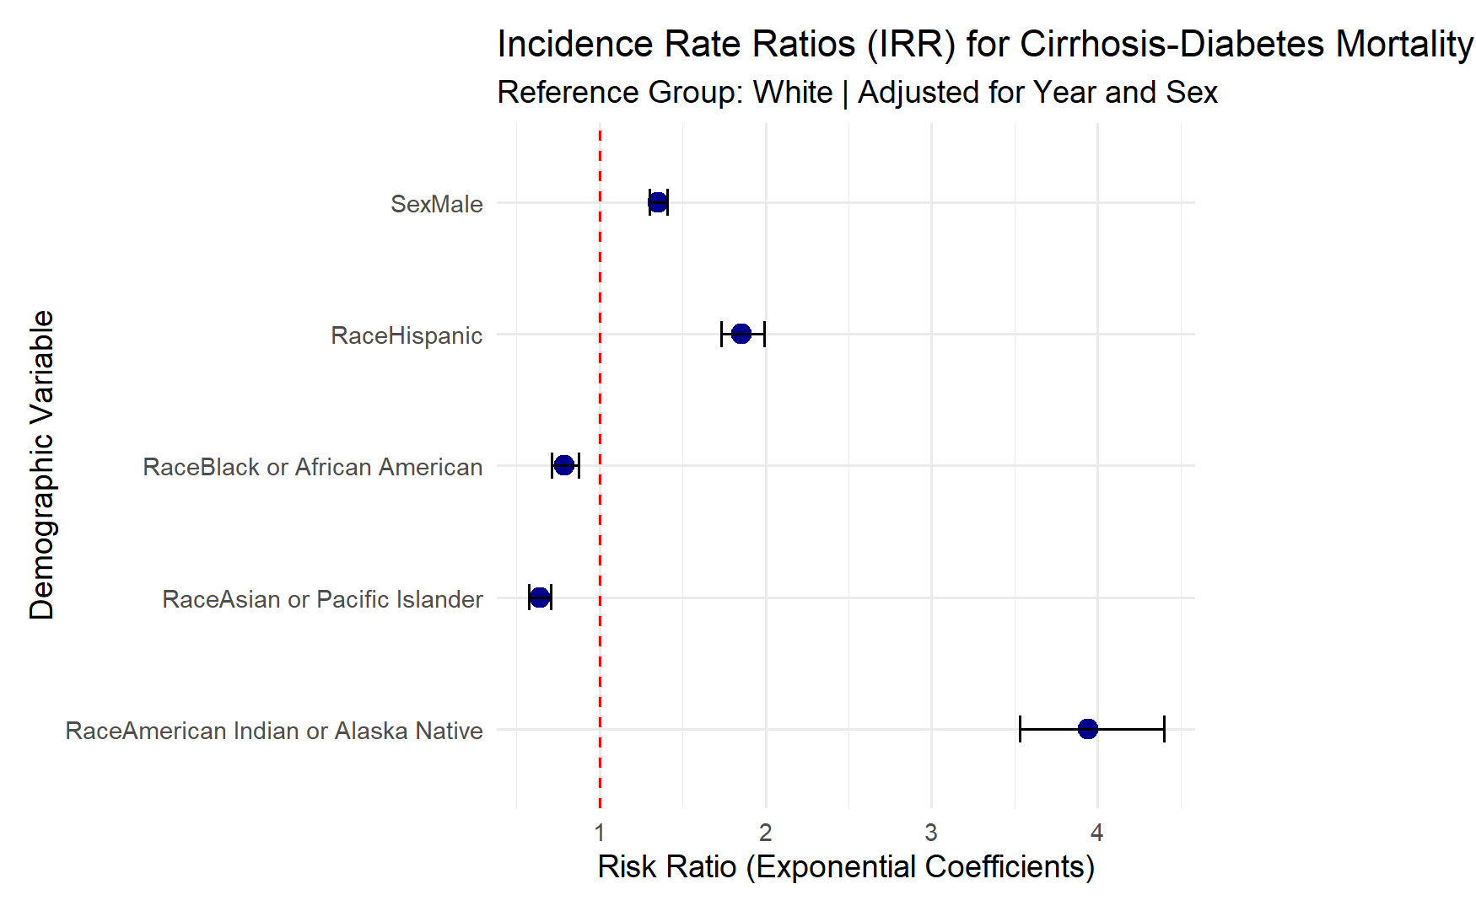

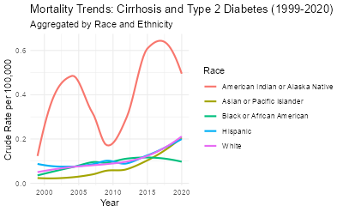

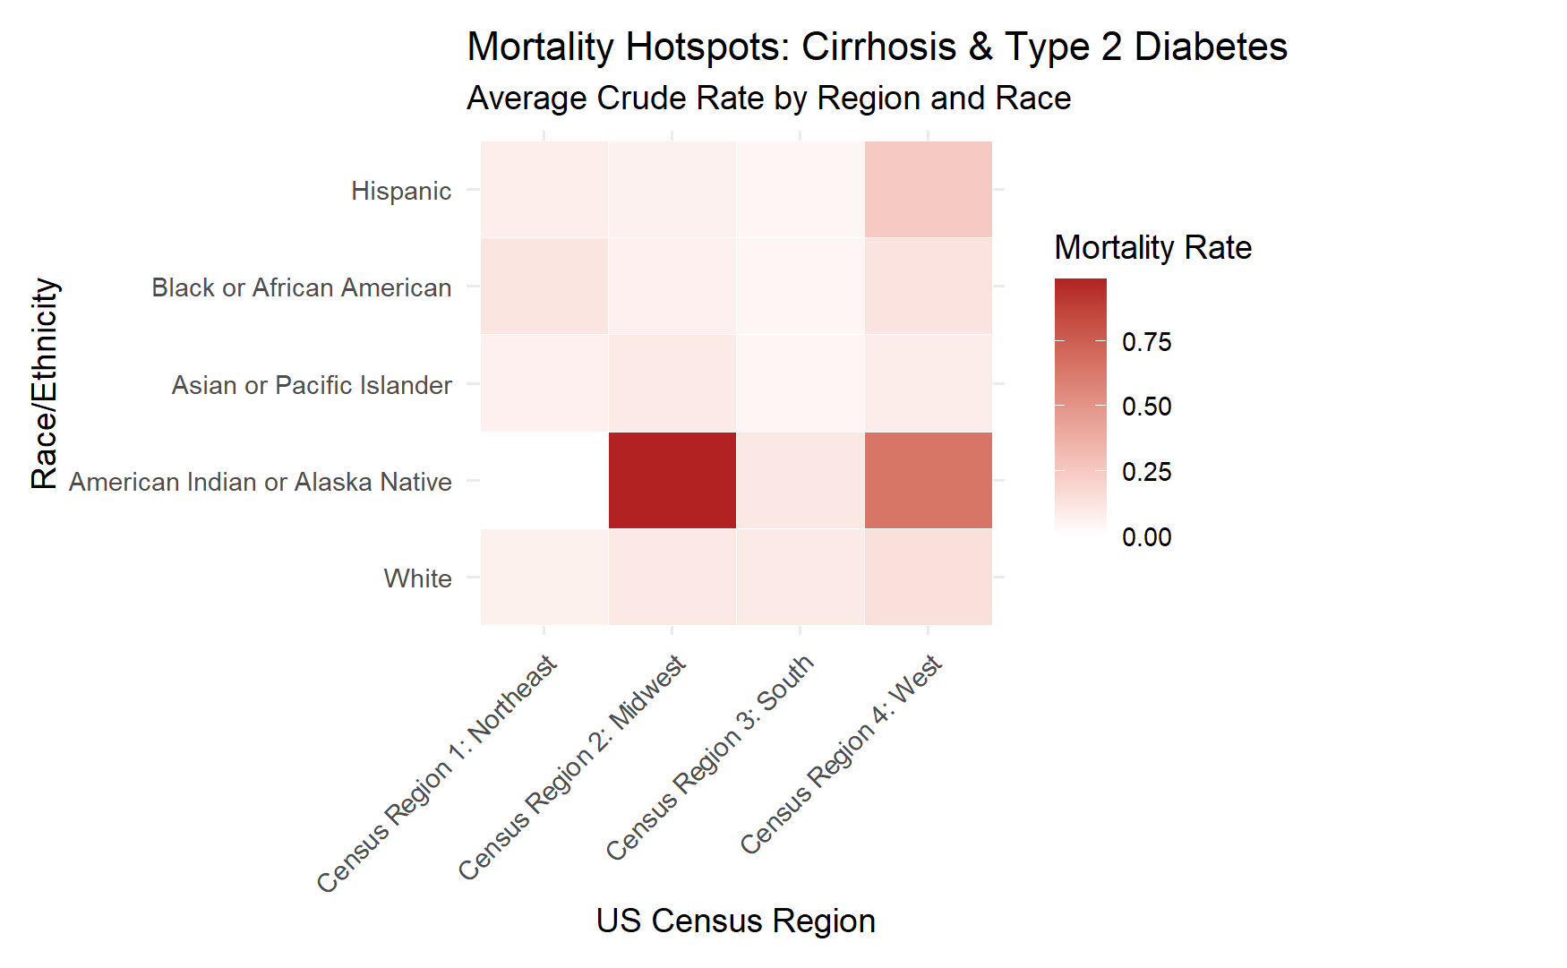

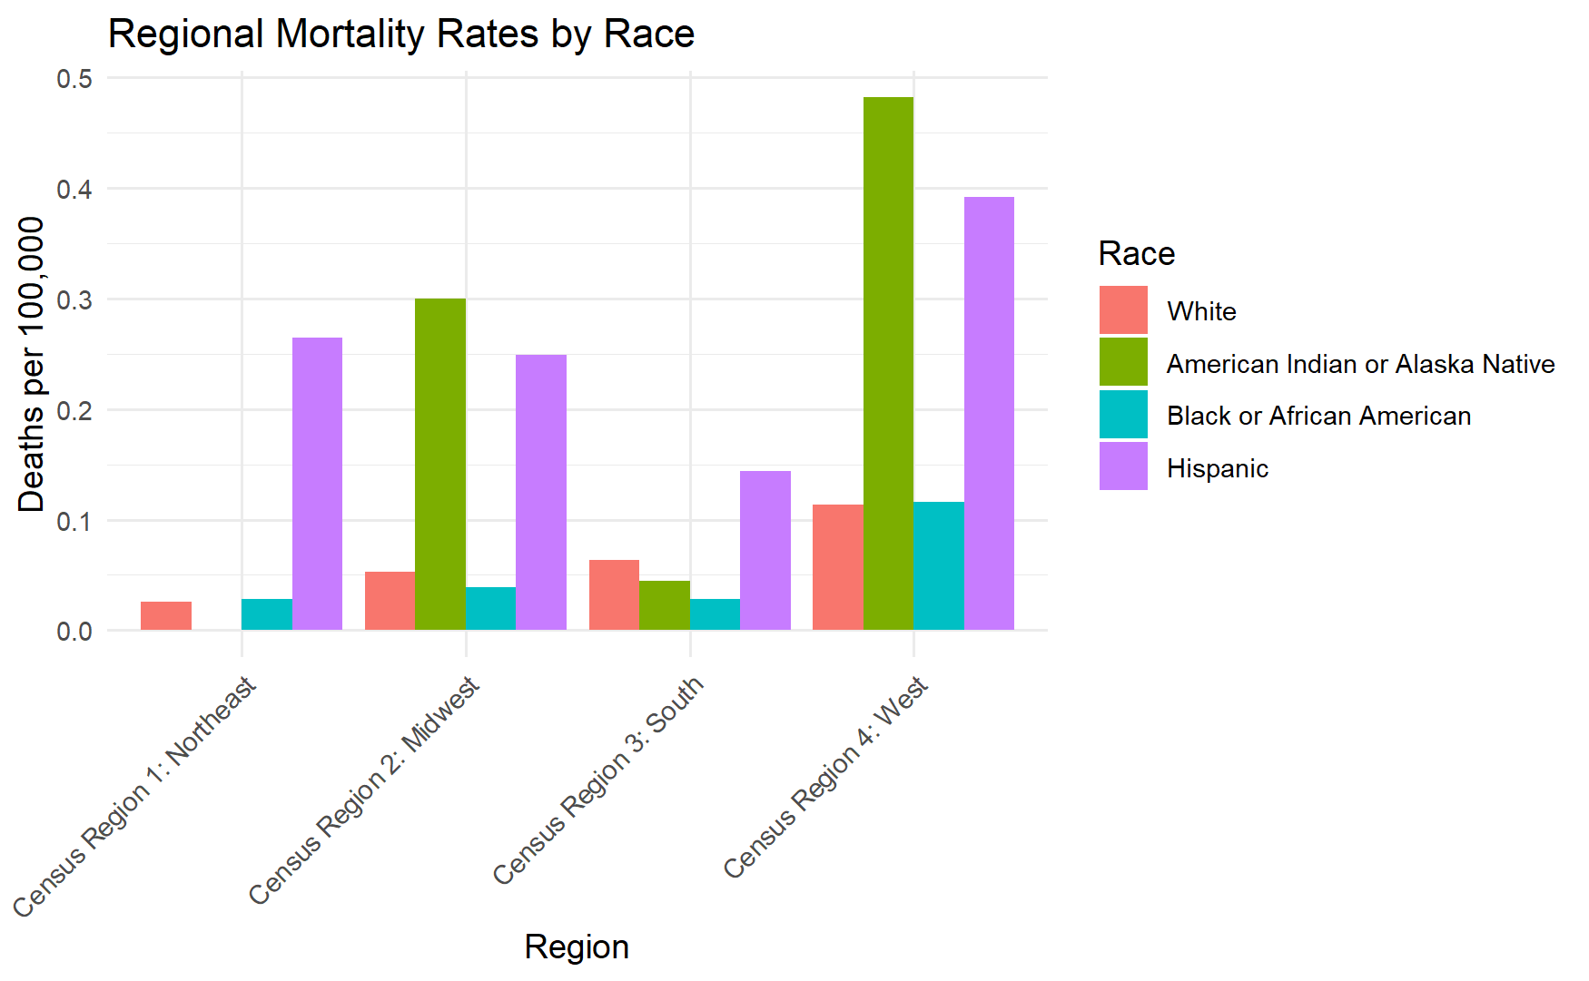

# A tibble: 4 × 3
`Census Region` AIAN_Disparity_Ratio Hispanic_Disparity_Ratio
<chr> <dbl> <dbl>
1 Census Region 1: Northeast 0 10.4
2 Census Region 2: Midwest 5.69 4.73
3 Census Region 3: South 0.709 2.27
4 Census Region 4: West 4.24 3.44

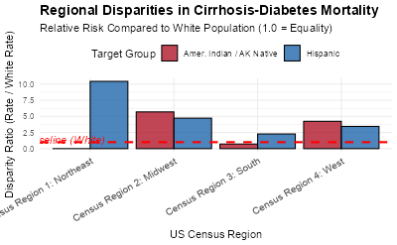

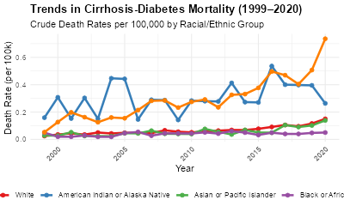

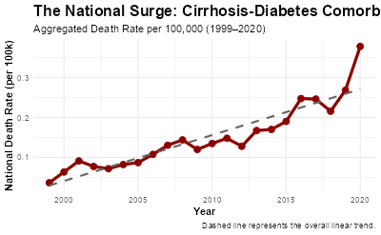

Call:
glm.nb(formula = Deaths_Both ~ Race + Sex + Year + offset(log(Population)),
data = robust_df, init.theta = 30.45950644, link = log)

Coefficients:
Estimate Std. Error z value Pr(>|z|)
(Intercept) -1.723e+02 1.998e+00 -86.198 <2e-16 ***
RaceAsian or Pacific Islander -2.481e-01 1.078e-01 -2.302 0.0214 *
RaceHispanic 5.129e-01 1.057e-02 48.521 <2e-16 ***
SexMale 4.031e-01 9.664e-03 41.714 <2e-16 ***
Year 7.910e-02 9.929e-04 79.670 <2e-16 ***
---
Signif. codes: 0 ‘***’ 0.001 ‘**’ 0.01 ‘*’ 0.05 ‘.’ 0.1 ‘ ’ 1

(Dispersion parameter for Negative Binomial(30.4595) family taken to be 1)

Null deviance: 15745.6 on 2735 degrees of freedom
Residual deviance: 2632.5 on 2731 degrees of freedom
AIC: 19528

Number of Fisher Scoring iterations: 1

Theta: 30.46
Std. Err.: 1.42

2 x log-likelihood: -19515.74
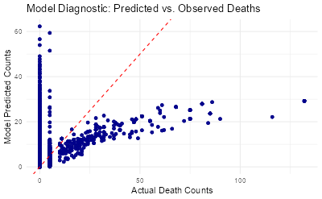

Predicted rate for 2026: 0.31
Percent increase from 2019 to 2026: 15.14 %

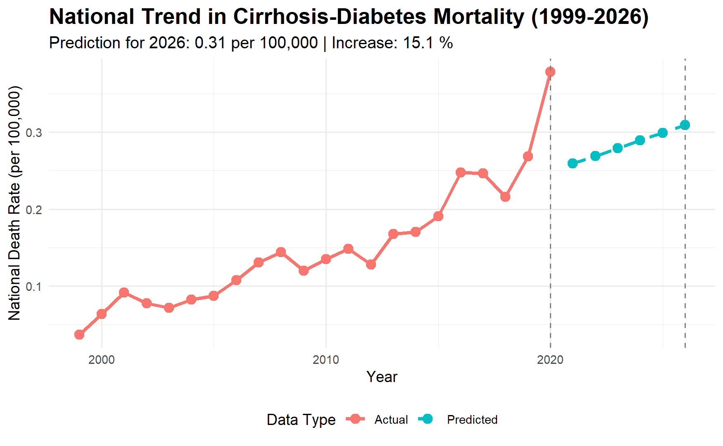

Predicted rate for 2026 (using 2018-2019 trend): 0.64
Percent increase from 2019 to 2026: 137.19 %

