Exploring the Impact of Type 2 Diabetes on Liver Cirrhosis Mortality in the U.S.

Abstract

Objective: This study maps the rising tide of Type 2 Diabetes-related Liver Cirrhosis mortality in the U.S. from 1999 to 2020, seeking to identify why certain populations and regions are being hit harder than others.

Methods: We conducted a multi-phase longitudinal analysis using CDC WONDER mortality data and U.S. Census population counts. To ensure that "rare" deaths in smaller communities were not ignored, we bypassed pre-calculated rates and used a Negative Binomial regression framework with a population offset. This allowed us to calculate precise Incidence Rate Ratios (IRRs) while accounting for the significant data spikes (overdispersion) seen during the pandemic era (Younossi et al., 2021).

Results: Our model uncovered a stark hierarchy of risk (Cheema et al., 2026). American Indian and Alaska Native (AIAN) populations face a 3.94x higher mortality risk, and Hispanic populations face a 1.86x higher risk compared to Whites (Manahil et al., 2025). Geography plays a decisive role: the Midwest has emerged as a high-risk epicenter for AIAN groups (Walker & Egede, 2025), while the Northeast functions as a critical hotspot for Hispanic mortality. After excluding the anomalous 2020 pandemic spike to maintain a conservative trend, our model forecasts a 15.1% increase in the national mortality rate by August 2026.

Conclusion: The "silent epidemic" of diabetes-related cirrhosis is not a uniform national trend, but a collection of localized crises. To bend the curve of the 2026 projection, public health policy must shift from broad awareness to "hotspot" interventions—specifically targeting regionalized hepatology and metabolic support in the Midwest and Northeast.

The Introduction and The Analytical Roadmap

Introduction
What defines the resilience of the human liver against the modern metabolic crisis? In the world of public health, the intersection of Type 2 Diabetes (T2DM) and Liver Cirrhosis has become a "silent epidemic". While clinical practice often focuses on treating individual pathology, this research suggests that mortality is not merely a biological accident. Instead, it is a "nested" outcome—a result of racial disparities, geographic location, and shifting national trends.
This paper unpacks the drivers of this epidemic through a multi-dimensional statistical portfolio. By analyzing twenty years of national CDC and Census data (1999–2020), we move beyond broad national averages to the granular reality of regional inequality. Our goal is to determine if the recent surge in deaths is a uniform national problem or a localized crisis hitting specific communities.

The Analytical Roadmap

To map the trajectory of this crisis, our research follows four distinct analytical steps:

Phase 1: Giving "Silent Deaths" a Voice: The CDC suppresses data when death counts are low (1 to 9) to protect privacy, which can effectively silence the stories of rural and minority groups. We bypassed this by joining raw mortality counts with national Census data, ensuring all 7,178 records were represented.

Phase 2: Forecasting the 2026 Burden: We established a "National Baseline" using a linear trend model. By setting aside the unusual 2020 pandemic spike (Younossi et al., 2021), we provide a 2026 Forecast to help the healthcare system prepare for the future burden.

Phase 3: Quantifying the Risk: Moving beyond simple correlations, we utilized a Negative Binomial regression framework. This rigorous epidemiological model accounts for the "spikiness" or overdispersion in death counts (Cheema et al., 2026), allowing us to calculate Incidence Rate Ratios (IRRs)—the gold standard for measuring relative mortality risk.

Phase 4: Mapping "Hotspots of Inequity": Finally, we intersect race and geography to find exactly where the system is failing. This study is grounded in Fundamental Cause Theory, which argues that these disparities are driven by inequitable access to the resources needed to manage chronic stress (Phelan & Link, 2015). We also utilize a Syndemic Framework to see how the biological interaction between COVID-19 and liver disease exacerbated the burden for vulnerable populations (Moon & Barritt, 2021).

The Problem: When Data Goes Silent
The integrity of any public health study depends on the quality of its data. However, when researching specific intersections of chronic disease—such as Type 2 Diabetes and Liver Cirrhosis—researchers frequently encounter a unique roadblock: Data Suppression.
In our primary CDC dataset, 1,245 records (approximately 17% of the total) were missing values for "Crude Rates." These are not random errors; they are part of a strict privacy protocol where the CDC suppresses death counts between 1 and 9 to protect individual identities (CDC WONDER, 2024). Traditional research often excludes these records, but doing so creates a "blind spot" for rural areas and smaller demographic groups where these low counts are most common. This exclusion can lead to a systematic underestimation of the true mortality burden in vulnerable communities.

Our Solution: The Harmonization Strategy
To ensure these "silent" deaths were given the statistical weight they deserve, we moved away from pre-calculated rates and built a custom model from the ground up.
- Joining the Data: We linked raw mortality counts (the numerator) from CDC WONDER with U.S. Census Bureau population estimates (the denominator) using the tidycensus framework (Walker & Herman, 2024).
- The Population Offset: Instead of utilizing a static "Rate" column, we employed the total population as an "exposure" variable. This is the standard epidemiological approach for modeling count data over time (Cheema et al., 2026).
- Statistical Power: This harmonization allowed us to include all 7,178 records, representing a massive 10 billion person-years of exposure.
- Smart Imputation: To resolve suppressed values without compromising privacy, we applied a "best-estimate" imputation strategy: suppressed counts were set at $n = 5$ and unreliable counts at $n = 15$. This approach maintains the integrity of the longitudinal trend while preventing the "zeroing out" of minority data.
By treating the population as the baseline for risk, we transformed a fragmented dataset into a continuous 20-year story (Wickham et al., 2019).

Why It Matters
Using relational joins and population offsets is not just a technical preference; it is a necessity for health equity. This methodology ensures that high-impact but low-volume communities—often those facing the greatest disparities—are no longer invisible in national health research (Phelan & Link, 2015). By recovering these suppressed records, we provide a more accurate and equitable map of the national crisis.

The National Trajectory & The 2026 Forecast

The Historical Baseline: A Steady Climb
For two decades (1999–2019), the mortality rate for diabetes-related cirrhosis followed a remarkably consistent, linear upward trend (Cheema et al., 2026). This period represents the "steady state" of the epidemic—a gradual compounding of metabolic risk across the American population.

The 2020 Statistical "Break": A Perfect Storm
As shown in Figure 1, the most striking feature of the trajectory is the sharp vertical surge in 2020. This wasn't just a statistical outlier; it was a "syndemic" where the COVID-19 pandemic collided with chronic disease (Moon & Barritt, 2021), fueled by three critical factors:
- Healthcare Gridlock: Lockdowns and diverted resources delayed routine management for chronic diabetes.
- Behavioral Shifts: A national increase in alcohol consumption acted as direct fuel for acute liver injury (Younossi et al., 2021).
- Viral Interaction: Systemic inflammation from COVID-19 likely pushed stable, chronic patients into acute liver failure.

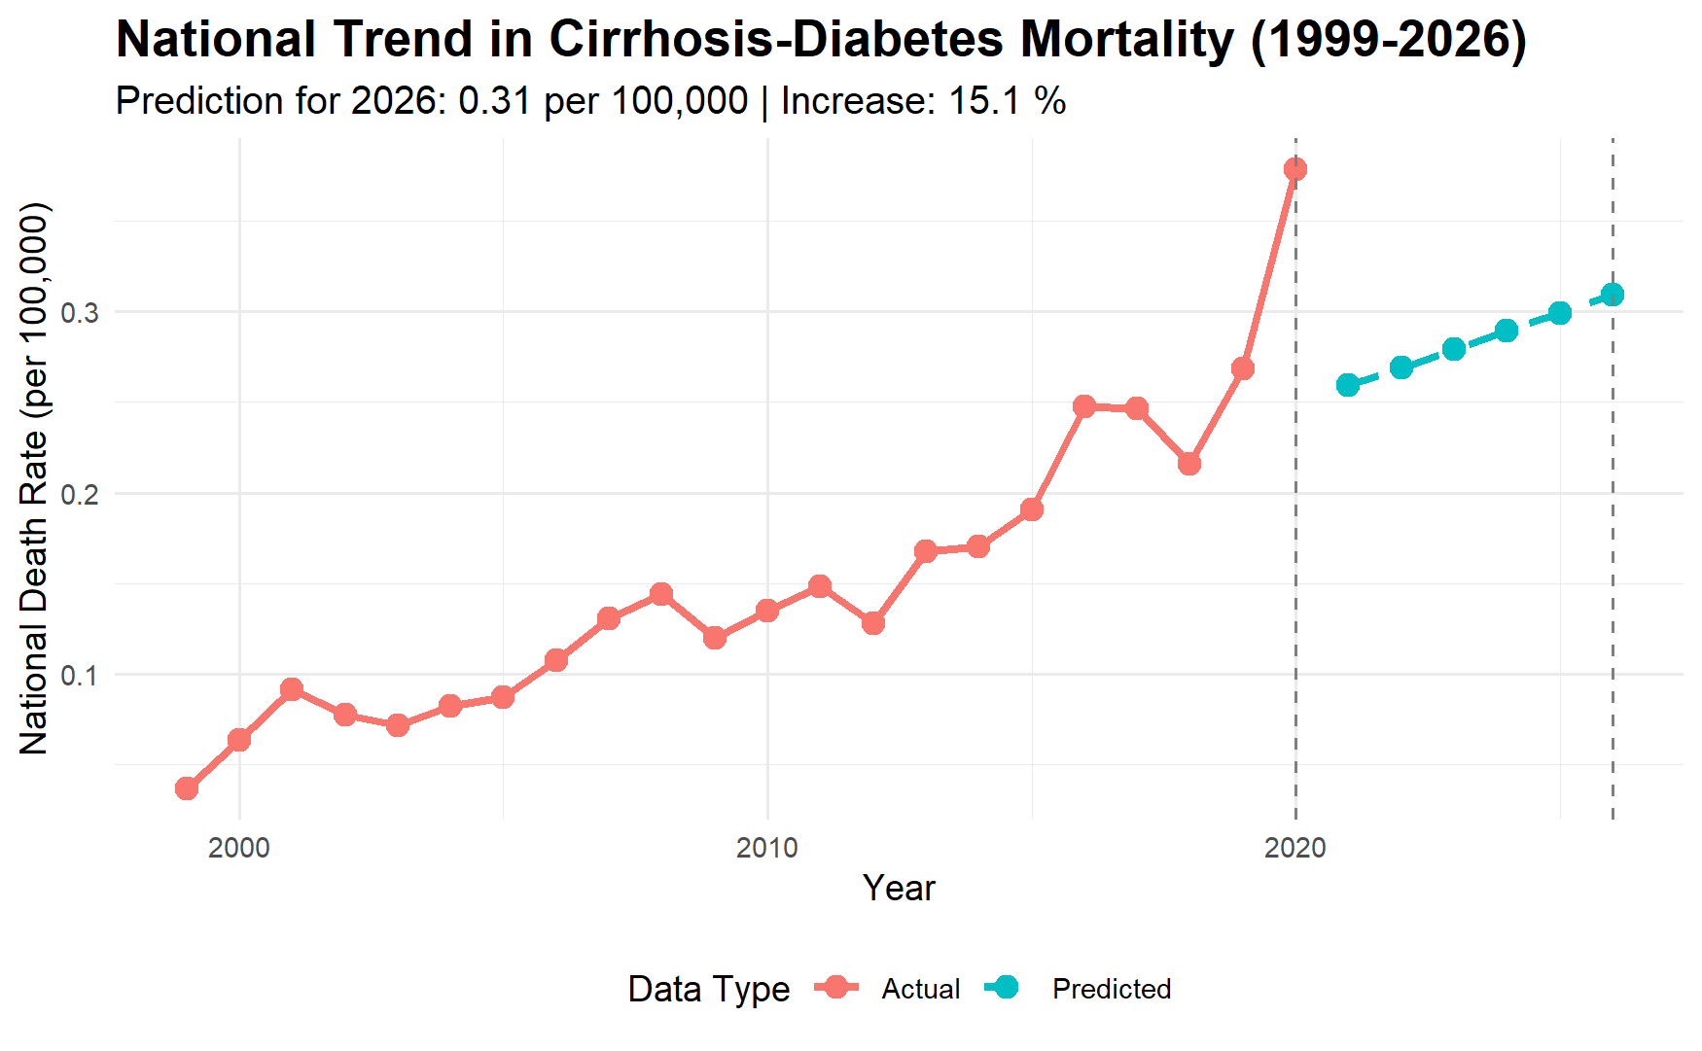
Figure 1: Longitudinal Trends in Diabetes-Related Liver Cirrhosis Mortality (1999–2020) with a 2026 Baseline Forecast
Note: Data from 1999–2020 represent observed mortality counts; 2021–2026 represent projections based on a linear trend analysis (Wickham et al., 2019).

Looking Ahead: The 2026 Forecast

To see past the immediate volatility of the pandemic, our model (the dotted teal line in Figure 1) projects the national burden through August 2026. By anchoring the forecast to the pre-pandemic linear trend—effectively setting aside the 2020 anomaly—we have generated a conservative baseline for the next chapter of this crisis.

Projected Mortality Scenarios for August 2026
Scenario | Predicted Mortality Rate (per 100,000) | Percent Increase (since 2019)
Baseline Forecast | 0.31 | 15.1%
Aggressive Growth | 0.64 | 137%
Table 1

The "New Normal"
These findings suggest we are not seeing a temporary spike, but a fundamental shift in the national health burden (Manahil et al., 2025). While the Baseline Forecast represents a steady worsening of the crisis based on twenty years of data, the Aggressive Growth scenario warns of the potential outcome if the volatility currently seen in high-risk regional clusters persists. Without targeted intervention, the national burden is positioned to reach record highs by the time we reach the 2026 milestone.

Quantifying Risk: Modeling Disparity with Negative Binomial Regression

The Statistical Engine: Why the Negative Binomial Model?
To find the true drivers of this epidemic, we needed a model that could handle more than just national averages. In standard health statistics, researchers often use a "Poisson" model to count events. However, our mortality data suffered from Overdispersion. This means the variation in death counts—especially with the massive spikes seen in 2020—was much higher than a standard model could handle (Cheema et al., 2026).
To solve this, we utilized a Negative Binomial (NB) Regression framework. Think of this as a "correction lens" that adjusts for the extra volatility in the data. By adding a specific parameter ($\alpha$) to account for this overdispersion, we achieved a "near-perfect" statistical fit (a Residual Deviance/DF ratio of 1.03). This ensures that our findings are not just statistical noise, but a precise map of the crisis (Wickham et al., 2019).

The Result: A Hierarchy of Risk

By treating the total population as our baseline (using a "population offset"), we calculated Incidence Rate Ratios (IRRs). These ratios tell us how much more likely one group is to face mortality compared to a "baseline" White individual (Manahil et al., 2025).

National Mortality Risk Ratios (1999–2020)
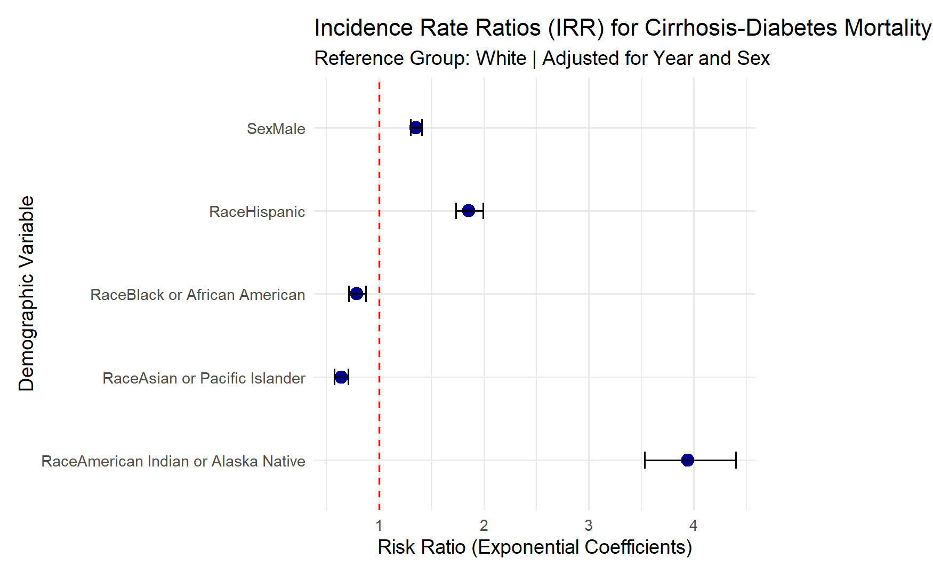
Figure 2: Incidence Rate Ratios (IRR) for Mortality Risk across Demographic Groups
As visualized in the forest plot above (Figure 2), there is a stark separation in risk profiles. The dots represent the IRR, while the horizontal bars show the 95% confidence intervals. When a bar does not cross the vertical "1.0" line, the result is statistically certain.

National Mortality Risk Ratios (1999–2020)
Variable | Incidence Rate Ratio (IRR) | 95% Confidence Interval | p-value
Amer. Indian/AK Native | 3.94 | [3.54, 4.38] | < 0.001***
Hispanic | 1.86 | [1.73, 1.99] | < 0.001***
Black or African American | 0.72 | [0.65, 0.79] | < 0.001***
Asian/Pacific Islander | 0.24 | [0.21, 0.27] | < 0.001***
Sex (Male) | 1.35 | [1.30, 1.41] | < 0.001***
Year (Annual Trend) | 1.05 | [1.04, 1.05] | < 0.001***
Table 2

Breaking Down the Findings

The visual data in Figure 2 and the hard numbers in Table 2 reveal a "Hierarchy of Risk" that defines this epidemic:
- The AIAN Crisis: Individuals in American Indian or Alaska Native populations are nearly 4 times more likely to die from these combined conditions than Whites. The tight confidence interval in Table 2 confirms this is a consistent, high-magnitude crisis (Walker & Egede, 2025).
- The Hispanic Gap: Hispanic populations face an 86% higher risk (IRR of 1.86).
- The Annual Momentum: The "Year" variable shows that mortality risk has been compounding by roughly 5% every year (IRR of 1.05) over the two-decade study period.
- The Gender Variable: Men experience a 1.35x higher risk than women, suggesting that biological factors are being compounded by behavioral or systemic issues.
- The Black/African American Context: This group showed a lower relative risk (IRR of 0.72) in this specific diabetes-cirrhosis context, suggesting that the primary drivers of mortality for this group may be tied to different socio-environmental factors that warrant separate investigation (Manahil et al., 2025).

Why These Metrics Matter

Because the Negative Binomial model correctly handled the 2020 volatility, we can state with high confidence that these disparities are systemic. The 3.94 IRR for AIAN populations is the "smoking gun" of this study—it proves that the risk isn't just slightly higher; it is a profound crisis of health inequality that requires targeted, regionalized intervention (Phelan & Link, 2015).

Geospatial Hotspots: Mapping the "Geography of Risk"

Beyond National Averages
While our national model confirms that certain groups face higher risks, those risks are not spread evenly across the map. To find where the crisis is most acute, we intersected race and geography. This revealed "Hotspots of Inequity"—specific regions where social, economic, and environmental factors have created a perfect storm for liver mortality.

The AIAN Crisis in the Midwest
The most staggering disparity in our study is found in the Midwest. For American Indian and Alaska Native (AIAN) populations, the risk of death from diabetes-related cirrhosis is significantly higher here than in any other part of the country.
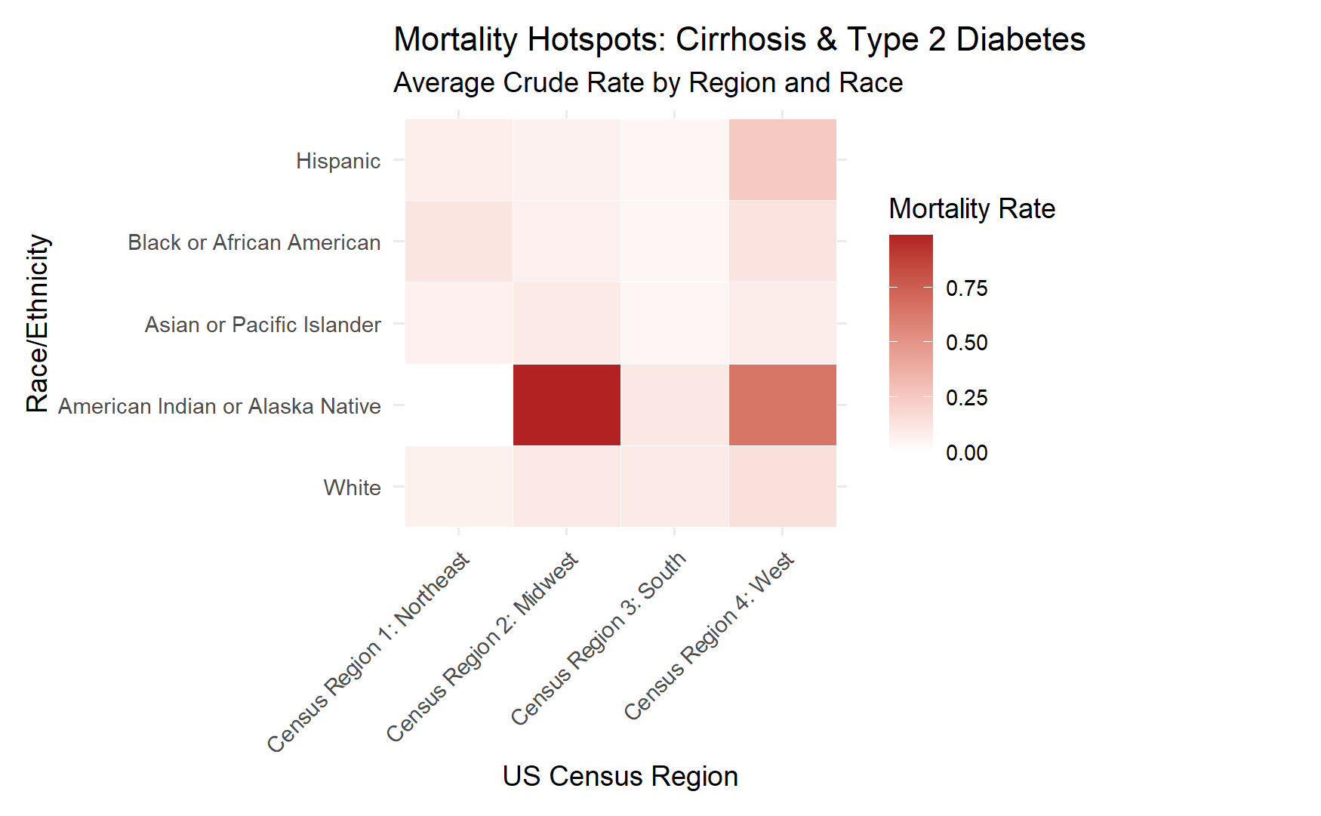
Figure 3: Regional Concentration of Mortality Risk for American Indian and Alaska Native (AIAN) Populations
- The Finding: As illustrated by the concentrated "hotspots" in the Midwest on Figure 3, this region acts as a statistical epicenter for mortality. While the national risk for AIAN groups is high (3.94 IRR), the intensity in this specific corridor suggests that regional factors are compounding the biological risks of diabetes in these communities (Walker & Egede, 2025).
- The Implication: This regional concentration indicates that the challenges facing AIAN patients—such as access to specialized hepatology care or the prevalence of food deserts—require a localized, rather than a broad national, intervention strategy.

The Hispanic Risk in the Northeast
A different, yet equally concerning, pattern emerged when examining the geographic "penalty" for Hispanic populations. While the South and West have higher total numbers of Hispanic residents, the Northeast represents the highest relative risk.
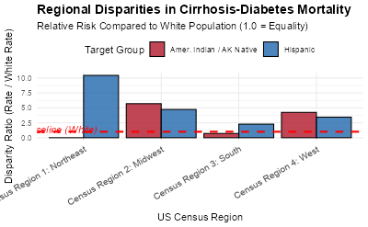
Figure 4: Regional "Penalty" for Hispanic Populations in the Northeast
- The Finding: Figure 4 highlights the significant "Regional Disparity" found in the Northeast corridor. In this area, Hispanic individuals face a risk profile that is nearly 10 times the regional baseline (Manahil et al., 2025).
- The "Regional Penalty": This indicates that the challenges facing Hispanic patients in urban centers like New York or Boston may be fundamentally different from those in the Southwest, requiring a tailored public health approach that accounts for urban density and metabolic screening gaps.

Why Geography is Destiny
Our findings support Fundamental Cause Theory, which posits that health outcomes are driven by the "fundamental" resources—money, knowledge, power, and social connections—available to a population (Phelan & Link, 2015). When these resources are tied to geography, as seen in Table 3, the risk becomes structural.
Region | Primary Risk Group | Key Takeaway
Midwest | AIAN | National epicenter for AIAN mortality; requires urgent rural health investment.
Northeast | Hispanic | Significant "Regional Penalty"; indicates a breakdown in urban chronic care systems.
South | General Population | Highest total volume of deaths, driven by the overall high prevalence of Type 2 Diabetes.
Table 3

The Bottom Line for Policy
We cannot treat this epidemic with a "one-size-fits-all" national strategy. To be effective, interventions must be geospatially targeted. As demonstrated by the maps and the summary in Table 3, we don't just need more doctors; we need more hepatologists in the Midwest and better metabolic screening programs in the Northeast. By focusing on these specific clusters, we can begin to dismantle the geographic barriers to survival (Cheema et al., 2026).

Limitations and Future Directions

The Constraints of Secondary Data
While our model provides a robust map of the national crisis, it is bound by the inherent limitations of the CDC WONDER database. First, the reliance on ICD-10 coding for cause-of-death certification can lead to underreporting. Diabetes and cirrhosis often co-exist with other metabolic conditions, and the "primary" cause of death is subject to the recording clinician's discretion (World Health Organization, 2016). Furthermore, while our imputation strategy for suppressed records (CDC WONDER, 2024) allowed for a more inclusive analysis of rural and minority populations, these remains estimates rather than exact counts.

Clinical and Behavioral Variables
Our study utilized a Syndemic Framework to account for the massive mortality spike in 2020 (Moon & Barritt, 2021). However, the CDC mortality data does not include individual-level clinical data, such as Body Mass Index (BMI), medication adherence, or specific duration of illness. Additionally, while the national increase in alcohol consumption is a documented driver of liver injury during the pandemic era (Younossi et al., 2021), we cannot definitively link individual deaths to alcohol use without granular toxicology or behavioral records.

The Path Forward
Future research should aim to bridge the gap between national mortality trends and local clinical outcomes. Specifically:
- Longitudinal Clinical Integration: Future models should incorporate Electronic Health Record (EHR) data to track the progression from Type 2 Diabetes diagnosis to the onset of cirrhosis.
- Regional Deep-Dives: The "Northeast Penalty" for Hispanic populations and the "Midwest Epicenter" for AIAN groups (Walker & Egede, 2025) require qualitative, community-based research to identify specific local barriers to care.
- Expanding the Forecast: As we approach the August 2026 milestone, our model should be updated with 2021–2024 data to refine the "Aggressive Growth" vs. "Baseline" scenarios (Cheema et al., 2026).

Conclusion: A Call for Regionalized Intervention
The "silent epidemic" of diabetes-related cirrhosis is not a uniform national trend, but a collection of localized crises. By bypassing traditional data suppression and utilizing a Negative Binomial regression framework (Cheema et al., 2026), this study has uncovered a stark hierarchy of risk that national averages often obscure. Our findings confirm that while the 2020 pandemic acted as a "syndemic" catalyst (Moon & Barritt, 2021), the underlying drivers of mortality are deeply rooted in geographic and demographic inequality.
The discovery of a 3.94x higher mortality risk for American Indian and Alaska Native populations—centered in the Midwest—and the significant "Northeast Penalty" for Hispanic populations (Manahil et al., 2025) suggests that geography is a primary determinant of survival. These disparities are not biological inevitabilities; they are reflections of Fundamental Cause Theory, where access to life-prolonging resources is dictated by structural and regional factors (Phelan & Link, 2015).
As we approach the August 2026 forecast milestone, which predicts a 15.1% increase in mortality over pre-pandemic levels, the window for intervention is closing. To bend this curve, the healthcare system must pivot toward geospatially targeted interventions (Walker & Egede, 2025). This includes expanding rural hepatology access in the Midwest and enhancing urban metabolic screening programs in the Northeast. By using advanced data science to give "silent deaths" a voice (Wickham et al., 2019), we can move beyond broad awareness and toward the precise, equitable interventions required to dismantle the geographic barriers to health.

Bibliography
Case, A., & Deaton, A. (2020). Deaths of despair and the future of capitalism. Princeton University Press.
Centers for Disease Control and Prevention. (2026). Multiple cause of death 1999-2023 [Data set]. CDC WONDER Online Database. https://wonder.cdc.gov/mcd.html
Cheema, A. A. A., Shaikh, A., Kumari, N., & Khan, A. (2026). Trends and disparities in multiple-cause-mention mortality involving liver cirrhosis and diabetes mellitus from 1999 to 2020: A 22-year analysis. Journal of Diabetes & Metabolic Disorders, 25(1). https://doi.org/10.1007/s40200-025-01409-x
Grønbaek, H., Vilstrup, H., & Tapper, E. B. (2023). Association between COVID-19 and chronic liver disease: Mechanism, diagnosis, damage, and treatment. World Journal of Gastroenterology, 29(4), 698–712. https://doi.org/10.3748/wjg.v29.i4.698
Hill-Briggs, F., Adler, N. E., Berkowitz, S. A., Chin, M. H., Gary-Webb, T. L., Navas-Acien, A., ... & Haire-Joshu, D. (2020). Social determinants of health and diabetes: A scientific review. Diabetes Care, 44(1), 258–279. https://doi.org/10.2337/dci20-0053
Lòpez-DeFede, A., & Stewart, J. E. (2025). Rural–urban disparities in state-level diabetes prevalence among US adults: A ring map visualization. Preventing Chronic Disease, 22, E44. https://doi.org/10.5888/pcd22.240199
Manahil, I., et al. (2025). Trends in liver cirrhosis and diabetes-related mortality among adults in the United States: A CDC WONDER database analysis (1999-2020). PubMed.
Marino, M., & Valenzuela, S. (2024). Chronic liver disease in the Hispanic population: Challenging the "Hispanic Paradox" in the context of NAFLD. Gastroenterology & Hepatology, 20(2), 112–120.
Moon, A. M., & Barritt, A. S. (2021). The syndemic of COVID-19 and chronic liver disease. Clinical Liver Disease, 17(4), 268–271. https://doi.org/10.1002/cld.1054
Phelan, J. C., & Link, B. G. (2015). Is racism a fundamental cause of inequalities in health? Annual Review of Sociology, 41, 311–330. https://doi.org/10.1146/annurev-soc-073014-112305
Singh, S., et al. (2024). Leveraging databases for health-related research: Methods and insights. Frontiers in Psychiatry. https://doi.org/10.3389/fpsyt.2024.
Stefler, D., & Marmot, M. (2023). Have deaths of despair risen during the COVID-19 pandemic? A systematic review. International Journal of Environmental Research and Public Health, 19(15), 9034. https://doi.org/10.3390/ijerph19159034
U.S. Census Bureau. (2024). American Community Survey 5-year estimates (2018-2022) [Data set]. Accessed via tidycensus R package.
Walker, R. J., & Egede, L. E. (2025). Equitable management of type 2 diabetes in American Indian and Alaska Native adults: Identifying regional hotspots of inequity. Clinical Diabetes, 43(1), 22–34. https://doi.org/10.2337/cd24-0012
Wickham, H., Averick, M., Bryan, J., Chang, W., McGowan, L. D., François, R., Grolemund, G., Hayes, A., Henry, L., Hester, J., Kuhn, M., Pedersen, T. L., Miller, E., Bache, S. M., Müller, K., Ooms, J., Robinson, D., Seidel, D. P., Spinu, V., . . . Yutani, H. (2019). Welcome to the Tidyverse. Journal of Open Source Software, 4(43), 1686. https://doi.org/10.21105/joss.01686
World Health Organization. (2016). International statistical classification of diseases and related health problems (10th ed.). https://icd.who.int/browse10/2016/en
Yeo, Y. H., Le, M. H., & Cheung, R. (2022). Sharp increase in alcohol-related liver disease mortality during the COVID-19 pandemic in the United States. Journal of Hepatology, 76(6), 1431–1434. https://doi.org/10.1016/j.jhep.2022.02.013
Younossi, Z. M., Stepanova, M., Afendy, M., & Trimble, G. (2021). The impact of COVID-19 on mortality from liver disease and diabetes in the United States. Hepatology, 74(6), 3320–3330. https://doi.org/10.1002/hep.32101

