buildroot学习：

Cannot execute cross-compiler '/home/young/tq210-toolchain/bin/arm-tq210-linux-gcc'
>>> toolchain-external-custom Configuring
Cannot execute cross-compiler '/home/young/tq210-toolchain/bin/arm-tq210-linux-gcc'
package/pkg-generic.mk:217: recipe for target '/home/young/buildroot-2017.08.1/output/build/toolchain-external-custom/.stamp_configured' failed
make[1]: *** [/home/young/buildroot-2017.08.1/output/build/toolchain-external-custom/.stamp_configured] Error 1
Makefile:79: recipe for target '_all' failed
make: *** [_all] Error 2
~/buildroot-2017.08.1$

处理：不要去指定gcc编译链地址

已有交叉编译链，自己去指定路径的情况

//----------------------------------------------------------------------------------------------------------------------
External toolchain kernel headers series (3.2.x) ---> （最好选用与平台所用的linux版本一致的headers，具体还要看交叉编译工具是否支持）
这个不太理解

Buildroot制作根文件系统过程（基于MYD-AM335X开发板） - ARM嵌入式 - 米尔科技论坛
http://www.myir-tech.com/bbs/thread-7134-1-1.html

External toolchain kernel headers series (3.2.x)--->（最好选用与平台所用的linux版本一致的headers，具体还要看交叉编译工具是否支持）

不太理解：
tq210 用的3.0.8的Linux Kernel ，选了3.0.x，报错

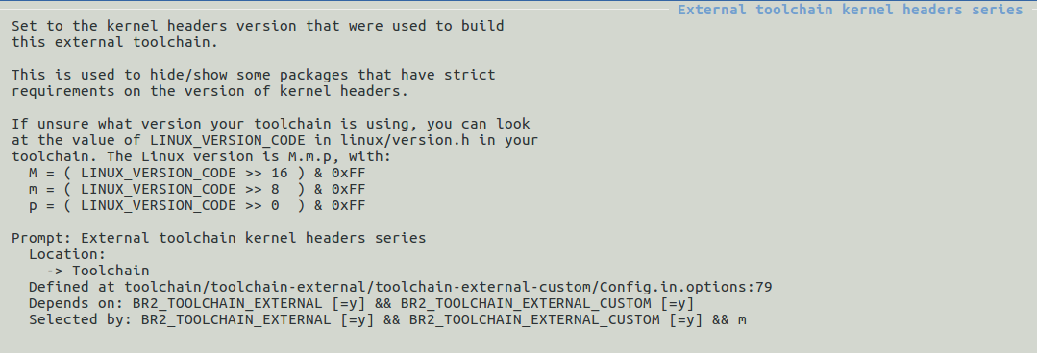

~/buildroot-2017.08.1$ make menuconfig
mkdir -p /home/young/buildroot-2017.08.1/output/build/buildroot-config/lxdialog
PKG_CONFIG_PATH="" make CC="/usr/bin/gcc" HOSTCC="/usr/bin/gcc" \
obj=/home/young/buildroot-2017.08.1/output/build/buildroot-config -C support/kconfig -f Makefile.br mconf
mktemp: 无法通过模板"/tmp/tmp.XXXXXXXXXX" 创建文件: 权限不够
/usr/bin/gcc -D_GNU_SOURCE -I/usr/include/ncursesw -DCURSES_LOC="<ncurses.h>" -DNCURSES_WIDECHAR=1 -DLOCALE -I/home/young/buildroot-2017.08.1/output/build/buildroot-config -DCONFIG_=\"\" -MM *.c > /home/young/buildroot-2017.08.1/output/build/buildroot-config/.depend 2>/dev/null || :
mktemp: 无法通过模板"/tmp/tmp.XXXXXXXXXX" 创建文件: 权限不够
/usr/bin/gcc -D_GNU_SOURCE -I/usr/include/ncursesw -DCURSES_LOC="<ncurses.h>" -DNCURSES_WIDECHAR=1 -DLOCALE -I/home/young/buildroot-2017.08.1/output/build/buildroot-config -DCONFIG_=\"\" -c conf.c -o /home/young/buildroot-2017.08.1/output/build/buildroot-config/conf.o
mktemp: 无法通过模板"/tmp/tmp.XXXXXXXXXX" 创建文件: 权限不够
mktemp: 无法通过模板"/tmp/tmp.XXXXXXXXXX" 创建文件: 权限不够
mktemp: 无法通过模板"/tmp/tmp.XXXXXXXXXX" 创建文件: 权限不够
*** Unable to find the ncurses libraries or the
*** required header files.
*** 'make menuconfig' requires the ncurses libraries.
***
*** Install ncurses (ncurses-devel) and try again.
***

Makefile:199: recipe for target '/home/young/buildroot-2017.08.1/output/build/buildroot-config/dochecklxdialog' failed
make[2]: *** [/home/young/buildroot-2017.08.1/output/build/buildroot-config/dochecklxdialog] Error 1
Makefile:860: recipe for target '/home/young/buildroot-2017.08.1/output/build/buildroot-config/mconf' failed
make[1]: *** [/home/young/buildroot-2017.08.1/output/build/buildroot-config/mconf] Error 2
Makefile:79: recipe for target '_all' failed
make: *** [_all] Error 2
~/buildroot-2017.08.1$

解决：/tmp 被挂载了，原因是之前测试安装的nfs，使用了
sudo mount -t nfs localhost:/opt/rootfs /tmp
所以卸载就可以，执行
sudo umount -t nfs localhost:/opt/rootfs /tmp

//------------------------------------------------------------------------------------------------------------------
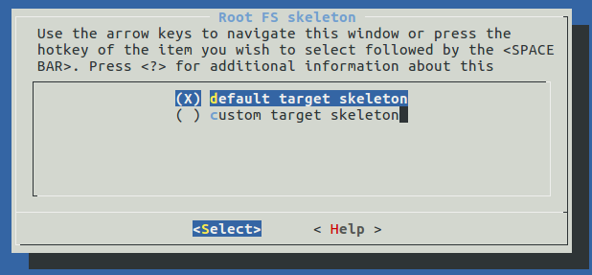

//---------------------------------------------------------------------------------------------------------------
>>> toolchain-external-custom Configuring
RPC support available in C library, please enable BR2_TOOLCHAIN_EXTERNAL_INET_RPC
package/pkg-generic.mk:217: recipe for target '/home/young/buildroot-2017.08.1/output/build/toolchain-external-custom/.stamp_configured' failed
make[1]: *** [/home/young/buildroot-2017.08.1/output/build/toolchain-external-custom/.stamp_configured] Error 1
Makefile:79: recipe for target '_all' failed
make: *** [_all] Error 2
make: Leaving directory '/home/young/buildroot-2017.08.1'
~/tq210-out$

处理：
make menuconfig 然后选上RPC
//-------------------------------------------------------------------------------------------------------------
Version mismatch error. This is libtool 2.4.6, but the libtool: definition of this LT_INIT comes from libtool 2.4. libtool: You should recreate aclocal.m4 with macros from libtool 2.4.6 libtool: and run autoconf again.

解决的问题(补充) - lovemu - 博客园
https://www.cnblogs.com/huanghuang/archive/2011/07/20/2111839.html

【已解决】cygwin下编译buildroot期间编译mpc时出错：libtool: Version mismatch error
https://www.crifan.com/buildroot_cygwin_compile_mpc_libtool_version_mismatch_error/

cd到aclocal.m4路径下，然后执行
1、rm －rf aclocal.m4；
2.autoreconf -f

