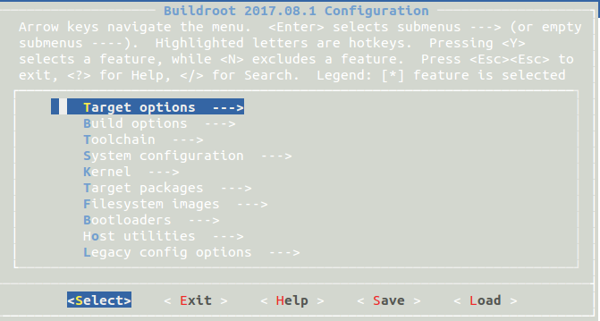

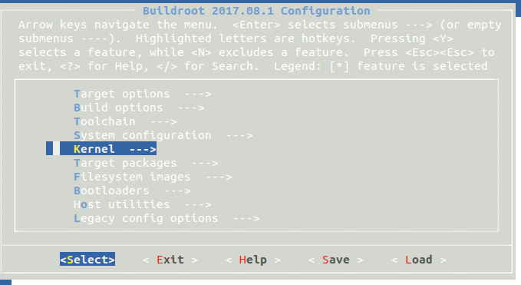

从主界面的Kernel--->进入，空格键选中Linux Kernel，默认出现如图

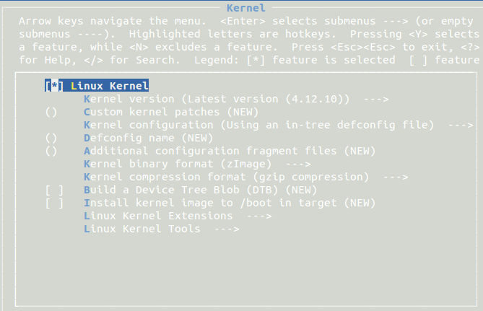

Kernel version (Latest version (4.12.10)) --->

(X) Latest version (4.12.10)

( ) Latest CIP SLTS version (v4.4.83-cip8)

( ) Custom version

( ) Custom tarball

( ) Custom Git repository

( ) Custom Mercurial repository

( ) Custom Subversion repository //根据自己情况需求，空格选中后，连按两次ESC返回

例如内核版本，选择自定义tar包，则在下行出现填入URL的地址，（可以使用本地地址，file:\\）

() Custom kernel patches (NEW) //这个的<Help>显示如下：

A space-separated list of patches to apply to the kernel. Each patch can be described as an URL, a local file path, or a directory. In the case of a directory, all files matching *.patch in the directory will be applied.

Kernel configuration (Using an in-tree defconfig file) --->

(X) Using an in-tree defconfig file

() Defconfig name //Enter进入，输入相应字符串

( ) Use the architecture default configuration

( ) Using a custom (def)config file

() Configuration file path //Enter进入，输入相应字符串

() Additional configuration fragment files (NEW) //这个的<Help>显示如下：

A space-separated list of kernel configuration fragment files,that will be merged to the main kernel configuration file.

Kernel binary format (zImage) --->

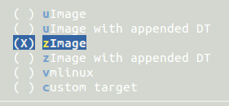

Kernel compression format (gzip compression) --->

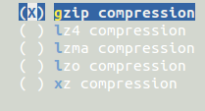

[ ] Build a Device Tree Blob (DTB) (NEW)

Compile one or more device tree sources into device tree blobs. Select the dts files to compile in the options below.

Device tree source (Use a device tree present in the kernel) --->



() Device Tree Source file names (NEW)

Name of the device tree source file, without the trailing .dts. You can provide a list of dts files to build, separated by spaces.

[ ] Install kernel image to /boot in target (NEW)

Linux Kernel Extensions ---> //这个的<Help>比较长，见它的README：

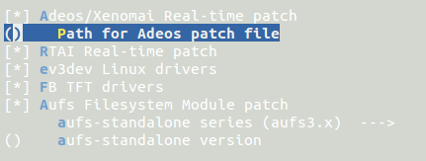

Linux Kernel Tools ---> //这个的<Help>比较长，见它的README

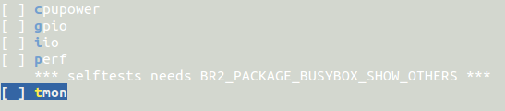

//-------------------------------------------------------------------------------------------------------------

具体应用,可参考

Buildroot构建指南——Linux内核 - zhou_chenz的博客 - CSDN博客

<http://blog.csdn.net/zhou_chenz/article/details/52348217>

使用buildroot编译内核常用几种方式：

1. Linux Kernel的官网(kernel.org)下载并编译内核：
2. 选择自定义的内核版本
3. 选择CPU相应的配置文件
4. Kernel输出的二进制格式 //1）、2）两点为重点，3）次要

退出，make；只编译内核的话，make linux

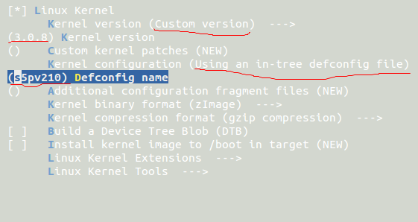

2. 使用用户自己的定制化内核

选择自定义的各种仓库或者tar包

指定url

指定CPU的配置文件.config的路径