User Manual – Bikeway Simulator

1. Introduction
The Bikeway Simulator is a Python-based application designed to model and visualize cyclist behavior across urban bikeway networks. It allows users to define a city network, simulate cyclist movements, and analyze performance indicators such as travel times, flow distribution, and route preferences.

2. System Requirements
Before installing or running the Bikeway Simulator, it's important to ensure that your system meets the necessary technical requirements. These include compatibility with major operating systems, a supported version of Python, and the correct installation of required libraries. Additionally, the simulator expects input data to be provided in specific Excel formats. The following table summarizes the essential system requirements for proper operation.
Requirement | Details
Operating System | Windows, macOS, or Linux
Python Version | 3.7 or higher
Libraries | Listed in requirements.txt
File Format | .xlsx or .xls

3. Preparing Excel Files
- NODOS sheet: defines intersections or entry points.
- ARCOS sheet: defines connections between nodes and attributes.
- Optional sheets: PERFILES and RUTAS for advanced simulations.

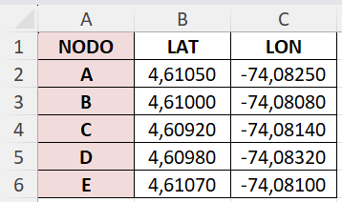
The NODOS sheet defines the key points in the cycling network, such as intersections or access points. Each row represents a unique node identified by a name and may include additional data like geographic coordinates (latitude and longitude). If coordinates are provided, the system automatically calculates real-world distances between nodes using the Haversine formula. This sheet is mandatory for building the network graph.
NODOS Sheet example

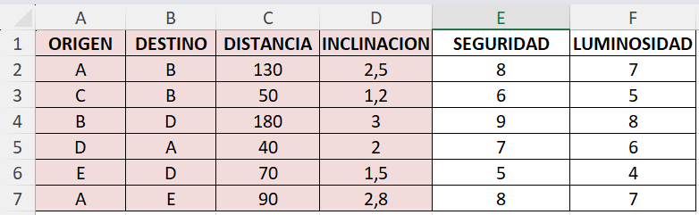
The ARCOS sheet specifies the connections between the nodes listed in the NODES sheet. Each row represents a segment of the cycling path, including attributes such as distance, safety, lighting, and slope. These attributes influence cyclists behavior during the simulation, affecting their speed and route choices. This sheet is also required and must be consistent with the NODES sheet.
ARCOS Sheet example

The PERFILES and RUTAS sheets are optional but enable more advanced and realistic simulations. The PERFILES sheet defines different cyclist types, each with specific preferences for route attributes (e.g., prioritizing safety over distance). Each profile has an associated probability of being selected during the simulation. The RUTAS sheet provides a matrix of destination probabilities for each origin node, allowing the modeling of realistic travel demand patterns across the network.

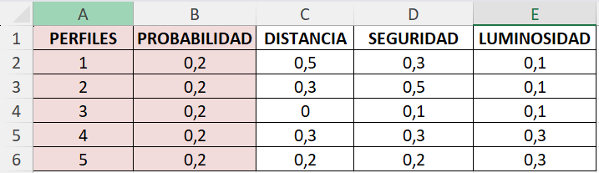
PERFILES Sheet example

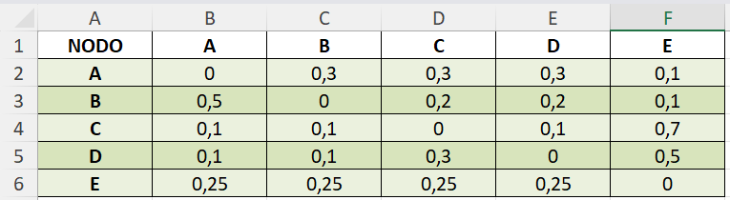
RUTAS Sheet example

4. Starting the Application
- Open terminal or command prompt.
- Navigate to project directory.
- Run: python main.py

To start the simulator, open a terminal or command prompt on your computer. Then, navigate to the folder where the project is located using the cd command. Once you're inside the project directory, run the application by typing python main.py and pressing Enter. This command launches the simulator, which will open a graphical interface with multiple panels. From there, you can begin loading your cycling network, configuring simulation parameters, and visualizing the results in real time.

5. Loading the Bikeway Network
- Click ‘Cargar Grafo’ in the Control Panel.
- Select your Excel file.
- Network appears in the Visualization Panel upon success.

To begin working with the simulator, the user must click the "Cargar Grafo" button located in the Control Panel. This action opens a file selection dialog where the user can choose the prepared Excel file containing the cycling network data. Once the file is selected, the simulator processes and validates its contents—checking for required sheets like NODOS and ARCOS and optionally loading PERFILES and RUTAS if available. Upon successful validation, the graph is internally loaded into the simulator’s configuration system, and the network is rendered visually in the Visualization Panel. This panel displays the nodes and edges of the network using an interactive graph, allowing users to observe the structure and flow of the cycling routes in real time.
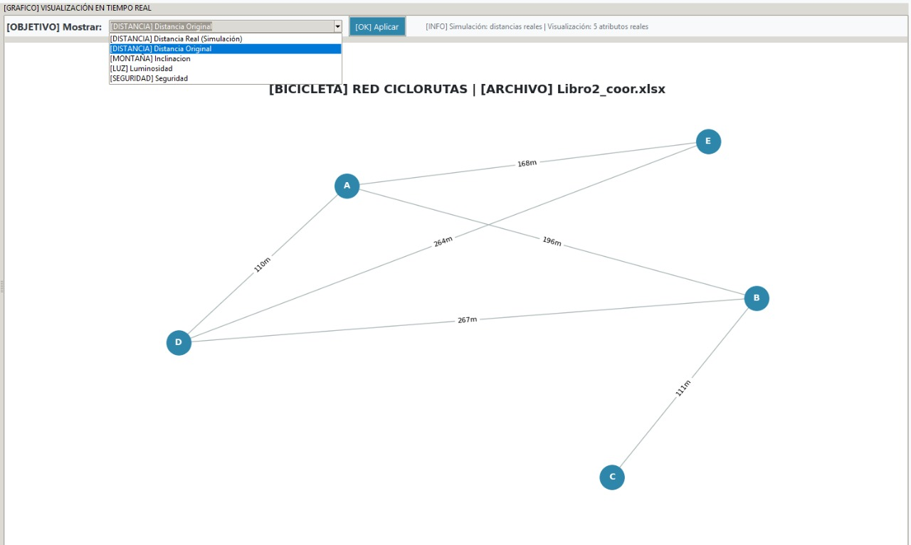
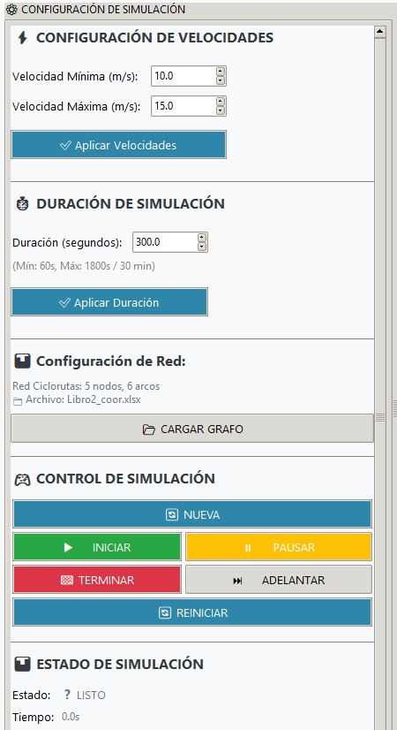
Control Panel Visualization Panel

6. Configuring Parameters
Before running a simulation, the user must configure three key parameters directly from the graphical interface. These parameters are accessible in the Control Panel, where users can input values for the minimum and maximum speed of cyclists, as well as the total duration of the simulation. These settings allow for customization of cyclist behavior and simulation timing, ensuring the model reflects realistic or experimental conditions depending on the user's goals.
Parameter | Description | Default | Range
Minimum Speed | Lowest cyclist speed (m/s) | 10.0 | 1.0–20.0
Maximum Speed | Highest cyclist speed (m/s) | 15.0 | 1.0–30.0
Simulation Duration | Total duration (s) | 300 | 60–1800

7. Setting Arrival Distributions
- Exponential: Random arrivals based on λ.
- Normal: Arrivals with mean and deviation.
- Gamma, Weibull, Log-Normal for advanced scenarios.

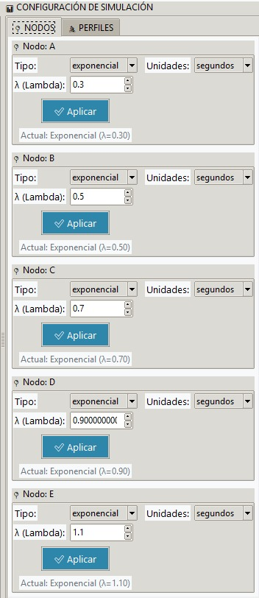
The simulator allows users to model cyclist arrivals using various probability distributions, which reflect different traffic patterns and behaviors. These distributions are configured directly from the main user interface, specifically in the Distribution Panel, and not through the Excel input files. Exponential distribution is commonly used to simulate random arrivals, where the rate parameter (λ) controls how frequently cyclists appear. Normal distribution introduces variability around a mean arrival time, useful for modeling more regular patterns. For advanced scenarios, the simulator also supports Gamma, Weibull, and Log-Normal distributions, which offer greater flexibility in shaping arrival curves, such as skewed or heavy-tailed behaviors. This configurability enables users to tailor simulations to match real-world conditions or explore hypothetical demand scenarios.
Distribution Panel

8. Running the Simulation
Before interacting with the simulation, users must understand how to control its execution using the available buttons in the Control Panel. These buttons allow full management of the simulation lifecycle, from initialization to termination. Each action—such as starting, pausing, advancing, or restarting the simulation—can be triggered manually, giving users flexibility to observe, analyze, or debug the system in real time. Once the simulation ends, results are automatically saved for further analysis. Below is a description of each button and its function:
Button | Description
New | Creates a new simulation with current settings.
Start | Begins simulation and spawns cyclists.
Pause / Resume | Temporarily halts or resumes simulation.
Advance | Moves simulation forward by 10 steps.
Restart | Restarts current simulation.
Stop | Ends simulation and saves results.

9. Understanding the Interface
- Visualization Panel: Displays graph and cyclist movements.
- Statistics Panel: Real-time performance metrics.
- Control Panel: Simulation parameters and controls.

The simulator interface is divided into several panels, each with a specific role to support the simulation process. The Visualization Panel displays the cycling network as a graph, showing nodes and edges, and animates the movement of cyclists in real time. This helps users observe traffic flow and route usage visually. The Statistics Panel provides live metrics during the simulation, such as the number of active cyclists, completed trips, average speeds, and route utilization, offering insights into system performance. The Control Panel is where users configure simulation parameters—like speed and duration—and manage the simulation using buttons to start, pause, advance, or stop the process. Together, these panels offer an interactive and informative environment for analyzing urban cycling dynamics.

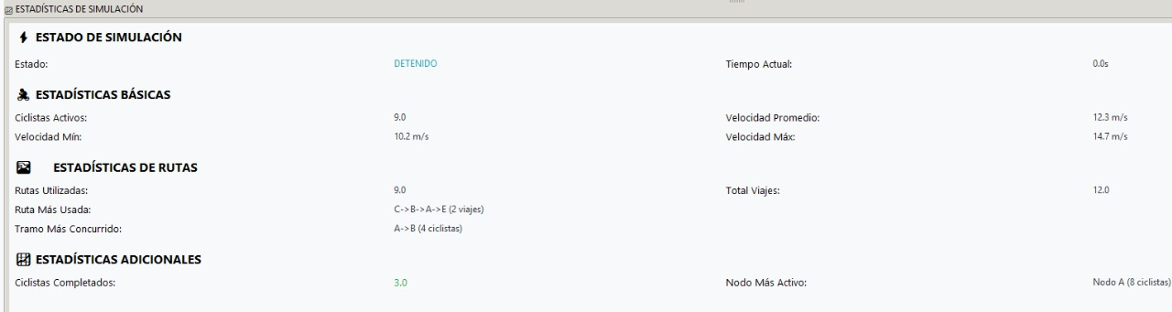
Statistics Panel

10. Interpreting Results
One key metric is the number of completed cyclists, which indicates how many trips were successfully finished during the simulation. The report also includes average speed, minimum speed, and maximum speed values, which help assess how route conditions—such as slope, safety, and lighting—affect cyclist movement.

Additionally, the simulator tracks the most-used routes, revealing which paths are preferred based on cyclist profiles and network attributes. This can highlight high-demand corridors or potential bottlenecks. The Arcs Used sheet shows how frequently each segment of the network was traversed, while the Cyclists per Node sheet provides insight into which nodes generated the most traffic.

11. Exporting Simulation Data
- Results are automatically saved in results/ folder as Excel files.
- Files contain summaries, routes, nodes, and travel times.

When a simulation ends, the system automatically generates an Excel file stored in the results/ folder. This file contains multiple sheets that offer a comprehensive overview of the simulation's performance and cyclist behavior. The "Resumen General" sheet includes aggregated statistics such as the total number of cyclists generated, total trips completed, simulation duration, and average, minimum, and maximum speeds. These metrics help assess overall system efficiency and traffic flow.

The "Rutas Utilizadas" sheet lists all the routes taken by cyclists, along with their frequency and percentage of total usage. This allows users to identify the most popular paths and potential high-demand corridors. The "Arcos Utilizados" sheet provides similar data but at the segment level, showing how often each edge (or arc) in the network was traversed, which is useful for pinpointing heavily used infrastructure.

The "Ciclistas por Nodo" sheet shows how many cyclists were generated from each node, helping to identify the most active origins in the network. The "Perfiles Utilizados" sheet breaks down the distribution of cyclist profiles, indicating how different preferences influenced route selection.

Finally, the "Tiempos de Viaje" sheet offers detailed travel time data, including average travel time per route, total travel time per cyclist, and time spent on each segment. This enables deeper analysis of route efficiency, delays, and the impact of network attributes like slope, safety, and lighting on travel duration.

Together, these sheets provide rich data for urban mobility analysis, infrastructure planning, and performance evaluation of cycling networks.

12. Troubleshooting and FAQs
- Ensure NODES and EDGES sheets exist and are valid.
- Use LAT/LON columns for real coordinates.
- Restart simulation after parameter changes.
- Apply changes with the buttons “Aplicar” where it applies.

13. Conclusion
The Bikeway Simulator offers a powerful and intuitive platform for analyzing cyclist behavior across urban networks. Its user-friendly interface allows for seamless configuration of simulation parameters, real-time visualization, and dynamic control of the simulation process. By using correctly structured Excel files, users can define complex networks, cyclist profiles, and demand patterns with precision. The simulator supports advanced modeling through customizable arrival distributions and route preferences; all managed directly from the interface. Upon completion, the system automatically exports detailed results in Excel format, enabling in-depth analysis of travel times, route usage, node activity, and cyclist performance. This makes the tool especially valuable for urban planners, researchers, and mobility analysts seeking data-driven insights to improve cycling infrastructure and policy.

