providers.csv

providers_ind.csv

deliveries_ind.csv

|Стан таблиць до застосування функцій можна побачити на попередній сторінці цього |документу. Після застосування функцій я повертаю їх стан до попереднього вигляду.

|Структура БД описана в csv_structure.py

get_m

result



--------------------------------------------------------------------------------------------------------------------------

get_s

result

--------------------------------------------------------------------------------------------------------------------------

del_m

result

del_s

result

--------------------------------------------------------------------------------------------------------------------------

update_m

result



update_s

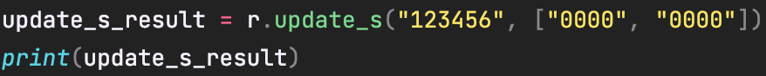

result

--------------------------------------------------------------------------------------------------------------------------

insert_m



result



insert_s

result

