

Rover Robotics Computer Setup Guide

Version | Date | Comments
1.0.0 | 1/16/20 | Initial Release
1.0.1 | 3/26/20 | Fix rover UART latency and xbox controller assignment issues
1.0.2 | 3/26/20 | Update ros install instructions
2.0.0 | 6/11/20 | Add RPLidar, move_base, robot localization and gmapping ROS packages and rename main launch files to starterkit_bringup.launch and slampack_bringup.launch
3.0.0 | 7/14/20 | Add ROS 2 install, create user “rover”
3.0.1 | 7/22/20 | Minor updates to add usersection
3.0.2 | 8/5/2020 | Minor usability updates and add RealSense driver install
3.0.3 | 10/10/2020 | Remove Xbox Controller Driver Support, Added Ps4
3.0.4 | 11/13/2020 | Edit the Intel RealSense install commands to fix errors

This document has been tested for the following computers, operating systems, and versions of ROS

Computers
- Nvidia Jetson TX2
- Nvidia Jetson Xavier AGX
- Nvidia Jetson Xavier NX
- Nvidia Jetson Nano
- Intel NUC7i5DNH1E
- ADLINK ROSCube Pico
- ADLINK Vizi AI

Operating Systems
- Ubuntu 18.04

Versions of ROS
- ROS Melodic

Table of Contents
Step 0 – Setup Rover user
Step 1 – Install nice to have programs
Step 2 – Install Ros 1 Melodic
Step 3 – Install Rover Packages
Step 4 – Install Ps4 Joystick driver and ros packages
Step 5 – Building Catkin_ws packages
Step 6a – Setup Systemd / Startup Script
Step 6b – Setup Udev Rules/Static Assign devices
Step 7 – Instal Intel Realsense Sensors (Optional)

This document was written so you can copy and paste commands in order and it should work.

Commands that should be typed into the terminal are highlighted in light grey

Text that needs to be placed inside a file is colored in light blue

 Be careful not to copy and paste any hidden characters

Step 0 – Create new User called rover (optional)
Optionally you can choose not to create a new user, you will just need to change the user name in the systemd scripts in step 4

To create a new user run the following command

sudo adduser rover

Set the password to rover
Set the full name to rover
Leave Room Number, Work Phone, Home Phone and Other blank

Then to give the user sudo permissions run this command

sudo usermod -aG sudo rover

From the users menu select unlock and change the rover user to auto login

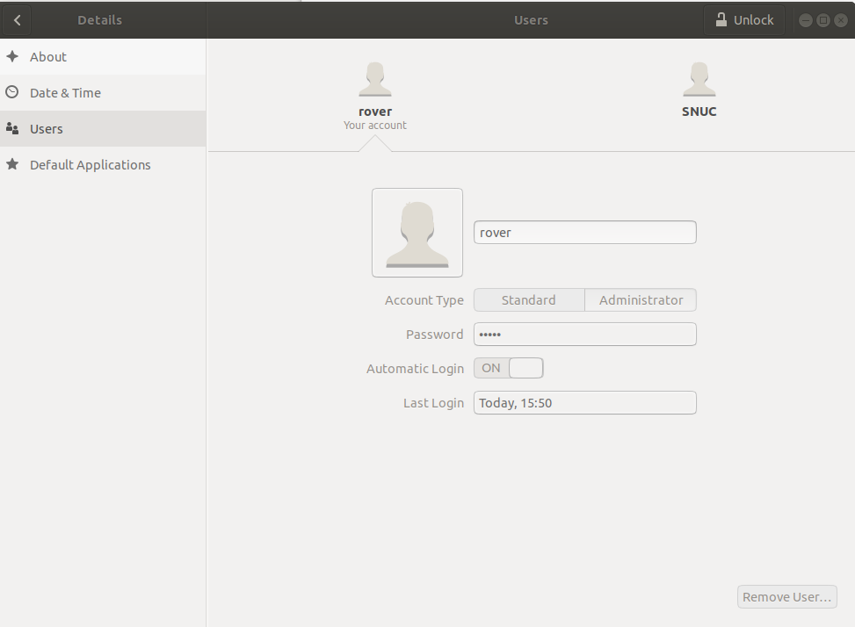

Step 1 - Install nice to have programs

Git must be installed to download Rover Robotics code from source

Nano must be installed to create and edit files

sudo apt install git

sudo apt install nano

sudo apt install net-tools

sudo apt install openssh-server

Step 2 - Install ROS 1 Melodic

The below commands in red are listed here just for reference. It is recommended to use the commands listed online for installing ROS to ensure they are up to date http://wiki.ros.org/melodic/Installation/Ubuntu. Particularly the second command that has the key that gets updated from time to time.

sudo sh -c 'echo "deb http://packages.ros.org/ros/ubuntu $(lsb_release -sc) main" > /etc/apt/sources.list.d/ros-latest.list'

sudo apt-key adv --keyserver 'hkp://keyserver.ubuntu.com:80' --recv-key C1CF6E31E6BADE8868B172B4F42ED6FBAB17C654

sudo apt update

sudo apt install ros-melodic-desktop

echo "source /opt/ros/melodic/setup.bash" >> ~/.bashrc

source ~/.bashrc

sudo apt install python-rosdep python-rosinstall python-rosinstall-generator python-wstool build-essential

sudo apt install python-rosdep

sudo rosdep init

rosdep update

Step 3 - Install Rover Robotics packages from source
We recommend installing from source so you can see the driver code that is running and edit it if you need. It’s also available as binaries if you move to production.

mkdir -p ~/catkin_ws/src

cd ~/catkin_ws/src

git clone https://github.com/RoverRobotics/rr_openrover_stack.git

Only use this command if you have a rplidar
git clone https://github.com/Slamtec/rplidar_ros.git

sudo apt-get install ros-melodic-twist-mux

sudo apt-get install ros-melodic-tf2-geometry-msgs

sudo apt-get install ros-melodic-robot-localization

sudo apt-get install ros-melodic-gmapping

sudo apt-get install ros-melodic-move-base

Step 4 - Install Joystick Drivers

Install the ROS joystick driver
sudo apt-get install ros-melodic-joy
Add yourself into input linux group
sudo usermod -a -G input rover
Installing Drivers and Ros Controller Driver

mkdir -p home/rover/drivers
cd home/rover/drivers
git clone https://github.com/naoki-mizuno/ds4drv --branch devel
cd ds4drv
mkdir -p home/rover/.local/lib/python2.7/site-packages
python2 setup.py install --prefix ~/.local
sudo cp udev/50-ds4drv.rules /etc/udev/rules.d/
cd ~/catkin_ws/src
git clone https://github.com/naoki-mizuno/ds4_driver

Step 5 - Building Ros packages.ros.org
Navigate to your catkin_ws
cd ~/catkin_ws
catkin_make
echo "source ~/catkin_ws/devel/setup.bash" >> ~/.bashrc
source ~/.bashrc

Step 6 – Create systemd scripts

These scripts start ROS when you boot your computer and they

sudo mkdir /etc/roverrobotics

sudo nano /etc/systemd/system/roscore.service
[Unit]
After=NetworkManager.service time-sync.target
[Service]
Type=forking
User=rover
# Start roscore as a fork and then wait for the tcp port to be opened
# ----------------------------------------------------------------
# Source all the environment variables, start roscore in a fork
# Since the service type is forking, systemd doesn't mark it as
# 'started' until the original process exits, so we have the
# non-forked shell wait until it can connect to the tcp opened by
# roscore, and then exit, preventing conflicts with dependant services
ExecStart=/bin/sh -c ". /opt/ros/melodic/setup.sh; . /etc/roverrobotics/env.sh; roscore & while ! echo exit | nc localhost 11311 > /dev/null; do sleep 1; done"
[Install]
WantedBy=multi-user.target

If you skipped step 0, fill in the user name where is says rover

sudo nano /etc/roverrobotics/env.sh
#!/bin/sh
export ROS_HOSTNAME=$(hostname).local
export ROS_MASTER_URI=http://$ROS_HOSTNAME:11311

sudo nano /etc/systemd/system/roverrobotics.service
[Unit]
Requires=roscore.service
PartOf=roscore.service
After=NetworkManager.service time-sync.target roscore.service
[Service]
Type=simple
User=rover
ExecStart=/usr/sbin/roverrobotics
[Install]
WantedBy=multi-user.target

sudo nano /usr/sbin/roverrobotics
#!/bin/bash
source ~/catkin_ws/devel/setup.bash
source /etc/roverrobotics/env.sh
export ROS_HOME=$(echo ~rover)/.ros
roslaunch rr_openrover_driver starterkit_bringup.launch &
PID=$!
wait "$PID"

sudo systemctl enable xboxdrv.service

sudo systemctl enable roverrobotics.service

sudo systemctl enable roscore.service

sudo chmod +x /usr/sbin/roverrobotics

Step 6b - Setup UDEV Rules (simlinks)

sudo nano /etc/udev/rules.d/roverrobotics.rules
# set the udev rule , make the device_port be fixed by rplidar
#
KERNEL=="ttyUSB*", ATTRS{idVendor}=="10c4", ATTRS{idProduct}=="ea60", MODE:="0777", SYMLINK+="rplidar"
# creates fixed name for rover serial communication
KERNEL=="ttyUSB[0-9]", ATTRS{idVendor}=="0403", ATTRS{idProduct}=="6001", MODE:="0777", SYMLINK+="rover", RUN+="/bin/setserial /dev/%k low_latency"
KERNEL=="ttyUSB[0-9]", ATTRS{idVendor}=="0403", ATTRS{idProduct}=="6015", MODE:="0777", SYMLINK+="rover", RUN+="/bin/setserial /dev/%k low_latency"
# create fixed mapping for xbox control to avoid inconsistent naming
SUBSYSTEM=="input", KERNEL=="js*", ATTRS{name}=="Xbox Gamepad (userspace driver)", SYMLINK="input/jsX"

sudo udevadm control --reload-rules && sudo udevadm trigger

Step 7 – Install RealSense D435i Dev Packages (optional)
Install the realsense librairies

sudo apt-key adv --keyserver keys.gnupg.net --recv-key F6E65AC044F831AC80A06380C8B3A55A6F3EFCDE || sudo apt-key adv --keyserver hkp://keyserver.ubuntu.com:80 --recv-key F6E65AC044F831AC80A06380C8B3A55A6F3EFCDE

sudo add-apt-repository "deb http://realsense-hw-public.s3.amazonaws.com/Debian/apt-repo bionic main" -u

sudo apt-get install librealsense2-dkms librealsense2-utils librealsense2-dev librealsense2-dbg

Install RealSense ROS packages from source

cd ~/catkin_ws/src

git clone https://github.com/IntelRealSense/realsense-ros.git

cd ~/catkin_ws/src/realsense-ros

git checkout tags/2.2.14

cd ~/catkin_ws/

sudo apt-get install ros-melodic-ddynamic-reconfigure

catkin_make

Step 6 - Reboot

sudo reboot

Appendix A - Advice
Don’t turn this document into a PDF and copy and paste commands, the PDF will insert hidden characters

