9439B

10:30-12:00 TF

Group #3

May 15, 2017

Arciosa, Rommel John

Calimlim, Nathaniel

Caguioa, Ma. Christine

Belocura, Lairde Vincent

De Alban, Kristine Jorgia

Dullao, Jeanne

Fernandez, Mariella

Kimayong, Kacey Camille

Marbella, Richard

Maslian, Averey

Quezada, Paul Ian

**Admin Module (PHP)**

* **Contains the following pages and functions:**
* *Login page* - customers or service provider can login with their account.
* Register page – new customer or service provider can create an account in the website.
* *Dashboard page* (main page of the website) - view and avail services.
* *Service Provider page* - list all the service provider and the status of service.
* *Customer page* - list all the customers.
* Request page - show all the request of customer and service provider.
* **Supporting technology:**

**Laravel** - is a powerful MVC PHP framework, designed for developers who need a simple and elegant toolkit to create full-featured web applications. Some of the features of Laravel are a modular packaging system with a dedicated dependency manager, different ways for accessing relational databases, utilities that aid in application deployment and maintenance, and its orientation toward syntactic sugar.

* **Screenshots**

**Client Module (Java)**

* **Contains the following pages and functions:**
* *Home page* (main page of the website) - view and select/avail services
* *Notification page -* view all the service provider respond in the request.
* *Transaction page - view all the past transactions of the customer.*
* *About Us page* - displays the mission and all information about the website.
* *Profile page –* show the information of the customer.
* **Supporting technology:**

**Bootstrap** - is the most popular HTML, CSS, and JavaScript framework for developing and designing responsive, mobile-first web sites and application. Bootstrap is completely free to download and use. It contains HTML- and CSS-based design templates for typography, forms, buttons, navigation and other interface components, as well as optional JavaScript extensions.

**Themes Used:**

**Dashboard** - is designed to be the perfect starting point for any dashboard or admin site. Charts, graphs, sortable tables, and more than a dozen other new components included.

**Carousel** - is a slideshow for cycling through a series of content, built with CSS 3D transforms and a bit of JavaScript. It works with a series of images, text or custom mark-up. It also includes support for previous/next controls and indicators.

* **Screenshots**

**Home Page**

This pages will view all the available services such as Tutorials for Academics, Languages, Instruments, and Cooking/Baking. This is the page where customers can add/cancel services. It will also display the name and contact information of the customer, type of services they offer, and the status of the service.

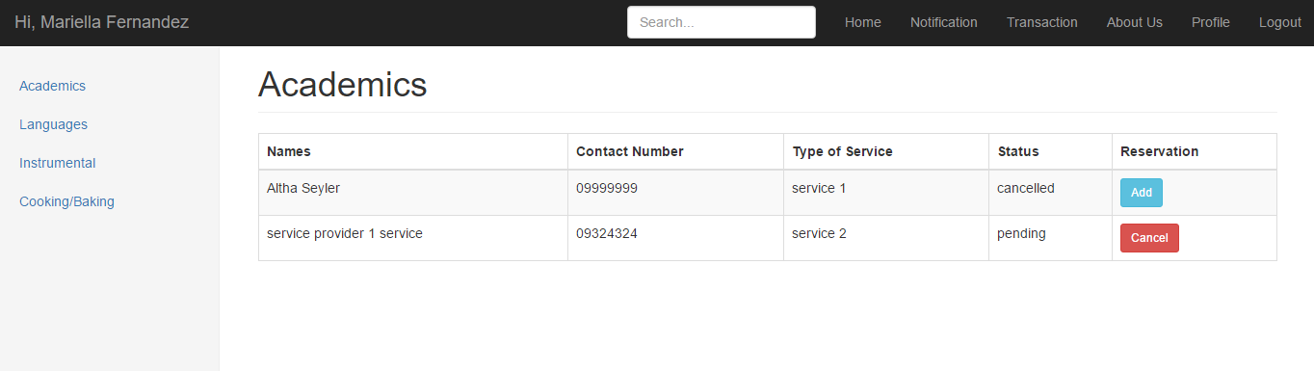

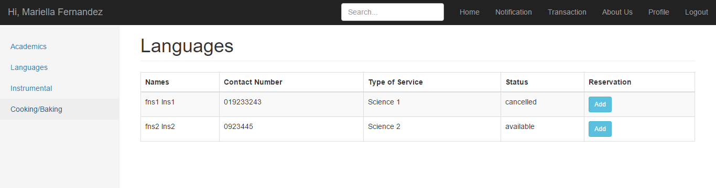

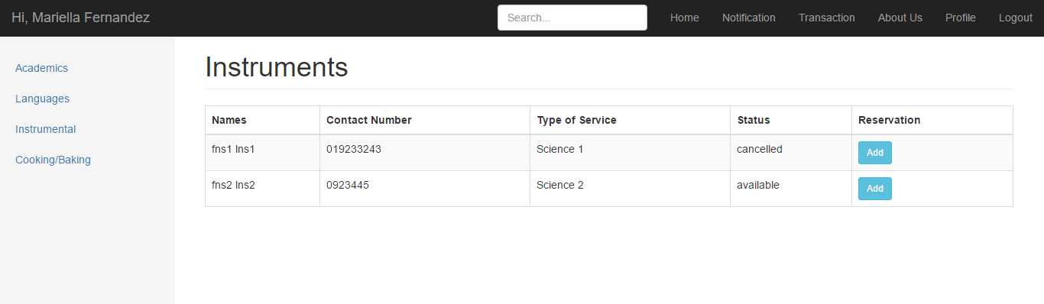

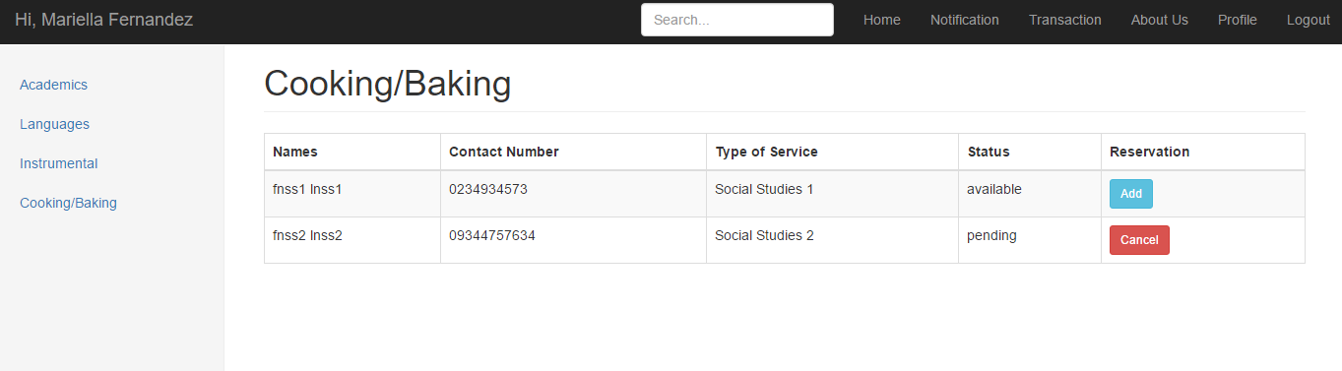

Once the customer click the ‘add’ button, a pop up will appear for the reservation of the service.

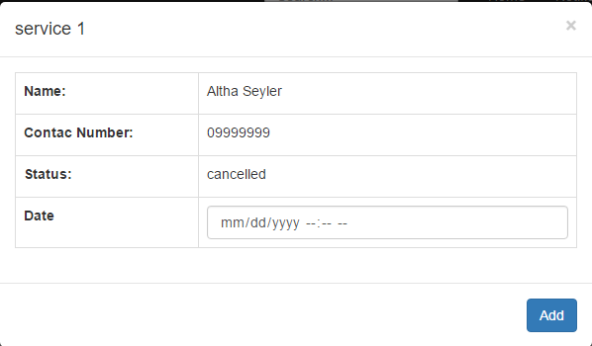

**Notification Page**

This page views all the service provider responds in the request.

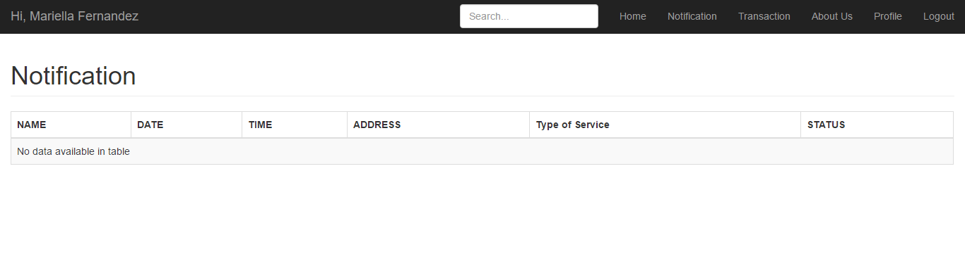

**Transaction Page**

This page views all the past transactions of the customer. It includes all the information about the transactions made by customer and service provider.

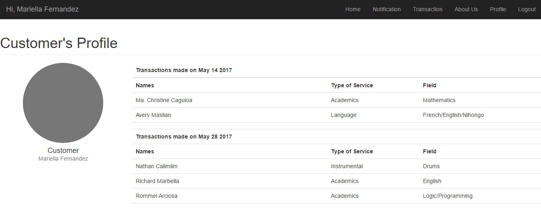

**About Us Page**

This page displays the Mission and all the information about the website.

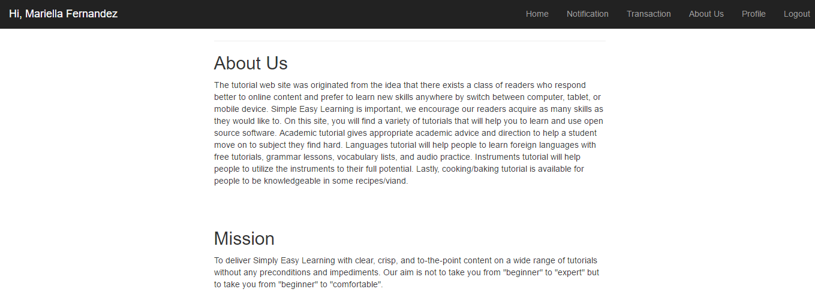

**Profile Page**

This page shows all the information about the customer.

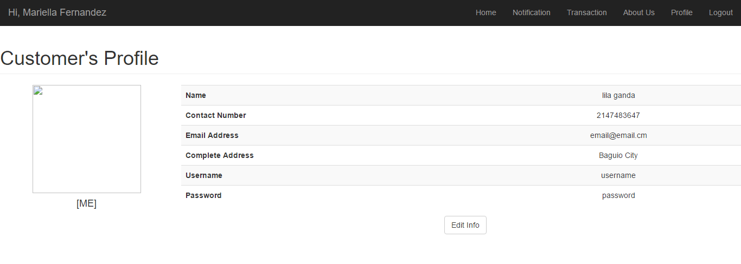

Customer can also edit his/her information if there’s a changes.

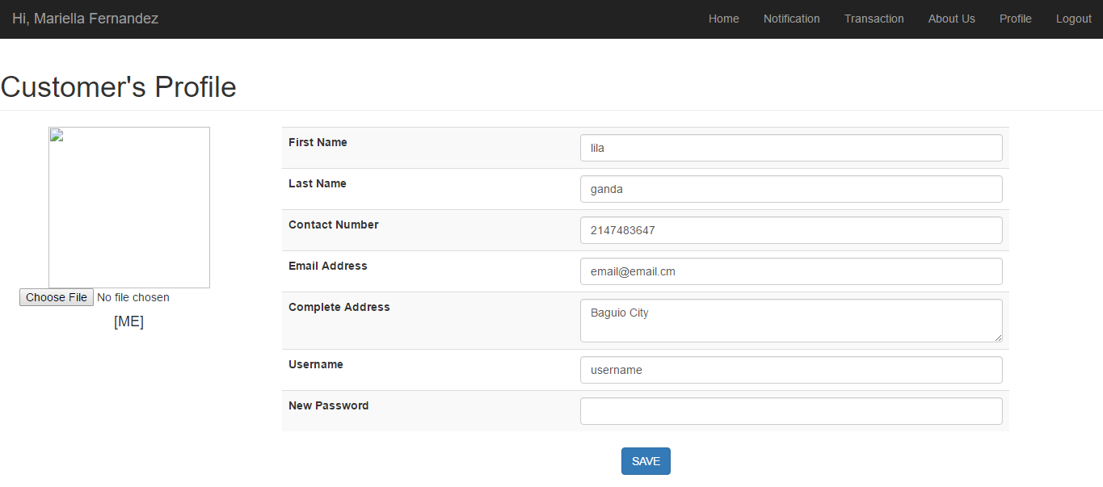

**Service Provider Module (Node.js)**

* **Contains the following pages and functions:**
* *Dashboard page* - lists all the scheduled services of service provider.
* *Service Request* - view all the customer who requested for their services.
* *Services* - page where service provider can add additional services.
* *Profile page -* show the information of the service provider.
* **Supporting technology:**

**Express** - is a minimal and flexible Node.js web application framework that provides a robust set of features for web and mobile applications. Express provides a thin layer of fundamental web application features, without obscuring Node.js features that you know and love.

* **Screenshots**