a)

select name, telegram_contact from student  
where city='Казань' or city='Москва'  
order by name desc

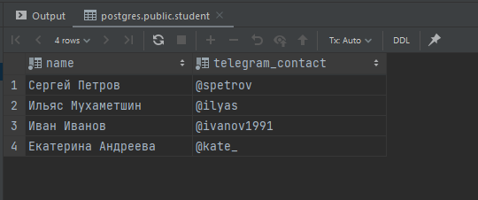

b)

select 'университет: '||name||'; количествостудентов: '||size as "полная информация"  
from college  
order by "полная информация"

-- в задании не указано по сортировке asc/desc, поэтому оставила по умолчанию

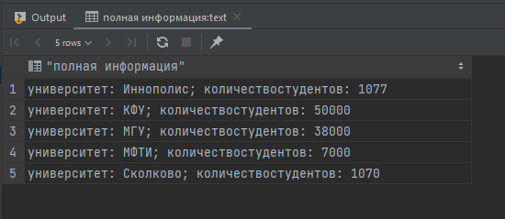

c)

select name, size  
from college where id in (10, 30, 50)  
order by size, name

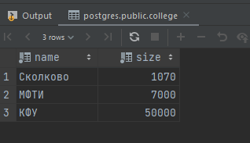

d)

select name, size  
from college where id not in (10, 30, 50)  
order by size, name

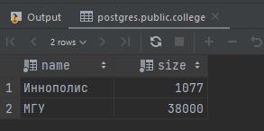

e)

select name, amount_of_students from course  
where amount_of_students>=27 or amount_of_students<=310  
order by name desc, amount_of_students desc

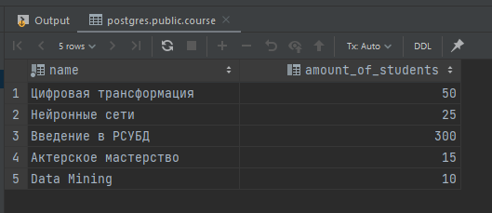

f)

select name from student  
union  
select name from course  
order by name desc

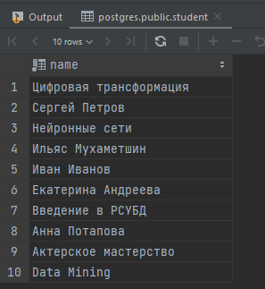

g)

select name, 'университет' as object_type from college  
union  
select name, 'курс' as object_type from course  
order by object_type desc, name desc

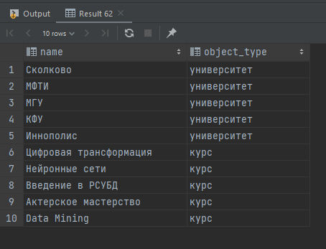

h)

select name, amount_of_students from course  
order by (case when amount_of_students=300  
then 0  
else 1  
end) asc, amount_of_students asc  
limit 3

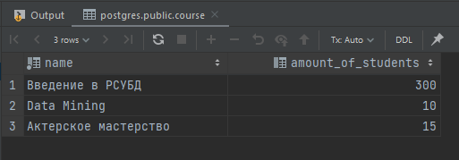

i)

insert into course (id, name, is_online, amount_of_students, college_id)  
values (60, 'Machine Learning', false, 17, 20)

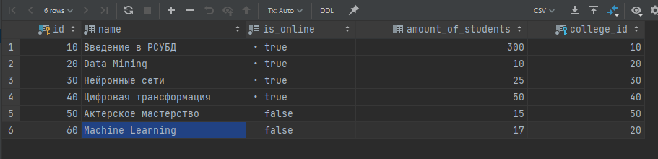

j)

(select id from course  
except  
select id from student_on_course)  
UNION  
(select id from student_on_course  
except  
select id from course)  
order by id asc

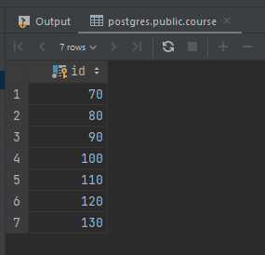

k)

select distinct st.name as student_name, crs.name as course_name, col.name as student_college, stc.student_rating  
from student st, course crs, college col, student_on_course stc  
where  
stc.student_id=st.id  
and stc.course_id=crs.id  
and st.college_id=col.id  
and stc.student_rating>50  
and col.size>5000  
order by student_name, course_name

-- в задании не указано по сортировке asc/desc, поэтому оставила по умолчанию

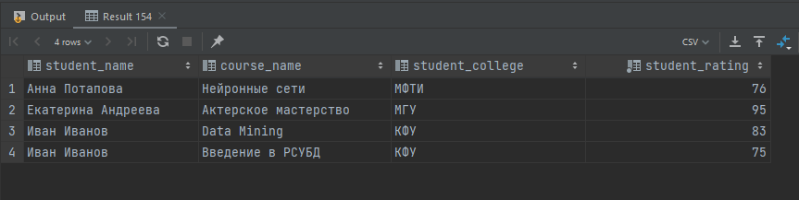

l)

select distinct p1.name as student_1,  
 p2.name as student_2,  
 m.city  
from student m  
join student p1 on p1.city = m.city  
join student p2 on p2.city = m.city  
where m.city is not null  
and p1.city=p2.city  
and p1.name<p2.name

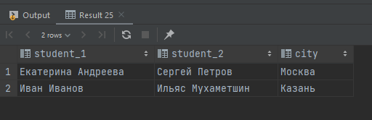

m)

select  
case when student_rating<30 then 'неудовлетворительно'  
 when student_rating>=30 and student_rating<60 then 'удовлетворительно'  
 when student_rating>=60 and student_rating<85 then 'хорошо'  
 else 'отлично'  
end as "оценка", *count*(student_id) as "количество"  
 from student_on_course  
group by "оценка"  
order by "оценка"

-- в задании не указано по сортировке asc/desc, поэтому оставила по умолчанию

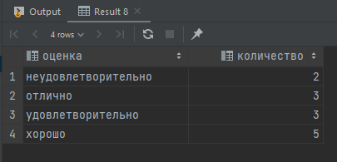

n)

select crs.name as "курс",  
case when stc.student_rating<30 then 'неудовлетворительно'  
 when stc.student_rating>=30 and stc.student_rating<60 then 'удовлетворительно'  
 when stc.student_rating>=60 and stc.student_rating<85 then 'хорошо'  
 else 'отлично'  
end as "оценка", *count*(stc.student_id) as "количество"  
 from student_on_course stc, course crs  
where stc.course_id=crs.id  
group by "оценка", "курс"  
order by "курс", "оценка"

