|  |
| --- |
| Threading Through Time: The Evolution and Implications of Sewing Machine Technology |
|  |
|  |
|  |
|  |
|  |
|  |
| RENE REY L. SALE  KENNETH ANTONIO  JAMES PATRICK INTONG |
|  |
|  |
|  |
|  |
|  |
|  |
| RESEARCH PAPER SUBMITTED TO THE DEPARTMENT OF  NATURAL SCIENCE, COLLEGE OF ARTS AND SICENCE,  BUKIDNON STATE UNIVERSITY, IN PARTIAL  FULFILLMENT OF THE REQUIREMENTS  FOR THE STS SUBJECT |
|  |
|  |
|  |
|  |
| BACHELOR OF SCIENCE IN INFORMATION TECHNOLOGY |
|  |
|  |
|  |
|  |
| DECEMBER 2024 |

|  |
| --- |
|  |

**TABLE OF CONTENTS**

Page

**Introduction** 1

Historical Antecedent of the technology 1

Inventor/s 2

Government and/or private agencies involvement/ support 2

**Discussion** 3

Advantages of Chosen Technology 3

Disadvantages of Chosen Technology 3

Ethical Considerations 4

Environmental Impacts (good and bad impacts) 4

**Summary and Discussion** 5

References 6

Appendices 7

Figure 1 7

Figure 2 8

**INTRODUCTION**

**Historical Antecedent of the technology**

***Origin of the Sewing Machine***

The history of the sewing machine begins with early attempts in the late 18th century. Thomas Saint patented the first design in 1790, aimed at stitching leather and canvas. However, his machine was impractical and never manufactured. In 1830, Barthelemy Thimonnier, a French tailor, created the first practical sewing machine, which used a hooked needle to produce a chain stitch. Despite its utility, his workshop was destroyed by hand-sewing artisans fearing job loss.The sewing machine transformed garment-making by significantly reducing manual stitching time—by as much as 80%—revolutionizing clothing production during the mid-19th century. Initially adopted in industrial centers across Europe and the U.S. in the 1850s and 1860s, it quickly became indispensable to clothing manufacturers. By enabling faster production and uniform quality, it drove the specialization of clothing items like jackets, gloves, and shirts. However, its influence extended beyond factories, becoming the world’s first mass-produced and mass-marketed consumer goods. By the early 20th century, less than 10% of sewing machines in markets like Britain and the U.S. were used for industrial purposes; the majority were purchased by households for home garment-making, significantly altering fashion trends and fostering a culture of home-produced clothing styles (Godley, 2020).

***Historical Antecedents***

This shift from industrial to domestic use highlights the sewing machine's dual role in advancing both factory-based production and personal creativity. As families across Europe, North America, and later other regions adopted the machine, it catalyzed cultural change, empowering individuals to explore fashion design from their homes. For example, the ease of creating Western-style clothing contributed to its diffusion in regions like Russia, Mexico, and Japan, blending global trends with local preferences. By enabling ordinary households to produce garments, the sewing machine democratized fashion and provided a means of economic participation, particularly for women, who were often the primary users of the device ([Smithsonian Libraries](https://www.sil.si.edu/DigitalCollections/hst/cooper/intro.htm); [Oxford Academic, 2020](https://academic.oup.com/ssjj/article-abstract/16/1/201/1720748)).Furthermore, the growth in domestic sewing machine sales shaped broader societal trends. In Britain, for instance, Singer Sewing Company’s installment payment plans made the machines accessible to lower-income families, allowing them to participate in the consumer economy. This phenomenon also reshaped manufacturing, as increased demand for domestic machines led to further specialization of industrial models, with workshops and factories adopting specific configurations tailored to mass production. By 1907, Britain alone had 190,000 industrial sewing machines, but this number was dwarfed by the millions of domestic machines in use (Godley, 2020).

***Modern Sewing Machines***

Modern sewing machines represent a blend of advanced technology and refined functionality, evolving significantly since the first electric model by Singer in 1889. By the mid-20th century, sewing machines incorporated electric motors and enhanced mechanisms, increasing precision and efficiency in both domestic and industrial settings. Modern machines now include computerized controls, offering programmable stitch patterns, automated threading, and embroidery capabilities. These features have diversified applications, extending to craftwork, professional tailoring, and large-scale industrial production. Sustainability has also become a focus, with some machines incorporating eco-friendly designs and material-recycling features

**Inventor/s**

Barthélemy Thimonnier pioneered the sewing machine, but his design was rudimentary and prone to failure. Elias Howe, an American inventor, refined the design with his lockstitch machine patented in 1846, which utilized a shuttle to interlock threads. This innovation solved critical mechanical issues, making sewing more reliable and efficient. Isaac Singer, though not the original inventor, was instrumental in the machine's adoption. He patented a more practical foot-treadle-powered machine in 1851, which improved usability and accessibility. Singer also introduced a revolutionary marketing model, including installment payment plans, ensuring the sewing machine became widely available to households worldwide

**Government and/or private agencies involvement/ support**

The sewing machine's success owes much to private enterprises like Singer Sewing Machine Company, which dominated the market with innovative sales tactics, including installment plans and global distribution. By 1907, Singer held up to 80% of the market in Britain. Governments indirectly supported its adoption during the industrial revolution by fostering industrialization and encouraging technological advancements for military and civilian textile production. The sewing machine became emblematic of industrial progress and household efficiency across diverse global regions.(Steele, 2013)

**DISCUSSION**

**Advantages of the Identified Technology**

The sewing machine has been transformative for both industrial and domestic contexts by greatly enhancing productivity and accuracy in garment production. In industrial settings, sewing machines reduced labor hours and allowed for standardized stitching, enabling mass production at unprecedented scales. This advancement fueled the growth of the ready-made clothing industry, which became a cornerstone of modern economies (Steele, 2013).

For households, the machine enabled individuals to produce garments affordably, fostering self-reliance and creativity. The affordability and availability of domestic sewing machines, coupled with flexible payment plans introduced by companies like Singer, made them accessible to a wide range of consumers, even in lower-income brackets. This democratization of sewing technology empowered families to repair or create clothing, promoting sustainability and cost savings (Smithsonian Libraries, 2020).Modern sewing machines have further diversified their use, incorporating features such as automated threading, computerized pattern designs, and multifunctional capabilities for embroidery and quilting. These innovations cater to professionals and hobbyists alike, expanding the applications of sewing technology to crafts, upholstery, and intricate design work. Importantly, sewing machines have also contributed to women's empowerment by fostering cottage industries, enabling income generation through tailoring and custom garment production (Godley, 2020).

**Disadvantages of the Identified Technology**

While sewing machines brought numerous benefits, they also had notable drawbacks. During their early adoption, they displaced traditional hand-sewing artisans, leading to significant economic disruptions. For instance, Barthelemy Thimonnier faced violent protests from French tailors whose livelihoods were threatened by his invention. This resistance reflected broader concerns over mechanization and job displacement, which persisted through the industrial revolution (Smithsonian Libraries, 2020).

In modern times, sewing machines have become integral to the fast fashion industry, which has been criticized for exploitative labor practices. Factory workers, particularly in developing nations, often endure long hours under poor conditions for minimal wages. This raises ethical concerns about the role of sewing technology in perpetuating global inequalities (Steele, 2013).Additionally, the complexity and cost of advanced sewing machines can make them inaccessible in low-income regions, where manual sewing remains dominant. This disparity highlights a technological divide that restricts equitable access to the benefits of modern innovations (Godley, 2020). Environmental issues are another significant drawback. Industrial sewing machines contribute to the ecological footprint of the textile industry, which is a major polluter. Improper disposal of outdated electronic and industrial sewing machines compounds the problem, as many contain non-biodegradable materials. Despite recent efforts to design eco-friendly models, addressing the environmental impact of sewing technology remains a challenge for manufacturers and consumers

**Ethical Considerations**

Rapid adoption of sewing machines in industrial contexts has raised ethical questions, particularly regarding labor practices in the garment industry. While sewing machines have improved efficiency, they are often used in sweatshops, where workers face long hours and inadequate wages. This concern is exacerbated in developing countries, where industrial sewing machines dominate factory floors. The ethical challenge lies in ensuring fair labor practices and promoting sustainable production. Additionally, concerns over intellectual property have historically arisen, as seen in legal disputes between early inventors like Elias Howe and Isaac Singer (Steele, 2013; Smithsonian Libraries) .

**Environmental Impacts (good and bad impacts)**

***Positive Environmental Impacts***

Sewing machines contribute positively to environmental sustainability by enabling the reuse and repair of clothing. This reduces the volume of textile waste, which is one of the fastest-growing waste streams globally. Consumers can extend the life cycle of garments by mending or altering them, counteracting the environmental costs associated with the production and disposal of fast fashion items. Additionally, home sewing practices promote slow fashion, encouraging consumers to focus on quality and durability over disposable trends. In industrial settings, innovations in sewing technology have facilitated more efficient material use, reducing fabric waste during garment production.Further, advancements in sewing machine design have led to the development of models that consume less electricity and support eco-friendly practices. Some manufacturers are actively incorporating recycled materials into their machines and designing for easier disassembly to improve recyclability (Hiner, 2020).

**Negative Environmental Impacts**

Despite these positive contributions, sewing machines also have notable environmental drawbacks, particularly in the context of mass production. Industrial sewing machines are integral to the fast fashion industry, which is a significant contributor to pollution and waste. Textile manufacturing processes enabled by these machines consume vast amounts of water and chemicals, leading to waterway contamination. The rapid production cycles of fast fashion often result in overproduction and massive waste, with many garments ending up in landfills or incinerators.Modern computerized sewing machines also contribute to electronic waste. These machines often contain non-recyclable components, such as plastic casings and intricate electronic circuits, which are challenging to dispose of sustainably. As the demand for technologically advanced models grows, so does the risk of increased e-waste. Addressing this issue requires the adoption of circular economy principles, such as producing modular, repairable machines and incorporating recyclable materials into manufacturing (Godley, 2020). Efforts to mitigate these impacts include campaigns promoting sustainable garment production and practices like upcycling. The rise of eco-conscious brands and consumer movements advocating for ethical production processes is also encouraging the adoption of greener technologies in the textile industry (Steele, 2013).

**SUMMARY AND CONCLUSION**

The sewing machine, initially developed in the 18th century, revolutionized both industrial garment production and domestic sewing practices. Pioneering inventors like Elias Howe and Isaac Singer refined the design, with Singer's foot-treadle machine making it more accessible to both households and factories. By the 20th century, the widespread use of sewing machines democratized fashion, allowing individuals to create and repair their clothing, which also fostered creativity, especially among women (Smithsonian Libraries, 2020). This shift brought about a cultural transformation, as families gained more autonomy in fashion design. However, the widespread adoption of the sewing machine had socio-economic consequences, such as the displacement of hand-sewing artisans and ethical dilemmas related to labor exploitation, particularly in the fast fashion industry (Steele, 2013). The global spread of mechanized garment production also fueled concerns over the environmental impact of the textile industry, including water consumption, waste generation, and the rise of e-waste from modern machines (Godley, 2020).

In conclusion, while the sewing machine undeniably enhanced productivity and expanded opportunities for individual creativity, it also contributed to significant social and environmental challenges. The fast fashion industry's reliance on mass production techniques and the growing use of modern, high-tech machines have exacerbated issues such as labor exploitation and environmental degradation. The future of sewing technology, however, lies in innovation that can strike a balance between efficiency and sustainability. Efforts to incorporate eco-friendly designs and promote ethical manufacturing practices are crucial in addressing these challenges and ensuring the technology's positive legacy (Steele, 2013; Hiner, 2020).

**REFERENCES**

Hiner, S. (2020). Paris, Capital of fashion. Edited by Valerie Steele. *French Studies*, *74*(4), 662–663. <https://doi.org/10.1093/fs/knaa181>

Godley, A. (2006). Selling the sewing machine around the world: Singer’s International Marketing Strategies, 1850–1920. *Enterprise & Society*, *7*(2), 266–314. <https://doi.org/10.1093/es/khj037>

Godley, A. (2023). The sewing machine. In *Routledge eBooks* (pp. 17–41). <https://doi.org/10.4324/9780429295607-3>

Steele, M. W. (2013). Fabricating consumers: the sewing machine in modern Japan. *Social Science Japan Journal*, *16*(1), 201–203. <https://doi.org/10.1093/ssjj/jys032>

The Sewing Machine: its invention and development. (n.d.-b). <https://www.sil.si.edu/DigitalCollections/hst/cooper/intro.htm>

**APPENDICES**

**Chosen Technology**

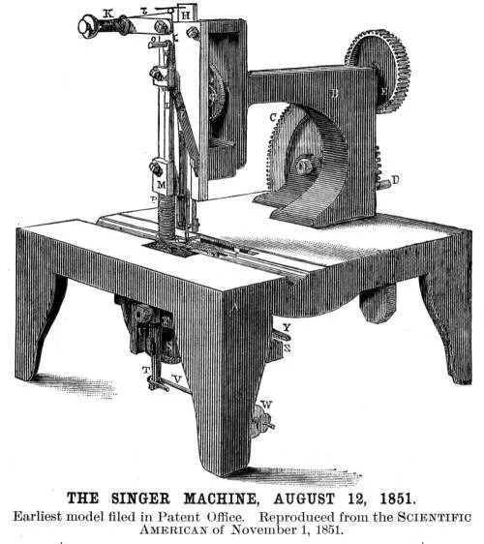

***Figure 1 Singer Sewing Machine from 1800s***

This image depicts a classic Singer sewing machine from the 19th century, a pivotal invention that revolutionized garment production. The machine, which became widely known for its foot-treadle operation, significantly increased sewing efficiency and was integral to the industrialization of the textile industry. The Singer model was among the first to be mass-produced, making home sewing more accessible and affordable for families.

**Improvement of the technology (from old time to modern)**

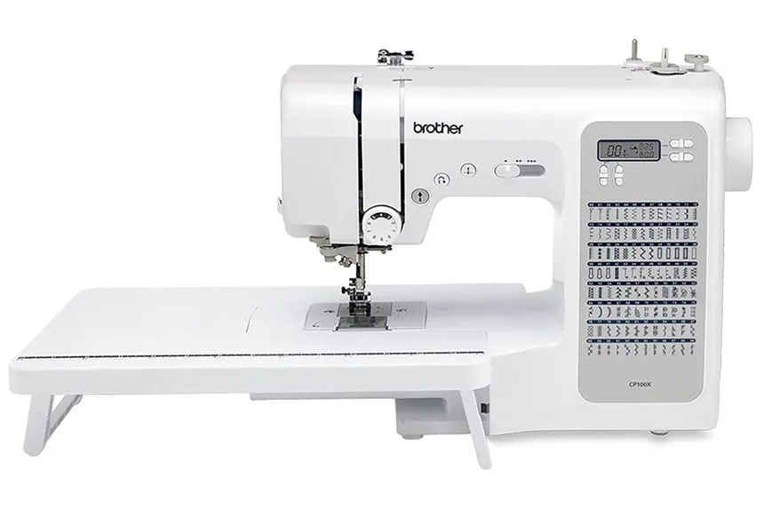

***Figure 2 Modern Sewing Machine***

This image showcases a modern sewing machine equipped with advanced features like computerized controls, automated threading, and diverse stitch options. These machines are designed for precision and versatility, catering to tasks such as garment construction, embroidery, and quilting. Unlike their 19th-century predecessors, modern machines integrate technology for enhanced efficiency, making them suitable for both domestic and industrial applications. They also reflect a growing emphasis on sustainability, with some models incorporating eco-friendly designs and energy-saving features.

**Evidence for your contribution to the group in making this paper**

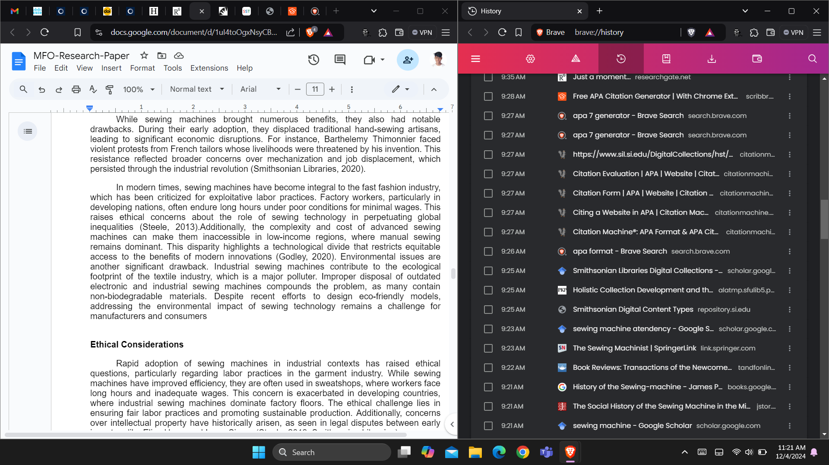

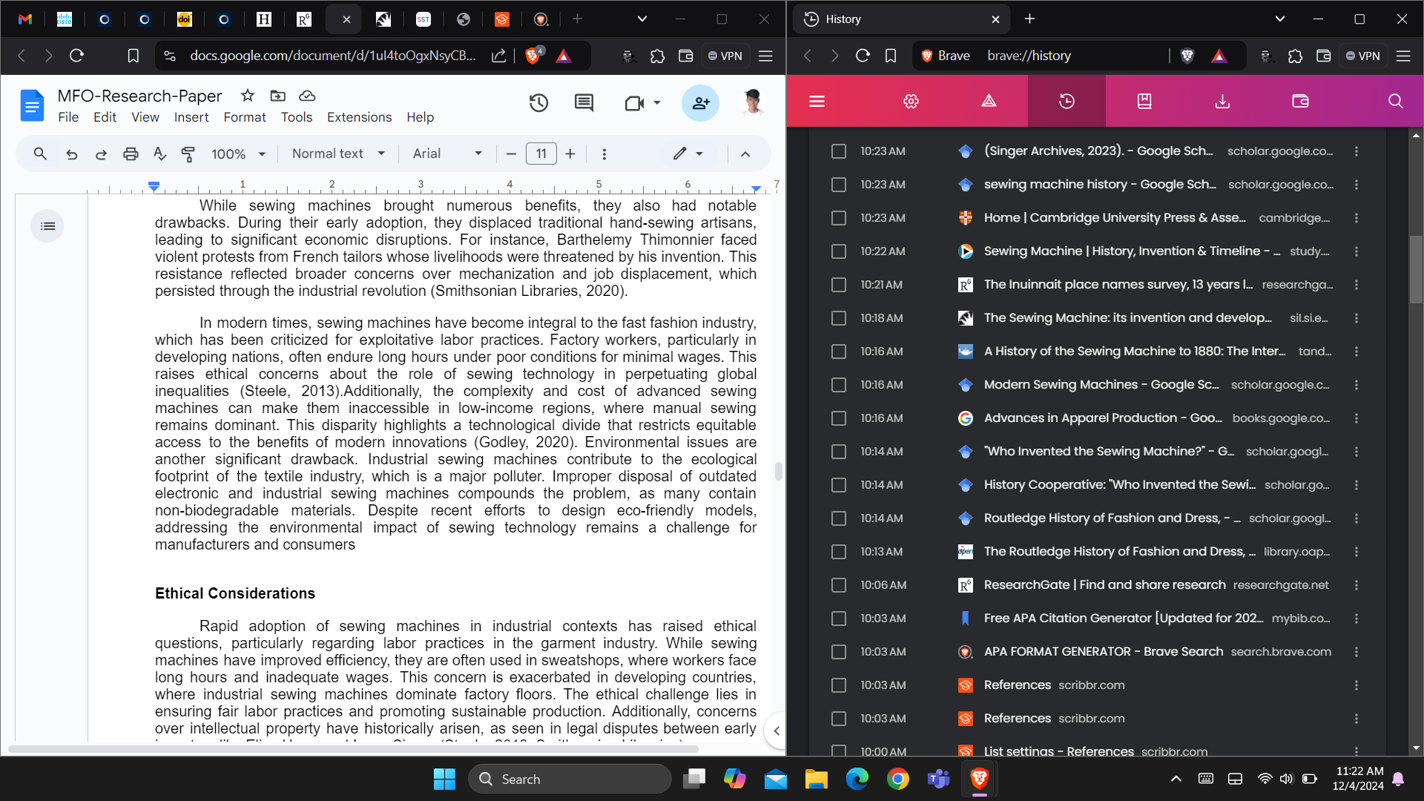

The recent history of searches on google scholars. This evident result shows the contribution of the formulation of this paper by reading articles and books .

**Group picture**

