MMORPG
Class Specification Report
Author: Author
Revision: 0.2

No Magic
One Allen Center, 700 Central Expressway South, Suite 110 Allen, Texas 75013 USA | octobre 08, 2014

Approval
The original of this document is approved and signed by:
Name:
Surname:
Title:
Date:

Signature:
Revision History
Revision | Date | Description | Author
0.1 | <date 1> | <draft> | <Author name>
0.2 | <date 2> | <release> | <Author name>

Table of Contents
Microsoft Word users please click here and press F9 to create Table of Contents.
OpenOffice.org users please remove this text and select Insert Table of Content from menu.

Table of Figures
Microsoft Word users please click here and press F9 to create Table of Contents.
OpenOffice.org users please remove this text and select Insert Table of Content from menu.

Introduction

Purpose
This document provides class, interface, and enumeration specification. The specification provides the details of the types being modeled within the system

Scope
This document is intended to define class specification for the {System Name}.

Overview
This document provides a list of all packages with a summary for each. Each package has a section that contains a list of its classes, interfaces and enumeration type, with a summary for each. Class and Interface contains description, summary tables, detailed member descriptions, and relation table.

Package Analyse_MMORPG::gestion_compte

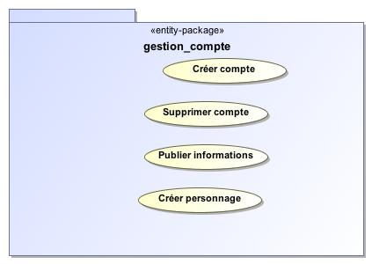
- gestion_compte

Name | gestion_compte
Qualified Name | Analyse_MMORPG::gestion_compte

Class InfoJoueur

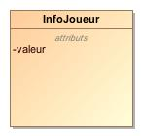
- InfoJoueur

Name | InfoJoueur
Qualified Name | Analyse_MMORPG::gestion_compte::InfoJoueur
Visibility | public
Abstract | false
Base Classifier
Realized Interface

Attribute Detail

type

Type | TypeInfoPubliable
Default Value
Visibility | private
Multiplicity | 1

valeur

Type
Default Value
Visibility | private
Multiplicity

Relation Detail

Association

Name
Related Element | - Joueur

Name
Related Element | - TypeInfoPubliable

Class Joueur

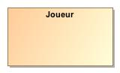
- Joueur

Name | Joueur
Qualified Name | Analyse_MMORPG::gestion_compte::Joueur
Visibility | public
Abstract | false
Base Classifier
Realized Interface

Attribute Detail

infos

Type | InfoJoueur
Default Value
Visibility | private
Multiplicity | *

personnage

Type | Personnage
Default Value
Visibility | private
Multiplicity | 0..1

Relation Detail

Association

Name
Related Element | - InfoJoueur

Name
Related Element | - Personnage

Class TypeInfoPubliable

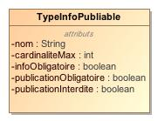
- TypeInfoPubliable

Name | TypeInfoPubliable
Qualified Name | Analyse_MMORPG::gestion_compte::TypeInfoPubliable
Visibility | public
Abstract | false
Base Classifier
Realized Interface

Attribute Detail

cardinaliteMax

Type | int
Default Value
Visibility | private
Multiplicity

infoObligatoire

Type | boolean
Default Value
Visibility | private
Multiplicity

nom

Type | String
Default Value
Visibility | private
Multiplicity

publicationInterdite

Type | boolean
Default Value
Visibility | private
Multiplicity

publicationObligatoire

Type | boolean
Default Value
Visibility | private
Multiplicity

Relation Detail

Association

Name
Related Element | - InfoJoueur

Package Analyse_MMORPG::gestion_jeu

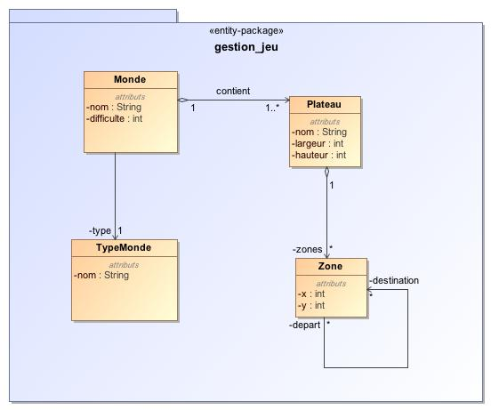
- gestion_jeu

Name | gestion_jeu
Qualified Name | Analyse_MMORPG::gestion_jeu

Class Monde

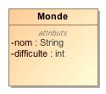
- Monde

Name | Monde
Qualified Name | Analyse_MMORPG::gestion_jeu::Monde
Visibility | public
Abstract | false
Base Classifier
Realized Interface

Attribute Detail

Type | Plateau
Default Value
Visibility | private
Multiplicity | 1..*

difficulte

Type | int
Default Value
Visibility | private
Multiplicity

nom

Type | String
Default Value
Visibility | private
Multiplicity

type

Type | TypeMonde
Default Value
Visibility | private
Multiplicity | 1

Relation Detail

Association

Name
Related Element | - TypeMonde

Name | affiche
Related Element | - ListeDesMondes

Name | contient
Related Element | - Plateau

Class Plateau

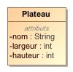
- Plateau

Name | Plateau
Qualified Name | Analyse_MMORPG::gestion_jeu::Plateau
Visibility | public
Abstract | false
Base Classifier
Realized Interface

Attribute Detail

hauteur

Type | int
Default Value
Visibility | private
Multiplicity

largeur

Type | int
Default Value
Visibility | private
Multiplicity

nom

Type | String
Default Value
Visibility | private
Multiplicity

zones

Type | Zone
Default Value
Visibility | private
Multiplicity | *

Relation Detail

Association

Name
Related Element | - Zone

Name | contient
Related Element | - Monde

Class TypeMonde

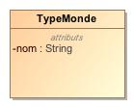
- TypeMonde

Name | TypeMonde
Qualified Name | Analyse_MMORPG::gestion_jeu::TypeMonde
Visibility | public
Abstract | false
Base Classifier
Realized Interface

Attribute Detail

Type | TypeCaracteristique
Default Value
Visibility | private
Multiplicity | *

nom

Type | String
Default Value
Visibility | private
Multiplicity

Relation Detail

Association

Name
Related Element | - FormulaireTypeMonde

Name
Related Element | - Monde

Name
Related Element | - TypeCaracteristique

Class Zone

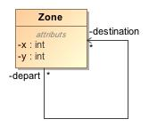
- Zone

Name | Zone
Qualified Name | Analyse_MMORPG::gestion_jeu::Zone
Visibility | public
Abstract | false
Base Classifier
Realized Interface

Attribute Detail

destination

Type | Zone
Default Value
Visibility | private
Multiplicity | *

x

Type | int
Default Value
Visibility | private
Multiplicity

y

Type | int
Default Value
Visibility | private
Multiplicity

Relation Detail

Association

Name
Related Element | - Plateau

Name
Related Element

Package Analyse_MMORPG::gestion_Joueurs

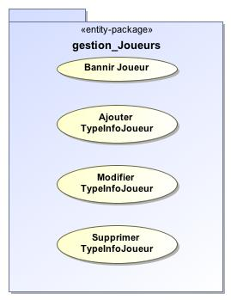
- gestion_Joueurs

Name | gestion_Joueurs
Qualified Name | Analyse_MMORPG::gestion_Joueurs

Package Analyse_MMORPG::jeu

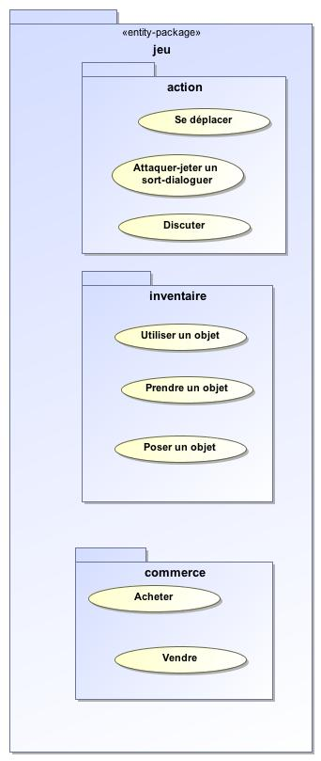
- jeu

Name | jeu
Qualified Name | Analyse_MMORPG::jeu

Package Analyse_MMORPG::jeu::action

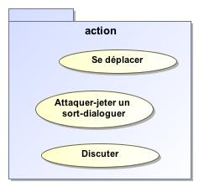
- action

Name | action
Qualified Name | Analyse_MMORPG::jeu::action

Package Analyse_MMORPG::jeu::commerce

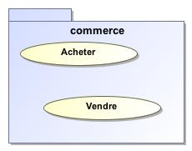
- commerce

Name | commerce
Qualified Name | Analyse_MMORPG::jeu::commerce

Package Analyse_MMORPG::jeu::immateriel

Name | immateriel
Qualified Name | Analyse_MMORPG::jeu::immateriel

Package Analyse_MMORPG::jeu::inventaire

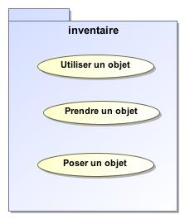
- inventaire

Name | inventaire
Qualified Name | Analyse_MMORPG::jeu::inventaire

Class CaracteristiquePossession

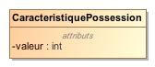
- CaracteristiquePossession

Name | CaracteristiquePossession
Qualified Name | Analyse_MMORPG::jeu::inventaire::CaracteristiquePossession
Visibility | public
Abstract | false
Base Classifier
Realized Interface

Attribute Detail

type

Type | TypeCaracteristiquePossession
Default Value
Visibility | private
Multiplicity | 1

valeur

Type | int
Default Value
Visibility | private
Multiplicity

Relation Detail

Association

Name
Related Element | - Possession

Name
Related Element | - TypeCaracteristiquePossession

Class Effet

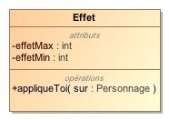
- Effet

Name | Effet
Qualified Name | Analyse_MMORPG::jeu::inventaire::Effet
Visibility | public
Abstract | false
Base Classifier
Realized Interface

Attribute Detail

Type | TypeCaracteristique
Default Value
Visibility | private
Multiplicity

effetMax

Type | int
Default Value
Visibility | private
Multiplicity

effetMin

Type | int
Default Value
Visibility | private
Multiplicity

Operation Detail

appliqueToi

Type
Visibility | public
Is Abstract | false
Parameter | - in sur : Personnage

Relation Detail

Association

Name
Related Element | - TypePossession

Name
Related Element | - TypePossession

Name
Related Element | - TypeCaracteristique

Class Possession

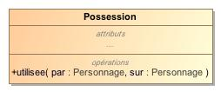
- Possession

Name | Possession
Qualified Name | Analyse_MMORPG::jeu::inventaire::Possession
Visibility | public
Abstract | false
Base Classifier
Realized Interface

Attribute Detail

Type | TypePossession
Default Value
Visibility | private
Multiplicity

caracteristiques

Type | CaracteristiquePossession
Default Value
Visibility | private
Multiplicity | *

poids

Type
Default Value
Visibility | private
Multiplicity

Operation Detail

utilisee

Type
Visibility | public
Is Abstract | false
Parameter | - in par : Personnage  - in sur : Personnage

Relation Detail

Association

Name
Related Element | - TypePossession

Name
Related Element | - CaracteristiquePossession

Name
Related Element | - Personnage

Class TypeCaracteristiquePossession

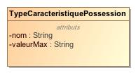
- TypeCaracteristiquePossession

Name | TypeCaracteristiquePossession
Qualified Name | Analyse_MMORPG::jeu::inventaire::TypeCaracteristiquePossession
Visibility | public
Abstract | false
Base Classifier
Realized Interface

Attribute Detail

nom

Type | String
Default Value
Visibility | private
Multiplicity

valeurMax

Type | String
Default Value
Visibility | private
Multiplicity

Relation Detail

Association

Name
Related Element | - TypePossession

Name
Related Element | - CaracteristiquePossession

Class TypePossession

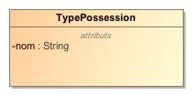
- TypePossession

Name | TypePossession
Qualified Name | Analyse_MMORPG::jeu::inventaire::TypePossession
Visibility | public
Abstract | false
Base Classifier
Realized Interface

Attribute Detail

caracteristiques

Type | TypeCaracteristiquePossession
Default Value
Visibility | private
Multiplicity | *

effetSurAuteur

Type | Effet
Default Value
Visibility | private
Multiplicity | *

effetSurCible

Type | Effet
Default Value
Visibility | private
Multiplicity | *

nom

Type | String
Default Value
Visibility | private
Multiplicity

Relation Detail

Association

Name
Related Element | - Effet

Name
Related Element | - Possession

Name
Related Element | - Effet

Name
Related Element | - TypeCaracteristiquePossession

Package Analyse_MMORPG::jeu::personnage

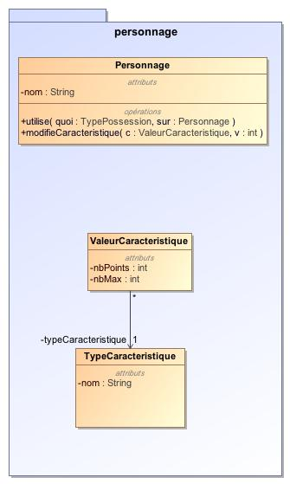
- personnage

Name | personnage
Qualified Name | Analyse_MMORPG::jeu::personnage

Class Metier

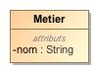
- Metier

Name | Metier
Qualified Name | Analyse_MMORPG::jeu::personnage::Metier
Visibility | public
Abstract | false
Base Classifier
Realized Interface

Attribute Detail

nom

Type | String
Default Value
Visibility | private
Multiplicity

Relation Detail

Association

Name
Related Element | - Personnage

Class Personnage

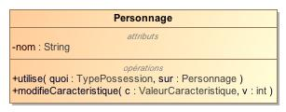
- Personnage

Name | Personnage
Qualified Name | Analyse_MMORPG::jeu::personnage::Personnage
Visibility | public
Abstract | false
Base Classifier
Realized Interface

Attribute Detail

Type | Metier
Default Value
Visibility | private
Multiplicity | 1

Type | Race
Default Value
Visibility | private
Multiplicity | 1

caracteristiques

Type | ValeurCaracteristique
Default Value
Visibility | private
Multiplicity | 1

nom

Type | String
Default Value
Visibility | private
Multiplicity

sacADos

Type | Possession
Default Value
Visibility | private
Multiplicity | *

Operation Detail

modifieCaracteristique

Type
Visibility | public
Is Abstract | false
Parameter | - in c : ValeurCaracteristique  - in v : int

utilise

Type
Visibility | public
Is Abstract | false
Parameter | - in quoi : TypePossession  - in sur : Personnage

Relation Detail

Association

Name
Related Element | - Race

Name
Related Element | - ValeurCaracteristique

Name
Related Element | - Metier

Name
Related Element | - Joueur

Name
Related Element | - Possession

Class Race

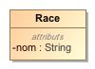
- Race

Name | Race
Qualified Name | Analyse_MMORPG::jeu::personnage::Race
Visibility | public
Abstract | false
Base Classifier
Realized Interface

Attribute Detail

nom

Type | String
Default Value
Visibility | private
Multiplicity

Relation Detail

Association

Name
Related Element | - Personnage

Class TypeCaracteristique

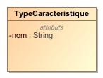
- TypeCaracteristique

Name | TypeCaracteristique
Qualified Name | Analyse_MMORPG::jeu::personnage::TypeCaracteristique
Visibility | public
Abstract | false
Base Classifier
Realized Interface

Attribute Detail

nom

Type | String
Default Value
Visibility | private
Multiplicity

Relation Detail

Association

Name
Related Element | - ValeurCaracteristique

Name
Related Element | - TypeMonde

Name
Related Element | - Effet

Class ValeurCaracteristique

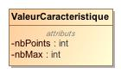
- ValeurCaracteristique

Name | ValeurCaracteristique
Qualified Name | Analyse_MMORPG::jeu::personnage::ValeurCaracteristique
Visibility | public
Abstract | false
Base Classifier
Realized Interface

Attribute Detail

nbMax

Type | int
Default Value
Visibility | private
Multiplicity

nbPoints

Type | int
Default Value
Visibility | private
Multiplicity

typeCaracteristique

Type | TypeCaracteristique
Default Value
Visibility | private
Multiplicity | 1

Relation Detail

Association

Name
Related Element | - Personnage

Name
Related Element | - TypeCaracteristique

Package Analyse_MMORPG::paquet_simple

Name | paquet_simple
Qualified Name | Analyse_MMORPG::paquet_simple

Class EntiteEsseulee

Name | EntiteEsseulee
Qualified Name | Analyse_MMORPG::paquet_simple::EntiteEsseulee
Visibility | public
Abstract | false
Base Classifier
Realized Interface

Package Conception_MMORPG::administrateur

Name | administrateur
Qualified Name | Conception_MMORPG::administrateur

Package Conception_MMORPG::administrateur::composants

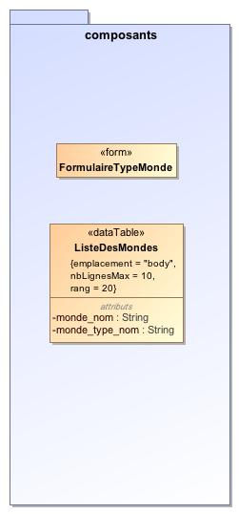
- composants

Name | composants
Qualified Name | Conception_MMORPG::administrateur::composants

Class FormulaireTypeMonde

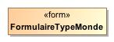
- FormulaireTypeMonde

Name | FormulaireTypeMonde
Qualified Name | Conception_MMORPG::administrateur::composants::FormulaireTypeMonde
Visibility | public
Abstract | false
Base Classifier
Realized Interface

Attribute Detail

Type | Mondes
Default Value
Visibility | private
Multiplicity

selected

Type | TypeMonde
Default Value
Visibility | private
Multiplicity | 1

Relation Detail

Association

Name
Related Element | - TypeMonde

Name
Related Element | - Mondes

Class ListeDesMondes

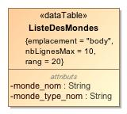
- ListeDesMondes

Name | ListeDesMondes
Qualified Name | Conception_MMORPG::administrateur::composants::ListeDesMondes
Visibility | public
Abstract | false
Base Classifier
Realized Interface

Attribute Detail

monde

Type | Monde
Default Value
Visibility | private
Multiplicity | *

monde_nom

Type | String
Default Value
Visibility | private
Multiplicity

monde_type_nom

Type | String
Default Value
Visibility | private
Multiplicity

Relation Detail

Association

Name
Related Element | - Mondes

Name | affiche
Related Element | - Monde

Package Conception_MMORPG::administrateur::pages

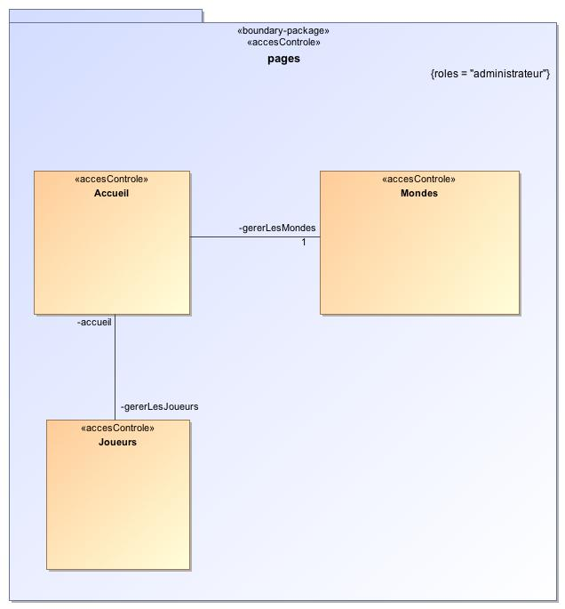
- pages

Name | pages
Qualified Name | Conception_MMORPG::administrateur::pages

Class Accueil

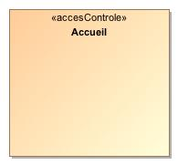
- Accueil

Name | Accueil
Qualified Name | Conception_MMORPG::administrateur::pages::Accueil
Visibility | public
Abstract | false
Base Classifier
Realized Interface

Attribute Detail

Type | Administrateur
Default Value
Visibility | private
Multiplicity

gererLesJoueurs

Type | Joueurs
Default Value
Visibility | private
Multiplicity

gererLesMondes

Type | Mondes
Default Value
Visibility | private
Multiplicity | 1

Relation Detail

Association

Name
Related Element | - Joueurs

Name
Related Element | - Mondes

Name
Related Element | - Administrateur

Class Joueurs

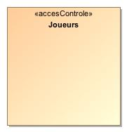
- Joueurs

Name | Joueurs
Qualified Name | Conception_MMORPG::administrateur::pages::Joueurs
Visibility | public
Abstract | false
Base Classifier
Realized Interface

Attribute Detail

accueil

Type | Accueil
Default Value
Visibility | private
Multiplicity

Relation Detail

Association

Name
Related Element | - Accueil

Class Mondes

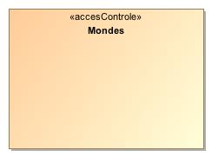
- Mondes

Name | Mondes
Qualified Name | Conception_MMORPG::administrateur::pages::Mondes
Visibility | public
Abstract | false
Base Classifier
Realized Interface

Attribute Detail

Type | ListeDesMondes
Default Value
Visibility | private
Multiplicity

Type | FormulaireTypeMonde
Default Value
Visibility | private
Multiplicity

Type | Accueil
Default Value
Visibility | private
Multiplicity

Relation Detail

Association

Name
Related Element | - FormulaireTypeMonde

Name
Related Element | - Accueil

Name
Related Element | - ListeDesMondes

Package Conception_MMORPG::joueur

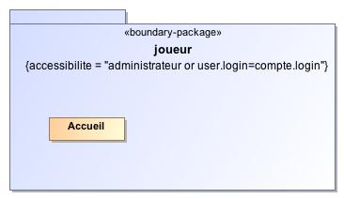
- joueur

Name | joueur
Qualified Name | Conception_MMORPG::joueur

Class Accueil

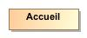
- Accueil

Name | Accueil
Qualified Name | Conception_MMORPG::joueur::Accueil
Visibility | public
Abstract | false
Base Classifier
Realized Interface

Attribute Detail

Type | Joueur
Default Value
Visibility | private
Multiplicity

Relation Detail

Association

Name
Related Element | - Joueur

Appendix A: Diagram

gestionJeu

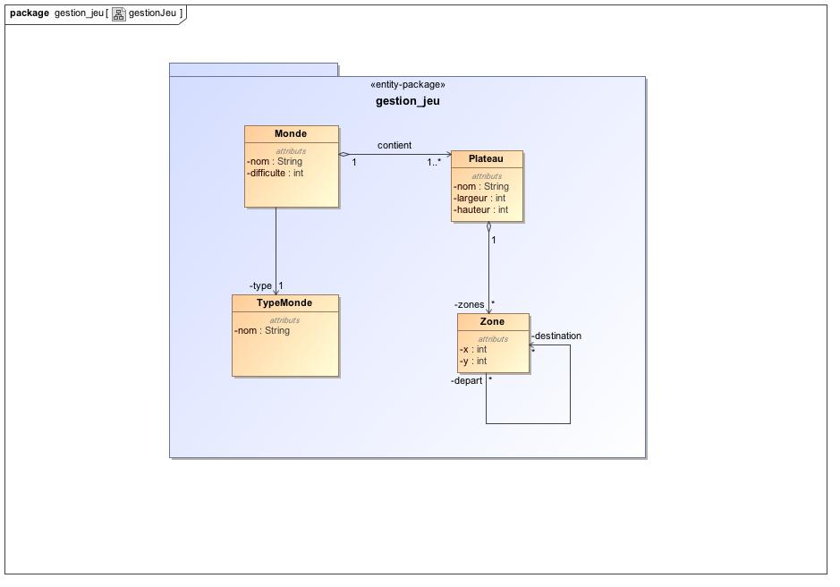
- gestionJeu

Gestion_Compte

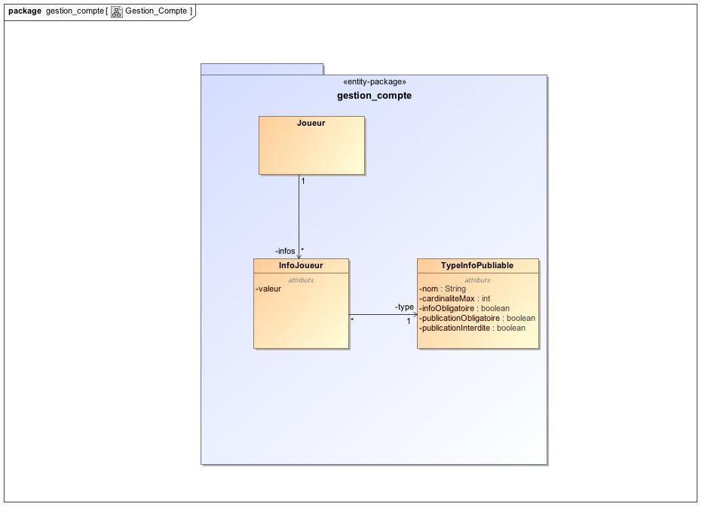
- Gestion_Compte

ihm_administrateur

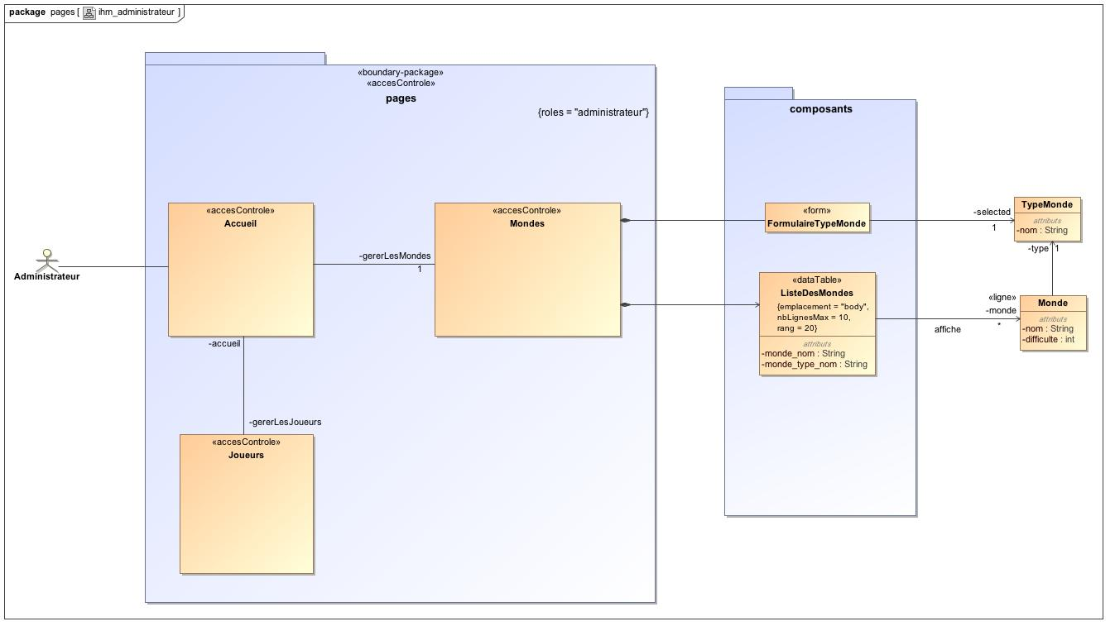
- ihm_administrateur

ihm_joueur

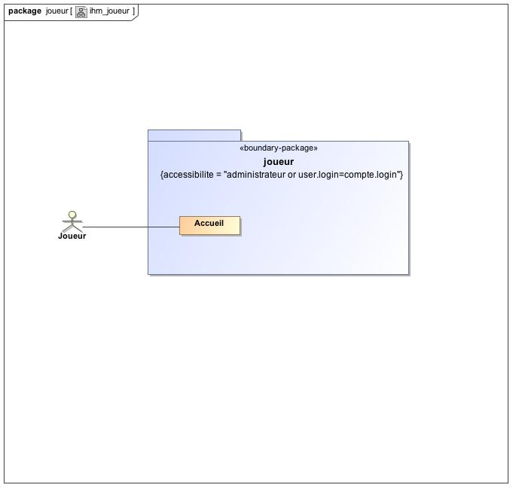
- ihm_joueur

inventaire

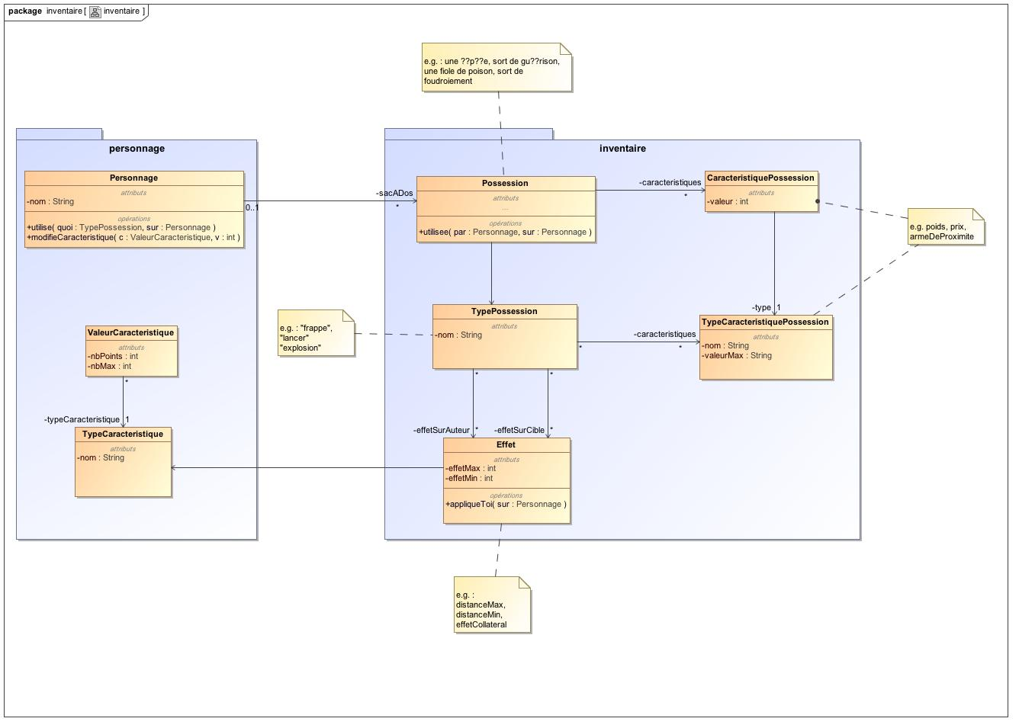
- inventaire

personnage

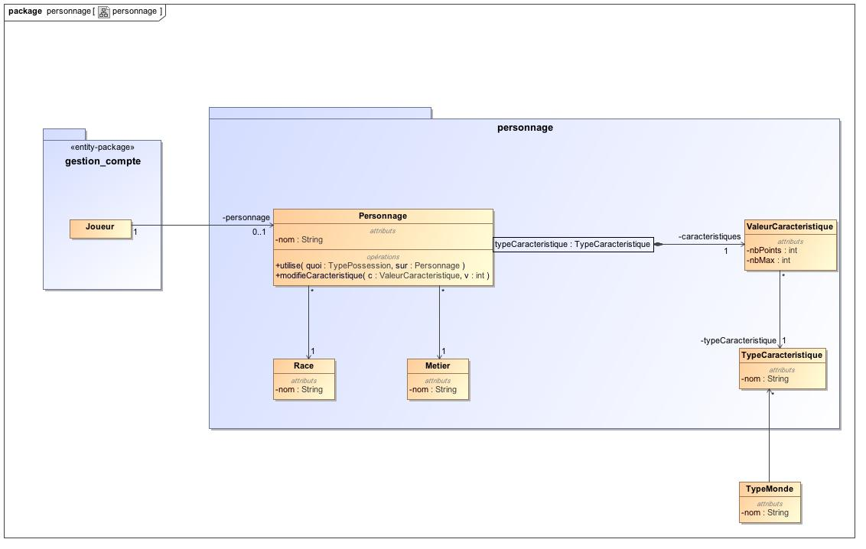
- personnage

