**Some Determinants of Sustainable Economic Reintegration**

EU-IOM Joint Initiative for Migrant Protection and Reintegration in the Sahel and Lake Chad Region

**Introduction**

Background. A short paragraph on the program.

Aim. What we assess, with which data, using which method.

Questions that should be answered.

Overall methodology (regression)

**Reintegration Economic Survey (RES)**

Introduction. What the RES is.

Sample size and main statistics. Methodology specifics.

Model 1: Determinants of Business Success

Model 2: Determinants of Business Profitability

Model 3: Effect of Training on Business Success

Model 4: Determinants of Future Intentions to Migrate

Model 5: Determinants of Employee Number

**Reintegration Sustainability Survey (RSS)**

Introduction. What the RSS is.

Sample size and main statistics. Including plot on correlations between RSS scores.

Model 6: Determinants of Sustainable Reintegration (Composite Score)

Model 7: Determinants of Sustainable Reintegration (Economic Score)

**Summary of Results**

A short discussion of the results.

With a table showing which predictors are significant across all models, and significance levels.

**Lessons Learned and Recommendations**

Recommendations concerning the results. That is, which variables are key, etc.

Recommendations concerning data issues and data wrangling.

**List of Figures and Tables**

**Appendices**

Summary of Data Sets Used

Data Analysis Plan

RES Descriptive Plots

RSS Descriptive Plots

Correlations Between RSS Scores (Table)

Interaction of Country and Business Type for Model 1

Model 5 with Time to receive assistance added

Model 5 with Assistance count added

Predicting Social score and Psychosocial score

**Other Submitted Documents**

These documents are submitted separately.

A folder containing all clean data sets used for analysis, with notes on how these were built.

A folder with all R scripts, which allows to reproduce all data processes.

A log of anomalies. Might be included in R scripts.

A log of changes to the data. Might be included in R scripts.

**Introduction**

**The Joint Initiative and assistance to voluntary return and reintegration**

The EU-IOM Joint Initiative for Migrant Protection and Reintegration was launched in April 2017 and implemented in 13 countries of the Sahel and Lake Chad Region.[1] A key element of the Joint Initiative is assistance to voluntary return and reintegration. Migrants who voluntarily decided to return received economic, social, and psychosocial support, such as job placement, training, housing, education, childcare, special security measures, and so on[2].

The overarching goal of the Joint Initiative is the successful reintegration of migrants in a dignified and sustainable manner[3]. It is therefore crucial to assess whether the reintegration measures offered to the migrants are efficient and positively contribute to this goal.

**Assessing measures of economic reintegration**

The current study assesses the effectiveness of some of these measures, with a focus on economic reintegration. For example, some respondents received business management training. Does this training positively influence reintegration, such that respondents who received it tend to have a higher business success than those who did not receive it? Furthermore, if training has a positive impact, is this impact the same for all business types or activities?

While exploring such questions, this study also considers factors that are not related to the assistance received by the migrants, but that might impact reintegration, such as age, gender, disability, where the respondents are based, where they are returning from, and so on. For example, we might find that training is most efficient for respondents engaged in retail, except in a given country, and only if the respondent has no disability.

**Exploring the determinants of sustainable reintegration using regression analysis**

To explore these complex relationships, and ultimately identify the determinants of sustainable economic reintegration, regression analysis was used. Regression analysis allows to use multiple factors or variables to explain an outcome. Examples of outcomes are whether the business of the respondents is profitable, or how high the Economic score of the respondents is. In short, regression analysis tells us which factors have an impact on reintegration, and whether this impact is positive or negative.

While doing so, regression also allows us to *isolate* the effect of each factor. For example, we might find that businesses launched by men are more profitable than businesses launched by women. Would it be correct to conclude that gender is a determinant of successful economic reintegration, and that helping men is therefore more efficient than helping women? No, because the apparent success of men might be explained by other factors. For example, men might be engaged in activities that are, in themselves, more profitable. In other words, it is the type of activity, not the gender, which would explain the apparent higher degree of success amongst men.

This is why regression analysis is useful. Regression analysis will evaluate the impact of each factor while holding the impact of all other factors constant. In the example above, it will evaluate the impact of gender while controlling for the impact of business activity. Regression analysis might then find than once we take into account business activity, there are no differences between men and women in terms of business profitability. And this would have obvious implications for programming. In this case, business activities that result in a high profitability should be encouraged, whereas gender should be considered irrelevant to business success.

**Study questions**

Six questions were investigated in this study. Four concerned economic reintegration, one concerned overall reintegration, and the last one concerned the respondents’ future intentions to migrate. The data used to answer these questions came from three questionnaires: the Reintegration Economic Survey (RES), the Reintegration Sustainability Survey (RSS), and Mimosa. Table X summarises the questions, how they were investigated, and their data source.

**Study Outline**

To be written last.

**Table X: Determinants of Economic Reintegration Considered in this Study**

|  |  |  |  |
| --- | --- | --- | --- |
|  | **Using these variables…** | **…To explain this variable** | **Data** |
| **1. What makes a successful returnee business?** | Age, Business members, Business type, Corona impact on business, Country, Country of return, Disability, Employee Number, First Choice, Gender, Interview Type, Migration Duration, Business management training, Received support as | Is your business open and well? | Reintegration Economic Survey (RES)  1,917 respondents |
| **2. What makes a profitable returnee business?** | Does your business cover your needs and those of your family? |
| **3. Does training contribute to returnee business success?** | Same as 1. and 2., with the following variables added:  Training type, Training duration, assistance duration, Return to reintegration | Is your business open and well? | Reintegration Economic Survey (RES) and  Mimosa  1,852 respondents |
| **4. What makes a successful economic reintegration?** | Age, Financial services, Gender, Material assistance, MB assistance duration, MB support duration, Medical support, MB form of assistance, Migration duration, Origin country, Psycho-social support, Return country, Social support, Training, Training duration | Economic reintegration score | Reintegration Sustainability Survey (RSS) and  Mimosa  1,196 Respondents |
| **5. What makes a successful reintegration overall?** | Composite reintegration score |
| **6. What makes returnees want to migrate again?** | Same as 1. and 2. | Do you plan to migrate again? | Reintegration Economic Survey (RES)  1,917 respondents |

**Appendix X: Frequencies of Reintegration Economic Survey (RES) Variables**

*Note*. Each variable has two graphs. The first graph shows frequencies from the raw data, whereas the second graph shows frequencies after recoding for regression analysis. The number of respondents is provided in the subtitle of each graph. Typically, the second graph has fewer answer options, and a smaller number of observations. That is because some answer options were grouped and and some missing answers or outliers were removed for regression analysis.

Variables are presented in the order in which they appear in the questionnaire, and only variables used in analyses are included. Dependent variables are presented in the main text.

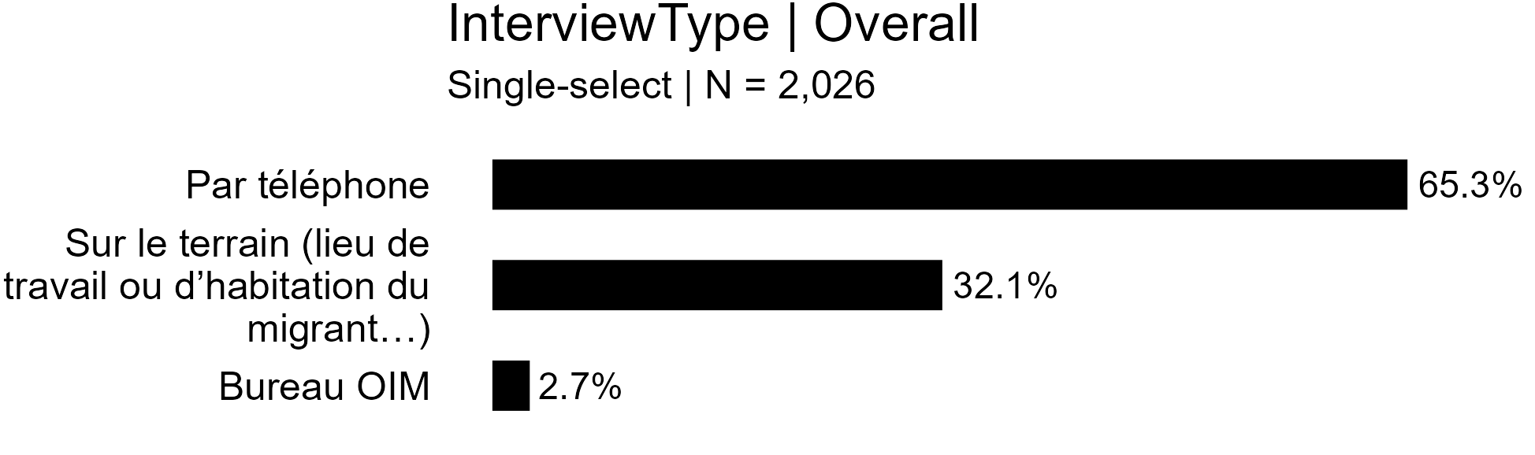

For regression analysis, recoded as:

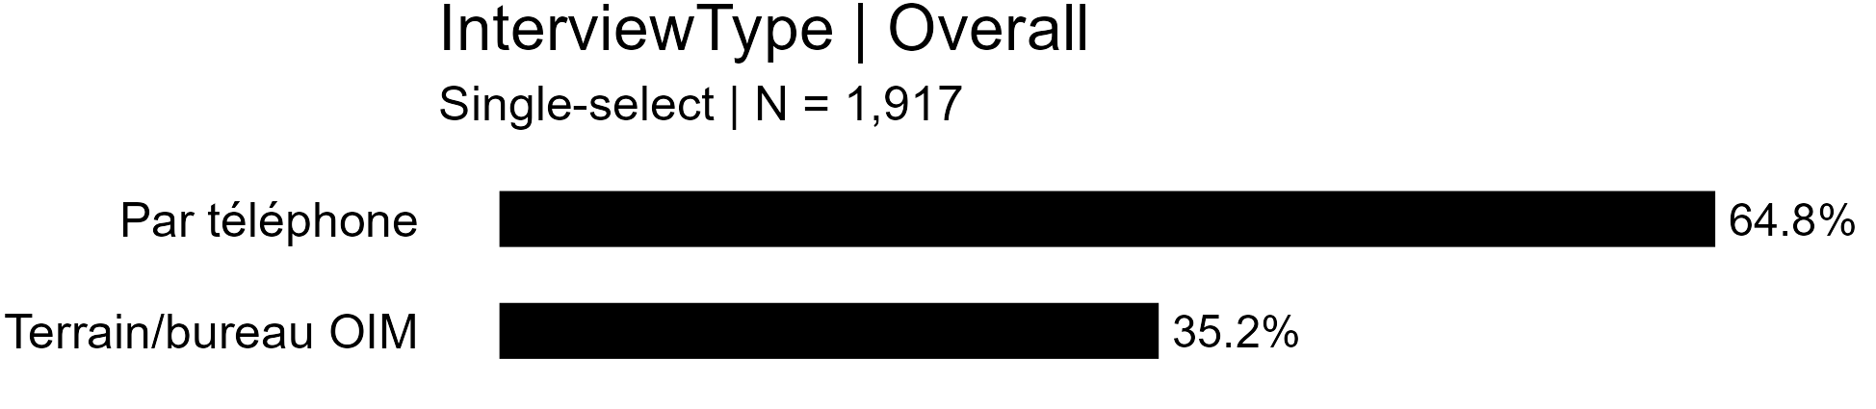

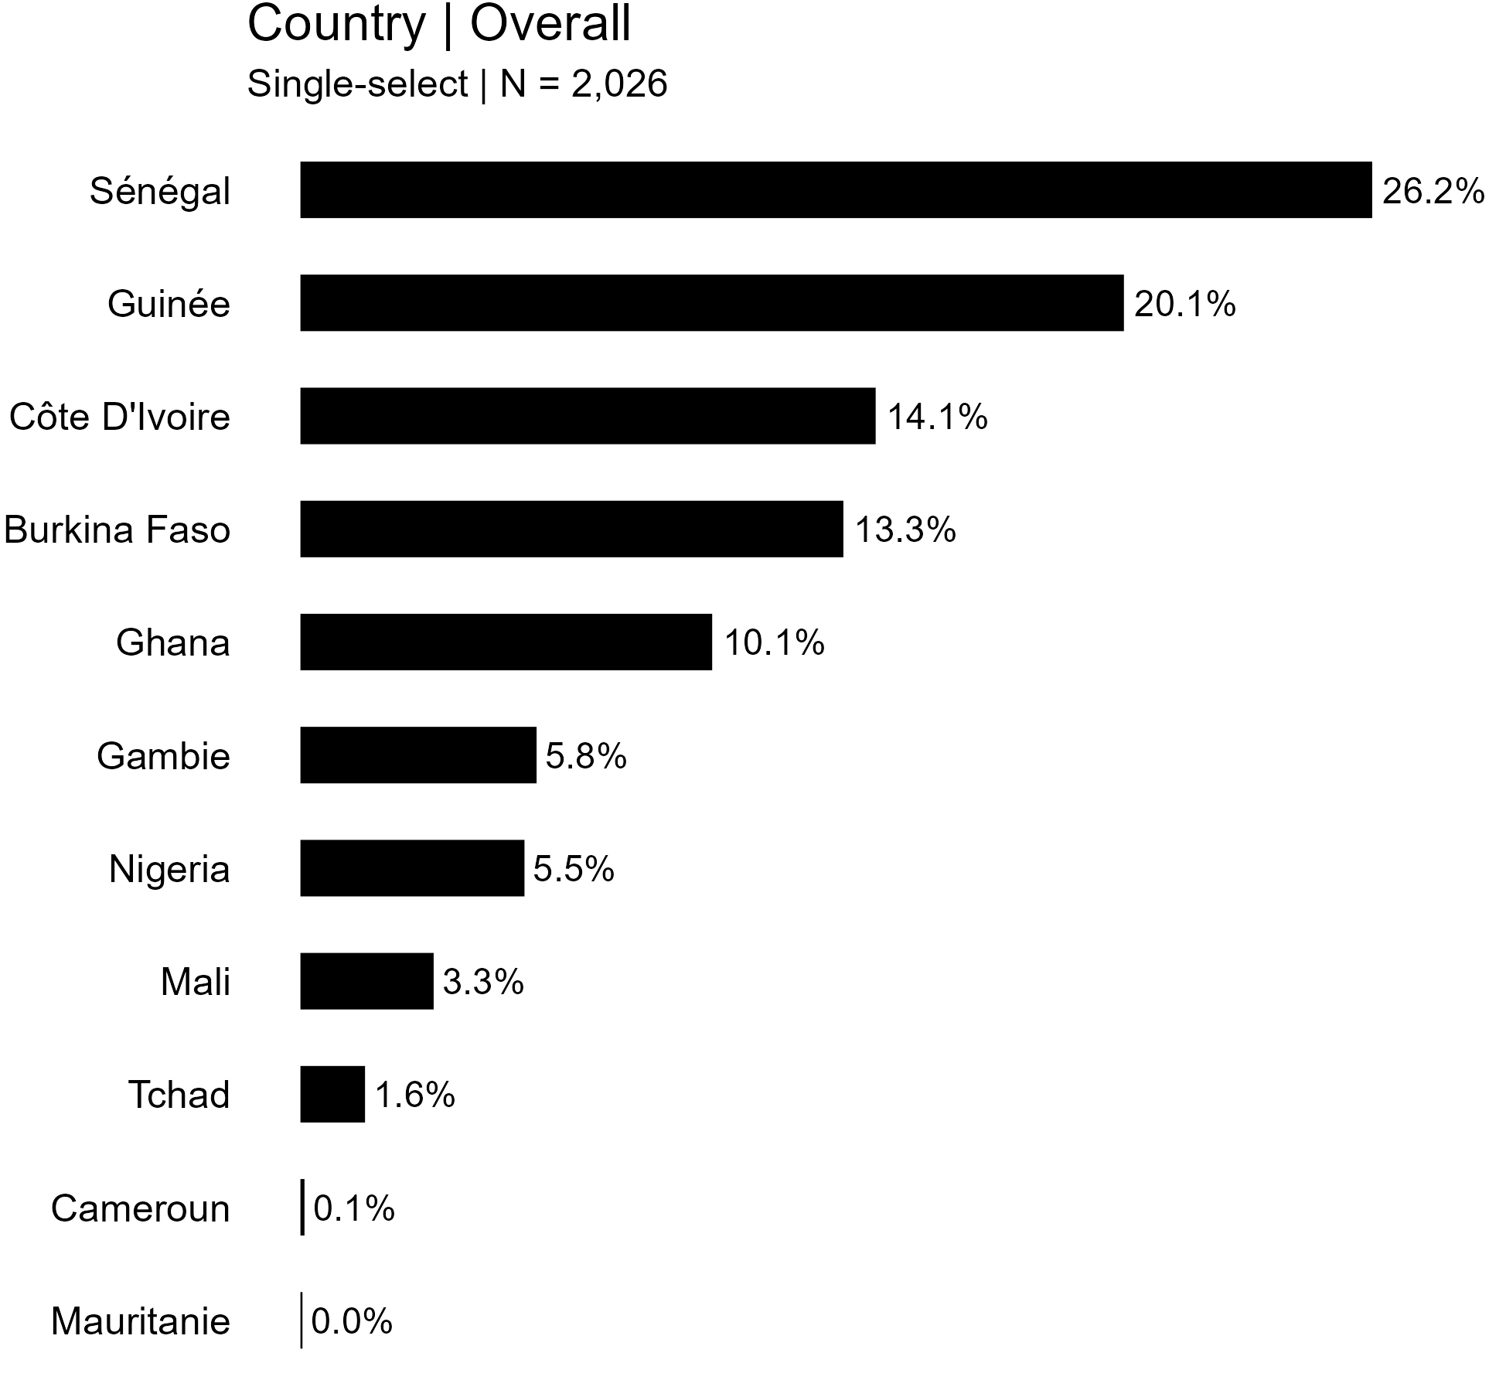

For regression analysis, recoded as:

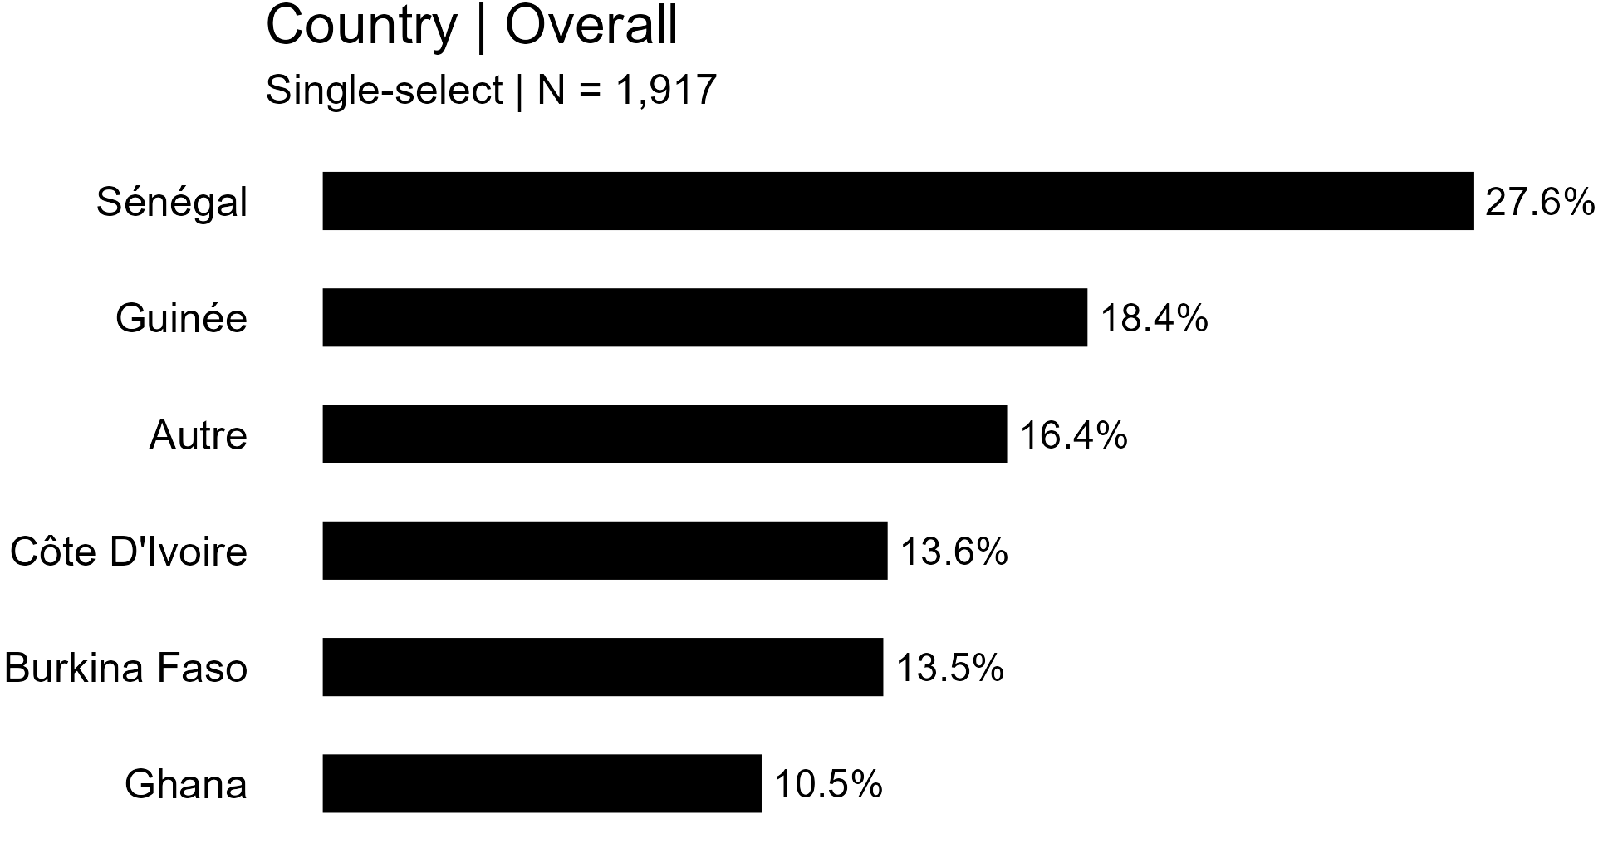

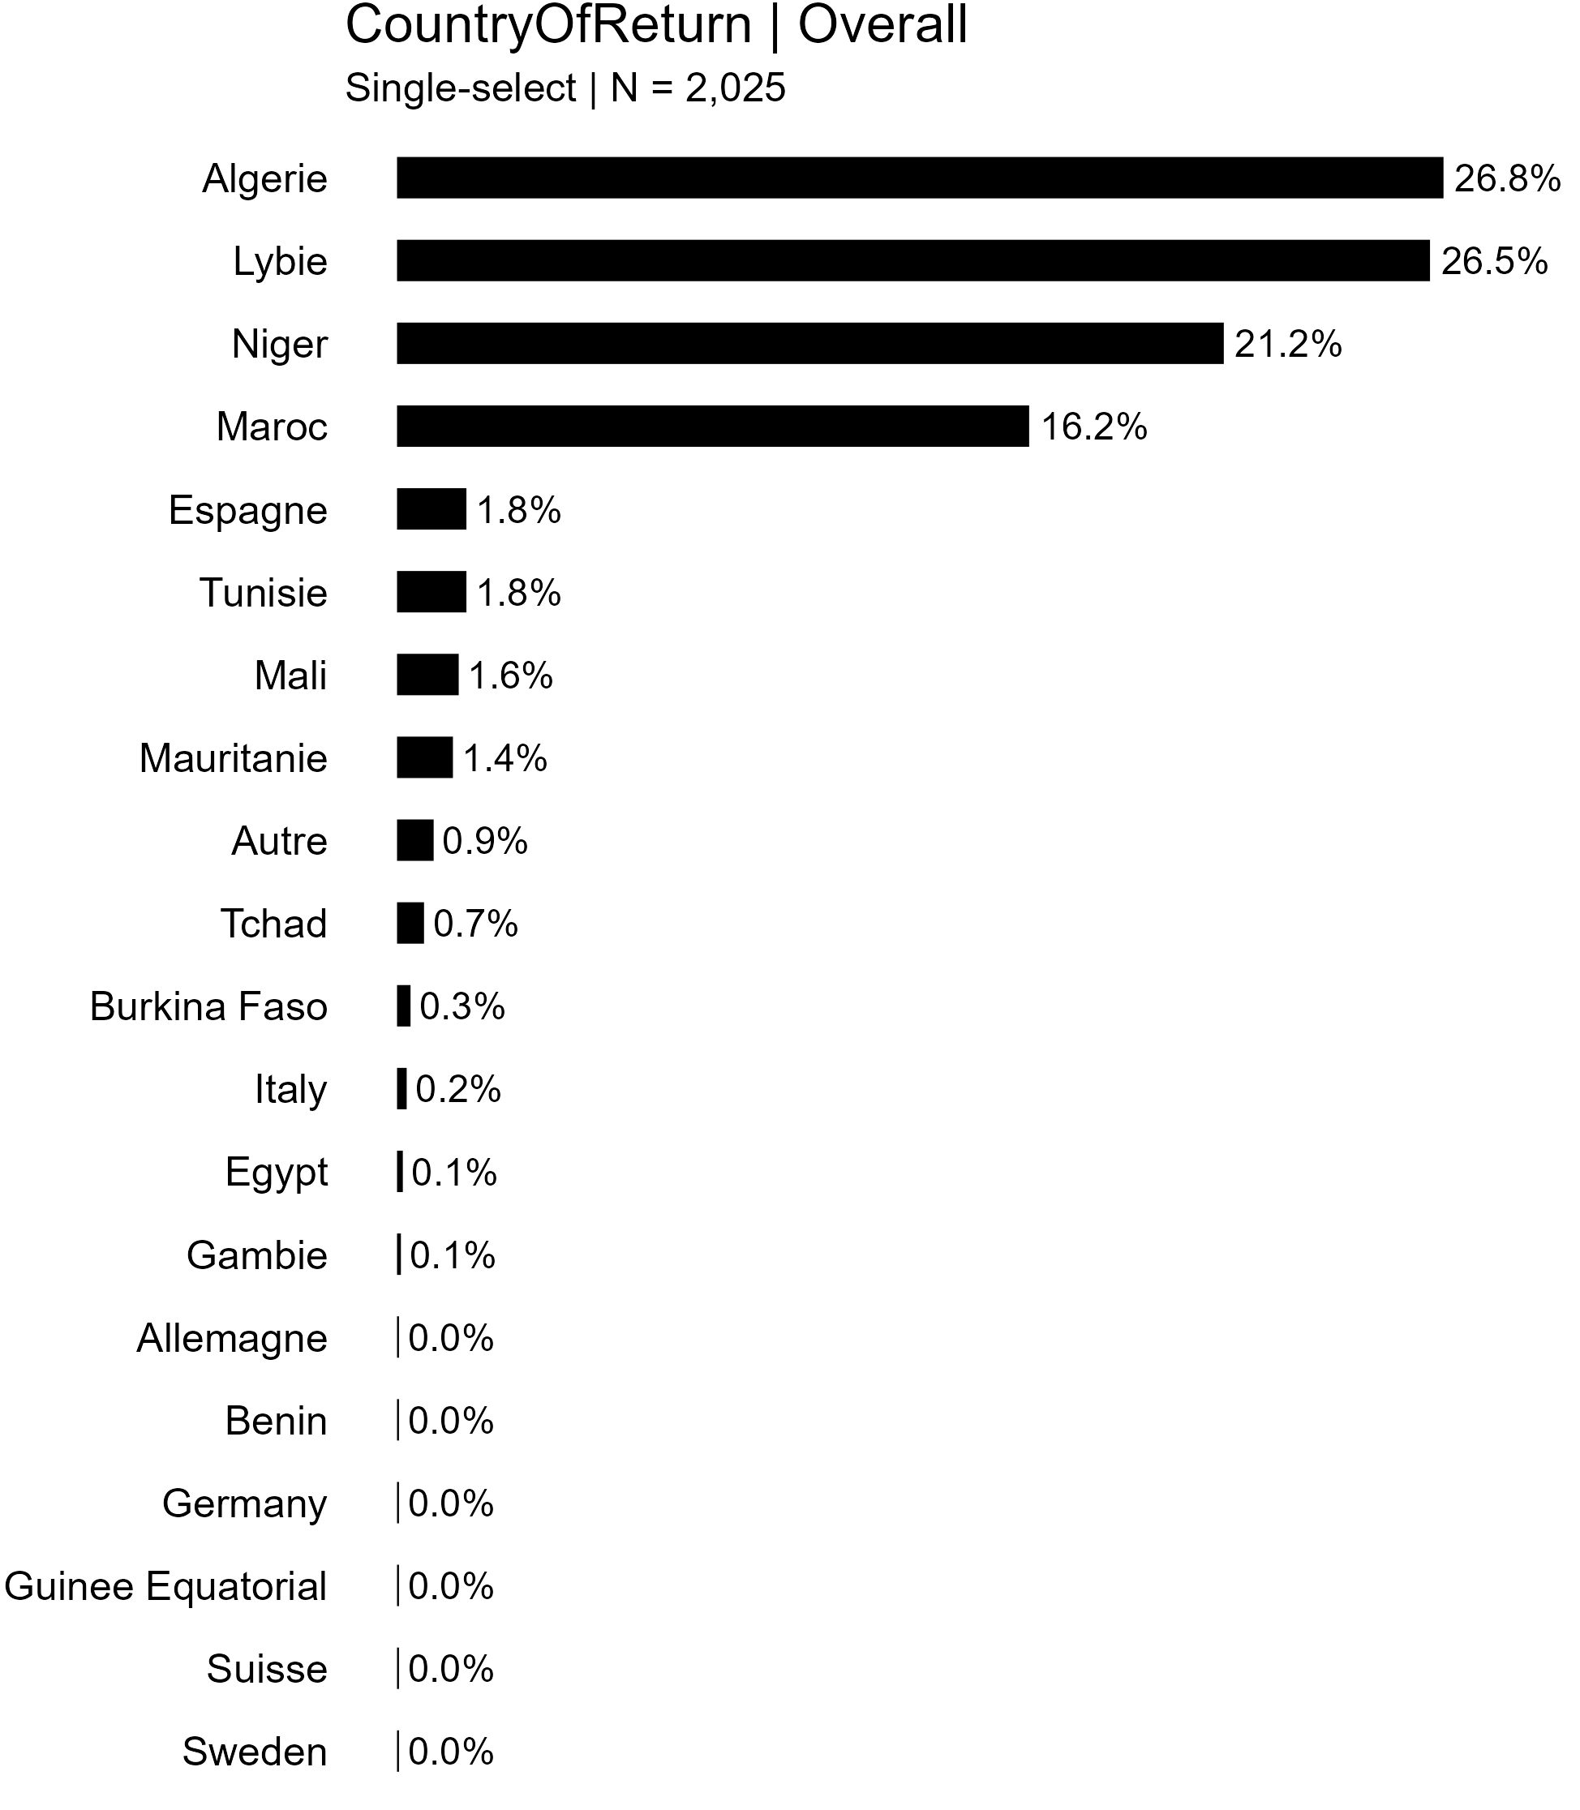

For regression analysis, recoded as:

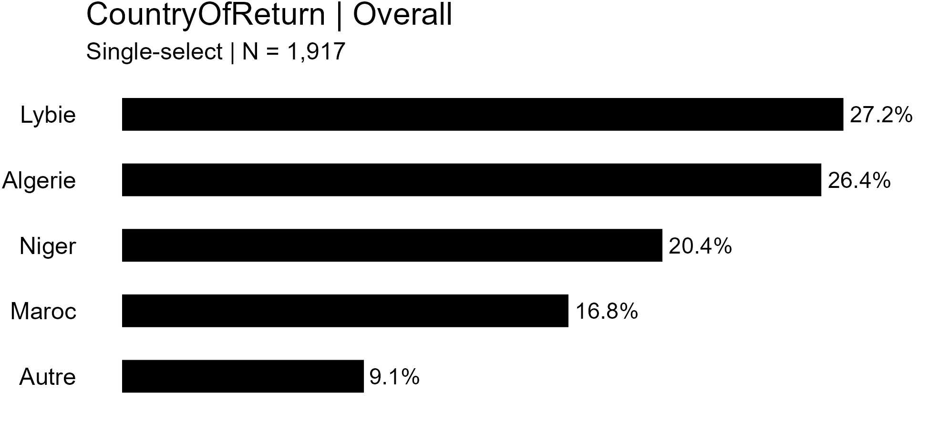

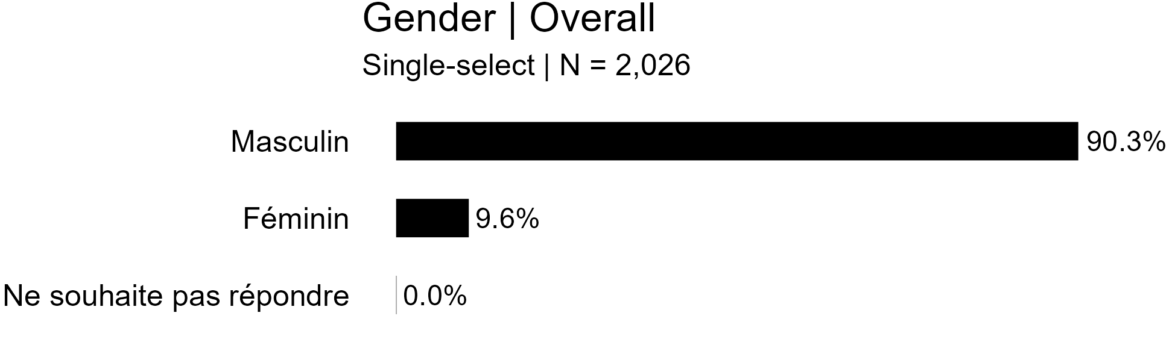

For regression analysis, recoded as:

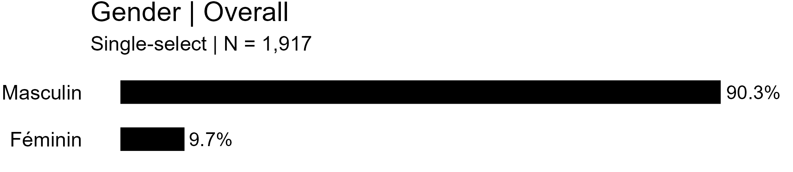

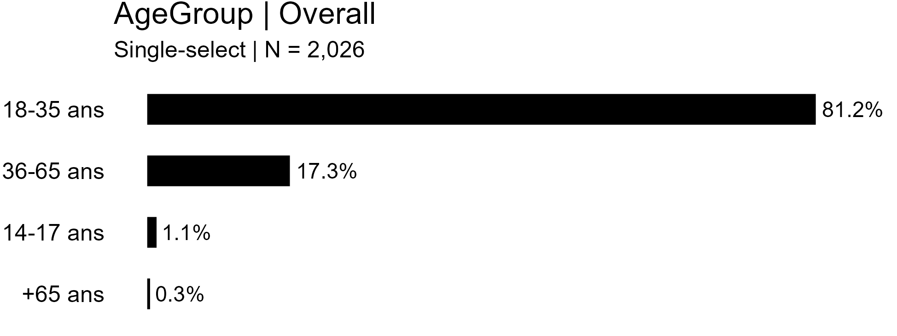

For regression analysis, recoded as:

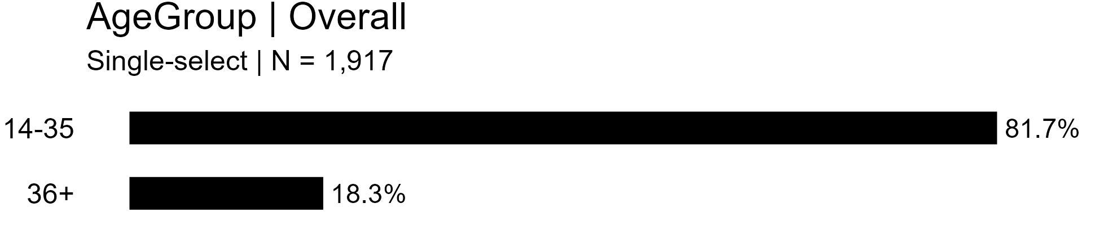

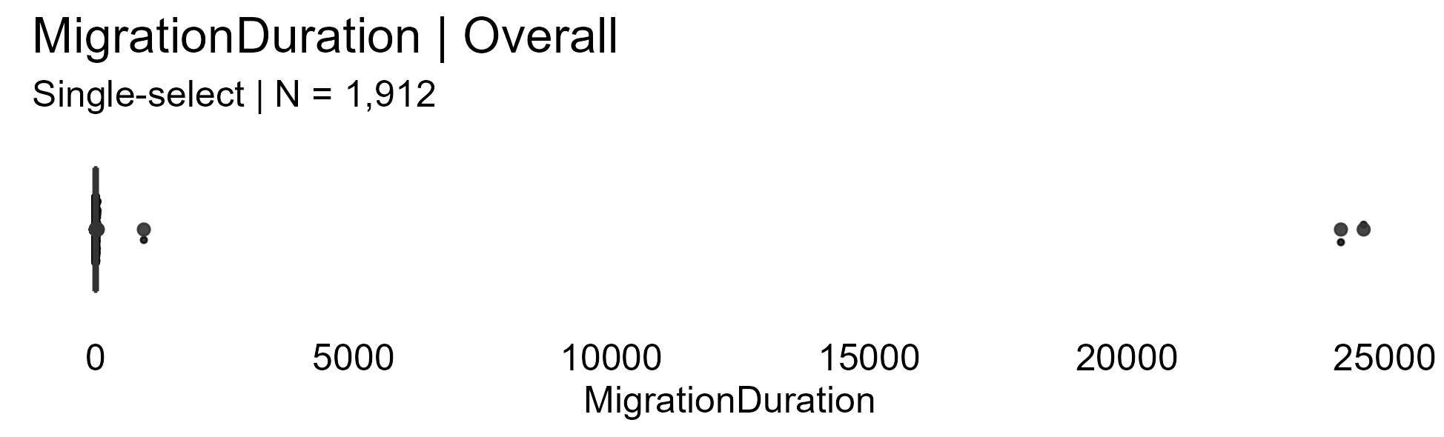

For regression analysis, recoded as:

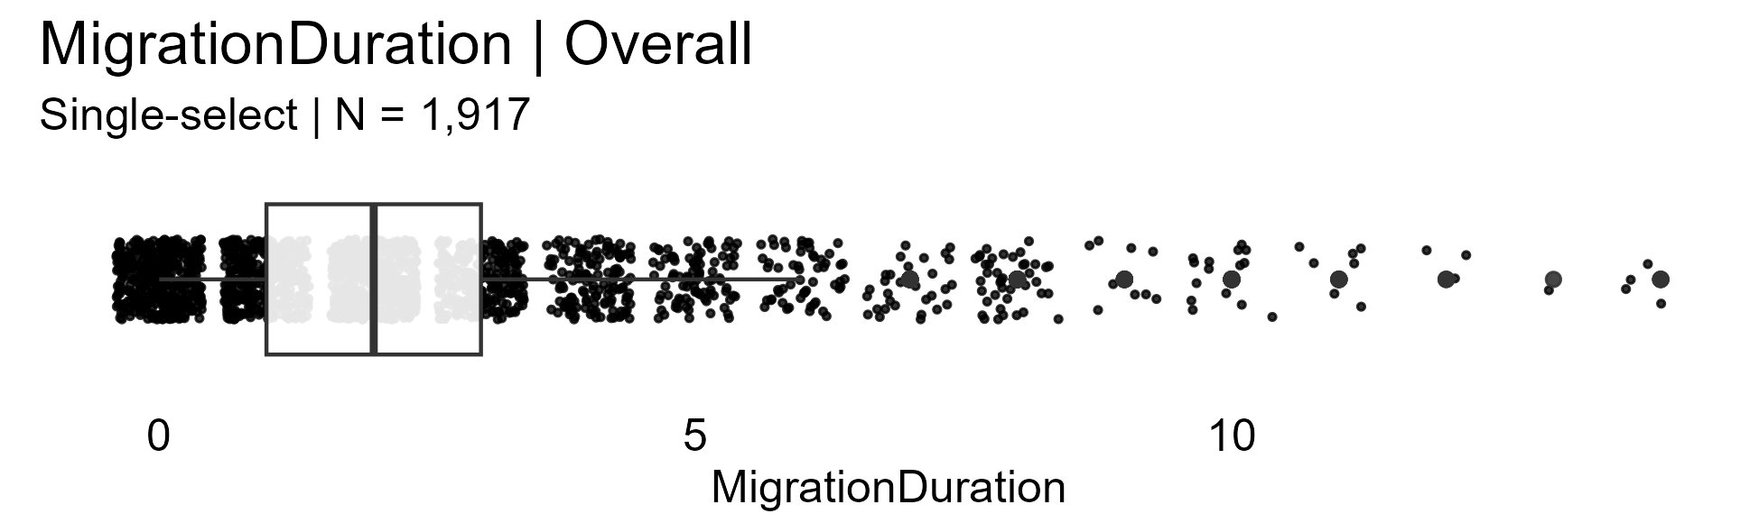

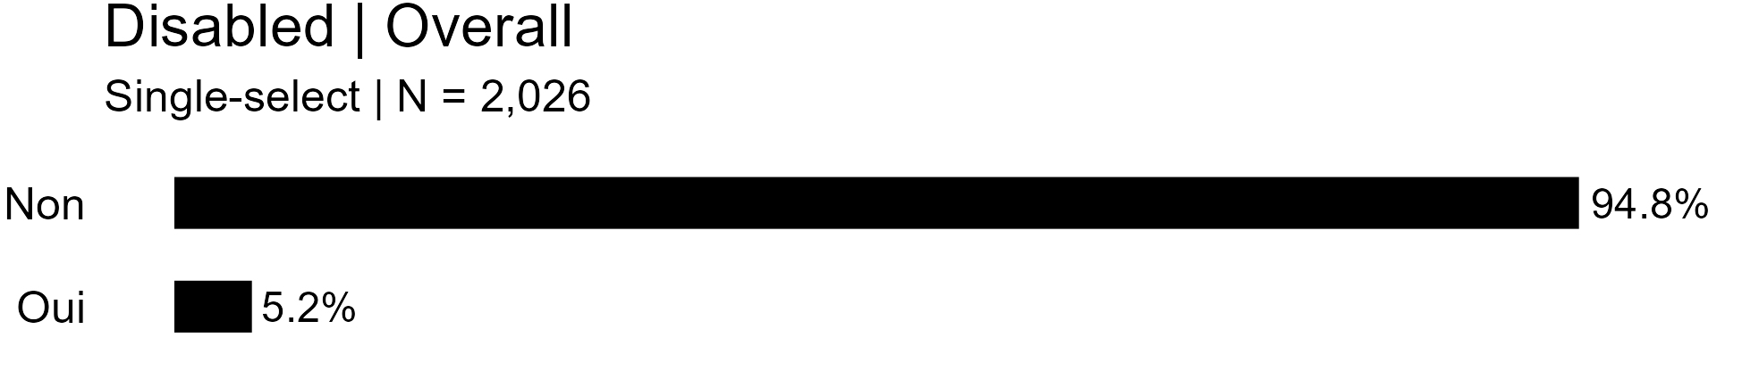

For regression analysis, recoded as:

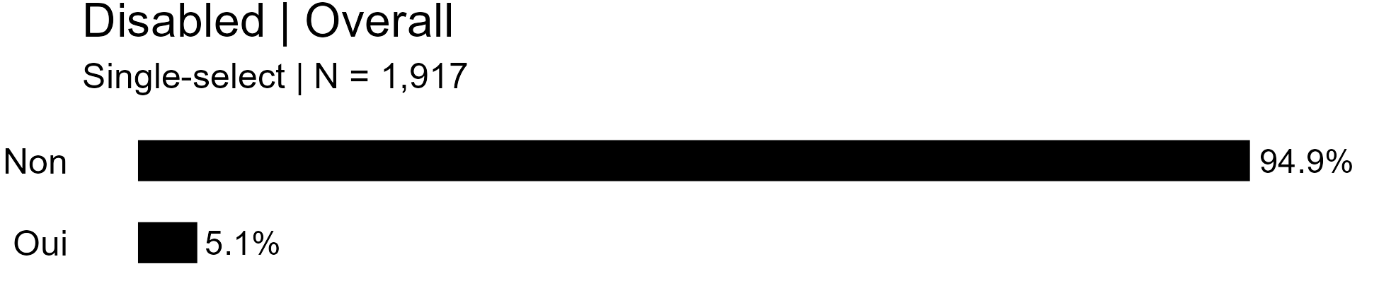

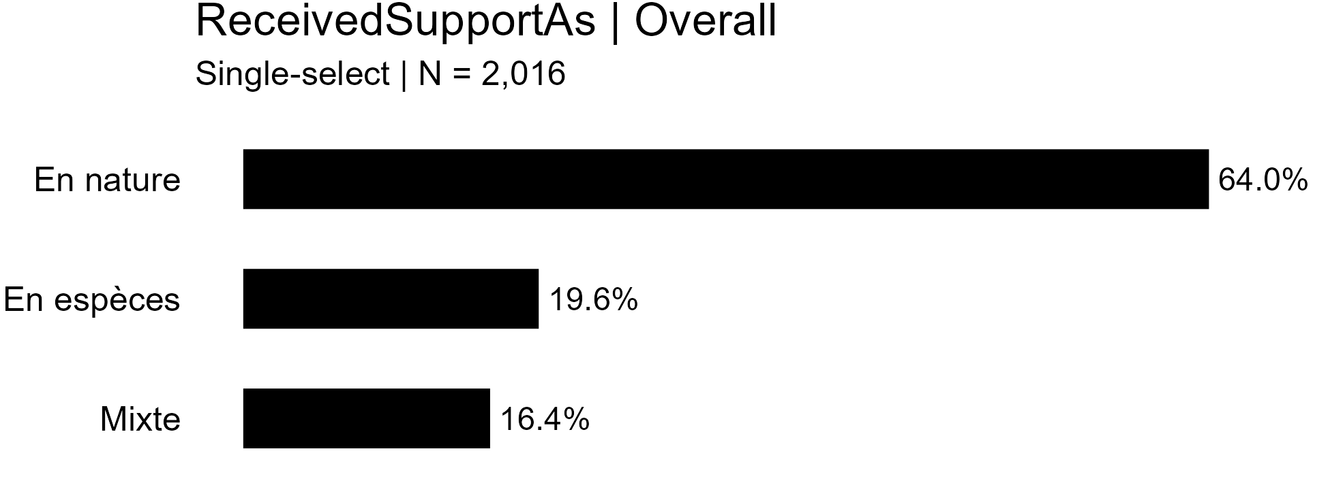

For regression analysis, recoded as:

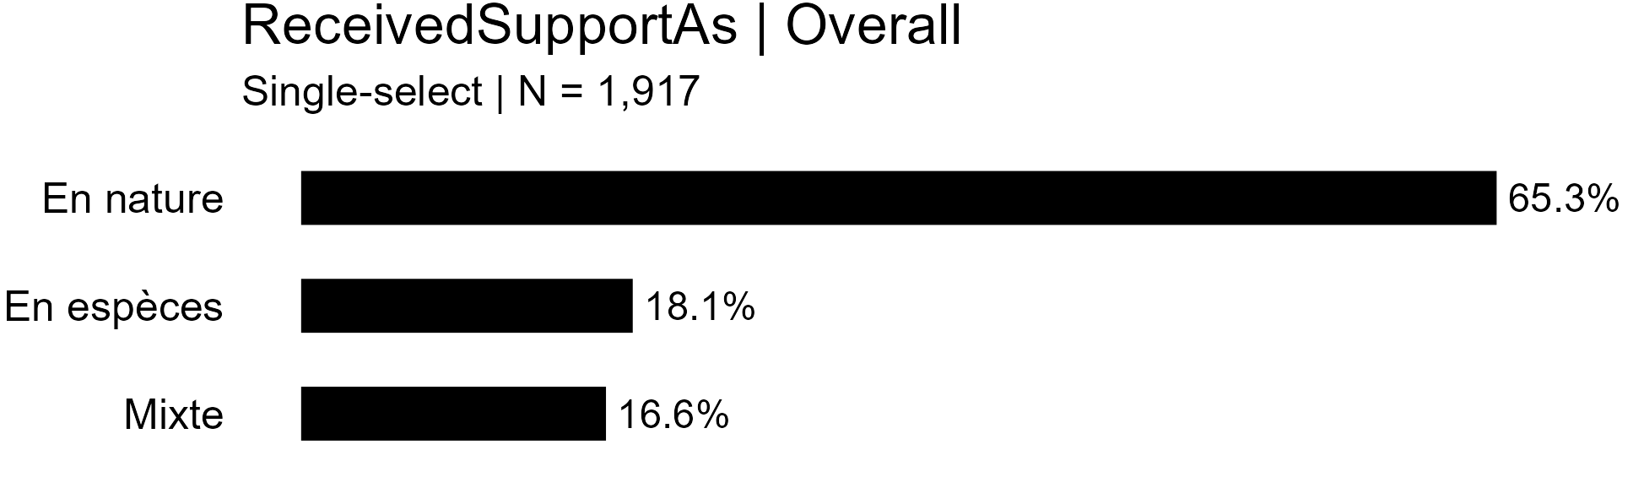

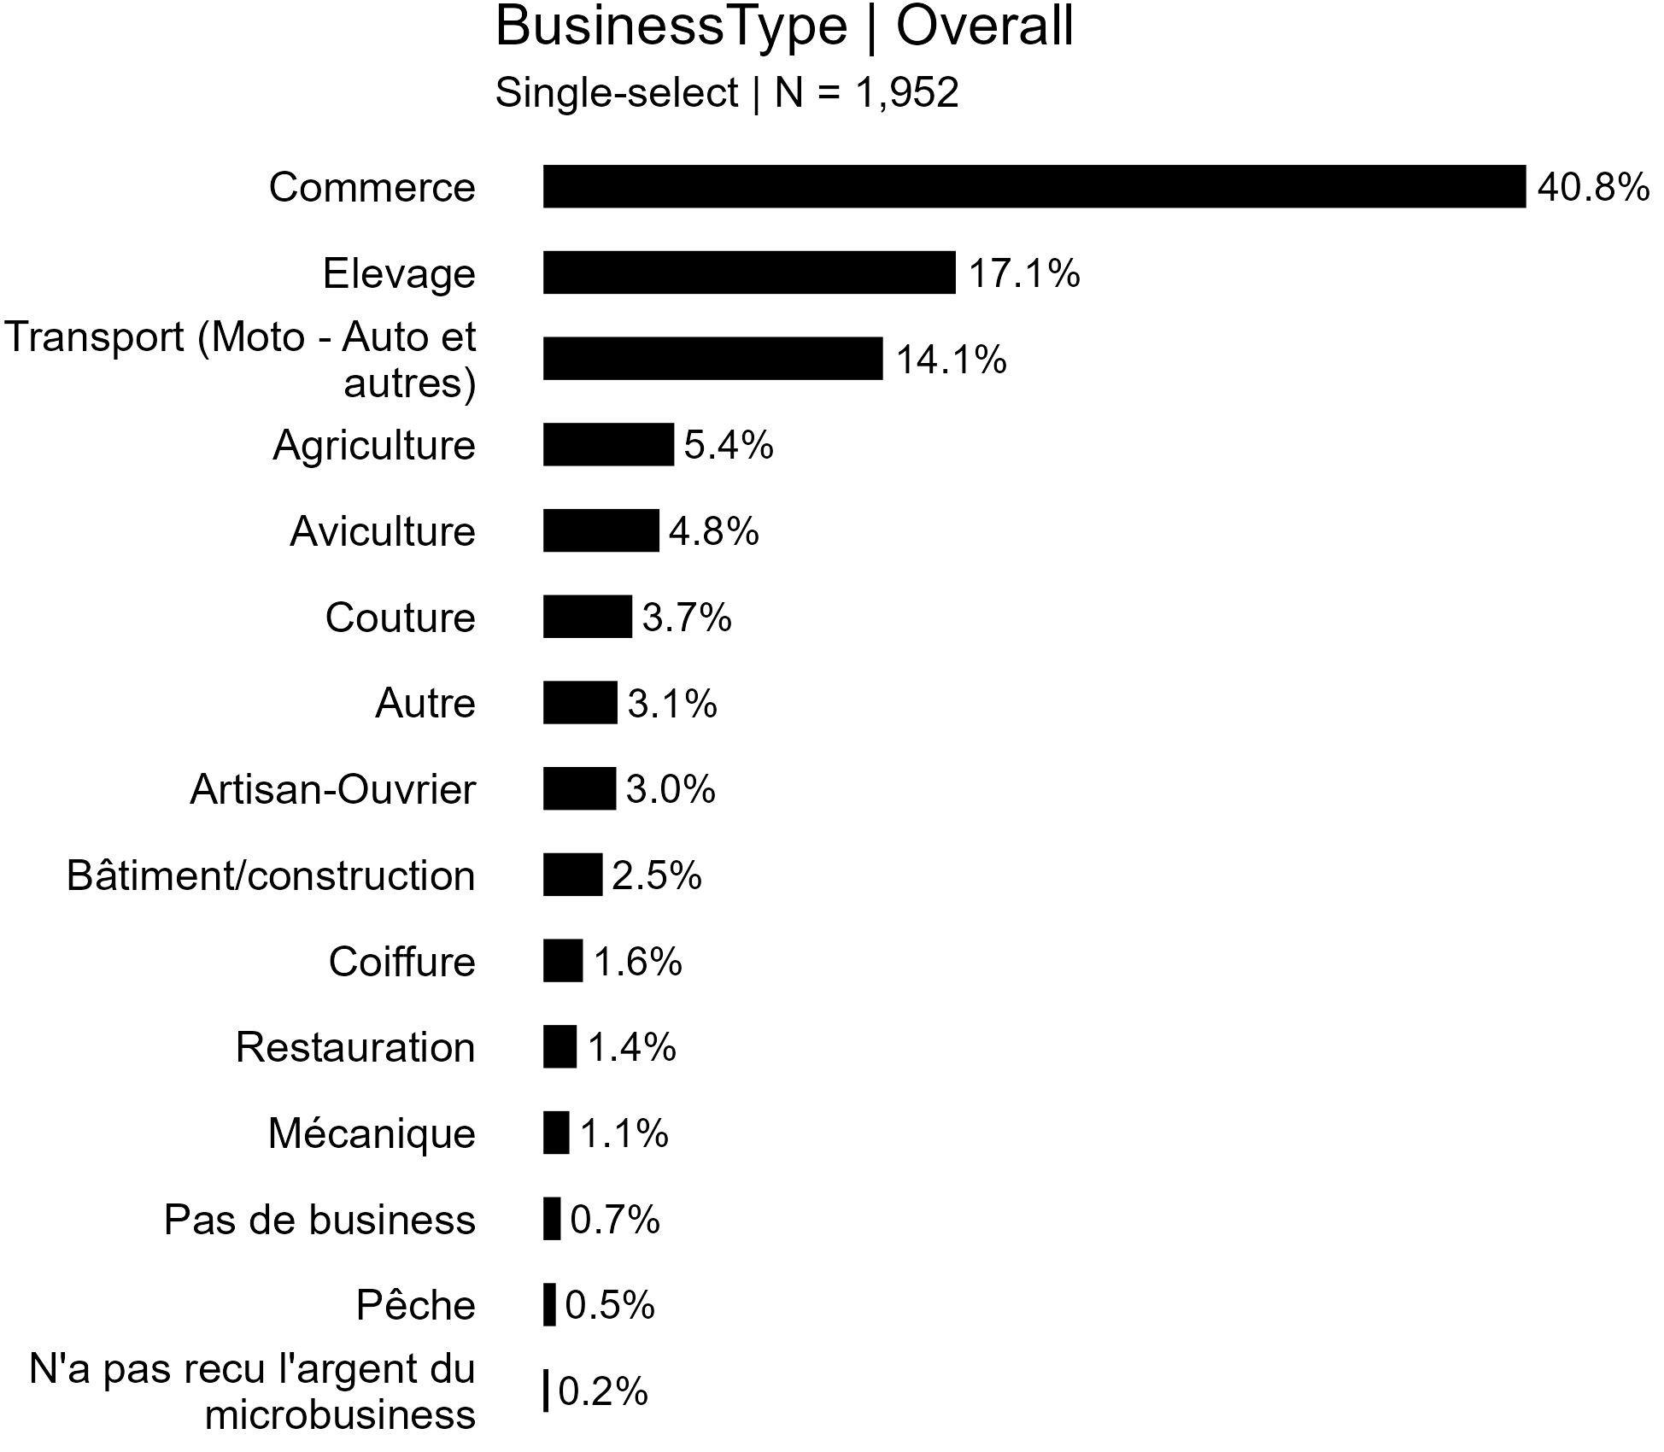

For regression analysis, recoded as:

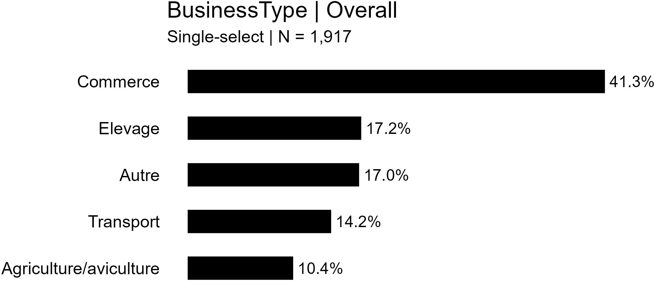

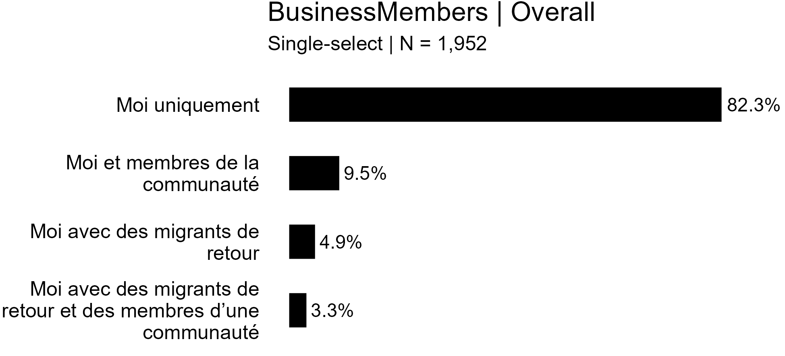

For regression analysis, recoded as:

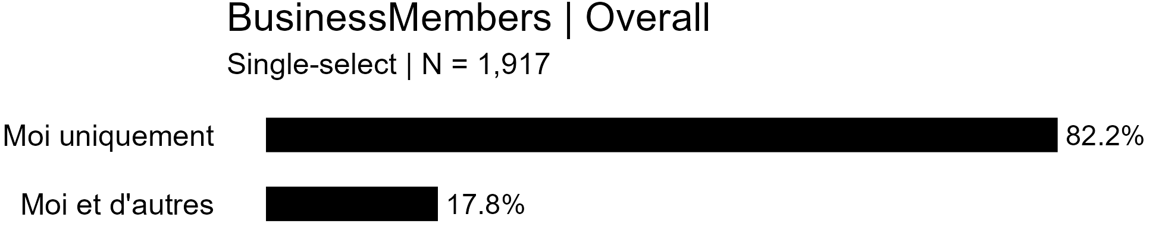

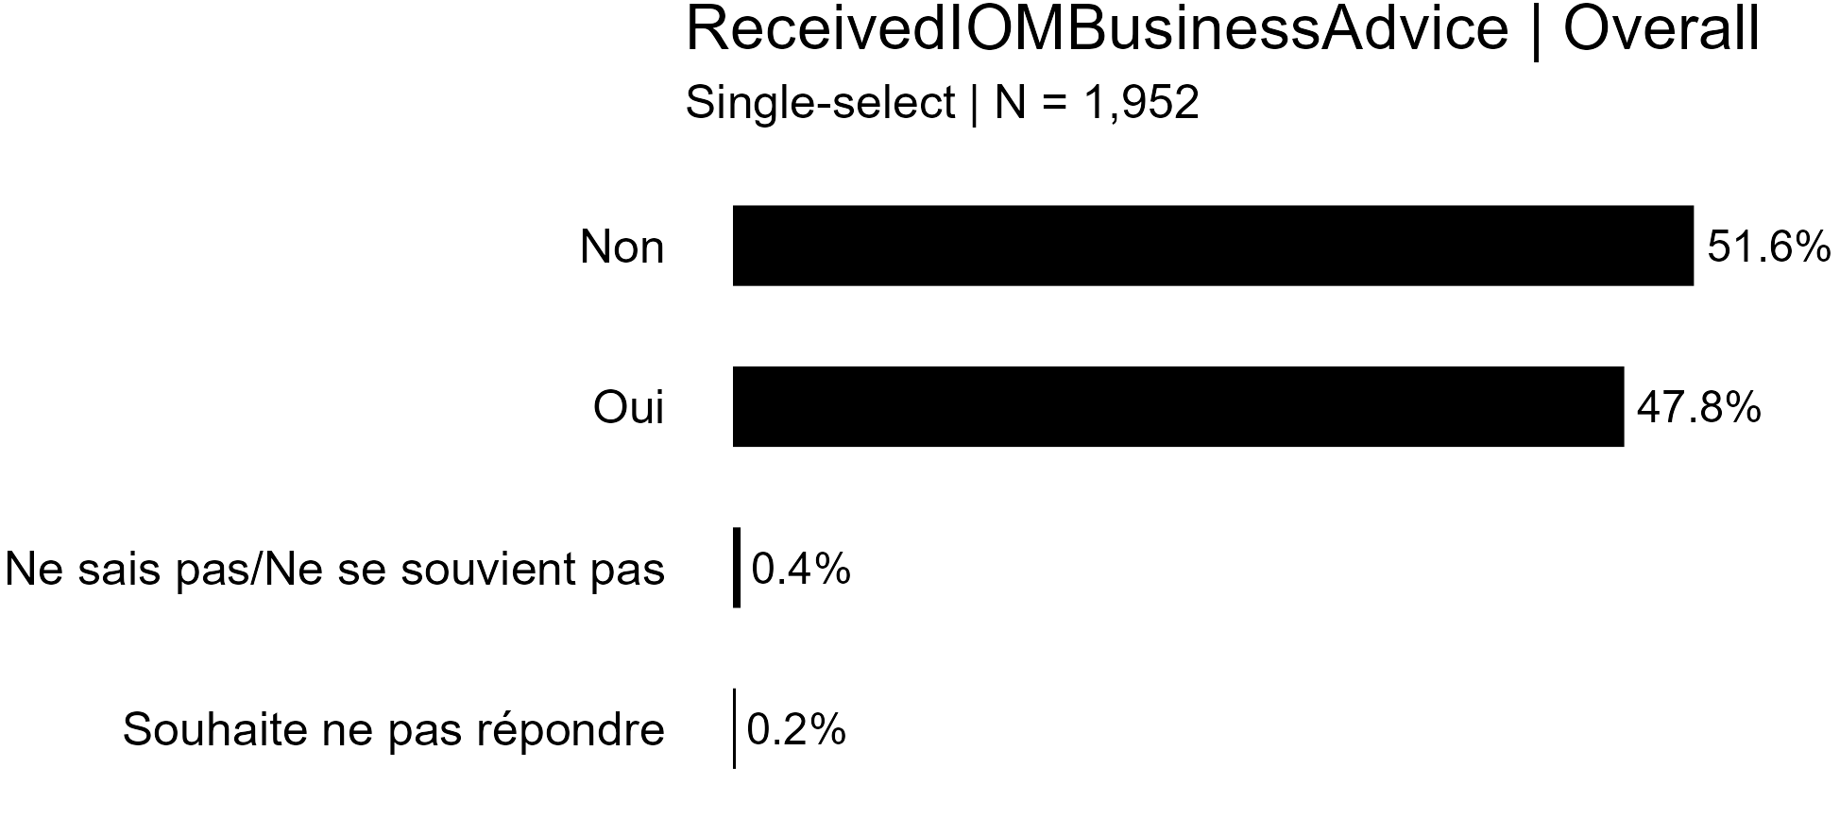

For regression analysis, recoded as:

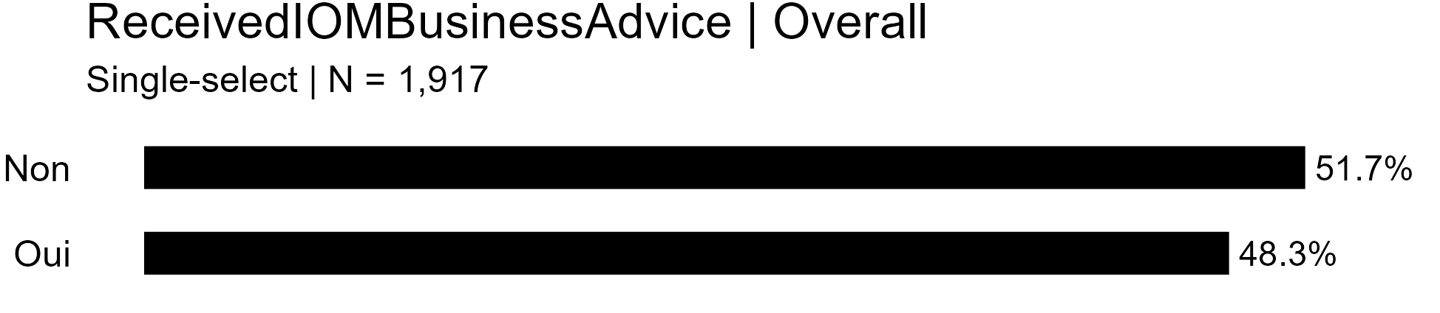

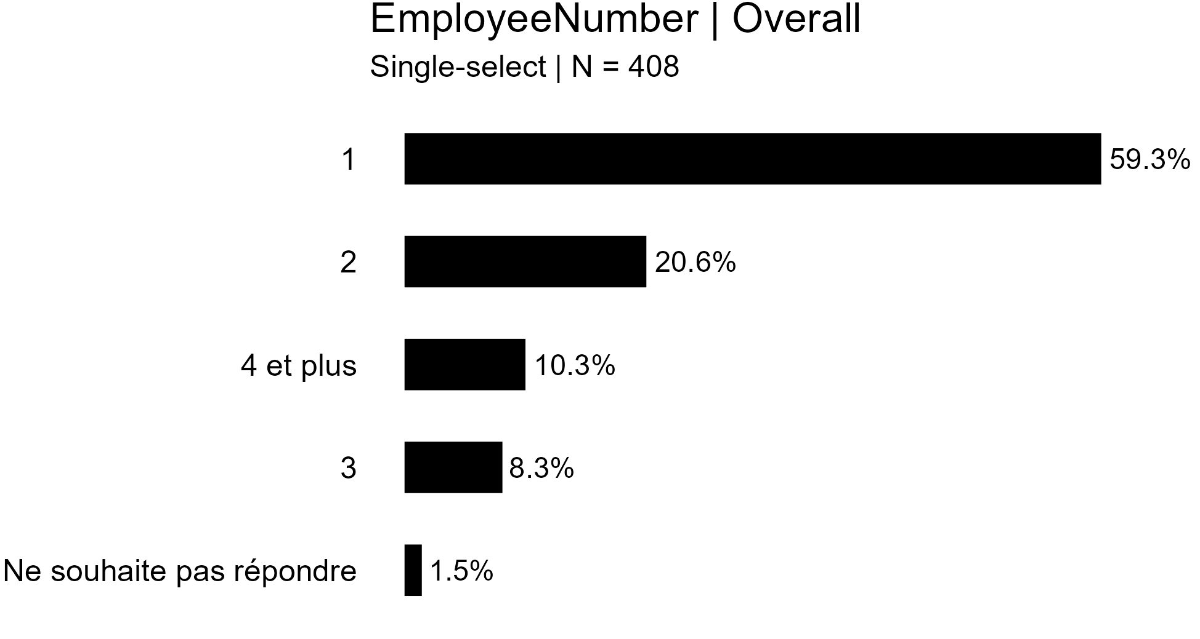

For regression analysis, recoded as:

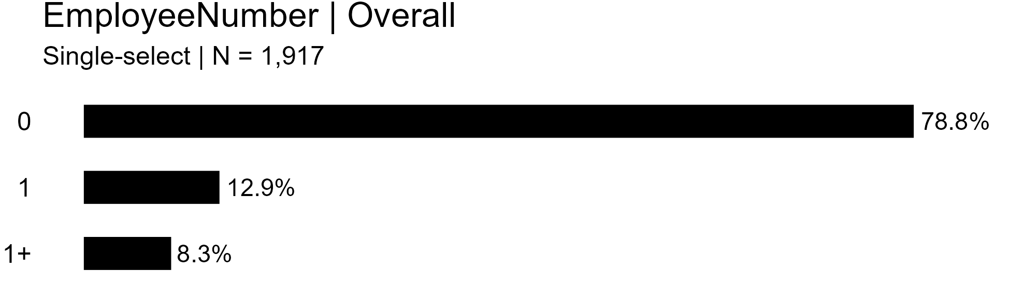

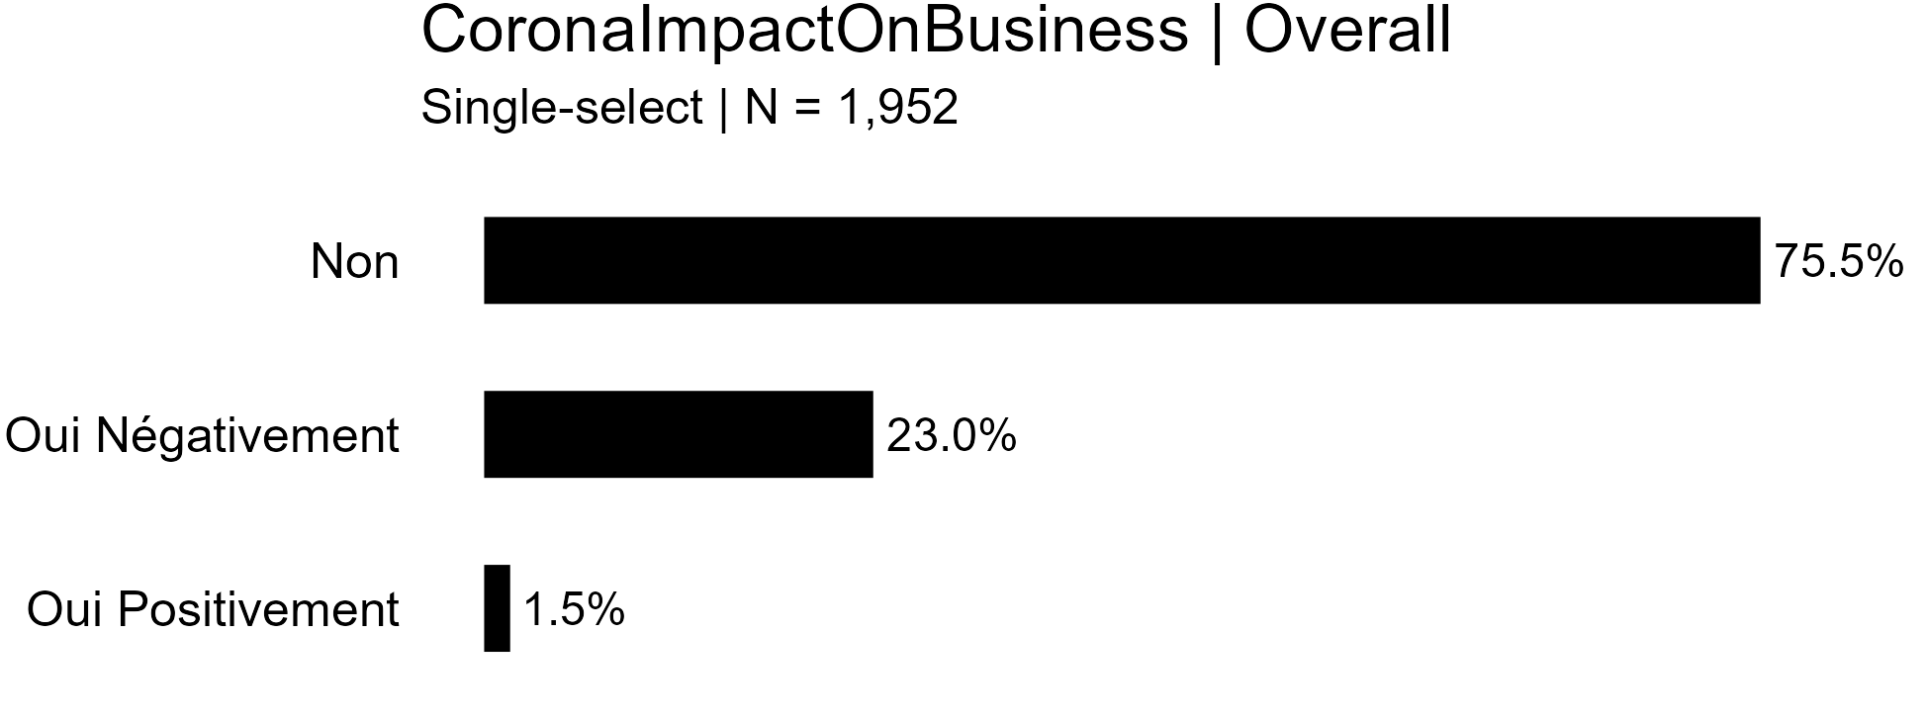

For regression analysis, recoded as:

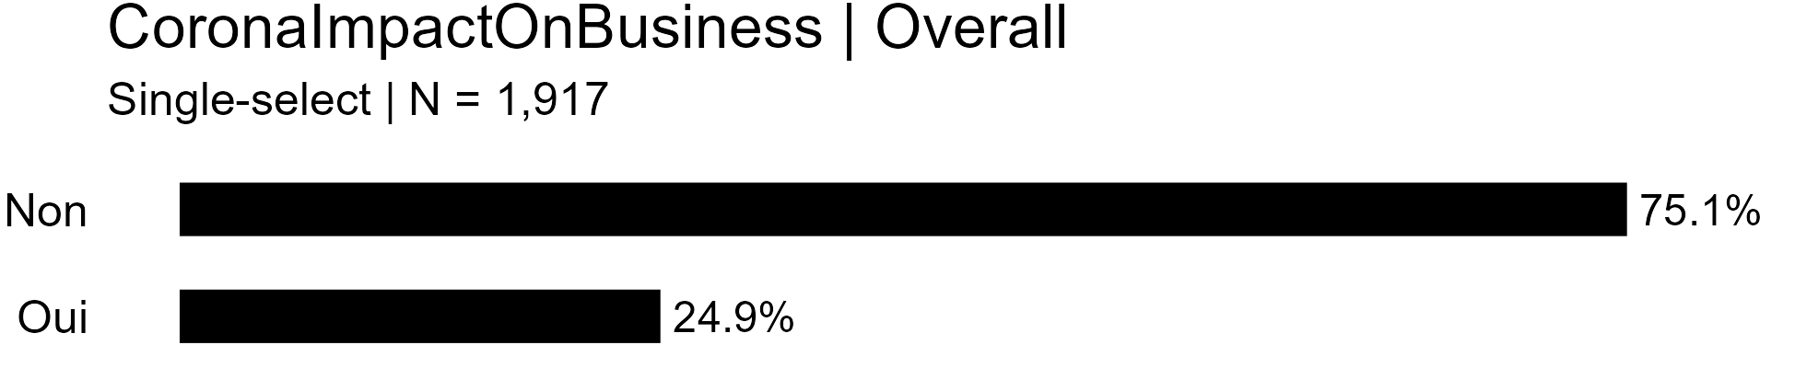

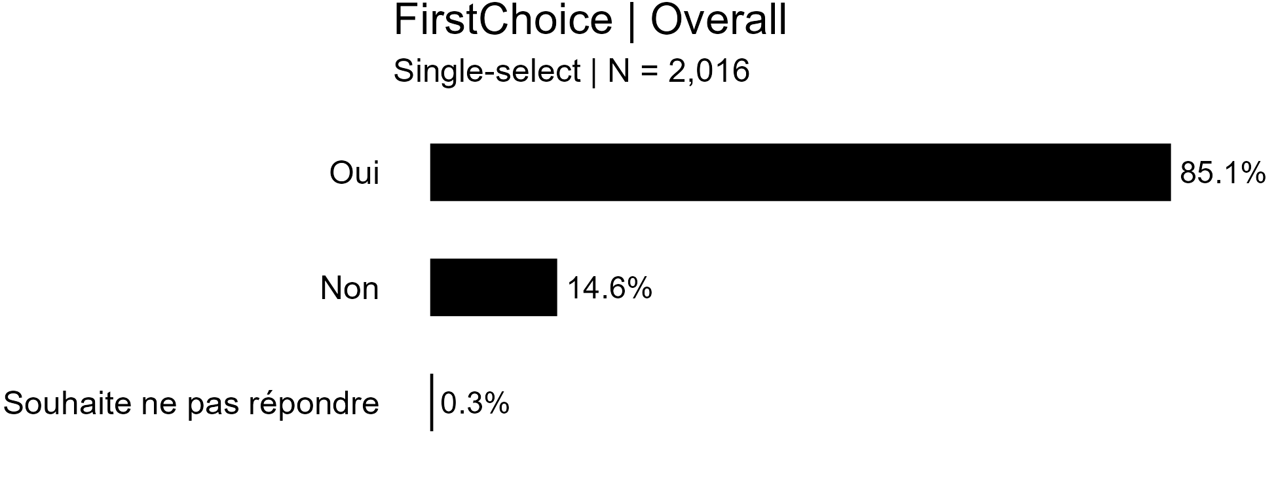

For regression analysis, recoded as:

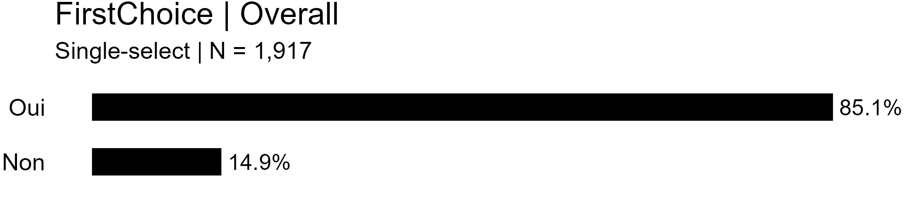

**Appendix X: Frequencies of Business Success by Each Independent Variable**

*Note*. Variables are presented in the order in which they appear in the questionnaire, and only variables used in analyses are included (i.e., variables recoded for regression analysis).

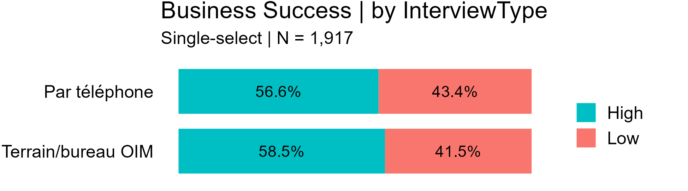

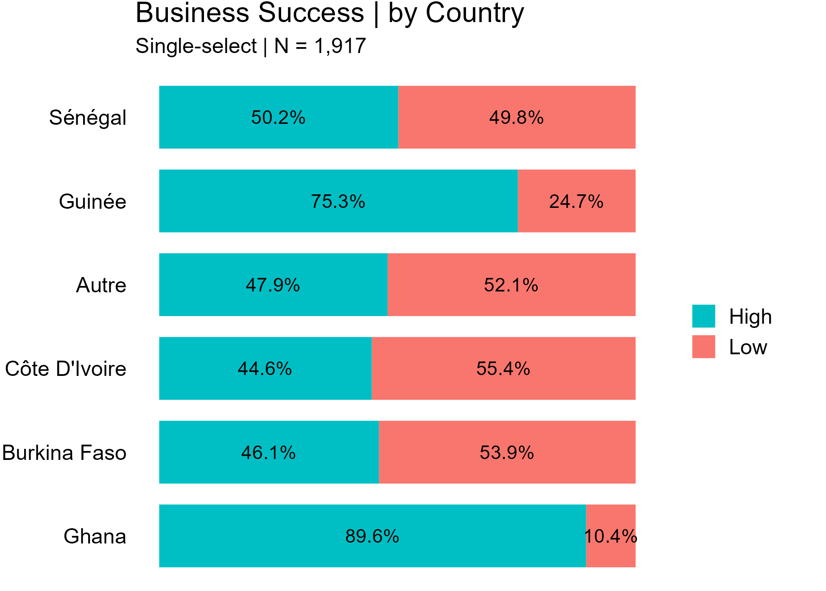

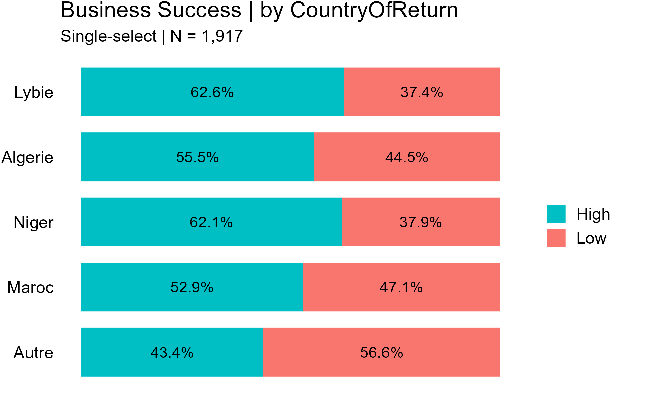

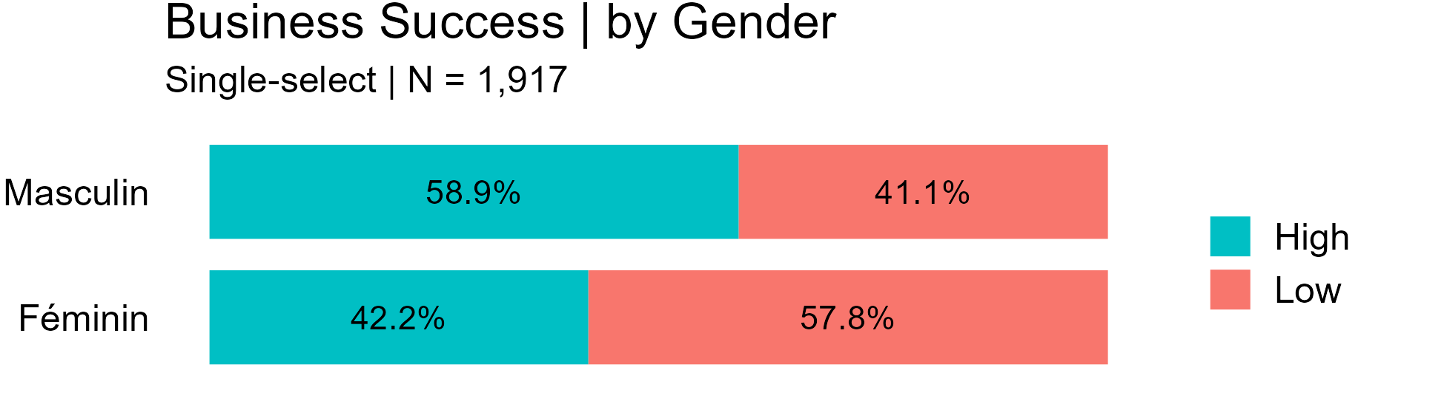

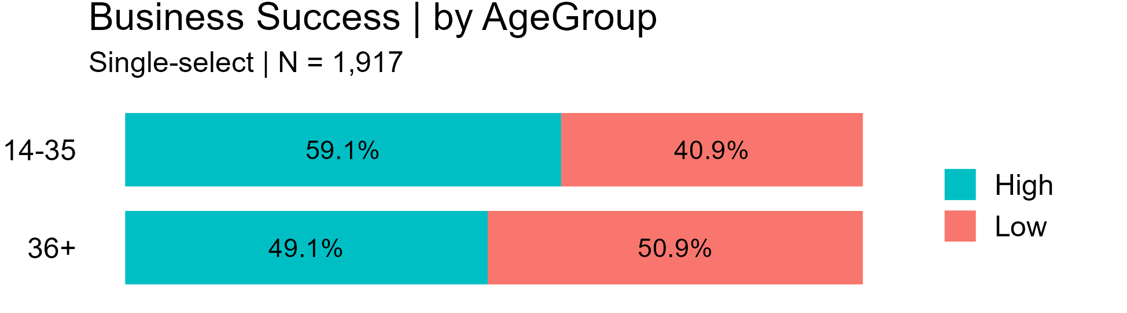

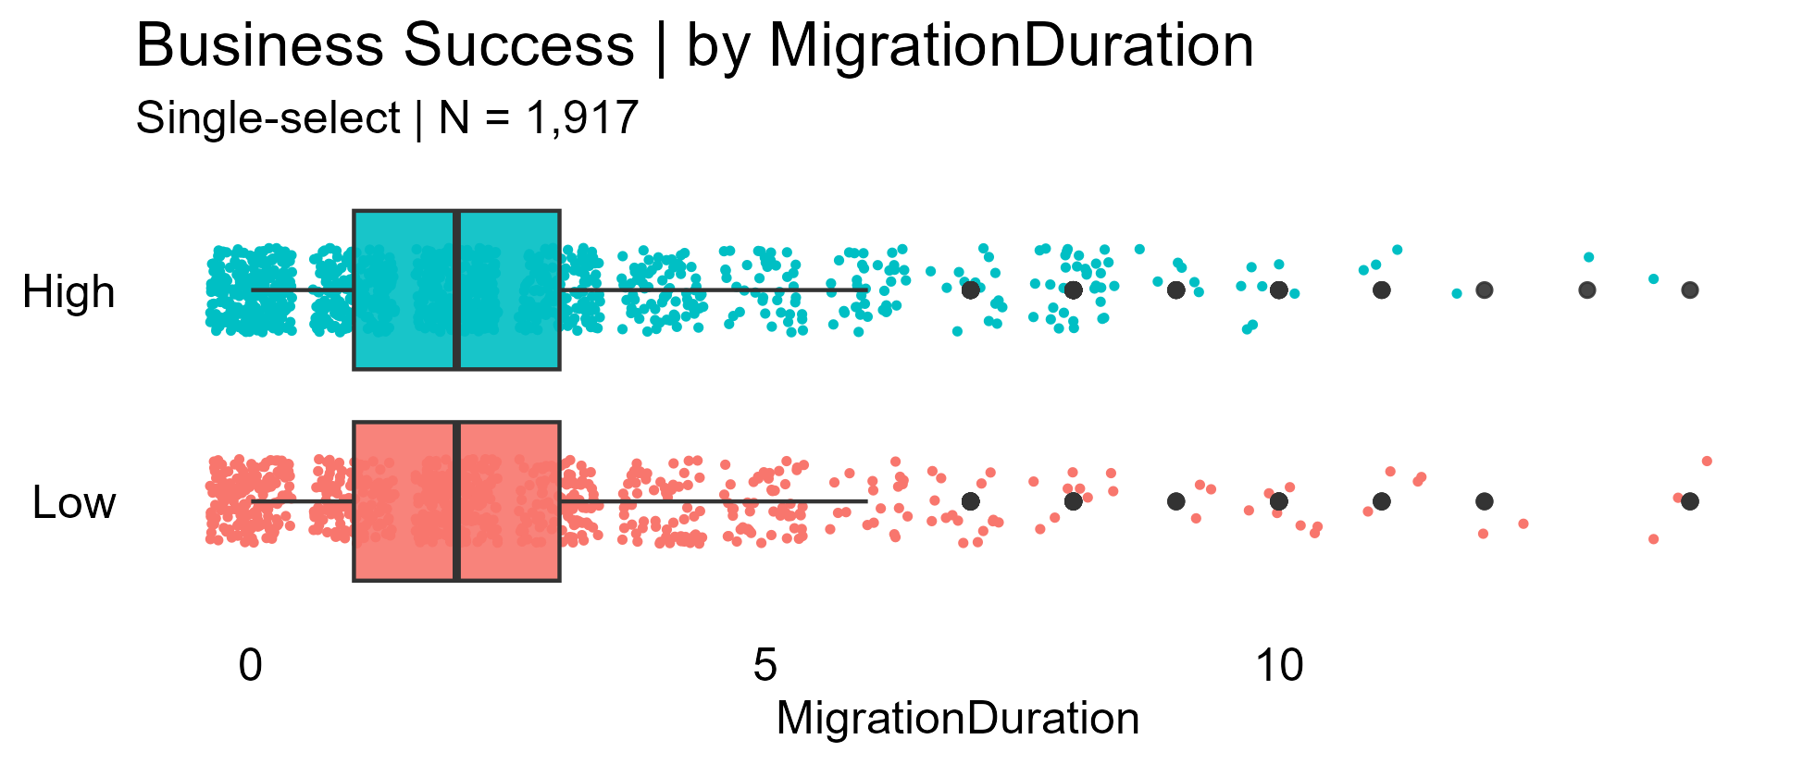

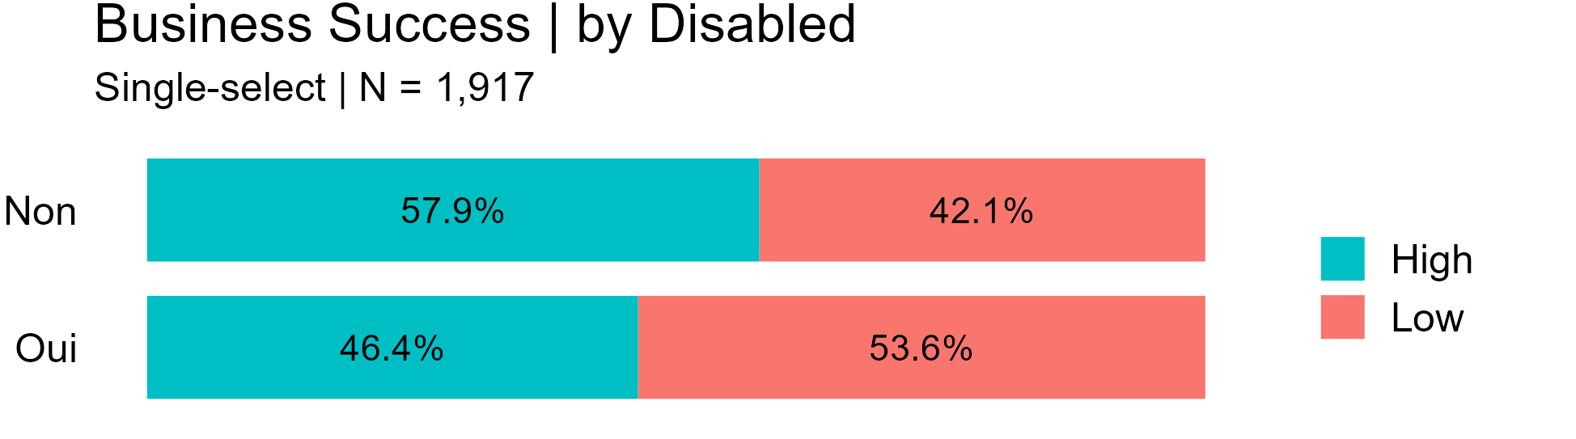

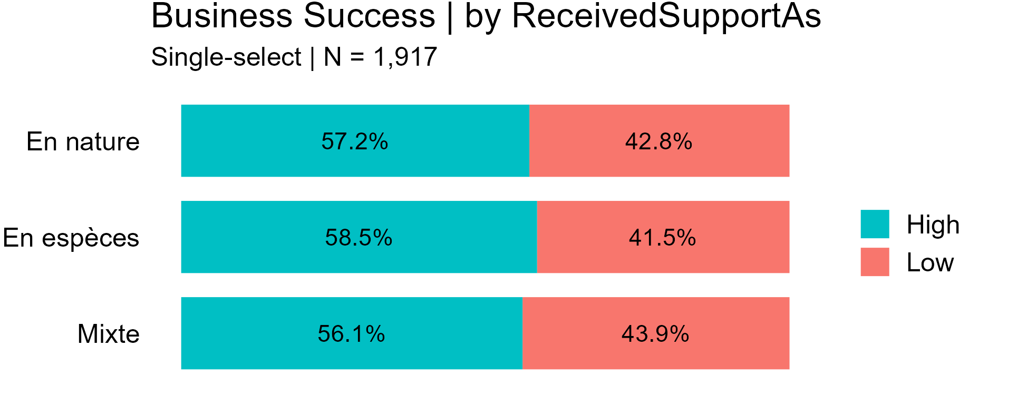

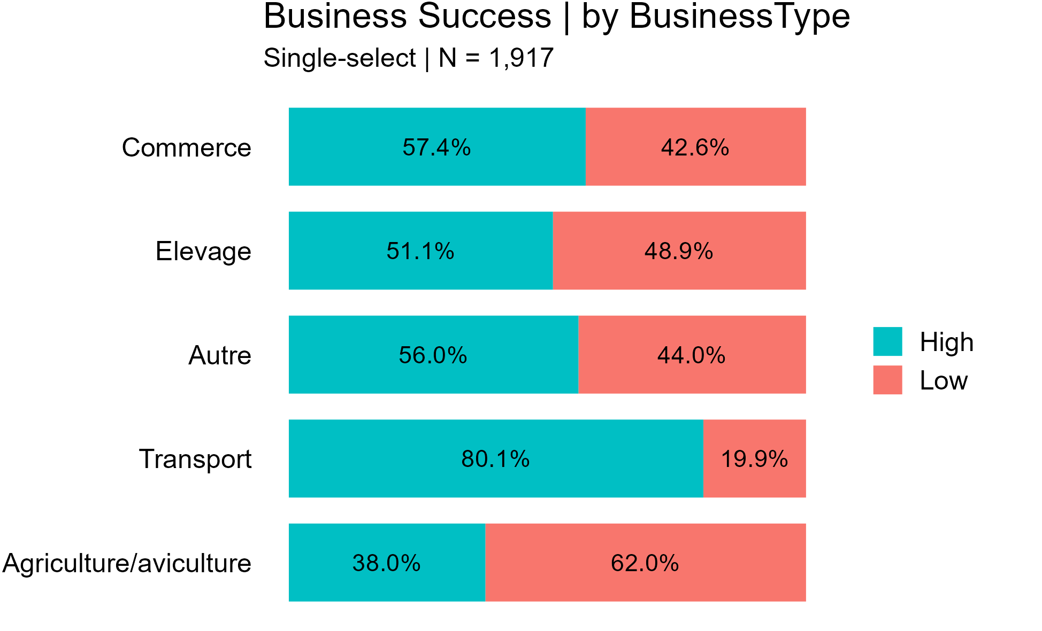

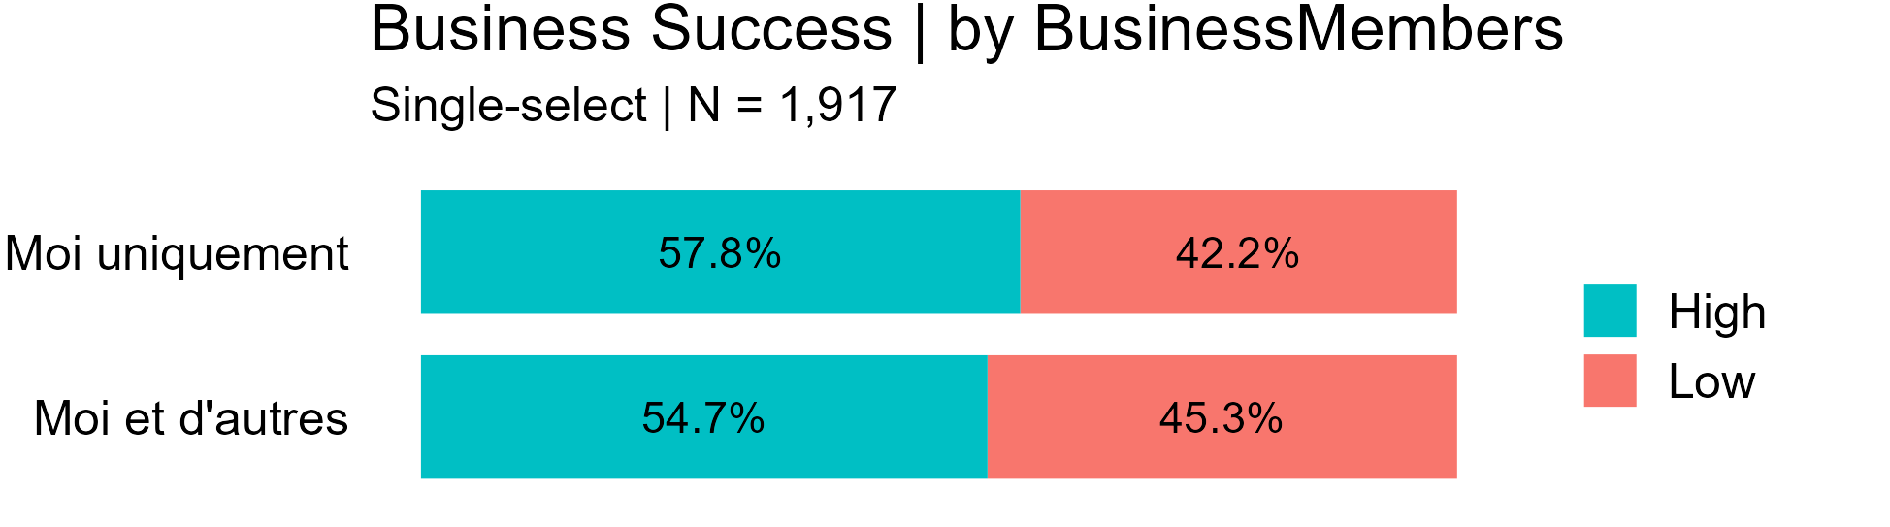

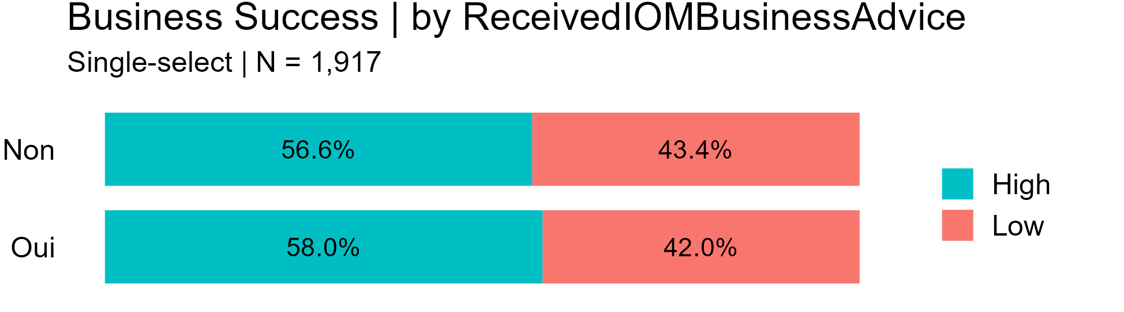

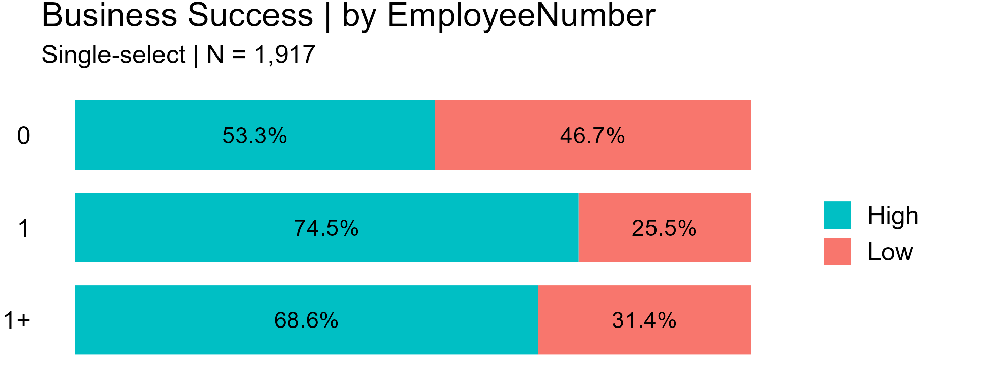

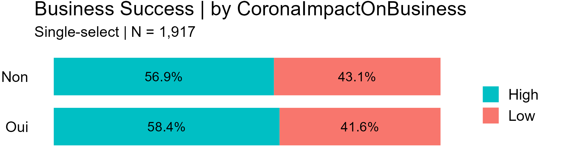

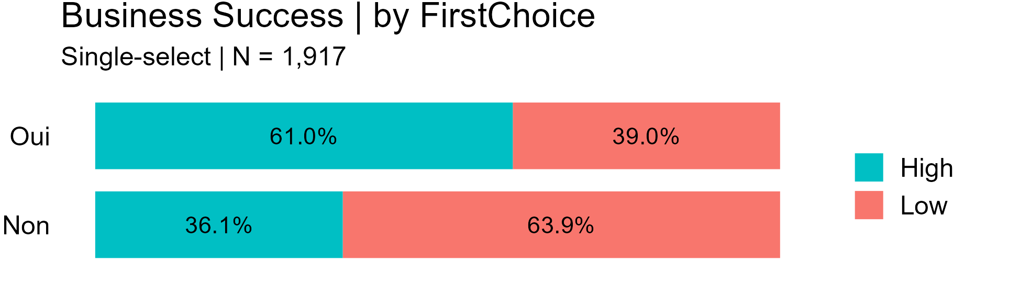

**Appendix X: Frequencies of Business Profitability by Each Independent Variable**

*Note*. Variables are presented in the order in which they appear in the questionnaire, and only variables used in analyses are included (i.e., variables recoded for regression analysis).

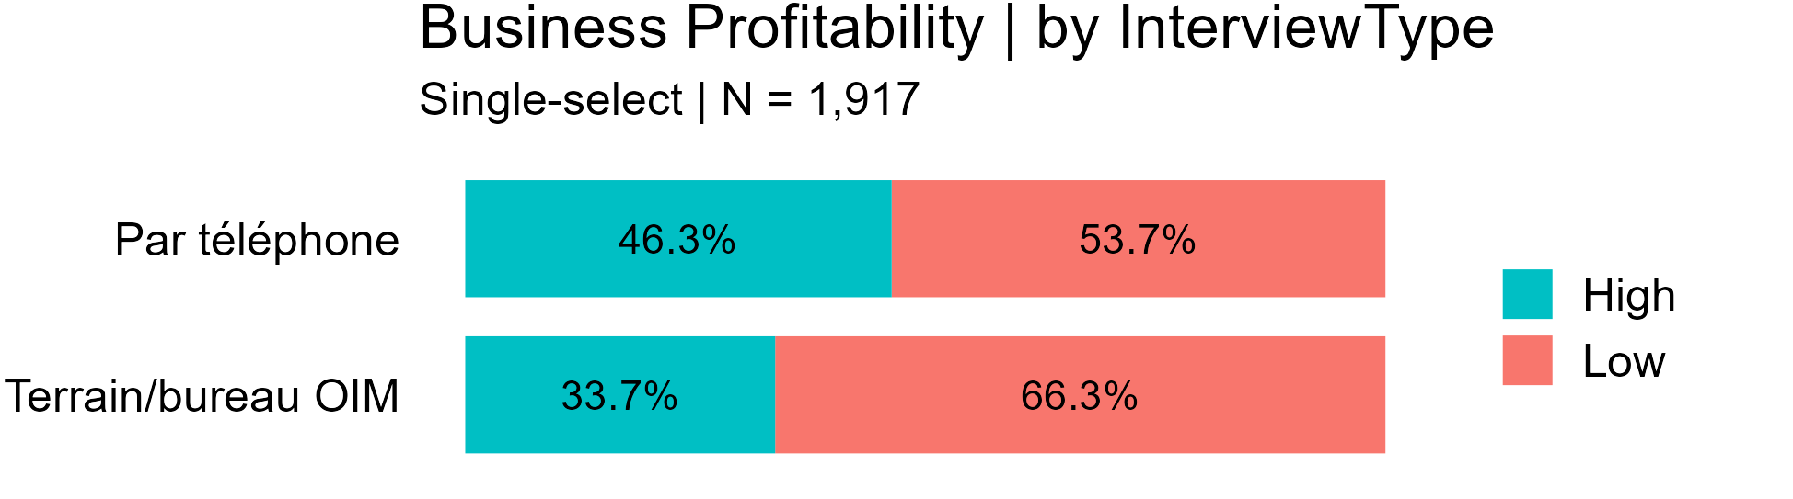

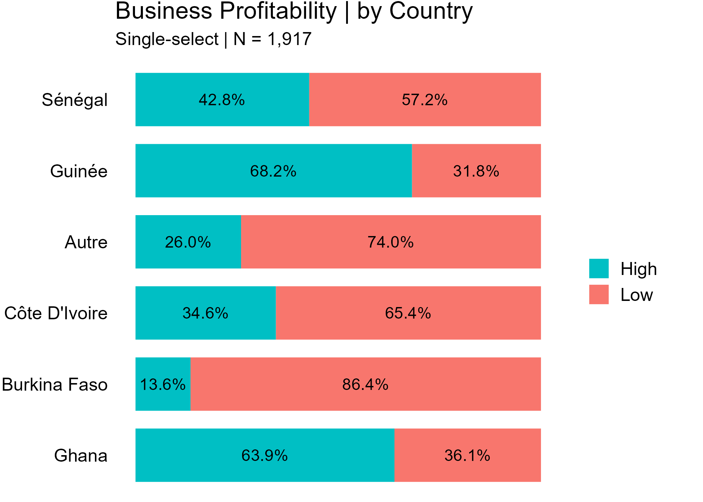

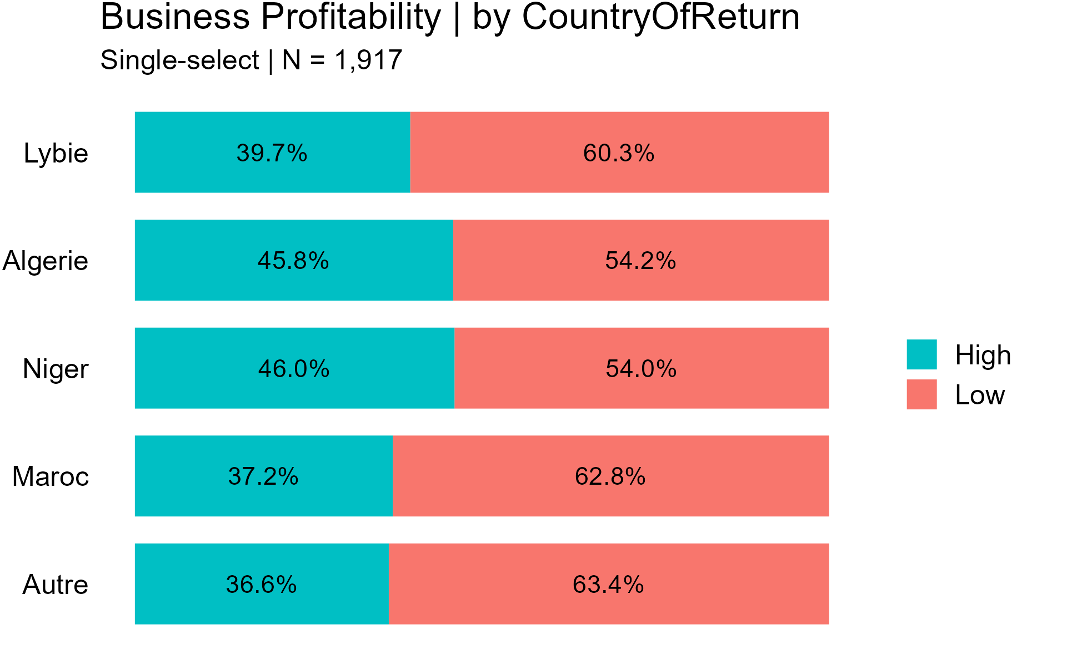

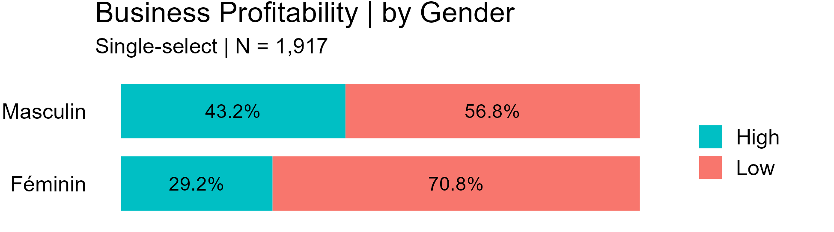

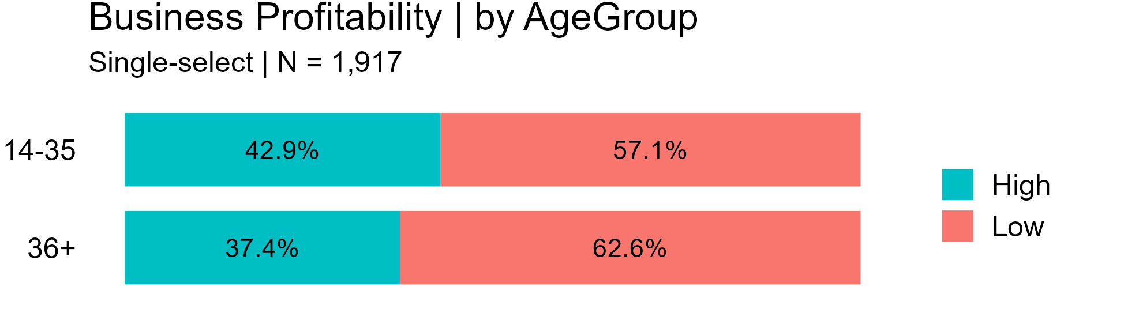

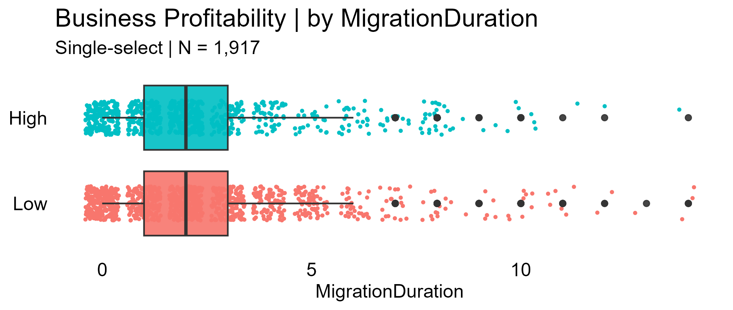

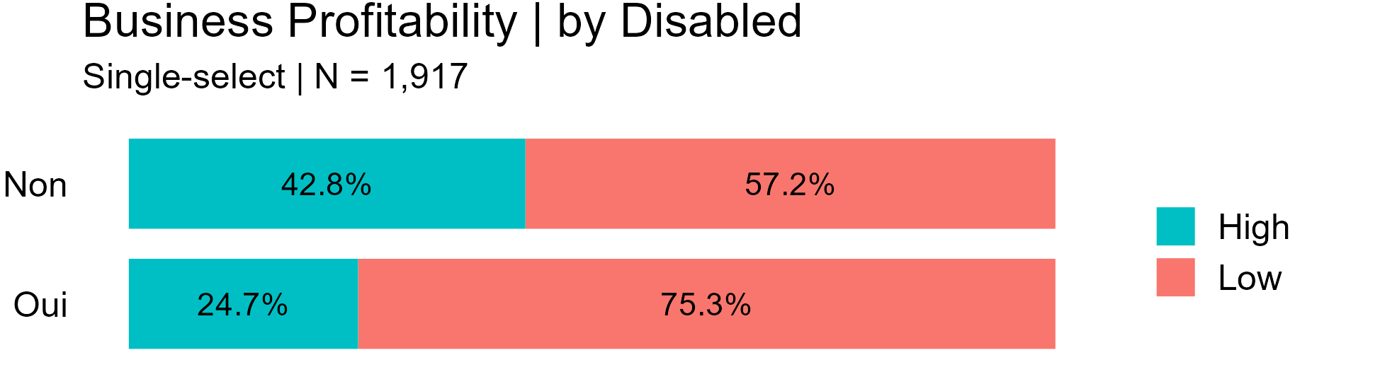

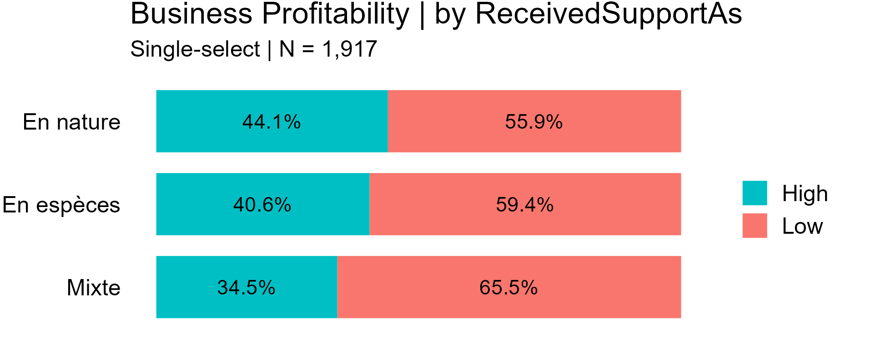

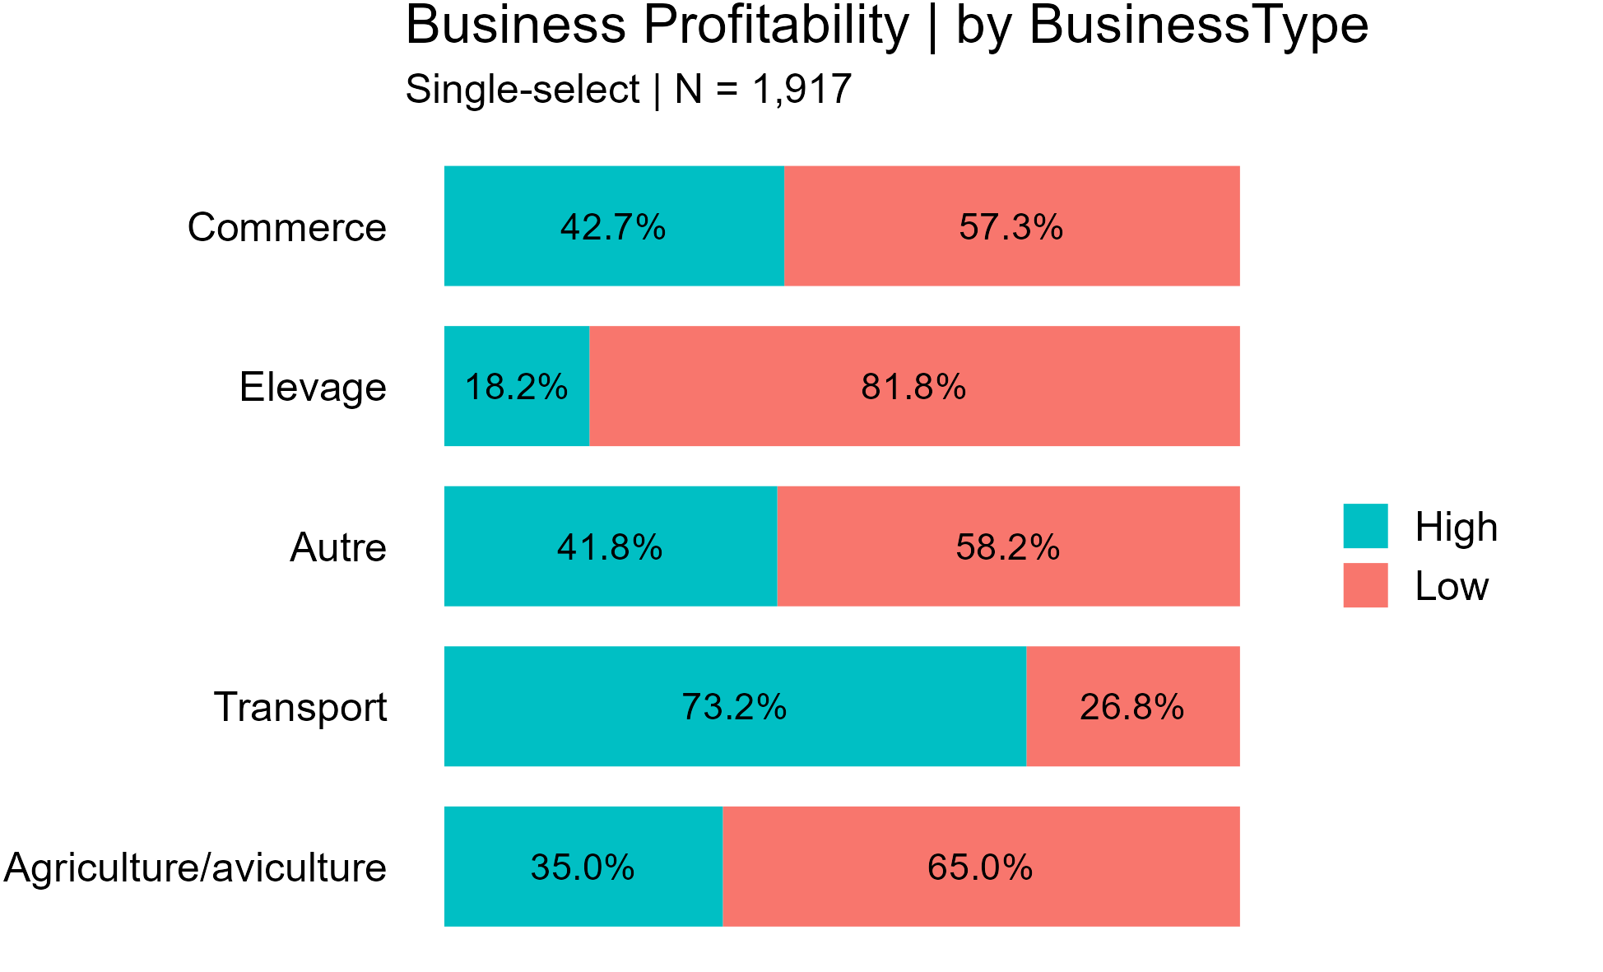

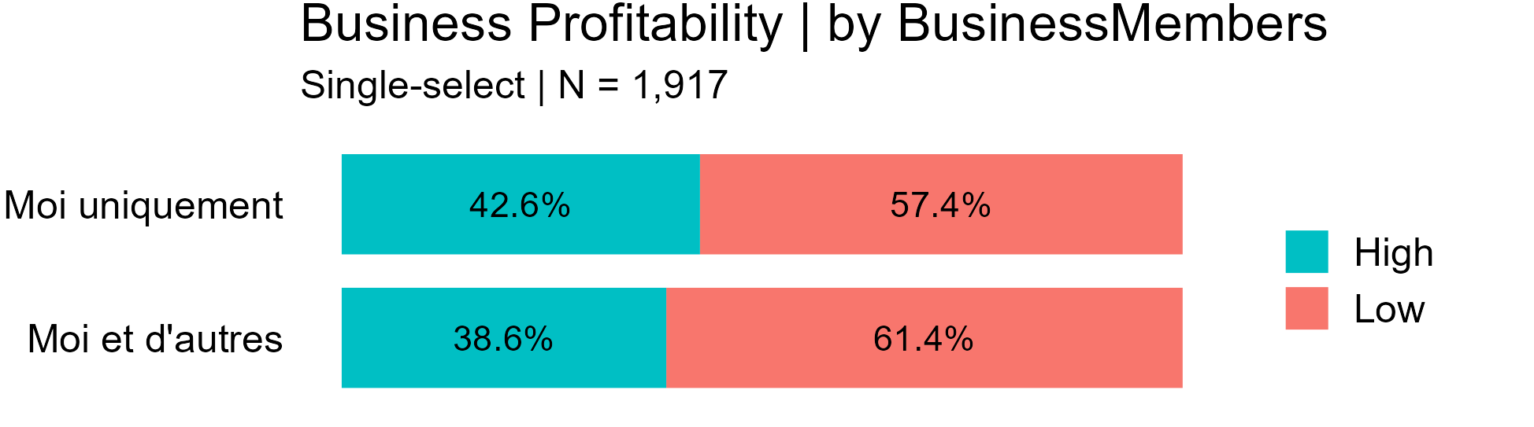

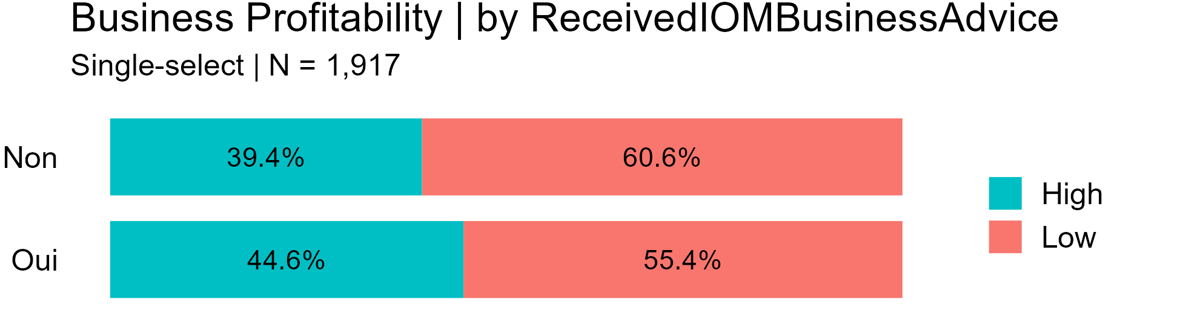

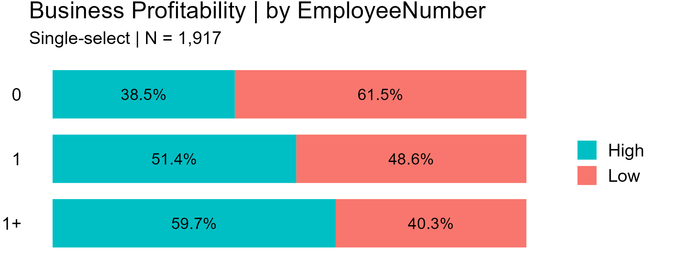

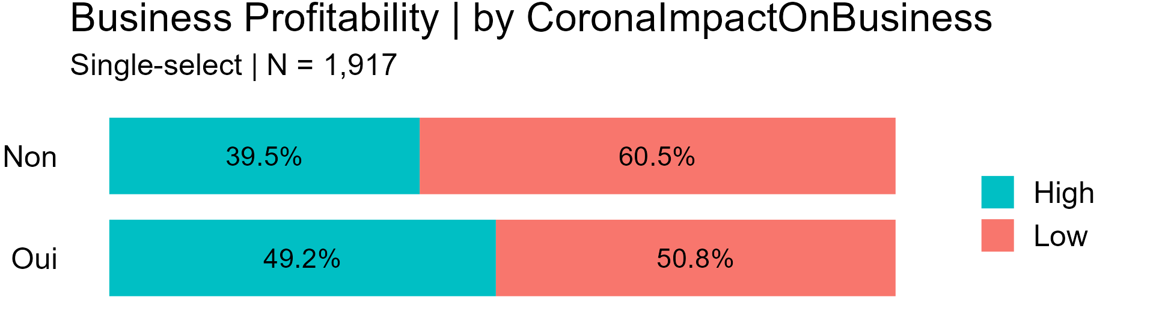

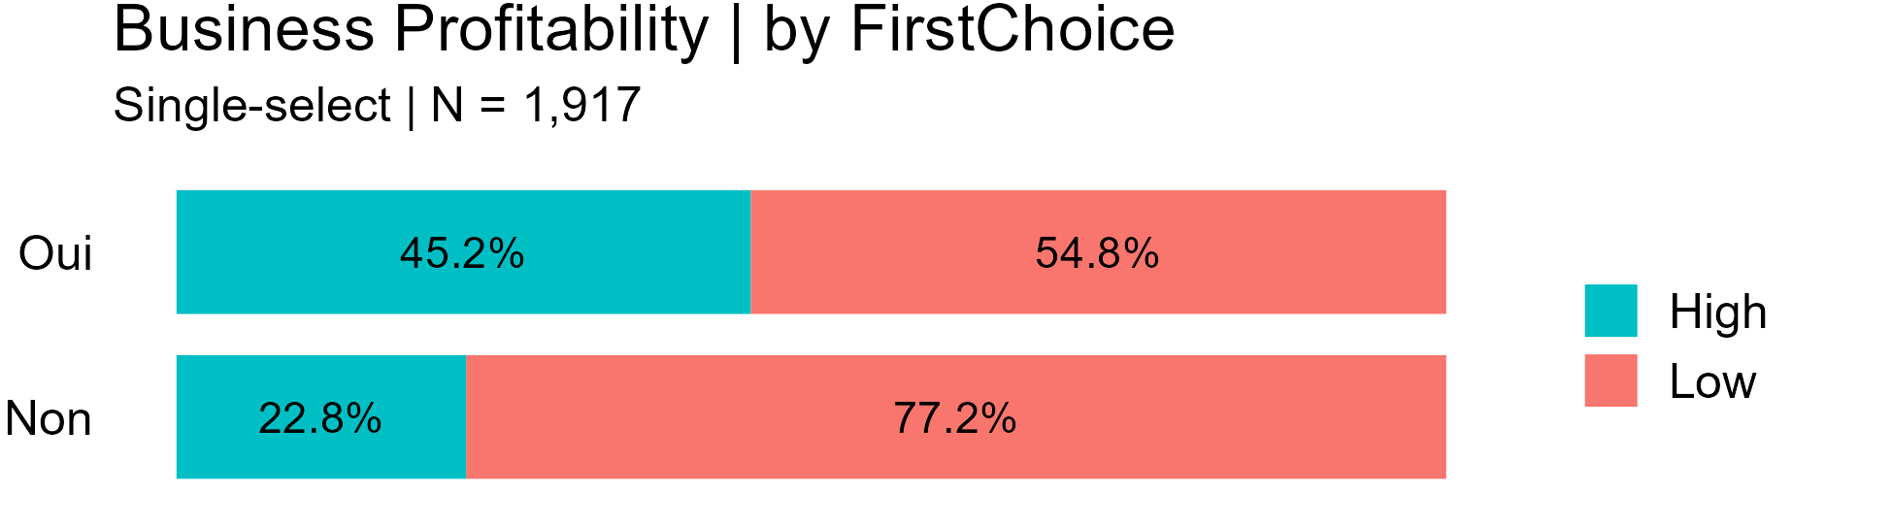

Business management training

From personal notes:

Cloture de l’initiative conjointe des 5 dernières années

Afrique de l’Ouest et Corne—16 pays

2021—avril 2023 était dernière phase*

C’est des retournés volontaires, qui sont accompagnés par l’OIM

[Afrique de l’Ouest, possibly Sahel]

[The Join Initiative was launched in 2016]

From Induction for new staff:

“The EU-IOM Joint Initiative (JI) for Migrant Protection and Reintegration in the Sahel and Lake Chad region was launched in April 2017 and implemented in 13 countries (Burkina Faso, Cameroon, Chad, Côte d’Ivoire, The Gambia, Ghana, Guinea, Guinea Bissau, Mali, Mauritania, Niger, Nigeria, and Senegal)”

The 2nd phase of the JI funded by DG INTPA under the NDICI started in November 2021 and is ending early 2023.*

OBJECTIVE I Protection and AVRR:

“Improve PROTECTION , provide assistance and enable the assisted VOLUNTARY RETURN of vulnerable and stranded migrants”

ASSISTANCE TO VOLUNTARY RETURN (AVR): Migrants who want to return will receive AVR assistance in the form of pre departure counselling, travel allowance and transportation. They will also receive immediate assistance upon arrival.

OBJECTIVE II Reintegration

“Improve theREINTEGRATION of returning migrants and strengthen national structures and capacities in terms of managing reintegration in a dignified and sustainable manner”

REINTEGRATION ACTIVITIES: Following counseling and individual orientation of returnees, reintegration assistance is provided. The assistance can be individual, collective, or community-wide as appropriate. Evaluations are carried out in order to monitor and assess the success of these activities.

Read Document, Joint Initiative’s Framework SOPs on AVRR, e.g., p. 14

1. Burkina Faso, Cameroon, Chad, Côte d’Ivoire, The Gambia, Ghana, Guinea, Guinea Bissau, Mali, Mauritania, Niger, Nigeria, and Senegal.
2. The full catalog of measures is available in the file “MiMOSA activities and dimension of reintegration assistance.xlsx”.
3. *EUTF-IOM Initiative for Migrant Protection and Reintegration: Standard Operating Procedures for Assisted Voluntary Return and Reintegration*, p. 6.