International Migrant Stocks 1990-2019

Contents

Overall 1

Overall (cumulative) 2

Select European Countries 2

Select European Countries (cumulative) 3

Africa (top 10) 3

Asia (top 10) 4

Europe (top 10) 4

World (2019, top 20) 5

### Overall

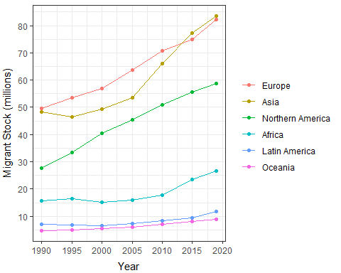

### Overall (cumulative)

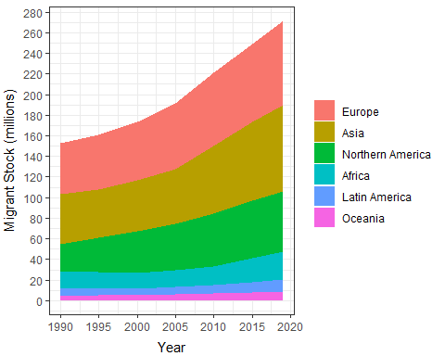

### Select European Countries

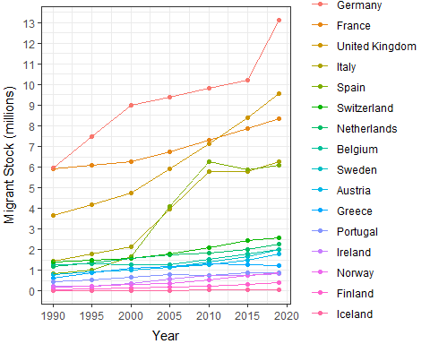

### Select European Countries (cumulative)

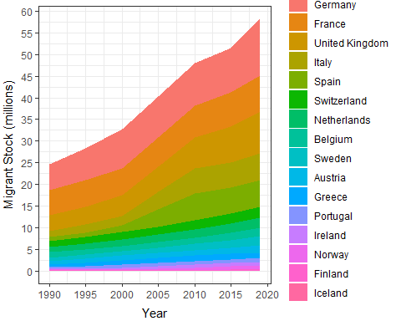

### Africa (top 10)

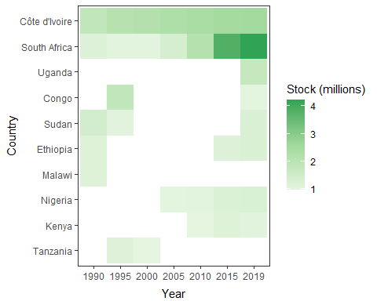

### Asia (top 10)

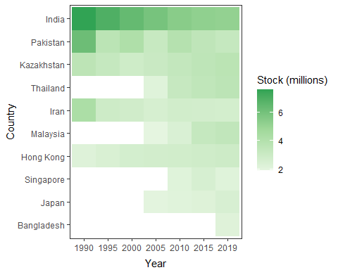

### Europe (top 10)

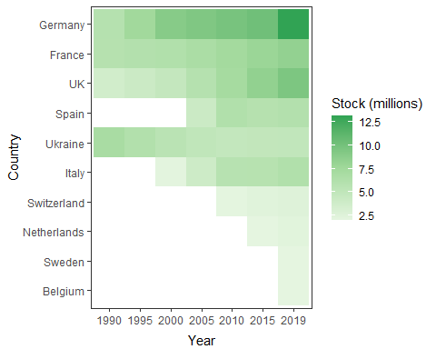

### World (2019, top 20)

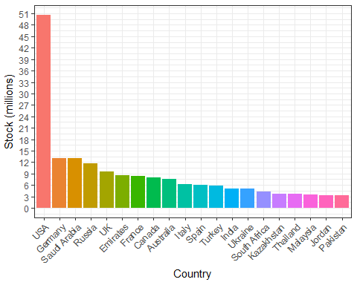

Source: United Nations, Department of Economic and Social Affairs. Population Division (2019). International Migrant Stock 2019 (United Nations database, POP/DB/MIG/Stock/Rev.2019)