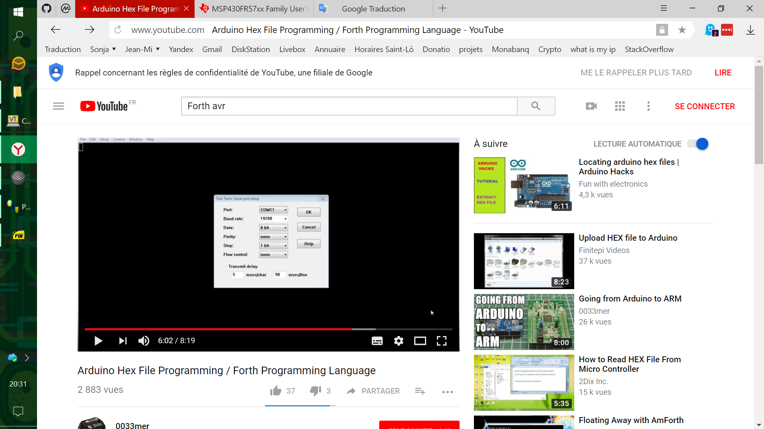
COMPETITOR : 19200 bds, 5ms/char, 90ms/line ⇒ throughput ~ 1kB/s

FAST FORTH 8MHz : 2457600 bds, 0ms/char, 0ms/line ⇒ throughput : 100 kB/s (with compilation)
