Wayfair Product & Sales Performance Report
E-Commerce Analytics Project — Annual Review (Jun 2025 – May 2026)

About This Report
Product catalog data (names and prices) was scraped directly from live Wayfair product listing pages. Customer identities and the full transaction history (invoices, dates, and quantities) are synthetically generated, since Wayfair's actual sales and customer data is proprietary and not accessible for this analysis. All customer names appearing in this report are computer-generated and do not refer to real individuals. Findings on product-level performance reflect real catalog data; findings on revenue totals, trends, and customer behavior reflect the simulated transaction layer built on top of it.

Executive Summary
Over the trailing twelve-month period, the simulated transaction history recorded 2,169 orders across 1,500 customers and 49 catalog products, totaling $708,998.19 in revenue. The analysis below breaks this down by time, product, and customer to surface where revenue concentrates and how purchasing behavior is distributed.
Metric | Value
Total Revenue | $708,998.19
Total Orders | 2,169
Total Units Sold | 2,874
Average Order Value | $326.88
Unique Customers | 1,500
Products Sold | 49 of 49 catalog items
Repeat Customer Rate | 28.0%

Key observations:
A single product — a $3,559.97 item — accounts for 33.1% of total revenue on its own, despite representing just 1 of 49 catalog items.
The top 5 products by revenue account for 52.4% of all revenue; the remaining 44 products share the rest.
28.0% of customers placed more than one order, a moderate repeat-purchase rate.
Monthly revenue ranged from roughly $43K to $95K per month and trended upward across the 12 full months of data.

Sales & Revenue Trends
The chart below shows monthly revenue across the 12 full months in the dataset (June 2025 through May 2026).
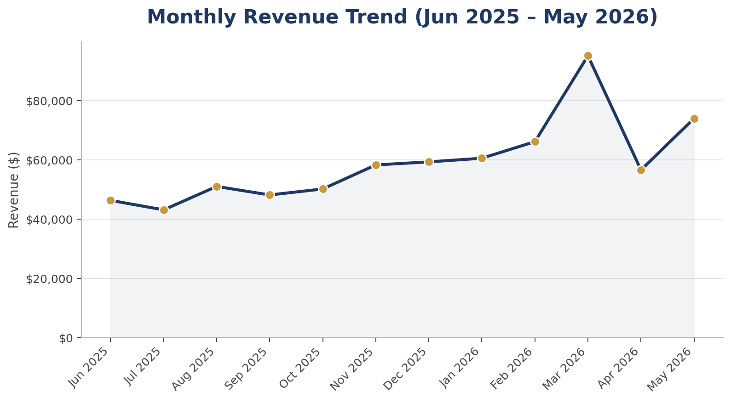
Revenue peaked in March 2026 at $95,126, which does not coincide with the usual holiday peak for home goods, and dipped to its lowest full-month point in July 2025 at $43,149. Order counts follow a similar rhythm, ranging from 122 to 227 orders per month. Comparing the first 3 months with the last 3, average monthly revenue grew by 61%. In this simulated dataset, much of that growth reflects the active customer base building up over the year, since new customers are acquired every month while earlier ones keep buying.

Product Performance
The chart below ranks the ten highest-revenue products. The top performer is highlighted.
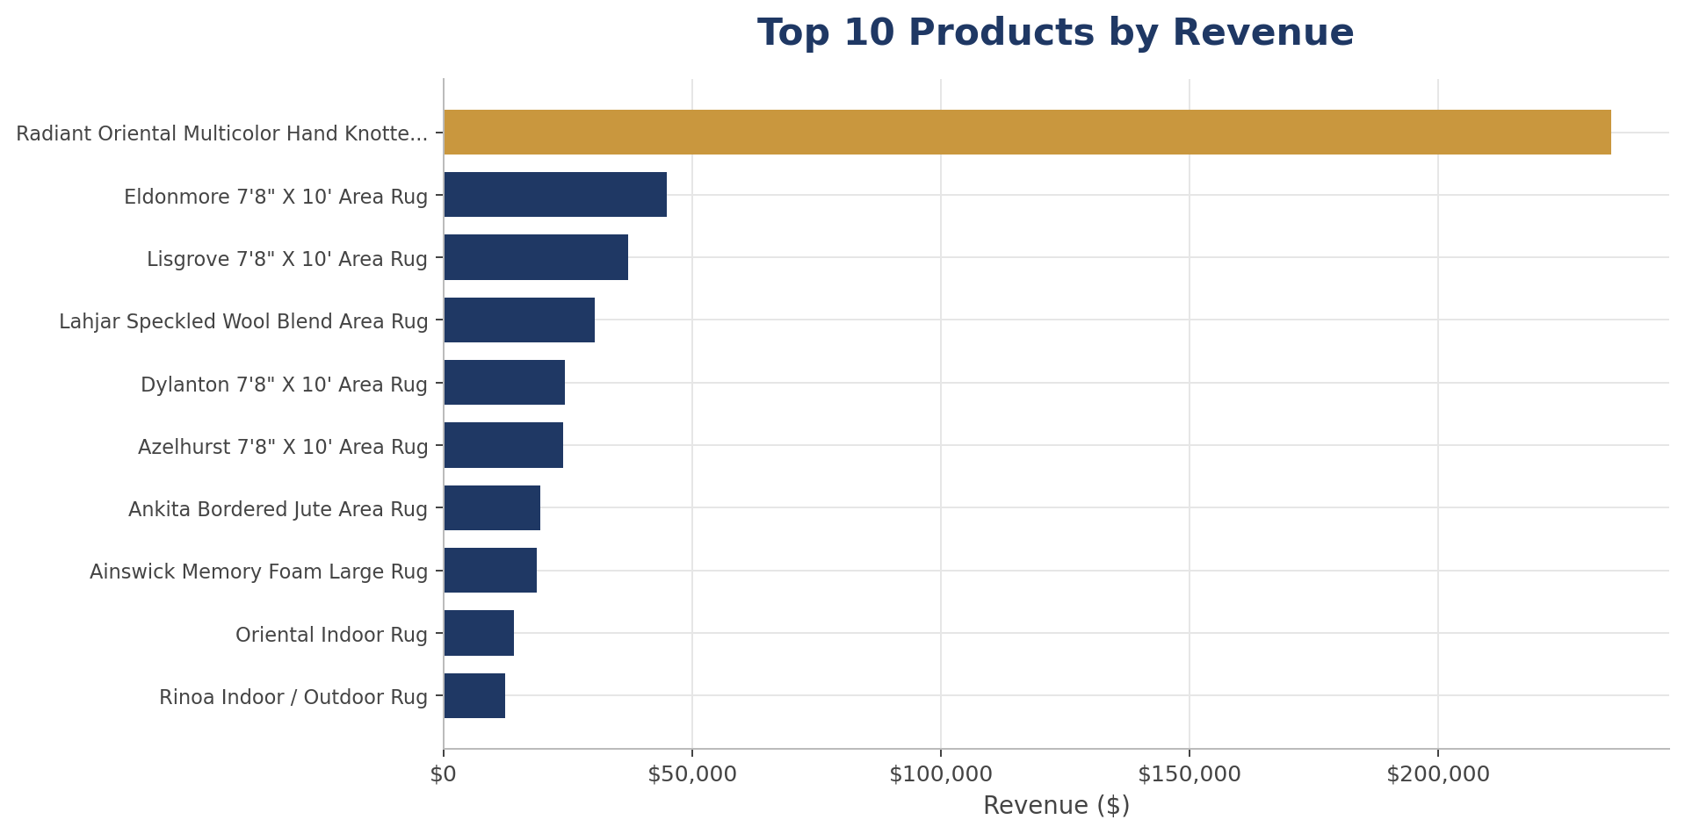

Top 10 Products by Revenue
Product | Revenue | Units Sold | Orders
Radiant Oriental Multicolor Hand Knotted Wool Blue, | $234,702.80 | 69 | 54
Eldonmore 7'8" X 10' Area Rug | $44,913.89 | 64 | 52
Lisgrove 7'8" X 10' Area Rug | $37,032.37 | 56 | 36
Lahjar Speckled Wool Blend Area Rug | $30,301.16 | 59 | 47
Dylanton 7'8" X 10' Area Rug | $24,383.91 | 52 | 42
Azelhurst 7'8" X 10' Area Rug | $23,973.13 | 36 | 32
Ankita Bordered Jute Area Rug | $19,395.16 | 59 | 49
Ainswick Memory Foam Large Rug | $18,807.00 | 33 | 31
Oriental Indoor Rug | $14,109.86 | 62 | 46
Rinoa Indoor / Outdoor Rug | $12,367.18 | 61 | 41

Bottom 5 Products by Revenue
Product | Revenue | Units Sold | Orders
Area Rug Machine Washable Rugs with Rubber Backing f | $1,201.92 | 60 | 42
Machine Washable Area Rugs for Entryway 2x3 Non-Slip | $1,322.32 | 66 | 48
Washable Oriental Area Rugs Non slip Green Rugs | $1,660.35 | 83 | 56
Loloi Botanical Ivory / Multi Area Rug | $1,679.97 | 51 | 41
Jodhveer Area Rug Washable Rug Non-Slip Backing Indo | $1,991.23 | 51 | 43

Notably, order counts for the lowest-revenue products (41–56 orders each) are comparable to those of the highest-revenue products — the gap is driven almost entirely by unit price, not by how often the product sells. Low-priced, frequently-selling items are moving consistent volume but contributing comparatively little revenue per transaction.

Revenue Concentration
The chart below ranks all 49 products from highest to lowest revenue (bars, left axis) alongside the cumulative share of total revenue they represent (line, right axis). The dashed line marks the 80% cumulative revenue threshold.
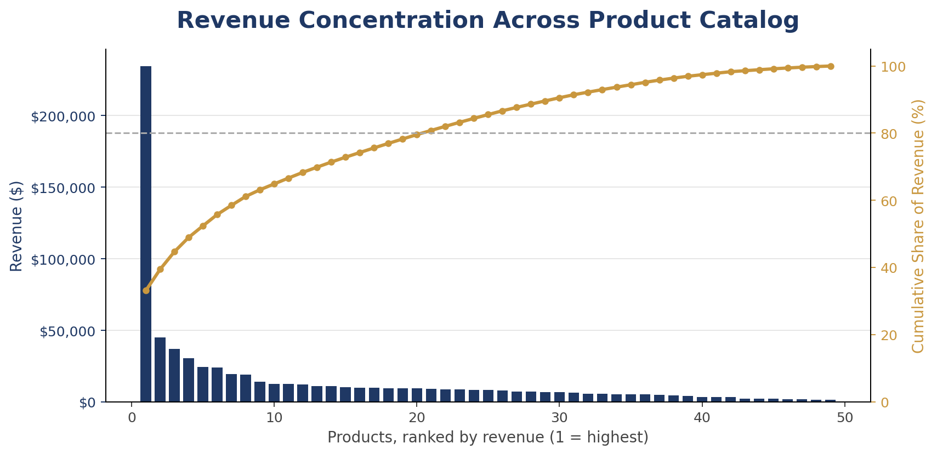
Revenue is meaningfully concentrated at the top of the catalog: it takes only 21 of 49 products (43% of the lineup) to reach 80% of total revenue, driven disproportionately by a small number of higher-priced rugs. This is a useful signal for inventory and marketing prioritization — the catalog's commercial performance is not evenly distributed across products.

Customer Behavior
The distribution below shows how many orders each of the 1,500 customers placed over the twelve-month period. Most customers (72%) placed a single order.
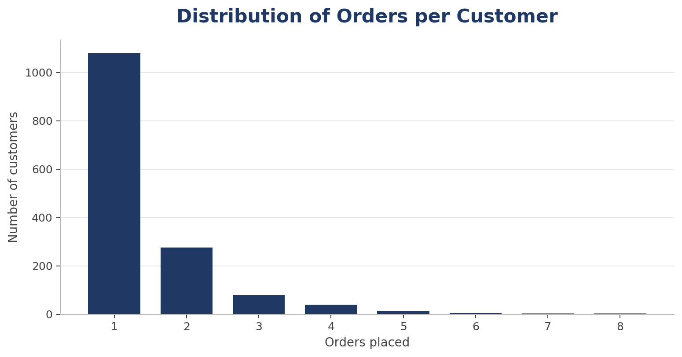
1,080 of 1,500 customers (72.0%) placed a single order, while 28.0% placed two or more — a moderate repeat rate. That is a plausible level for big-ticket home goods such as area rugs, though it reflects the simulation's assumptions rather than observed Wayfair shopper behavior.

Top 10 Customers by Revenue
Customer names below are computer-generated and do not represent real individuals.
Customer | Total Revenue | Orders
Lisa Morris | $17,998.38 | 4
Paul Willis | $17,271.20 | 1
Andrew Reeves | $16,555.63 | 3
Jonathan Delgado | $7,223.41 | 3
Kim Brown | $6,897.28 | 1
Isaac Miller | $6,517.22 | 1
Renee Bruce | $5,580.41 | 5
Kayla Rodriguez | $5,167.89 | 5
Angie Henderson | $4,112.24 | 4
Tyler Davis | $4,065.53 | 2

Customer Segmentation (RFM)
Each customer is scored on three dimensions — Recency (how recently they last ordered), Frequency (how many orders they placed), and Monetary value (how much they spent). Scores are assigned on a 1–5 quintile scale relative to the rest of the customer base, then combined into the segment labels below. Because scores are relative, every segment is defined against this population rather than an absolute benchmark.
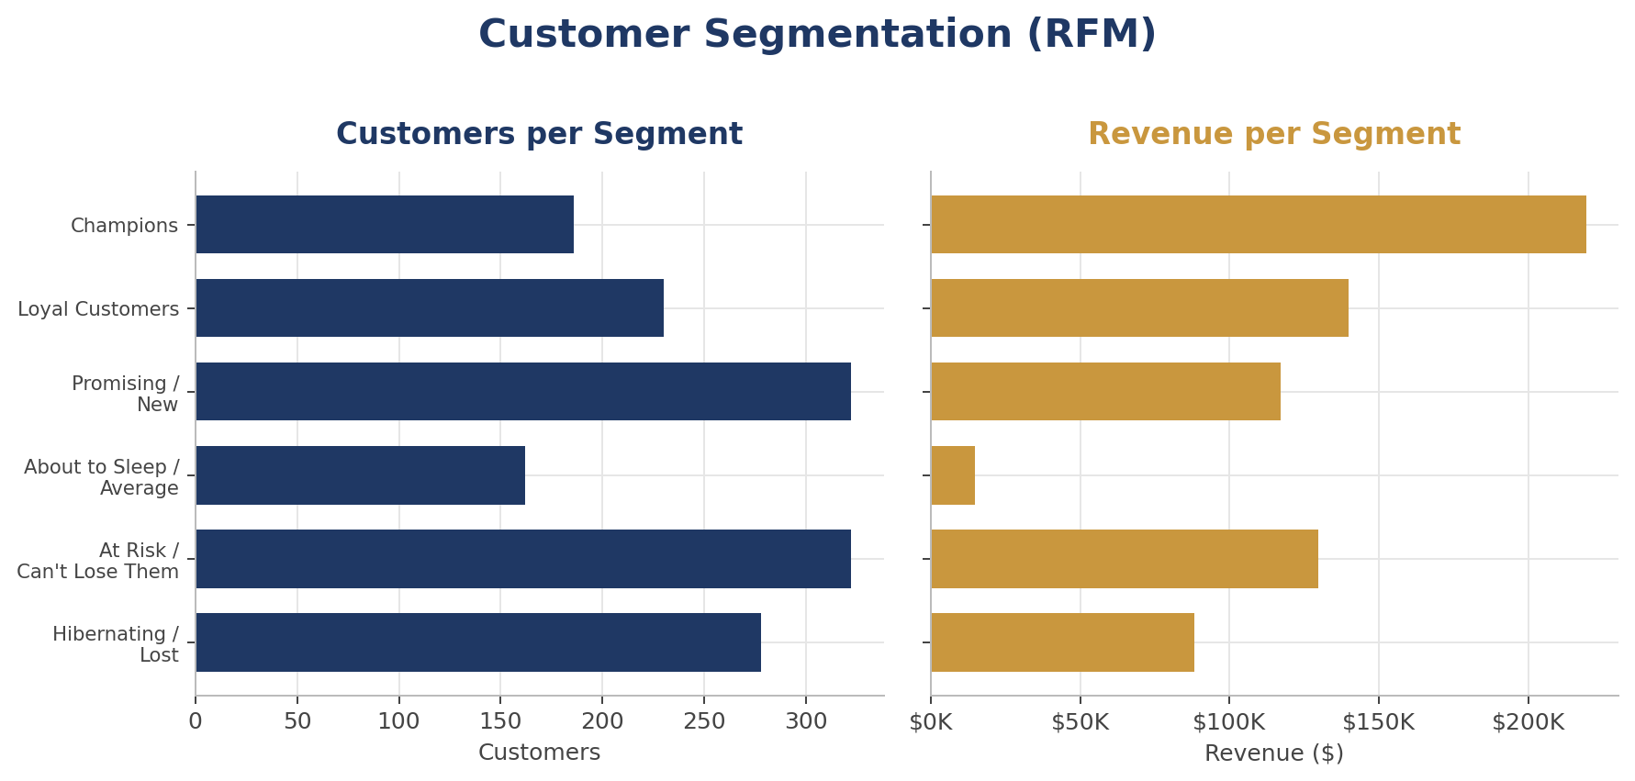

Segment Breakdown
Segment | Customers | % of Base | Revenue | % of Revenue | Avg Value
Champions | 186 | 12.4% | $219,214.45 | 30.9% | $1,178.57
Loyal Customers | 230 | 15.3% | $139,850.04 | 19.7% | $608.04
Promising / New | 322 | 21.5% | $117,082.57 | 16.5% | $363.61
About to Sleep / Average | 162 | 10.8% | $14,926.18 | 2.1% | $92.14
At Risk / Can't Lose Them | 322 | 21.5% | $129,793.64 | 18.3% | $403.09
Hibernating / Lost | 278 | 18.5% | $88,131.31 | 12.4% | $317.02

Champions — high scores across all three dimensions, and also the largest revenue contributor — number 186 customers (12.4% of the base) and generate 30.9% of revenue, at $1,178.57 per customer against a base-wide average of $472.67. At Risk / Can't Lose Them holds 322 customers worth $129,793.64 (18.3% of revenue) who bought frequently but have not returned recently — the segment where retention effort has the most revenue at stake. Hibernating / Lost accounts for 18.5% of customers but only 12.4% of revenue, so reactivation spend here should be weighed against its comparatively low return.
One caveat carries over from the simulation's design: customer purchase rates and lifetimes are drawn from assumed distributions rather than observed from real shoppers. Segment sizes here therefore describe the simulated population, not the expected real-world customer distribution.

Key Takeaways
Revenue is heavily weighted toward a small number of high-ticket products — one rug alone accounts for 33.1% of total revenue. Any stockout or pricing change on this item would have an outsized impact on overall performance.
The top 5 products (10% of the catalog) generate 52.4% of all revenue, while the bottom half of the catalog contributes comparatively little despite similar order volumes — suggesting unit price, not popularity, is the primary revenue driver.
Monthly revenue trended upward over the year, largely because the simulated customer base builds up as new customers are acquired each month.
28.0% of customers bought more than once, a moderate repeat rate. That is a plausible level for big-ticket home goods such as area rugs, though it reflects the simulation's assumptions rather than observed Wayfair shopper behavior.
RFM segmentation concentrates revenue as sharply as the product catalog does: 12.4% of customers in the Champions segment drive 30.9% of revenue, pointing retention effort at a well-defined group.
The project extends this descriptive view with individual-level churn prediction, cohort retention tracking, and campaign ROI modeling.

Data sources: product_catalog_clean.csv (scraped Wayfair catalog data), raw_sales_data.csv (simulated transaction history), and rfm_segments.csv (derived customer segments). Generated by scripts/generate_report.py as part of the e-commerce analytics project pipeline; all figures in this report are computed from those files at generation time.

