

Assignment 1:

Sharp Mail Order

Employee Sales bonus

Tom Tsiliopoulos

Georgian College

Table of Contents

Summary: 3

GUI Sketch: 3

Code Planning 4

# Summary:

This application is designed to calculate the amount of money an employee of Sharp Mail Order earned, based on the total sales of the company, given the sales of the store during the sale period, and the number of hours the employee worked during the period of that sale. The store was open for one hundred and sixty hours during the sale, as a result the user cannot enter an employee’s hours that exceed one hundred and sixty hours.

# GUI Sketch:

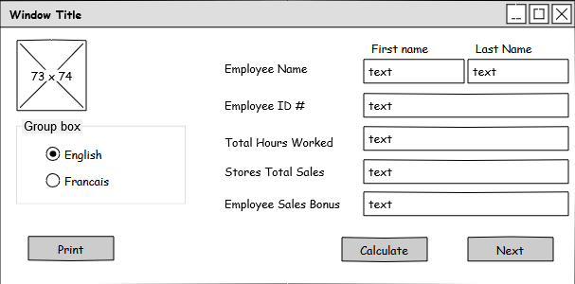

Input Employees name

Input store’s sales here

Input employees hours worked

Input store’s sales here

Output of Employee’s share of sales

Click to calculate the employee’s share of the sales

Click to go to the next employee

Click to send form to printer

Select language

# Code Planning

|  |  |
| --- | --- |
|  |  |
| Form_Load | Loads form and sets focus on employee first name |
| englishButton_CheckedChanged | Convert all labels to english |
| frenchButton_CheckedChanged | Convert all labels to french |
| calculateButton_Click | Calculates the employee’s share of the stores sales |
| nextButton_Click | Clears all fields but the total sales field to allow input for next employee |
|  |  |
|  |  |
|  |  |
|  |  |
|  |  |
|  |  |
|  |  |
|  |  |
|  |  |
|  |  |
|  |  |