GA-HW6 Genetic Algorithm

作業內容:

使用基因演算法解01背包問題

|  |  |  |  |  |  |  |  |  |  |  |
| --- | --- | --- | --- | --- | --- | --- | --- | --- | --- | --- |
|  | A | B | C | D | E | F | G | H | I | J |
| 重量 | 1 | 2 | 3 | 4 | 5 | 6 | 7 | 8 | 9 | 10 |
| 價格 | 6 | 7 | 8 | 9 | 10 | 11 | 12 | 13 | 14 | 15 |

每項物品各有10個

背包限重:275

參數設計:

**實驗次數**:100

**迭代次數**:200

**Srand seed**: time(NULL)

**族群規模**:8(每代8條基因)

**染色體數量**:100(10種物品各有10個 Y/N)

**選擇方法**: 輪盤法(選擇4個不重複基因進pool)

**交配方法**:均勻交配(多點交配)

**交配率**:1 (從pool拿出的基因全去交配產生新的子代不保留親代基因)

**突變方法**:多點突變

**突變率**:0.05 (子代的每條基因有0.05的機率去突變)

Code說明:

**void initialpop();**

初始化基因(pop)，用rand()%2隨機決定染色體0/1，

產生完需再呼叫fix()將超過限重的基因修補

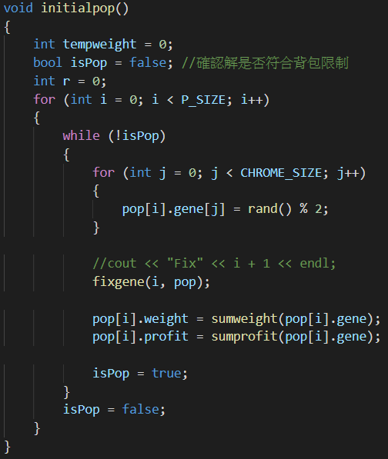

**void selection();**

一開始嘗試使用菁英法(挑選4個當親代產生4個子代，且親代不突變)

但發現容易卡在615因此換使用輪盤法

先算各別選取機率存到pro，運用rand做輪盤法。

|  |  |
| --- | --- |
| EX:  Gene A.pro 0.4  Gene B.pro 0.3  Gene C.pro 0.2  Gene D.pro 0.1  rand()＜0.4選A  0.4<rand()<0.4+0.3選B  0.7<rand()<0.7+0.2選C  0.9<rand()<0.9+0.1選D |  |

使用list將要丟進pool的4個基因index先存起來，且不會有重複的

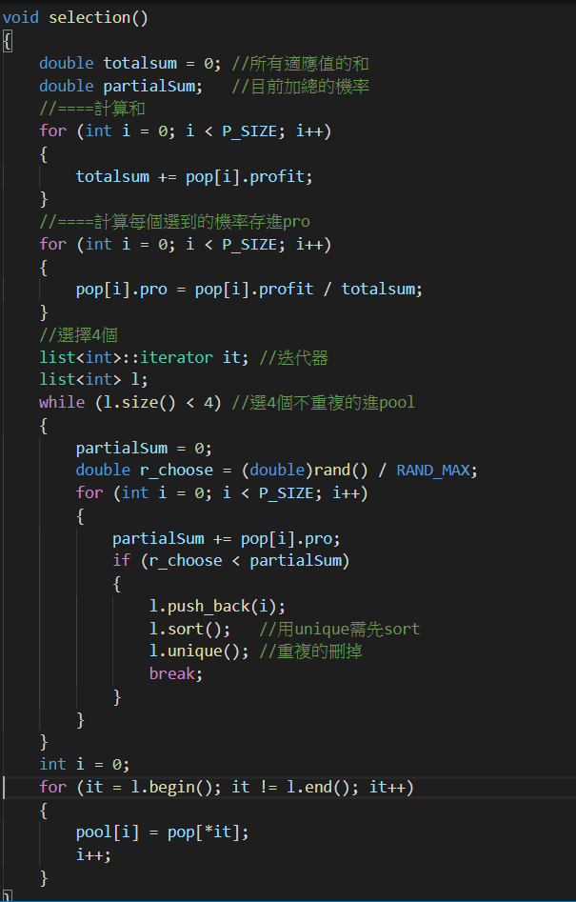

**void crossover();**

一開始使用雙點交配(用rand()隨機產生2切點)，但經過fix()後的基因有前半段大多為1

後半段大多為0特性，因此發現雙點交配後的變化並不大

所以此處使用均勻交配(多點交配)且交配率為1(由下表測試得出)不保留親代基因，希望基因能有更細緻的變化

**表-交配率參數測試(沒設srand seed)**

|  |  |  |  |  |  |  |  |
| --- | --- | --- | --- | --- | --- | --- | --- |
| **交配率** | 1 | 0.99 | 0.98 | 0.95 | 0.9 | 0.8 | 0.7 |
| **代數** | 37.44 | 38.84 | 50.52 | 41.26 | 58.32 | 51.52 | 73.54 |

**EX:**

**親代**

**基因A: 1111 101 000**

**基因B: 1111 010 000**

|  |  |
| --- | --- |
| **使用雙點交配** | **使用均勻交配** |
| **假設切點為4、7**  **子代**  **基因C: 1111010000 = 基因B**  **基因D: 1111101000 = 基因A** | **假設mask:0110010010**  **子代**  **基因C: 1111111000**  **基因D: 1111000000** |

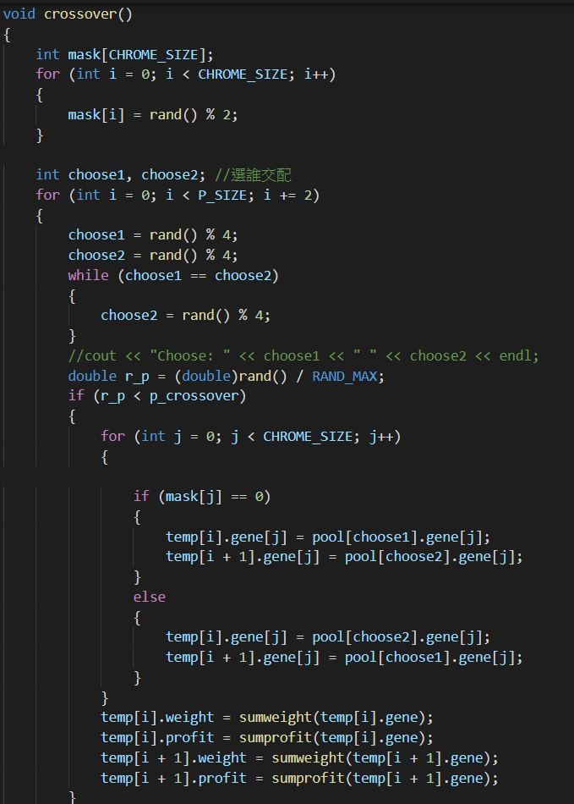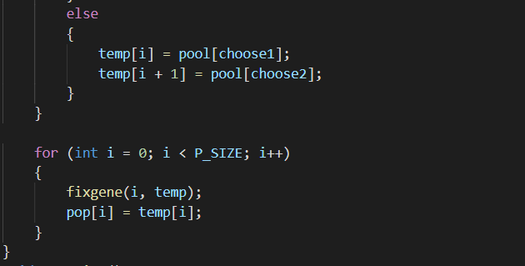

**void mutation();**

這邊採用多點突變且每條基因突變率為0.05

(測試過0.2、0.1、0.08、0.05、0.03、0.01，發現0.05為較好參數)

**表-突變率參數測試(沒設srand seed)**

|  |  |  |  |  |  |  |
| --- | --- | --- | --- | --- | --- | --- |
| **突變率** | 0.2 | 0.1 | 0.08 | 0.05 | 0.03 | 0.01 |
| **平均代數** | 119.38 | 58.5 | 61.44 | 51.52 | 76.94 | 144.12 |

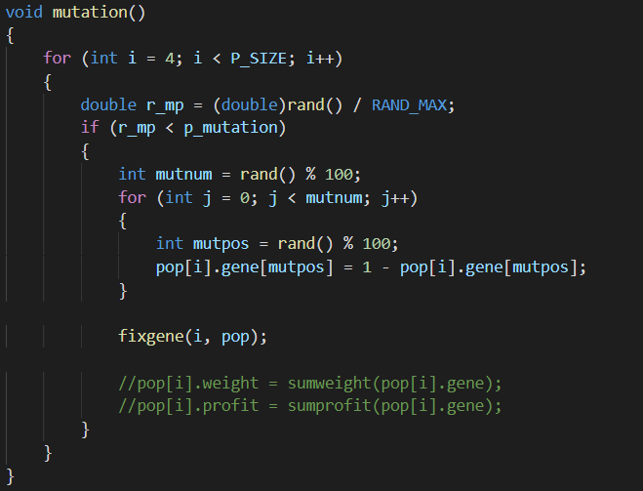

**void fixgene(int i, population p[]);**

將重量超過275或不滿275的基因修復到盡量接近275

一開始只將超過重量的拿出，後來發現效果不好，因此增加了如果重量小於275能繼續放東西直到不能放

重量超過275時從後面物品開始拿出(CP值較低的)

重量小於275還能放時由前面物品開始放入(CP值較高的)

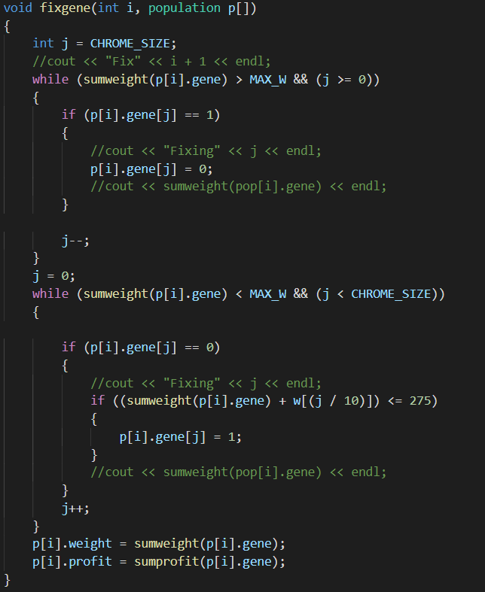

實驗數據:

|  |  |
| --- | --- |
| 平均profit | 620.00000 |
| 平均找到的代數 | 41.86000 |
| 平均找到的計算次數 | 359.87000 |
|  | |

**每次實驗數據:**

|  |  |  |  |  |
| --- | --- | --- | --- | --- |
| Experiment1  Global best gene_Generation: 17  Global best gene:  A:10 B:10 C:10 D:10 E:10 F:10 G:7 H:2 I:0 J:0  Global best profit: 620  Global best weight: 275 | Experiment11  Global best gene_Generation: 170  Global best gene:  A:10 B:10 C:10 D:10 E:10 F:10 G:7 H:2 I:0 J:0  Global best profit: 620  Global best weight: 275 | Experiment21  Global best gene_Generation: 44  Global best gene:  A:10 B:10 C:10 D:10 E:10 F:10 G:7 H:2 I:0 J:0  Global best profit: 620  Global best weight: 275 | Experiment31  Global best gene_Generation: 25  Global best gene:  A:10 B:10 C:10 D:10 E:10 F:10 G:7 H:2 I:0 J:0  Global best profit: 620  Global best weight: 275 | Experiment41  Global best gene_Generation: 50  Global best gene:  A:10 B:10 C:10 D:10 E:10 F:10 G:7 H:2 I:0 J:0  Global best profit: 620  Global best weight: 275 |
| Experiment2  Global best gene_Generation: 45  Global best gene:  A:10 B:10 C:10 D:10 E:10 F:10 G:7 H:2 I:0 J:0  Global best profit: 620  Global best weight: 275 | Experiment12  Global best gene_Generation: 67  Global best gene:  A:10 B:10 C:10 D:10 E:10 F:10 G:7 H:2 I:0 J:0  Global best profit: 620  Global best weight: 275 | Experiment22  Global best gene_Generation: 44  Global best gene:  A:10 B:10 C:10 D:10 E:10 F:10 G:7 H:2 I:0 J:0  Global best profit: 620  Global best weight: 275 | Experiment32  Global best gene_Generation: 65  Global best gene:  A:10 B:10 C:10 D:10 E:10 F:10 G:7 H:2 I:0 J:0  Global best profit: 620  Global best weight: 275 | Experiment42  Global best gene_Generation: 30  Global best gene:  A:10 B:10 C:10 D:10 E:10 F:10 G:7 H:2 I:0 J:0  Global best profit: 620  Global best weight: 275 |
| Experiment3  Global best gene_Generation: 98  Global best gene:  A:10 B:10 C:10 D:10 E:10 F:10 G:7 H:2 I:0 J:0  Global best profit: 620  Global best weight: 275 | Experiment13  Global best gene_Generation: 18  Global best gene:  A:10 B:10 C:10 D:10 E:10 F:10 G:7 H:2 I:0 J:0  Global best profit: 620  Global best weight: 275 | Experiment23  Global best gene_Generation: 58  Global best gene:  A:10 B:10 C:10 D:10 E:10 F:10 G:7 H:2 I:0 J:0  Global best profit: 620  Global best weight: 275 | Experiment33  Global best gene_Generation: 23  Global best gene:  A:10 B:10 C:10 D:10 E:10 F:10 G:7 H:2 I:0 J:0  Global best profit: 620  Global best weight: 275 | Experiment43  Global best gene_Generation: 66  Global best gene:  A:10 B:10 C:10 D:10 E:10 F:10 G:7 H:2 I:0 J:0  Global best profit: 620  Global best weight: 275 |
| Experiment4  Global best gene_Generation: 34  Global best gene:  A:10 B:10 C:10 D:10 E:10 F:10 G:7 H:2 I:0 J:0  Global best profit: 620  Global best weight: 275 | Experiment14  Global best gene_Generation: 28  Global best gene:  A:10 B:10 C:10 D:10 E:10 F:10 G:7 H:2 I:0 J:0  Global best profit: 620  Global best weight: 275 | Experiment24  Global best gene_Generation: 42  Global best gene:  A:10 B:10 C:10 D:10 E:10 F:10 G:7 H:2 I:0 J:0  Global best profit: 620  Global best weight: 275 | Experiment34  Global best gene_Generation: 93  Global best gene:  A:10 B:10 C:10 D:10 E:10 F:10 G:7 H:2 I:0 J:0  Global best profit: 620  Global best weight: 275 | Experiment44  Global best gene_Generation: 142  Global best gene:  A:10 B:10 C:10 D:10 E:10 F:10 G:7 H:2 I:0 J:0  Global best profit: 620  Global best weight: 275 |
| Experiment5  Global best gene_Generation: 30  Global best gene:  A:10 B:10 C:10 D:10 E:10 F:10 G:7 H:2 I:0 J:0  Global best profit: 620  Global best weight: 275 | Experiment15  Global best gene_Generation: 50  Global best gene:  A:10 B:10 C:10 D:10 E:10 F:10 G:7 H:2 I:0 J:0  Global best profit: 620  Global best weight: 275 | Experiment25  Global best gene_Generation: 19  Global best gene:  A:10 B:10 C:10 D:10 E:10 F:10 G:7 H:2 I:0 J:0  Global best profit: 620  Global best weight: 275 | Experiment35  Global best gene_Generation: 22  Global best gene:  A:10 B:10 C:10 D:10 E:10 F:10 G:7 H:2 I:0 J:0  Global best profit: 620  Global best weight: 275 | Experiment45  Global best gene_Generation: 108  Global best gene:  A:10 B:10 C:10 D:10 E:10 F:10 G:7 H:2 I:0 J:0  Global best profit: 620  Global best weight: 275 |
| Experiment6  Global best gene_Generation: 65  Global best gene:  A:10 B:10 C:10 D:10 E:10 F:9 G:9 H:1 I:0 J:0  Global best profit: 620  Global best weight: 275 | Experiment16  Global best gene_Generation: 118  Global best gene:  A:10 B:10 C:10 D:10 E:10 F:10 G:7 H:2 I:0 J:0  Global best profit: 620  Global best weight: 275 | Experiment26  Global best gene_Generation: 25  Global best gene:  A:10 B:10 C:10 D:10 E:10 F:10 G:7 H:2 I:0 J:0  Global best profit: 620  Global best weight: 275 | Experiment36  Global best gene_Generation: 50  Global best gene:  A:10 B:10 C:10 D:10 E:10 F:10 G:7 H:2 I:0 J:0  Global best profit: 620  Global best weight: 275 | Experiment46  Global best gene_Generation: 135  Global best gene:  A:10 B:10 C:10 D:10 E:10 F:10 G:7 H:2 I:0 J:0  Global best profit: 620  Global best weight: 275 |
| Experiment7  Global best gene_Generation: 54  Global best gene:  A:10 B:10 C:10 D:10 E:10 F:10 G:7 H:2 I:0 J:0  Global best profit: 620  Global best weight: 275 | Experiment17  Global best gene_Generation: 90  Global best gene:  A:10 B:10 C:10 D:10 E:10 F:10 G:7 H:2 I:0 J:0  Global best profit: 620  Global best weight: 275 | Experiment27  Global best gene_Generation: 137  Global best gene:  A:10 B:10 C:10 D:10 E:10 F:10 G:7 H:2 I:0 J:0  Global best profit: 620  Global best weight: 275 | Experiment37  Global best gene_Generation: 75  Global best gene:  A:10 B:10 C:10 D:10 E:10 F:10 G:7 H:2 I:0 J:0  Global best profit: 620  Global best weight: 275 | Experiment47  Global best gene_Generation: 109  Global best gene:  A:10 B:10 C:10 D:10 E:10 F:9 G:9 H:1 I:0 J:0  Global best profit: 620  Global best weight: 275 |
| Experiment8  Global best gene_Generation: 54  Global best gene:  A:10 B:10 C:10 D:10 E:10 F:10 G:7 H:2 I:0 J:0  Global best profit: 620  Global best weight: 275 | Experiment18  Global best gene_Generation: 39  Global best gene:  A:10 B:10 C:10 D:10 E:10 F:10 G:7 H:2 I:0 J:0  Global best profit: 620  Global best weight: 275 | Experiment28  Global best gene_Generation: 5  Global best gene:  A:10 B:10 C:10 D:10 E:10 F:10 G:7 H:2 I:0 J:0  Global best profit: 620  Global best weight: 275 | Experiment38  Global best gene_Generation: 16  Global best gene:  A:10 B:10 C:10 D:10 E:10 F:10 G:7 H:2 I:0 J:0  Global best profit: 620  Global best weight: 275 | Experiment48  Global best gene_Generation: 52  Global best gene:  A:10 B:10 C:10 D:10 E:10 F:10 G:7 H:2 I:0 J:0  Global best profit: 620  Global best weight: 275 |
| Experiment9  Global best gene_Generation: 52  Global best gene:  A:10 B:10 C:10 D:10 E:10 F:10 G:7 H:2 I:0 J:0  Global best profit: 620  Global best weight: 275 | Experiment19  Global best gene_Generation: 40  Global best gene:  A:10 B:10 C:10 D:10 E:10 F:10 G:7 H:2 I:0 J:0  Global best profit: 620  Global best weight: 275 | Experiment29  Global best gene_Generation: 113  Global best gene:  A:10 B:10 C:10 D:10 E:10 F:10 G:7 H:2 I:0 J:0  Global best profit: 620  Global best weight: 275 | Experiment39  Global best gene_Generation: 22  Global best gene:  A:10 B:10 C:10 D:10 E:10 F:10 G:7 H:2 I:0 J:0  Global best profit: 620  Global best weight: 275 | Experiment49  Global best gene_Generation: 48  Global best gene:  A:10 B:10 C:10 D:10 E:10 F:10 G:7 H:2 I:0 J:0  Global best profit: 620  Global best weight: 275 |
| Experiment10  Global best gene_Generation: 41  Global best gene:  A:10 B:10 C:10 D:10 E:10 F:10 G:7 H:2 I:0 J:0  Global best profit: 620  Global best weight: 275 | Experiment20  Global best gene_Generation: 25  Global best gene:  A:10 B:10 C:10 D:10 E:10 F:10 G:7 H:2 I:0 J:0  Global best profit: 620  Global best weight: 275 | Experiment30  Global best gene_Generation: 23  Global best gene:  A:10 B:10 C:10 D:10 E:10 F:10 G:7 H:2 I:0 J:0  Global best profit: 620  Global best weight: 275 | Experiment40  Global best gene_Generation: 53  Global best gene:  A:10 B:10 C:10 D:10 E:10 F:10 G:7 H:2 I:0 J:0  Global best profit: 620  Global best weight: 275 | Experiment50  Global best gene_Generation: 31  Global best gene:  A:10 B:10 C:10 D:10 E:10 F:10 G:7 H:2 I:0 J:0  Global best profit: 620  Global best weight: 275 |

其他:

嘗試將輪盤法再作改善，以平移方法將最小值設為1其他跟著平移，加大機率的差距

|  |  |
| --- | --- |
| 原 | 改 |
| |  |  | | --- | --- | | 575 | 0.2407 | | 590 | 0.2470 | | 605 | 0.2532 | | 619 | 0.2591 | | |  |  | | --- | --- | | 575 → 1 | 0.0111 | | 590 → 15 | 0.1667 | | 605 → 30 | 0.3333 | | 619 → 44 | 0.4889 | |

且有調整突變率成0.25

發現50次實驗內平均30代就能找到最佳解620

實驗結果:

