Everyday rain, not just storms: Rainfall and intercity travel in China
Liang Wangª, Mengqi Wangª, Xiaodong Zhang^{a,*}, Xinghua Zhang^{b,*}
ª Beijing Municipal Institute of City Planning and Design, Beijing, 100045, China
^{b} Center of Soft Matter Physics and its Applications, and School of Physics, Beihang University, Beijing, 100191, China
* Corresponding authors. E-mail: zhang-xd23@mails.tsinghua.edu.cn (Xiaodong Zhang), zhangxh@bjtu.edu.cn (Xinghua Zhang)

Highlights
- Everyday rain cuts intercity flows in China by 2% (moderate) to 6% (rainstorms).
- Rain effects decay with distance; trips under 150 km respond most.
- Snow-prone and typhoon days are far more disruptive than ordinary rain.
- Drier cities respond more to moderate and heavy rain, consistent with adaptation.
- Everyday rain removes 0.9–1.1 billion trips a year once next-day effects count.

Abstract
Research on weather and mobility has focused on travel within cities and on single extreme events. We estimate how daily rainfall affects intercity travel across China, using 28.8 million daily origin–destination (OD) observations on 26,442 stable links among 365 prefecture-level cities in 2023–2025. Flows come from DIMNet-CPC, a calibrated daily intercity mobility dataset; rainfall comes from ERA5-Land at 2,385 weather-station locations. Effects are identified from day-to-day rainfall variation within OD links, net of link-by-month, link-by-weekday and date fixed effects. We set aside two kinds of special weather: typhoon days, identified from IBTrACS tracks, and snow-prone days, with daily mean temperature below 2 °C. On the remaining everyday days, flows fall smoothly with rainfall, by about 2% in moderate rain and 4–6% in rainstorms (50–100 mm), with a further fall the next day; light rain lowers flows only at the destination. Effects decay with distance: rainstorms cut flows within 150 km by about 8% but long-haul flows by 2–7%. Cities in drier climates respond more strongly to moderate and heavier rain, consistent with adaptation. The same precipitation is far more disruptive on snow-prone and typhoon days. Counting effects up to three days after the rain, everyday rain removes 0.9–1.1 billion intercity trips a year, far more than is lost on snow-prone and typhoon days. Results hold with temperature controls, finer fixed effects, Poisson estimation, three-way clustering and placebo tests; region-by-date fixed effects and gauge-based rainfall give somewhat smaller effects. Adaptation should target routine rain on short intercity corridors as well as snow and typhoon emergencies.
Keywords: Rainfall; Intercity travel; Human mobility; Climate adaptation; Tropical cyclones; Snow; China

1. Introduction
Rain is the most common weather hazard that travellers face. Unlike heatwaves or floods, it arrives on a large share of days in most of the world’s populated regions, and climate change is making heavy precipitation more frequent and more intense (Seneviratne et al., 2021). Transport researchers have long documented that rain changes how people travel within cities: it suppresses walking and cycling, shifts demand toward cars, taxis and ride-hailing, and slows road traffic (Koetse and Rietveld, 2009; Böcker et al., 2013; Gössling et al., 2023). Far less is known about how rain affects travel between cities, even though intercity trips sustain labour markets, family ties, tourism and the integration of city regions. In China alone, the stable intercity links we study carry about 48 billion trips a year.
Two strands of evidence bear on this question, but neither answers it. The first studies everyday weather and travel demand, mostly for a single city and a single mode, such as bus ridership in Brisbane (Tao et al., 2018), public transport in Shenzhen (Zhou et al., 2017) or taxis and ride-hailing in New York (Brodeur and Nield, 2018). The second studies the resilience of human mobility to extreme events, typically one storm or flood at a time: Hurricane Sandy (Wang and Taylor, 2014), the 2021 Zhengzhou flood (Tang et al., 2023; Li et al., 2026), Typhoon Mawar in Japan (Yao et al., 2025) or the 2018 heavy rain in Japan (Liu et al., 2026). Recent national-scale work in China has examined how extreme weather and the COVID-19 pandemic jointly suppressed mobility (Liu et al., 2023), and how intercity connectivity helps cities recover from extreme rainfall (Liu and Bai, 2026). The closest study of intercity flows uses toll data from one province’s freeway network and finds that rain at both trip ends matters (Yang et al., 2021).
This leaves four gaps. First, the extreme-event literature cannot tell us how much disruption comes from ordinary rain. A rainstorm may cut travel sharply, but light and moderate rain occur on far more days, so their cumulative effect may be larger. Second, aggregate city-level measures cannot separate rain at the origin from rain at the destination, or show how sensitivity varies with trip distance and therefore with transport mode. Third, it is unclear whether the same rainfall matters equally everywhere. If travellers and infrastructure adapt to local climate, as they do to heat (Barreca et al., 2016; Heutel et al., 2021), cities in wet regions should respond less to a given amount of rain. Fourth, many of the most disruptive precipitation days are not ordinary rain. In East Asia the heaviest rain often comes with typhoons, when wind, warnings and service suspensions accompany it, and in northern China much winter precipitation falls as snow or freezing rain. Estimates that pool these days attribute typhoon and snow disruption to rainfall.
We address these gaps with a national panel of daily intercity flows. We combine DIMNet-CPC, a newly released dataset of calibrated daily origin–destination (OD) flows among China’s prefecture-level cities (Xu et al., 2026), with ERA5-Land rainfall extracted at 2,385 weather-station locations and summed over Beijing-time days (Muñoz-Sabater et al., 2021). The estimation sample covers 26,442 stable directed links observed daily from 2023 to 2025, or 28.8 million link-days. We estimate rainfall dose–response functions for origin and destination rain within OD links, absorbing seasonal, weekly and national shocks with high-dimensional fixed effects, and use IBTrACS cyclone tracks (Knapp et al., 2010) and daily temperature to set aside typhoon-influenced and snow-prone days, which we analyse separately. We also control for temperature and re-estimate the model with a gauge-based rainfall analysis.
The paper makes four contributions. (1) It provides the first national estimates of how the full distribution of daily rainfall, not just extremes, affects intercity OD flows, distinguishing origin from destination rain. (2) It shows that the response decays with distance, so short intercity trips bear most of the burden. (3) It documents climate adaptation in intercity travel: cities in drier climates react more strongly to the same moderate or heavier rainfall, and the difference narrows when rainfall is measured relative to local norms. (4) It separates everyday rain from typhoon and snow-prone days and converts effects into trips. Typhoon days explain most of the disruption attributed to extreme rainfall and snow-prone days much of the apparent effect of light precipitation, while everyday rain, counting next-day effects, removes an estimated 0.9–1.1 billion intercity trips a year.
The rest of the paper proceeds as follows. Section 2 reviews related work. Section 3 describes the data, Section 4 the empirical strategy and Section 5 the results. Section 6 discusses mechanisms, policy implications and limitations, and Section 7 concludes.

2. Literature review

2.1 Weather and everyday travel
A large body of work links daily weather to travel behaviour. Reviews conclude that precipitation reduces discretionary and active travel, shifts mode choice toward motorised and sheltered modes, and degrades road performance (Koetse and Rietveld, 2009; Böcker et al., 2013; Gössling et al., 2023). Smart-card and trip-record studies quantify these effects at fine time scales. Rain lowers hourly bus ridership in Brisbane, with lagged responses that vary across the network (Tao et al., 2018). Public transport ridership in Shenzhen is likewise weather-sensitive (Zhou et al., 2017). In New York, rainy hours see about 22% more Uber trips and 5% more taxi trips (Brodeur and Nield, 2018), showing that rain redistributes travel as well as suppressing it. Mobile-phone traces show that activity patterns become more dispersed on rainy days (Horanont et al., 2013), and traffic data show congestion rising with hourly rainfall in Beijing, Tianjin and Shijiazhuang, by different amounts in each city (Xiong et al., 2022).
Several studies find that weather effects differ across places. In a comparison of Dutch, Norwegian and Swedish city regions, Böcker et al. (2019) attribute regional differences to climate, transport systems and habits. In Germany, precipitation affects cyclists in metropolitan areas less than in peripheral and rural areas (Galich and Nieland, 2023). These comparisons involve a handful of regions, so they cannot separate climate from other local differences.

2.2 Extreme rainfall and mobility resilience
A second strand uses mobility big data to study disasters. Wang and Taylor (2014, 2016) show that human mobility during hurricanes and other disasters is perturbed but retains its statistical regularities, up to a limit set by disaster strength. Studies of the 2021 Zhengzhou flood find that pluvial flooding reduced trips while leaving the structure of the mobility network largely intact (Tang et al., 2023), and that intercity outflows and inflows in the Central Plains urban agglomeration fell by roughly 31% and 26% (Li et al., 2026). Yao et al. (2025) report similar patterns at agglomeration and regional scales during Typhoon Mawar in Japan. Liu et al. (2026) find that Japan’s 2018 heavy rain cut peak daily cross-city commuting by about 8% and shopping trips by about 20%, and that alternative routes sped recovery. For the Beijing–Tianjin–Hebei region, Zhao et al. (2025) simulate a 100-year rainstorm and estimate that it would reduce the efficiency of the intercity mobility network by about 26%.
Two national studies of China are closest to ours. Liu et al. (2023) show, for 313 cities during the COVID-19 pandemic, that rainfall above 20 mm/day raised the risk that intra- and intercity mobility fell below pre-pandemic levels, with stronger and delayed effects in dense, lower-income cities. Liu and Bai (2026) show for 366 cities that stronger intercity connectivity speeds the recovery of intra-city mobility after extreme rainfall. Yao et al. (2026) combine flood simulations with intercity mobility to project disruption under future climate. These studies treat rainfall as an extreme shock and mobility as a city-level outcome. They do not estimate how intercity OD flows respond to the full range of everyday rainfall, nor do they separate tropical cyclones from other heavy rain.

2.3 Intercity travel, distance and climate adaptation
Evidence on weather and intercity travel is sparse. Using freeway toll data for Shandong province, Yang et al. (2021) find that heavy rain and snow reduce OD volumes, that rain at the destination and the origin–destination rainfall difference both matter, and that effects begin about a day before and last about two days after severe weather. A survey in Xi’an shows that weather shifts the choice among air, high-speed rail, conventional rail and coach (Li et al., 2021), and highway volumes in the Greater Bay Area depend jointly on weather and holidays (Lin et al., 2022). Because the shares of road, rail and air travel vary systematically with distance (Xiang et al., 2026), distance is a natural axis along which rain sensitivity may vary. Short trips are more discretionary and more road-based; long trips are more often pre-booked and rail- or air-based. Closest in design to our study, Liang and Wang (2025) use fixed-effects panels to show that heatwaves reduce intra-city trips and inbound intercity trips in Chinese cities, with larger effects in small and less affluent cities.
Methodologically, we draw on the climate-econometrics literature, which treats day-to-day weather as a quasi-random shock conditional on location and time fixed effects and estimates nonlinear dose–response functions with bins (Dell et al., 2014; Hsiang, 2016). This literature also warns that gridded weather products smooth extremes and introduce measurement error (Auffhammer et al., 2013). It has documented adaptation: mortality responses to heat have declined over time and are smaller in hotter places (Barreca et al., 2016; Heutel et al., 2021). We apply the same logic to rainfall and intercity travel, asking whether places that see more rain respond less to it.

3. Data

3.1 Intercity flows
Intercity flows come from DIMNet-CPC (Xu et al., 2026), which provides directed daily OD flows, in person-trips, among China’s 366 prefecture-level and higher administrative units for 2020–2025. The dataset calibrates Baidu Migration’s relative intensity indices to national daily passenger statistics. A link’s flow is the product of a national daily conversion factor and the link’s Baidu relative intensity, $F_{ijt}=k_{t} q_{ijt}$. Because $k_{t}$ is common to all links on a day, date fixed effects absorb it, so the percentage effects we estimate are identified from the Baidu intensities. The calibration matters for converting those effects into numbers of trips (Section 5.5).
We use 1 January 2023 to 31 December 2025 (1,096 days). This window has no missing dates and no COVID-19 travel restrictions. DIMNet-CPC publishes a link only when it appears in the top-100 origin or destination list of one of its ends. A missing link-day therefore means “not disclosed”, not zero. Rain could push small links below the disclosure threshold, which would bias estimates toward zero if we used every observed record. We therefore restrict the sample to stable links that are disclosed on at least 95% of days: 26,442 of the 132,622 directed links ever observed, carrying 98.0% of all disclosed flow. Sansha is excluded because no representative rainfall series exists for it (Section 3.2), leaving 365 cities.
The median stable link carries 709 trips a day (mean 5,003), and the median link distance is 552 km. Short links dominate volumes: links under 150 km are 6% of links but carry half of all flow (Table 1).

3.2 Rainfall and temperature
Rainfall is ERA5-Land total precipitation (0.1°, about 9 km), a land-surface reanalysis driven by ERA5 (Muñoz-Sabater et al., 2021). We use a compilation that extracts the series at the locations of 2,421 China Meteorological Administration stations for 1950–2026. Hourly accumulations are de-accumulated and summed over Beijing-time (UTC+8) days, the same day definition as the mobility data. Thirty-six coastal and island stations fall in ERA5-Land ocean grid cells and return series that are zero on every day. We treat these as missing rather than dry and drop them, leaving 2,385 stations. City rainfall is the mean over stations within each city (median six stations). Ten cities with no valid station inside their boundary take the mean of the two nearest valid stations, all within 100 km of the city centroid except for Sansha (1,094 km), which we exclude.
We bin daily rainfall using China’s national standard (GB/T 28592-2012): none (<0.1 mm), light (0.1–9.9), moderate (10–24.9), heavy (25–49.9), rainstorm (50–99.9) and extreme (≥100 mm). To measure rainfall relative to local norms, we also bin wet-day rainfall at each city’s 1991–2020 75th, 90th, 95th and 99th percentiles. We classify cities with 1991–2020 mean annual precipitation of at least 800 mm as humid; this isohyet roughly follows the Qinling–Huaihe line separating northern and southern China (Fig. 1). Reanalysis rainfall is known to overstate the frequency of light rain and understate extremes over China (Xie et al., 2022), so we also use an independent, gauge-based product.
For temperature and as a check on rainfall, we use two 0.5° gauge-based grids from the NOAA Climate Prediction Center (CPC; unrelated to the DIMNet-CPC flow data): the Global Unified Gauge-Based Analysis of Daily Precipitation, which interpolates rain-gauge reports by optimal interpolation (Xie et al., 2007; Chen et al., 2008), and the CPC Global Daily Temperature analysis of daily maximum and minimum temperature. City values are means over the grid cells that overlap each city, weighted by overlap area, and daily mean temperature is the average of the maximum and minimum. CPC daily totals follow national reporting conventions rather than Beijing-time days, but same-day CPC rainfall matches our series best (correlation of log(1 + rainfall) 0.82, against 0.65 for the previous day and 0.47 for the next), so we use same-day values. The two rainfall series agree on the spatial pattern, with a correlation of about 0.9 in city mean annual rainfall, but not on how often light rain falls: CPC records rain on 49.4% of city-days against 57.7% for ERA5-Land, and 27% of the city-days that ERA5-Land classes as light rain are dry in CPC (Table 1).
We also use the CPC temperature to identify snow-prone days. A city-day is snow-prone if its daily mean temperature is below 2 °C, close to the air temperatures at which rain and snow are equally likely over Northern Hemisphere land (Jennings et al., 2018). Precipitation on these days, recorded as water equivalent, may fall as snow, sleet or freezing rain. Snow-prone days make up 14.3% of city-days and are concentrated in drier northern cities, where they account for 21% of days with light precipitation, against 4% in humid cities; 15.6% of link-days have a snow-prone end and no typhoon.

3.3 Tropical cyclones
Tropical cyclone (TC) tracks are from IBTrACS v04r01 for the western North Pacific (Knapp et al., 2010), at three-hour intervals. We include provisional tracks for 2025, which lack CMA intensities but give positions. A city-day is typhoon-influenced if a TC centre, including decaying remnant lows, passes within 500 km of the city centroid at any time during the Beijing-time day. This radius is standard for attributing rainfall to TCs (Lonfat et al., 2004; Ren et al., 2006); we also report results with a 300 km radius. Between 2023 and 2025, 84 TCs influenced 283 cities on 6,005 city-days (1.5%), and 2.5% of link-days had a TC near at least one end. TCs dominate the heaviest rain: 70% of city-days with ≥100 mm are typhoon-influenced, 75% in humid cities and 20% in drier ones.
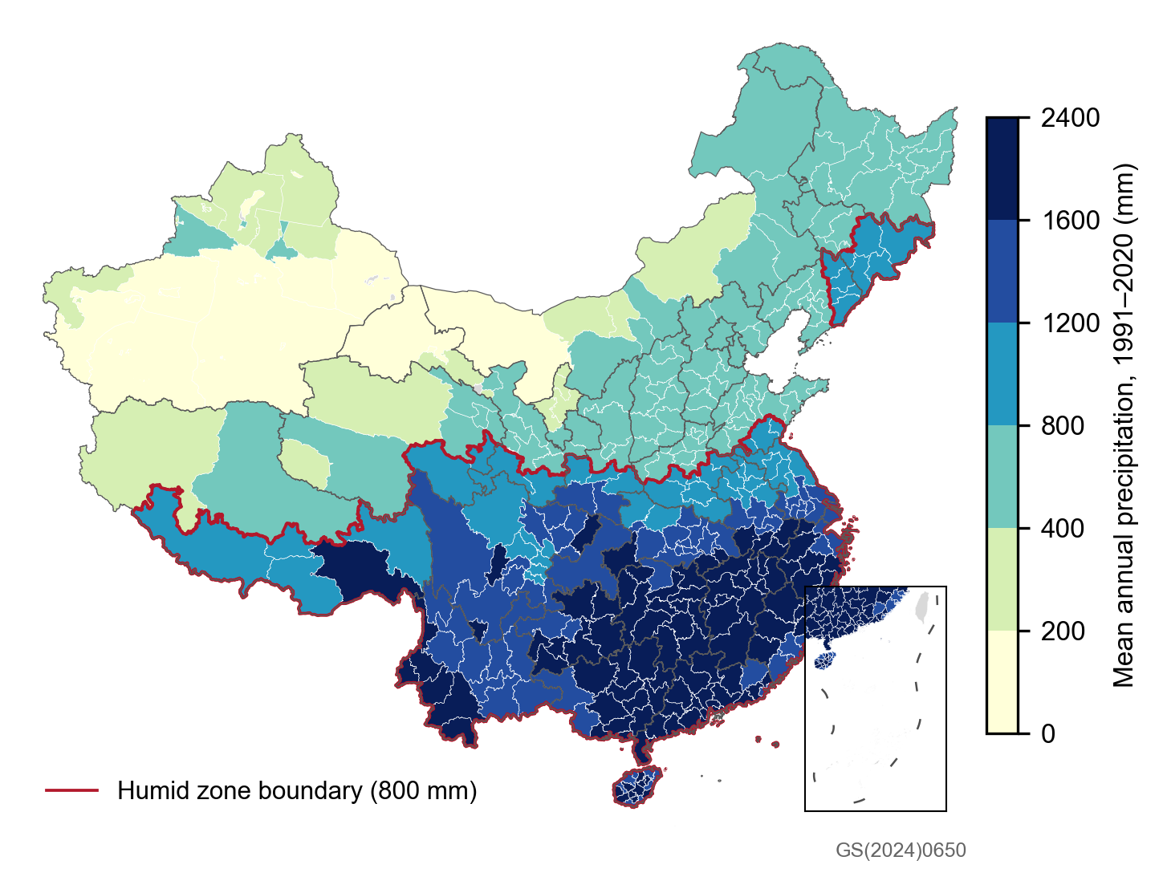
Fig. 1. Study area: cities shaded by 1991–2020 mean annual precipitation (ERA5-Land); red line, 800 mm humid-zone boundary; grey, outside the sample. Base map GS(2024)0650.
Table 1. Descriptive statistics, 2023–2025.
Variable | Value
Cities (prefecture level and above) | 365
Stable directed links (share of disclosed flow) | 26,442 (98.0%)
Days | 1,096
Link-days: all / without typhoons / main sample (everyday) | 28,777,077 / 28,072,836 / 23,573,128
Daily trips per link: median (mean) | 709 (5,003)
Link distance, km: median (mean) | 552 (713)
Links under 150 km: share of links / share of flow | 6.0% / 49.9%
Stations used after quality control | 2,385
City-days by rain bin, ERA5-Land, %: none / light / moderate / heavy / rainstorm / extreme | 42.3 / 48.7 / 6.8 / 1.8 / 0.38 / 0.04
City-days by rain bin, CPC gauge analysis, %: none / light / moderate / heavy / rainstorm / extreme | 50.6 / 40.2 / 6.6 / 2.1 / 0.52 / 0.06
Daily mean temperature, °C: mean (5th–95th percentile) | 14.9 (−7.1 to 29.6)
Mean annual precipitation 1991–2020, mm: mean (range) | 1,125 (38–2,342)
Humid cities (≥800 mm) | 225
Typhoon-influenced city-days (≤500 km) | 6,005 (1.5%)
Snow-prone city-days (CPC daily mean <2 °C) | 14.3%

4. Empirical strategy

4.1 Baseline model
For link ij (origin i, destination j) on day t, we estimate
$$lnF_{ijt}=\sum_{b=1}^{5}{β_{b}^{O}} 1\left[R_{it}∈b\right]+\sum_{b=1}^{5}{β_{b}^{D}} 1\left[R_{jt}∈b\right]+\sum_{c=1}^{4}{\left(γ_{c}^{O} 1\left[A_{it}∈c\right]+γ_{c}^{D} 1\left[A_{jt}∈c\right]\right)}+μ_{ij,m\left(t\right)}+η_{ij,w\left(t\right)}+λ_{t}+ε_{ijt}$$
where R is daily rainfall in the five non-zero bins of Section 3.2, with dry days as the reference. A is rainfall accumulated over the previous seven days (t−7 to t−1), binned at 10, 25, 50 and 100 mm. Wet days cluster in wet spells, and the seven days before a ≥25 mm day average 60–76 mm against 10 mm before a dry day. Without this control, the rain coefficients would partly capture the effect of a wet period. The fixed effects μ (link × year-month) absorb each link’s seasonality and trend; η (link × day-of-week) absorbs weekly rhythms such as commuting and weekend travel; and λ (date) absorbs national shocks, including public holidays, the Spring Festival travel season and DIMNet’s daily conversion factor $k_{t}$. We report effects as percentage changes, 100 × (exp(β) − 1).
Identification rests on the standard assumption in weather studies: conditional on a link’s month and weekday and on the national date effect, day-to-day rainfall is as good as random (Dell et al., 2014; Hsiang, 2016). The coefficients are reduced-form total effects. They include travellers’ own responses and any operator responses, such as service changes, that rain triggers.
The main specification uses everyday link-days: those with no TC within 500 km of either end and no snow-prone end (23.57 million observations, 82% of the total). Typhoon days combine rain with wind, warnings and pre-emptive suspensions, and snow-prone days combine precipitation with snow, ice and freezing roads, so we analyse both separately. For typhoons, we estimate on all days a model in which each rain bin is interacted with a typhoon indicator at the same end. For snow, we estimate on days without typhoons a model in which precipitation bins are estimated separately for snow-prone and other ends, controlling for snow-prone days themselves. Both models report effects relative to a dry day of the same type. We estimate all models in R with fixest (Bergé, 2018), which handles the roughly 950,000 link × year-month and 185,000 link × weekday fixed effects.

4.2 Inference
Standard errors are clustered two-way by origin and destination city. Large weather systems hit many cities on the same day, so we also cluster three-way by origin, destination and date. Three-way clustering of the full sample exceeds available memory, so we compute both sets of standard errors on the same 30% random sample of links. We treat the three-way results as the conservative basis for inference (Cameron et al., 2011; Cameron and Miller, 2015).

4.3 Heterogeneity and dynamics
To study distance, we split links into five great-circle distance bands between city centroids (<150, 150–300, 300–500, 500–1,000 and >1,000 km) and re-estimate the model in each band. Each band then has its own date effects. To study climate, we split links by whether the origin is humid (≥800 mm). We also interact the rain bins with the origin’s standardised log mean annual precipitation, re-estimate with local-percentile bins, and split by the four official regions (East, Central, West, Northeast).
To study timing, we replace the rain bins with indicators for light (0.1–10 mm), moderate (10–25 mm) and ≥25 mm rain at each end on days t−3 to t+3 relative to the flow day, plus t−7 and t+7 as placebos. Rain seven days after the flow day cannot plausibly cause it, so a non-zero coefficient there signals residual confounding. To gauge the size of such spurious associations more generally, we also add to the main model rainfall shifted by ±7, ±14, ±21 or ±28 days, or by 364 or 728 days (the same weekday one and two years earlier), binned as none, light, moderate and ≥25 mm, one shift at a time. None of these can affect travel on the flow day, so their coefficients describe the noise against which the actual effects should be judged.
We also estimate city-level models for total outflow and inflow summed over stable links. These control for the flow-weighted share of a city’s destinations (or origins) experiencing moderate or heavy rain, with city × year-month, city × weekday and date fixed effects.

4.4 Robustness
We re-estimate the main model with Poisson pseudo-maximum likelihood on flow levels (Santos Silva and Tenreyro, 2006; Correia et al., 2020), replace link × year-month with link × week fixed effects, narrow the typhoon radius to 300 km, move the snow threshold to 0 °C or 4 °C, and include snow-prone days. To absorb regional shocks, such as provincial school holidays and regional events, we replace the national date fixed effects with origin-region × date and destination-region × date fixed effects for China’s seven geographic regions. We also add daily mean temperature at both ends in 5 °C bins, with 15–20 °C as the reference. With these extra regressors the model exceeds available memory on the full sample, so we estimate it on a 50% random sample of links and compare it with the main model on the same sample. We do the same for the distance-band and dry–humid splits. Finally, we replace ERA5-Land rainfall, both on the day and in the antecedent-rainfall control, with the CPC gauge analysis, binned in the same way.

4.5 Converting effects into trips
To express effects in trips, we compute each link-day’s counterfactual flow without rain and sum the difference from observed flow. Rain also lowers flows on the following days (Section 5.4), so for everyday rain we use the dynamic model with light, moderate and ≥25 mm rain on days t to t−3, estimated separately by distance band. The counterfactual flow is $F_{ijt}/exp\left(\sum_{k=0}^{3}{\left[{\hat{β}}_{k,c\left(i,t−k\right)}^{O}+{\hat{β}}_{k,c\left(j,t−k\right)}^{D}\right]}\right)$, where c is the rain class at the origin or destination k days earlier. We report 95% confidence intervals from 1,000 draws of the coefficients from their clustered covariance matrices. For comparison we also report losses counting only the flow day, from the same dynamic model and from the baseline model. To show sensitivity, we recompute same-day losses with the region-by-date and gauge-based models, with coefficients net of the mean placebo coefficient, and with the light-rain effect set to zero at the origin or at both ends. Losses on snow-prone and typhoon days use the same-day coefficients of the corresponding models. Because only stable links are counted, all totals are lower bounds.

5. Results

5.1 Dose–response
On everyday days, intercity flows fall steadily as rainfall rises (Fig. 2, Table 2). Rain at the origin reduces a link’s flow by 1.8% in moderate rain, 2.1% in heavy rain and 3.8% in a rainstorm; light rain at the origin has no detectable effect (−0.2%, p = 0.14). Destination rain matters slightly more: −0.7% in light rain, −1.7% in moderate rain, −3.0% in heavy rain and −5.8% in a rainstorm. For extreme rain (≥100 mm) the destination effect is −8.5%; the origin estimate (−5.3%) is imprecise because few everyday city-days reach this level. Under three-way clustering every coefficient except origin light and origin extreme rain remains significant at the 5% level. City-level totals confirm the pattern. A city’s total outflow falls by 1.3% in light rain and 5.6% in a rainstorm, and its inflow by 1.3% and 6.2%. Measured relative to local norms, rain above a city’s 99th percentile reduces flows by 3.7% (origin) and 5.2% (destination).
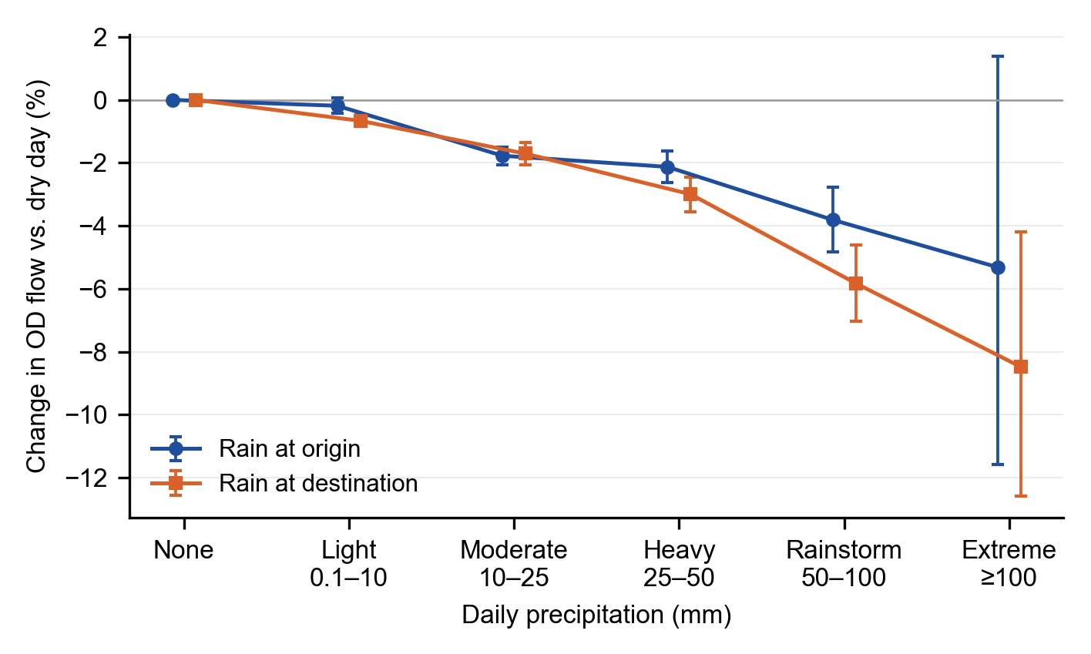
Fig. 2. Change in OD flow relative to a dry day, by rainfall at the origin and destination, everyday days (no typhoon and no snow-prone end), 2023–2025. Bars are 95% confidence intervals, clustered by origin and destination.
Table 2. Main estimates, everyday days (percentage change relative to a dry day).
Rain bin | OD flow [95% CI] | Three-way clustered p | PPML (30% of links) | City total outflow | City total inflow
Origin rain
Light (0.1–10 mm) | −0.2 [−0.4, 0.1] | 0.33 | −0.6* | −1.3***
Moderate (10–25) | −1.8*** [−2.1, −1.5] | <0.001 | −3.1*** | −2.6***
Heavy (25–50) | −2.1*** [−2.6, −1.6] | <0.001 | −4.2*** | −4.1***
Rainstorm (50–100) | −3.8*** [−4.8, −2.8] | <0.001 | −5.1*** | −5.6***
Extreme (≥100) | −5.3 [−11.6, 1.4] | 0.23 | −15.9 | −14.1***
Destination rain
Light (0.1–10 mm) | −0.7*** [−0.8, −0.5] | 0.001 | −0.9*** |  | −1.3***
Moderate (10–25) | −1.7*** [−2.1, −1.4] | <0.001 | −2.1*** |  | −2.4***
Heavy (25–50) | −3.0*** [−3.5, −2.4] | <0.001 | −3.3*** |  | −3.3***
Rainstorm (50–100) | −5.8*** [−7.0, −4.6] | <0.001 | −5.7*** |  | −6.2***
Extreme (≥100) | −8.5*** [−12.6, −4.2] | 0.013 | −3.0 |  | −10.7***
Observations | 23,573,128 | 7.1 million | 7,082,469 | 336,586 | 336,578
Notes: Everyday days exclude link-days (city-days in the city models) with a tropical cyclone within 500 km of either end or a snow-prone end (CPC daily mean temperature below 2 °C). All models control for 7-day antecedent rainfall at both ends. OD models include link × year-month, link × weekday and date fixed effects; city models include city × year-month, city × weekday and date fixed effects and the flow-weighted share of partner cities with moderate or heavy rain. Confidence intervals and stars (* p<0.05, ** p<0.01, *** p<0.001) use two-way clustering by origin and destination (city models: city and date). Column 3 reports p-values with three-way clustering by origin, destination and date on a 30% random sample of links.

5.2 Distance
Sensitivity to rain declines with distance (Fig. 3). Rain at the origin cuts flows on links under 150 km by 3.8% in moderate rain and 8.1% in a rainstorm, against 1.0% and 2.0% on links over 1,000 km. Destination rain follows the same gradient up to 1,000 km: from −4.0% to −0.9% in moderate rain and from −8.3% to −4.3% in a rainstorm. Beyond 1,000 km, destination effects tick up (−1.2% and −6.5%) but remain smaller than on short links. Light rain matters mainly on short links: under 150 km it lowers flows by 1.4% at the origin and 1.3% at the destination, and beyond 500 km it has no origin effect. Extreme rain, omitted from Fig. 3 because of wide intervals, shows the same decline at the origin, from −21.1% under 150 km to −1.9% (not significant) at 500–1,000 km. Adding temperature controls, estimated on half of the links, changes the light-rain to rainstorm coefficients in each band by at most 0.5 percentage points (0.2 on average).
Because short links both respond most and carry most flow, they bear most of the loss. Counting next-day effects, everyday rain removes 3.2% of counterfactual trips on links under 150 km, 2.3% at 150–300 km, 2.0% at 300–500 km, 1.6% at 500–1,000 km and 0.9% beyond (Section 5.5). Links under 300 km account for 86% of the everyday loss.
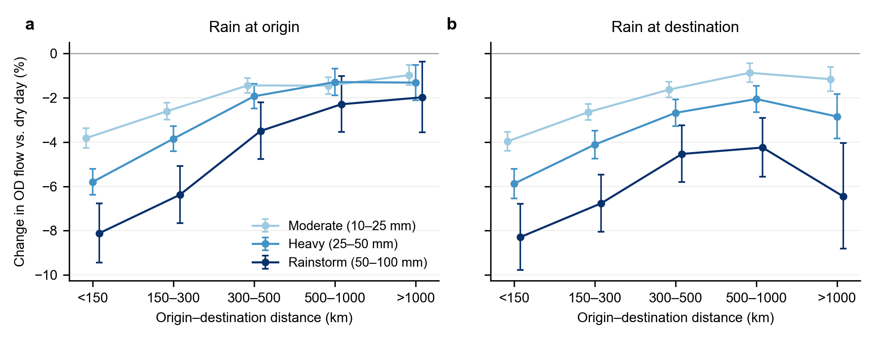
Fig. 3. Change in OD flow by rainfall bin and origin–destination distance, estimated separately for each distance band, everyday days. (a) Rain at the origin; (b) rain at the destination. Bars are 95% confidence intervals.

5.3 Climate adaptation and regional differences
The same rainfall matters more where rain is less common (Fig. 4a). For origins in drier climates (<800 mm a year), flows fall by 2.0% in moderate rain, 3.3% in heavy rain and 5.2% in a rainstorm; for humid origins the corresponding effects are 1.3%, 1.5% and 3.2%. In light rain the difference is small (−0.4% against +0.1%). The continuous interaction gives the same answer: each standard deviation of higher long-run precipitation at the origin shrinks the effect of moderate, heavy and rainstorm rain by 1.1, 1.5 and 2.7 percentage points. Effects of extreme rain do not differ by climate (−4.8% and −4.7%, both imprecise).
Snow accounts for part of the gap seen when snow-prone days are pooled with rain. In drier cities 21% of light-precipitation days are snow-prone, against 4% in humid cities, and with snow-prone days included the dry–humid gap in light rain is 1.2 percentage points rather than 0.5. Within the main sample, temperature does not explain the gap. Drier cities also tend to be colder, but with temperature controls, estimated on half of the links, the dry and humid coefficients change by at most 0.4 percentage points, and the origin gap widens slightly, from 0.7 to 0.9 points in moderate rain and from 1.9 to 2.3 points in a rainstorm.
Measuring rain relative to local norms narrows the gap (Fig. 4b). Rain between the local 95th and 99th percentiles reduces flows by 1.3% from humid origins and 2.4% from drier ones, and above the 99th percentile the two are the same (−3.5% and −3.4%). Part of the north–south difference therefore reflects how unusual a given rainfall is locally, and part reflects other differences, such as road conditions, mode mix and habits. By region, the Northeast (−8.1% in a rainstorm) and the West (−4.8%) are most sensitive and the East (−3.5%) and Centre (−2.9%) least (Fig. 4c).
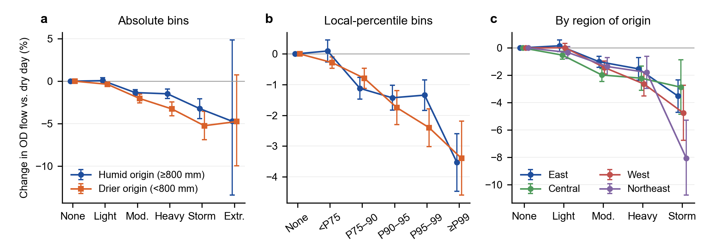
Fig. 4. Rain at the origin, everyday days. (a) Absolute bins by origin climate; (b) local-percentile bins by origin climate; (c) absolute bins by region of origin. Bars are 95% confidence intervals.

5.4 Timing and placebo tests
Rain reduces travel on the day it falls and the next day, and the lost trips are not made up later (Fig. 5). After ≥25 mm of rain at the origin, flows fall by 1.7% on the day and 2.3% the following day, then return to normal with no rebound over the next two days. Destination rain of ≥25 mm reduces flows by 3.0% on the day and 2.0% the next day, with smaller negative effects persisting to day 3 (−1.4%). Flows to a destination fall slightly (−1.1%, p < 0.05) the day before heavy rain arrives, consistent with travellers responding to forecasts. Moderate rain shows the same pattern at a smaller size: −1.4% on the day and −1.9% the next day at the origin, and −1.3% and −1.1% at the destination. Light rain at the destination lowers flows by 0.4% on the day and 0.7% the next day, while light rain at the origin has no effect on any day. Because no positive lagged effects appear, the reductions look like cancelled trips rather than trips shifted to a later day within the window.
The ±7-day placebo tests are clean for light and moderate rain: rain seven days before or after the flow day has effects within ±0.3% and none is significant. For ≥25 mm they are not fully clean. Heavy origin rain seven days after the flow day is associated with 1.1% higher flows (p < 0.01), and heavy destination rain seven days before with 0.9% lower flows (p < 0.05).
Shifted-rain placebos give a fuller picture of the noise (Table 3). Across the ten shifts, placebo coefficients alternate in sign and average close to zero (−0.07% to +0.13%), so they do not point to a systematic bias. Their typical absolute size is about 0.2 percentage points for light rain, 0.3–0.4 for moderate rain and 0.5–0.6 for ≥25 mm, and region-by-date fixed effects shrink it by 21–45%. Against this noise, destination effects are three to six times the typical placebo at every intensity, including light rain (−0.7%), and origin effects of moderate and heavier rain three to five times. The origin light-rain effect (−0.2%) cannot be distinguished from the placebos, consistent with its absence in Section 5.1.
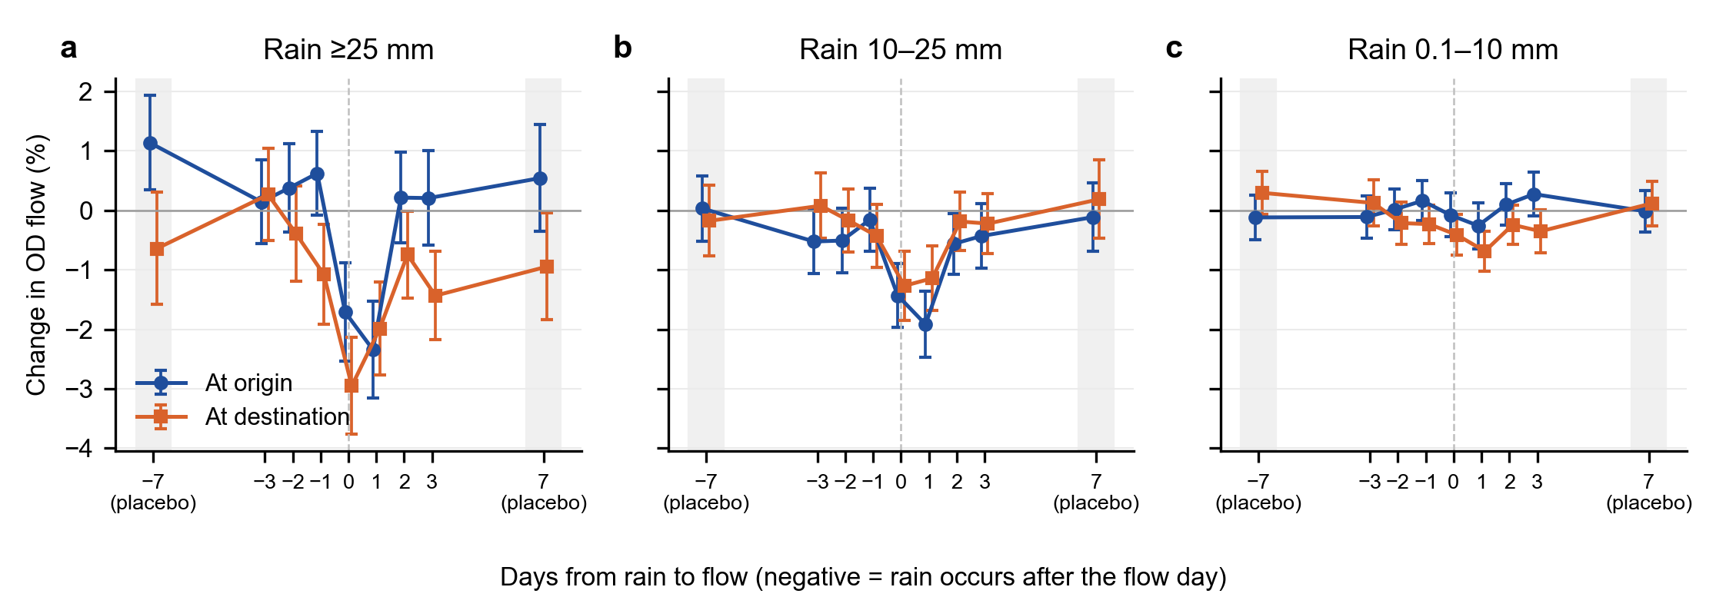
Fig. 5. Change in OD flow on days around rainfall at the origin and destination, everyday days: (a) ≥25 mm; (b) 10–25 mm; (c) 0.1–10 mm. Negative values on the horizontal axis mean the rain falls after the flow day; ±7 are placebo days. Estimated on a 30% sample of links; bars are 95% confidence intervals with three-way clustering.
Table 3. Placebo tests with shifted rainfall, everyday days (percentage change relative to a dry day).
Rain | Effect on the day | Placebo mean | Mean absolute placebo | Placebo range | Significant placebos (of 10)
A. National date fixed effects
Origin, light | −0.2 | 0.00 | 0.17 | −0.3 to 0.4 | 4
Origin, moderate | −1.8*** | −0.07 | 0.36 | −0.6 to 0.6 | 6
Origin, ≥25 mm | −2.1*** | 0.11 | 0.62 | −1.1 to 1.1 | 5
Destination, light | −0.7*** | 0.09 | 0.23 | −0.4 to 0.5 | 5
Destination, moderate | −1.7*** | 0.09 | 0.31 | −0.5 to 0.5 | 3
Destination, ≥25 mm | −3.0*** | 0.13 | 0.50 | −0.6 to 0.9 | 5
B. Region × date fixed effects
Origin, light | 0.1 | 0.02 | 0.11 | −0.1 to 0.2 | 2
Origin, moderate | −1.1*** | 0.01 | 0.23 | −0.6 to 0.5 | 3
Origin, ≥25 mm | −1.6*** | 0.14 | 0.49 | −0.5 to 0.9 | 5
Destination, light | −0.5*** | 0.07 | 0.15 | −0.3 to 0.3 | 2
Destination, moderate | −1.4*** | 0.10 | 0.17 | −0.3 to 0.3 | 2
Destination, ≥25 mm | −2.6*** | 0.15 | 0.38 | −0.5 to 0.8 | 4
Notes: Effect on the day is from the main model (Panel A) or from the model with origin-region × date and destination-region × date fixed effects for seven regions (Panel B), on all everyday link-days; for ≥25 mm it is the heavy-rain bin (25–50 mm), the smallest effect above 25 mm. Placebo statistics summarise ten regressions on a 30% random sample of links, each adding to the main model rainfall shifted by ±7, ±14, ±21 or ±28 days, or by 364 or 728 days. Significant placebos have p < 0.05 with two-way clustering by origin and destination. * p<0.05, ** p<0.01, *** p<0.001.

5.5 Annual losses
Counting effects on the flow day and the following three days, everyday rain removes about 1.14 billion intercity trips a year (95% CI 1.04–1.24 billion), or 2.6% of counterfactual dry-weather travel on everyday days (Table 4). Lagged effects roughly double the loss: counting only the flow day, the same dynamic model gives 0.56 billion and the baseline model 0.73 billion. Most of the loss comes from frequent, modest rain (Fig. 6a). Removing one class at a time, light rain accounts for 0.62 billion trips, moderate rain for 0.34 billion and rain of 25 mm or more for 0.17 billion. Light-rain losses arise at the destination and on short links. Setting the origin light-rain effect, which does not pass the placebo test, to zero reduces the total to 0.88 billion (0.78–0.99 billion), so we report the everyday loss as 0.9–1.1 billion trips a year. Alternative specifications move the same-day loss between 0.53 billion (origin light rain set to zero) and 0.75 billion (net of the mean placebo coefficient), and even if light rain had no effect at all, same-day losses from moderate and heavier rain would be 0.32 billion.
Snow-prone and typhoon days add further losses. Counting the flow day only, precipitation on snow-prone days removes 0.11 billion trips a year, almost all of it in light precipitation, and rain on typhoon days 0.13 billion. These totals are not directly comparable with the everyday figure, which includes lagged effects, but even the same-day everyday loss is more than twice their sum.
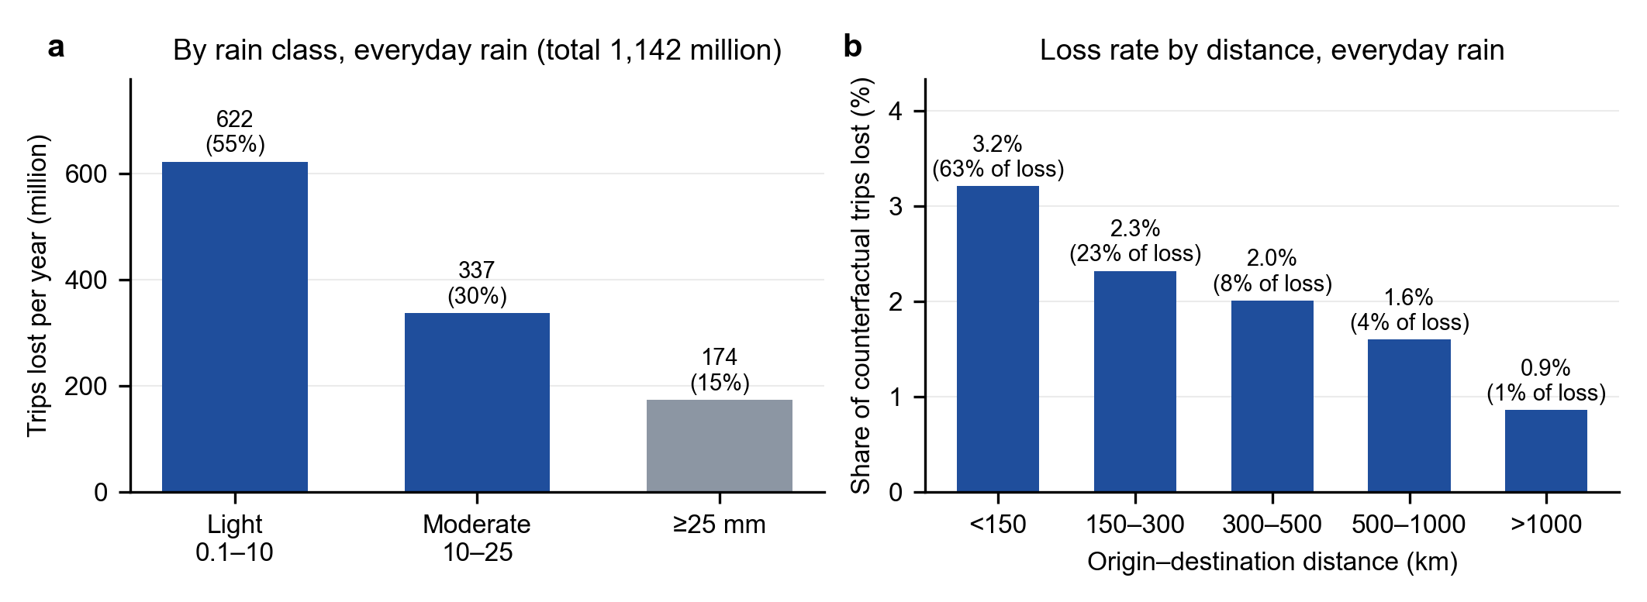
Fig. 6. Annual intercity trips lost to everyday rain, counting effects up to three days after the rain, 2023–2025 average. (a) By rain class, removing one class at a time, with share in parentheses; (b) share of counterfactual trips lost by distance band, with share of total loss in parentheses.
Table 4. Annual intercity trips lost to everyday rain under alternative specifications (million trips, 2023–2025 average).
Specification | Days counted | Loss | 95% CI
Dynamic model (main estimate) | Flow day and next 3 days | 1,142 | 1,041–1,241
Dynamic model, origin light rain set to zero | Flow day and next 3 days | 881 | 781–988
Dynamic model | Flow day | 564 | 514–616
Baseline model | Flow day | 732 | 685–783
Baseline model, origin light rain set to zero | Flow day | 531 | 487–572
Baseline model, light rain set to zero | Flow day | 316 | 296–336
Baseline model, net of mean placebo coefficient | Flow day | 754 | 706–806
Region × date fixed effects | Flow day | 536 | —
Gauge-based rainfall (NOAA CPC) | Flow day | 619 | —
Memo: snow-prone days / typhoon days | Flow day | 113 / 127 | —
Notes: All everyday rows use coefficients estimated separately by distance band on everyday link-days; the dynamic model has light, moderate and ≥25 mm rain on days t to t−3 at each end. Confidence intervals come from 1,000 draws of the coefficients from their clustered covariance matrices and are not computed for the last three rows. Snow-prone and typhoon losses use the precipitation-phase and typhoon-interaction models.

5.6 Typhoon days and snow-prone days
Typhoon days behave very differently from ordinary rainy days (Fig. 7, Table 5). Pooling all days, extreme rain cuts flows by 22.4% at the origin and 27.1% at the destination, and rainstorms by 7.5% and 10.1%. Removing the 2.5% of link-days near a tropical cyclone shrinks these effects to −5.5%, −8.8%, −4.0% and −6.0%, while light and moderate effects barely change. When rain bins are interacted with a typhoon indicator, the same rainfall on a typhoon day lowers flows by an additional 24% (origin) and 32% (destination) at ≥100 mm. Even light rain at a typhoon-affected destination lowers flows by an extra 6.5%, suggesting that warnings and service suspensions depress travel beyond the rain itself. At the city level, total outflow on days with ≥100 mm falls by 31.8% when typhoon days are included and by 14.7% when they are excluded.
Typhoon days also produce two patterns that would otherwise be misread as features of rainfall. With all days pooled, destination rain of ≥100 mm cuts long-haul flows (>1,000 km) by 27.8%, almost as much as short-haul flows; without typhoon days the long-haul effect is −5.9%. With all days pooled, humid origins appear more sensitive than drier ones to ≥100 mm (−23.6% versus −8.4%), the opposite of the adaptation pattern. That reversal disappears once typhoon days are removed.
Snow-prone days are a second kind of special weather (Table 5). On days without typhoons, the same precipitation lowers flows far more when it falls at a snow-prone end. At the origin, 0.1–10 mm on a snow-prone day cuts flows by 5.5% and 10–25 mm by 13.1%, against no effect and 1.3% for rain on other days; at the destination, light precipitation on a snow-prone day lowers flows by 3.7%, against 0.6% for rain. Snow-prone days themselves, with or without precipitation, lower flows from the origin by 3.7%. These effects fit the hazards of snow and freezing rain, such as slippery roads, expressway closures and reduced coach services, rather than the inconvenience of rain. Because snow-prone days are common in drier northern cities, pooling them with rain inflates the light-rain effects and the dry–humid gap (Section 5.3); excluding them leaves the moderate- to extreme-rain effects almost unchanged (Fig. 7).
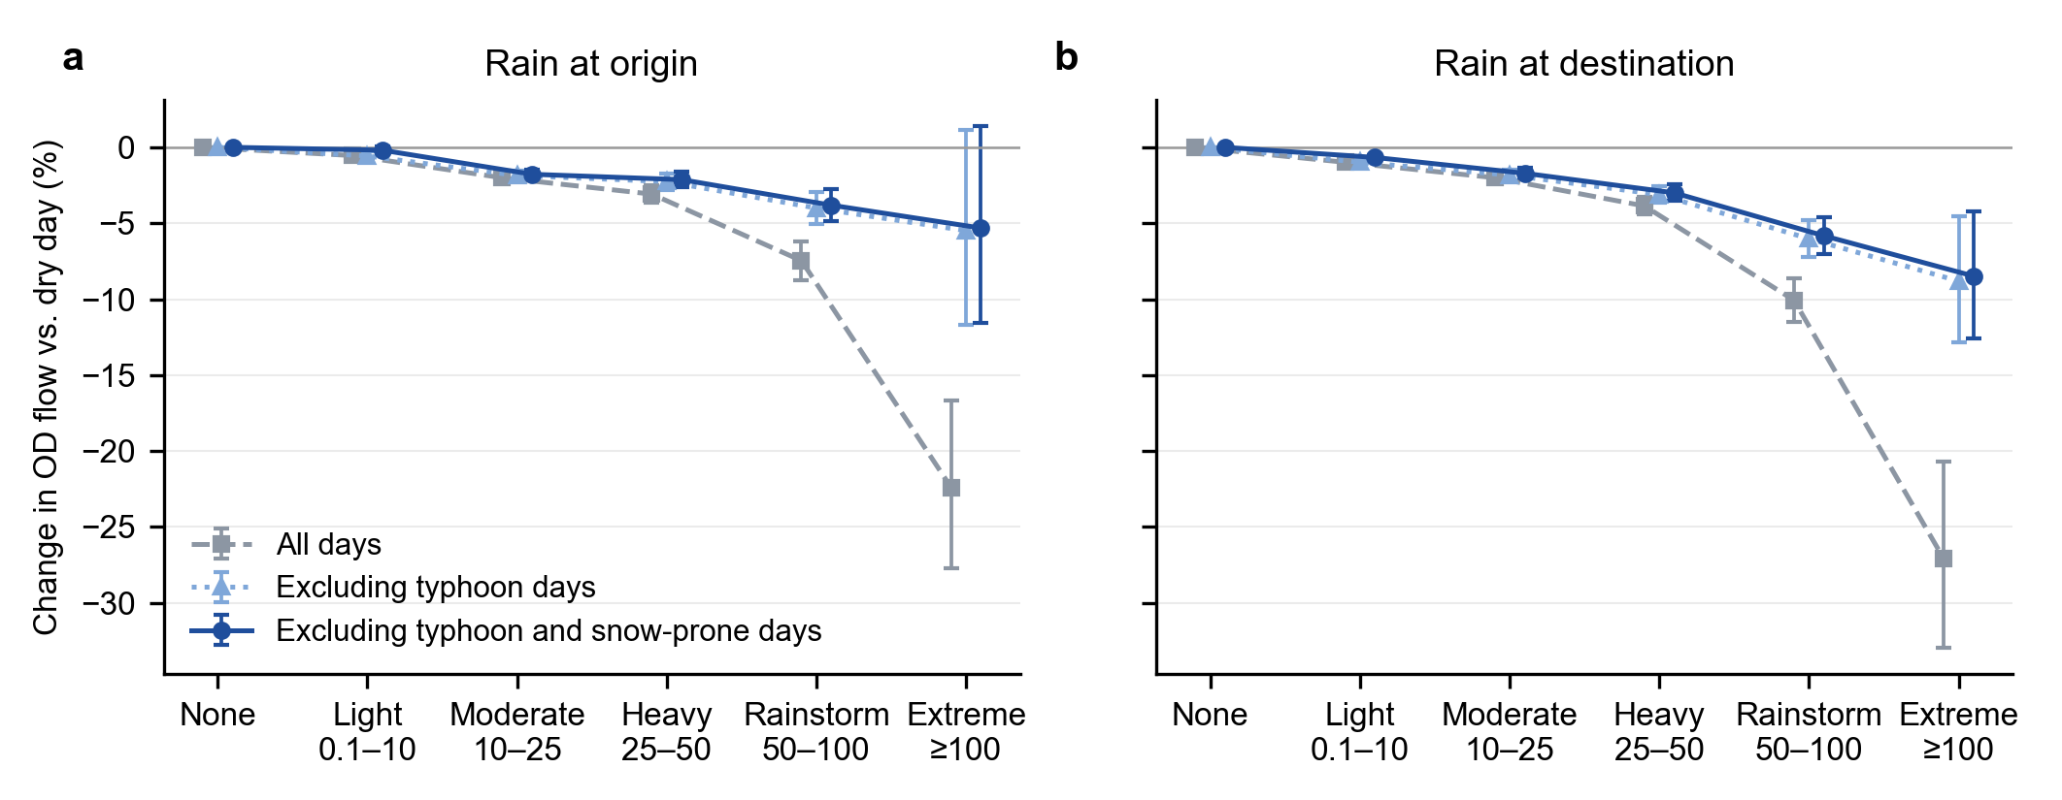
Fig. 7. Change in OD flow by rainfall bin on all days, on days without typhoons, and in the main sample, which also excludes snow-prone days. (a) Rain at the origin; (b) rain at the destination. Bars are 95% confidence intervals.
Table 5. Effects of the same precipitation by type of day (percentage change relative to a dry day of the same type).
Precipitation | Everyday, origin | Snow-prone, origin | Typhoon, origin | Everyday, destination | Snow-prone, destination | Typhoon, destination
Light (0.1–10 mm) | −0.2 | −5.5*** | −0.2 | −0.7*** | −3.7*** | −7.5
Moderate (10–25) | −1.8*** | −13.1*** | −3.6 | −1.7*** | −3.9 | −10.2
Heavy (25–50) | −2.1*** | −13.8** | −6.9 | −3.0*** | −6.8 | −13.7
Rainstorm (50–100) | −3.8*** | −26.5*** | −14.9 | −5.8*** | −20.6*** | −25.4
Extreme (≥100) | −5.3 | — | −27.9 | −8.5*** | — | −37.9
Notes: Everyday: main model. Snow-prone: precipitation-phase model on days without typhoons (50% of links), coefficients for precipitation at an end whose daily mean temperature is below 2 °C; too few snow-prone days have ≥100 mm to estimate. Typhoon: rain-bin × typhoon model on all days (50% of links), sum of the base and interaction coefficients; significance of the interaction terms is reported in the text. * p<0.05, ** p<0.01, *** p<0.001, two-way clustering by origin and destination.

5.7 Robustness
Table 6 shows that the main estimates are stable across specifications. Replacing link × month with link × week fixed effects, which absorb seasonality within months, changes the moderate-rain and rainstorm coefficients by at most 1.5 percentage points. Poisson estimation on flow levels gives similar or larger effects, except in the sparsely populated extreme bin. Three-way clustering inflates standard errors but leaves the moderate, heavy and rainstorm effects significant at p < 0.001. Narrowing the typhoon radius to 300 km, moving the snow threshold to 0 °C or 4 °C, or including snow-prone days barely moves the estimates. Omitting the antecedent-rainfall control changes the all-days estimates by at most 0.2 points.
Temperature does not account for the rainfall effects. Adding temperature bins at both ends changes no light-rain to rainstorm coefficient by more than 0.3 percentage points (Table 6, comparing the two rows estimated on the same 50% of links), and by no more than 0.5 points in the distance-band and dry–humid splits (Sections 5.2 and 5.3). Temperature itself matters: relative to a 15–20 °C day, flows fall by 3.0% when the origin’s daily mean is between 2 and 10 °C and by 1.7% at 10–15 °C, with smaller effects at the destination (−2.7% and −1.0%). With CPC gauge-based rainfall, light- and moderate-rain effects are close to the main estimates (origin −0.3% and −1.5%, destination −0.8% and −1.6%). Effects of heavier rain are smaller, especially at the destination (rainstorm −3.5% against −5.8%; extreme −5.1% against −8.5%), consistent with the 0.5° grid smoothing local downpours so that a city’s heaviest rain days are identified less sharply. The size of rainstorm effects is therefore best read as a range of about 3.5–6%.
Region-by-date fixed effects make the estimates smaller but leave their pattern intact. They shrink the moderate-rain to rainstorm effects by 12–35% (origin moderate rain −1.1%, destination rainstorm −4.8%) and remove the already negligible origin light-rain effect; the dose–response and the decline with distance remain. Part of this shrinkage is likely attenuation. With these fixed effects, effects are identified only from rainfall differences between cities in the same region on the same day, so rain systems that cover a whole region no longer contribute and measurement error weighs more. We therefore keep national date effects in the main specification and treat the region-by-date estimates as a lower bound.
Table 6. Robustness: selected coefficients (percentage change relative to a dry day).
Specification | Origin moderate | Origin rainstorm | Origin extreme | Dest. moderate | Dest. rainstorm | Dest. extreme
Main: everyday days, link × month FE | −1.8*** | −3.8*** | −5.3 | −1.7*** | −5.8*** | −8.5***
Link × week FE | −1.5*** | −4.5*** | −6.4* | −1.4*** | −4.3*** | −6.6**
PPML, 30% of links | −3.1*** | −5.1*** | −15.9 | −2.1*** | −5.7*** | −3.0
Three-way clustering, 30% of links | −1.8*** | −3.9*** | −5.2 | −1.7*** | −6.2*** | −7.7*
Typhoon radius 300 km | −1.8*** | −4.1*** | −6.1 | −1.8*** | −6.1*** | −8.2***
Snow threshold 0 °C | −1.8*** | −3.8*** | −5.3 | −1.7*** | −5.9*** | −8.6***
Snow threshold 4 °C | −1.7*** | −3.8*** | −5.3 | −1.7*** | −5.8*** | −8.5***
Region × date fixed effects (7 regions) | −1.1*** | −3.0*** | −4.9 | −1.4*** | −4.8*** | −5.6**
Main model, 50% of links | −1.8*** | −3.7*** | −5.7 | −1.7*** | −6.1*** | −8.2***
Adding temperature bins, 50% of links | −1.6*** | −3.4*** | −5.1 | −1.7*** | −6.1*** | −8.3***
Gauge-based rainfall (NOAA CPC) | −1.5*** | −3.4*** | −1.7 | −1.6*** | −3.5*** | −5.1***
Gauge-based rainfall and temperature, 50% of links | −1.4*** | −3.1*** | −0.6 | −1.6*** | −3.7*** | −5.0***
Including snow-prone days | −1.9*** | −4.0*** | −5.5 | −1.8*** | −6.0*** | −8.8***
All days, including typhoon and snow-prone days | −2.0*** | −7.5*** | −22.4*** | −2.0*** | −10.1*** | −27.1***
All days, no antecedent-rain control | −2.0*** | −7.6*** | −22.6*** | −2.0*** | −10.2*** | −27.1***
Notes: * p<0.05, ** p<0.01, *** p<0.001. Everyday days exclude link-days with a tropical cyclone within 500 km of either end or a snow-prone end (CPC daily mean temperature below 2 °C unless stated). Clustering by origin and destination except in the three-way row. Rows marked “50% of links” use the same random half of links; temperature enters as daily-mean bins at each end (reference 15–20 °C). Gauge-based rows replace both daily and antecedent rainfall with the NOAA CPC gauge analysis. The region × date row replaces date fixed effects with origin-region × date and destination-region × date fixed effects.

6. Discussion

6.1 Everyday rain, snow and typhoons
The results point to three distinct ways in which precipitation reduces intercity travel. On ordinary rainy days the response is smooth, modest and concentrated on short trips, and the lost trips are not recovered within three days. This pattern fits a demand channel. Short intercity trips are more discretionary, such as visiting family, shopping or leisure, and are mostly made by car, coach or conventional rail, so rain raises their generalised cost through slower roads, worse access to stations and less pleasant activities at the destination. Travellers respond by cancelling rather than postponing. Long trips are more often pre-booked, purpose-bound and made by high-speed rail or air, which ordinary rain barely affects. That destination rain matters more than origin rain, and that light rain matters only at the destination, suggests that conditions at the place of activity weigh more heavily than conditions at departure, consistent with Yang et al. (2021).
Snow-prone days differ in degree. The same precipitation cuts flows several times more, and even light amounts at the origin reduce departures by about 5%, as snow and freezing rain make roads slippery, close expressways and slow buses and coaches. Typhoon days follow yet another logic. The same rainfall depresses flows several times more; long-haul trips into an affected city fall almost as much as short ones; and even light rain at a typhoon-affected destination reduces travel by 6.5%. These are the signatures of a supply channel: pre-emptive suspension of flights, high-speed rail and ferries, expressway closures and official warnings. Pooled estimates mix these channels. Attributing typhoon disruption to rainfall overstates how much heavy rain alone disrupts travel, and attributing snow disruption to rainfall inflates the effects of light rain and the apparent sensitivity of dry northern regions.

6.2 Adaptation
Cities in drier climates respond more strongly to the same moderate or heavier rainfall, mirroring the adaptation found for heat and mortality (Barreca et al., 2016; Heutel et al., 2021). Part of the raw north–south difference is snow rather than rain, and part closes when rain is measured relative to local norms, so rarity itself matters: a 25 mm day is routine in Guangzhou but unusual in Lanzhou. The remainder may reflect durable investments and habits, such as drainage capacity, road and vehicle preparedness, and travellers’ familiarity with rain. This has a forward-looking implication. Heavy precipitation is projected to intensify across much of the world (Seneviratne et al., 2021). Where rain is becoming more frequent in regions that are not adapted to it, the intercity travel response may initially be larger than in historically wet regions.

6.3 Policy implications
Three implications follow. First, adaptation for intercity travel should not focus only on extremes. Everyday rain removes 0.9–1.1 billion trips a year, mostly in light and moderate rain, and links under 300 km account for 86% of the loss. Improving the rain resilience of short corridors could therefore address most of the everyday loss. Relevant measures include drainage and surface quality on expressways and national roads, sheltered access to intercity bus and rail stations, and timely travel information. Second, the larger response in drier regions argues for prioritising adaptation where rain is unfamiliar and where projected increases in heavy rain are concentrated. Third, snow-prone and typhoon days are short, intense and partly policy-driven, so they warrant a separate emergency-management lens. Winter road maintenance and coordinated coach and expressway operations on snow-prone days, and coordinated suspension and resumption decisions, flexible rebooking and clear communication on typhoon days, may reduce lost travel without compromising safety.

6.4 Limitations
Several limitations qualify these findings. First, the flows are model-based estimates. DIMNet-CPC calibrates Baidu location data to national totals, so our percentage effects inherit any differences between Baidu users and the travelling population, and we observe only disclosed links. Restricting to stable links avoids truncation bias for 98% of flows but leaves the smallest links unstudied. Second, rainfall in the main analysis comes from a reanalysis at station locations rather than from rain gauges. ERA5-Land overstates the frequency of light rain and understates extremes over China (Xie et al., 2022). A gauge-based analysis reproduces the light- and moderate-rain effects but gives smaller effects for rainstorms and extreme rain, and its 0.5° grid is coarse for small cities, so the size of the heaviest-rain effects remains uncertain by a few percentage points. Third, we classify snow-prone days by daily mean temperature rather than by observed precipitation type, so some snow days remain in the main sample and some rainy days are set aside; the estimates are, however, insensitive to thresholds between 0 and 4 °C. Fourth, we add temperature only in robustness checks on half of the links, and other weather, such as wind and visibility, is not controlled; temperature leaves the main estimates essentially unchanged. Fifth, the loss estimates rely on a dynamic model whose next-day coefficients are as large as the same-day ones on many links. If part of the next-day effect reflects how the mobility data date trips rather than how people behave, it still belongs to the same rain event, but placebo coefficients of 0.2–0.6 percentage points set a noise floor, which is why we report the loss as a range. Losses on snow-prone and typhoon days count the flow day only and are lower bounds. Sixth, our distance-based typhoon definition misses cyclone-related rain far from the storm centre, as in the 2023 Beijing rainstorm linked to Typhoon Doksuri, so the typhoon contribution is, if anything, understated. Finally, we observe distance but not mode, and our period, 2023–2025, follows the pandemic, so behaviour may differ in other periods.

7. Conclusions
Using 28 million daily observations of intercity flows among 365 Chinese cities, this paper estimates how rainfall shapes travel between cities. On ordinary days, rain reduces intercity flows by about 2% in moderate rain and 4–6% in a rainstorm, with a further reduction on the next day, while light rain matters only at the destination. Effects are larger at the destination than the origin, larger on short trips than long ones, and larger in drier climates than in humid ones. Lost trips are cancelled rather than postponed. Snow-prone days and typhoon days are distinct phenomena: the same precipitation disrupts travel several times more, and pooling them with ordinary rain misattributes their disruption to rainfall.
The central message is that the burden of rain on intercity mobility lies mostly in the everyday. Because modest rain is so common, it removes far more trips each year, an estimated 0.9–1.1 billion on the stable links studied here, than the rare storms that dominate the resilience literature. Planning for climate-resilient regional transport should therefore pair emergency responses to snow and typhoons with routine improvements that keep short intercity corridors working in ordinary rain, especially in regions where heavy rain is becoming more common but remains unfamiliar.
Future work should pin down the effects of heavy rain with denser gauge or radar data, observe transport modes and precipitation type directly, and study the mechanisms of snow and typhoon disruption, including warnings and service suspensions, in their own right.

Declarations
Data availability. Intercity flows: DIMNet-CPC v1.0, Figshare, CC BY 4.0 (doi:10.6084/m9.figshare.33154163). Rainfall: ERA5-Land hourly data, Copernicus Climate Change Service (doi:10.24381/cds.e2161bac), extracted at weather-station locations by a third-party compilation [describe source and licence]. Tropical cyclone tracks: IBTrACS v04r01, NOAA National Centers for Environmental Information. Gauge-based precipitation and temperature: NOAA CPC Global Unified Gauge-Based Analysis of Daily Precipitation and CPC Global Daily Temperature, provided by the NOAA Physical Sciences Laboratory (PSL), Boulder, Colorado, USA (https://psl.noaa.gov). The city-level daily rainfall and temperature series and typhoon and snow-prone flags derived for this study will be made available [repository and DOI to be added].
Code availability. Processing and estimation code (Python and R) will be deposited at [repository to be added].
CRediT authorship contribution statement. Liang Wang: Conceptualization, Methodology, Software, Formal analysis, Data curation, Visualization, Writing – original draft. Mengqi Wang: Validation, Writing – review & editing. Xiaodong Zhang: Supervision, Resources, Writing – review & editing. Xinghua Zhang: Supervision, Writing – review & editing. [All authors to confirm.]
Declaration of competing interest. The authors declare that they have no known competing financial interests or personal relationships that could have appeared to influence the work reported in this paper.
Funding. This work was supported by the Key Program of the National Natural Science Foundation of China, “Spatiotemporal optimization methods supported by geospatial artificial intelligence” (Grant No. 42430106).
Acknowledgements. CPC data provided by the NOAA PSL, Boulder, Colorado, USA, from their website at https://psl.noaa.gov.
Declaration of generative AI and AI-assisted technologies in the writing process. During the preparation of this work the authors used Claude (Anthropic) to assist with literature search, data processing code, statistical analysis and drafting of the manuscript. After using this tool, the authors reviewed and edited the content as needed and take full responsibility for the content of the publication. [Authors to confirm and adapt.]

References
Auffhammer, M., Hsiang, S.M., Schlenker, W., Sobel, A., 2013. Using weather data and climate model output in economic analyses of climate change. Review of Environmental Economics and Policy 7(2), 181–198. https://doi.org/10.1093/reep/ret016
Barreca, A., Clay, K., Deschênes, O., Greenstone, M., Shapiro, J.S., 2016. Adapting to climate change: The remarkable decline in the US temperature-mortality relationship over the twentieth century. Journal of Political Economy 124(1), 105–159. https://doi.org/10.1086/684582
Bergé, L., 2018. Efficient estimation of maximum likelihood models with multiple fixed-effects: The R package FENmlm. CREA Discussion Papers 13, University of Luxembourg.
Böcker, L., Dijst, M., Prillwitz, J., 2013. Impact of everyday weather on individual daily travel behaviours in perspective: A literature review. Transport Reviews 33(1), 71–91. https://doi.org/10.1080/01441647.2012.747114
Böcker, L., Uteng, T.P., Liu, C., Dijst, M., 2019. Weather and daily mobility in international perspective: A cross-comparison of Dutch, Norwegian and Swedish city regions. Transportation Research Part D 77, 491–505. https://doi.org/10.1016/j.trd.2019.07.012
Brodeur, A., Nield, K., 2018. An empirical analysis of taxi, Lyft and Uber rides: Evidence from weather shocks in NYC. Journal of Economic Behavior & Organization 152, 1–16. https://doi.org/10.1016/j.jebo.2018.06.004
Cameron, A.C., Gelbach, J.B., Miller, D.L., 2011. Robust inference with multiway clustering. Journal of Business & Economic Statistics 29(2), 238–249. https://doi.org/10.1198/jbes.2010.07136
Cameron, A.C., Miller, D.L., 2015. A practitioner’s guide to cluster-robust inference. Journal of Human Resources 50(2), 317–372. https://doi.org/10.3368/jhr.50.2.317
Chen, M., Shi, W., Xie, P., Silva, V.B.S., Kousky, V.E., Higgins, R.W., Janowiak, J.E., 2008. Assessing objective techniques for gauge-based analyses of global daily precipitation. Journal of Geophysical Research: Atmospheres 113(D4), D04110. https://doi.org/10.1029/2007JD009132
Correia, S., Guimarães, P., Zylkin, T., 2020. Fast Poisson estimation with high-dimensional fixed effects. Stata Journal 20(1), 95–115. https://doi.org/10.1177/1536867X20909691
Dell, M., Jones, B.F., Olken, B.A., 2014. What do we learn from the weather? The new climate-economy literature. Journal of Economic Literature 52(3), 740–798. https://doi.org/10.1257/jel.52.3.740
Galich, A., Nieland, S., 2023. The impact of weather conditions on mode choice in different spatial areas. Future Transportation 3(3), 1007–1028. https://doi.org/10.3390/futuretransp3030056
Gössling, S., Neger, C., Steiger, R., Bell, R., 2023. Weather, climate change, and transport: A review. Natural Hazards 118, 1341–1360. https://doi.org/10.1007/s11069-023-06054-2
Heutel, G., Miller, N.H., Molitor, D., 2021. Adaptation and the mortality effects of temperature across U.S. climate regions. Review of Economics and Statistics, advance online publication. https://doi.org/10.1162/rest_a_00936
Horanont, T., Phithakkitnukoon, S., Leong, T.W., Sekimoto, Y., Shibasaki, R., 2013. Weather effects on the patterns of people’s everyday activities: A study using GPS traces of mobile phone users. PLoS ONE 8(12), e81153. https://doi.org/10.1371/journal.pone.0081153
Hsiang, S., 2016. Climate econometrics. Annual Review of Resource Economics 8, 43–75. https://doi.org/10.1146/annurev-resource-100815-095343
Jennings, K.S., Winchell, T.S., Livneh, B., Molotch, N.P., 2018. Spatial variation of the rain–snow temperature threshold across the Northern Hemisphere. Nature Communications 9, 1148. https://doi.org/10.1038/s41467-018-03629-7
Knapp, K.R., Kruk, M.C., Levinson, D.H., Diamond, H.J., Neumann, C.J., 2010. The International Best Track Archive for Climate Stewardship (IBTrACS). Bulletin of the American Meteorological Society 91(3), 363–376. https://doi.org/10.1175/2009BAMS2755.1
Koetse, M.J., Rietveld, P., 2009. The impact of climate change and weather on transport: An overview of empirical findings. Transportation Research Part D 14(3), 205–221. https://doi.org/10.1016/j.trd.2008.12.004
Li, T., Wei, S., Sun, Y., Du, F., Wang, J., 2026. Quantifying the impact of extreme weather event on intercity mobility in urban agglomerations: A Bayesian structural time series analysis. Transport Policy 176, 103925. https://doi.org/10.1016/j.tranpol.2025.103925
Li, X., Ma, Q., Wang, W., Wang, B., 2021. Influence of weather conditions on the intercity travel mode choice: A case of Xi’an. Computational Intelligence and Neuroscience 2021, 9969322. https://doi.org/10.1155/2021/9969322
Liang, Y., Wang, D., 2025. Heatwaves reduce intra- and intercity human mobility in China. Environmental Research Letters 20, 124027. https://doi.org/10.1088/1748-9326/ae1e13
Lin, P., He, Y., Pei, M., Yang, R., 2022. Data-driven spatial-temporal analysis of highway traffic volume considering weather and festival impacts. Travel Behaviour and Society 29, 95–112. https://doi.org/10.1016/j.tbs.2022.06.001
Liu, H., Bai, X., 2026. Intercity connectivity enhances urban mobility resilience to extreme rainfall. Nature Climate Change 16, 1037–1044. https://doi.org/10.1038/s41558-026-02713-x
Liu, H., Wang, J., Liu, J., Ge, Y., Wang, X., Zhang, C., 2023. Combined and delayed impacts of epidemics and extreme weather on urban mobility recovery. Sustainable Cities and Society 99, 104872. https://doi.org/10.1016/j.scs.2023.104872
Liu, H., Kajitani, Y., Yang, Y., Yamaguchi, K., Tatano, H., 2026. Unraveling the impacts of heavy rainfall on cross-city human mobility. Transportation Research Part D 158, 105446. https://doi.org/10.1016/j.trd.2026.105446
Lonfat, M., Marks, F.D., Chen, S.S., 2004. Precipitation distribution in tropical cyclones using the Tropical Rainfall Measuring Mission (TRMM) Microwave Imager: A global perspective. Monthly Weather Review 132(7), 1645–1660. https://doi.org/10.1175/1520-0493(2004)132<1645:PDITCU>2.0.CO;2
Muñoz-Sabater, J., Dutra, E., Agustí-Panareda, A., Albergel, C., et al., 2021. ERA5-Land: A state-of-the-art global reanalysis dataset for land applications. Earth System Science Data 13(9), 4349–4383. https://doi.org/10.5194/essd-13-4349-2021
Ren, F., Wu, G., Dong, W., Wang, X., Wang, Y., Ai, W., Li, W., 2006. Changes in tropical cyclone precipitation over China. Geophysical Research Letters 33(20), L20702. https://doi.org/10.1029/2006GL027951
Santos Silva, J.M.C., Tenreyro, S., 2006. The log of gravity. Review of Economics and Statistics 88(4), 641–658. https://doi.org/10.1162/rest.88.4.641
Seneviratne, S.I., Zhang, X., Adnan, M., Badi, W., et al., 2021. Weather and climate extreme events in a changing climate. In: Climate Change 2021: The Physical Science Basis. Contribution of Working Group I to the Sixth Assessment Report of the Intergovernmental Panel on Climate Change. Cambridge University Press, pp. 1513–1766. https://doi.org/10.1017/9781009157896.013
Tang, J., Zhao, P., Gong, Z., Zhao, H., et al., 2023. Resilience patterns of human mobility in response to extreme urban floods. National Science Review 10(8), nwad097. https://doi.org/10.1093/nsr/nwad097
Tao, S., Corcoran, J., Rowe, F., Hickman, M., 2018. To travel or not to travel: ‘Weather’ is the question. Modelling the effect of local weather conditions on bus ridership. Transportation Research Part C 86, 147–167. https://doi.org/10.1016/j.trc.2017.11.005
Wang, Q., Taylor, J.E., 2014. Quantifying human mobility perturbation and resilience in Hurricane Sandy. PLoS ONE 9(11), e112608. https://doi.org/10.1371/journal.pone.0112608
Wang, Q., Taylor, J.E., 2016. Patterns and limitations of urban human mobility resilience under the influence of multiple types of natural disaster. PLoS ONE 11(1), e0147299. https://doi.org/10.1371/journal.pone.0147299
Xiang, Y., Zeng, T., Yu, W., et al., 2026. Distance-dependent patterns of intercity passenger mode share: A multiscale analysis of socioeconomic and spatiotemporal heterogeneity. PLoS ONE 21(9), e0352112. https://doi.org/10.1371/journal.pone.0352112
Xie, P., Chen, M., Yang, S., Yatagai, A., Hayasaka, T., Fukushima, Y., Liu, C., 2007. A gauge-based analysis of daily precipitation over East Asia. Journal of Hydrometeorology 8(3), 607–626. https://doi.org/10.1175/JHM583.1
Xie, W., Yi, S., Leng, C., Xia, D., Li, M., Zhong, Z., Ye, J., 2022. The evaluation of IMERG and ERA5-Land daily precipitation over China with considering the influence of gauge data bias. Scientific Reports 12, 8085. https://doi.org/10.1038/s41598-022-12307-0
Xiong, M., Han, Z., Lu, B., et al., 2022. Effects of rainfall on the weekday traffic flow in major cities of the Beijing–Tianjin–Hebei region, China, in 2021. Advances in Climate Change Research 13(6), 858–867. https://doi.org/10.1016/j.accre.2022.11.009
Xu, Z., Zheng, H., Xu, G., Ma, J., 2026. Daily intercity human mobility estimates across Chinese cities from 2020 to 2025. Scientific Data. https://doi.org/10.1038/s41597-026-08296-8
Yang, X., Yue, X., Sun, H., Gao, Z., Wang, W., 2021. Impact of weather on freeway origin-destination volume in China. Transportation Research Part A 143, 30–47. https://doi.org/10.1016/j.tra.2020.11.007
Yao, Q., Lu, C., Li, M., Zhai, W., Lin, J., Xu, H., 2026. Climate change-induced floods disrupt intercity mobility in China: A national-scale assessment. Travel Behaviour and Society 42, 101132. https://doi.org/10.1016/j.tbs.2025.101132
Yao, Y., Liang, L., Zhang, Y., Wang, Y., Hu, Z., Fan, Y., 2025. Resilience patterns of multiscale human mobility under extreme rainfall events using massive individual trajectory data. Annals of the American Association of Geographers 115, 578–602. https://doi.org/10.1080/24694452.2024.2435927
Zhao, N., Zhang, Y., Chen, X., Xiao, J., Lu, Y., Zhai, W., Zhai, G., 2025. Resilience measurement and enhancement of population mobility network in Beijing-Tianjin-Hebei urban agglomeration under extreme rainfall impact. Journal of Transport Geography 126, 104253. https://doi.org/10.1016/j.jtrangeo.2025.104253
Zhou, M., Wang, D., Li, Q., Yue, Y., et al., 2017. Impacts of weather on public transport ridership: Results from mining data from different sources. Transportation Research Part C 75, 17–29. https://doi.org/10.1016/j.trc.2016.12.001

