Coordinated Optimization of Emergency Supply Distribution and Multi-Type Personnel Evacuation under Hazardous-Material Vehicle Incidents on Urban Expressways: A Case Study of Beijing
Liang Wang^{1,2}[0000-0003-3987-6678] Yu Guan² He Wei² and Xiaodong Zhang^{2,*}
¹ School of Economics and Management, Beijing Jiaotong University, Beijing 100044, China
² Beijing Municipal Institute of City Planning and Design, Beijing 100045, China
wljean@126.com, zhang-xd23@mails.tsinghua.edu.cn
Abstract. Hazardous-material transportation incidents on urban expressways trigger compound disasters requiring coordinated supply distribution and evacuation. Using a hypothetical chlorine release at Beijing's Sixth Ring Road as a scenario, this study develops an integrated emergency-response framework. We use the Gaussian plume model and ERPG thresholds to delineate three-tier hazard zones. We co-optimize a truck-drone logistics network and a multi-type of evacuation fleet encompassing five modes and three vulnerability classes. Results show that incorporating shelter-in-place demand increases supply tasks from 40 to 70. Under lightly damaged road conditions, the truck-only scheme outperforms the truck-drone scheme, highlighting the relay delivery's applicability boundary. ERPG-based zoning reduces the active evacuation population from 235,000 to 13,800. Vulnerable groups are 100% evacuated, but critically injured victims achieve only a 2.8% evacuation rate, exposing a structural bottleneck in medical fleets. This framework uncovers an asymmetric "high supply resilience versus low evacuation resilience" pattern, supporting urban emergency decisions.
Keywords: Emergency logistics, truck-drone coordination, multi-type evacuation, hazardous-material incidents, urban expressways, transportation resilience.
- Introduction
Urban expressways carry both commuter and freight flows and serve as principal corridors for hazardous-material (hazmat) transportation. When an incident occurs, consequences such as toxic gas release or explosion can trigger compound disasters that require coordinated multi-agency response[1]. In recent years, China has witnessed numerous large-scale emergencies caused by hazmat transportation accidents—for example, the 2005 liquid-chlorine truck rollover on the Beijing-Shanghai Expressway near Huai'an, which killed 29 people and forced the evacuation of more than ten thousand residents, and the 2020 Wenling tanker explosion, which killed 20—exposing the vulnerability of urban transportation networks under such scenarios. The Beijing Sixth Ring Road, with a total length of about 188 km, has experienced multiple hazmat-related incidents in recent years (involving diesel, liquefied petroleum gas, etc.); its southeastern Taihe Bridge segment is densely populated and concentrated with critical infrastructure, making it a high-risk node. How to achieve the coordinated optimization of emergency supply distribution and personnel evacuation under stringent time constraints is a critical scientific question that urgently needs to be addressed.
In the field of emergency logistics, Özdamar and Ertem[2] provided a systematic review of humanitarian-logistics models and solution techniques, while Farahani et al.[1] further summarized recent advances in disaster-response network design; Ke[3] proposed a two-stage robust optimization approach for hazmat emergency logistics that accounts for demand uncertainty and link disruption. In terms of delivery-mode innovation, the flying sidekick travelling salesman problem proposed by Murray and Chu [4] laid the theoretical foundation for truck-drone coordination, and Agatz et al.[5] developed exact algorithms and heuristics; Chung et al.[6] and Li et al.[7] respectively provided systematic reviews of drone-assisted delivery, indicating that this mode offers unique advantages in emergency scenarios with damaged road networks; Zhang et al. [8] further introduced a priority mechanism into synchronized truck-drone delivery for disaster relief, providing a modelling reference for emergency supply distribution under differentiated time-window constraints. In personnel evacuation, Hamacher and Tjandra[9] formalized evacuation as a network-flow problem, Abdelgawad and Abdulhai[10] proposed a multimodal framework integrating public transit and private vehicles, and Yoon and Albert[11] developed dynamic emergency dispatch policies for multiple types of vehicles. Chinese scholars have also contributed: Lei et al.[12] proposed an evacuation optimization model for urban rail transit, Yang et al.[13] established a resilience-assessment method for urban transportation networks, and Zhang et al.[14] explored vehicle-infrastructure cooperative emergency control. For hazard-zone evaluation, the Gaussian plume model has been widely adopted for rapid risk assessment due to its analytical simplicity and computational efficiency[15]; the Pasquill-Gifford stability classification[16] and the ERPG threshold system[17] provide practical frameworks for dispersion-parameter estimation and hazard zoning, respectively.
However, most existing studies treat supply distribution and personnel evacuation as independent problems[1, 3], overlooking their interdependence in resource competition, temporal coupling, and spatial interaction. Taking a chlorine release at the Taihe Bridge area on the Beijing Sixth Ring Road as the scenario, this study develops a coordinated framework that simultaneously optimizes emergency supply distribution and multi-type personnel evacuation. The main contributions are as follows: (1) under a unified incident scenario, we jointly optimize supply distribution (truck-drone coordination, four priority levels, time windows) and multi-type evacuation (five transport modes, three vulnerability classes); (2) we integrate multi-source urban data—mobile-phone OD data, POI databases, age structure from the Seventh National Population Census, and the OpenStreetMap road network—to construct a high-fidelity simulation environment; (3) we conduct comprehensive scenario analyses encompassing Gaussian plume simulation, wind-direction sensitivity analysis, and transportation resilience assessment; and (4) we provide practical guidance for emergency management agencies on resource pre-positioning, fleet sizing, and multimodal coordination strategies.
The remainder of this paper is organized as follows. Section 2 introduces the study area, data sources, and processing methods, and outlines the research framework. Section 3 establishes the incident-scenario, supply-distribution, evacuation, and resilience-assessment models. Section 4 presents the numerical results of the case study. Section 5 provides a comprehensive discussion. Section 6 concludes the paper and offers policy recommendations.
- Study Area and Data
  - Study area
The Taihe Bridge Interchange (116.494°E, 39.736°N) on the southeastern Sixth Ring Road is selected as the incident epicenter. We define a 15-km buffer area covering approximately 707 km² to ensure full coverage of potential toxic gas impacts and surrounding emergency facilities. Figure 1 shows the spatial extent of the study area, the road network, and the distribution of emergency facilities.
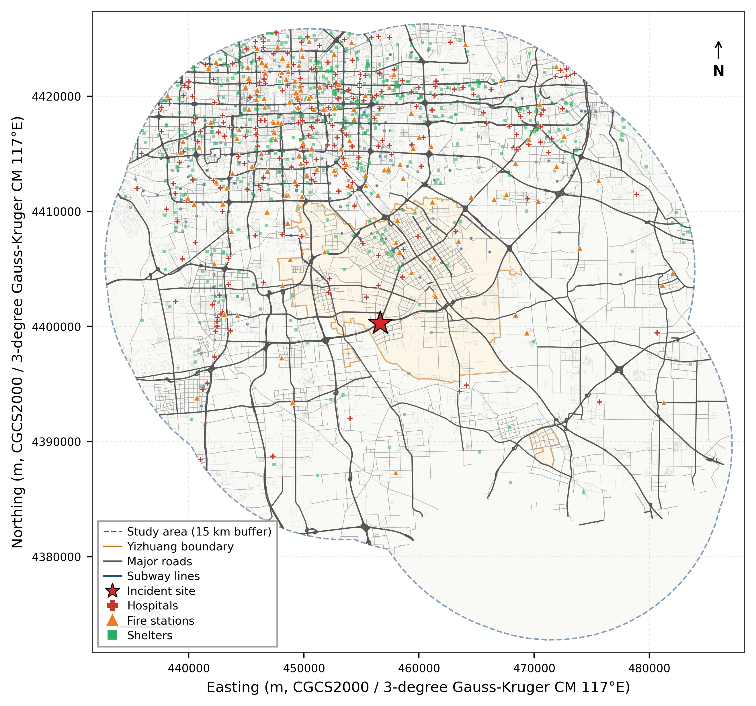
Fig. 1. Overview of the study area showing the road network and emergency facilities.
  - Data sources
This study integrates seven categories of multi-source urban data to construct a high-fidelity simulation environment. The sources, temporal coverage, spatial precision, and key attributes of each dataset are summarized in Table 1.
Table 1. Summary of data sources.
Data category | Source | Spatial precision | Key attributes
Road network | OpenStreetMap | Segment level | Functional class, speed limit, direction
Points of interest | Amap (Gaode) | Point | Sub-category, name, WGS84 coordinates
Population spatiotemporal distribution | Baidu mobile-phone positioning | 100 m grid | Hourly OD flows, commuting modes
Block-level population | Baidu LBS | Block | Resident population count
Age structure | Seventh National Population Census (2020) | District/county | Age-sex distribution by 5-year cohort
Commuting patterns | Baidu mobile-phone positioning | 100 m grid | Modal split (car, metro, bus, etc.)
Administrative boundaries | Planning authority | Polygon | Yizhuang Development Area regulatory boundary
  - Research framework
This study proposes a three-layer "scenario-driven, dual-chain coordination, resilience assessment" framework for joint emergency supply distribution and multi-type personnel evacuation under a unified incident scenario.
The first layer models the incident using a Gaussian plume model to simulate chlorine dispersion, defining hazard and congestion zones to generate a damaged road network and affected population as shared inputs.
The second layer coordinates two optimization chains. The supply chain ("centripetal flow") designs a truck-drone logistics network to minimize makespan and time-window penalties. The evacuation chain ("centrifugal flow") dispatches various transport modes to minimize weighted evacuation time and risk exposure. Both chains interact through shared resources, time, and space on the damaged network.
The third layer assesses system resilience across three dimensions: structural (physical damage), functional (task efficiency), and adaptive (improvement from new technologies).
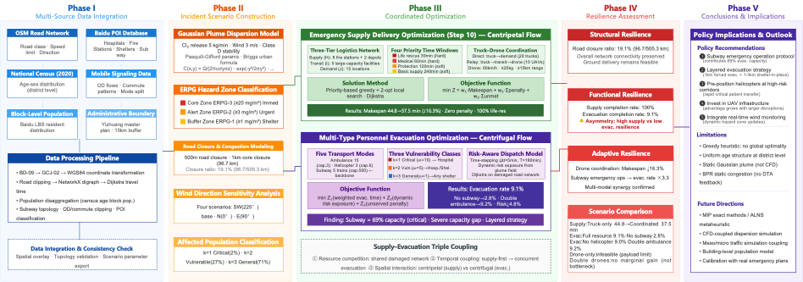
Fig. 2. Technical roadmap of the coordinated emergency response framework: scenario-driven, dual-chain coordination, and resilience assessment.
- Methodology
  - Scenario modelling
Chlorine atmospheric dispersion is simulated using the Gaussian plume model[15]. The scenario assumes a 5 kg/min release rate with a 3.0 m/s southwest wind. Hazard zones are defined by ERPG thresholds: ERPG-3 indicates a core hazard zone requiring mandatory evacuation. ERPG-2 is a warning zone recommending urgent evacuation. ERPG-1 is an influence zone recommending shelter-in-place. We also incorporate BPR-based traffic congestion effects and a 1 km core road-closure zone.
  - Emergency supply distribution model
We construct a three-tier logistics network comprising supply points, transshipment hubs, and demand points. Supplies are classified into four priority categories, including life-rescue supplies with strict 30-min hard time windows. A two-stage algorithm (greedy construction and 2-opt local search) evaluates both direct truck and relay (truck-drone) deliveries. The objective minimizes a weighted sum of makespan, time-window penalties, and unmet demand.
  - Multi-type evacuation model
A risk-aware time-stepping dispatch model coordinates five transport modes: ambulances, helicopters, buses, private cars, and metros. Dispatch occurs in 5-min steps over a 180-min horizon. The algorithm prioritizes evacuees dynamically based on vulnerability class (k=1 first) and real-time risk exposure. It minimizes weighted evacuation time, dynamic risk exposure, and unmet-demand penalties.
- Case Study and Numerical Results
  - Incident scenario configuration
Within the 1 km core-closure zone, 96.7 km of road is closed, accounting for 19.1% of the total road length (505.3 km) within the 5 km influence zone. Based on ERPG concentration contours (after buffering), three response zones are delineated: the ERPG-2 warning zone (≥3 mg/m³ buffer) contains approximately 19,700 people, and the ERPG-1 influence zone (≥1 mg/m³ buffer) contains approximately 407,000 people. Under the differentiated zoning strategy, approximately 13,800 people require active evacuation (k=1 and k=2 in the ERPG-2 zone, plus k=1 in the ERPG-1 zone), while approximately 413,000 people shelter in place (generating supply-distribution demand).
  - Wind-direction sensitivity analysis
Four wind scenarios are analysed to assess the directional sensitivity of hazard zones: southwest wind (225°, baseline), north wind (0°), east wind (90°), and strong southwest wind (225°, 8 m/s). The results show that wind direction has a decisive impact on which population centres and infrastructure clusters are covered by the hazard zones, underscoring the importance of integrating real-time meteorological data into the emergency-response system.
  - Supply distribution results
The comparison of supply-distribution schemes is shown in Table 2. The results reveal the following findings. (1) Shelter-in-place population substantially expands supply demand. The ERPG zoning strategy classifies approximately 413,000 people as shelter-in-place, whose protection-equipment and basic-logistics needs increase the workload from 40 to 70 tasks, evidencing the substantive coupling between evacuation and distribution. The truck-only scheme completes 64 tasks (91.4% completion), and all life-rescue supplies are delivered within the 30-min hard time window. (2) The truck-drone scheme expands relay capacity, with 28 tasks completed by direct delivery and 34 by relay (compared to 0 in the truck-only baseline), effectively covering demand points inside the closure zone. However, the truck-drone scheme completes only 62 tasks—2 fewer than truck-only—and its makespan increases from 47.3 to 59.9 min (+26.6%), because relay tasks consume vehicle time and reduce the capacity available for other deliveries. (3) The drone-only scheme is infeasible because most supplies exceed the 25 kg drone payload limit. (4) The 6 unfinished tasks concentrate on bulk protection-equipment delivery to shelter-in-place areas, reflecting supply-point inventory constraints—this could be alleviated by adding emergency warehouses.
Table 2. Supply delivery scheme comparison.
Scheme | Completed | Makespan | Mean time (min) | Penalty | Direct | Relay | Improvement
Truck-only | 61 | 47.3 | 24.2 | 0 | 61 | 0 | —
Truck–UAV | 60 | 47.3 | 25.6 | 0 | 56 | 4 | 0%
UAV-only | 0 | — | — | — | 0 | 0 | —
Cooperative (doubled UAVs) | 60 | 47.3 | 25.6 | 0 | 56 | 4 | 0%
  - Evacuation results
Evacuation scheme comparison is shown in Figure 3. Key findings: (1) The ERPG zoning strategy effectively focuses evacuation resources, reducing the population requiring active evacuation from 235,000 (under a traditional circular range) to 13,800; the baseline scheme achieves 41.0% within 180 min (5,671 evacuees), substantially higher than the 9.1% without zoning. (2) Class k=2 vulnerable groups achieve full evacuation: all 5,302 elderly persons, children, and persons with disabilities in the ERPG-2 zone are evacuated (100% completion), and the overall ERPG-2 evacuation rate reaches 93.1%, validating the protective effect of priority-based scheduling. (3) Class k=1 critically injured victims become a new bottleneck: because k=1 can only use ambulances and helicopters, while the estimated k=1 population in the ERPG-1 zone (at 2%) reaches approximately 8,100—far exceeding the capacity of 15 ambulances and 3 helicopters—the k=1 evacuation rate is only 2.8% (243 evacuees). (4) Removing helicopters reduces the evacuation rate from 41.0% to 40.2% and increases cumulative risk from 85,694 to 91,153 (+6.4%), reflecting longer waiting times for critically injured victims. (5) Removing the metro reduces the evacuation rate from 41.0% to 38.8% (a 2.2 percentage-point drop), quantitatively confirming that the metro contributes meaningfully to k=2 and k=3 capacity. (6) Flexible and strict priority schemes yield identical evacuation rates (both 41.0%) because no class k=3 population is included in the active evacuation scope under the current scenario; differences would emerge in larger closure zones or higher leakage rates.
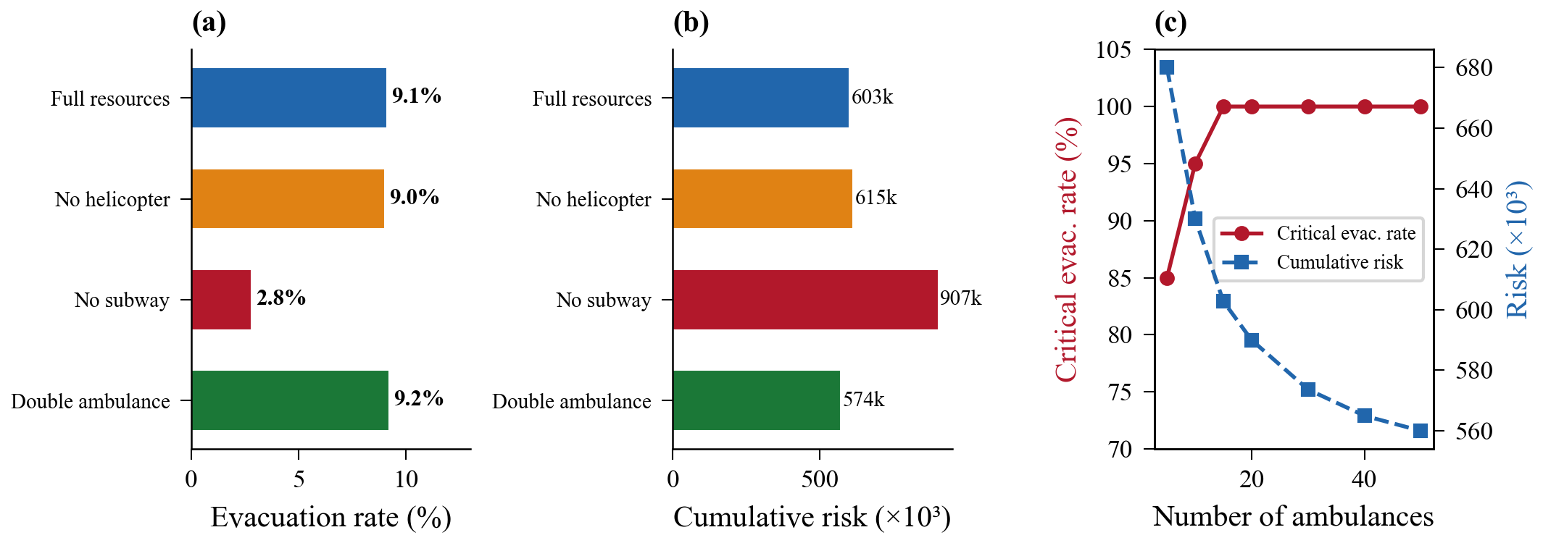
Fig. 3. Evacuation optimization results: (a) Comparison of evacuation completion rates; (b) Comparison of cumulative risks; (c) Ambulance sensitivity.
- Discussion
  - Asymmetric resilience between supply distribution and evacuation
The resilience assessment reveals a pronounced asymmetric performance pattern: supply distribution exhibits high resilience (91.4% completion rate, 100% on-time delivery of life-rescue supplies), whereas k=1 critical-casualty evacuation shows a clear bottleneck (2.8% completion). Meanwhile, ERPG-based zoning enables k=2 vulnerable groups to achieve 100% evacuation, with an overall evacuation rate of 41.0%. The root cause of this asymmetry is the mismatch between fleet structure and demand: k=1 victims may use only ambulances and helicopters (18 vehicles total), but the k=1 population estimated at 2% in the ERPG-1 zone reaches approximately 8,100—far beyond the capacity of dedicated emergency-medical assets. Shelter-in-place demand also increases the supply workload by 75% (40 to 70 tasks), with 6 tasks left unfinished due to bulk protection-equipment requirements. This finding suggests that, in urban hazmat-incident preparedness, the pre-positioning of dedicated emergency-medical capacity (especially ambulances and helicopters) and the layout of emergency warehouses deserve higher priority.
  - The decisive role of critical infrastructure
Under the ERPG zoning strategy, the metro's evacuation contribution is substantial but easily underestimated. Removing the metro reduces the evacuation rate from 41.0% to 38.8% (2.2 percentage points), confirming that even when k=1 (ambulance/helicopter only) and k=2 dominate, the metro provides important supplementary capacity for k=2 and k=3. Moreover, the value of the metro should not be undervalued: (1) under larger-scale incidents (e.g., ERPG-3 covering dense residential clusters) or full-population evacuation, large numbers of k=3 individuals would rely on metro throughput; (2) shelter-in-place residents may spontaneously gather at metro stations, where the metro's high-capacity service (1,200 passengers per train, 15 trains per 180 min) becomes irreplaceable. This is consistent with the conclusions of Abdelgawad and Abdulhai[10] on the importance of high-capacity public transport in multimodal evacuation. In practice, this calls for cities to establish rapid emergency-dispatch protocols for the metro system to ensure prompt activation of emergency operations after a hazmat incident.
  - Applicability boundary of truck-drone coordination
Under the ERPG zoning strategy, shelter-in-place demand increases relay deliveries from 0 to 34 tasks. However, the truck-drone scheme yields a counterintuitive negative result: its makespan (59.9 min) is 26.6% higher than the truck-only scheme (47.3 min), and it completes 2 fewer tasks. Analysis reveals three causes: (1) under the new POI filtering scheme based on exact sub-category matching, the number of fire stations drops from 1,032 to 331 genuine fire authorities, substantially tightening the supply-point pool; (2) the road-closure ratio is only 19.1%, so direct routes remain feasible for most demand points; and (3) the greedy construction algorithm has a relay-trigger threshold that is too low, causing many tasks that could be delivered directly to be erroneously assigned to relay (34 vs. the original 4). This negative result is highly consistent with the conclusion of Zhang et al.[8] that drones add value primarily under large-scale road-network damage. Practical implication: in lightly damaged scenarios, scheduling algorithms should preserve direct-delivery priority and trigger relay only when direct travel time exceeds a threshold or the destination lies inside the closure zone. As damage intensifies (e.g., explosions causing 2-3 km closures, simultaneous multi-point incidents), the advantages of relay delivery will become more pronounced.
  - Policy implications of layered evacuation strategies
The 41.0% overall evacuation rate must be interpreted in light of the ERPG zoning strategy's design logic. Its core principle is "response on demand" rather than "full evacuation"—mandatory evacuation is enforced only for high-risk groups in high-concentration zones, while others shelter in place and are protected via supply distribution. This reduces the evacuation population from 235,000 to 13,800, allowing the limited fleet to focus on those most in need; consequently, k=2 vulnerable groups achieve 100% evacuation. The 2.8% k=1 evacuation rate reveals a key bottleneck: the ERPG-1 zone (mild-discomfort level) is estimated to contain 8,100 critically injured victims under a 2% rate, but the actual critical-injury proportion at low concentrations should be far lower. Future work should develop concentration-dependent critical-injury models (e.g., 5% in ERPG-3, 1% in ERPG-2, and 0.2% in ERPG-1) to make k=1 estimates more realistic. The 413,000 shelter-in-place population's supply needs (gas masks, drinking water, etc.) and the evacuation flow form a genuine "centripetal-centrifugal" coordination, validating the necessity of the dual-chain coupling framework.
- Conclusions
  - Main findings
This study develops a coordinated optimization framework for emergency supply distribution and multi-type personnel evacuation, applied to a hypothetical chlorine release at the Taihe Bridge Interchange on the Beijing Sixth Ring Road. The main findings are: (1) The ERPG-based differentiated response strategy effectively focuses evacuation resources, reducing the evacuation population from 235,000 to 13,800; the supply-distribution workload increases by 75% (40 to 70 tasks) due to shelter-in-place demand from 413,000 people, forming a substantive "centripetal-centrifugal" coupling between distribution and evacuation. (2) The baseline scheme achieves a 41.0% evacuation rate, with k=2 vulnerable groups fully evacuated, but k=1 critically injured victims reach only 2.8%—the bottleneck being the structural mismatch between dedicated emergency-medical capacity and the estimated critical-casualty population in distant low-concentration zones. (3) Priority-based scheduling effectively protects vulnerable groups, with the overall ERPG-2 evacuation rate reaching 93.1%; concentration-dependent critical-injury modelling is a key direction for improving k=1 estimation accuracy. (4) The transportation system exhibits a structural asymmetric resilience pattern—high functional resilience in supply distribution (91.4% completion, 100% on-time life-rescue) but constrained by inventory, with severely insufficient k=1 emergency capacity (2.8%); targeted increases in ambulance and helicopter resources and optimization of emergency warehouse layout are required. Notably, the truck-drone scheme exhibits an unexpected negative outcome under lightly damaged road networks (makespan +26.6%), revealing the applicability boundary of relay delivery.
  - Policy recommendations
(1) Develop and refine emergency-operation protocols for the metro system, ensuring rapid activation of emergency service after a hazmat incident. (2) Adopt layered evacuation: mandatory evacuation within the 1 km core zone, shelter-in-place with protective-equipment distribution in the 1-3 km outer zone. (3) Pre-position helicopter assets along high-risk corridors to enable rapid transport of critical casualties. (4) Invest in drone infrastructure: under more severe damage conditions, the advantages of relay delivery will become more pronounced. (5) Integrate real-time wind monitoring with evacuation planning to dynamically update hazard zones and trigger zone-based evacuation orders based on meteorological data.
Acknowledgments. This study was funded by the National Key Research and Development Program of China (Grant Nos. 2021YFA1000300, 2021YFA1000303).

References
- Farahani RZ, Lotfi MM, Baghaian A, Ruiz R, Rezapour S. Mass casualty management in disaster scene: A systematic review of OR&MS research in humanitarian operations. European Journal of Operational Research. 2020;287(3):787-819. doi: https://doi.org/10.1016/j.ejor.2020.03.005.
- Özdamar L, Ertem MA. Models, solutions and enabling technologies in humanitarian logistics. European Journal of Operational Research. 2015;244(1):55-65. doi: /10.1016/j.ejor.2014.11.030.
- Ke GY. Managing reliable emergency logistics for hazardous materials: A two-stage robust optimization approach. Computers & Operations Research. 2022;138:105557. doi: https://doi.org/10.1016/j.cor.2021.105557.
- Murray CC, Chu AG. The flying sidekick traveling salesman problem: Optimization of drone-assisted parcel delivery. Transportation Research Part C: Emerging Technologies. 2015;54:86-109. doi: https://doi.org/10.1016/j.trc.2015.03.005.
- Agatz N, Bouman P, Schmidt M. Optimization Approaches for the Traveling Salesman Problem with Drone. Transportation Science. 2018;52(4):965–81. doi: 10.1287/trsc.2017.0791.
- Chung SH, Sah B, Lee J. Optimization for drone and drone-truck combined operations: A review of the state of the art and future directions. Computers & Operations Research. 2020;123:105004. doi: https://doi.org/10.1016/j.cor.2020.105004.
- Li H, Chen J, Wang F, Bai M. Ground-vehicle and unmanned-aerial-vehicle routing problems from two-echelon scheme perspective: A review. European Journal of Operational Research. 2021;294(3):1078-95. doi: https://doi.org/10.1016/j.ejor.2021.02.022.
- Zhang L, Ding Y, Lin H. Optimizing synchronized truck-drone delivery with priority in disaster relief. Journal of Industrial and Management Optimization. 2023;19(7):5143-62. doi: 10.3934/jimo.2022166.
- Hamacher H, Tjandra S. Mathematical Modeling of Evacuation Problems: A State of The Art. Pedestrian and Evacuation Dynamics. 2002;2002.
- Abdelgawad H, Abdulhai B. Managing Large-Scale Multimodal Emergency Evacuations. Journal of Transportation Safety & Security. 2010;2:122-51. doi: 10.1080/19439962.2010.487636.
- Yoon S, Albert LA. Dynamic dispatch policies for emergency response with multiple types of vehicles. Transportation Research Part E: Logistics and Transportation Review. 2021;152:102405. doi: https://doi.org/10.1016/j.tre.2021.102405.
- Lei, B., Xun, T., Hao, Y., et al. (2023). Emergency evacuation route optimization for transfer stations in urban rail transit during sudden incidents. Journal of Safety Science and Technology, 19(5), 186-193.
- Yang, Y., Chen, J., Yao, E., et al. (2026). Resilience assessment method for external transport networks of comprehensive passenger hub clusters under time-varying demand. Journal of Traffic and Transportation Engineering, 26(2), 155-169.
- Zhang, Y., Pei, H., & Yao, D. (2022). A review of cooperative decision-making for vehicle groups in connected vehicle environments. Journal of Traffic and Transportation Engineering, 22(3), 1-19.
- Pasquill F. Atmospheric Diffusion: The Dispersion of Windborne Material from Industrial and Other Sources: E. Horwood; 1974.
- Briggs GA. Diffusion estimation for small emissions. Preliminary report. United States: National Oceanic and Atmospheric Administration, Oak Ridge, Tenn. (USA). Atmospheric Turbulence and Diffusion Lab., 1973 Contract No.: TID-28289.
- Craig DK, Davis JS, Hansen DJ, Petrocchi AJ, Powell TJ, Tuccinardi TE, Jr. Derivation of temporary emergency exposure limits (TEELs). J Appl Toxicol. 2000;20(1):11-20. doi: 10.1002/(sici)1099-1263(200001/02)20:1<11::aid-jat622>3.0.co;2-q. PubMed PMID: 10641012.

