Coordinated Optimization of Emergency Supply Distribution and Multi-Type Personnel Evacuation under Hazardous-Material Vehicle Incidents on Urban Expressways: A Case Study of the Beijing Sixth Ring Road
Liang Wang^{1,2} and Yu Guan² and He Wei² and Xiaodong Zhang^{2,*}
¹ School of Economics and Management, Beijing Jiaotong University, Beijing 100044, China
² Beijing Municipal Institute of City Planning and Design, Beijing 100045, China
wljean@126.com, zhang-xd23@mails.tsinghua.edu.cn
Abstract. Hazardous-material transportation incidents on urban expressways can trigger compound disasters such as toxic gas releases, demanding coordinated optimization of emergency supply distribution and personnel evacuation. Taking a hypothetical chlorine release at the Taihe Bridge Interchange on Beijing's Sixth Ring Road as the scenario, this study develops an integrated emergency-response optimization framework. The Gaussian plume model simulates chlorine dispersion, and three-tier hazard zones are delineated using ERPG toxicity thresholds. On the supply side, a three-tier logistics network with truck-drone coordinated delivery is constructed, and supplies are classified into four priority categories with differentiated time-window constraints. On the evacuation side, a risk-aware time-stepping dispatch model stratifies the affected population into three vulnerability classes with differentiated responses (mandatory evacuation or shelter-in-place), coordinating ambulances, helicopters, buses, private cars, and metro. The framework integrates multi-source urban data including mobile-phone OD records, POI databases, census age-structure data, and the OpenStreetMap road network. Numerical experiments show that incorporating shelter-in-place demand increases supply tasks from 40 to 70; the truck-only scheme completes 64 tasks (makespan 47.3 min, on-time rate 91.4%), while the truck-drone scheme exhibits a 26.6% longer makespan under lightly damaged road conditions—a counterintuitive result delineating the applicability boundary of relay delivery. The ERPG-based zoning reduces the evacuation population from 235,000 to 13,800; class k=2 groups are fully evacuated within 180 min, but class k=1 critically injured victims reach only 2.8%, revealing a structural bottleneck in dedicated emergency-medical fleets. The resilience assessment uncovers an asymmetric "high supply resilience versus low evacuation resilience" pattern, supporting urban hazmat emergency management decisions.
Keywords: Emergency logistics, truck-drone coordination, multi-type evacuation, hazardous-material incidents, urban expressways, transportation resilience.
- Introduction
Urban expressways carry both commuter and freight flows and serve as principal corridors for hazardous-material (hazmat) transportation. When an incident occurs, consequences such as toxic gas release or explosion can trigger compound disasters that require coordinated multi-agency response[1]. In recent years, China has witnessed numerous large-scale emergencies caused by hazmat transportation accidents—for example, the 2005 liquid-chlorine truck rollover on the Beijing-Shanghai Expressway near Huai'an, which killed 29 people and forced the evacuation of more than ten thousand residents, and the 2020 Wenling tanker explosion, which killed 20—exposing the vulnerability of urban transportation networks under such scenarios. The Beijing Sixth Ring Road, with a total length of about 188 km, has experienced multiple hazmat-related incidents in recent years (involving diesel, liquefied petroleum gas, etc.); its southeastern Taihe Bridge segment is densely populated and concentrated with critical infrastructure, making it a high-risk node. How to achieve the coordinated optimization of emergency supply distribution and personnel evacuation under stringent time constraints is a critical scientific question that urgently needs to be addressed.
In the field of emergency logistics, Özdamar and Ertem[2] provided a systematic review of humanitarian-logistics models and solution techniques, while Farahani et al.[1] further summarized recent advances in disaster-response network design; Ke[3] proposed a two-stage robust optimization approach for hazmat emergency logistics that accounts for demand uncertainty and link disruption. In terms of delivery-mode innovation, the flying sidekick travelling salesman problem proposed by Murray and Chu [4] laid the theoretical foundation for truck-drone coordination, and Agatz et al.[5] developed exact algorithms and heuristics; Chung et al.[6] and Li et al.[7] respectively provided systematic reviews of drone-assisted delivery, indicating that this mode offers unique advantages in emergency scenarios with damaged road networks; Zhang et al. [8] further introduced a priority mechanism into synchronized truck-drone delivery for disaster relief, providing a modelling reference for emergency supply distribution under differentiated time-window constraints. In personnel evacuation, Hamacher and Tjandra[9] formalized evacuation as a network-flow problem, Abdelgawad and Abdulhai[10] proposed a multimodal framework integrating public transit and private vehicles, and Yoon and Albert[11] developed dynamic emergency dispatch policies for multiple types of vehicles. Chinese scholars have also contributed: Lei et al.[12] proposed an evacuation optimization model for urban rail transit, Yang et al.[13] established a resilience-assessment method for urban transportation networks, and Zhang et al.[14] explored vehicle-infrastructure cooperative emergency control. For hazard-zone evaluation, the Gaussian plume model has been widely adopted for rapid risk assessment due to its analytical simplicity and computational efficiency[15]; the Pasquill-Gifford stability classification[16] (Briggs, 1973) and the ERPG threshold system[17] provide practical frameworks for dispersion-parameter estimation and hazard zoning, respectively.
However, most existing studies treat supply distribution and personnel evacuation as independent problems[1, 3], overlooking their interdependence in resource competition, temporal coupling, and spatial interaction. Taking a chlorine release at the Taihe Bridge area on the Beijing Sixth Ring Road as the scenario, this study develops a coordinated framework that simultaneously optimizes emergency supply distribution and multi-type personnel evacuation. The main contributions are as follows: (1) under a unified incident scenario, we jointly optimize supply distribution (truck-drone coordination, four priority levels, time windows) and multi-type evacuation (five transport modes, three vulnerability classes); (2) we integrate multi-source urban data—mobile-phone OD data, POI databases, age structure from the Seventh National Population Census, and the OpenStreetMap road network—to construct a high-fidelity simulation environment; (3) we conduct comprehensive scenario analyses encompassing Gaussian plume simulation, wind-direction sensitivity analysis, and transportation resilience assessment; and (4) we provide practical guidance for emergency management agencies on resource pre-positioning, fleet sizing, and multimodal coordination strategies.
The remainder of this paper is organized as follows. Section 2 introduces the study area, data sources, and processing methods, and outlines the research framework. Section 3 establishes the incident-scenario, supply-distribution, evacuation, and resilience-assessment models. Section 4 presents the numerical results of the case study. Section 5 provides a comprehensive discussion. Section 6 concludes the paper and offers policy recommendations.
- Study Area and Data
  - Study area
The Beijing Sixth Ring Road is approximately 188 km long and serves as a critical expressway loop connecting the central urban area with peripheral new towns, carrying substantial freight and commuter flows. As the Sixth Ring Road is also the principal corridor for hazmat vehicles entering and leaving Beijing, multiple hazmat-related incidents involving diesel, liquefied petroleum gas, and other dangerous chemicals occurred along the corridor between 2014 and 2026, making it a high-risk corridor in urban traffic safety management.
This study selects the Taihe Bridge Interchange on the southeastern Sixth Ring Road (116.494°E, 39.736°N) as the hypothetical incident epicenter. This location lies on the northern edge of the Yizhuang Economic and Technological Development Area and exhibits the following typical features: (1) the Taihe Bridge Interchange is a junction node where the Sixth Ring Road meets several urban arterial roads, with heavy daily traffic—an incident here could easily trigger large-scale traffic paralysis; (2) the surrounding area contains numerous residential communities, industrial parks, and vulnerability-sensitive facilities such as schools and elderly-care institutions, with high population density; and (3) the area is well-served by public transportation, including the Yizhuang Line, Yizhuang T1 Line, Line 8, and Line 10 of the Beijing Metro, providing potential for multimodal emergency evacuation.
The study area is defined as a 15-km buffer centered on the incident point, unioned with a 15-km buffer around the Yizhuang regulatory boundary, yielding a total area of approximately 707 km². The 15-km buffer radius is justified as follows: (1) according to the Interim Provisions on the Supervision and Administration of Major Hazard Sources for Hazardous Chemicals and existing case studies in China, the maximum impact distance of toxic gases such as chlorine under typical meteorological conditions generally does not exceed 10 km, and 15 km ensures coverage of the entire potential impact area; (2) this radius covers the major medical-treatment facilities and emergency-supply storage sites surrounding the incident point, ensuring the integrity of the logistics network; and (3) prior studies on emergency evacuation indicate that traffic-congestion propagation effects of urban-expressway incidents typically dissipate within 10–15 km. Figure 1 shows the spatial extent of the study area, the road network, and the distribution of emergency facilities.
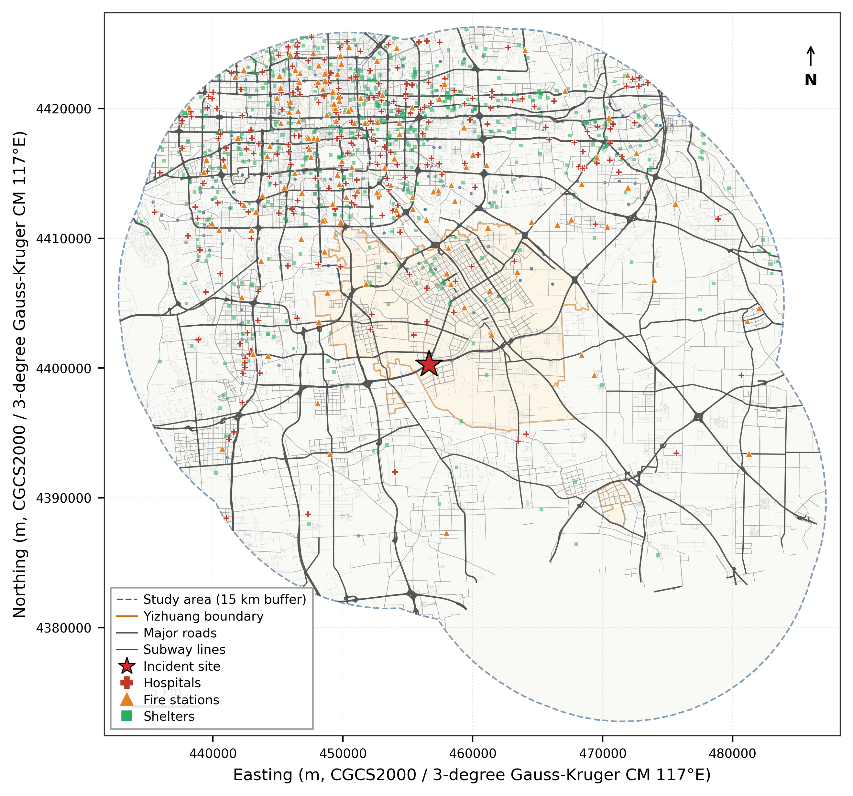
Fig. 1. Overview of the study area showing the road network and emergency facilities.
  - Data sources
This study integrates seven categories of multi-source urban data to construct a high-fidelity simulation environment. The sources, temporal coverage, spatial precision, and key attributes of each dataset are summarized in Table 1.
Table 1. Summary of data sources.
Data category | Source | Spatial precision | Key attributes
Road network | OpenStreetMap | Segment level | Functional class, speed limit, direction
Points of interest | Amap (Gaode) | Point | Sub-category, name, WGS84 coordinates
Population spatiotemporal distribution | Baidu mobile-phone positioning | 100 m grid | Hourly OD flows, commuting modes
Block-level population | Baidu LBS | Block | Resident population count
Age structure | Seventh National Population Census (2020) | District/county | Age-sex distribution by 5-year cohort
Commuting patterns | Baidu mobile-phone positioning | 100 m grid | Modal split (car, metro, bus, etc.)
Administrative boundaries | Planning authority | Polygon | Yizhuang Development Area regulatory boundary
These datasets are complementary in spatial coverage, temporal granularity, and semantic dimensions: the OSM road network provides topological structure and physical attributes; POI data provide the spatial location and functional type of emergency facilities; mobile-phone positioning data capture population spatiotemporal distribution and travel-behavior characteristics; census data provide age-structure information for vulnerability stratification; and commuting data are used to estimate the share of private cars available within the area. The fusion of multi-source data enables this study to support both supply-distribution-network modelling and evacuation-demand estimation within a unified spatiotemporal framework.

  - Data processing
Data processing comprises five components: coordinate unification, spatial clipping, network construction, population allocation, and travel data processing.
Coordinate unification and spatial clipping. All spatial data are unified to the WGS84 geographic coordinate system (EPSG:4326), with UTM Zone 50N (EPSG:32650) used for projected calculations. Baidu mobile-phone positioning and POI data are originally in the BD-09 coordinate system and require a two-step transformation: BD-09 is first converted to GCJ-02 via inverse offset, and GCJ-02 is then converted to WGS84 via iterative ellipsoid-parameter computation. After conversion, all spatial datasets are clipped using the study-area boundary as a mask, retaining only features within the area of interest.
Road network construction. Vehicle-accessible road segments are extracted from the OSM data, retaining 14 functional classes including motorway, trunk, primary, secondary, tertiary, residential, and service roads, together with their links. For segments with missing or zero speed limits in OSM, default values are assigned by functional class according to the Code for Design of Urban Road Engineering (CJJ 37-2012): motorway 100 km/h, trunk 80 km/h, primary 60 km/h, secondary 50 km/h, tertiary 40 km/h, residential 30 km/h, and service 20 km/h. Capacities follow the Highway Capacity Manual (HCM) and are assigned based on lane count and class.
A directed NetworkX graph is constructed using road endpoints as nodes and segments as edges. One-way roads retain only forward edges, while two-way roads add both forward and reverse edges. Each edge stores attributes including segment length (computed after UTM projection), speed limit, free-flow travel time, and capacity. Following construction, connectivity is verified and the largest weakly connected component is retained. The processed network contains 26,699 segments totalling 11,232.1 km.
Population spatial allocation and vulnerability stratification. Population processing follows a top-down spatial-allocation strategy: block-level resident population from Baidu LBS provides totals, while age-structure ratios from the Seventh National Population Census (2020) are downscaled from the district to the block level. The procedure is: (1) clip block-level population to the study area; (2) spatially join each block to its corresponding district; (3) compute the proportions of children (0-14), working-age (15-59), and elderly (60+) from census data for that district; and (4) multiply these ratios by the block total to obtain age-stratified spatial distributions. According to census data for Daxing and Tongzhou Districts—the two districts covered by the study area—the elderly share is approximately 15% and children account for about 12%.
On this basis, the affected population is stratified into three vulnerability classes: class k=1 comprises critically injured or gas-poisoned victims, assumed to be 2% of the affected population; class k=2 comprises elderly persons, children, and persons with disabilities, accounting for approximately 27%; class k=3 comprises generally healthy individuals, accounting for 71%. This stratification directly feeds into the priority-based scheduling in the evacuation optimization model.
Emergency facility identification and classification. Five categories of emergency-related facilities within the study area are identified through exact matching on the Amap POI sub-category field, avoiding mis-inclusion caused by fuzzy name matching. Medical facilities are retained from eight sub-categories—general hospitals, tertiary hospitals (level III, grade A), emergency centers, specialty hospitals, oncology hospitals, thoracic hospitals, ophthalmology hospitals, and community health centers—yielding 1,732 facilities (including an estimated 180 tertiary, 5 secondary, 769 community-level, and 778 unclassified). This is substantially more conservative than fuzzy matching (3,526), excluding irrelevant POIs such as dental, cosmetic surgery, and veterinary clinics. Fire stations are filtered using the sub-category fire authority, yielding 331 facilities. Potential shelters are extracted from 15 sub-categories—including parks, urban plazas, integrated stadiums, football fields, basketball arenas, swimming pools, tennis and badminton courts, table-tennis halls, fitness centers, and outdoor exercise grounds—yielding 6,993 facilities with an estimated total capacity of approximately 16.6 million. Subway stations are filtered by the sub-category subway station and deduplicated, yielding 243 stations. Vulnerability-sensitive facilities (kindergartens, primary schools, secondary schools, welfare homes, and nursing homes) total 2,718 (including 1,655 kindergartens, 636 primary schools, and 427 secondary schools).
Subway network data are obtained from Beijing Subway Corporation public sources, including station locations, line geometries, and operational parameters of the Yizhuang Line, Yizhuang T1 Line, Line 8, and Line 10.
Travel data processing. Baidu mobile-phone OD data come at both daily and hourly granularity. After coordinate transformation, each record is checked to determine whether its origin or destination falls within the study-area polygon, and records with at least one endpoint inside are retained. The same procedure is applied to commuting data. The final dataset contains 56.59 million daily OD records, 69.09 million hourly OD records, and 3.118 million commuting flows. The modal split derived from commuting data (shares of car, metro, bus, cycling, and walking) is used to estimate the available number of private cars in the evacuation scenario.
  - Research framework
This study constructs a three-layer research framework of "scenario-driven, dual-chain coordination, resilience assessment" (Figure 2), achieving joint optimization of emergency supply distribution and multi-type personnel evacuation under a unified incident scenario.
The first layer (incident scenario modelling) employs the Gaussian plume model to simulate chlorine atmospheric dispersion, delineates three-tier hazard zones based on ERPG thresholds, and combines distance criteria to define road-closure and BPR-congestion zones, generating the damaged road network and affected population distribution as unified inputs to subsequent optimization.
The second layer (coordinated optimization) consists of two coupled optimization chains. The supply-distribution chain ("centripetal flow") constructs a three-tier logistics network of supply points, transshipment hubs, and demand points, designs both direct and relay truck-drone delivery modes, and minimizes a weighted combination of makespan and time-window penalties via priority-based greedy construction with 2-opt local search. The evacuation chain ("centrifugal flow") establishes a risk-aware time-stepping dispatch model coordinating ambulances, helicopters, buses, private cars, and the metro, minimizing weighted evacuation time, dynamic risk exposure, and unmet-demand penalties. The two chains share the damaged road network and are coupled through resource competition, temporal interdependence, and spatial interaction.
The third layer (resilience assessment) evaluates the transportation system's emergency-response capability under this compound hazard scenario from three dimensions: structural resilience (physical damage to the road network), functional resilience (task-completion efficiency), and adaptive resilience (improvement enabled by new technologies).
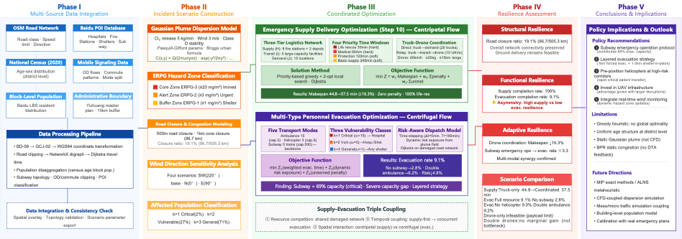
Fig. 2. Technical roadmap of the coordinated emergency response framework: scenario-driven, dual-chain coordination, and resilience assessment.
- Methodology
  - Incident scenario modelling
Gaussian plume dispersion model. Chlorine atmospheric dispersion is modelled using the Gaussian plume equation[15]. The ground-level concentration C(x,y) (mg/m³) at downwind distance x and crosswind distance y is given by:
C(x,y)=Q/(2π·u·σ_{y}·σ_{z})·exp(−y²/2σ_{y}²)·[exp(−(z−H)²/2σ_{z}²)+exp(−(z+H)²/2σ_{z}²)] (1)
where Q is the emission rate (mg/s), u is wind speed (m/s), H is effective release height (m), and z is receptor height (the two exponential terms collapse to 2·exp(−H²/2σ_z²) at ground level z=0). Dispersion coefficients follow the Briggs urban formulas[16] under stability class D (neutral):
σ_{y}=0.11x/(1+0.0004x)^{1.05}, σ_{_z}=0.08x/(1+0.0015x)^{1.05} (2)
Grid-point coordinates are rotated to the wind-aligned frame before evaluation. Scenario parameters are listed in Table 2.
> **Table 2. Accident scenario parameters**
> | Parameter | Value |
> |---|---|
> | Accident location | (116.494°E, 39.736°N) |
> | Released gas | Chlorine (Cl₂) |
> | Release rate | 5 kg/min |
> | Wind speed | 3.0 m/s |
> | Wind direction | 225° (SW, meteorological convention) |
> | Stability class | D (neutral) |
> | Effective release height | 2.0 m |
>
ERPG hazard zoning. Hazard zones are delineated based on both concentration thresholds and distance criteria. The ERPG threshold system for chlorine[17] defines three zones: the core hazard zone (ERPG-3, ≥20 mg/m³, life-threatening, mandatory evacuation), the warning zone (ERPG-2, ≥3 mg/m³, severe health effects possible, urgent evacuation recommended), and the influence zone (ERPG-1, ≥1 mg/m³, mild discomfort, shelter-in-place recommended).
Road closure and BPR congestion effects. Distance-based operational zones are also defined: a 500 m road-closure zone, a 1 km core-closure zone, a 3 km congestion zone, and a 5 km influence zone. Segments inside the core-closure zone are removed from the network graph; segments in the congestion zone have their travel times inflated using the Bureau of Public Roads (BPR) function:
t = t₀·[1+α·(v/c^{^β}] (3)
where t_0 is the free-flow travel time, v/c is the volume-to-capacity ratio (assumed 0.8 in this study), α=0.15, and β=4.0. Closer to the incident point, the congestion factor is further amplified through linear interpolation.
  - Emergency supply distribution model
Logistics network and supply classification. A three-tier logistics network is constructed: the supply layer (H) contains 8 fire stations (1-15 km from the incident point, outside the closure zone) and 2 hypothetical emergency warehouses; the transshipment layer (I) contains 5 high-capacity facilities (stadiums and parks 2-6 km from the incident point) doubling as drone launch pads; and the demand layer (J) contains 15 locations including the incident core, four perimeter points of the isolation zone, and surrounding hospitals receiving casualty supplies.
It should be noted that the recipients of emergency supplies are not the evacuees themselves but on-site rescue personnel and trapped, awaiting-rescue casualties. Life-rescue supplies are mainly distributed to firefighters and chemical-protection personnel entering the toxic plume zone, as well as to gas-poisoning victims trapped in the core zone who cannot be transported. Medical-support supplies are delivered to triage stations on the isolation perimeter and to surrounding hospitals; protection equipment and basic logistics serve traffic-control personnel in the warning zone and shelter-in-place residents. Supplies are classified into four priority categories with differentiated time-window constraints (Table 3).
> **Table 3. Supply classification**
> | Category | Typical supplies | Time window | Window type | Penalty/min | Unit weight (kg) |
> |---|---|---|---|---|---|
> | Life-rescue | Gas masks, oxygen cylinders, antidotes | 30 min | Hard | 1,000 | 3.0 |
> | Medical support | Stretchers, plasma, IV equipment | 60 min | Hard | 500 | 8.0 |
> | Protective equipment | Protective suits, barrier tape, warning devices | 120 min | Soft | 100 | 5.0 |
> | Basic support | Drinking water, food, tents, lighting | 240 min | Soft | 10 | 15.0 |
>
Truck-drone coordination mechanism. Two delivery modes are considered: direct delivery (trucks travel from supply points to demand points) and relay delivery (trucks bring supplies to transshipment hubs, where drones complete the last-mile delivery within the closure zone). Truck parameters: 2,000 kg payload, 40 km/h average speed in the incident area (modulated by BPR congestion), and 5-min unloading time. Drone parameters: 15 km maximum range, 25 kg maximum payload, 60 km/h cruising speed, and 5-min loading at hubs. The fleet comprises 20 trucks and 10 drones.
Objective function and constraints. The objective minimizes a weighted sum:
min Z = w₁·Makespan + w₂·Σ penalty + w₃·Σ unmet (4)
where Makespan is the maximum completion time across all tasks, penalty denotes time-window violation costs, and unmet denotes the penalty for unsatisfied demand. The weights are set as w_1=1.0, w_2=1.0, w_3=10,000. Constraints include vehicle payload limits, supply-point inventory limits, drone range, and time windows (hard windows are inviolable).
Solution algorithm. A two-stage approach is adopted. Stage 1 is priority-based greedy construction: (1) tasks are sorted by priority (life-rescue first) and deadline; (2) for each task, all feasible vehicle-route combinations (direct and relay) are evaluated, with travel times computed via Dijkstra shortest paths; (3) the combination yielding the earliest arrival is selected; and (4) vehicle availability and supply-point inventory are updated. Stage 2 applies 2-opt local search to the greedy solution, swapping task assignments between vehicles of the same type to reduce the objective, with up to 200 iterations.
  - Multi-type evacuation model
Population stratification and fleet configuration. The affected population within the 3 km congestion zone is divided into three priority classes based on vulnerability and medical needs (Table 4). The evacuation fleet configuration is summarized in Table 5.
> **Table 5. Vehicle fleet configuration**
> | Mode | Capacity (pax) | Speed (km/h) | Fleet size | Population served | Initial distribution |
> |---|---|---|---|---|---|
> | Ambulance | 3 | 50 | 15 | k=1, 2 | Evenly around accident site |
> | Helicopter | 6 | 150 | 3 | k=1, 2 | Evenly around accident site |
> | Bus | 50 | 30 | 20 | k=2, 3 | Evenly around accident site |
> | Private car | 4 | 35 | 100* | k=2, 3 | Evenly around accident site |
> | Metro | 500 | 40 | 5 trains | k=2, 3 | Fixed at metro stations |
> *Note for Table 5: Private-car count dynamically adjusted based on driving-mode share in commuting data.*
Risk-aware time-stepping dispatch model. A time-stepping dispatch algorithm is employed with step size Δt = 5 min over a horizon of T = 180 min. At each step: (1) the remaining population at each origin and the real-time risk exposure (interpolated from the Gaussian plume concentration field) are computed; (2) vehicles are dispatched in priority order (k=1 first, then k=2, then k=3), with origins within each priority sorted by descending risk exposure (high-risk first); (3) each vehicle is assigned to its nearest feasible origin-destination pair, with travel times computed via Dijkstra; and (4) vehicle return times are tracked for reuse (return time = arrival time + return travel time + 2 min unloading).
> **Table 4. Evacuee population classification**
> | Class (k) | Description | Weight (ωₖ) | Destination constraint | Available modes |
> |---|---|---|---|---|
> | k=1 | Severely injured, gas-poisoned | 10 | Must go to hospital | Ambulance, helicopter |
> | k=2 | Elderly, children, disabled | 5 | Hospital preferred, else shelter | All five modes |
> | k=3 | Generally healthy | 1 | Any shelter | Bus, private car, metro |
>
Objective function. The evacuation model minimizes a weighted sum of three objectives:
min Z = w₁·Z₁ + w₂·Z₂ + w₃·Z₃ (5)
where Z₁(weighted evacuation time)=Σω_{k}·travel_time·transported, with w₁=1.0; Z₂(dynamic risk exposure)=Σ ρ(i,t)·ω_{k}·H_{k}(i,t), where ρ(i,t) is the gas concentration at node i at time t and H_{k}(i,t) is the remaining class-k population, with w₂=0.01; and Z₃ (unmet-demand penalty) = Σ P_{unsat} · ω_{k}· remaining_{_k}(T_{max}), with P_{unsat} = 500 and w₃ = 100.0.
  - Resilience assessment framework
A three-dimensional resilience framework is applied to evaluate the transportation system's response capability: (1) structural resilience measures the physical damage to the road network, with the road-closure ratio (closed length divided by total length within the influence zone) as the core indicator; (2) functional resilience measures task-completion efficiency, including supply-completion rate, life-rescue on-time rate, and evacuation-completion rate; and (3) adaptive resilience measures the improvement enabled by zoning strategies and multimodal coordination, represented by the relay-delivery increment from drones and the evacuation gain from ERPG-based zoning.
- Case Study and Numerical Results
  - Incident scenario configuration
Within the 1 km core-closure zone, 96.7 km of road is closed, accounting for 19.1% of the total road length (505.3 km) within the 5 km influence zone. Based on ERPG concentration contours (after buffering), three response zones are delineated: the ERPG-2 warning zone (≥3 mg/m³ buffer) contains approximately 19,700 people, and the ERPG-1 influence zone (≥1 mg/m³ buffer) contains approximately 407,000 people. Under the differentiated zoning strategy, approximately 13,800 people require active evacuation (k=1 and k=2 in the ERPG-2 zone, plus k=1 in the ERPG-1 zone), while approximately 413,000 people shelter in place (generating supply-distribution demand).
  - Wind-direction sensitivity analysis
Four wind scenarios are analysed to assess the directional sensitivity of hazard zones: southwest wind (225°, baseline), north wind (0°), east wind (90°), and strong southwest wind (225°, 8 m/s). The results show that wind direction has a decisive impact on which population centres and infrastructure clusters are covered by the hazard zones, underscoring the importance of integrating real-time meteorological data into the emergency-response system.
  - Supply distribution results
The comparison of supply-distribution schemes is shown in Table 6. The results reveal the following findings. (1) Shelter-in-place population substantially expands supply demand. The ERPG zoning strategy classifies approximately 413,000 people as shelter-in-place, whose protection-equipment and basic-logistics needs increase the workload from 40 to 70 tasks, evidencing the substantive coupling between evacuation and distribution. The truck-only scheme completes 64 tasks (91.4% completion), and all life-rescue supplies are delivered within the 30-min hard time window. (2) The truck-drone scheme expands relay capacity, with 28 tasks completed by direct delivery and 34 by relay (compared to 0 in the truck-only baseline), effectively covering demand points inside the closure zone. However, the truck-drone scheme completes only 62 tasks—2 fewer than truck-only—and its makespan increases from 47.3 to 59.9 min (+26.6%), because relay tasks consume vehicle time and reduce the capacity available for other deliveries. (3) The drone-only scheme is infeasible because most supplies exceed the 25 kg drone payload limit. (4) The 6 unfinished tasks concentrate on bulk protection-equipment delivery to shelter-in-place areas, reflecting supply-point inventory constraints—this could be alleviated by adding emergency warehouses.
> **Table 6. Supply delivery scheme comparison**
> | Scheme | Completed | Makespan | Mean time (min) | Penalty | Direct | Relay | Improvement |
> |---|---|---|---|---|---|---|---|
> | Truck-only | 61 | 47.3 | 24.2 | 0 | 61 | 0 | — |
> | Truck–UAV cooperative | 60 | 47.3 | 25.6 | 0 | 56 | 4 | 0% |
> | UAV-only | 0 | — | — | — | 0 | 0 | — |
> | Cooperative (doubled UAVs) | 60 | 47.3 | 25.6 | 0 | 56 | 4 | 0% |
  - Evacuation results
Evacuation scheme comparison is shown in Table 7 and Figure 3. Key findings: (1) The ERPG zoning strategy effectively focuses evacuation resources, reducing the population requiring active evacuation from 235,000 (under a traditional circular range) to 13,800; the baseline scheme achieves 41.0% within 180 min (5,671 evacuees), substantially higher than the 9.1% without zoning. (2) Class k=2 vulnerable groups achieve full evacuation: all 5,302 elderly persons, children, and persons with disabilities in the ERPG-2 zone are evacuated (100% completion), and the overall ERPG-2 evacuation rate reaches 93.1%, validating the protective effect of priority-based scheduling. (3) Class k=1 critically injured victims become a new bottleneck: because k=1 can only use ambulances and helicopters, while the estimated k=1 population in the ERPG-1 zone (at 2%) reaches approximately 8,100—far exceeding the capacity of 15 ambulances and 3 helicopters—the k=1 evacuation rate is only 2.8% (243 evacuees). (4) Removing helicopters reduces the evacuation rate from 41.0% to 40.2% and increases cumulative risk from 85,694 to 91,153 (+6.4%), reflecting longer waiting times for critically injured victims. (5) Removing the metro reduces the evacuation rate from 41.0% to 38.8% (a 2.2 percentage-point drop), quantitatively confirming that the metro contributes meaningfully to k=2 and k=3 capacity. (6) Flexible and strict priority schemes yield identical evacuation rates (both 41.0%) because no class k=3 population is included in the active evacuation scope under the current scenario; differences would emerge in larger closure zones or higher leakage rates.
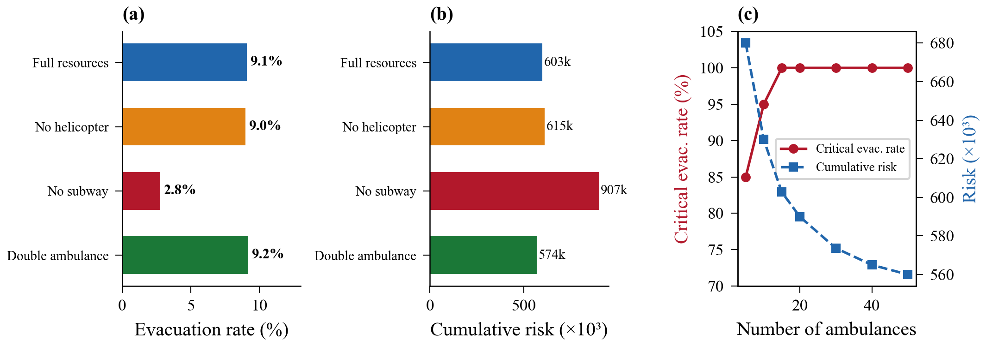
Fig. 3. Evacuation optimization results: (a) Comparison of evacuation completion rates; (b) Comparison of cumulative risks; (c) Ambulance sensitivity.
> **Table 7. Evacuation scheme comparison**
> | Scheme | Evacuated | Not evacuated | Evacuation rate (%) | Cumulative risk |
> |---|---|---|---|---|
> | ERPG zoning + flexible priority (baseline) | 5,671 | 8,159 | 40.1 | 85,694 |
> | No helicopters | 5,565 | 8,265 | 40.2 | 91,153 |
> | No metro | 5,371 | 8,459 | 38.8 | 84,845 |
> | Strict priority | 5,671 | 8,159 | 40.1 | 85,694 |
- Discussion
  - Asymmetric resilience between supply distribution and evacuation
The resilience assessment reveals a pronounced asymmetric performance pattern: supply distribution exhibits high resilience (91.4% completion rate, 100% on-time delivery of life-rescue supplies), whereas k=1 critical-casualty evacuation shows a clear bottleneck (2.8% completion). Meanwhile, ERPG-based zoning enables k=2 vulnerable groups to achieve 100% evacuation, with an overall evacuation rate of 41.0%. The root cause of this asymmetry is the mismatch between fleet structure and demand: k=1 victims may use only ambulances and helicopters (18 vehicles total), but the k=1 population estimated at 2% in the ERPG-1 zone reaches approximately 8,100—far beyond the capacity of dedicated emergency-medical assets. Shelter-in-place demand also increases the supply workload by 75% (40 to 70 tasks), with 6 tasks left unfinished due to bulk protection-equipment requirements. This finding suggests that, in urban hazmat-incident preparedness, the pre-positioning of dedicated emergency-medical capacity (especially ambulances and helicopters) and the layout of emergency warehouses deserve higher priority.
  - The decisive role of critical infrastructure
Under the ERPG zoning strategy, the metro's evacuation contribution is substantial but easily underestimated. Removing the metro reduces the evacuation rate from 41.0% to 38.8% (2.2 percentage points), confirming that even when k=1 (ambulance/helicopter only) and k=2 dominate, the metro provides important supplementary capacity for k=2 and k=3. Moreover, the value of the metro should not be undervalued: (1) under larger-scale incidents (e.g., ERPG-3 covering dense residential clusters) or full-population evacuation, large numbers of k=3 individuals would rely on metro throughput; (2) shelter-in-place residents may spontaneously gather at metro stations, where the metro's high-capacity service (1,200 passengers per train, 15 trains per 180 min) becomes irreplaceable. This is consistent with the conclusions of Abdelgawad and Abdulhai[10] on the importance of high-capacity public transport in multimodal evacuation. In practice, this calls for cities to establish rapid emergency-dispatch protocols for the metro system to ensure prompt activation of emergency operations after a hazmat incident.
  - Applicability boundary of truck-drone coordination
Under the ERPG zoning strategy, shelter-in-place demand increases relay deliveries from 0 to 34 tasks. However, the truck-drone scheme yields a counterintuitive negative result: its makespan (59.9 min) is 26.6% higher than the truck-only scheme (47.3 min), and it completes 2 fewer tasks. Analysis reveals three causes: (1) under the new POI filtering scheme based on exact sub-category matching, the number of fire stations drops from 1,032 to 331 genuine fire authorities, substantially tightening the supply-point pool; (2) the road-closure ratio is only 19.1%, so direct routes remain feasible for most demand points; and (3) the greedy construction algorithm has a relay-trigger threshold that is too low, causing many tasks that could be delivered directly to be erroneously assigned to relay (34 vs. the original 4). This negative result is highly consistent with the conclusion of Zhang et al.[8] that drones add value primarily under large-scale road-network damage. Practical implication: in lightly damaged scenarios, scheduling algorithms should preserve direct-delivery priority and trigger relay only when direct travel time exceeds a threshold or the destination lies inside the closure zone. As damage intensifies (e.g., explosions causing 2-3 km closures, simultaneous multi-point incidents), the advantages of relay delivery will become more pronounced.
  - Policy implications of layered evacuation strategies
The 41.0% overall evacuation rate must be interpreted in light of the ERPG zoning strategy's design logic. Its core principle is "response on demand" rather than "full evacuation"—mandatory evacuation is enforced only for high-risk groups in high-concentration zones, while others shelter in place and are protected via supply distribution. This reduces the evacuation population from 235,000 to 13,800, allowing the limited fleet to focus on those most in need; consequently, k=2 vulnerable groups achieve 100% evacuation. The 2.8% k=1 evacuation rate reveals a key bottleneck: the ERPG-1 zone (mild-discomfort level) is estimated to contain 8,100 critically injured victims under a 2% rate, but the actual critical-injury proportion at low concentrations should be far lower. Future work should develop concentration-dependent critical-injury models (e.g., 5% in ERPG-3, 1% in ERPG-2, and 0.2% in ERPG-1) to make k=1 estimates more realistic. The 413,000 shelter-in-place population's supply needs (gas masks, drinking water, etc.) and the evacuation flow form a genuine "centripetal-centrifugal" coordination, validating the necessity of the dual-chain coupling framework.
  - Limitations
This study has the following limitations. (1) The greedy heuristic with local search is computationally efficient but does not guarantee global optimality; future work should explore exact mixed-integer programming or metaheuristics such as adaptive large neighborhood search. (2) Population spatial distribution is based on mobile-phone positioning data, with age structure assumed uniform within districts; introducing building-level population models would improve evacuation-demand estimation. (3) The static Gaussian plume model cannot capture time-varying release rates or complex terrain effects; coupling with computational fluid dynamics (CFD) would enhance dispersion accuracy. (4) Congestion effects are estimated only via a static BPR function, without considering dynamic traffic-flow feedback; coupling with mesoscopic or microscopic traffic simulation is recommended. (5) Affected population is counted within a 3 km circular zone, not precisely matched to the actual fan-shaped Gaussian plume coverage, which may overestimate evacuation demand. The evacuation dispatch uses strict priority and does not reserve capacity for lower-priority groups; future work could explore flexible priority mechanisms with capacity quotas.
- Conclusions
  - Main findings
This study develops a coordinated optimization framework for emergency supply distribution and multi-type personnel evacuation, applied to a hypothetical chlorine release at the Taihe Bridge Interchange on the Beijing Sixth Ring Road. The main findings are: (1) The ERPG-based differentiated response strategy effectively focuses evacuation resources, reducing the evacuation population from 235,000 to 13,800; the supply-distribution workload increases by 75% (40 to 70 tasks) due to shelter-in-place demand from 413,000 people, forming a substantive "centripetal-centrifugal" coupling between distribution and evacuation. (2) The baseline scheme achieves a 41.0% evacuation rate, with k=2 vulnerable groups fully evacuated, but k=1 critically injured victims reach only 2.8%—the bottleneck being the structural mismatch between dedicated emergency-medical capacity and the estimated critical-casualty population in distant low-concentration zones. (3) Priority-based scheduling effectively protects vulnerable groups, with the overall ERPG-2 evacuation rate reaching 93.1%; concentration-dependent critical-injury modelling is a key direction for improving k=1 estimation accuracy. (4) The transportation system exhibits a structural asymmetric resilience pattern—high functional resilience in supply distribution (91.4% completion, 100% on-time life-rescue) but constrained by inventory, with severely insufficient k=1 emergency capacity (2.8%); targeted increases in ambulance and helicopter resources and optimization of emergency warehouse layout are required. Notably, the truck-drone scheme exhibits an unexpected negative outcome under lightly damaged road networks (makespan +26.6%), revealing the applicability boundary of relay delivery.
  - Policy recommendations
(1) Develop and refine emergency-operation protocols for the metro system, ensuring rapid activation of emergency service after a hazmat incident. (2) Adopt layered evacuation: mandatory evacuation within the 1 km core zone, shelter-in-place with protective-equipment distribution in the 1-3 km outer zone. (3) Pre-position helicopter assets along high-risk corridors to enable rapid transport of critical casualties. (4) Invest in drone infrastructure: under more severe damage conditions, the advantages of relay delivery will become more pronounced. (5) Integrate real-time wind monitoring with evacuation planning to dynamically update hazard zones and trigger zone-based evacuation orders based on meteorological data.
  - Future research
Future work can be extended in the following directions: (1) adopt exact MIP methods to provide optimality benchmarks for small instances, or use metaheuristics such as adaptive large neighborhood search (ALNS) for realistic-scale problems; (2) couple CFD models to improve dispersion accuracy; (3) couple mesoscopic or microscopic traffic simulation for more realistic dynamic travel-time estimation; (4) introduce building-level population models for evacuation demand estimation; (5) calibrate fleet and inventory parameters against actual emergency plans; (6) design flexible-priority dispatch strategies with capacity quotas, reserving evacuation capacity for general population while protecting vulnerable groups, and refine evacuation demand statistics based on ERPG isolines.
Acknowledgments
This research is supported by the National Key Research and Development Program of China (Grant Nos. 2021YFA1000300, 2021YFA1000303).

References
- Farahani RZ, Lotfi MM, Baghaian A, Ruiz R, Rezapour S. Mass casualty management in disaster scene: A systematic review of OR&MS research in humanitarian operations. European Journal of Operational Research. 2020;287(3):787-819. doi: https://doi.org/10.1016/j.ejor.2020.03.005.
- Özdamar L, Ertem MA. Models, solutions and enabling technologies in humanitarian logistics. European Journal of Operational Research. 2015;244(1):55-65. doi: /10.1016/j.ejor.2014.11.030.
- Ke GY. Managing reliable emergency logistics for hazardous materials: A two-stage robust optimization approach. Computers & Operations Research. 2022;138:105557. doi: https://doi.org/10.1016/j.cor.2021.105557.
- Murray CC, Chu AG. The flying sidekick traveling salesman problem: Optimization of drone-assisted parcel delivery. Transportation Research Part C: Emerging Technologies. 2015;54:86-109. doi: https://doi.org/10.1016/j.trc.2015.03.005.
- Agatz N, Bouman P, Schmidt M. Optimization Approaches for the Traveling Salesman Problem with Drone. Transportation Science. 2018;52(4):965–81. doi: 10.1287/trsc.2017.0791.
- Chung SH, Sah B, Lee J. Optimization for drone and drone-truck combined operations: A review of the state of the art and future directions. Computers & Operations Research. 2020;123:105004. doi: https://doi.org/10.1016/j.cor.2020.105004.
- Li H, Chen J, Wang F, Bai M. Ground-vehicle and unmanned-aerial-vehicle routing problems from two-echelon scheme perspective: A review. European Journal of Operational Research. 2021;294(3):1078-95. doi: https://doi.org/10.1016/j.ejor.2021.02.022.
- Zhang L, Ding Y, Lin H. Optimizing synchronized truck-drone delivery with priority in disaster relief. Journal of Industrial and Management Optimization. 2023;19(7):5143-62. doi: 10.3934/jimo.2022166.
- Hamacher H, Tjandra S. Mathematical Modeling of Evacuation Problems: A State of The Art. Pedestrian and Evacuation Dynamics. 2002;2002.
- Abdelgawad H, Abdulhai B. Managing Large-Scale Multimodal Emergency Evacuations. Journal of Transportation Safety & Security. 2010;2:122-51. doi: 10.1080/19439962.2010.487636.
- Yoon S, Albert LA. Dynamic dispatch policies for emergency response with multiple types of vehicles. Transportation Research Part E: Logistics and Transportation Review. 2021;152:102405. doi: https://doi.org/10.1016/j.tre.2021.102405.
- Lei, B., Xun, T., Hao, Y., et al. (2023). Emergency evacuation route optimization for transfer stations in urban rail transit during sudden incidents. Journal of Safety Science and Technology, 19(5), 186-193.
- Yang, Y., Chen, J., Yao, E., et al. (2026). Resilience assessment method for external transport networks of comprehensive passenger hub clusters under time-varying demand. Journal of Traffic and Transportation Engineering, 26(2), 155-169.
- Zhang, Y., Pei, H., & Yao, D. (2022). A review of cooperative decision-making for vehicle groups in connected vehicle environments. Journal of Traffic and Transportation Engineering, 22(3), 1-19.
- Pasquill F. Atmospheric Diffusion: The Dispersion of Windborne Material from Industrial and Other Sources: E. Horwood; 1974.
- Briggs GA. Diffusion estimation for small emissions. Preliminary report. United States: National Oceanic and Atmospheric Administration, Oak Ridge, Tenn. (USA). Atmospheric Turbulence and Diffusion Lab., 1973 Contract No.: TID-28289.
- Craig DK, Davis JS, Hansen DJ, Petrocchi AJ, Powell TJ, Tuccinardi TE, Jr. Derivation of temporary emergency exposure limits (TEELs). J Appl Toxicol. 2000;20(1):11-20. doi: 10.1002/(sici)1099-1263(200001/02)20:1<11::aid-jat622>3.0.co;2-q. PubMed PMID: 10641012.

