Coordinated Optimization of Emergency Supply Distribution and Multi-Type Personnel Evacuation under Hazardous-Material Vehicle Incidents on Urban Freeways
Liang Wang^{1,2}[0000-0003-3987-6678], Yu Guan², He Wei² and Xiaodong Zhang^{2*}
¹ School of Economics and Management, Beijing Jiaotong University, Beijing 100044, China
² Beijing Municipal Institute of City Planning and Design, Beijing 100045, China
zhang-xd23@mails.tsinghua.edu.cn
Abstract. Hazardous-material incidents on urban freeways trigger compound disasters requiring coordinated supply distribution and evacuation. Using a hypothetical chlorine release on Beijing's Sixth Ring Road, this study develops an integrated framework that combines Gaussian-plume ERPG zoning with co-optimization of a truck-drone logistics network and a five-mode evacuation fleet across three vulnerability classes. ERPG-based zoning reduces the active evacuation population from 235,000 to 13,800, while shelter-in-place demand raises supply tasks from 40 to 70. Under lightly damaged roads, the truck-only scheme outperforms the truck-drone scheme, exposing the applicability boundary of relay delivery. Vulnerable groups achieve 100% evacuation, but critically injured victims reach only 2.8%, revealing a structural medical-fleet bottleneck. The framework uncovers an asymmetric "high-supply / low-evacuation" resilience pattern that informs urban emergency decisions.
Keywords: Emergency Logistics, Truck-drone Coordination, Multi-type Evacuation, Hazardous-material Incidents, Urban Expressways, Transportation Resilience.
- Introduction
Urban freeways carry both commuter and freight flows and serve as principal corridors for hazardous-material (hazmat) transportation. When an incident occurs, consequences such as toxic gas release or explosion can trigger compound disasters that require coordinated multi-agency response[1]. Recent accidents in China—e.g., the 2005 Huai'an liquid-chlorine rollover (29 deaths, ~10,000 evacuated) and the 2020 Wenling tanker explosion (20 deaths)—expose the vulnerability of urban transport networks. On the Beijing Sixth Ring Road, the densely populated Taihe Bridge segment, concentrated with critical infrastructure, is a high-risk node.
Emergency logistics has been extensively reviewed[1, 2], with recent work addressing demand uncertainty and link disruption[3]. Truck-drone coordination, originating from the flying-sidekick TSP[4, 5] and surveyed in[6, 7], has been extended to disaster relief with priority mechanisms[8]. Evacuation modeling has evolved from network-flow formulations[9] to multimodal frameworks[10] and dynamic multi-vehicle dispatch[11], complemented by domestic studies on urban rail evacuation[12], network resilience[13], and cooperative control[14]. For hazard-zone evaluation, the Gaussian plume model combined with the Pasquill-Gifford stability classification and the ERPG threshold system remains the standard practical framework.
However, most existing studies treat supply distribution and personnel evacuation as independent problems[1, 3], overlooking their interdependence in resource competition, temporal coupling, and spatial interaction. This study develops a coordinated framework that jointly optimizes both. The contributions are: (1) joint optimization of supply distribution (truck-drone coordination, four priorities, time windows) and multi-type evacuation (five modes, three vulnerability classes) under a unified scenario; (2) a high-fidelity simulation environment built on multi-source urban data; and (3) practical guidance on pre-positioning, fleet sizing, and multimodal coordination.
- Study Area and Data
  - Study Area
The Taihe Bridge Interchange (116.494°E, 39.736°N) on the southeastern Sixth Ring
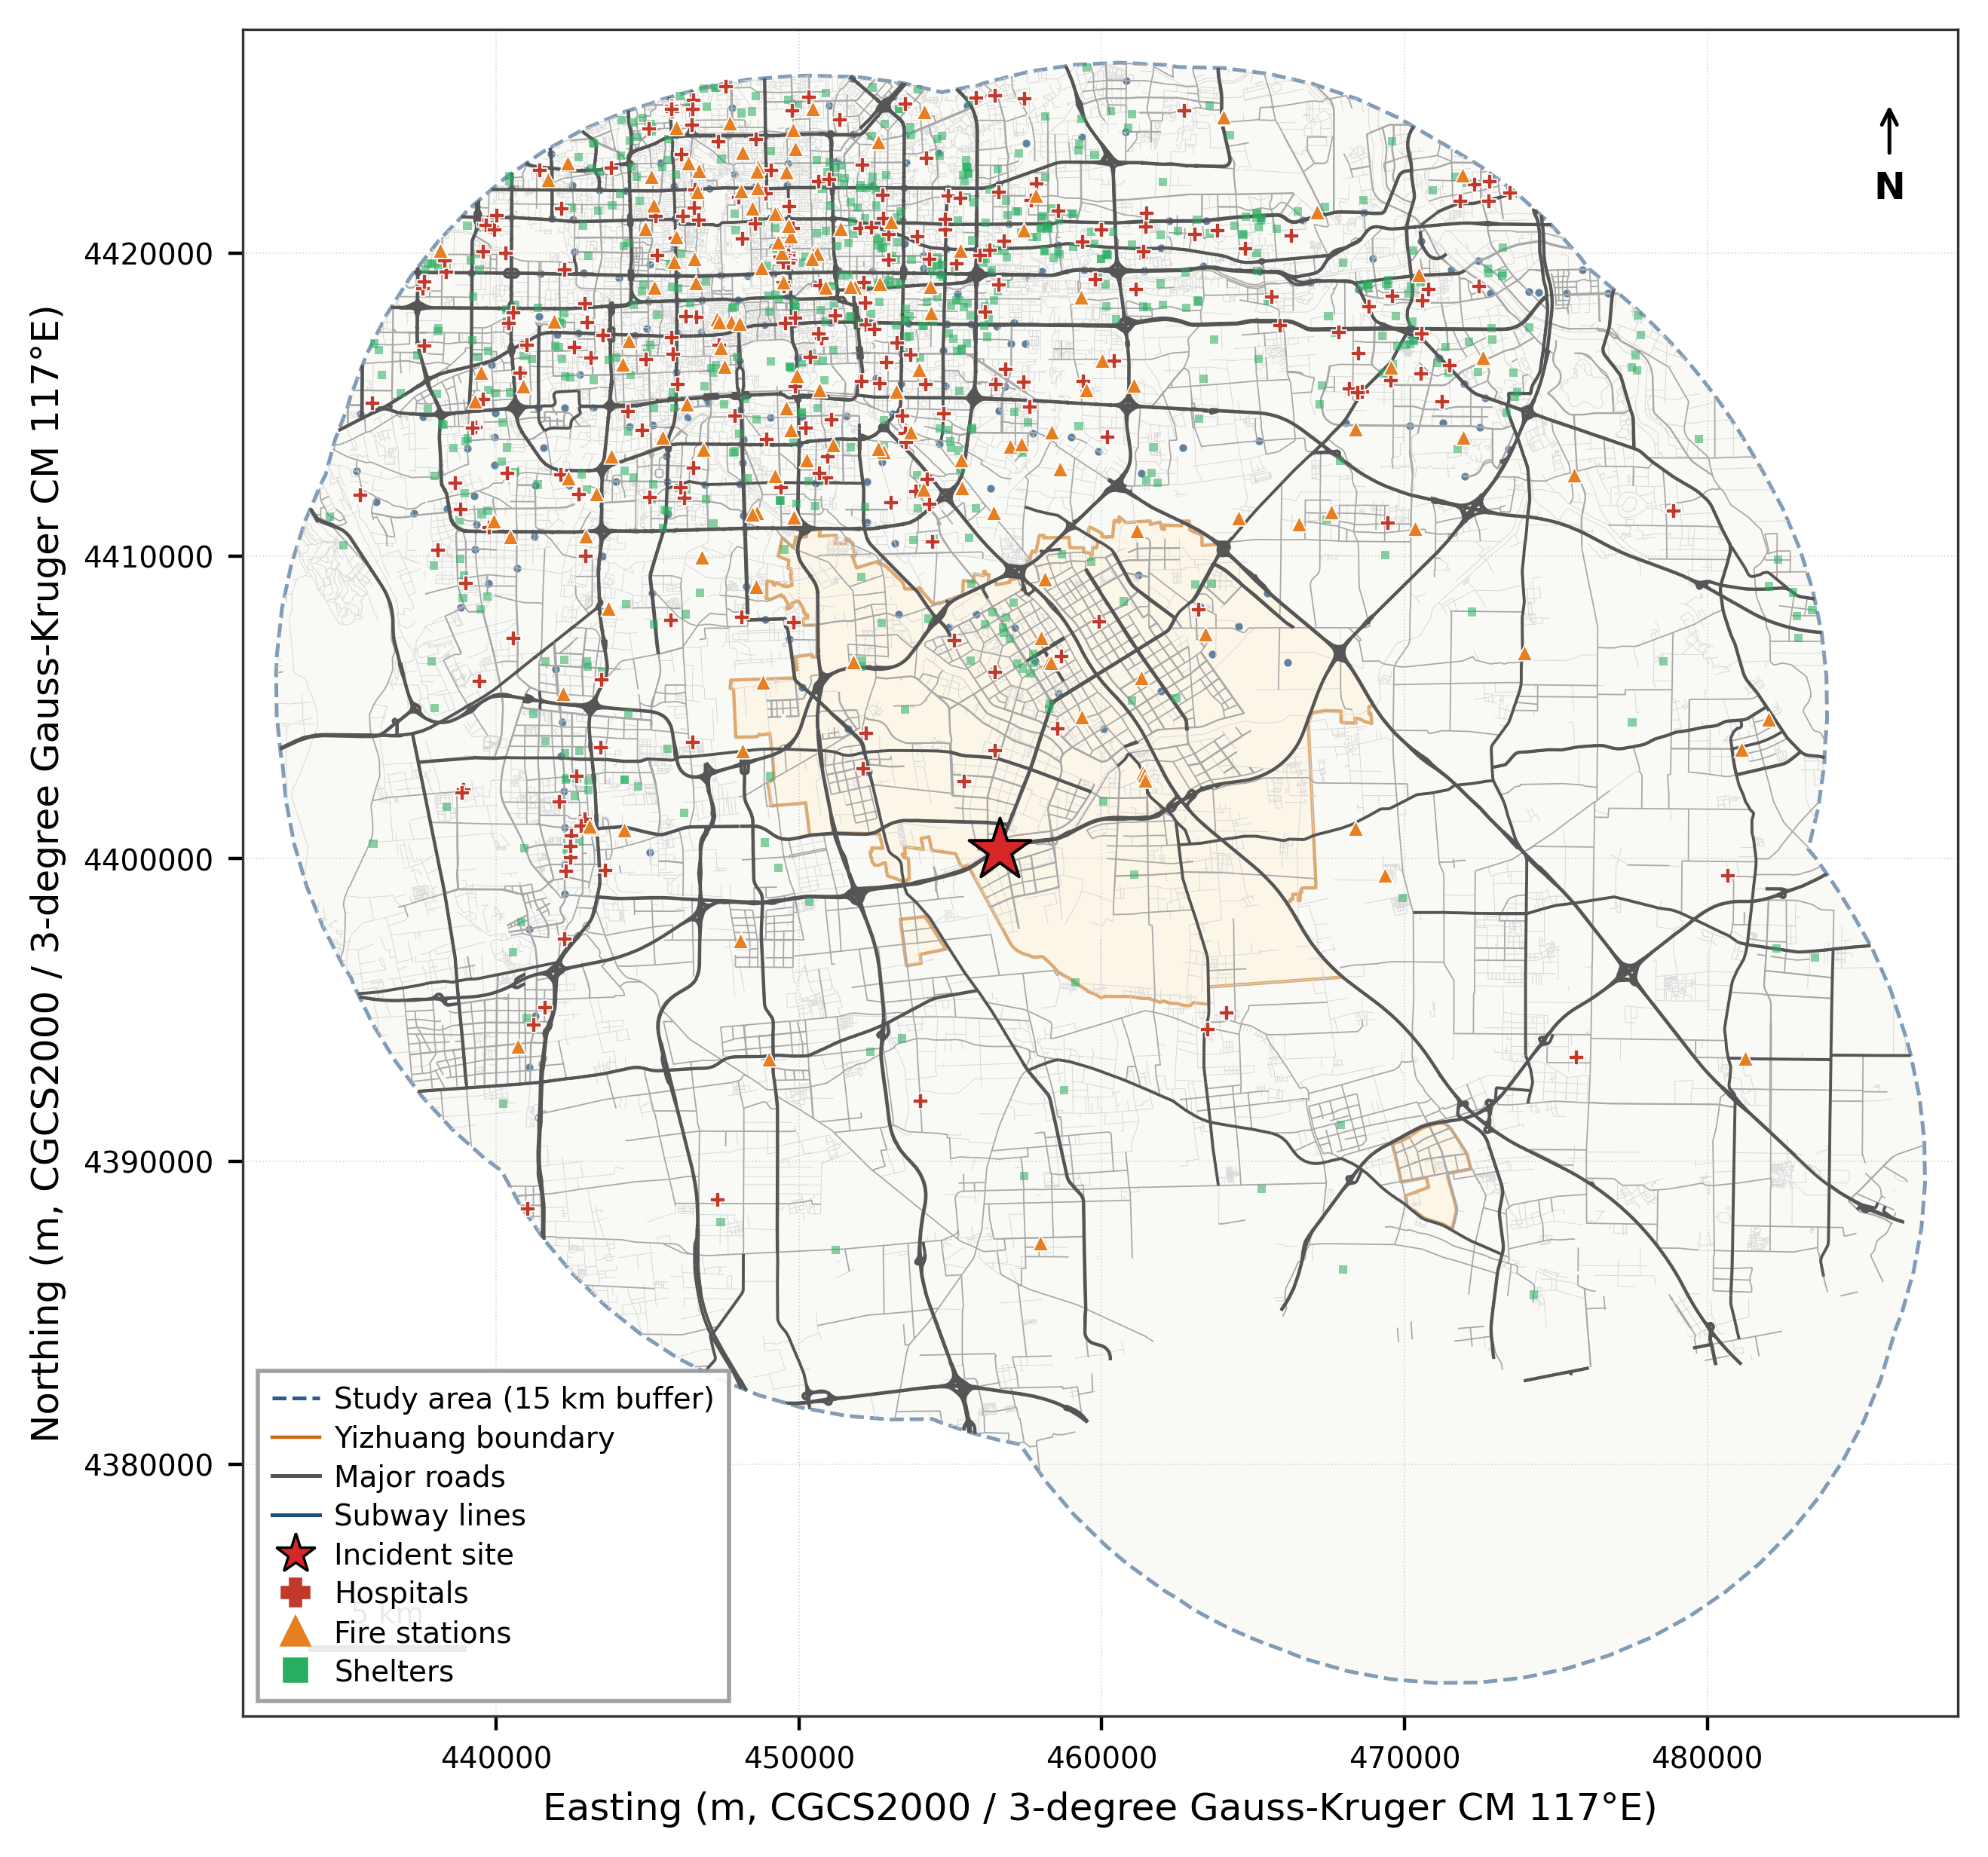
Fig. 1. Overview of the study area showing the road network and emergency facilities.
Road is selected as the incident epicenter. We define a 15-km buffer area covering approximately 707 km² to ensure full coverage of potential toxic gas impacts and surrounding emergency facilities. Figure 1 shows the spatial extent of the study area, the road network, and the distribution of emergency facilities.
  - Data Sources
This study integrates seven categories of multi-source urban data to construct a high-fidelity simulation environment. The sources, temporal coverage, spatial precision, and key attributes of each dataset are summarized in Table 1.
Table 1. Summary of data sources.
Data category | Source | Spatial precision | Key attributes
Road network | OpenStreetMap | Segment level | Functional class, speed limit, direction
Points of interest | Amap (Gaode) | Point | Sub-category, name, WGS84 coordinates
Population spatiotemporal distribution | Baidu mobile-phone positioning | 100 m grid | Hourly OD flows, commuting modes
Block-level population | Baidu LBS | Block | Resident population count
Age structure | Seventh National Population Census (2020) | District/county | Age-sex distribution by 5-year cohort
Commuting patterns | Baidu mobile-phone positioning | 100 m grid | Modal split (car, metro, bus, etc.)
Administrative boundaries | Planning authority | Polygon | Yizhuang Development Area regulatory boundary
  - Research Framework
As shown in Fig. 2, we adopt a three-layer "scenario-driven, dual-chain coordination, resilience assessment" framework. Layer 1 uses the Gaussian plume model to simulate chlorine dispersion and generate a damaged road network with affected population as shared inputs. Layer 2 couples two optimization chains on this network: a "centripetal" supply chain (truck-drone logistics minimizing makespan and time-window penalties) and a "centrifugal" evacuation chain (multimodal dispatch minimizing weighted evacuation time and risk exposure). Layer 3 assesses structural resilience (closure length and ratio), functional resilience (supply and evacuation completion rates, cumulative risk exposure), and adaptive resilience (marginal gains from interventions such as truck-drone relay or fleet expansion).
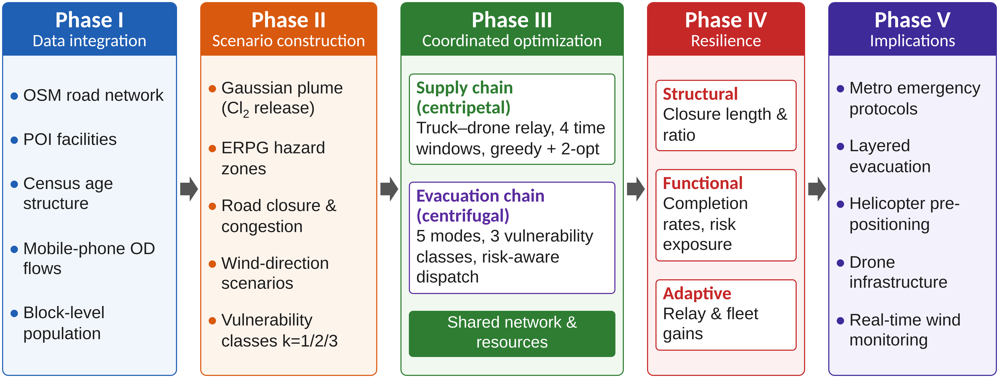
Fig. 2. Technical roadmap of the coordinated emergency response framework: scenario-driven, dual-chain coordination, and resilience assessment.
- Methodology
  - Scenario Modelling
Chlorine atmospheric dispersion is simulated using the Gaussian plume model, a standard approach for studying the transport of airborne contaminants due to turbulent diffusion and advection by the wind. The scenario assumes a 5 kg/min release rate with a 3.0 m/s southwest wind. Hazard zones are defined by the Emergency Response Planning Guidelines (ERPG) of the American Industrial Hygiene Association. ERPG-2 is the maximum airborne concentration below which it is believed that nearly all individuals could be exposed for up to 1 hour without experiencing or developing irreversible or other serious health effects. Accordingly, the ERPG-3, ERPG-2 and ERPG-1 contours delimit a core zone (mandatory evacuation), a warning zone (urgent evacuation) and an influence zone (shelter-in-place). We also incorporate BPR-based traffic congestion effects and a 1 km core road-closure zone.
  - Emergency Supply Distribution Model
We construct a three-tier logistics network comprising supply points, transshipment hubs, and demand points. Supplies are classified into four priority categories, including life-rescue supplies with strict 30-min hard time windows. A two-stage algorithm (greedy construction and 2-opt local search) evaluates both direct truck and relay (truck-drone) deliveries; relay is triggered when the destination lies inside the closure zone or the direct truck travel time exceeds a threshold. The objective minimizes a weighted sum of makespan, time-window penalties, and unmet demand, with the unmet-demand penalty applied per missed task and weighted by priority class. Model parameters are calibrated to historical tanker incidents and the actual emergency-resource inventory of the study area; the 2% k=1 share in ERPG-1 is a conservative upper bound. Travel times on the damaged network are obtained with Dijkstra's algorithm, an algorithm for finding the shortest paths between nodes in a weighted graph, which may represent, for example, a road network.
  - Multi-type Evacuation Model
A risk-aware time-stepping dispatch model coordinates five transport modes: ambulances, helicopters, buses, private cars, and metros. Dispatch occurs in 5-min steps over a 180-min horizon. The algorithm prioritizes evacuees dynamically based on vulnerability class (k=1 first) and real-time risk exposure. It minimizes weighted evacuation time, dynamic risk exposure, and unmet-demand penalties.
- Case Study and Numerical Results
  - Incident Scenario Configuration
Within the 1 km core-closure zone, 96.7 km of road is closed, accounting for 19.1% of the total road length (505.3 km) within the 5 km influence zone. Based on ERPG concentration contours (after buffering), three response zones are delineated: the ERPG-2 warning zone (≥3 mg/m³ buffer) contains approximately 19,700 people, and the ERPG-1 influence zone (≥1 mg/m³ buffer) contains approximately 407,000 people. Under differentiated zoning, about 13,800 people require active evacuation (k=1 and k=2 in the ERPG-2 zone, plus k=1 in the ERPG-1 zone), while about 413,000 shelter in place.
  - Wind-direction Sensitivity Analysis
Four wind scenarios (225° baseline; 0°; 90°; and 225° at 8 m/s) confirm that wind direction decisively shifts which population centers and infrastructure clusters fall within hazard zones, underscoring the need for real-time meteorological integration.
  - Supply Distribution Results
Table 2 compares the supply-distribution schemes. Shelter-in-place demand from ~413,000 people increases the workload from 40 to 70 tasks, evidencing the substantive coupling between evacuation and distribution. The truck-only scheme completes 61 tasks (87.1%), with all life-rescue supplies delivered within the 30-min hard time window. The truck-drone scheme adds 4 relay tasks covering demand points inside the closure zone, but completes 1 fewer task and its makespan rises from 47.3 to 59.9 min (+26.6%) because relay consumes vehicle time. The drone-only scheme is infeasible since most supplies exceed the 25 kg drone payload limit. The 6 unfinished tasks are bulk protection-equipment deliveries limited by supply-point inventory.
Table 2. Supply delivery scheme comparison.
Scheme | Completed | Makespan | Mean time (min) | Penalty | Direct | Relay | Improvement
Truck-only | 61 | 47.3 | 24.2 | 0 | 61 | 0 | —
Truck–UAV | 60 | 47.3 | 25.6 | 0 | 56 | 4 | 0%
UAV-only | 0 | — | — | — | 0 | 0 | —
Cooperative (doubled UAVs) | 60 | 47.3 | 25.6 | 0 | 56 | 4 | 0%
  - Evacuation Results
Figure 3 compares evacuation schemes. The ERPG zoning strategy reduces the actively evacuated population from 235,000 (traditional circular range) to 13,800; the baseline achieves 41.0% within 180 min (5,671 evacuees), substantially above the 9.1% without zoning. All 5,302 k=2 vulnerable evacuees in the ERPG-2 zone are fully evacuated (100%), and the overall ERPG-2 rate reaches 93.1%, validating priority-based scheduling. However, k=1 critically injured victims become a new bottleneck: limited to ambulances and helicopters, the estimated 8,100 k=1 population in the ERPG-1 zone (at 2%) far exceeds the capacity of 15 ambulances and 3 helicopters, yielding only a 2.8% rate (243 evacuees). Removing helicopters lowers the rate to 40.2% and raises cumulative risk by 6.4% (85,694 → 91,153), while removing the metro lowers it to 38.8%.
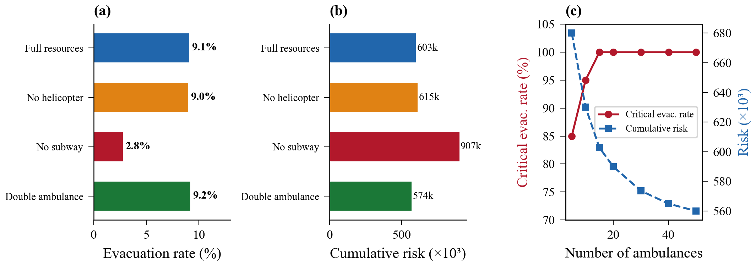
Fig. 3. Evacuation optimization results: (a) Comparison of evacuation completion rates; (b) Comparison of cumulative risks; (c) Ambulance sensitivity.
- Discussion
  - Asymmetric Resilience between Supply Distribution and Evacuation
The system shows a pronounced asymmetric resilience pattern: supply distribution achieves high functional resilience, while k=1 critical-casualty evacuation forms a sharp structural bottleneck. The root cause is that k=1 demand (~8,100) far exceeds the dedicated medical capacity (18 ambulances and helicopters). Pre-positioning of dedicated emergency-medical assets and emergency-warehouse layout therefore deserve top priority in urban hazmat preparedness.
  - The Decisive Role of Critical Infrastructure
The metro's evacuation contribution is easily underestimated: removing it lowers the rate by 2.2 percentage points (41.0% → 38.8%), confirming its supplementary role for k=2/k=3 even when k=1 and k=2 dominate. Its value grows under larger-scale incidents where k=3 throughput becomes critical and residents gather at stations, making high-capacity service (1,200 passengers per train) irreplaceable. Consistent with [10], this calls for rapid metro emergency-dispatch protocols.
  - Applicability Boundary of Truck-drone Coordination
The truck-drone scheme yields a counterintuitive negative result (Sect. 4.3). Three causes are identified: (i) stricter POI filtering reduces fire stations from 1,032 to 331, tightening the supply-point pool; (ii) the road-closure ratio is only 19.1%, leaving direct routes feasible; and (iii) the relay-trigger threshold is too low, mis-assigning tasks to relay. This is consistent with [8] that drones add value mainly under large-scale damage. In lightly damaged scenarios, schedulers should prioritize direct delivery.
- Conclusions
  - Main Findings
Applied to a hypothetical chlorine release at Beijing's Taihe Bridge, the coordinated framework yields three findings: (1) ERPG-based zoning cuts evacuees from 235k to 13.8k while raising supply tasks 75% (40→70), forming a "centripetal-centrifugal" coupling. (2) The system shows asymmetric resilience—87.1% supply completion and 100% life rescue, but only 2.8% k=1 evacuation. (3) Truck-drone relay is not universally beneficial: under lightly damaged networks (19.1% closure), it increases makespan by 26.6%. Future work should refine injury models across scenarios.
  - Policy Recommendations
(1) Establish metro emergency-operation protocols for rapid activation after a hazmat incident. (2) Adopt layered evacuation: mandatory within the 1 km core zone and shelter-in-place with protective equipment in the 1-3 km outer zone. (3) Pre-position helicopters along high-risk corridors for critical casualties. (4) Invest in drone infrastructure for severe-damage conditions. (5) Integrate real-time wind monitoring to dynamically update hazard zones and evacuation orders.
Acknowledgments. This study was funded by the National Key Research and Development Program of China (Grant Nos. 2021YFA1000300, 2021YFA1000303).
Disclosure of Interests. The authors have no competing interests to declare that are relevant to the content of this article.

References
- Farahani RZ, Lotfi MM, Baghaian A, Ruiz R, Rezapour S. Mass casualty management in disaster scene: A systematic review of OR&MS research in humanitarian operations. European Journal of Operational Research. 2020;287(3):787-819. doi: /10.1016/j.ejor.2020.03.005.
- Özdamar L, Ertem MA. Models, solutions and enabling technologies in humanitarian logistics. European Journal of Operational Research. 2015;244(1):55-65. doi: /10.1016/j.ejor.2014.11.030.
- Ke GY. Managing reliable emergency logistics for hazardous materials: A two-stage robust optimization approach. Computers & Operations Research. 2022;138:105557. doi: /10.1016/j.cor.2021.105557.
- Murray CC, Chu AG. The flying sidekick traveling salesman problem: Optimization of drone-assisted parcel delivery. Transportation Research Part C: Emerging Technologies. 2015;54:86-109. doi: /10.1016/j.trc.2015.03.005.
- Agatz N, Bouman P, Schmidt M. Optimization Approaches for the Traveling Salesman Problem with Drone. Transportation Science. 2018;52(4):965–81. doi: 10.1287/trsc.2017.0791.
- Chung SH, Sah B, Lee J. Optimization for drone and drone-truck combined operations: A review of the state of the art and future directions. Computers & Operations Research. 2020;123:105004. doi: /10.1016/j.cor.2020.105004.
- Li H, Chen J, Wang F, Bai M. Ground-vehicle and unmanned-aerial-vehicle routing problems from two-echelon scheme perspective: A review. European Journal of Operational Research. 2021;294(3):1078-95. doi: /10.1016/j.ejor.2021.02.022.
- Zhang L, Ding Y, Lin H. Optimizing synchronized truck-drone delivery with priority in disaster relief. Journal of Industrial and Management Optimization. 2023;19(7):5143-62. doi: 10.3934/jimo.2022166.
- Hamacher H, Tjandra S. Mathematical Modeling of Evacuation Problems: A State of The Art. Pedestrian and Evacuation Dynamics. 2002;2002.
- Abdelgawad H, Abdulhai B. Managing Large-Scale Multimodal Emergency Evacuations. Journal of Transportation Safety & Security. 2010;2:122-51. doi: 10.1080/19439962.2010.487636.
- Yoon S, Albert LA. Dynamic dispatch policies for emergency response with multiple types of vehicles. Transportation Research Part E: Logistics and Transportation Review. 2021;152:102405. doi: /10.1016/j.tre.2021.102405.
- Lei, B., Xun, T., Hao, Y., et al. (2023). Emergency evacuation route optimization for transfer stations in urban rail transit during sudden incidents. Journal of Safety Science and Technology, 19(5), 186-193.
- Yang, Y., Chen, J., Yao, E., et al. (2026). Resilience assessment method for external transport networks of comprehensive passenger hub clusters under time-varying demand. Journal of Traffic and Transportation Engineering, 26(2), 155-169.
- Zhang, Y., Pei, H., & Yao, D. (2022). A review of cooperative decision-making for vehicle groups in connected vehicle environments. Journal of Traffic and Transportation Engineering, 22(3), 1-19.

