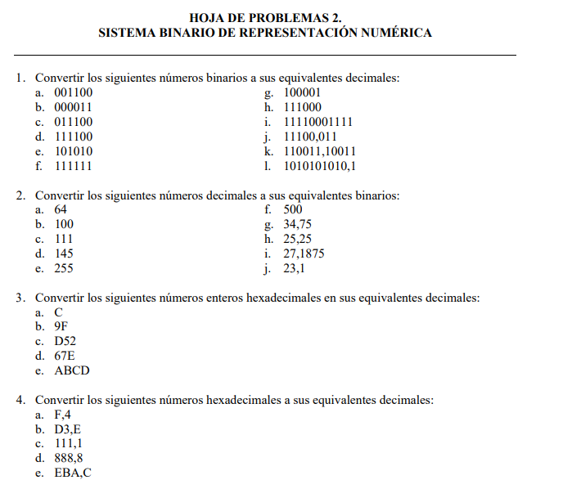

**1.**

a 001100 = 12

b.000011= 3

c.011100 = 28

d.111100 = 60

f.101010 = 42

g.111111 = 63

h.100001 = 33

i.111000 = 56

j.11110001111 =1935

k.11100.011= 28375

l.110011.10011 = 5159375

m.1010101010.1 = 6825

2.

64=1000000

100=1100100

111=1101111

145=10010001

255=11111111

500=111110100

3475=100010.11

2525=11001.01

271875=11011.0011

231=10111.0001100110

**3.**

C=12

9F=159

D52=3410

67E=1662

ABCD=43981

**4.**

F.4=15.25

D3.E=211.875

111.1=273.0625

888.8=2184.5

EBA.C=3770.75