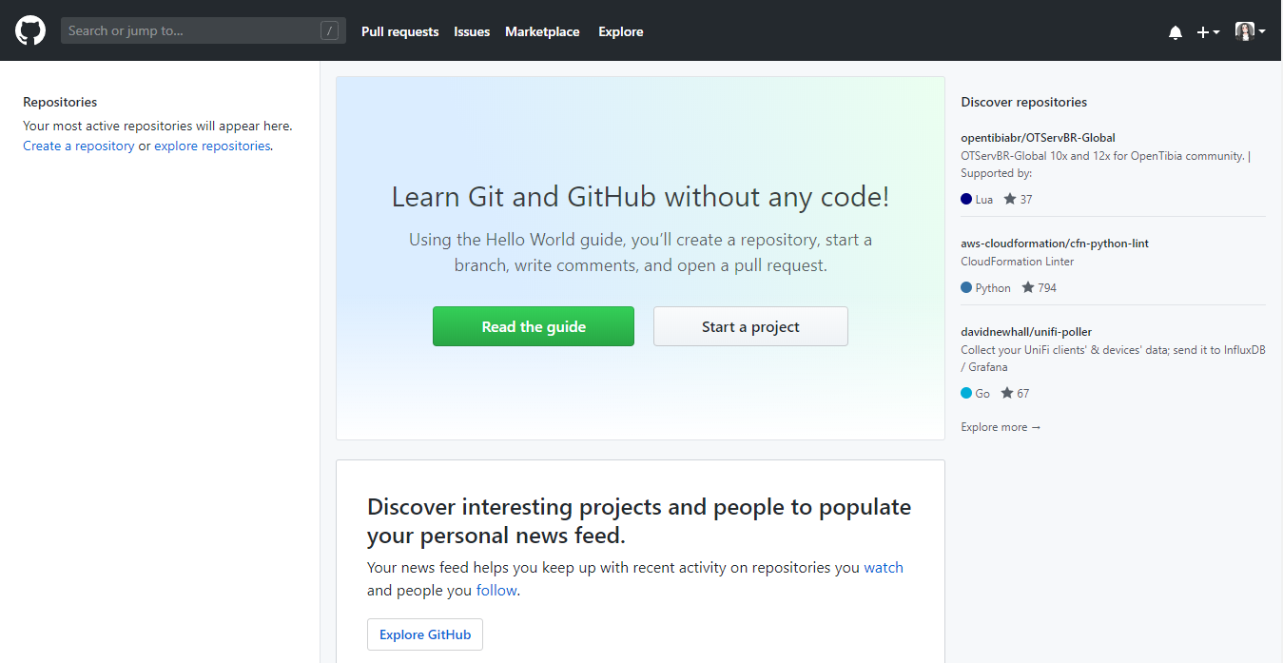**1. Create a GitHub account**

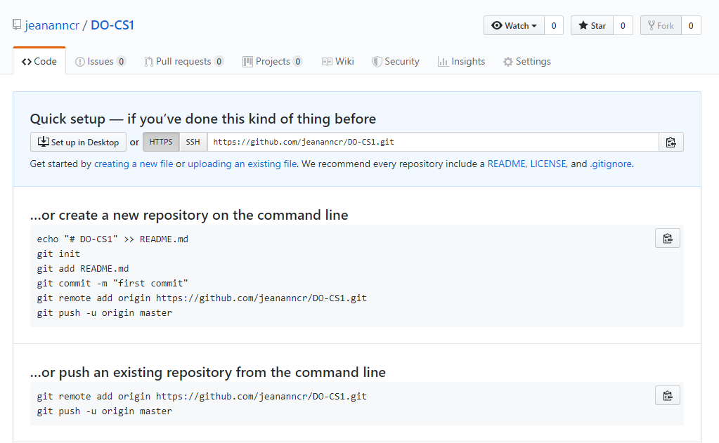**2. Create a repository**

**3. Create a folder**

**4. Connect your local folder to your GitHub Repository**

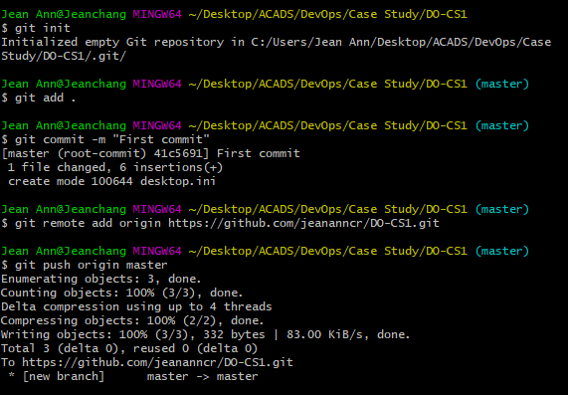

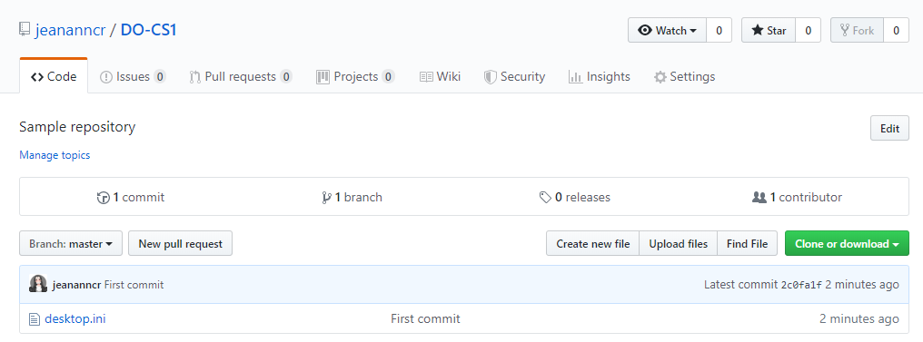

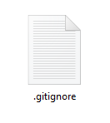**5. Create a “.gitignore” file**

**6. Create a file to be ignored**

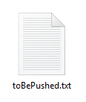**7. Create a new file and push it to the repository**

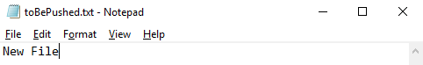

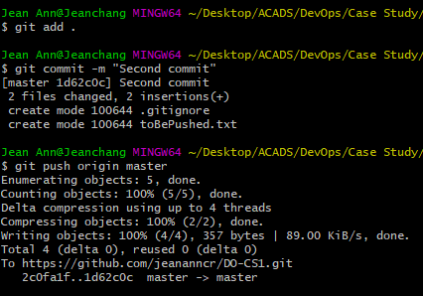

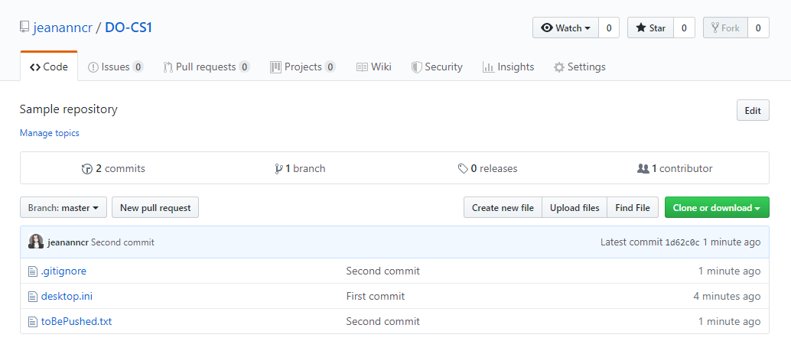

**8. Create a new branch.**

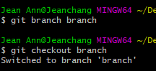

**9. Update the file in the newly created branch and push it to your repository**

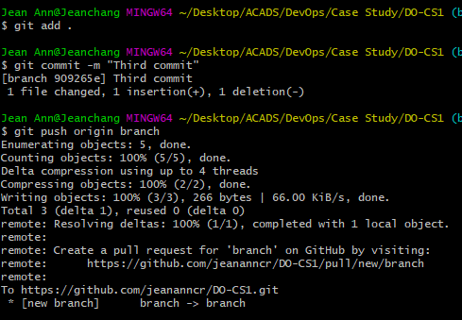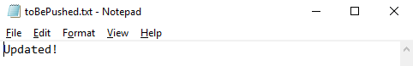

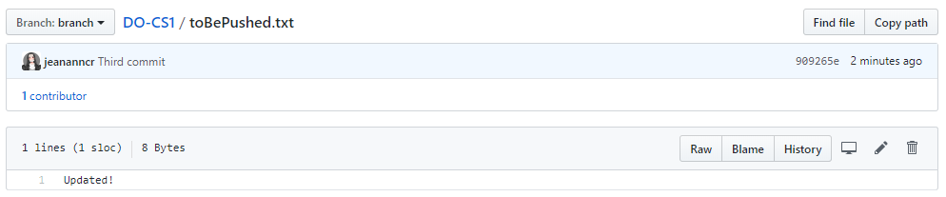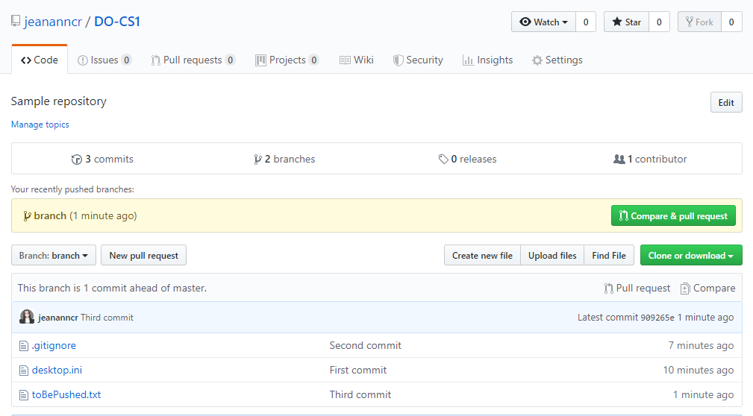

After

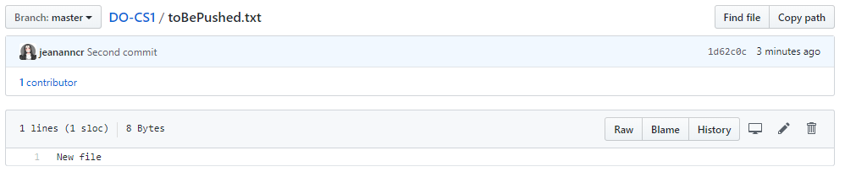

Before

**10. Merge the changes to the master branch.**

