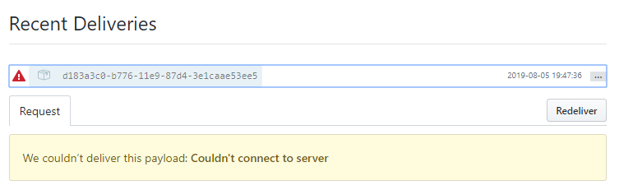**EXTRA**

Uh-oh, there’s an error on GitHub webhook.

What GitHub consider “local” is not your local machine, thus it won’t contact “localhost” or 127.0.0.1. They say you need to specify an IP address GitHub can contact over the internet—not just “localhost.” So, I’m going to install ngrok to expose localhost urls over the internet.

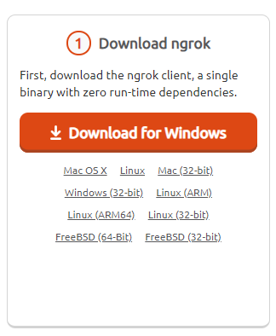**1.** Go to <https://ngrok.com/download> and choose a platform.

**2.** Unzip the downloaded package and place the ngrok.exe in a folder of your choosing. Make sure that the folder is in your PATH environment variable.

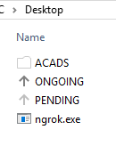

**3.** Open cmd, go to the folder where the ngrok.exe is and type “ngrok http <port no.>”.

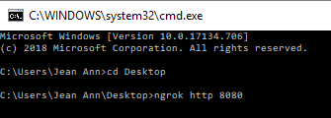

**4.** Ngrok will give you a temporary address and paste it on your web browser.

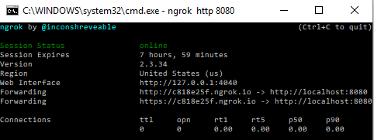

**5.** Log in to Jenkins.

**6.** Go to your Git repository -> **Settings** -> **Webhooks**, paste the temporary address and add “/github-webhook” on **Payload URL** field.

