

Research Project Proposal

Topic: Online Smart School Platform

**FACULTY**: Information Technology

**DEPARTMENT**: Networks and Communication Systems

**Prepared by:**

**Names:** NIZIGIYIMANA Armel

**Id:** #20162

**Phone**: 0785038816

**Email**: [nizigiarmel2015@gmail.com](mailto:nizigiarmel2015@gmail.com)

*Done at Kigali, On 5th* September, 2019

**I. Background of the Study**

Based on the old system a Lecturer teach and after students create a either a WhatsApp group, an email group or other brings flash disks to get notes of the material covered every week from the teacher and when doing evaluation or exam student wait for paper to get their marks. Also as the case study is Adventist University of Central Africa (Gishushu Campus), Information technology is a faculty where team work is key.

Let take this example to explain the old system:

Kamana and Keza are all students in IT and are taking Java course, Keza is a genius and Kamana is not, Kamana starts a java assignment at home and face an error, he has toc call Keza and ask him for help, Keza might not pick the phone or might not be able to fix the error, Kamana has to go to school and search for help from others students.

He might even reach at school Keza has no class that day, and because of many students are busy, Kamana didn’t get a help, now he is bored and wait for student who finished the assignment to give it to him and edit it and submit it. But he submit what he doesn’t understand.

**II. Project Objectives**

1. **General Objective**

The general objective of the **Smart School online platform** is to develop a web application that will allow lecturers and students to interact easily and make a flexible working environment.

**2. Specific Objectives**

Below are specific objectives of the new system:

* Reduce calls or sms from students claiming notes to lecturers
* Reduce calls and sms from students to genius students because it can be done online
* Reduce expenses for students who come to school to help other students
* Increase IT skills to the users because all questions can be seen by every user of the system avoid asking the same question many times
* Reduce expenses for students coming to school searching for help
* Reduce fear of asking for help because its’s an online system
* Getting notes at real time
* Reduce awareness because lecturer can post announcement

**III. Problem statement**

* ***Time consumption***
* When student need support he must come to school to search for help
* ***Lack of working environment***
* Because of the difficult working environment, student might drop school or change faculty.
* Because of lack of money to come to school every time you get an error, that causes many students to retake courses
* ***Selfishness***
* Genius students might get profit of other students and ask them money for help or other thing depending on the student
* ***Others***
* Many flash can corrupt lecturers’ computers.
* There are many claims from students after posting transcript
* Some students don’t have smart phone to join WhatsApp groups
* Some students might reach the exam period without notes

**IV. Proposed Solution**

After analyzing the problem of the old system of AUCA, **Smart School Online platform** will implement the following:

In the proposed system:

* There is function where lecturer can upload notes and marks
* There is option where student can download notes
* There is a platform where Student can ask question
* There is an option to comment on a question if you have an answer
* There is an option to delete/edit a question you posted if you want
* There is an option to send a private message if you think your question is very easy
* There is an option to upload a user profile picture so that you can know who asked or answered a question.

**V. The Main Module of the new System**

|  |  |  |
| --- | --- | --- |
| **Input** | **Processes** | **Output** |
| User creates accounts by providing his profile | The application process the request, save the information | Notify if it is all saved or fail to save |
| User login into a system | The application process the request. By checking | Notify if username and password not matching, if matching login. |
| User ask question | The application checks for the action of the user | The question is published to everyone |
| Lecturer select course and upload notes | The application process the request, from the user | Marks uploaded under the specific course |
| User logout in the system | The application process the request, | Notify that you logged out |

**VI. Requirements**

***VI.1.Functional Requirements***

* The system should allow new user to sign up and login
* The system should allow lecturers to upload notes and marks of a specific course
* The system should allow users to exchange private message
* The system should allow Student to ask question
* The system should allow student to edit/delete question
* The system should allow any user to comment on question
* The system should allow user to edit/delete her comment
* The student should allow a user to upload a profile picture
* The system should allow user to edit/remove profile picture
* The system should have an option to option to list all Questions
* The system should have an option to views all users of the system

***VI.2.Non-Fuctional Requirements***

* **Maintainability:**
  + - The system should be easily to maintain it, once is needed
* **Security:**
  + - The system must be able to hide the users information
    - The password for user must be made of at least 6 characters
    - The System will block you once you clicks 5 times on login steps
    - User must only edit/delete his post
* **Operational:**
  + - The system should be able to run on any OS.
* **User friendly:**
  + - The System will be user friendly
    - The system must be easy for a user to use.
* **Privacy:**
  + - The system shall be able to protect the users privacy
* **Availability:**
  + - The system shall have high availability
    - The system shall not have unexpected downtime
    - The system shall have downtime at most 5 hours/month

**VII. Technologies and Tools to be Used**

**Operating system: Linux UBUNTU**

**Programming language:** HTML, CSS, Ruby (Ruby on rails Framework)

**DBMS:** PostgreSQL

**Text editor:** Vs Code

**Tools of designing models:** Enterprise architecture, Visual Paradigm

**VIII. Work Breakdown Structure**

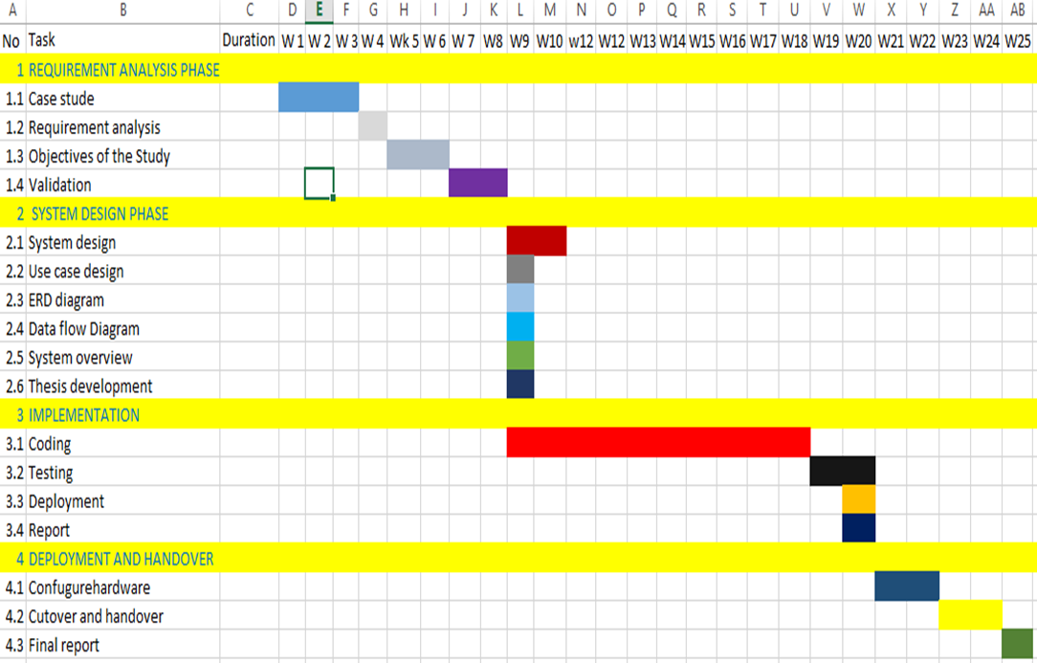

**IX. Project Plan**

|  |  |  |  |  |  |  |  |
| --- | --- | --- | --- | --- | --- | --- | --- |
| Task Id | Task Names | | Duration | | Status | | |
|  | | | | | | | |
| 1. Requirement Analysis 1.5 months | | | | | | | |
| 1.1 | Analysis Existing System | | 1 Week | | | Open | |
| 1.2 | Description of the Existing System | | 1 Week | | | Open | |
| 1.3 | Analysis a new System | | 1 Week and half | | | Open | |
| 1.4 | Determine project requirement | | 4 Days | | | Open | |
| 1.5 | Meet a Supervisor | | 1 Week | | | Open | |
| 1. System Design 1 month | | | | | | | |
|  | | | | | | | |
| 2.1 | Architecture | | 1 Week | | | Open | |
| 2.2 | Database Design | | 1 Week | | | Open | |
| 2.3 | UI design/ Program Design | | 1 Week | | | Open | |
| 2.4 | Meet a Supervisor | | 1 Week | | | Open | |
|  | | | | | | | |
| 1. System Implementation 1.5 months | | | | | | | |
| 3.1 | Coding | | 3 Weeks | | | Open | |
| 3.2 | Testing | | 1 Week | | | Open | |
| 3.3 | Execution | | 1 Week | | | Open | |
| 3.4 | Meet a Supervisor | | 1 Week | | | Open | |
| 4. Deployment 2 Weeks | | | | | | | |
| 4.1 | | Final report | | 1 Weeks | | | Open |
| 4.2 | | Writing report | | 4 Weeks | | | Open |
| 4.3 | | Meet a Supervisor | | 2 Weeks | | | Open |