

Research Project Proposal

Online Rwandan Security Companies Platform

**FACULTY**: Information Technology

**DEPARTMENT**: Networks and Communication Systems

**Prepared by:**

HARERIMANA Alain Fleury

**Phone**: 0789969231

**Email**: hfleury19@gmail.com

1. Background of the Study

Nowadays the use of information technology in different domain is increasing and taking important role in our country development, the enhancement of the ICT is playing important role through different government environment as well as in private security, political, social-economic, in scientific and particularly in education.

The private security industry today plays a primary role in ensuring that citizens of Rwanda and the entire world are kept safe from criminal activities perpetrated by outlaws. Many countries in the world, including Rwanda, IT has become one of the factors contributing to the overall security of the nation. It helps organizations and institutions to control their activities easily when they are computerized.

The employees of private security were hired as guards and were stationed outside banks, schools, hospitals, and other public and private buildings. Today, even the governments are relying on them to ensure the security of their nation's infrastructures and the safety of its people. The changing trends in the security industry have seen the private sector become more involved in matters of national security. The government has realized the need to incorporate all available resources towards eliminating threats posed by terrorism.

My case will mainly focus on how customers can find the best security guard based on specific criteria and also hire one of employees in the security companies.

1. Description of the Current System

In the current system, when a customer is looking for an agency to handle his security needs, he/she search on Internet the security companies in Rwanda and when he/she reaches any website for the company for example ISCO security company he/she finds information about the company and the services offered by the company as well as the address and contacts.

So the client after deciding of which company to work with he/she contacts them or goes to their headquarters to sign the work contract and the company assigns the security guards to the client.

1. Description of the Problem Statement.

The problem of the existing system can be subdivided in three major parts:

* **Time consumption**

In the current system, when customers seek out for a security guard, they must visit different companies trying to find the best one which fulfill their requirements. The problem with this process is that it can take longer and expensive because you may reach in one company and find that their requirements are not matching with your needs.

* **Lack of awareness of existing companies**

For a client to find a list of those security companies, it is a tough task since there is no specific resource of where to look for their details as well as their system of work and this makes it a long process by visiting different websites whereby some of them do not provide all the desired information by the client who wants to hire them

* **Inefficiency to deliver specific services online**

Even if one is able to find an agency to work with, it still becomes a problem if you want to order online for one of their employees. For more clarity if a customer has certain specific details they want from that guard, for example, if he wants a French speaking guard or someone who is highly experienced. The problem of the current system is that it does not make it possible to order online for that one employee who fulfills those specific requirements based on what a client desires.

1. Description of the proposed solution.

As the proposed system will be a web-based application that will help customers to find easily and quickly all information about security companies without visiting them in person and also customers will be able to choose the good one that has all requirements according to the needs of customer.

In the new system, the security company shall register all their employees (Guards) with specific details about work experience, education background and details that clients may require and all these informations will be listed to the website for each client who wants to review them.

This will give these solutions according to the problems stated above:

* No more time wasting due to the faster services.
* Provide more information about security companies.
* Provide specific details about guards working for a specific company.

1. The Main Module for the New System

|  |  |  |
| --- | --- | --- |
| **Input** | **Processes** | **Output** |
| User creates accounts by providing his profile | The application process the request, save the information | Notify if it is all saved or fail to save |
| User login into a system | The application process the request. By checking | Notify if username and password not matching, if matching login. |
| User checks the guard’s information | The application checks for desired services | Notify if security guard found or not |
| User request a guard | The application process the request, from the user | Notify if the request has been accepted or not due to the above step |
| User logout in the system | The application process the request, | Notify that you are done |

1. Project Objectives
2. I. General Objective

General objectives of this project are to design and implement an **Online Rwandan Security Companies Platform** Which will provide information about security companies and the specific details of their guards in Rwanda.

VI. II. Specific Objectives

* To implement web-based software used to provide information about security companies and the specific details of their guards in Rwanda.
* To validate or evaluate the new system.
* To improve the services given to the community.
* To generate a periodic report.

1. Requirements

VII. I. Functional Requirement

* The system must only allow a user to login by using a valid username and password
* The system should allow the companies to create accounts.
* The system should allow the users to create accounts.
* The system should allow the user to view companies’ information.
* The system should allow the user to view company’s guard information.
* The user should be able to logout once he/she finishes the alert
* The system should be able to assignee a new password once is needed
* The system must be able to do backup
* The system must be able to retrieve the information from the database.
* The system must be able to validate while entering the information.

VII. II. Non-Functional Requirement

* **Maintainability:**
  + - The system should be easily to maintain it, once is needed
* **Security:**
  + - The system must be able to hide the users information
    - The system includes all available safeguards from viruses, worms and Trojans Etc.
    - The System will block you once you clicks 3 times on login steps
* **Operational:**
  + - The system should be able to run on any android OS.
* **User friendly:**
  + - The System will be user friendly
    - The system must be easy for a user to use.
* **Privacy:**
  + - The system shall be able to protect the users privacy
* **Availability:**
  + - The system shall have high availability
    - The system shall not have unexpected downtime
    - The system shall have downtime at most 3 hours/month

VIII. Tools and Technologies to be used

**Operating system:** any operating system.

**Programming language:** HTML, CSS, Bootstrap, Ruby (Ruby On rails Framework)

**DBMS:** PostgreSQL

**Text editor:** VS Code

**Tools of designing models:** Enterprise architecture, Visual Paradigm,

IX. Architecture Design of the Proposed System

1. ***Functional Diagram***

A functional diagram is used to show system’s functions that will be constructed and the implementation process of data diagram. Function diagram shows what you are going to do.

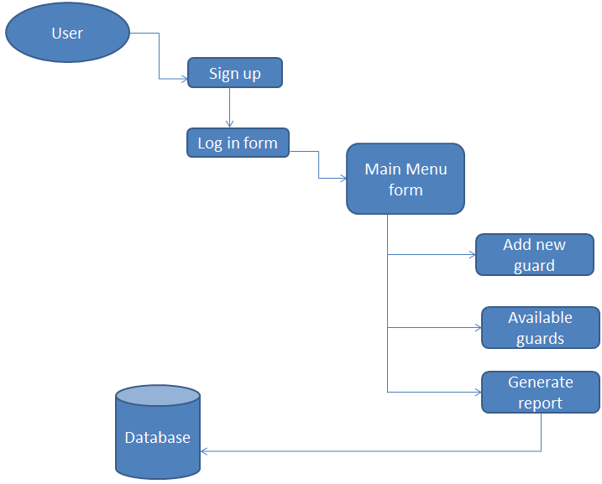

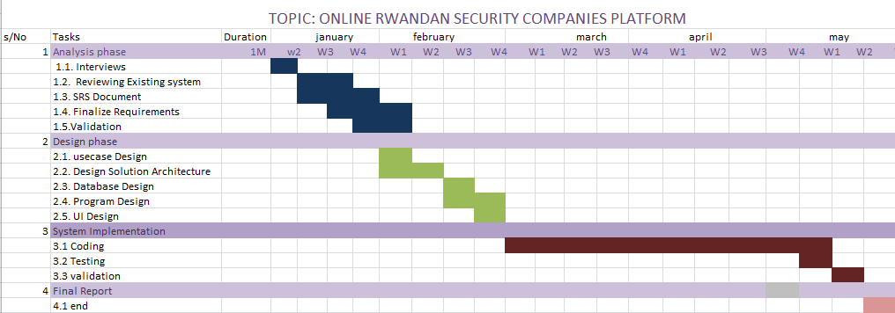X. Work Breakdown structure

XI. Work Plan

|  |  |  |  |  |  |  |  |
| --- | --- | --- | --- | --- | --- | --- | --- |
| Task Id | Task Names | | Duration | | Status | | |
|  | | | | | | | |
| 1. Requirement Analysis 1.5 months | | | | | | | |
| 1.1 | Analysis Existing System | | 1 Week | | | Open | |
| 1.2 | Description of the Existing System | | 1 Week | | | Open | |
| 1.3 | Analysis a new System | | 1 Week and half | | | Open | |
| 1.4 | Determine project requirement | | 4 Days | | | Open | |
| 1.5 | Meet a Supervisor | | 1 Week | | | Open | |
| 1. System Design 1 month | | | | | | | |
|  | | | | | | | |
| 2.1 | Architecture | | 1 Week | | | Open | |
| 2.2 | Database Design | | 1 Week | | | Open | |
| 2.3 | UI design/ Program Design | | 1 Week | | | Open | |
| 2.4 | Meet a Supervisor | | 1 Week | | | Open | |
|  | | | | | | | |
| 1. System Implementation 1.5 months | | | | | | | |
| 3.1 | Coding | | 3 Weeks | | | Open | |
| 3.2 | Testing | | 1 Week | | | Open | |
| 3.3 | Execution | | 1 Week | | | Open | |
| 3.4 | Meet a Supervisor | | 1 Week | | | Open | |
| 4. Deployment 2 Weeks | | | | | | | |
| 4.1 | | Final report | | 1 Weeks | | | Open |
| 4.2 | | Writing report | | 4 Weeks | | | Open |
| 4.3 | | Meet a Supervisor | | 2 Weeks | | | Open |