Morphogenesis Of The Outside
ↄ⃝ Copyleft Pa-F 2015 – CC0 – Jb Labrune + extra thanks to Matt Hare, Jan Ritsema & Paf Summer University

There are many ways to mix genres.

Hacking, blending, agitating, encrypting, intricating, weaving, cyphering, entangling, percolating, undominating, representing, projecting, jamming, interlocking, exapting, knotting, blurring, smoothing, transforming the striated into the seamless, infinitizing...

And by genres, i mean genders, forms, categories, types, manifolds, cosmoses...

Genres are traditionally defined regarding different entities they resemble. They ex-ist out of these outsides. Their "shapes" are counter-forms. Therefore, investigating how they evolve and develop over time, space and scale would require an epigenetic xenology, the morphogenesis of the outside(s).

Accordingly an out-side implies an in-side. There is an inherent duality - dualness, dualism, difference, division, dissociation, diversion, dislocation - gravitating around genres. They are often perceived in our culture as dimorphic entities.

A cosmo-accelerationist remix of genres, a turbo genderfuck, would consist precisely in challenging sexual, conventional and traditional dimorphism. In that respect, i introduce libidinal and socio-cultural diffeomorphism. This term comes from a branch of mathematics called topology. A diffeomorphism – or differentiable homeomorphism - is an isomorphism of smooth manifolds. It is an invertible function that maps one differentiable entity to another.

Our hypothesis is double: this concept should help to understand how the "outside" could be seen as an homeomorph alterity, but also as a differentiable self. An exaptive recursive identity leading to a morphogenesis from the outside, an epigenetic feedback loop: a diffeomorphogenesis.

From a neoliberal perspective, there are many "outsides": fringes, marginal practices & people, avant-gardes, copyleft, so-called 'peripheral' countries, but also off-shore islands, transnational corporations and of course plants and animals in the anthropocene. How do these articulate with established socio-political core systems ? Which strategies arise when negotiating with power structures based on asymmetric secrecy, governance lock-ins and generalized copyright ?

We'll answer by exploring some practical ideas for the creation of experimental places, creative environments and institutional experiences based on recursive governance and diffeomorphic strategies to cope with cryptopolitical insides.
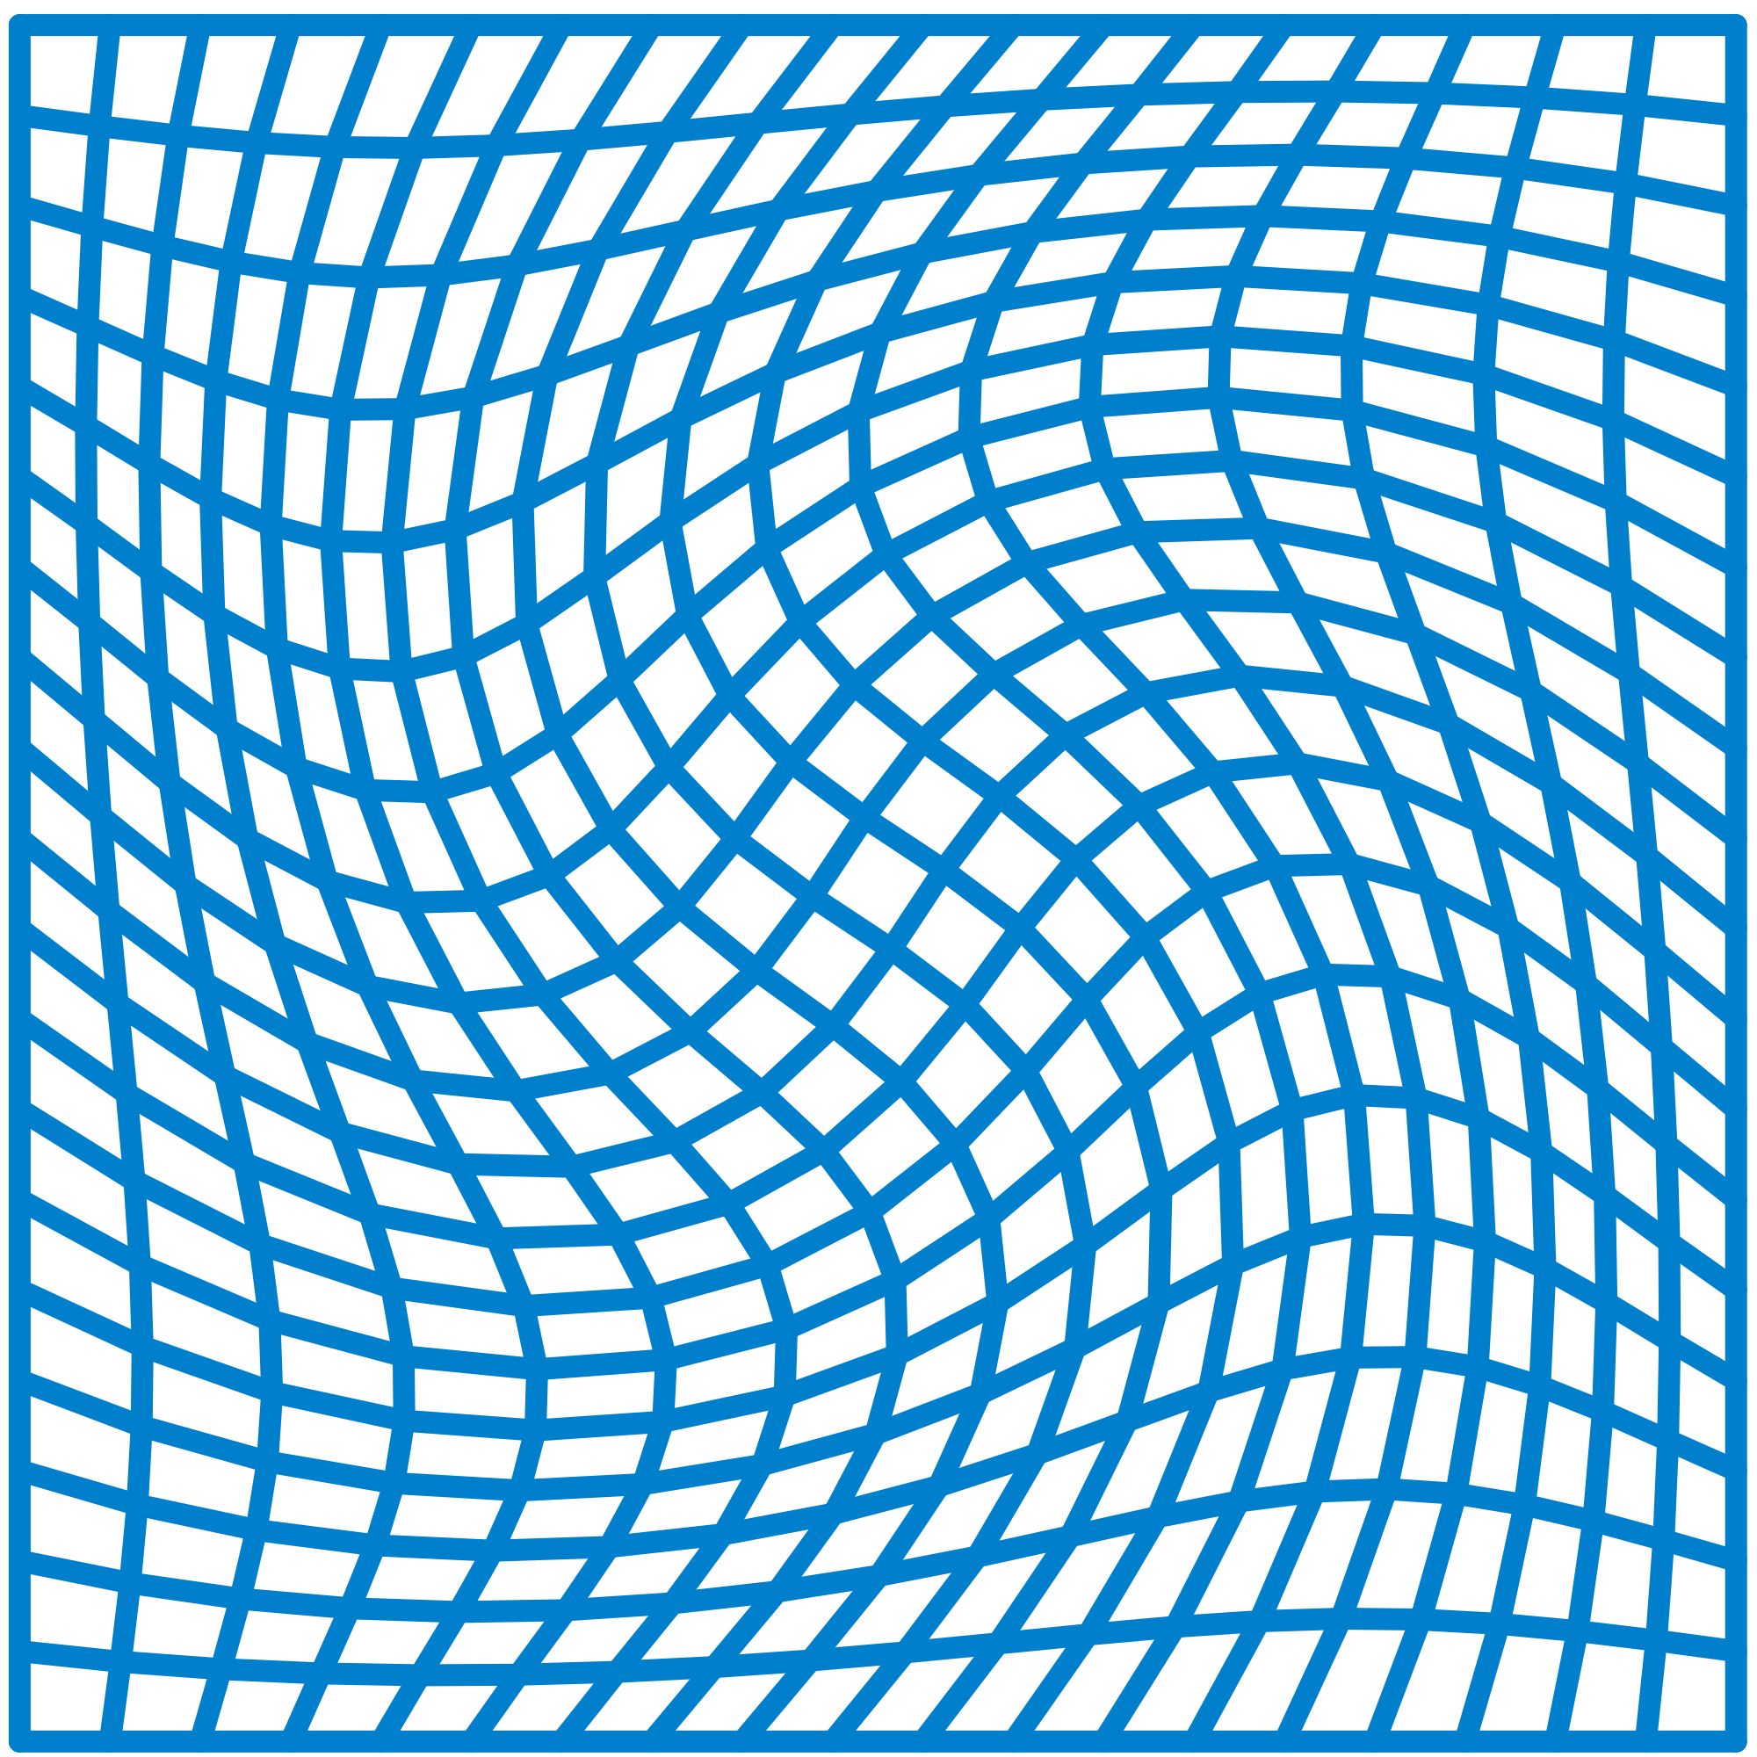
The image of a rectangular grid on a square under a diffeomorphism from the square onto itself
Oleg Alexandrov - self-made with MATLAB - Source code (MATLAB) – License CC0 Public Domain

% Compute a diffeomorphism from a square to a square which leave
% the boundary fixed.

function main()

N = 20; % num of grid points
epsilon = 0.1; % displacement for each small diffeomorphism
num_comp = 10; % number of times the diffeomorphism is composed with itself

S = linspace(-1, 1, N);

[X, Y] = meshgrid(S);

Z = X; W = Y;

% take num_comp compositions of the same small diffeomorphism
for iter = 1:num_comp

for i=1:N
for j=1:N

[Z(i, j), W(i, j)] = small_diffeo(Z(i, j), W(i, j), epsilon);

end
end

end

% graphing settings
lw = 2;
mycolor = [1, 0, 0.1];
small = 0.1;

figure(1); clf; hold on;
for i=1:N
plot(X(:, i), Y(:, i), 'linewidth', lw, 'color', mycolor);
plot(X(i, :), Y(i, :), 'linewidth', lw, 'color', mycolor);
end
axis([-1-small, 1+small, -1-small, 1+small]);
axis equal; axis off;

figure(2); clf; hold on;
for i=1:N
plot(Z(:, i), W(:, i), 'linewidth', lw, 'color', mycolor);
plot(Z(i, :), W(i, :), 'linewidth', lw, 'color', mycolor);
end
axis([-1-small, 1+small, -1-small, 1+small]);
axis equal; axis off;

function [z, w] = small_diffeo(x, y, epsilon);

A1=epsilon*(cos(pi*x)+1)*(cos(pi*y)+1)/4.0;
A2=epsilon*cos(pi*x/2)*cos(pi*y/2);

A = (A1+A2)/2;

z = x +(-y)*A;
w = y +( x)*A;

1. Xenology
The challenge with a proposition such as “the morphogenesis of the outside” is to establish which field or context is appropriate to frame it. It affords very different notions. Shape, space, time, scale, territory, philosophy, metaphysics, architecture, politics, biology, complex sciences, epistemology, inter-disciplines, but also pseudo-science, alchemy, theology, science of fiction, mythology.
The latter traditionally consider things, objects, entities outside of our realm. They preserve the integrity of the other - of the foreigner - by treating it/her/him as a stranger, an hostile enemy or, as a guest-friend, depending on the flavor. They propose an extended discourse on the xenos, the distant friend, outside of the local philos. Xenia vs Philia. Accordingly, I propose to adopt a xenological point-of-view in addition to a philosophical one.
Consequently, this leads to outsiding philosophy itself from our thinking. And, as a preliminary gesture, proceeding to its retreat. Allowing to recognize that if we want to immerse ourselves into the outside, we might operate first what religious poets call a TsimTsum, a dimensional contraction. Avoiding the void in a contracted refuge. Neither chaos nor order but a single entity intricating them. A yod detached from the aleph. Philosophy as a singular dot in a scalar horizon of Xenology.

2. Morphogenesis of the outside

2.1. Short history of the terms
Morphogenesis refers to the way a shape arises, a form evolves over time or a being expresses its structure for instance in embryogenesis. In 1952, Alan M. Turing describes in his article “The Chemical Basis of Morphogenesis” how “systems, although they may originally be homogeneous, may later develop a pattern or a structure due to an instability of the homogeneous equilibrium, which is triggered by some random disturbances”.
Few years before him, in 1917, the Scottish mathematical biologist D'Arcy Wentworth Thompson published a descriptive book on the physico-structural influences on biological form. Although he criticized the evolutionist approach from Darwin, he tackled morphostasis through mathematical morphogenesis, using simple geometric rules. Thompson analysed for instance the polyhedral forms of Radiolaria (protozoa developing a siliceous exoskeleton ) from the Challenger expedition drawn by Ernst Haeckel in 1904. He inspired Turing but also Conrad Hal Waddington, a british developmental biologist, paleontologist, geneticist, embryologist and philosopher who laid the foundations for systems biology and epigenetics.
Dutch sociocybernetist Felix Geyer places Morphogenesis as the foundational brick of Complexity : “In stressing this possibility for self-organization, for "order out of chaos", Prigogine comes close to the concept of autopoiesis. In modern societies, the mechanistic and deterministic Newtonian worldview - emphasizing stability, order, uniformity, equilibrium, and linear relationships between or within closed systems - is being replaced by a new paradigm.

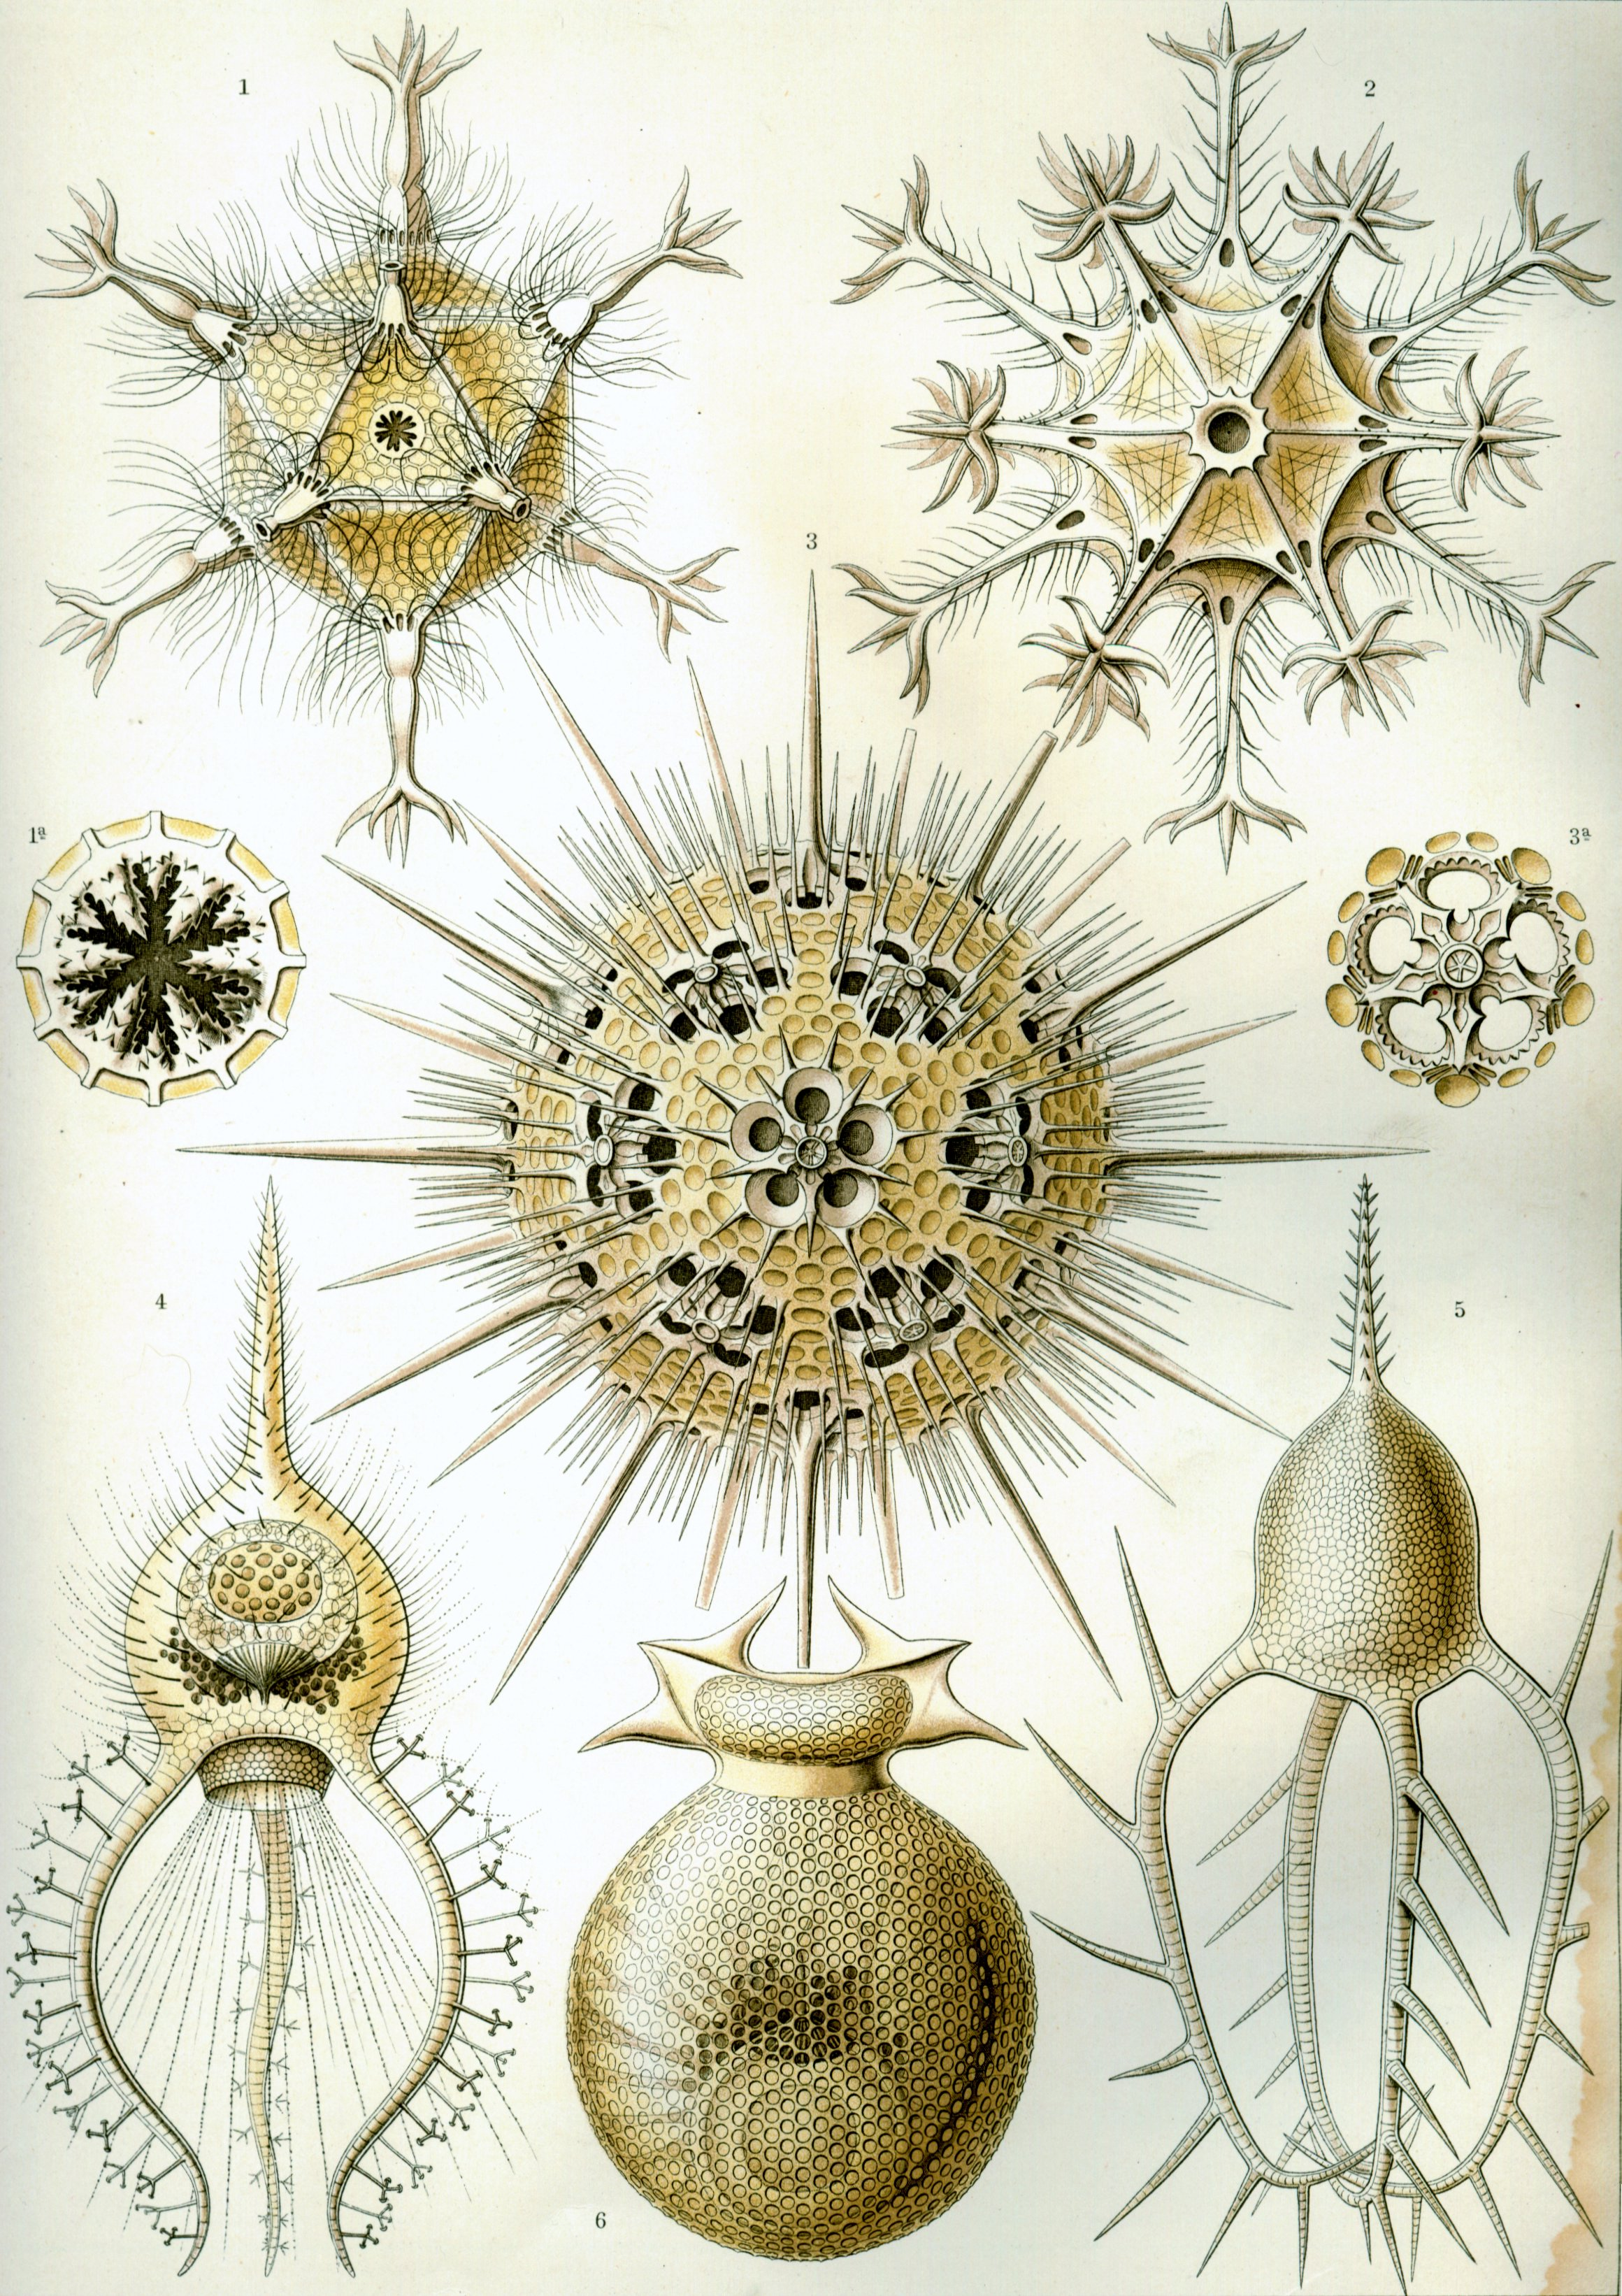
Ernst Haeckel - Kunstformen der Natur (1904), plate 1: Phaeodaria – License Public Domain CC0

Circogonia icosahedra (Haeckel) = Circogonia icosahedra Haeckel, 1887 (1a: opening of shell) Circostephanus coronarius (Haeckel) = Circostephanus coronarius Haeckel, 1887 Haeckeliana porcellana (John Murray) = Haeckeliana porcellana Murray, 1885 (3a: pore circle without spines) Cortinetta tripodiscus (Haeckel) = Cortinetta tripodiscus Medusetta tetranema (Haeckel) = Medusetta tetranema Haeckel, 1887 Challengeria murrayi (Haeckel) = Protocystis murrayi (Haeckel, 1887)
This new paradigm is more in line with today's accelerated social change, and stresses disorder, instability, diversity, disequilibrium, non-linear relationships between open systems, morphogenesis and temporality. Prigogine indeed calls it the science of complexity. It is exemplified amongst others by Prigogine himself, Maturana and Varela, Laszlo and "second-order cybernetics" in general: i.e. the (non-mechanistic) study of open systems in interaction with their observers.”

Today, in biology, it's considered that animal markings, segmentation of animals, phyllotaxis, neuronal activation patterns like tonotopy, and predator-prey equations' trajectories are all examples of natural patterns constructed through morphogenesis. Similarly, in other scientific fields, phenomenas and entities such as Belousov-Zhabotinsky reactions, Liesegang rings, Bénard cells, Lasers, cloud formations in stripes or rolls, ripples in icicles, washboard patterns on dirtroads, dendrites in solidification, liquid crystals, solitons, sphere packing and cellular automata are examples of morphogenesis.

A side can be a flat outer surface of an object, especially one that is not the top, the bottom, the front, or the back; an edge or border of something; a place next to something. The out side is therefore an outside of something. Over its edge, beyond the next entity close to it or an alternate surface to its own.

This very short history would of course welcome a thorough philosophical assessment of the concept of Outside but also of Form, Evolution, Becoming, etc.. Nonetheless, I tried to register the terms in a different context than mine which we will see next is somehow distant to historicity and traditional philosophical historical linearity and causality.

2.2. Short speculation on the terms
Morphogenesis
From a linear point-of-view, morphogenesis is the accountable difference between different states of a form. The evolution or reception of diverse segments. Different forms browsed in a versatile repertoire of sequenced dimorphisms.
From a xenological point-of-view, morphogenesis is neither a bottom-up structural accretion nor a top-down theological revelation. It is a recursive metaphor across perpetually generating spaces, times and scales. Patterns as invariants in a multidimensional operation.
Outside of what ?

- void -> tohu-bohu / tsimtsum / fiat lux
- universe -> contingent metaphysics
- a sheet of paper -> diffeomorphism
- cybernetics -> self-referential cybernetics
- masculine rational advantage -> xenology
- verbal language -> iconic & enactive expression
- cryptopolitical power -> supranatural propitiatory talent

2.3. What other concepts have been associated with it?
Iridescence
Camouflage
Transparency
Crypto-capitalism
Power
Shamanism
Playing

2.4. In what ways has this concept affected the lives of people?
30000 years argument from Eric Gunther and Jeff Lieberman

2.5. From Dimorphism to Diffeomorphism
How might this concept be changed to work better?
- Morphogenesis of an outside: separated evolution, growth → epigenesis
- Morphogenesis from the outside: intrication, entanglement, co-constitution → Diffeomorphogenesis

3. Diffeomorphogenesis
By what kinds of evidence can the proposition be proved or disproved ?
Can we prove that there is a diffeomorphogenesis ?
Can we disprove it ?

4. What counter-arguments must be confronted and refuted ?

5. Practical implications

5.1 Exotic philosophy
Outside philosophy, philosophy as an outside

5.2 Crypto-political studies
- Outside europe, Outside the body, Outside institution, Outside capitalism and neoliberalism.

5.3 Socio-cultural recursions
- Outside-In places
- Introspective creativity, copyleft, non-ecclesiastic free software, bioware and hardware.
- Inside-Out institutions

https://en.wikipedia.org/wiki/Gender_bender
http://www.critcrim.org/redfeather/chaos/006challenges.html

