Data :

For this project, we collected data from different sources on the web. There exists several database updated on a regular basis listing most professional matches. We managed to put together a dataset including all ATP matches from 1991 to 2020. Here is a snapshot of the original dataset :

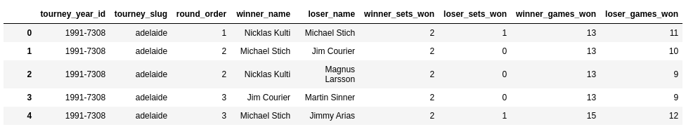
We then did an extensive feature engineering work to add statistics on the players (ATP rank, physical traits, specific tennis statistics). Please note that we will not be using the player name as a feature.

Player static data | Static traits : Height, Weight, Birth date  Tennis characteristics: Handedness, Backhand,
Tourney’s data | Court (indoor/outdoor), Surface, Date, Round, Tourney’s name, Number of contestants
Player’s Statistics | ATP Ranking (current and historical), Round historical performance, Surface historical performance  Games data : Service statistics, Break-point performance
Player’s current shape | Number of games played in the tournament/past year

Finally, as the final goal is to “beat the odds”, we found online odds data from several betting sites on most ATP matches since 2000. We plan to leverage it to see how well we perform compared to the bookmakers as a baseline.

Analytics approach :

Usually, most people bet on “gut feeling” or by following the advice of tennis experts. We come up with an analytics approach that can be broken down in tree main steps :
- Using classification models, predict the winner of the match
- For each prediction, come up with a “confidence” measure of our prediction
- Use this measure to develop a large-scale betting strategy, comparing our inferred odds to the bookmakers’

