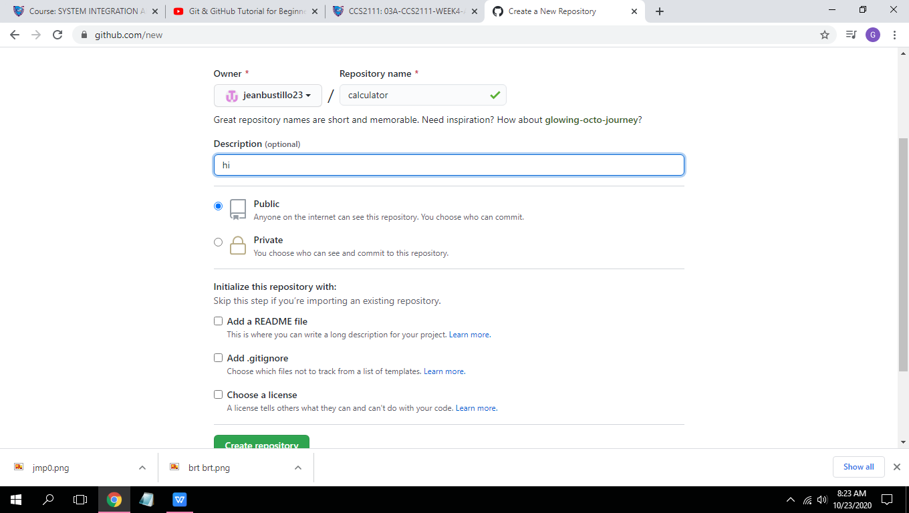

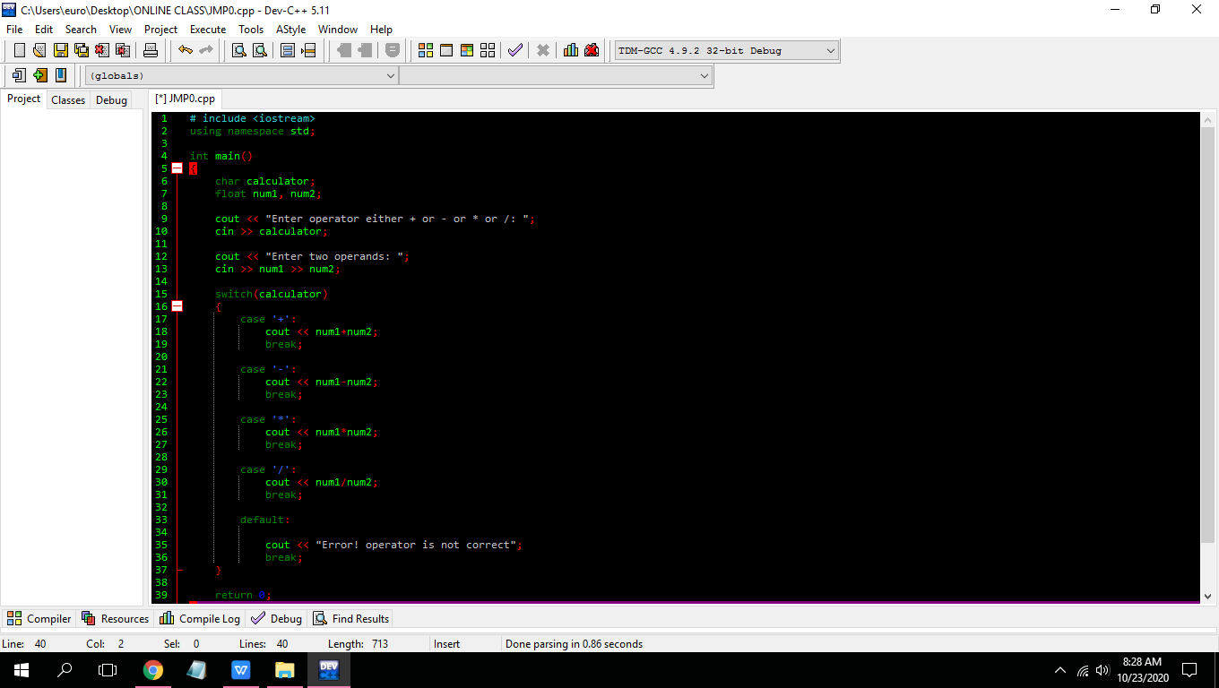

# include <iostream>

using namespace std;

int main()

{

char calculator;

float num1, num2;

cout << "Enter operator either + or - or * or /: ";

cin >> calculator;

cout << "Enter two operands: ";

cin >> num1 >> num2;

switch(calculator)

{

case '+':

cout << num1+num2;

break;

case '-':

cout << num1-num2;

break;

case '*':

cout << num1*num2;

break;

case '/':

cout << num1/num2;

break;

default:

cout << "Error! operator is not correct";

break;

}

return 0;

}

