- Window
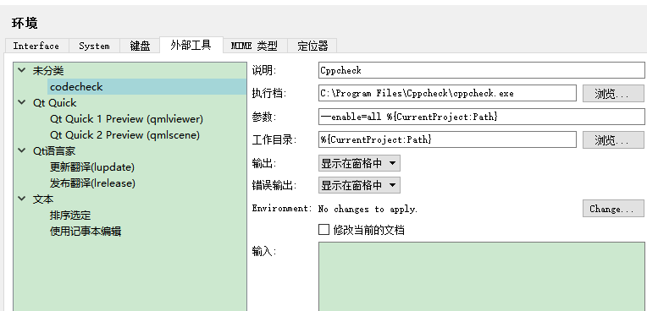

- Linux
make SRCDIR=build CFGDIR=/usr/share/cppcheck/
sudo make install CFGDIR=/usr/share/cppcheck/

