Patient Records Request/Transfer In iSanté

Access this capability for patients not already in care at your local facility from the patient menu:

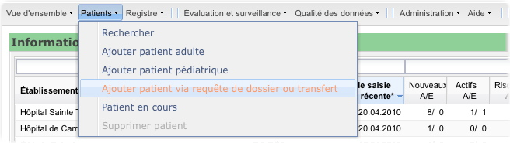

Access this capability for an existing patient from that patient's forms list:

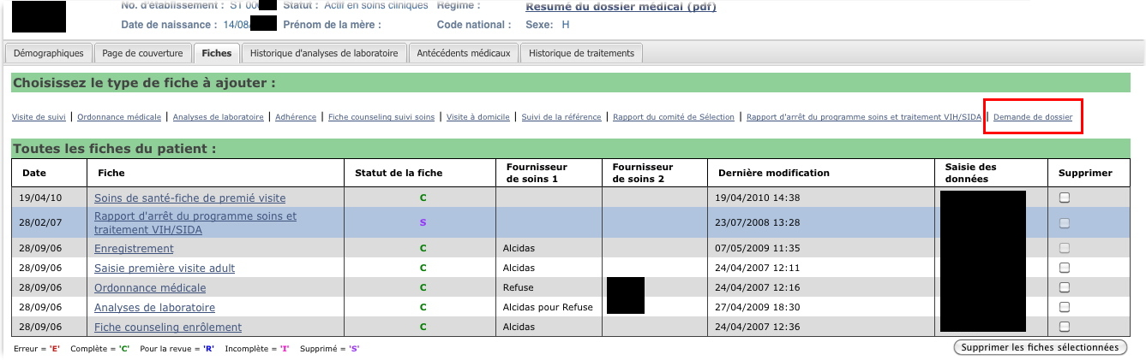

After clicking on one of these options, this page is displayed:

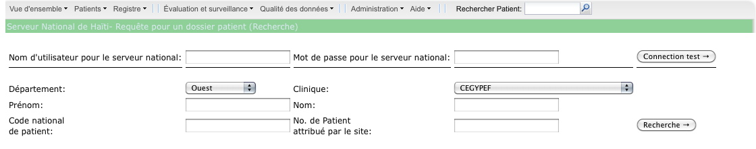

Enter your assigned Haiti National server username/password and verify that you can establish a connection via the 'Test Connection' button:

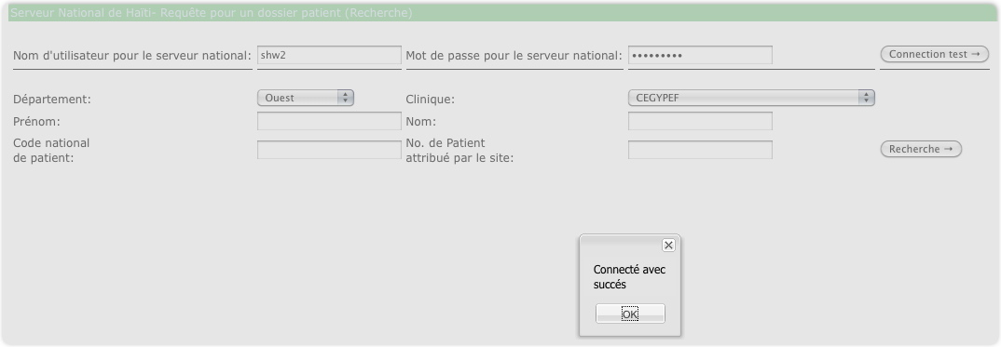

Entering an incorrect username or password yields this message:

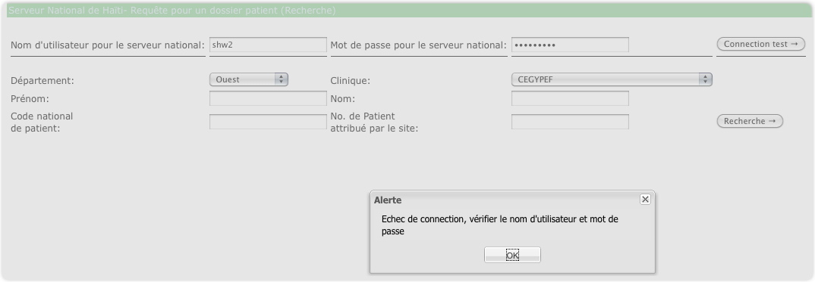

At this point, you can enter values in the search fields. You must search within one location (clinic site) at a time. Fill in the other fields as completely as possible to get a close match.

1. Select the desired **Department**. The **Clinic** dropdown will automatically be populated with all iSanté clinics within that department.
2. Select the desired **Clinic**.

You may enter one or more of the remaining fields. If you choose to enter a field, you must supply at least three (3) characters within that field.

1. If known, enter **Prénom**.
2. If known, enter **Nom**.
3. If known, enter **Code national de patient**.
4. If known, enter **No. de patient attribué par le site**.

Now click **Aller**. If patients are found meeting your criteria, the window will continue to show your criteria, but will now display a list of each patient that matches those criteria. Shown below is a successful search for patients named Jean:

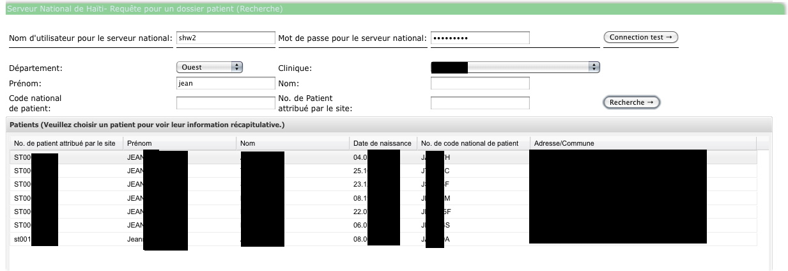

If you don't supply at least three characters, you will see this dialog:

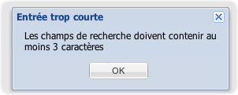

If your search finds no patients, you will see this dialog:

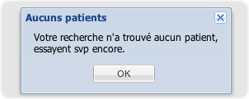

If the search is not particularly exact, you may see this dialog:

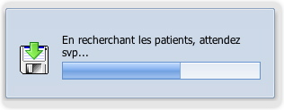

Usually, once the search is complete, this dialog will go away automatically. Rarely, this dialog may continue to be displayed. In that case, just refresh the page and begin again with a more precisely defined search.

After determining that a patient in the retrieved list is the correct patient, select that patient's row in the list. You will see additional detailed information about the patient and have the opportunity to retrieve that patient's clinical summary report, make a records request, or make a transfer request via buttons above the detailed information:

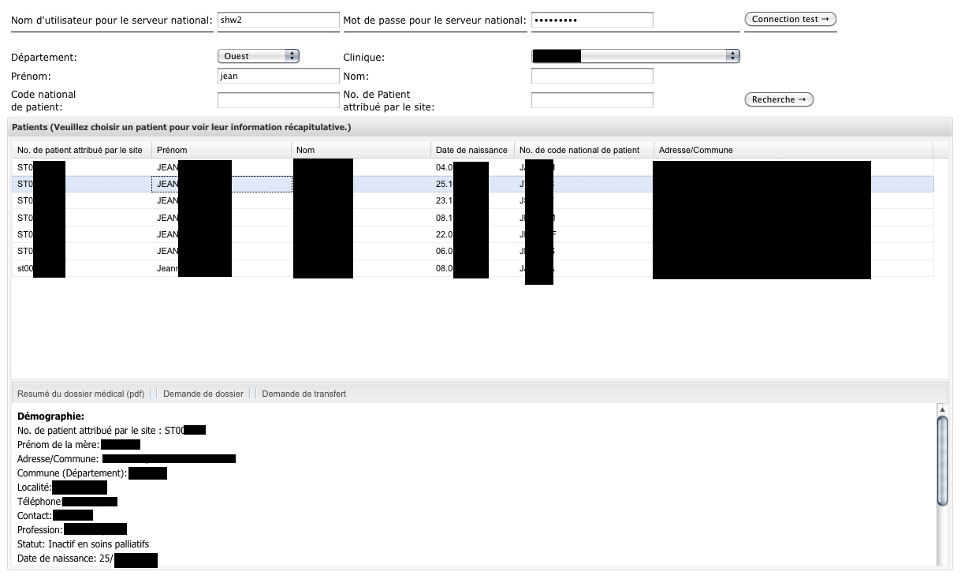

The current list of detailed attributes (which can be used to further verify that you have located the correct patient) is:

|  |
| --- |
| **Démographie** |
| No. de patient attribué par le site |
| Prénom de la mère |
| Adresse/Commune: |
| Commune (Département) |
| Localité |
| Telephone |
| Contact |
| Occupation |
| Statut |
| Date de naissance |
| **Clinique** |
| Taille |
| Poids |
| Grossesse actuelle |
| Semaines de gestation |
| Toutes les fiches du patient |
| Date de saisie la plus récente |
| Date début ARV |
| CD4 le plus récent: , Date |

When you retrieve the clinical summary report using the first button, the request will be recorded as an event in your local server.

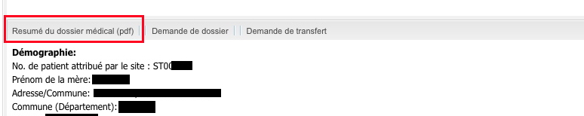

When you click the second button (Records Request), the patient's demographic information (if a new patient in your clinic) and clinical summary report will be exported from the national server and added to your local server.

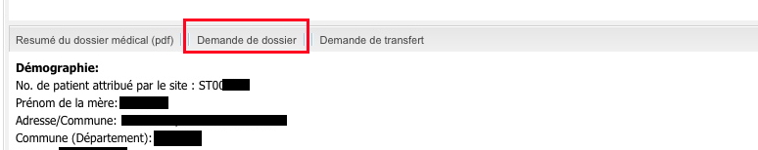

Similarly, clicking the third button (Transfer Request") will export the patient's demographic information (if a new patient in your clinic) and clinical summary report from the national server and add it to your local server. A successful request will result in display of the clinical summary report as part of the request transaction.

In addition, a patient discontinuation form will automatically be generated for the patient's original clinic.

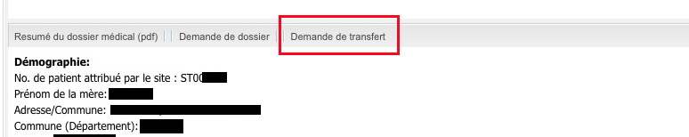

The generation of the discontinuation form for the original clinic is the only difference between a records request and a transfer request.

If the request is made for a patient new to the clinic, the user is taken to the registration form for the patient. A local clinic id should be assigned at that time. The registration form is based upon the patient's demographic information at the previous site and will look like this:

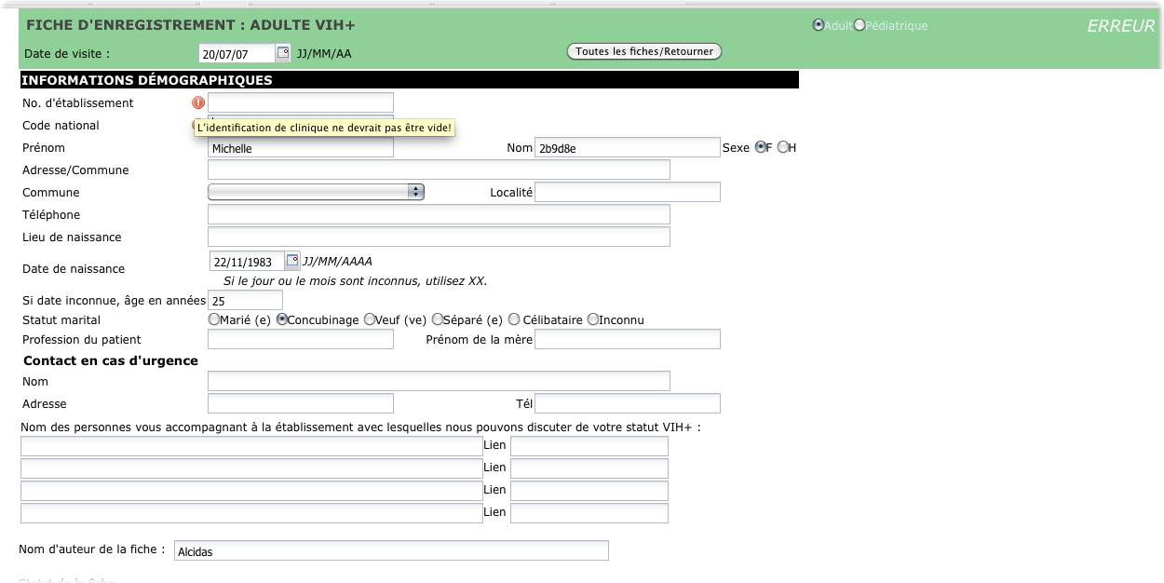

If the request originated from a current patient's forms list, the user is taken to the clinical summary report that was obtained via the request:

