Monthly calendar template
Snapshot of both my personal (pink) and work (green) calendars on Google, including reminder-tasks (yellow), for the next four weeks: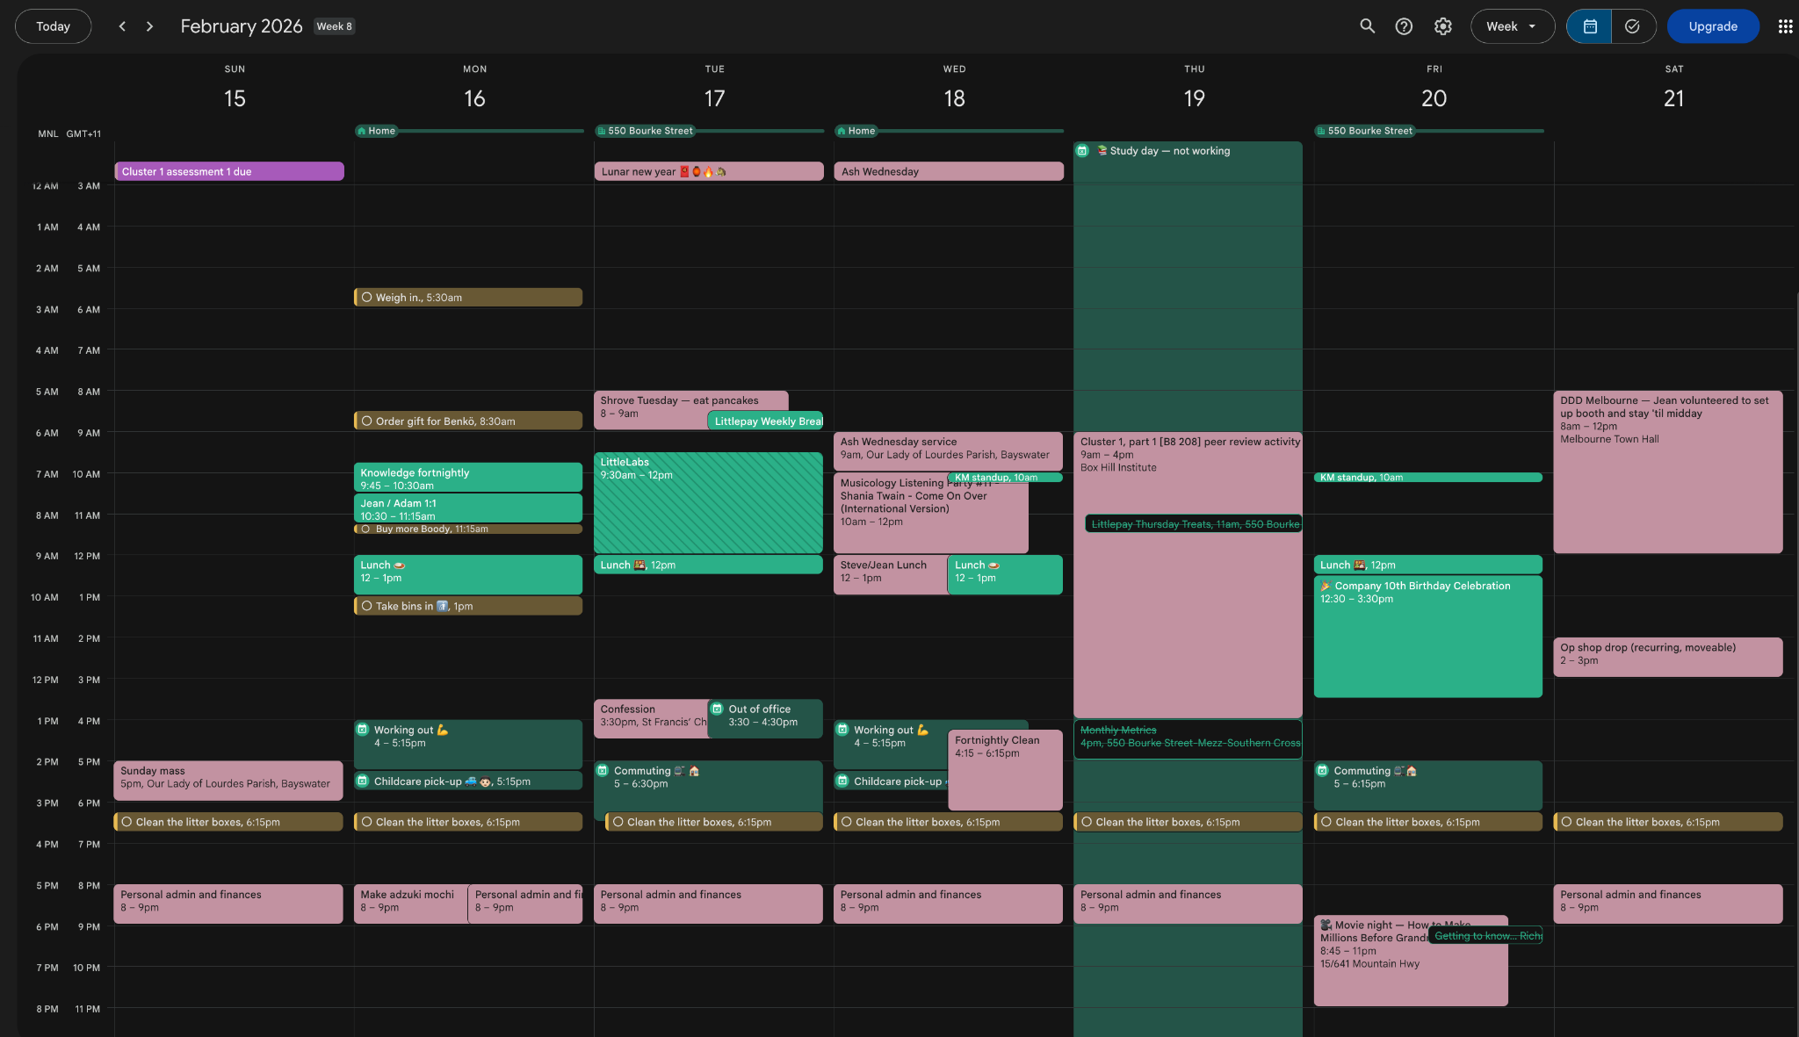
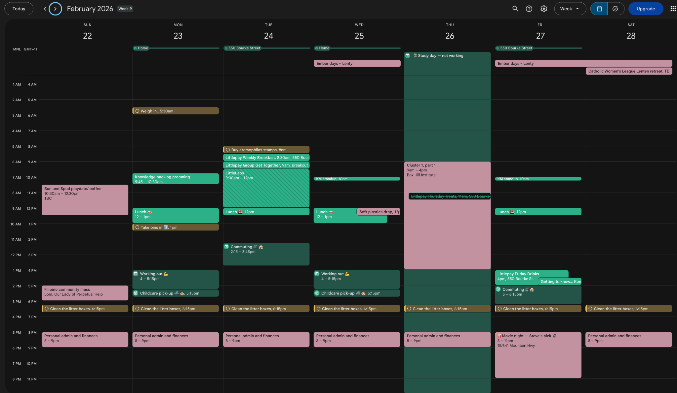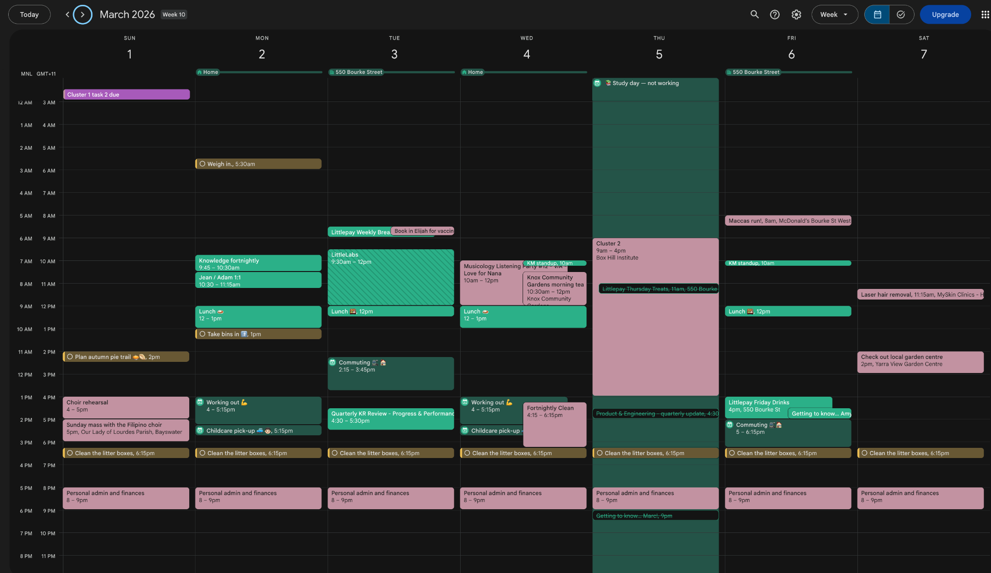
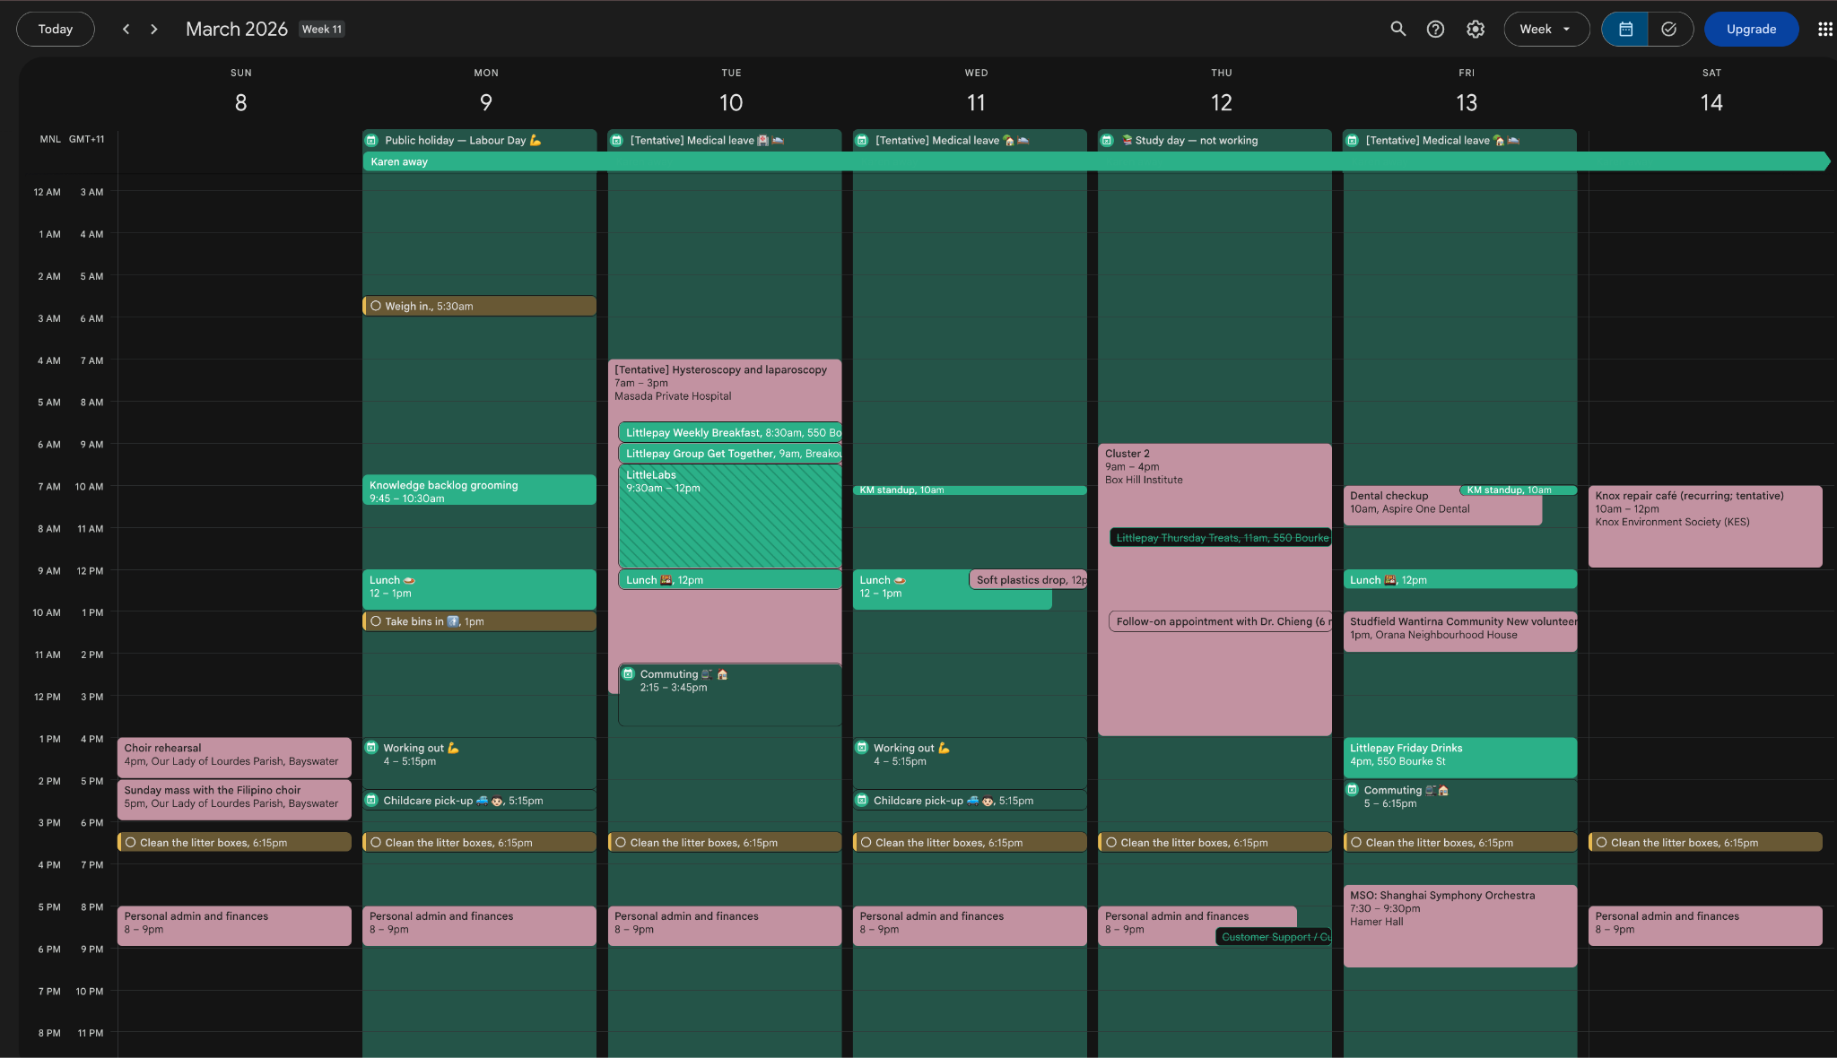
I’ve marked my upcoming medical leave tentative, because I am waiting on the admission notice and other fees, before I lodge my leaves with work. But my manager and team have been apprised, and I will clean up that week once my leaves are formally lodged and approved.
The procedure is minimally invasive and I have recovered quickly from the same procedure. I am fairly confident that I can make it to class on the Thursday following.

