VHD Library
How to improve guide

Author : Alexis Jeandet
Mail : alexis.jeandet@lpp.polytechnique.fr

Index
I File organization presentation 2
I.1 APB_DEVICES folder 2
I.2 Boards folder 2
I.3 Designs folder 2
I.4 Lib folder 2
I.5 Licenses folder 2
I.6 LPP_drivers folder 2
I.7 Scripts folder 2
II How to add a VHDL IP 2
II.1 Add a VHDL IP to an existing package 2
II.2 Add a new package 4
III How to add properly an APB device or a vendor 4
IV How to 4

File organization presentation

APB_DEVICES folder
This folder is used to store the list of APB devices and APB vendors.

Boards folder
This folder store boards to be copied to the boards folder in GRLIB.

Designs folder
This folder store designs to be copied to the designs folder in GRLIB.

Lib folder
This folder store all the VHDL IPs.

Licenses folder
This folder store licenses for VHDL and C files.

LPP_drivers folder
This folder store C drivers for AMBA devices developed by LPP.

Scripts folder
This folder store all scripts used with VHDLib.

How to add a VHDL IP

To add a VHDL IP you need first to choose if your IP will belong to an existing package or a new package.

Add a VHDL IP to an existing package
To add a VHDL IP to an existing package, you just need to copy your file to the folder containing the package. Then you must add your IP entity definition in the package file.

Example:
We will add an adder IP to general_purpose package:

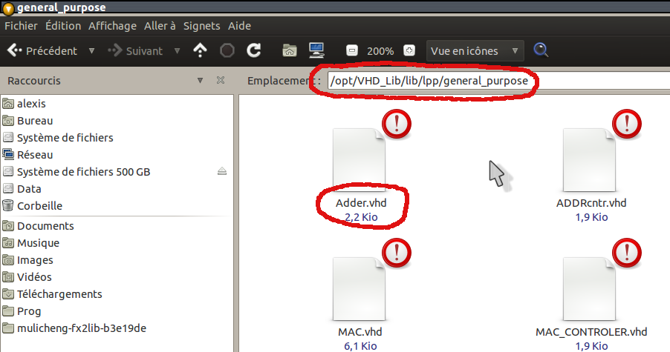
First we copy the VHDL file to general_purpose folder:

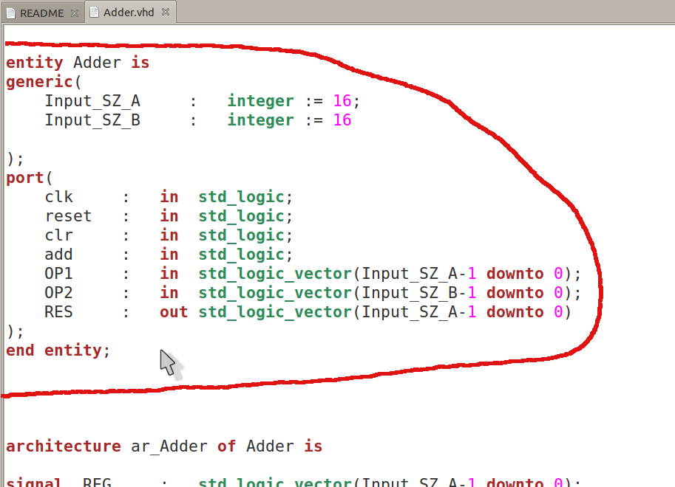

Then copy the entity definition of the adder:

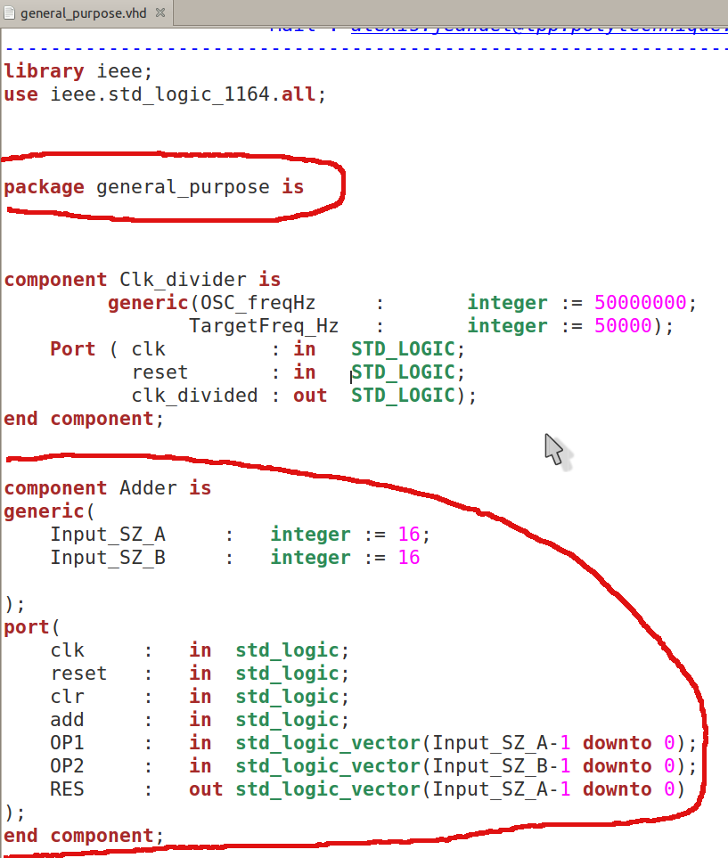

Add it to “general_purpose.vhd” package:

Add a new package

How to add properly an APB device or a vendor

How to

