(1) Clarify the situation with respect to the case of 50 vs 51, or 100 vs 101, in Fig 1, where the exceedingly small experimental difference that is reported here seemed very surprising to both reviewers, and to me, and would seem prima facie to disconfirm the model to some extent.

The results reported in Figure 1 were model results instead of experimental results, and we have rewritten the caption to more clearly reflect this fact. With regards to why the difference in Figure 1 is small, the magnitude of the difference is controlled by a cost parameter, which determines how much more “costly” it is for a speaker to utter “51” versus “50.” This cost may be due to factors such as availability, frequency, and the complexity of different number terms (Solt et al., 2011). However, we do not make assumptions about which particular psychological factors are responsible for the cost. We simply assume that there is a cost difference, which is supported by previous research (e.g. Oldfield & Wingfield 1965; Balota & Chumbley 1984; Mehler 1992; Jansen & Pollmann, 2001). We then show that a model that incorporates this cost difference produces interpretations of round and sharp numbers that closely align with humans’ judgments.

Since we do not precisely measure the extent to which each sharp number is costlier than its round counterpart, we originally posited a sharp/round cost ratio of 1.8 with the guidance of intuition and model experimentation. After receiving very helpful comments from the editor and reviewers, we decided to fit the cost parameter in a more systematic manner. We first varied the cost ratio from 1 to 4 in increments of 0.1 and identified the cost parameter that maximizes the correlation between model predictions and the human data from Experiment 1. We found that the cost ratio that produces the maximal fit is 1.3, with a correlation of 0.974. However, the 95% confidence interval for this correlation is [0.9675213, 0.9792691], meaning we cannot determine conclusively that 1.3 is superior to a cost parameter that results in a correlation within this range. As a result, we identified the cost ratios that produce correlations within this range and fit the cost ratio to the halo effect observed in the human data from Experiment 1. We did this by choosing the cost ratio within this range that maximizes the correlation between humans’ and models’ difference scores for exact versus fuzzy interpretations. We found that the cost ratio that best captures the magnitude and pattern of the halo effect found in participants’ data was 3.6. This produces an overall correlation of 0.9676 with human data from Experiment 1, which lies within the 95% confidence interval of [0.9675213, 0.9792691] produced by the optimal parameter. Since the cost ratio is higher, this more systematic selection of the cost parameter yields a larger difference between the model’s exact/fuzzy interpretation of “50” and “51,” as shown in Figure 1-revised below.

On the level of presentation, a potential reason why the halo effect seemed smaller than it actually is in the original Figure 1 (Figure 1-original) is because the scales on the y-axes were kept constant across the panels. Since the bottom two rows of panels have larger values, the scales for the “exact” and “fuzzy” panels were larger than necessary, causing the bars to be relatively smaller and more difficult to distinguish. Figure 1-revised (left) now has free y scales, allowing the differences between round and sharp numbers for “exact” and “fuzzy” interpretations to be more apparent in the graph. We have replaced Figure 1-original with Figure 1-revised in order to more clearly present the important patterns in the model predictions.

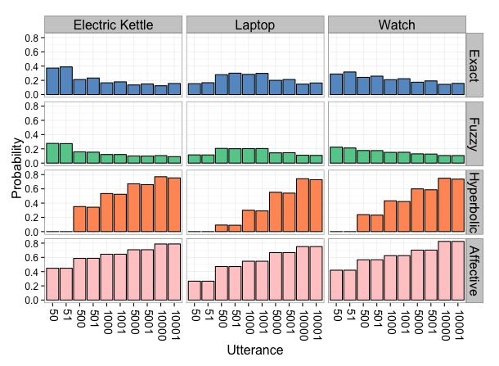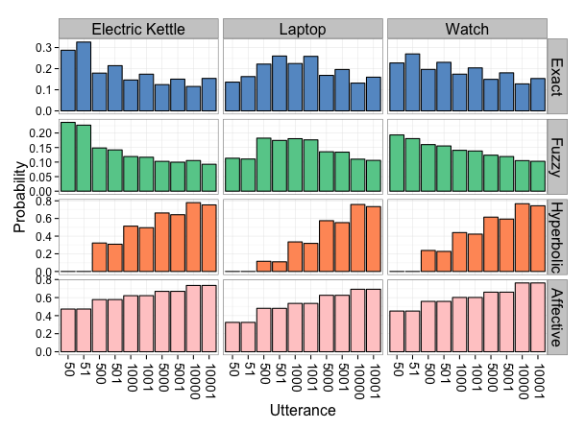Figure 1-revised Figure 1-original

(2) Make the clarifying introductory remarks about the model that Referee #2 asks for.

We have revised the introduction to include an informal overview of RSA models and its components.

(3) Make the charts clearer, more self-explanatory, and easier to read in the way that Referee #1 asks for.

We have made the figures more self-explanatory and easier to read by including more detail in the captions and increasing the size of the labels. We have also made the axes labels more self-explanatory and easier to interpret. Finally, we have changed the colors so that the figures are still readable when printed in grey scale.

(4) Say more about the prior probabilities, where they come from (just stipulated? how might one do better?),

The prior probabilities of prices and affect were measured empirically in Experiment 3a and 3b, respectively. The main text has been revised to clarify that we measured the priors by asking participants to report the probability of prices (Experiment 3a) and affect given prices (Experiment 3b).

We could elicit the prior probabilities in a different way by examining a database of prices from sources such as Amazon.com. If we did that, we would be able to measure “true” price distributions instead of people’s estimations of these distributions. However, we reasoned that measuring people’s estimations would allow us to more directly assess how people use their (potentially noisy and imperfect) world knowledge to understand language.

How important a role do the priors play in the predictions?

The prior probabilities play a very important role in the predictions. As shown in Figure 3a and Figure 4b, replacing these priors with a uniform distribution alters the model’s predictions and does not produce the same patterns we see in participants’ interpretations. By eliciting people’s background knowledge of these distributions and incorporating them in our model, our goal was to show that both nonlinguistic knowledge (such as the probability of certain states of the world) and linguistic knowledge (such as the literal semantics of “1000” and general principles of communication) shape how people understand language. Our model is able to combine these types of knowledge to accurately predict people’s interpretations of number words. As a result, the prior probabilities are critical to the model because we believe that they are critical to how people understand language in general. However, the prior probabilities alone are not sufficient, since relying on prior probabilities alone without taking into account linguistic information would result in identical interpretations of “The watch cost 50 dollars” and “The watch cost 1000 dollars.” Instead, the model also needs to consider linguistic information such as the literal meaning of the utterance and principles of communication. By incorporating both types of knowledge, the model interprets the utterances in ways that closely align with human judgments.

And some optional but recommended changes:   
  
(5) Try to address the "significance-skepticism" expressed by referee #1 in a way that could help non-linguist readers better appreciate the value of these results and the novelty of the methods used.

We have revised the main text to emphasize that our contribution is two-fold and consists of more than a simple extension to the previous RSA models. First, we incorporated a two-dimensional representation of meaning in the model to capture both the state of the world and a speaker’s affective attitude towards it. As Reviewer #2 noted, this is related to Chris Potts’ work regarding the expressive dimension of language (Potts, 2006). However, simply extending the representation of meaning to two dimensions without including communicative goals is insufficient for modeling the nonliteral interpretations that we see in our behavioral data. In a model where the listener considers both the state of the world and affect but does not reason about which dimension the speaker wants to communicate about, the listener would infer that “The kettle cost 10,000 dollars” means that the speaker likely thinks it was too expensive, because a $10,000 kettle is a priori associated with a high probability of affect. Such an extended model would be able to capture information about the speaker’s affect. However, the listener under this model would still interpret the utterance to mean that the kettle actually cost $10,000, because the listener believes that the speaker wants to be informative, and there is nothing to be informative about except the actual price state. To fully explain and model nonliteral interpretation, we incorporated a second critical insight, which is that the listener needs to reason about the speaker’s communicative goal, namely which dimensions—price, affect, or both—the speaker wants to communicate about. By jointly inferring the speaker’s communicative goal and the price state and affect, the listener can now reason that “The kettle cost 10,000 dollars” is a very likely utterance given that the actual price is around $50, the speaker thinks it’s too expensive, and the speaker only cares about maximizing information regarding affect. This results in an interpretation that is much closer to people’s judgments. Our insight regarding communicative goals is closely related to previous theoretical and empirical work showing that context and questions under discussion shape people’s interpretations of sentences (Wilson & Carston, 2006;). However, to our knowledge our work is the first to formalize this insight and incorporate it in a model of pragmatic reasoning. This is an important and non-trivial extension to the basic RSA models, and it is critical for producing nonliteral interpretations. We believe that these two insights (representing meaning as having multiple dimensions and positing that the listener performs joint inference on both meaning and the speaker’s communicative goal) contribute significantly to a scientific understanding of how people understand language. We hope that our revisions express this significance more clearly.

(6) Address any of the other concerns of the two referees that you are able to.   
  
  
Reviewer Comments:   
  
  
Reviewer #1: 

The core result, while it makes sense, would also come as a surprise to very few people, especially people who study pragmatics. In fact, the core result is already suggested by many existing theories of nonliteral language use, and supported by lots of other empirical data.

As described in our response to the editor’s comment (5) above, the core result is two-fold— that nonliteral interpretations can arise from the listener reasoning about the affective subtext of an utterance, and critically, that the listener jointly infers the speaker’s communicative goal and the two-dimensional meaning of an utterance. While there has been theoretical and empirical work that supports these ideas, to our knowledge our work is the first to provide quantitative evidence that both elements are crucial for producing nonliteral interpretations. It is not entirely obvious from previous work, at least to our knowledge, that the listener’s uncertainty about the question under discussion is a critical part of what drives nonliteral interpretation. We believe that the empirical evidence and model we present introduces novel ideas about the nature of nonliteral language understanding (namely that meaning may have multiple dimensions, and a listener reasons about which dimension is relevant in the given context in a rational manner). As a result, we believe that our work makes a contribution to the field above and beyond confirming existing theories.

Thus, the contribution of the paper is not to be the first to suggest that nonliteral language use conveys emotion and emphasis (i.e., affect): many people already believe this. The contribution of the paper is simply to formalize this idea. The formalization, moreover, is a fairly straightforward extension of an existing series of models (the RSA/pedagogical models). The extension consists of simply adding the existence of an affect (and a corresponding prior P\_A) into the recursive structure of the model. It then derives people's utterances and interpretations by assuming that both people involved in the conversation reason about the affect as well.

As described in our response to the editor’s comment (5), simply adding an affect dimension to the recursive structure of the model is insufficient for capturing nonliteral language understanding. As shown in Figure 2a, a model that has the affect dimension but does not reason about the speaker’s goals interprets “The electric kettle cost 1000 dollars” as meaning that the kettle actually cost $1000 dollars, which is clearly not how people interpret the utterance. This is because while the “No goals” model is aware of the affective dimension, it is not able to reason about which dimension is more likely to be relevant, and thus is not able to reason about which dimension is less likely to be literally true. We believe that this incorporation of goal inference is a nontrivial and important extension to the RSA models, and is critical for predicting a range of rich phenomena in language understanding.

A model should, ideally, tell us something new, or at least clarify and extend existing beliefs.

We have revised the main text to clarify that our model does say something new about language understanding beyond confirming existing theories that may seem obvious or intuitive.

1. I really didn't see how the model captures pragmatic halo. (That is to say, it didn't look to me like it did, but I might be missing something). According to the main text, Figure 1 apparently shows the pragmatic halo effect, but as far as I can tell, it doesn't - at most it shows an extremely small effect that is hardly visible on the graph at all. Looking at the "fuzzy" row (which I believe corresponds to the times that the model interpreted the utterance as "fuzzy"), it appears to me that for all the price pairs (e.g., 50/51, 100/101, etc) there is no difference between the probability assigned to the exact one and the probability assigned to the fuzzy one.

As described in our response to the editor’s comment (1), we have modified our selection process for the cost parameter as well as our presentation of Figure 1 to make our model predictions clearer and easier to interpret.

[Relatedly, are the axes for the model in Figure 3b the same as for humans? If so I'm quite surprised given Figure 1, and I think I must be misinterpreting Figure 1. If not, then it really needs to show the model axes as well because otherwise it may be quite misleading about the magnitude of the predictions made by the model vis-a-vis the magnitude of the effect in humans.]

The axes in Figure 3b are identical for the model and for humans. The magnitude of the predictions made by the model closely aligns with the magnitude of the predictions made by humans. What may have been confusing in the presentation is that the axes in Figure 3b is the *difference* in probability between an exact interpretation and a fuzzy interpretation of an utterance, while the axis for Figure 1 is the absolute probability of exact and fuzzy interpretations. We have changed the axis label for Figure 3b to make this clearer. Also, note that the scales for Figure 3b are relatively small and fine-grained (0.04 ~ 0.10, 0.02 intervals), while the scales for Figure 1 are larger and more course-grained (0 ~ 0.8, 0.2 intervals). We have adjusted the scales for Figure 1 to be smaller and more fine-grained for exact and fuzzy interpretations, so that the magnitude in Figure 1 and Figure 3b may be visually more comparable.

2. A key question I have reading this paper is how much of the model performance is due to the prior probabilities P\_A and P\_S.

As described in our response to the editor’s comment (4), the prior probabilities P\_A and P\_S are indeed extremely important for the model’s performance. This is precisely because we believe the background knowledge captured by these prior probabilities are extremely important for people’s interpretations as well.

Put another way, how much of this could be explained assuming a model that didn't have this recursion (i.e., just stopped after modeling the speaker assuming a literal listener, i.e., stopped at the base case of the recursion)?

Our model (and all RSA models published thus far) is meant to model the listener’s interpretation distribution and not the speaker’s utterance distribution. Although it would be interesting in the future to examine whether the speaker model matches people’s performance in language production tasks, that lies beyond the scope of the current paper. As a result, we cannot stop after modeling the speaker assuming a literal listener as Reviewer #1 suggested. We have to either go up one more level and model a pragmatic listener reasoning about a speaker who reasons about a literal listener, which is what we did in this paper; or, we have to stop at the true base case, which is just a literal listener. Since a literal listener is by definition literal, he will always interpret utterances literally with no consideration of prior probabilities, utterance costs, or other dimensions that the speaker may wish to communicate about. This clearly would not be able to explain the nonliteral interpretations that we see in the human data, since “10,000 dollars” would always be interpreted as meaning $10,000 with probability 1. As a result, the recursive step in which the listener reasons about a speaker and, importantly, the speaker’s goals is necessary for producing these results.

More generally, it would also be interesting to just see the priors for each, because I have the strong impression that a great deal depends on having the correct ones (indeed, Figure 4 suggests this).

Below is a figure showing the price priors that we elicited from participants in Experiment 3a (should we add that as a panel in the Figure 5?). Comparing this figure to people’s interpretations of the different utterances (Figure 5a in the paper), we see that while the priors affect people’s interpretations of utterances, participants assign different probabilities to states that are extremely unlikely under the prior distribution given different utterances (e.g. participants are much more likely to interpret “10,000 dollars” as meaning $10,000 than to interpret “50 dollars” as meaning $10,000). This means that both nonlinguistic information from the price priors and linguistic information from the utterance shape people’s interpretations. However, it is not obvious how one would combine these two sources of information in a straightforward or linear manner. Our model provides a natural and theoretically motivated way of incorporating both sources of information, and the framework we use is consistent with previous approaches to computational models of pragmatics.

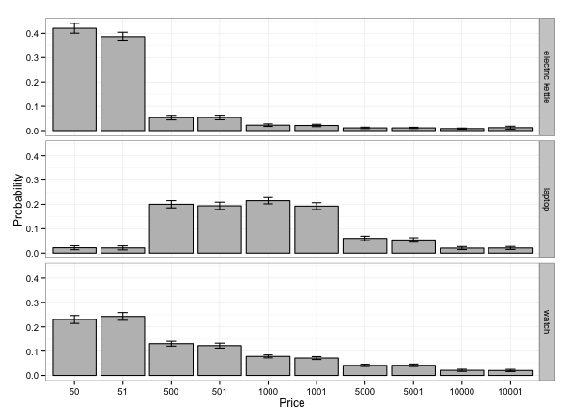

The way P\_A is constructed, in fact, as it is almost builds in the answer: a set of participants has rated the prior probability that an object costs $X, as well as the probability that people think it's expensive at $Y if they say U when the talk about it... and then, a model that knows this concludes something sensible  
about the price of the object that the person says U about.

Although both P\_S and P\_A are indeed important for the model, it is not quite obvious how a person would combine this background knowledge and linguistic knowledge to conclude something sensible about the price of an object that is described as costing U dollars. One of our contributions is that we propose and empirically evaluate a way to incorporate these sources of knowledge in a theoretically motivated framework of pragmatic reasoning.

That is (sort of) fine from an explanatory viewpoint, because presumably adult speakers do have these priors and that is what they are using to make sense of these interactions. But in another sense it does leave a huge amount unknown: how do people learn the priors - especially P\_A? (It's fairly obvious where people might learn about P\_S, i.e., prices of kettles, laptops, and watches).

How people learn priors is indeed an interesting and important question that deserves further research. However, that is beyond the scope of the current paper. Instead, we assume that people have certain knowledge of the world, and our goal is to measure that knowledge and incorporate it in a model of pragmatics to show that it predicts how people interpret utterances. We agree with Reviewer #1 that P\_S could be learned by exposure to the prices of various everyday items. As for P\_A, we speculate that after having learned the price distributions of various items, people develop judgments for which prices are unusually high. Since people generally do not want to pay unusually high amounts of money for items, these higher prices are more likely to elicit a judgment of “too expensive.” As a result, we believe that people have knowledge of P\_A, and thus it is a natural piece of knowledge to elicit from subjects to incorporate into our model.

How much of the theoretical work is it doing? Given that I suspect the answer is "a lot" it would be at least nice to see what it is, and how similar it is to the model predictions.

We hope that we have answered this in our response to editor’s comment (4) as well as with a figure of the price priors.

3. In general these figures are very hard to read. I appreciate the authors are trying to put a lot of information in a little space, but the captions could be way more informative. For instance, the meaning of the axes is never explained for Figures 4a and 2a - going into the text I see it is the likelihood that the item cost that much (but how much? The same as the utterance? I am baffled. And I shouldn't have to scour the text just to be able to read the figure).

The captions for Figure 2a and 4a have been revised to clarify the meaning of the axes. Both the x and y axes are in units of probability. In Figure 2a, each point in the scatterplot represents the probability that a certain utterance is interpreted as a certain price state. Since there are 10 utterances for each of the 3 item types, there are 30 possible unique utterances such as “The electric kettle cost 50 dollars” and “The laptop cost 10,000 dollars.” For each of the utterances, there are 10 possible interpreted pries ($50, $51, $500, $501, etc). As a result, there are 300 possible utterance/price state pairs, and thus 300 points. Figure 2a plots the probability of each utterance/price state pair as predicted by the model (x axis) and rated by humans (y axis). Thus the position of a point (which is an utterance U/price state S pair) is determined by the probability that the utterance U is interpreted as price state S.

In Figure 2b, each point represents the probability that a certain utterance is interpreted as conveying affect when the interpreted price state is greater than or equal to the utterance (in other words, when the utterance is either hyperbolic or literal). There are 45 such utterance/price state pairs (collapsed over round and sharp numbers), and thus 45 points in Figure 4a. Figure 4a plots the probability of each utterance/price state pair conveying affect as predicted by the model (x axis) and rated by humans (y axis). Thus the position of a point (which is an utterance U/price state S pair) is determined by the probability that an utterance U interpreted as price state S conveys affect.

It would also be nice to make figures that show up if the paper is printed in grayscale - e.g., use different shapes and brightness levels for the points in the figure, not things that are so similar that they all look the same in gray. Also, the labels on most of the figures are tiny and everything is quite hard to see.

Please see our response to the editor’s comment (3).

4. I know this is in the realm of further model development... but why do we need to have non-uniform utterance cost to get the bias for exact interpretation in Figure 3b?

Assuming different costs for round and sharp numbers is crucial for the bias towards exact interpretation of sharp numbers. Without a difference in utterance cost, there is no reason for a speaker to choose a round utterance over a sharp utterance when she wishes to communicate a range of price states and not a particular price state. We believe that awareness of cost is at least in part responsible for people’s tendency to interpret sharp numbers as more exact—because they are aware of the alternative, less psychologically costly utterances that the speaker could have said if they had wanted to communicate imprecisely but did *not* say, and thus infer that they meant to communicate precisely. A similar use of utterance cost has been shown to predict Horn implicatures (Bergen et al., 2012), and here we show that it accounts for interpretation of number words as well.

I mean, I see how the model requires it - but that seems like a kludge to me: why should "51" be more costly to say than "50"? If it's simply length of time it takes to say it, then, "250" should be way more costly than even "51" but I would suspect you don't want to assume that. (I know there is a literature with other models that assume this but I think it's a kludge there too).

As described in our response to the editor’s comment (1), the cost of an utterance may be due to factors such as availability, frequency, and complexity of the number terms, and we do not make specific assumptions about which factors are most important. We have revised the main text to make it clearer that cost is not necessarily determined by the length of the utterance. However, we also wanted to clarify that this cost difference is supported by other research and is a reasonable assumption to make.

You shouldn't have to hardcode a cost into a full model: it should follow from a properly specified affect (perhaps you would need one with more than binary states). That is, the model should reflect the intuition that people will say "50" instead of the actual price of "51" not because 51 is costly for some reason, but rather to (a) communicate uncertainty or lack of confidence about the exact cost - I know there was a CogSci paper in 2011(?) about this but I forget the exact title, sorry, maybe something about number preference - or (b) if more precise information isn't relevant. A model that included these factors should get the pragmatic halo effect to follow naturally, rather than getting an effect [to the extent there is one - see my #1] for a more uninteresting reason.

While there may be a way to use a more fine-grained representation of affect to capture the different degrees of affect conveyed by sharp versus round numbers (e.g. confidence levels, etc), our model posits that pragmatic halo is primarily driven by utterance costs, while hyperbole is primarily driven by affect. What unifies the ways in which the two phenomena are modeled is the fact that in both cases, the listener reasons about the speaker’s communicative goals and performs joint inference on the goal and the meaning. Our model thus shows that incorporating goal inference allows us to flexibly integrate different types of linguistic and nonlinguistic knowledge (knowledge of utterance costs, literal meanings, prices distributions, and affect) in the listener’s reasoning. We believe that this is an interesting and novel explanation for the pragmatic halo effect, and we hope that our revision expresses this more clearly.

Also, why was utterance cost set as it was, and how dependent were the final results on the particular value of C(u)?

Please see our response to the editor’s comment (1).

5. Finally, this is by no means a criticism, just a thought question for future work. It seems to me that this model (which accepts non-truthful interpretations by interpreting them as non-literal) would break if it ADDITIONALLY had the capacity to recognise that sometimes people lie: either it would always think that a non-truthful interpretation was a lie, or it would think that all non-truthful interpretations were hyperbole or pragmatic halo. (I might be wrong.) People, obviously, can make sense of both nonliteral interpretations and blatant lies. How would you try to reconcile both possibilities within a single model? (We can even allow the liar to not be very good - i.e., to be modelled by not taking the recursion very far). This could, I think, be very interesting (maybe even interesting enough for PNAS) because the answer is much more non-obvious (at least to me!).

This is a really interesting idea and certainly merits further investigation, although not within the scope of this particular project. In our current model, we assume that the speaker and listener have full access to the same background knowledge P\_S and P\_A, i.e. common ground. In a model where lying is possible, it would be interesting to examine whether a listener that has only partial background knowledge would be able to identify when a speaker is lying, and whether certainty of lying can be predicted by the amount of shared knowledge. A crucial difference between interpreting an utterance as a lie versus a hyperbolic statement is whether the listener believes that the speaker means for the listener to uncover the true price state. When the background knowledge is fully accessible to both speaker and listener, it is easier for the listener to uncover the true price state. However, when the listener has uncertainty about the background knowledge, we do agree that interesting predictions about lies versus truthful figures of speech could emerge.

But we also think that the paper, as it stands, makes it difficult to follow, and so we encourage the authors to improve on its presentation. This concerns the explanation of the RSA model on p. 1, where crucial parts remain unexplained - e.g., C(u) for the cost of the utterance, the idea of recursivity, the role of e to create a "diminishing return" for each recursion which guarantees asymptotic behavior, P(m) for the prior probability for the meaning m, etc. These things are partly explained later, but at this point the reader is puzzled. Perhaps it would be suitable to give an informal overview and then integrate the presentation of the model with the application at hand, which is done here in the section "Model" in the "Materials and Models" section on p. 5.

Please see our response to the editor’s comment (2).

On p. 2 the authors suggest a model in which interpretation has two dimensions, one related to the state of the world, one related to the emotional attitude of the speaker. This is directly related to Christopher Pott's two-dimensional theory of meaning, which should be mentioned here. 

We thank Reviewer #2 for the reference, and we included it in the main text when introducing the two dimensions of interpretations.

On Fig. 1, it is astonishing that the experimental results showed only very small differences between e.g. "100" and "101" in terms of likelihood for an exact interpretation. We expect an effect of the type of experiment here, see below.

As mentioned in our response to the editor’s comment (1), Figure 1 shows model predictions and not experimental results. We have clarified the captions to reflect this.

What is the motivation to take 1.8 as cost for sharp numbers (with respect to 1 for round numbers)?

Please see our response to the editor’s comment (1).

In general, readers might be alerted that roundness does not always relate to shorter numbers, e.g. with the temporal scale (where e.g. 45 minutes can be argued to be rounder than 50 minutes, cf. Solt e.a., [http://www.zas.gwz-berlin.de/fileadmin/mitarbeiter/solt/The\_Preference\_for\_Approximation\_-](http://www.zas.gwz-berlin.de/fileadmin/mitarbeiter/solt/The_Preference_for_Approximation_-" \t "_blank)   
\_final.pdf)

As described in our response to the editor’s comment (1), we believe that utterance costs may be due to factors such as availability, frequency, and complexity of the number terms. We agree that these factors are context-dependent, and as a result different numbers may be round or sharp in different contexts (such as prices, times, and number of eggs, etc.). In fact, Solt et al. (2011) have shown evidence for domain-specific scale granularity that affects the processing of numbers in the time domain.

There are two problems that we see with the experiment itself, not with its presentation:   
  
1. It strikes us that the question how much a kettle, watch or laptop computer ("really") cost can be seen as questioning the truthfulness of Bob, the speaker. This is o.k. for the hyperbolic reading, but perhaps not so for the fuzzy reading.

While we certainly agree that questioning Bob’s truthfulness would be problematic, we were careful with our wording and presentation to avoid making it sound like Bob’s truthfulness should be questioned. A screenshot of the experiment is shown below. By asking participants to rate each of the possible prices on slider bars, and by wording the task as “Pleas rate how likely it is that the electric kettle cost the following amounts of money,” we are not indicating that Nathan did not “really” spend $5,000 on the watch.

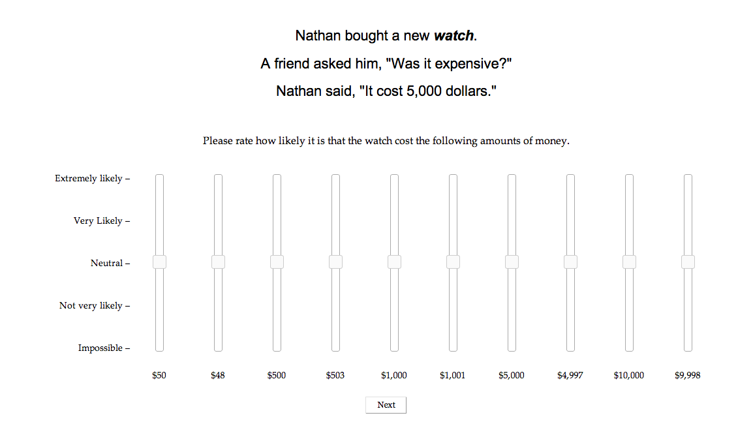

Also, if a subject has heard Bob say a sharp price, like 51 dollars, then it is likely that he will be understood as specifying a sharp value when Bob used a round number, like 50 dollars. 

We thank Reviewer #2 for this insight and suggestion. One detail to clarify is that since the speaker’s names are randomized and each name only appears once for each participant, it is unlikely that subjects will attribute biases towards using round versus sharp numbers to a particular speaker. However, we agree with the general concern that there may be order effects in the data. To examine this, we took the first 5 trials that each participant saw (out of 15) and compared them with the last 5 trials. We did find that the halo effect was stronger in the first trials, which was mainly driven by the fact that sharp numbers were interpreted more exactly in the first trials than the last trials. However, both sets of trials still showed significant halo effects, where the difference score between exact and fuzzy interpretations are significantly different higher for sharp versus round numbers. This suggests to us that while there may be carryover effects from previous trials or simply effects of fatigue, a small but significant halo effect is still observed throughout the trials.

2. If numbers are given by the Arabic notation, as in 50 dollars, then it is likely that there is a bias towards a precise interpretation compared to spoken numbers or numbers written as fifty dollars. In particular, we feel that the Arabic notation has a strong bias against an hyperbolic interpretation.

We agree that the Arabic notation might elicit a bias towards precise interpretations. However, presenting the stimuli in spoken form introduces a great deal of complexity and potential confounds such as prosodic information, which we wanted to eliminate at least in the first step towards examining hyperbole understanding. We could try presenting the numbers written out as “fifty dollars,” which could remove this bias but perhaps introduce others. For example, since numbers are less frequently presented in words, by selecting this unusual presentation, we may unwittingly prime participants to believe that minimizing cost is not an issue in this particular experimental context, since writing the numbers out in words is clearly more costly than presenting the numerals. As a result, we decided that it was preferable to use the more “common” and less unusual presentation. However, regardless of this potential bias with the Arabic notation, participants still reported hyperbolic and fuzzy interpretations in ways that seem intuitive and reasonable.