Week 3 – Hypothesis testing

Jeanette Henry

T-tests can be used to find if two sets of data are significantly different from each other. In this case, we are testing if Drugs XYZ and ABC have a significant effect on the heart rates of 18 people. Because the same people’s heart rates are measured before and after it is a paired test. Because we want to know if it is higher or lower it is two-sided.

As we see in ln[12] the p-value between the initial B.P. and the B.P. after XYZ is 0.2691 meaning they are not significant. Therefore, the XYZ drug does not have a significant impact on that patients despite it lowering the average BP by 0.4167. In the summary of the groups we can see that the two sets are very similar.

In ln[19] we see that when looking at initial vs ABC the p-value is 3.582e-07 proving that they are significantly different. It also shows that the average BPI was lowered by 7.0 which is much more than that of the XYZ drug.

[Jupyter Notebook](http://localhost:8888/tree)

In [10]:

*#Starting B. P. will be BP initial*

BPI **=** c(155,142,145,160,149,152,157,159,166,163,158,161)

In [11]:

*#B.P. After XYZ will be BP final*

BPF **=** c(152,142,144,159,150,153,156,160,165,162,159,160)

In [12]:

t.test(BPI, BPF, alternative = c("two.sided"), paired=TRUE)

*# p-value greater thatn .05 not significantly different*

        Paired t-test

data: BPI and BPF  
t = 1.1639, df = 11, p-value = 0.2691  
alternative hypothesis: true difference in means is not equal to 0  
95 percent confidence interval:  
 -0.3712632 1.2045965  
sample estimates:  
mean of the differences   
 0.4166667

In [13]:

summary(BPI)

Min. 1st Qu. Median Mean 3rd Qu. Max.   
 142.0 151.2 157.5 155.6 160.2 166.0

In [14]:

summary(BPF)

Min. 1st Qu. Median Mean 3rd Qu. Max.   
 142.0 151.5 157.5 155.2 160.0 165.0

In [15]:

hist(BPI, breaks=(10))

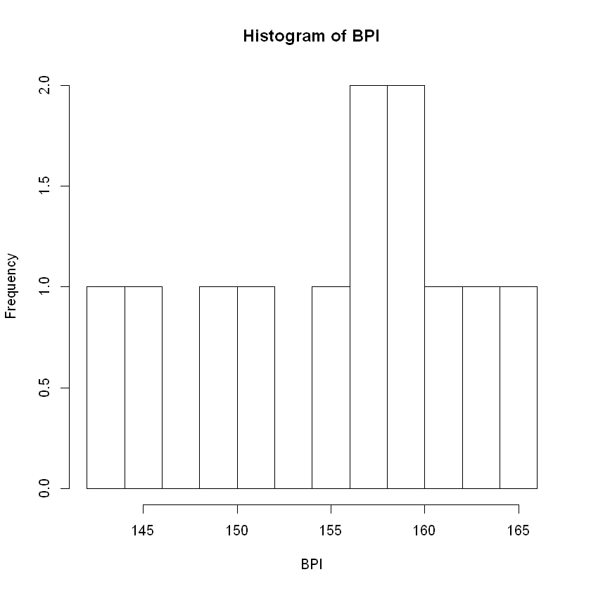

In [16]:

hist(BPF, breaks=(10))

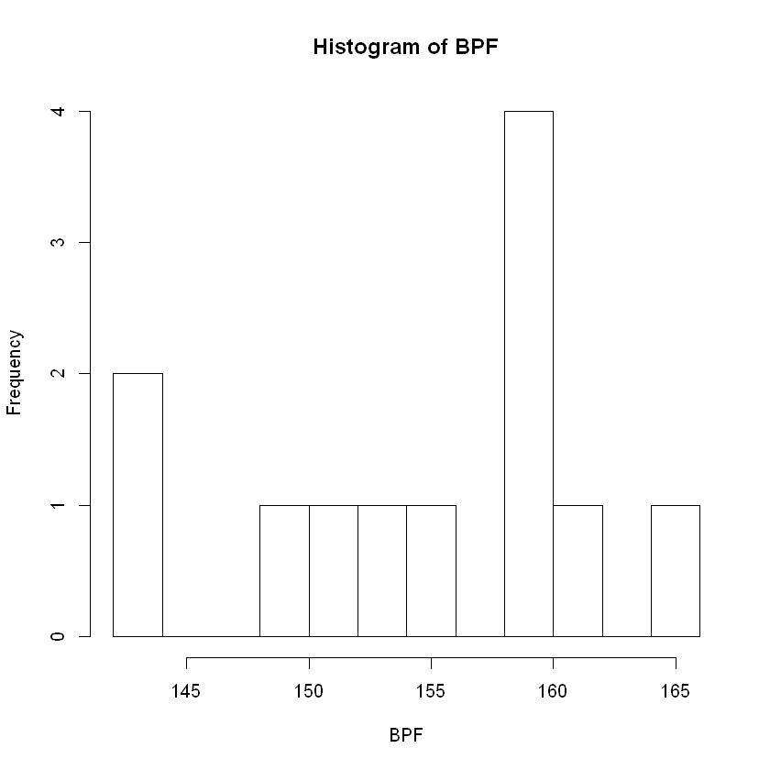

In [17]:

*#Starting B. P. will be BP initial*

BPI **=** c(155,142,145,160,149,152,157,159,166,163,158,161)

In [18]:

*#B.P. After ABC will be ABC*

ABC **=** c(150,135,142,153,142,147,152,149,158,155,150,150)

In [19]:

t.test(BPI, ABC, alternative = c("two.sided"), paired=TRUE)

*# p-value greater thatn .05 not significantly different*

        Paired t-test

data: BPI and ABC  
t = 10.747, df = 11, p-value = 3.582e-07  
alternative hypothesis: true difference in means is not equal to 0  
95 percent confidence interval:  
 5.566413 8.433587  
sample estimates:  
mean of the differences   
 7

In [20]:

summary(BPI)

Min. 1st Qu. Median Mean 3rd Qu. Max.   
 142.0 151.2 157.5 155.6 160.2 166.0

In [21]:

summary(ABC)

Min. 1st Qu. Median Mean 3rd Qu. Max.   
 135.0 145.8 150.0 148.6 152.2 158.0

In [22]:

hist(BPI, breaks=(10))



In [23]:

hist(ABC, breaks=(10))

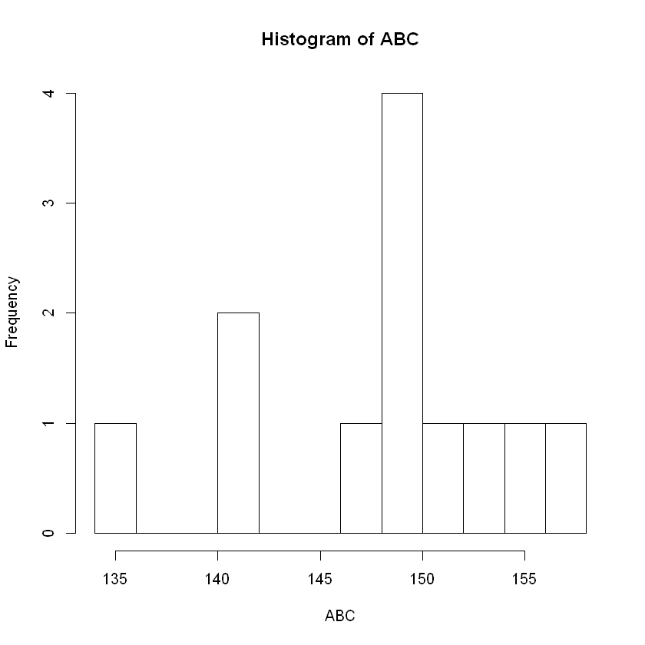

*From <*[*http://localhost:8888/notebooks/statstest/W3Hypothesis.ipynb*](http://localhost:8888/notebooks/statstest/W3Hypothesis.ipynb)*>*