CJP AI PERSONA KIOSK
Dimensional Modelling for Retrieval

Framework, schematic, and the relevance of each selected model / method
Foundation for Liberty and Prosperity · pipeline arch-baseline-v3
What “dimensional modelling” means here
Yes — the retrieval pipeline includes a dimensional model. But the word dimensions does two different jobs in this project, and they must be kept apart:
Embedding dimensions — the 1024 numbers in a bge-large vector (384 for MiniLM). These are latent, machine-learned coordinates — no human can read them. This is a property of the embedding model.
Topic dimensions (the dimensional model) — a separate, human-meaningful layer of 34 curated topics, each represented as a centroid vector. These are the “dimensions” the retrieval measures a query against. THIS is the dimensional model.
So the dimensional model is the 34-topic centroid soft-prior: each topic is the average embedding of its documents, and a query’s similarity to the 34 centroids yields a relevance vector that biases retrieval toward the right theme — a soft prior, not a hard gate.
The framework
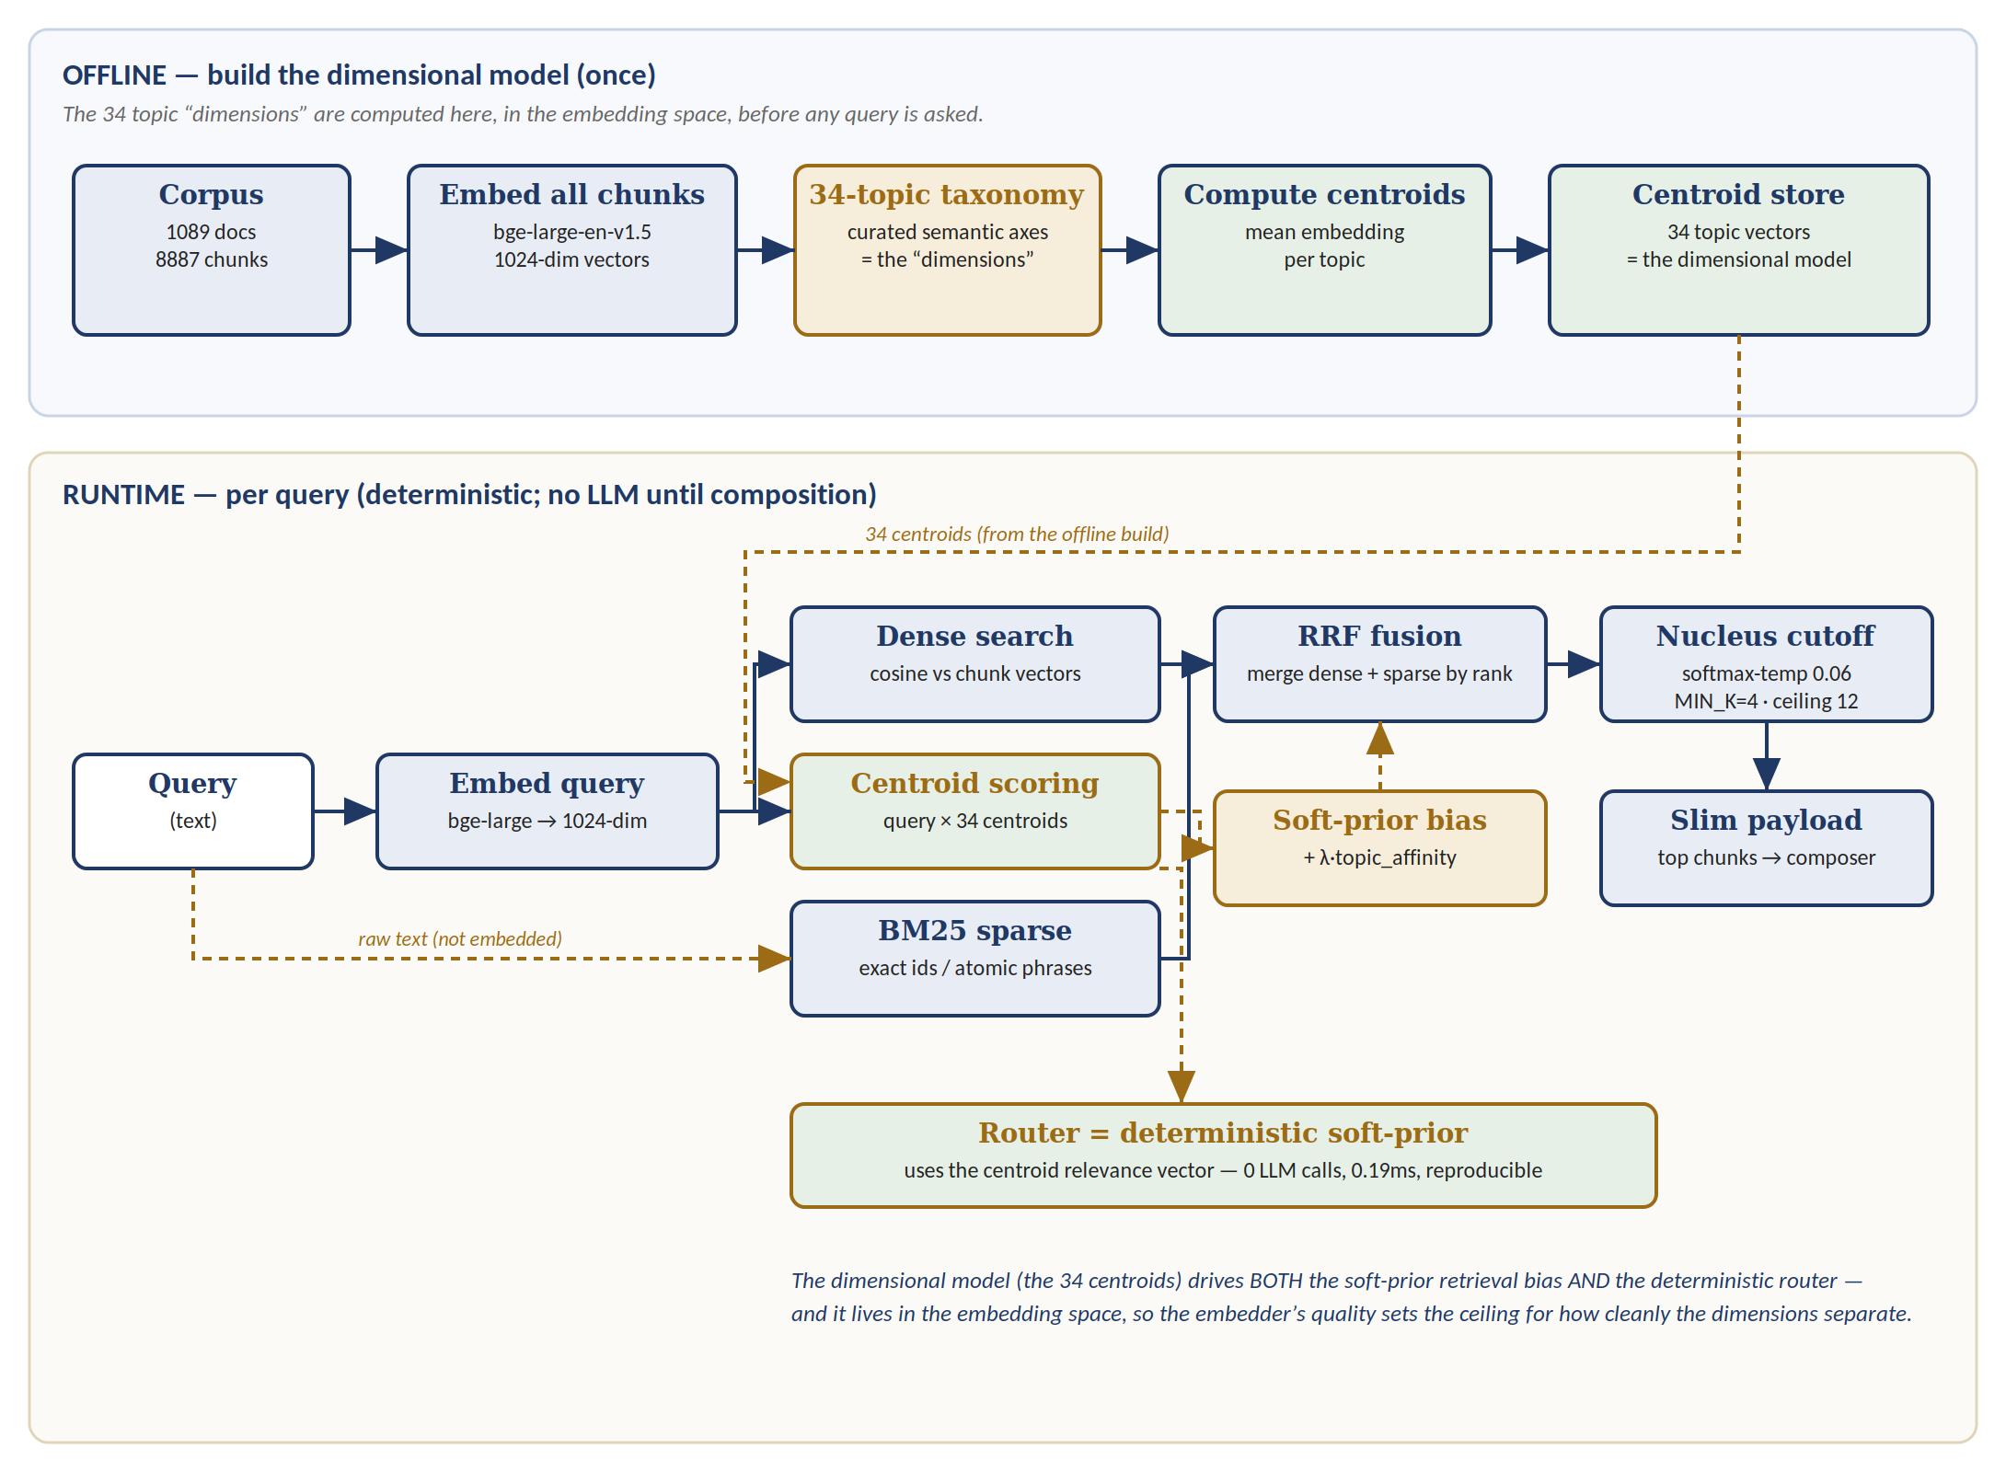
The 34 centroids are built once offline; at query time they bias retrieval and drive the deterministic router.
Why each selected model / method — and its role
Embedding — bge-large-en-v1.5 (1024-dim)
Role: the space everything lives in. Chunk vectors, the 34 centroids, and the query vector are all in this one space — the dimensional model is literally built out of these embeddings.
Why selected: strongest local/open English recall of the candidates, kept offline (no API on the hot path, data-governance-safe for a legal corpus). Its quality sets the ceiling for how cleanly the 34 dimensions separate — a weak embedder blurs the centroids together.
Sparse arm — BM25 (atomic-phrase dictionary)
Role: the lexical arm, independent of the dimensional model. It matches exact strings — case names, statute numbers — that no semantic dimension can reliably surface.
Why selected: the legal corpus needs exact-identifier matching; corpus analysis (94% of keywords in one doc, 91% multi-word) fit BM25 far better than TF-IDF. The dimensions handle thematic precision; BM25 handles identifier precision — complementary, so both run regardless of embedder quality.
Centroid scoring — the soft-prior (the dimensional model itself)
Role: this is the dimensional model. Query × 34 centroids → a topic relevance vector that nudges retrieval toward the right theme.
Why selected: a soft prior (bias) beats a hard topic gate — a wrong topic guess only nudges, it can’t drop recall to zero the way a hard filter would. Cheap (~6ms) and it also feeds the router.
Dense search — brute-force exact cosine
Role: retrieves passages by meaning in the same embedding space the dimensions live in.
Why selected: brute-force over 827 chunks is exact (no approximation error) and sub-3ms; ANN (HNSW/FAISS) is the documented scale-path only once the corpus grows large.
RRF fusion — reciprocal rank fusion
Role: merges the dense (meaning) and sparse (exact) result lists into one ranking; the centroid soft-prior then biases the fused result.
Why selected: fuses by rank, so the two arms’ incompatible score scales never need calibrating — robust and parameter-light versus brittle weighted-score fusion.
Cutoff — softmax-temp nucleus (MIN_K=4, ceiling 12)
Role: decides how many chunks to keep, by relevance rather than a fixed count.
Why selected: flat top-k was wasteful/degenerate; the relevance nucleus adapts chunk count to how much good material exists — −28% input tokens with no grounding loss.
Router — deterministic soft-prior
Role: picks topic / register up front. It reuses the centroid relevance vector — the same dimensional-model signal — rather than a separate model.
Why selected: the Haiku LLM router was removed — deterministic routing is 0.19ms, free, reproducible, and adds zero LLM calls before composition.
How it interlocks
- One space, three uses: the embedding space holds the chunk vectors (for dense search), the 34 centroids (the dimensional model), and the query vector — so embedder quality drives all three.
- Semantic + lexical, fused: dense search + BM25 cover meaning and exact identifiers respectively; RRF fuses them; the centroid soft-prior biases the result toward the right dimension.
- The dimensional model does double duty: the same 34-centroid relevance vector powers both the soft-prior retrieval bias and the deterministic router — no extra model, no LLM call.
- Tuning note: the model is built and running (~6ms); how strongly the prior biases (λ / topic_affinity) is tuned in W3.4, not yet set.

