A Retrieval-Grounded Judicial Persona Kiosk: Hybrid Retrieval with a Centroid-Based Dimensional Model and an Embedding-Model Trade Study for Edge Deployment
[Author list & order TBD: Dev0, Pao, Sheena, Dok — affiliations: Foundation for Liberty and Prosperity]
WORKING PAPER / PRE-SUBMISSION DRAFT — July 2026. Pre-tuning baseline results; sections marked [PENDING] await sub-$2 verification runs.
Abstract
We present the design, measurement, and embedding-model trade study of a retrieval-augmented generation (RAG) system that answers visitor questions in the persona of a retired Chief Justice, targeting deployment on a GPU-less desktop robot (Raspberry Pi CM4). The system combines dense retrieval (bge-large-en-v1.5), sparse lexical retrieval (BM25 with a curated atomic-phrase dictionary), reciprocal rank fusion, a 34-topic dimensional model — topic centroids in embedding space that softly bias retrieval and drive a deterministic router with zero pre-composition LLM calls — an adaptive softmax-temperature nucleus cutoff, and a streamed LLM composer overlapped with incremental text-to-speech. On a frozen 40-query anchor with a human-labeled gold set (34 recall-gradeable items), the baseline achieves recall@5 = 0.971 on reachable gold with zero fabricated citations across all runs, at US$0.028 per uncached answer and a perceived response onset of ~2.5 s via stream-overlap. Per-stage instrumentation attributes 86% of retrieval latency to query embedding, motivating a four-candidate embedding trade study (bge-large fp32, MiniLM-L6, bge-base, int8-quantized bge-large) using per-candidate centroid rebuilds and a proposed metric, recall@chunks-sent, which grades at the retrieval depth the composer actually receives. Key findings: int8 quantization is quality-lossless (identical hits; cosine fidelity 1.0) but yields only ~10% CPU speedup — a memory fix, not a speed fix; recall@chunks-sent compresses the small-model quality gap by 2–4× relative to recall@5 (bge-base: −2.9 pts at 4× lower query latency); and the smallest model uniquely retrieves one document to which the entire bge family is blind. We discuss the resulting host-versus-edge deployment frames and the evaluation-integrity controls (frozen artifacts, content-aware diffs, denominator assertions) that detected and repaired a mid-study gold-set corruption within one run.
Keywords: retrieval-augmented generation; hybrid retrieval; embedding models; quantization; edge deployment; conversational kiosk; evaluation integrity.
1 Introduction
Museum and civic-education kiosks increasingly employ conversational agents, but grounding requirements are unusually strict when the agent speaks as a real public figure: every claim must trace to the figure's actual writings, fabrication is reputationally unacceptable, and the deployment target — an interactive desktop robot — imposes hard latency and memory budgets without GPU acceleration. This paper documents a three-week pilot that built and measured such a system for the Foundation for Liberty and Prosperity (FLP): a kiosk persona of retired Philippine Chief Justice Artemio V. Panganiban, grounded in a 1,089-document corpus of his columns, speeches, books, and biography.
Contributions: (1) an architecture combining hybrid retrieval with a centroid-based dimensional model that provides topic control as a soft prior rather than a hard gate, reused by a deterministic router that eliminates all pre-composition LLM calls; (2) full per-stage latency/cost instrumentation showing query embedding dominates retrieval (86%); (3) a four-candidate embedding trade study with methodology contributions — per-candidate centroid rebuilds and the recall@chunks-sent metric — that materially change the perceived quality/latency trade; (4) an honest account of evaluation-integrity engineering, including a frozen-artifact corruption incident detected by the evaluation's own consistency assertions.
2 System Architecture
The pipeline has an offline build phase and a deterministic per-query runtime (Fig. 1). Offline, all 8,887 chunks from 1,089 documents are embedded once; a curated 34-topic taxonomy defines the dimensions, and each topic's centroid is the mean embedding of its member chunks. The pilot retrieves from a frozen, theme-balanced 95-document subset (827 chunks; 19 documents per theme), an eval-time allowlist deliberately decoupled from chunking.
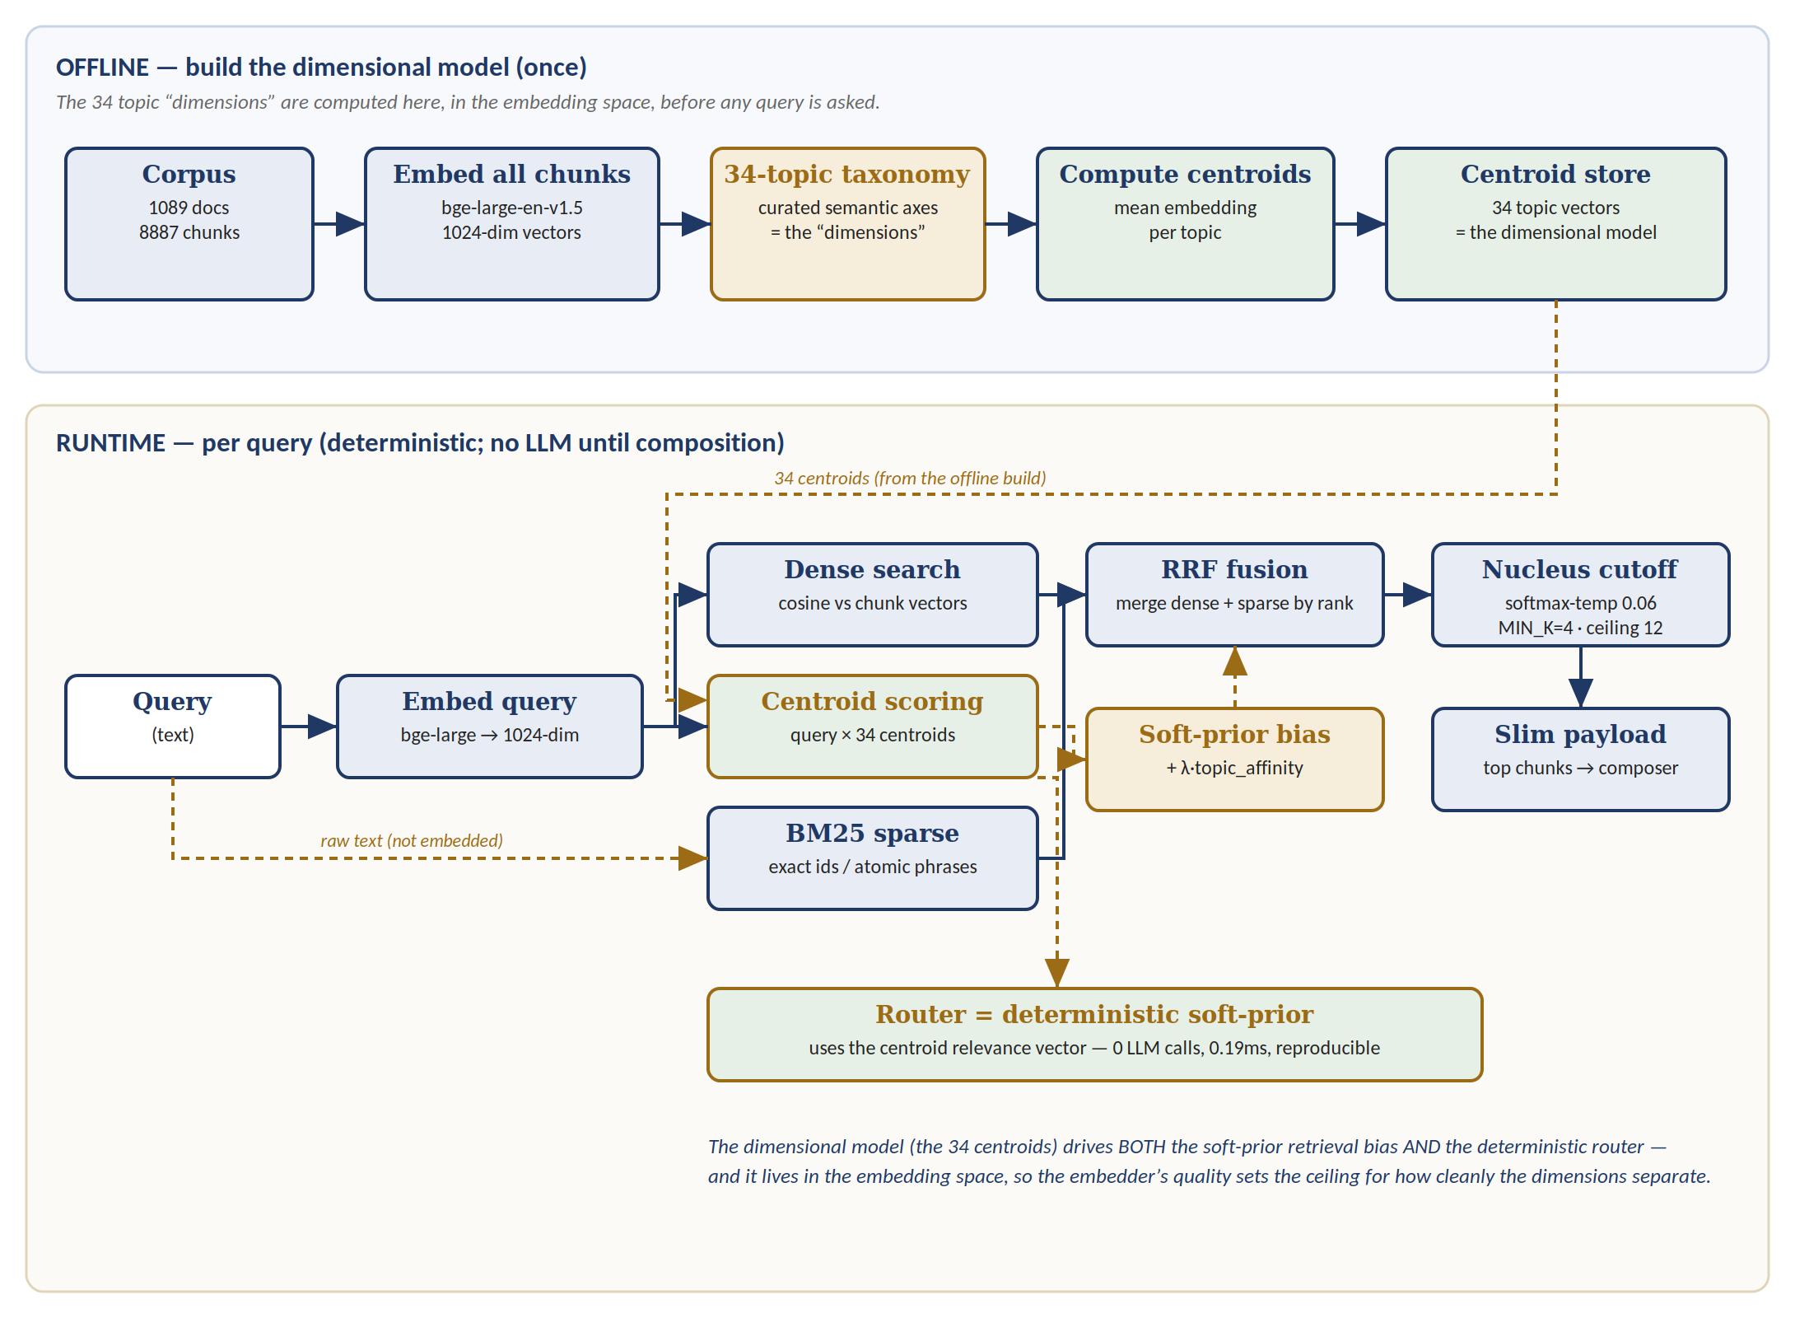
Figure 1. Offline dimensional-model build (top) and deterministic per-query runtime (bottom). Gold dashed paths carry the centroid signal, which biases retrieval and drives the router.
2.1 Runtime components
- Query embedding (bge-large-en-v1.5, 1024-d, resident) — the shared space in which chunks, centroids, and queries live.
- Dense search — exact brute-force cosine over 827 chunk vectors (<3 ms at pilot scale; ANN is the documented scale path).
- Sparse arm — BM25 over chunk text plus a curated atomic-phrase dictionary. Corpus analysis motivated this: 94% of keywords occur in exactly one document and 91% are multi-word phrases, favoring BM25 with phrase entries over TF-IDF; exact legal identifiers (case names, statute numbers) are unreachable by semantic match alone.
- Fusion — reciprocal rank fusion (RRF) merges the two ranked lists without cross-arm score calibration; a λ-weighted topic-affinity term from the dimensional model then biases (never gates) the fused ranking.
- Adaptive cutoff — softmax-temperature nucleus selection (temp 0.06, MIN_K = 4, ceiling 12) keeps chunks by relevance mass rather than fixed count; it replaced a degenerate flat top-p over raw RRF scores (which retained 753/827 chunks) and reduced composer input tokens by 28% with zero grounding loss.
- Deterministic router — reuses the centroid relevance vector to select topic/register in 0.19 ms; an earlier LLM router was removed, leaving zero LLM calls before composition.
- Composer — a streamed LLM (Claude Sonnet) with a cached static persona prefix, slim chunk payload (−49% input tokens vs whole-document), and a trailing ENVELOPE metadata block (cited doc-ids, register) kept out of the spoken stream. A question-keyed decline directive handles out-of-scope queries (§5.4).
- Voice front-end — sentence-chunked stream-overlap to TTS: speech begins on the first completed sentence while generation continues (perceived onset ~2.5 s vs ~8.8 s full-wait).
3 Evaluation Methodology
3.1 Frozen anchor and gold set
All quality claims are graded against a frozen 40-query anchor (SHA-pinned) spanning five case types, with a human-labeled gold set assigning per-query gold document ids, scope labels, confidence, and expected behavior. Grading is scope-aware: 34 in-scope queries are recall-gradeable; two out-of-scope probes are graded on declining; two meta queries on identity response; two corpus-gap queries on graceful non-fabrication. Sentinel labels (OOS/META/GAP) are never treated as document ids. The gold universe is restricted per query to the frozen 95-document pilot subset; three queries whose original gold lay outside it were re-anchored or honestly re-classified as gaps rather than scored as structural misses.
3.2 Metrics
- recall@k (doc-level): a query hits at k if any top-k chunk's parent document is in its gold set.
- recall@chunks-sent (proposed): recall graded at the k the adaptive cutoff actually returned for that query in the canonical run (median 9, range 4–12) — i.e., at the retrieval depth the composer really receives. Fixed-k metrics misstate adaptive-retrieval systems: recall@5 understates and recall@10 overstates what reaches composition.
- Grounding: fabricated-citation rate (cited id absent from corpus or from that query's retrieved set) and empty-citation rate. Fabrication is necessary but not sufficient; citation coverage is checked separately.
- Latency: per-stage wall-clock (embed, sparse, dense, fusion, centroid, cutoff, router) with p50/p95; compose-side TTFT and full-compose; TTFA (first audio) via replay proxy, live measurement pending.
- Cost: all four API token buckets logged with rate constants; cached and uncached regimes reported separately — sporadic kiosk traffic exceeds cache TTL, so uncached is the honest regime.
3.3 Integrity controls
Runs are reproducible from provenance blocks (eval SHA, commit, embedder, cutoff params, transport, timestamp). Transport is asserted native-TLS for latency-sensitive runs after a proxy-transport regression fabricated a spurious empty-citation case. Frozen files are verified with content-aware diffs (CRLF-normalized), never line-count equality — a rule adopted after a restore operation, mis-verified by insert/delete-count equality, destroyed three uncommitted gold corrections; the corruption was detected within one run by a hard denominator assertion (N = 34) and repaired from the committed grading record, with non-grading columns reconciled cell-by-cell against the labeler's authoritative copy and verified by per-column hash.
4 Embedding-Model Trade Study
Per-stage instrumentation attributed 86% of retrieval latency to query embedding (535 ms p50 of 621 ms total on a workstation GPU) and revealed GPU-state instability (165→535 ms across sessions on the same hardware) — both critical for the deployment target, a Raspberry Pi CM4 with no GPU and ~4 GB RAM shared with the robot stack. We therefore ran a four-candidate trade study, entirely offline ($0 API):
Table 1. Candidates.
Candidate | Model | Dim | Params | Est. RAM
A (baseline) | bge-large-en-v1.5 fp32 | 1024 | 335 M | ~1,340 MB
B | all-MiniLM-L6-v2 | 384 | 22.7 M | ~91 MB
C | bge-base-en-v1.5 | 768 | 109 M | ~437 MB
D | bge-large-en-v1.5 int8 (dynamic) | 1024 | 335 M | ~400–500 MB
Method. Each candidate receives a full parallel build — chunk matrix, query embeddings, and a per-candidate centroid rebuild (the dimensional model lives in embedding space; reusing baseline centroids across spaces would sandbag alternatives). The BM25 arm, RRF, soft-prior mechanics, and cutoff parameters are held fixed; only the dense space changes. Grading uses the identical scope-aware code path against the same gold. Production configuration is never modified; all artifacts are parallel-named. Int8 fidelity was verified by cosine similarity of quantized vs fp32 vectors (mean 1.0 on sample). Latency was benchmarked per candidate on GPU and CPU-forced (the CM4 proxy), with cold-first/warm-rest splits from a 20× repeated-query design.
Centroid-separation statistics were computed per model but are reported only with a cross-model caveat: mean pairwise centroid cosine (bge-large 0.922 vs MiniLM 0.774) is not comparable across models because the bge family compresses cosine range; per-model percentile ranges are given as context, not as a head-to-head score. Three topics had zero members in the pilot subset and received neutral-fallback centroids (flagged).
5 Results
5.1 Baseline quality, latency, cost
Table 2. Baseline (pre-tuning) results on the frozen anchor.
Metric | Value | Note
recall@5 / @1 (reachable, N=34) | 0.971 / 0.735 | 1 coverage miss (B9); 8 rank-2/3 near-misses
Fabricated citations | 0 / 40 | across all runs, incl. under real billing failure
Empty-cited in-scope | 0 | native transport
Retrieval latency | 621 ms p50 | embed 535 ms (86%); BM25 71 ms; router 0.19 ms
TTFT / full compose | 1.53 s / 10.4 s p50 | full compose hidden under speech by streaming
Perceived onset (TTFA) | ~2.5 s p50 (replay proxy) | [PENDING: live measurement, ~US$0.30]
Cost per answer | US$0.028 uncached | US$0.015 cached; sporadic kiosk traffic → uncached is honest
5.2 Trade-study quality
Table 3. Quality (N=34, identical grading path, repaired v4 gold).
Candidate | recall@1 | recall@5 | recall@chunks-sent | recall@10 | Δ@chunks-sent vs A
A bge-large fp32 | 0.735 | 0.971 | 0.971 | 0.971 | —
B MiniLM | 0.559 | 0.853 | 0.912 | 1.000 | −5.9 pts
C bge-base | 0.618 | 0.882 | 0.941 | 0.971 | −2.9 pts
D bge-large int8 | 0.735 | 0.971 | 0.971 | 1.000 | 0.0
Three findings. (i) Quantization is quality-lossless here: D reproduces A's hits exactly (zero hit@5 differences; identical near-miss ranks). (ii) recall@chunks-sent compresses the small-model gap 2–4× relative to recall@5: MiniLM's apparent −11.8 pts becomes −5.9; bge-base's becomes −2.9 — because the adaptive cutoff sends a median of 9 chunks, and fixed-k@5 grades a depth the composer does not actually operate at. *(iii) One document (query B9) is retrieved only by MiniLM* (rank 5; absent from A's ranking entirely, rank 6 in C, rank 10 in D) — an embedding-family blind spot: all bge variants, including the lossless quantization, inherit it. This is diagnostic for fusion tuning rather than a model-selection driver.
5.3 Trade-study latency and footprint
Table 4. Latency and footprint. CPU-forced runs proxy the GPU-less CM4.
Candidate | CPU query p50 (CM4 proxy) | GPU warm p50 | Cold-first (GPU) | Vector store (8,887 chunks)
A fp32 | 859 ms | 90 ms | 6,487 ms | 36.4 MB
B MiniLM | 44 ms | 27 ms | (small) | 13.7 MB
C bge-base | 216 ms | (intermediate) | (intermediate) | 27.3 MB
D int8 | 781 ms | — (CPU-targeted) | — | 36.4 MB
The ladder is decisive on the speed axis — B 44 ms, C 216 ms, D 781 ms, A 859 ms — and reveals the study's central surprise: int8 quantization is a memory fix, not a speed fix (≈10% CPU gain), so D fits the CM4's RAM but plausibly lands at 1.5–3 s/query on ARM, at the edge of the interaction budget. The 20× design also corroborated the GPU-state instability (cold-first 6.5 s vs 89 ms warm for A), confirming that a quiet kiosk operates predominantly in the cold regime. One-off index builds (D: 81.7 min CPU for 827 chunks) are host-side costs, not runtime costs.
5.4 Out-of-scope behavior
The cosine-threshold scope gate proved inert: out-of-scope probes score inside the in-scope similarity band (a weather query at 0.583 vs the lowest in-scope at 0.574), so no threshold separates them without false-declining genuine content. The working mechanism is a layered design — a loose gate retained as an orphan-fallback bias plus a question-keyed composer decline directive — verified to decline both probes while the three lowest-similarity in-scope queries answer normally. Verification breadth is the limitation: n=2 probes; expansion (including an adversarial probe) is queued. [PENDING: 3 in-scope re-verifications interrupted by a billing failure, ~US$0.10.]
6 Discussion
- The embedder is the deployment decision. With 86% of retrieval latency in one component and a 20× CPU spread across candidates, embedding-model choice is the edge-vs-host topology choice: host-side retrieval keeps A's canonical quality; on-device favors C as the balanced fit (−2.9 pts at 216 ms/437 MB), with D viable if real ARM latency proves acceptable and B if latency dominates. A single Raspberry Pi 4 benchmark would settle D-vs-C; the trade study leaves that as the one open datum.
- Fixed-k recall misleads adaptive-retrieval systems. recall@chunks-sent changed the decision materially (a 2–4× gap compression); we suggest adaptive-cutoff RAG evaluations report at delivered depth as standard practice.
- A soft prior preserved recall where a gate would not. The dimensional model contributes topic control at ~6 ms with no hard-gate recall risk, and its reuse by the router removed all pre-composition LLM latency/cost. Its limits also showed: centroid cosine could not separate out-of-scope queries, pushing scope control to the composer layer.
- Grounding held under adversity. Zero fabrications across every run — including a run that degraded mid-flight on a real billing failure — supports the slim-payload + envelope design; the one apparent empty-citation case was traced to a proxy-transport artifact, not the pipeline.
- Evaluation integrity is an engineering discipline. The gold-corruption incident and its one-run detection argue for denominator assertions, content-aware frozen-file checks, provenance blocks, and artifact-over-memory audits as first-class RAG methodology, not housekeeping.
7 Limitations and Threats to Validity
- Single corpus, single persona, single language (English); N = 34 recall-gradeable queries — adequate for engineering decisions, small for statistical claims; no significance testing is asserted.
- CPU-forced desktop runs proxy the CM4; real ARM measurements are pending. RSS-based memory probes failed; RAM figures are parameter-based estimates, flagged as such.
- TTFA is a replay proxy; live first-audio latency is unmeasured. Composer cost/latency telemetry derives from the directive-OFF configuration; directive-ON deltas pending.
- Out-of-scope verification breadth is n = 2 probes. Six gold labels carry low confidence pending SME confirmation. The 95-document subset is theme-balanced, not corpus-representative (corpus ≈ 55% theme A) — chosen deliberately for per-theme eval power.
- All results are the pre-tuning baseline; fusion-weight and composer-config sweeps (targeting the B9 blind spot and the rank-2/3 cluster) are future work.
8 Conclusion
A hybrid-retrieval RAG kiosk with a centroid-based dimensional model achieves high grounded quality (recall@5 0.971 reachable; zero fabricated citations) at kiosk-viable cost (US$0.028/answer uncached) and perceived latency (~2.5 s onset), with a fully deterministic pre-composition path. The embedding trade study shows the quality/efficiency frontier is friendlier than fixed-k metrics suggest — bge-base concedes only 2.9 points at delivered depth for a 4× CPU speedup and a third of the memory — while int8 quantization, though perfectly quality-preserving, buys memory rather than speed. Model choice therefore resolves into deployment topology, with one ARM measurement outstanding. Future work: live TTFA, fusion tuning against the identified blind spot, OOS hardening, on-robot integration (Linux TTS, ASR seam), and human A/B persona evaluation.
Acknowledgments
[TBD — FLP support; corpus and gold-set labeling (Sheena); implementation (Pao); technical review (Dok). Note: the retired Chief Justice's estate/permissions statement required for publication.]
References
[PLACEHOLDERS — to be completed for the target venue:] BM25 (Robertson & Zaragoza); Reciprocal Rank Fusion (Cormack et al., 2009); BGE embeddings (Xiao et al., 2023); Sentence-BERT/MiniLM (Reimers & Gurevych, 2019; Wang et al., 2020); RAG (Lewis et al., 2020); nucleus sampling (Holtzman et al., 2020); dynamic quantization (ONNX Runtime); MTEB benchmark (Muennighoff et al., 2022).
Data & code availability: evaluation artifacts, provenance blocks, and the bake-off scripts are version-controlled in the project repository (commits d86e976–6412ab0); the corpus comprises copyrighted works used with the Foundation's authorization and is not publicly redistributable.

