**ADMIN**

Files list

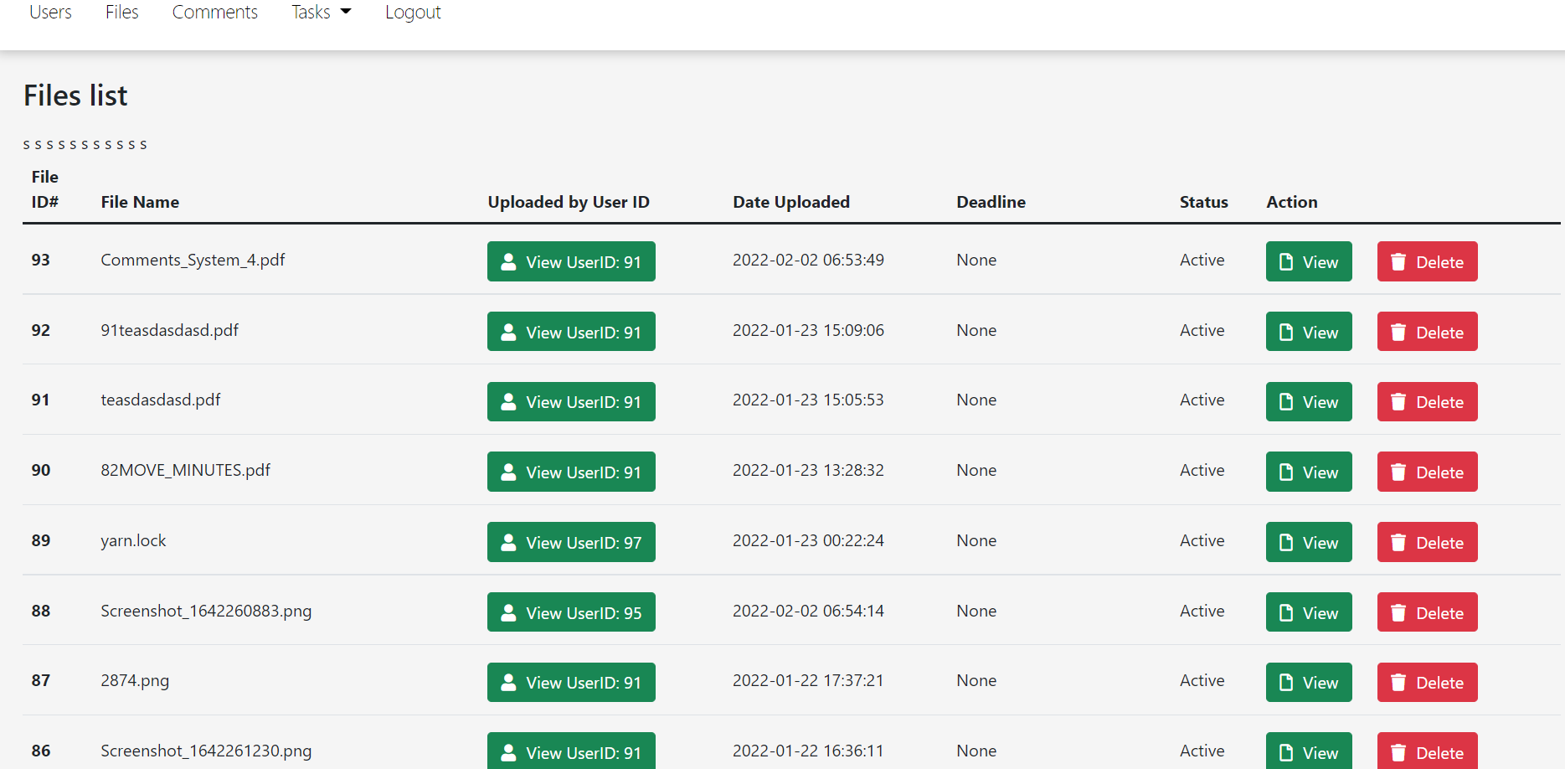

* Remove the pin and delete files (Remove Actions Column Delete, Remove T)
* Add sortation of the files (word, excel, pdf, etc.)

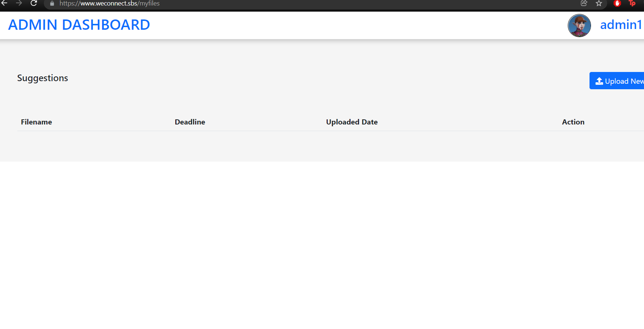

* If you delete a specific file, it will display this, which is wrong. Trash file button in file view

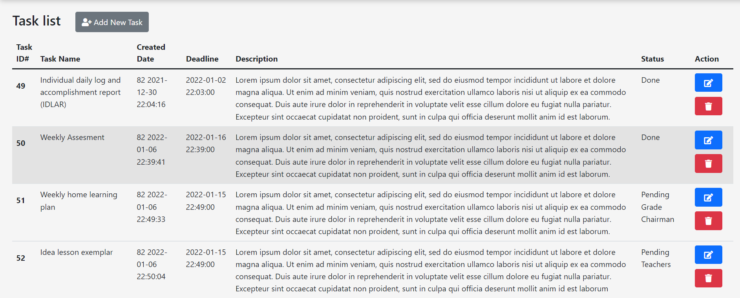

* The tasks that the admin should only be doing are the update of the system and creation of the user’s account.
* The creation or the user that will assign each task is the PRINCIPAL NOT THE ADMIN.

**TEACHER**

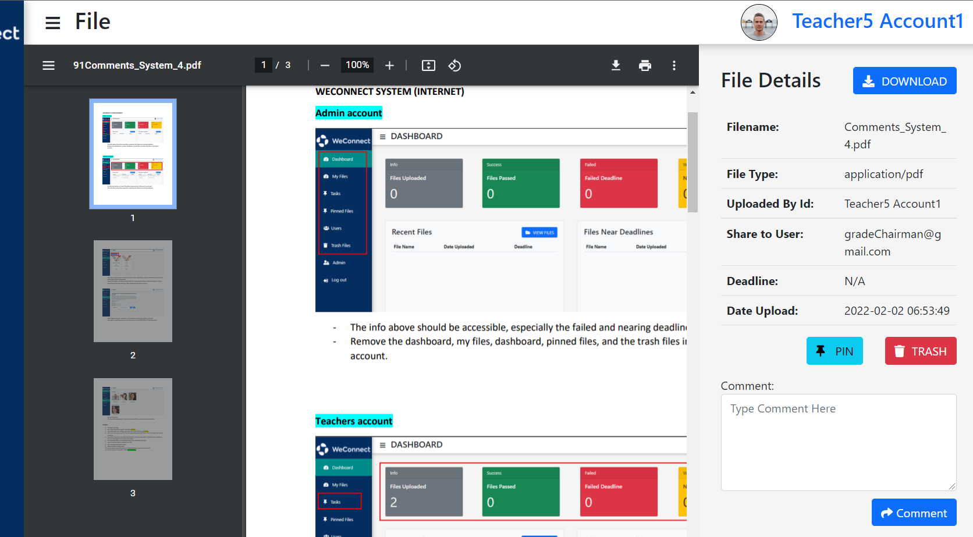

* ADD THE ROLE-BASED BASED ON THE WORD DOCUMENT.
* Add the notification for email/text/system itself.

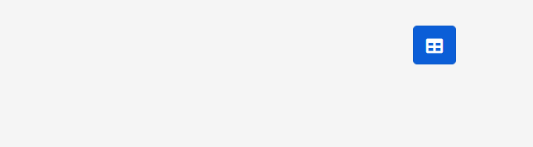

* Add the sort for the task files.

ALWAYS FOLLOW THE INSTRUCTIONS OR THE TASKS IN THE WORD DOCUMENT.