**Ink Code**

**Laravel Test**

This is a simple web application; it contains two modules (Login-Orders).

Login:

It is a simple login page for authentication, we have created 5 users: one administrator and 4 normal users.

Email: [admin@gmail.com](mailto:admin@gmail.com)

[User1@gmail.com](mailto:User1@gmail.com)

[User2@gmail.com](mailto:User2@gmail.com)

[User3@gmail.com](mailto:User3@gmail.com)

[User4@gmail.com](mailto:User4@gmail.com)

Password: password

Orders:

It is a simple module to show all CRUD functions.

The index page contains a searchable table that contains all orders main information. A button is set to add new order, when adding new orders, we have to specify the user by selecting his name then fill the shipping information and finally selecting multiple products: every product will take a random quantity from 1 to 10 (this method is just for testing, or in real projects we get these orders from the cart of the user).

When we update the order, the products will take new random quantity.

The order detail page, it contains all information about the order: list of products and shipping address.

The delete button will delete the order with all the details.

API Request:

The API request show the list of all users with all their orders and details.

UML Diagram:

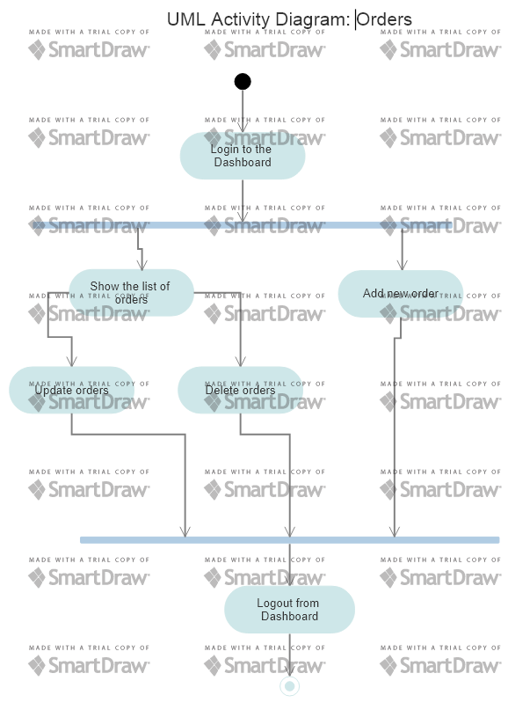

ERD Diagram:

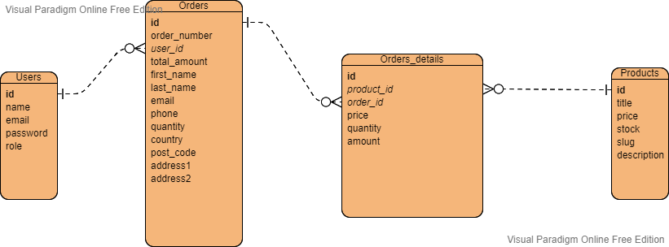

Installation:

1. Download and unzip the code to your local server
2. Create in the phpMyAdmin a new database and configure the .env with your root password and name of the database.
3. In the command prompt execute these commands:
4. Composer installs
5. Php artisan migrate:fresh –seed
6. Php artisan serve