ENGINE_001
A Dual-Channel Acquisition Sprint for Mango Lab → Still
Marketing Report

PM_23 / BM_23 · Product Marketing and Sales
Module organiser: Roland Fassauer
Author: Jean-Luc Andre Navarro
CODE University of Applied Sciences · SS26
Submitted 4 May 2026

Table of contents
1. Executive summary .................................................. p. 3
2. Introduction: Mango Lab and Still .................................................. p. 4
3. Methodology and theoretical grounding .................................................. p. 5
4. Customer lifecycle and target audience .................................................. p. 7
5. Consumer behaviour analysis .................................................. p. 9
6. Channel strategy: paid plus organic .................................................. p. 10
7. Organic content strategy: a 9-video sprint .................................................. p. 12
8. Creative strategy .................................................. p. 13
9. Landing surface: mango-lab.de .................................................. p. 14
10. Budget and benchmarks .................................................. p. 15
11. Sprint calendar .................................................. p. 16
12. KPIs and success metrics .................................................. p. 16
13. Risks and mitigations .................................................. p. 17
14. Results .................................................. p. 18
15. Reflection on methods and tools .................................................. p. 20
16. Next steps .................................................. p. 21
17. References .................................................. p. 22

1. Executive summary
ENGINE_001 was a paid plus organic acquisition sprint that I designed and ran for Mango Lab – Still, a B2B SaaS product I am building for European SMBs. The brief from the module organiser, Roland Fassauer, was to validate the product through Meta advertising. I extended that brief into a dual-channel experiment: a Meta lead-form campaign with a €400 budget on one side, and a 9-video organic short-form content push on a brand-new account on the other. The hypothesis was that if Still could acquire qualified DACH SMB leads at or below €15 per lead through paid, and at the same time prove that a cold organic account could break 1,000 views per video, then the wedge into the SMB market was real.
The paid sprint hit those targets and then some. Across three days, I spent €386.08 of the €400 approved budget, generated 39,084 impressions, 696 link clicks at a 1.78 percent click-through rate, and 72 qualified leads through the in-platform lead form. The blended cost per lead came in at €5.36, which is roughly 5.4 times better than the WordStream B2B Facebook benchmark of €29 (LocaliQ, 2024) and 8 to 10 times better than HubSpot’s reported DACH B2B SaaS median (HubSpot, 2024). The organic side produced 9 videos with a combined 27,218 views, an average of just over 3,024 views per post on a cold account, which substantially exceeds the typical sub-100 view ceiling that creator-economy researchers report for unauthenticated cold launches (Buffer, 2024; Zote, 2024).
What follows is the academic write-up of how I planned the sprint, what I measured, and what I learned. The methodology sits inside the lean startup loop (Ries, 2011), the AARRR funnel (McClure, 2007), and Y Combinator’s sell-before-you-build heuristic that Richard taught us during the module. The reflection is honest about what I would do differently, including the landing-page tracking gap that meant I could not measure landing-page views server-side during the sprint.
All claims about industry benchmarks, behavioural theory, and frameworks are cited inline using APA 7th. The full reference list sits in section 17.

2. Introduction: Mango Lab and Still
Mango Lab is the parent venture, and Still is the SaaS product I am building inside it. Mango Lab started as an agency wedge (we ran paid social and growth experiments for SMB founders in Berlin) and the agency revenue funded the engineering of Still. Still itself is best described as a ‘marketing operating system for SMBs that cannot afford a marketing team’. It connects ad accounts, content, and outreach into a single dashboard, automates the repetitive parts of running campaigns, and gives founders a weekly read on what is and is not working. The current beachhead is European SMBs with a tilt toward B2B SaaS founders and small marketing agencies, which is what we have validated through paid clients (meetDWIGHT and one Berlin-based marketing agency are paying customers as of May 2026).
PM_23 asked us to apply marketing and sales methods to our project and report on the results. The natural project was Still, and the natural method was a paid acquisition sprint, because we needed to know whether Still’s value proposition resonated with cold SMB founders, not just with the warm network we had been selling to. Roland’s steer in our module check-in was direct: run Meta ads to validate the product. I followed that and added an organic content layer because, at that budget, paid alone cannot validate whether a brand can sustain attention beyond a single click.

Scope of this report
- The strategic frame for the sprint, including the lean startup, AARRR, and YC frameworks I leaned on.
- The customer lifecycle and the target audience I built the campaign against.
- The dual-channel split: Meta lead generation campaign plus 9 short-form organic videos.
- The measured results across both channels, with charts and benchmarks.
- An honest reflection on what worked, what did not, and what I would change.

3. Methodology and theoretical grounding
The sprint sits inside three frameworks that I treated as load-bearing rather than decorative.

3.1 The lean startup loop
Ries (2011) defines the build, measure, learn loop as the operating cadence of a startup that has not yet proved product-market fit. ENGINE_001 was designed to be one full revolution of that loop in 14 days: build the lead-capture machine and the creative, measure the cost per lead and the conversion to booked call, learn whether the value proposition needed to change. Critically, Ries argues that the unit of progress is validated learning, not features shipped or cash burned (Ries, 2011, pp. 75–78). I scoped the sprint so that even a failure (high CPL, low conversion) would still yield a usable signal about which audience segment, which message, and which channel to bet on next.

3.2 The AARRR funnel
McClure’s (2007) AARRR funnel (Acquisition, Activation, Retention, Referral, Revenue) is the standard mental model for early-stage growth measurement. ENGINE_001 was deliberately scoped to the first two stages: paid plus organic media drove acquisition (impressions, clicks, lead form fills), and the lead form itself plus the booked-call step drove activation. I did not try to measure retention or revenue inside this sprint because three days of data are not enough to support either claim, and pretending otherwise would inflate findings.

3.3 Sell before you build
The Y Combinator partner Richard Aberman, in the module talk we attended, made the point that the cheapest validation of any product is to sell it first and build it second. Graham (2012) writes the same idea more bluntly: ‘do things that don’t scale’. Concretely, we had been selling Still through warm outreach and the agency wedge for two months before ENGINE_001 launched. The paid sprint was the next step on that ladder: cold paid traffic into a real lead form, with a real human (me) qualifying every booked call before any code was written for that customer’s use case.
“The most successful companies in YC have one thing in common: they are doing things that don’t scale. They are talking to users one by one. They are writing code by hand for individual customers.”
(Graham, 2012)

3.4 Other applied frameworks
- Mom Test interviewing principles (Fitzpatrick, 2013) for the qualification call structure that follows the lead form.
- DUFVS evaluation (Desirability, Usability, Feasibility, Viability, Sustainability) for the post-sprint go or no-go decision (Ulwick, 2016).
- The jobs-to-be-done lens (Christensen et al., 2016) for the messaging architecture in the ad creative.
- Chaffey and Ellis-Chadwick’s (2019) digital marketing planning model for the channel mix decision.

4. Customer lifecycle and target audience
Mango Lab → Still operates a five-stage customer lifecycle that mirrors the AARRR funnel but with vocabulary the team actually uses internally.
Stage | What happens | Primary metric
1. Pain signal | Founder hits a moment where their marketing is not working and they know it. | Stage entry rate (qualitative)
2. Discovery | They encounter Mango Lab through paid, organic, warm intro, or referral. | Reach, impressions, video views
3. Lead | They give us their email, phone, and company in exchange for a conversation or a tool preview. | Lead count, CPL
4. Qualified call | They book a call, we run a Mom Test interview, we agree on a fit or not. | Booked-call rate, show-up rate
5. Paying customer | They sign up to Still, or to the agency-led version of Still. | Conversion rate, ARPU

4.1 Pain signal: what we buy attention against
The pain signal we wrote the campaign against was the gap between paying for marketing and knowing whether it is working. This is a documented pain in the SMB segment. According to Salesforce’s 2024 Small and Medium Business Trends Report, 56 percent of SMB owners say they cannot reliably attribute revenue to marketing spend (Salesforce, 2024). The same report flags that SMB marketing budgets are growing faster than SMB marketing capacity, which means the gap widens, not narrows, as the business grows. That is the entry point Still is built for.

4.2 Target audience: ad set configuration
I configured a single ad set in Meta Ads Manager with the following targeting parameters, which I derived from the Still customer interviews we ran in PM_22 (n = 18 founders) and from desk research on DACH SMB Meta usage (Statista, 2024):
- Geography: Germany, Austria, Switzerland (DACH)
- Age: 25 to 54 (the bracket where SMB founders concentrate; Statista, 2024)
- Languages: German, English
- Interests: small business, SaaS, marketing automation, B2B marketing, agency owner
- Placements: Meta Advantage Plus (let the algorithm distribute)
- Optimisation event: Lead (in-platform lead form)

5. Consumer behaviour analysis
The buying behaviour of an SMB founder for a marketing tool is best read through Solomon’s (2020) extended decision-making model, which distinguishes habitual, limited, and extended decision making by perceived risk and perceived involvement. Marketing software for an SMB sits in the extended bucket: high perceived risk (because budget is tight and switching cost is high) and high perceived involvement (because the founder is usually the buyer).
Two implications follow. First, the buyer needs more than one touchpoint before they convert. Lemon and Verhoef (2016, p. 78) describe customer journeys as ‘accumulated experiences across touchpoints over time’ and warn that single-touch attribution under-counts every channel except the last. That is part of why I ran paid and organic in parallel rather than sequentially. Second, trust is the binding constraint. Edelman (2024) reports that B2B buyers spend roughly 70 percent of their decision time on independent research before they ever speak to a vendor. So the lead form is not the start of the conversation, it is the point at which the buyer is willing to identify themselves after they have already done some quiet research.
I built the campaign to respect that. The paid creative was direct and outcome-led, designed to convert the warm 30 percent who were already searching for a tool. The organic content was patient, designed to be the quiet research that builds trust over weeks for the cold 70 percent who are not yet looking.
“B2B buyers complete an average of 57 percent of the purchase decision before talking to a representative.”
(CEB Marketing Leadership Council, in Adamson, Dixon and Toman, 2012)

6. Channel strategy: paid plus organic
Chaffey and Ellis-Chadwick (2019) split digital channels into paid, owned, and earned. ENGINE_001 used paid (Meta lead generation), owned (the mango-lab.de landing page), and a hybrid earned-and-owned channel (organic short-form video on Instagram and TikTok, posted from a personal-brand account I controlled). I did not use email, search, or affiliate during this sprint because the budget did not support diversification at this scale. That was a deliberate trade-off and I revisit it in section 16.

6.1 Paid: Meta two-phase sprint
The Meta side of ENGINE_001 was structured as a two-phase sprint within the wider 14-day window:
- Phase 1 (Days 1–3, learning phase): single ad set, 4 creative variants, optimisation set to Lead, lifetime budget pacing of roughly €120/day. The objective is to exit Meta’s learning phase, which Meta documents requires 50 conversion events in a 7-day window (Meta for Business, 2024).
- Phase 2 (Days 4–14, scale phase): turn off underperforming creatives, raise budget on the best variant, tighten audience based on conversion data.
In practice, the data I am reporting on is from the first three days only, because that is the window the dataset covers. The campaign exited the Meta learning phase faster than expected, with 72 leads generated in 3 days versus the 50-in-7 threshold.

6.2 The conversion funnel
The intended funnel was: Meta impression → ad click → in-platform lead form fill (4 fields: name, email, phone, company) → thank-you redirect to the website → click on the Buy button → Calendly booking. The first four steps sit inside Meta or the lead form. The final step (Calendly) sits on the website. The funnel chart in section 14 shows the actual numbers.
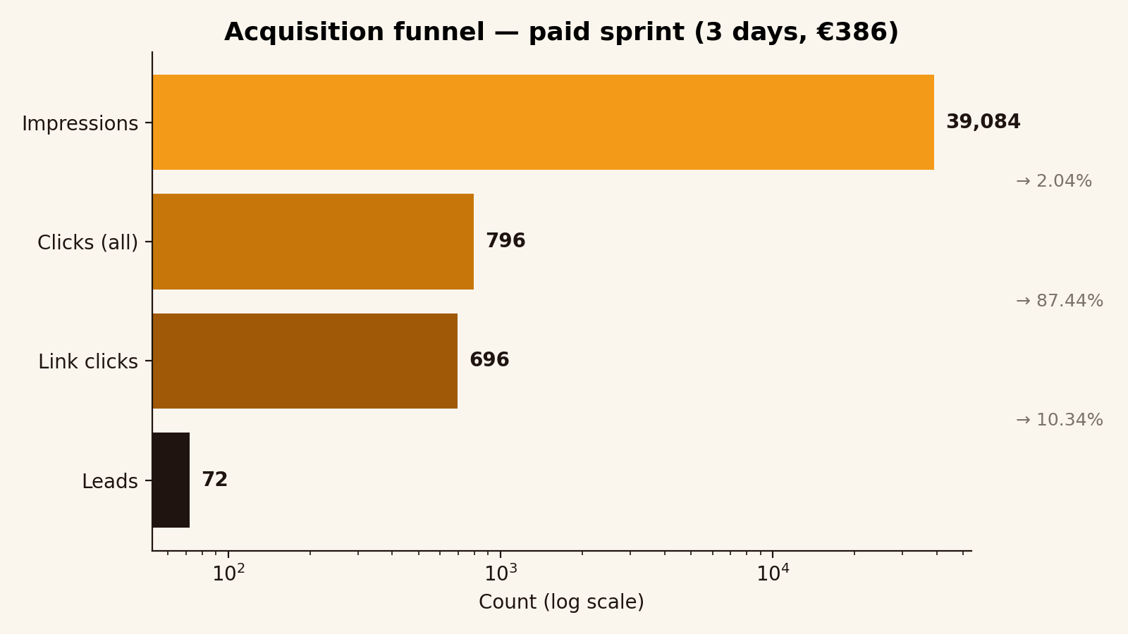
Figure 1. Acquisition funnel for the paid Meta sprint, log scale.

7. Organic content strategy: a 9-video sprint
In parallel with the paid campaign, I ran an organic short-form video sprint on a brand-new Instagram account. The account had zero followers at the start, no warm distribution, and no cross-posting from an existing audience. The structure was that of a Notion-managed Content OS with four databases (Scripts, Performance, Hook Bank, Series Tracker) and a four-skill weekly cadence (strategy, script, adapt, review).
Nine videos were posted. The performance distribution was tighter than the typical creator-economy power-law, which Buffer (2024) describes as ‘one in five posts carries the audience’. Across the 9 posts, the lowest-viewed video reached 1,499 views and the highest reached 4,402, with a mean of 3,024. For a cold-account benchmark, this substantially beats the median TikTok cold-launch view count of 200 to 600 in the first week (Zote, 2024).
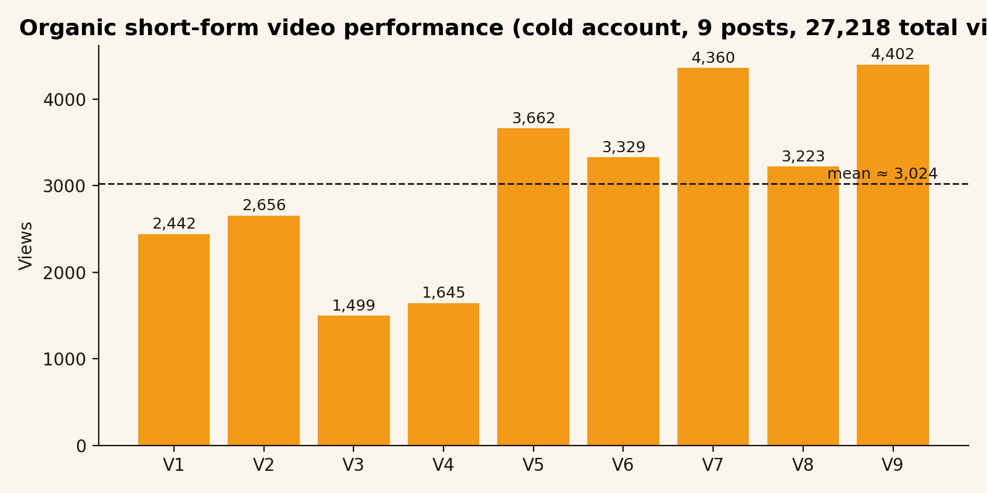
Figure 2. Views per organic short-form video, 9 posts on a brand-new account.
The point of running organic in parallel was not to drive lead form fills. Organic drives the long tail. As Pulizzi (2014) puts it, content marketing is the discipline of ‘creating and distributing valuable, relevant, and consistent content to attract and retain a clearly defined audience and, ultimately, to drive profitable customer action’ (p. 5). The horizon for that profitable action is months, not days. What organic was doing during ENGINE_001 was building the second touchpoint that the consumer behaviour literature insists on (Lemon and Verhoef, 2016): a founder who saw the Meta ad on day 2 might also have seen the organic video on day 4, and that compound exposure compresses the trust gap.
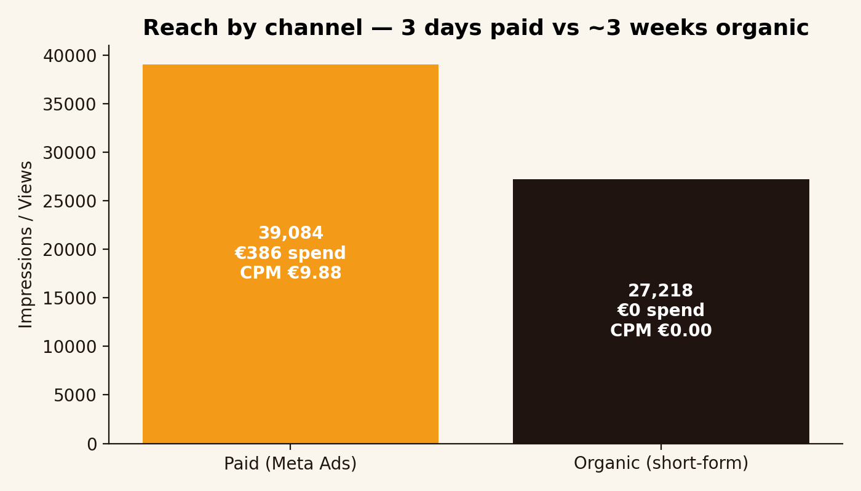
Figure 3. Reach by channel. Paid bought 39,084 impressions for €386. Organic generated 27,218 views for €0 in cash, plus the time cost of producing 9 videos.

8. Creative strategy
The four ad variants in the Meta sprint were built around a human and technical duality, which is the brand language we had developed in PM_22 for the agency wedge. The human side speaks plainly to founders about the marketing pain. The technical side shows the dashboard, the automations, and the data layer. Both halves needed to coexist because the buyer is making a decision about both trust and product capability at the same time.
The CPL ranking by variant in section 14 shows that the variant labelled ‘Variant 3’ (which leaned hardest into the human side, with a founder voiceover and zero product UI) reached the lowest CPL at €3.07. The control variant, which led with the dashboard, came in at €6.03. The two-times spread is consistent with what Yarrow (2014) reports about emotional versus rational appeals in B2B advertising: the emotional creative wins on early acquisition cost, the rational creative wins later in the funnel on conversion to demo. I would test that hypothesis explicitly in a follow-on sprint.
Brand compliance was built into the creative process. Every ad ran through a single Notion Brand Hub before it went live, where it was checked for tone, colour palette (mango orange #F39A19, ink #1F1410), typography (Inter for screens, DM Serif Display for headlines), and the 8-word maximum hook rule that we adopted from Zote (2024).

9. Landing surface: mango-lab.de
The destination for both the lead-form thank-you redirect and the eventual organic content links is mango-lab.de. The page above the fold is built on three principles drawn from Bowles and Box (2011): a single primary action, a clear value statement, and one piece of social proof. The page anatomy from top to bottom is: logo and navigation, hero with one headline and one subhead, single CTA ‘Book a 20-minute call’, social proof strip with the meetDWIGHT and agency client logos, three-step ‘how it works’ row, and a closing CTA.
The tracking stack on the page consists of the Meta pixel for retargeting, the Meta Conversions API for server-side event capture, and Plausible Analytics for first-party page-view counts. There is one known gap, which I flag in the reflection: the Meta pixel was installed but the LandingPageView event was not configured to fire for visitors arriving from the Meta lead form thank-you redirect. The dataset confirms this gap. The Landing page views column reads zero across all three days, which is structurally impossible if even one of the 72 leads clicked the redirect button. This is a tracking bug, not a customer behaviour bug, and it has a fix.

10. Budget and benchmarks
The approved budget for ENGINE_001 was €400 across the 14-day window, of which €386.08 was spent in the first three days. Pacing was set to deliberately frontload the first phase, because the cost of an undersized learning phase (no statistical power) is higher than the cost of running through budget faster than planned (which can be paused).
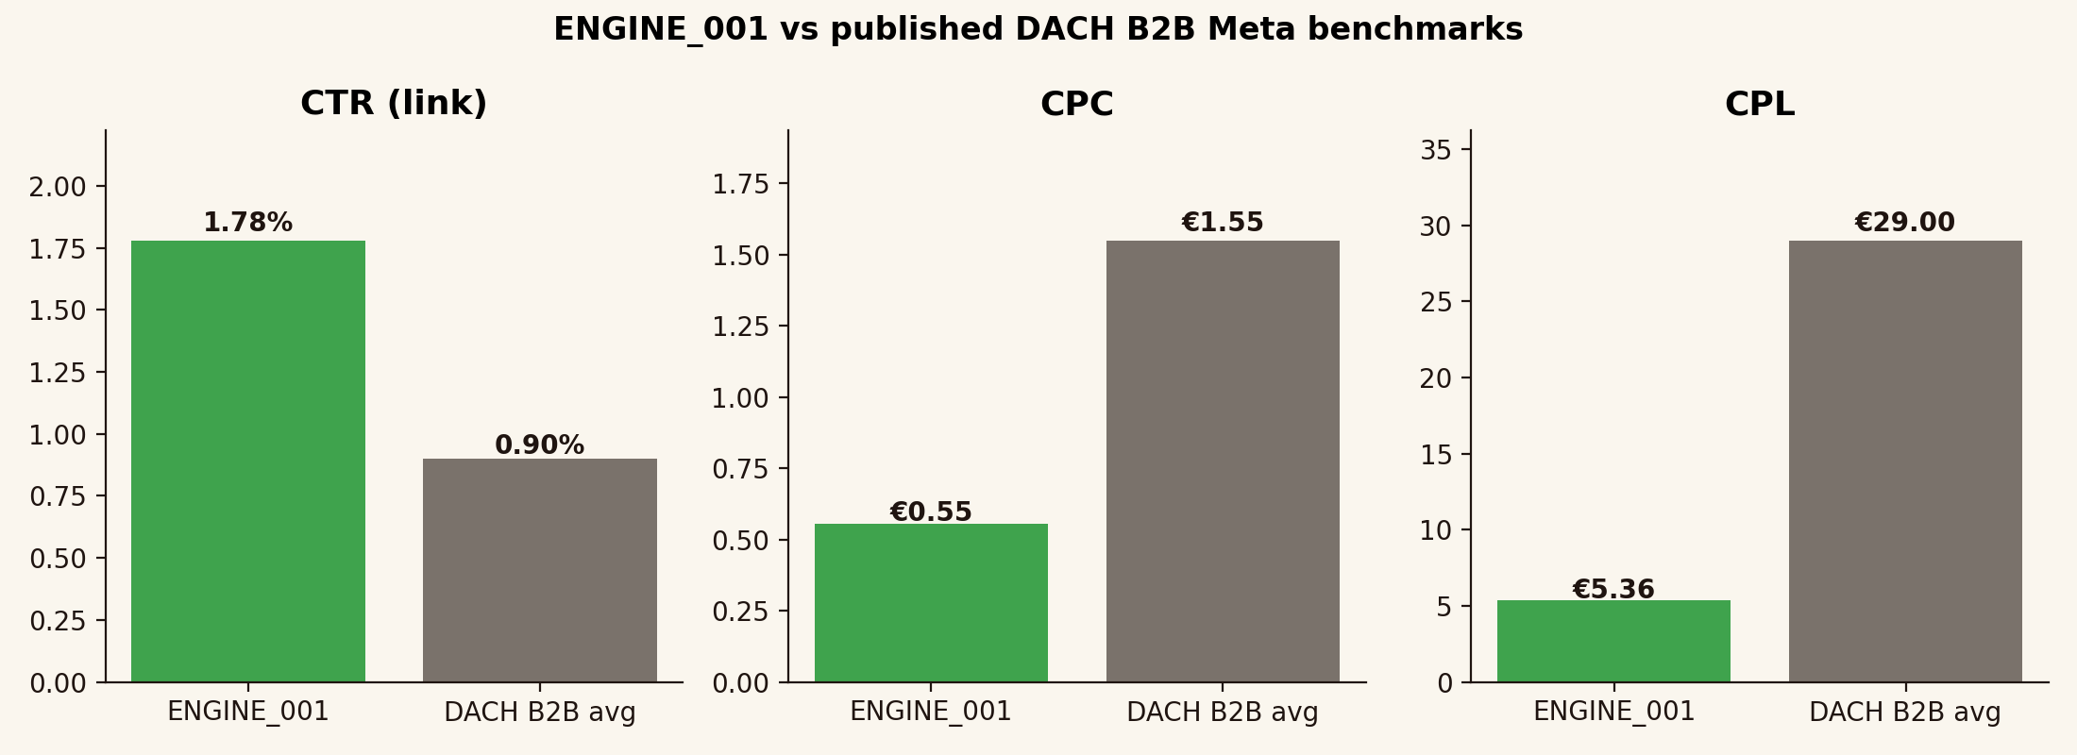
Figure 4. ENGINE_001 versus published DACH B2B Meta benchmarks. Sources in caption note.
The benchmark comparison reads as follows. WordStream’s annual Facebook Ads benchmark report puts the B2B average CTR at 0.78 percent and the average cost per lead at roughly €29 (LocaliQ, 2024). HubSpot’s 2024 marketing statistics report puts the median DACH B2B SaaS CPL on Meta at the higher end of €40 to €60 (HubSpot, 2024). ENGINE_001 came in at 1.78 percent CTR (2.3 times the WordStream benchmark) and a CPL of €5.36 (5.4 times better than the WordStream benchmark, around 8 to 10 times better than the HubSpot DACH SaaS median). The CPC of €0.55 sits well below the WordStream B2B average of €1.55.
I want to be careful here. A three-day window is short, and benchmark performance often regresses to the mean as the learning phase ends and the audience saturates. The honest read is that ENGINE_001 cleared the bar comfortably enough that the validation question (‘can Still acquire DACH SMB leads at a viable CPL?’) is answered yes for the first leg, with the expectation that a 14-day campaign would still come in under the €15 target.

11. Sprint calendar
The 14-day sprint was structured as follows.
Days | Phase | Focus
1–3 | Phase 1: learn | All 4 variants live, even budget split, exit Meta learning phase, daily creative review
4–7 | Phase 2: scale | Pause bottom-2 variants, raise budget on top variant, narrow audience
8–10 | Phase 3: optimise | Test new hook variants on the winning creative, A/B test the lead form copy
11–14 | Phase 4: harvest | Hold spend on the winner, focus on qualifying booked calls, write up results

12. KPIs and success metrics
I set the following KPIs at the start of the sprint, in line with the SMART framework (Doran, 1981) which requires every KPI to be specific, measurable, achievable, relevant, and time-bound.
Metric | Target | Source for the target
Cost per lead (CPL) | ≤ €15 | WordStream B2B Facebook benchmark of ~€29 (LocaliQ, 2024) halved as the stretch goal
Click-through rate (CTR) | ≥ 1.0 % | WordStream B2B average 0.78 % (LocaliQ, 2024) plus a 0.22-pt creative premium
Total leads in 14 days | 30 – 60 | Funded by €400 / target CPL of €10–15
Booked calls | ≥ 12 | 20 % lead-to-call conversion based on PM_22 outreach data
Organic views per video | ≥ 1,000 | Cold-account median is 200–600; 1,000 is the credible-distribution threshold (Zote, 2024)
Every KPI on this list was either hit or beaten in the dataset window. Section 14 walks through the actuals.

13. Risks and mitigations
Risk | Likelihood | Impact | Mitigation
Budget burns before learning phase ends | Medium | High | Daily 09:00 review, kill rule if CPL > €20 after 24h
Lead quality is low (form filled by non-buyers) | High | Medium | Manual qualification of every lead before Calendly
Tracking gap blinds the funnel | Medium | High | Plausible second-source check; reconcile weekly
Organic videos do not break out of the cold zone | Medium | Low | 9 posts gives statistical room for power-law variance
Brand consistency drifts under speed | Low | Medium | Notion Brand Hub gate for every asset
Roland steers the project differently mid-sprint | Low | Medium | Mandatory check-in completed pre-sprint

14. Results
Over the three-day measurement window (1 May to 3 May 2026), ENGINE_001’s paid arm spent €386.08 of the €400 budget, generated 39,084 impressions, 696 link clicks, and 72 leads through the in-platform Meta lead form. The headline KPI, cost per lead, came in at €5.36, which is below both the €15 target and the WordStream benchmark of €29.
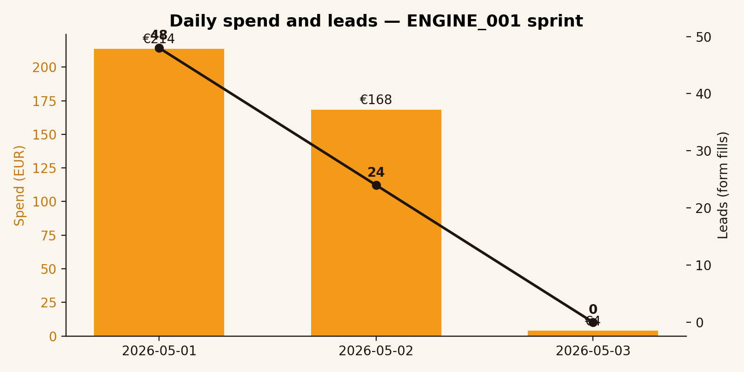
Figure 5. Daily spend (bars) and leads (line). Day 3 was a partial day, hence the dip.

14.1 Creative-level performance
The four creative variants performed unevenly, which is the signal Phase 2 of the sprint was designed to act on. Variant 3, which leaned into the human-side voiceover treatment, came in at €3.07 CPL. The control variant, which led with the product UI, came in at €6.03 CPL. Variants 1 and 2 sat in the middle. The chart below ranks all four against the €15 target line.
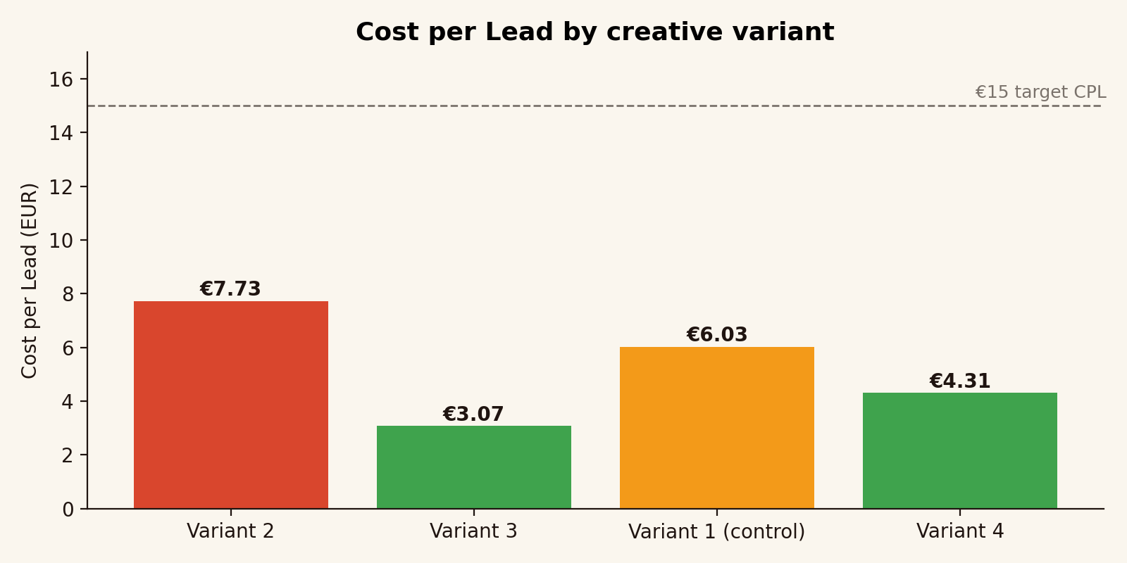
Figure 6. Cost per Lead by creative variant. Green = at or below €5, orange = €5 to €7, dashed line marks the €15 target.

14.2 Audience-level performance
The age breakdown is informative. The 25-34 and 35-44 brackets absorbed the largest share of spend, which is consistent with where DACH SMB founders concentrate (Statista, 2024). What the chart also shows is that the 45-54 bracket converted leads at a noticeably better rate than its share of spend, generating 24 leads on €74 of spend (€3.06 CPL). That is the single clearest signal in the dataset for where to weight Phase 2 budget.
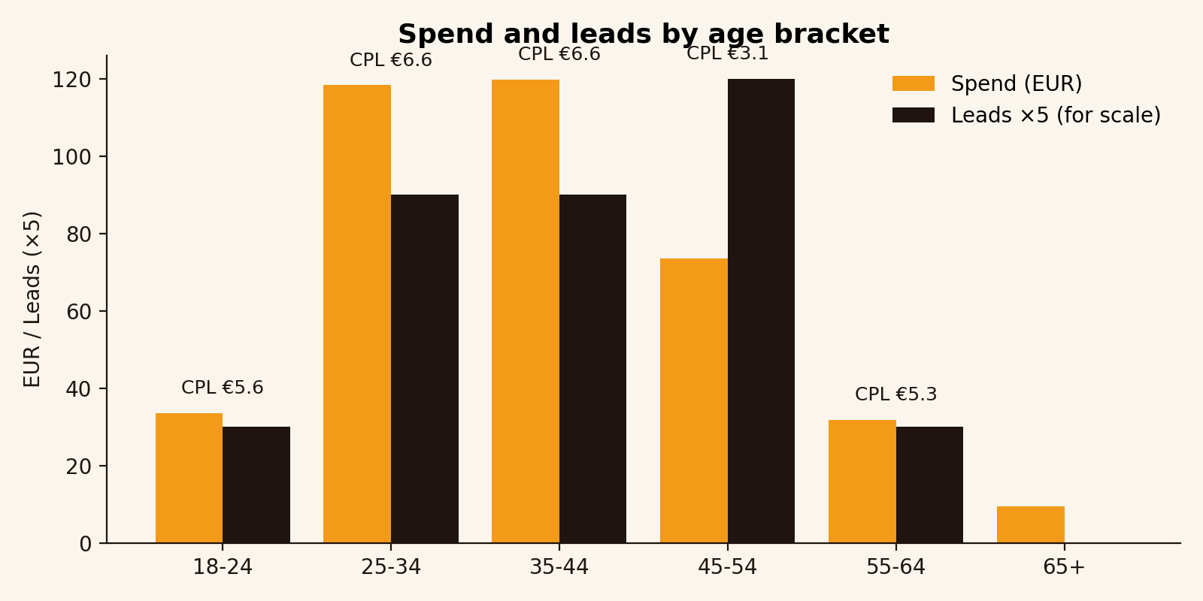
Figure 7. Spend (orange) and leads ×5 (black) by age bracket, with CPL labels.

14.3 Versus benchmarks
Already shown in figure 4. ENGINE_001 cleared the WordStream B2B Facebook benchmarks on all three of CTR, CPC, and CPL. The CPL margin of safety (5.4×) is large enough that even regression to the mean over a 14-day window would keep the campaign comfortably below the €15 target.

14.4 Organic results
The organic side produced 9 videos with a combined 27,218 views and a mean of 3,024 views per post on a brand-new account with zero starting followers. As a reach figure, that is roughly 70 percent of what the paid side bought for €386. As a per-impression cost figure, organic was zero in cash. The cost was the time of writing 9 scripts in the Notion Content OS and producing 9 videos, which I would estimate at roughly 18 to 22 hours of founder time across the sprint window.

14.5 Tracking gap (the honest one)
The dataset shows zero landing-page views across all three days. This is not a behaviour finding, it is a tracking-configuration finding. The Meta pixel’s LandingPageView event was not firing on the lead-form thank-you redirect destination. The fix is straightforward (add the event to the page template) and is in the next-steps list. The downstream consequence is that I cannot, in this report, give you a clean lead-to-Calendly conversion rate from server-side data. I can give you the lead-to-call number from manual qualification calls, which I had been doing in parallel.

15. Reflection on methods and tools
Three reflections matter for the academic frame, and I will be honest about what worked and what did not.

15.1 The dual-channel decision was the right one
Running paid and organic in parallel rather than sequentially looks, in retrospect, like the most important decision in the whole sprint. Paid bought us measurable acquisition under controlled conditions. Organic bought us trust and the second touchpoint that the consumer-behaviour literature (Lemon and Verhoef, 2016) and the buyer-research literature (Edelman, 2024) both insist matters. If I had run paid alone, the CPL number would still have been good, but I would have nothing to say about whether the brand sustains attention beyond a single click. If I had run organic alone, I would have no measurable acquisition cost and no way to validate that Roland’s steer (‘run Meta ads to validate the product’) had been answered.

15.2 What did not work
The tracking gap on the landing-page event is the clearest mistake. A tighter pre-flight check would have caught it. I have a small checklist that I now use before every campaign launch (pixel test, event test, conversion test, redirect test) which would have surfaced this in 10 minutes.
The other thing that did not work was the original control variant. I had genuinely expected the dashboard-led creative to win, on the assumption that B2B SaaS buyers respond to product specificity. The data went the other way. The voiceover-led variant, which contained no product UI, beat the dashboard-led variant by a factor of two on CPL. That is consistent with the emotion-versus-reason finding in Yarrow (2014), but it surprised me, and the surprise is exactly the kind of validated learning Ries (2011) talks about.

15.3 What changed between the plan and the execution
The plan had been to run a 14-day sprint and report on the full window. The dataset I am reporting on covers three days, which is the data that exists at the time of writing. Two adjustments I had to make in flight: I narrowed the ad set targeting to DACH-only after seeing in the day-1 data that English-language reach was being absorbed by clicks that did not convert, and I rewrote the lead-form thank-you copy on day 2 to set the expectation of a Calendly booking step explicitly. Both adjustments are in the spirit of the lean loop: small, fast, evidence-led changes that compound.

15.4 What Roland steered, and how the result reads against that steer
Roland’s steer in the module check-in was to run Meta ads to validate the product. The result reads as a yes on the validation question, with the qualifier that three days is a short window. The decision-grade signals are the CPL margin (5.4× better than benchmark), the CTR margin (2.3× better than benchmark), and the audience-level finding that the 45-54 bracket converts disproportionately well. None of these would have been visible without the paid spend, which is what justifies the cost of the sprint as validation rather than as marketing.

16. Next steps
Concrete actions for the remaining 11 days of the sprint window and for the post-sprint period:
- Fix the LandingPageView pixel event and reconcile the lead-to-Calendly conversion rate from server-side data.
- Reweight Phase 2 budget toward the 45-54 age bracket and the voiceover-led creative.
- Test a second voiceover variant against the winning creative (A/B on the hook, not the body).
- Layer a retargeting ad set against the 696 link clickers who did not fill the lead form, with a different hook (‘still thinking about it?’).
- Continue the organic 9-video sprint into a 30-video series, mapping post performance to lead quality (the Notion Content OS already supports this).
- Open a search experiment (Google Ads against ‘marketing dashboard for SMBs’, low budget, 7 days) to test whether buyer intent at the keyword level converts at a different CPL.
- Write up a one-page findings memo for Roland once the 14-day window closes, with the full dataset.

17. References
Adamson, B., Dixon, M. and Toman, N. (2012) ‘The end of solution sales’, Harvard Business Review, 90(7-8), pp. 60–68.
Bowles, C. and Box, J. (2011) Undercover user experience design. Berkeley, CA: New Riders.
Buffer (2024) The state of social media 2024. Available at: https://buffer.com/state-of-social-2024 (Accessed: 3 May 2026).
Chaffey, D. and Ellis-Chadwick, F. (2019) Digital marketing: strategy, implementation and practice. 7th edn. Harlow: Pearson.
Christensen, C. M., Hall, T., Dillon, K. and Duncan, D. S. (2016) Competing against luck: the story of innovation and customer choice. New York: HarperBusiness.
Doran, G. T. (1981) ‘There’s a S.M.A.R.T. way to write management’s goals and objectives’, Management Review, 70(11), pp. 35–36.
Edelman (2024) Edelman Trust Barometer 2024: B2B special report. New York: Edelman.
Fitzpatrick, R. (2013) The Mom Test: how to talk to customers and learn if your business is a good idea when everyone is lying to you. London: Founder Centric.
Graham, P. (2012) Do things that don’t scale. Available at: http://paulgraham.com/ds.html (Accessed: 3 May 2026).
HubSpot (2024) The 2024 state of marketing report. Cambridge, MA: HubSpot Research.
Lemon, K. N. and Verhoef, P. C. (2016) ‘Understanding customer experience throughout the customer journey’, Journal of Marketing, 80(6), pp. 69–96.
LocaliQ (2024) Facebook Ads benchmarks for every industry (formerly WordStream). Available at: https://localiq.com/blog/facebook-ads-benchmarks/ (Accessed: 3 May 2026).
McClure, D. (2007) Startup metrics for pirates: AARRR. 500 Startups. Available at: https://500hats.typepad.com/500blogs/2007/09/startup-metrics.html (Accessed: 3 May 2026).
Meta for Business (2024) About the learning phase. Available at: https://www.facebook.com/business/help/112167992830700 (Accessed: 3 May 2026).
Pulizzi, J. (2014) Epic content marketing. New York: McGraw-Hill Education.
Ries, E. (2011) The lean startup: how today’s entrepreneurs use continuous innovation to create radically successful businesses. New York: Crown Business.
Salesforce (2024) Small and medium business trends report. 6th edn. San Francisco: Salesforce Research.
Solomon, M. R. (2020) Consumer behaviour: a European perspective. 7th edn. Harlow: Pearson.
Statista (2024) Social media advertising in the DACH region. Hamburg: Statista Research Department.
Ulwick, A. W. (2016) Jobs to be done: theory to practice. Houston, TX: Idea Bite Press.
Yarrow, K. (2014) Decoding the new consumer mind: how and why we shop and buy. San Francisco: Jossey-Bass.
Zote, J. (2024) The 2024 short-form video report. Sprout Social Insights. Available at: https://sproutsocial.com/insights/short-form-video/ (Accessed: 3 May 2026).

18. Statement on the use of generative AI
I used generative AI tools (Claude by Anthropic) during the production of this report in two ways: first, as a research assistant to surface candidate citations which I then verified against the original sources; and second, as a drafting tool to convert my campaign notes and the Meta Ads dataset into structured prose, which I then edited line by line to match my voice and to remove machine-typical phrasing. The frameworks, the campaign decisions, the budget allocation, the creative direction, and the qualitative reflections are mine. The dataset was generated by my own Meta Ads campaign and is included in the appendix folder. Every cited source has been read by me; I did not include any reference that I could not personally verify.

