Sub-objective 1.4: Train oat-pea intercrop genomic prediction models. Estimate the accuracy of genomic prediction of intercrop-related breeding values of each crop and the ability to predict overall performance of specific oat-pea combinations using cross-validation.
Analyzing Oat-Pea Intercrop Performance: We described two, related ways to evaluate an intercrop. The first is called a general and specific mixing ability (GMA/SMA) model, which is analogous to the evaluation of hybrid performance, with two species instead of two heterotic groups [35–37,69]. Performance of intercrop plots is partitioned into general (GMA) and specific mixing ability (SMA) components. GMA is the average performance of each cultivar when intercropped with any genotype of the companion species and SMA is the performance deviation of specific combinations.
The second model partitions the GMA into Producer (Pr) and Associate (As) effects [35]. Pr-effects are effects of a genotype on its own performance while As-effects are its effects on the performance of its companion [41,42]. Pr and As effects are also known as direct and indirect genetic effects [30,57,58]. Conventionally, Pr-As models require two separate analyses, by species. As we describe below, with genomic relatedness information, a joint analysis is possible.

General and Specific Mixing Ability Model
The performance of a candidate mixture (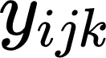) can be expressed as a weighted combination of the merit of the two species and each species’ merit can itself be an index of multiple traits. For simplicity, let’s assume equal weights. We can predict the mixture performance using the GMA-SMA model originally described by Wright (1985) (Equation 1).

(1)
The generic fixed (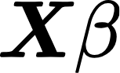) and random (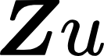) effect components are there to accommodate the experimental design. There are two random-effects that capture the general mixing abilities of the i oats (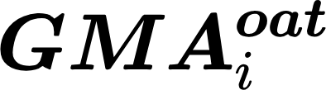) and j peas (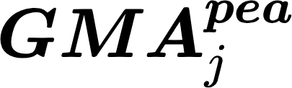) and an third capturing the interaction effect or specific mixing ability of the ijth oat-pea combination (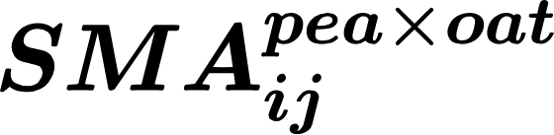). The genetic random effects are distributed as:
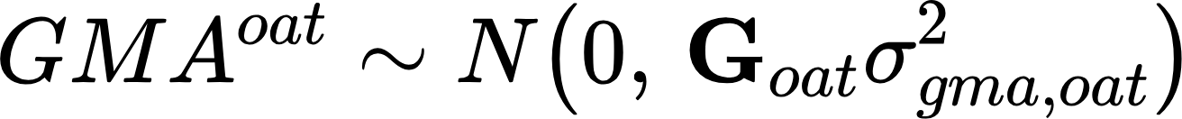, , .
The GMA components estimate variance in average performance of one species mixed with the other (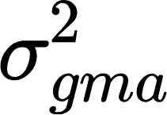). The variance in performance deviation among specific combinations is 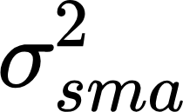. Each component is modeled with corresponding marker-derived genomic relatedness matrices (GRMs). For each species’ GMA term, the GRMs ( and 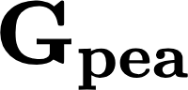) have the dimension of the number of entries for each species, i.e. 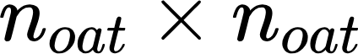 and 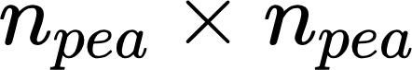. For the SMA term, the GRM’s dimensions should be the number of unique possible combinations of 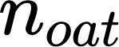 and 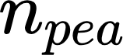. We can use 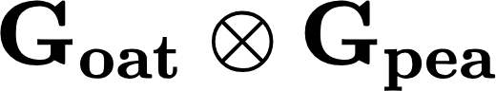 where  represents a kronecker product for the oat-pea SMA covariance matrix. Notice that this specification predicts all possible combinations’ performance even if a combination was not observed.

The Producer-Associate Model
The performances of each species, from the mixture plots, can also be analyzed with a direct-indirect genetic effect model (DGE-IGE), also called the producer-associate model [30,35,41,42,59].
This analytic approach must typically be done with two separate analyses, in our case one for oats, another for peas.
(Eqn. 2)

Here, the yield (or merit index) for oats is modeled as: the direct genetic effect of oat genotypes on their own performance (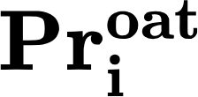, producer-effect), indirect genetic effects of pea genotypes on oat performance (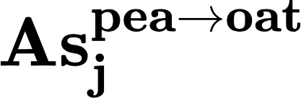, associate-effect) and an interaction effect allowing performance deviations of each oat when in specific combination with a pea (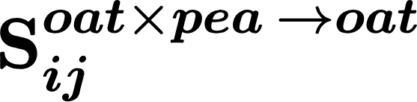, direct x associate-effect interaction). This model is extensible for genomic prediction [57,58]. These random genetic effects are distributed as:
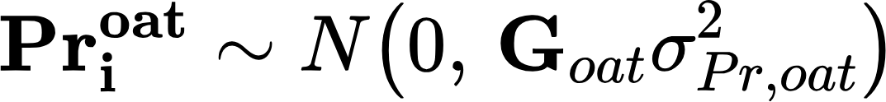, , .
Pea yield can be modeled in the same way in a parallel analysis.
Notice that the kinship matrices and overall set-up of the variance components in this model are similar to the GMA-SMA model; The following clarifies why:
These analyses are as simple as the one for general and specific mixing ability but characterize each oat and pea accession in more detail by distinguishing their own ability to perform (producer effect) versus their impact on the performance of their partner (associate effect). An unfortunate side effect of separating the analysis of oat performance from that of pea performance is that it causes the estimation of the oat (pea) producer effect to occur in a different analysis from the estimation of the oat (pea) associate effect. Yet we have every biological reason to believe that the producer and the associate-effects should be correlated and therefore to want to include an estimate of the covariance between them in the analysis.
Below, we propose a bivariate model capable of jointly analyzing the performance of the oat and the pea together.

Jointly analyzing two-species mixtures with a bivariate DGE-IGE model:
With the aid of genomic covariances, the following analysis arises by concatenating models (2) and (3):
Proper use of incidence matrices causes the genetic components (e.g. , ) to be appropriately incorporated as part of the estimate for each performance observation. Now we are estimating these four vectors together in one analysis, so we can impose a covariance structure on them.
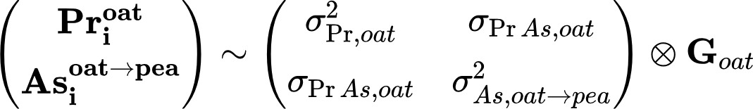
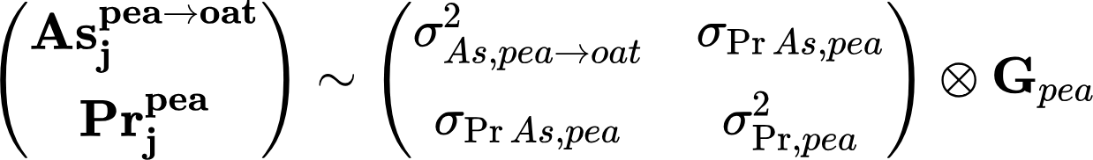
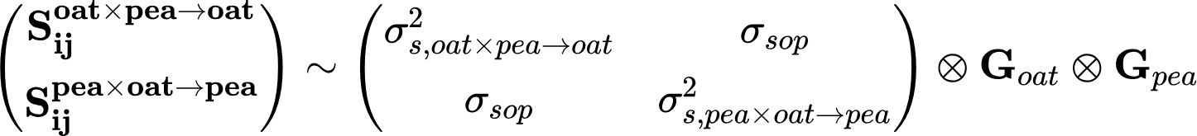
The 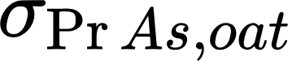 and 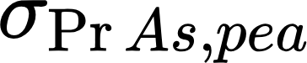 parameters are the covariances between the producer and associate effects for oat and pea, respectively. There may also be reason and possibility to estimate error covariance components between the vectors 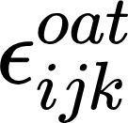 and 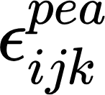.
To our knowledge, this model hasn’t been used before. As part of Sub-obj. 1.4 we will determine if this full model can be fit using mixed-model software (e.g. asreml, BGLR, BLUPF90). To date, we have fit a simplified version of it (omitting specific combination effects) using BGLR (see preliminary data).

